THE PORTRAYAL OF ENVIRONMENTAL CORPORATE SOCIAL RESPONSIBILTY (1970’s-2010): A LOOK AT THE NEW YORKER’S CARTOONS

Honors Thesis

Presented in Partial Fulfillment of the Requirements

For the Degree of Bachelor of Education
In the School of Business
at Salem State University

By

Jessica Herrera

Zlatinka N Blaber
Faculty Advisor
Department of Accounting and Finance

***

Commonwealth Honors Program
Salem State University
2017

Abstract
Corporate Social Responsibility (CSR) has become a hot topic. This thesis focuses on analyzing the way environmental CSR has been depicted over 40 years (1970-2010) by cartoon artists in The New Yorker magazine. The research question addressed is: How have The New Yorker cartoonists’ views of Carroll’s (1991) CSR components changed over time? This study adopts a mixed methods methodology – qualitative visual methods (cartoon analysis) and quantitative counting of instances of presence of certain elements or lack thereof. An in-depth qualitative and quantitative analysis of eight selected cartoons was performed. The qualitative part of the analysis was done by partially adopting Carroll’s framework of CSR, i.e. by adopting three of the four Carroll’s (1991) components of CSR and the SCIM-C model. This model was used to analyze the cartoons from a historical context. The quantitative part of the analysis was done by counting the number of “yes” and “no” answers to several questions based on the same work. The results of the analysis demonstrate that throughout the specified time period, 1970 to 2010, cartoonists viewed corporations and corporate executives as primarily profit driven, disregarding of ethical societal expectations, and rather careless about complying with existing environmental laws.

Table of Contents
Abstract i
Table of Contents ii
Acknowledgements iii
1. Introduction 1
2. Literature Review 3
2.1. The Evolution of CSR 3
2.1.1. CSR and the Environment 5
2.1.2. Environmental Laws and Regulations in 1970-2010 8
2.1.3. A Brief History of The New Yorker Cartoons 9
3. Research Question 10
4. Theoretical Framework 11
5. Methodology 13
5.1. Step 1: Initial Data Selection 13
5.1.1. Step 2: Data Reduction 14
5.1.2. Step 3: Qualitative Analysis 15
5.1.3. Step 4: Quantitative Analysis 17
6. Data Presentation and Analysis 17
7. Findings 37
8. Conclusion: 41
Appendix A: Environmental Laws in the United States 41
Appendix B: 30 Cartoons Initially Selected 43
References: 45

Acknowledgements

First and foremost, I would like to express my sincere gratitude to my thesis advisor Zlatinka Blaber. Without her assistance, motivation, and knowledge, this paper would have never been accomplished. Her enthusiasm for the topic and the end results is what truly motivated me to finish. I could not have imagined having a better thesis advisor.

Besides my advisor, I would also like to thank Scott Nowka for his support and encouragement. His dedication to Salem State University’s honors program is admirable.

Lastly, I would like to thank my family for their continuous support throughout the process of writing my thesis and my four years and a half at Salem State University. Their words of encouragement and support are truly what always motivated me to do my best. I will be eternally grateful to them all.

Introduction
Corporate Social Responsibility (CSR) is a fairly recent concept. In the United States (U.S.), the idea of CSR emerged around the start of the 20th century (Lawrence and Weber, 2017). Corporations at that time came under attack for being too large, powerful, and guilty of antisocial practices. As a result, numerous business executives advised corporations to use their power to participate in voluntary initiatives that would benefit society rather than for profits alone (Ibid.; Brown, 2011).

Since the emergence of CSR, there have been numerous studies that focus on the topic. For example, some studies have focused on determining whether an investment in CSR brings any return to the corporation (Aupperle, Carroll and Hatfield, 1985; McWilliams and Siegel, 2000), while other studies have focused on the views of stakeholders towards CSR (Andriof and McIntosh, 2001; Shruti, 2011). Yet, only a few studies (Lee and Carroll, 2011) consider an external to the company point of view on CSR. These external to the company views consist of any views that do not specifically pertain to any individuals that are internal to a corporation (employees and managers) or who may be in one way or another firmly invested in the corporation’s success – shareholders and creditors. An external perspective on CSR is important because focusing only on the corporate side of the subject matter exhibits a corporate bias, rather than an external to the company point of view. This study attempts to fill this first research gap (Gap n. 1) by looking at the way cartoonists, people external to the corporate world, have viewed the subject of CSR. A “cartoon” has been defined as a “sketch or drawing, usually humorous, as in a newspaper or periodical, symbolizing, satirizing, or caricaturing some action, subject, or person of popular interest” (www.dictionary.com).
CSR has widely been regarded as a “business approach that contributes to sustainable development by delivering economic, social, and environmental benefits for all stakeholders” (Financial Times, n.d.). However, CSR continues to be an evolving concept. The way that it is understood and carried out differs greatly among companies and countries. In a study by Dahlsrud, thirty-seven varying definitions of CSR are identified and discussed (Dahlsrud, 2006). In his study, Dahlsrud concludes that all thirty-seven definitions of CSR either involved one or a few of the following five dimensions: environmental, social, economic, stakeholder, and voluntariness. Thus, CSR is a very broad concept.

For purposes of this thesis, the cartoons used in the cartoon analysis only consider one dimension of CSR: the environmental dimension. The analysis considers how cartoon artists depicted the way corporations, or individuals closely involved with corporations, have or have not fulfilled their responsibilities related to environmental sustainability. This was done by partially adopting Carroll’s (1991) framework of CSR in which he determines that businesses have four main responsibilities to society: economic, legal, ethical, and philanthropic. This thesis considers the economic, legal, and ethical responsibilities as components of the environmental dimension of CSR.

This research attempts to fill another research gap, besides Gap n. 1 above: provide an analysis of cartoonists’ perspectives on environmental CSR (Gap n. 2). The cartoons presented and analyzed in this thesis are found in The New Yorker, a magazine which, since its inception in 1925, has been regarded as an excellent source for keeping up with current events. The New Yorker has a wide audience outside of New York and is also read internationally. Furthermore, The New Yorker cartoons are widely recognized for being unique among the world’s cartooning styles because of their ability to be realistic, truthful, and right (Mankoff et al., 2006).

This research first reviews the literature on CSR, focusing on the following: (1) the evolution of CSR from 1970 to 2010, (2) CSR and the environment, (3) environmental laws and regulations established from 1970 to 2010, and (4) a brief history on The New Yorker cartoons. The later portion of this study will focus on an in-depth review on Carroll’s (1991) framework of CSR and offer a discussion and analysis of eight cartoons by partially adopting the Summarizing, Contextualizing, Inferring, Monitoring, and Corroborating model (SCIM-C model) (CWMC, n.d.).

Literature Review

The Evolution of CSR

Howard R. Bowen, for long, has been considered the father of CSR. In his book Social Responsibilities of the Businessman, Bowen is said to have marked the beginning of the modern period of literature on this subject (Bowen, 1953). Bowen’s work carried on from the belief that the several hundred largest businesses at the time were vital centers of power and that the actions of these businesses touched the lives of citizens in numerous ways (Carroll, 2008). Bowen’s definition of CSR was the following: “It refers to the obligation of businessmen to pursue those policies, to make those decisions, or to follow those lines of action which are desirable in terms of the objectives and values of our society” (Bowen, et al., 2013, p. 6). Since the 1950s businesses have evolved and so have CSR definitions.
The year 1970, for example, marked one of the most controversial years for corporations and their role in society. This can be attributed to the economist Milton Friedman’s publicly declared view on CSR: “There is one and only one social responsibility of business – to use its resources and engage in activities designed to increase its profits so long as it stays within the rules of the game, which is to say, engages in open and free competition without deception or fraud” (Friedman, 1970, p. 17). Friedman, further justified his reasoning by stating that businesses cannot have responsibilities because corporations are only artificial persons (Ibid.). And so, presumably, the individuals who are to be responsible are businessmen – sole proprietors, partners or corporate executives. As far as corporations are concerned, since corporate executives act as agents of their shareholders, their main responsibilities are to these shareholders.

As suggested in Dahlsrud’s (2006) study mentioned above, CSR has proven to be not only an important and evolving concept, but also one that is associated with the following dimensions: environmental, social, economic, stakeholder, and voluntariness. Society has always expected that corporations should have, besides economic responsibilities to their shareholders, responsibilities to the rest of their stakeholders, including the environment. Furthermore, Archie B. Carroll, created a pyramid of CSR which identified four corporate responsibilities. His four-part definition of CSR was originally framed as follows: “Corporate social responsibility encompasses the economic, legal, ethical, and discretionary (philanthropic) expectations that society has of organizations at a given point in time” (Carroll 1991, p. 39-48). This comprehensive definition of CSR has been widely utilized by CSR theorists (Wartick and Cochran, 1985; Lee 2008) and empirical researchers (Lee and Carroll, 2011; Clarkson, 1995). Carroll’s definition is one of CSR’s most widely used definitions.
Nowadays, corporations are ever more involved in CSR-related practices. This involvement however is not only a result of good intentions, but also of economic benefits from being socially responsible. According to a study in 2010, conducted by Cone Communications, a public relations agency that specializes in corporate responsibility, 41 percent of Americans said that they have purchased a product in the past year because it was associated with a social or environmental cause (CSRWire, 2010). Furthermore, 83 percent of consumers said that they have wanted more of the products and services that they use to benefit causes (Ibid.). As competition blooms, corporations attempt to become ever more involved in socially beneficial causes, to be regarded as both ethical and responsible entities. The 2008 KPMG International Survey of CSR showed that nearly 80% of the Global Fortune 250 companies now release CSR reports alongside their annual financial reports. KPMG found that this was an increase of 50% since 2005 when this survey was last conducted (CSRWire, 2008).

CSR and the Environment

The state of our environment is deteriorating. This can be attributed to the fact that numerous countries use nonrenewable sources of energy, such as coal, oil, and gas. The burning of these fossil fuels results in the release of greenhouse gasses, such as carbon dioxide, which trap the sun’s rays in the atmosphere. Consequently, this has resulted in the gradual warming of the planet and has had a detrimental effect not only on the planet itself, but also on the lives of many people worldwide. Being cognizant of this, corporations have attempted to create initiatives that positively impact the environment or that make up for their business-related operations that negatively affect the environment. Some of these initiatives include reengineering the way products are manufactured; thus, reducing their carbon footprint. Two corporations that have adopted similar initiatives include the Ford Motor Company and the Disney Corporation. For long, automotive manufacturers used to be some of the heaviest polluters. Yet, Ford Motor Company attempted to turn this image around by implementing a ten-part environmental policy that has been operating for years. For example, Ford uses sustainable fabrics in its vehicles and both the Escape and Focus models are 80 percent recyclable (Ripton, 2014). Disney, on the other hand, uses zero net direct greenhouse gas emissions policies in all its facilities and is efficiently working to reduce its indirect greenhouse gas emissions by reducing its electrical consumption. Furthermore, Disney has a zero-waste policy, uses water savings technologies, and is working towards lowering the carbon footprint of its product manufacturing and distribution (Ibid.).

Other corporations, though, have not been so proactive as the Ford Motor Company and Disney in adopting initiatives that work to limit their pollution levels. In fact, there have been various cases in which corporations have proven to act in a negligent manner towards the environment. For example, one of the best well-known cases of corporate environmental negligence is British Petroleum’s (BP) oil spill in the Gulf of Mexico in 2010. The Deepwater Horizon oil rig exploded on 20 April 2010, killing eleven people and spilling 210 million gallons of oil into the Gulf. Investigations into the causes of the spill indicated significant negligence. It was determined that the primary wrongdoer was BP due to its determined pursuit of lower costs. Poor quality materials, as well as ignoring safety measures, created conditions for the explosion (Schneider, 2017). Unfortunately, the human and environmental costs of the spill turned out to be far costlier and devastating than the attempt to cut costs. In addition to the eleven deaths, this spill had a disastrous effect on marine life and coastal marsh ecosystems, as well as on the local fishing industry.

Moreover, let us consider an initiative that ExxonMobil undertook to deny the existence of climate change. In 1999, Exxon spent millions of dollars on a public-relations effort to deny the existence of climate change, so that they could continue to sell their oil to consumers. Further investigations indicated that ExxonMobil had funded foundations that had paid a small group of scientists and public-relations professionals to cast doubt on the idea of climate change. The impact was catastrophic – especially in the U.S. It turns out that while most of the world was taking climate change seriously and enacting policies to reduce carbon footprint and greenhouse gas emissions, the U.S. was increasing its use of fossil fuels and was thus contributing to greenhouse gas emissions. Further research on the topic suggests that there are corporations that continue to fund climate change denialism (Schneider, 2017).

There are many corporations that have undoubtedly become committed to being environmentally conscious and who thus have implemented various initiatives to benefit society and minimize their potentially negative impact on the environment. There are, however, also, numerous corporations that have proven to be rather careless about their environmental impact. This has become a big problem – based on a 2008 study conducted by a London-based consultancy, Truscost, it was found that the estimated combined environmental damage of the world’s 3,000 biggest companies amounted to $2.2. trillion, a figure bigger than the sum of the national economies of all but seven countries in the world that year. Furthermore, it was found that the biggest single impact on the $2.2 trillion estimate, was emissions of greenhouse gasses (Jowit, 2010). These numbers speak volumes: corporations are at fault for a lot of the environmental damage in the world.

Environmental Laws and Regulations in 1970-2010

As a result of the excessive amount of environmental damage caused by business activities, and more specifically corporate activities, the U.S. government has implemented laws and regulations that would limit individuals’ and corporations’ abilities to pollute the environment and/or cause any other form of damage. This environmental movement began in the 1970s when President Nixon proposed the establishment of the U.S. Environmental Protection Agency (EPA). This entity was created to protect human health and the environment. Listed below are a couple of the most significant environmental laws, established in the 1970s by the EPA, which have been greatly impacting various business sectors in the U.S. Additional environmental laws established between 1970 and 2010 are listed in Appendix A.

Clean Air Act (1970): The Clean Air Act (CAA) was originally enacted in 1970. The CAA is the comprehensive federal law that regulates air emissions from stationary and mobile sources (EPA, 2017). Furthermore, this law authorizes the EPA to establish National Ambient Security Standards (NAAQS) to protect both public health and welfare. The NAAQS also regulate emissions of hazardous air pollutants. The CAA was amended in 1977 and 1990- for the purpose of setting new goals for achieving attainment of NAAQS since numerous states had failed to meet established deadlines (Ibid.).

Clean Water Act (1972): The Clean Water Act (CWA) was originally enacted in 1948 and was called the Federal Water Pollution Act. The Act; however, was significantly reorganized in 1972 and named the CWA (EPA, 2017). The CWA regulates discharges of pollutants into the waters of the U.S. as well as the quality standards for surface waters. The CWA made it unlawful to discharge any pollutant into navigable waters, unless a permit had been obtained (Ibid.).

A Brief History of The New Yorker Cartoons

Cartoon and caricature have been a common language of entertainment since at least the seventeenth century. The New Yorker began publishing cartoons since its first issue which dates back 92 years – 21 February 1925. Since its debut, The New Yorker has been highly recognized for its distinct cartoons which illustrate social characters as they occur in the real world. From the earliest days of The New Yorker, Harold Ross, the magazine’s founder and first editor, attended an art meeting every Tuesday afternoon in which he would sort through hundreds of sketches proposed as cartoons for the magazine. Ross spent countless hours individually looking at the submitted cartoons, a process still performed by the current cartoon editor, Emma Allen. The cartoon editor evaluates more than 500 cartoons per week (NPR, 2015). Throughout the editing process, there are countless cartoons omitted from publication. Many cartoonists have had a lot to say about the cartoon editor’s stringent requirements and expectations for publication. Thurber, who began attending art meetings long before he began submitting drawings of his own, wrote that Ross was “by far the most painstaking, meticulous, hairsplitting, detail criticizer the world of editing has known” (Mankoff et. al., 2006, p. viii).

It takes a bright, creative, and artistic mind to become a cartoon artist. However, to be a New Yorker cartoonist, it takes even more talent – given the stringent publication expectations. As stated by Bob Mankoff, former cartoon editor, “…new cartoonists especially ask me – why do you want me to do 10 cartoons every week? I say because 9 out of 10 things in life don’t work out” (NPR, 2015). Cartoonists have the unique ability to not only make us laugh but also “to sum up whole states of mind and particular moments in the history of manners through a few small pencil marks” (Mankoff et. al., 2006, p. x). This ability, alongside The New Yorker’s cartoon witty style, is what makes The New Yorker cartoons special: “The New Yorker cartoon style, though far from uniform, is distinct among the world’s cartooning styles because, for all its ellipses and simplifications, it always carries within it a small seed of realism, and gets its effects more by being truthful than by being wild, more by being right than by being wacky” (Ibid.).

The New Yorker, throughout its long existence, has proven to be one of the nation’s most used source for news, commentary, and daily entertainment. It has influenced many public perspectives in a way that is subtle but real – by incorporating humor in a realistic way. According to Mediamark Research (2009), The New Yorker was read nationwide with 53 percent of its circulation being in the top 10 U.S. metropolitan areas; the average age of The New Yorker reader was 47 (compared to 43 in 1980 and 46 in 1990); and, the average household income of The New Yorker readers was $109,877 (compared to $62,788 in 1980 and $70,233 in 1990). This is important to note because, as demonstrated in the cartoon analysis portion of this study, many New Yorker cartoons are set in what could be understood as a metropolitan area and portray businessmen who appear to be middle-aged and wealthy. In other words, the cartoons mimic those who, perhaps, may have been the magazine’s most common readers.

Research Question
Now that the literature on CSR and The New Yorker cartoons has briefly been reviewed, it is time to focus on the research question of this research. Answering this question would help fill the two research gaps identified earlier. The research question is: How have The New Yorker cartoonists’ views of Carroll’s (1991) CSR components changed over time?

Theoretical Framework
As mentioned earlier, Carroll’s framework of CSR, originally stated as follows: “Corporate social responsibility encompasses the economic, legal, ethical, and discretionary (philanthropic) expectations that society has of organizations at a given point in time” (Carroll, 1991), has been one of CSR’s most widely used definitions. In the framework, Carroll highlights the numerous responsibilities of business based on the above-mentioned components: economic, legal, ethical, and philanthropic. A more in-depth view of the responsibilities mentioned can be seen in Tables 1 and 2, adapted from Carroll (1991).

Table 1: Economic and Legal Components of CSR

Economic Components  (Responsibilities) | Legal Components  (Responsibilities)
1.It is important to perform in a manner consistent with maximizing earnings per share. | 1. It is important to perform in a manner consistent with expectations of government and law.
2. It is important to be committed to being as profitable as possible. | 2. It is important to comply with various federal, state, and local regulations.
3. It is important to maintain a strong competitive position. | 3. It is important to be a law-abiding corporate citizen.
4. It is important to maintain a high level of operating efficiency. | 4. It is important that a successful firm be defined as one that fulfills its legal obligations.
5. It is important that a successful firm be defined as one that is consistently profitable. | 5. It is important to provide goods and services that at least meet minimal legal requirements.
Source: Adapted from (Carroll, 1991, p. 39, 40)

Table 2: Ethical and Philanthropic Components of CSR
Ethical Components  (Responsibilities) | Philanthropic Components  (Responsibilities)
1.It is important to perform in a manner consistent with expectations of societal mores and ethical norms. | 1. It is important to perform in a manner consistent with the philanthropic and charitable expectations of society.
2. It is important to recognize and respect new or evolving ethical norms adopted by society. | 2. It is important to assist the fine and performing arts.
3. It is important to prevent ethical norms from being compromised in order to achieve corporate goals. | 3. It is important that managers and employees participate in voluntary and charitable activities within their local communities.
4. It is important that good corporate citizenship be defined as doing what is expected morally or ethically. | 4. It is important to provide assistance to private and public educational institutions.
5. It is important to recognize that corporate integrity and ethical behavior go beyond mere compliance with laws and regulations. | 5. It is important to assist voluntarily those projects that enhance a community’s “quality of life.”
Source: Adapted from (Carroll, 1991, p. 39, 40)

Carroll’s framework of CSR encompasses a rather comprehensive view of CSR. However, because this research study only encompassed the environmental dimension of CSR, Carroll’s framework was only partially adopted, i.e. only the economic, legal, and ethical components are considered here. The philanthropic component is left out since it is usually geared towards corporate giving to society; and thus, it does not deal with the environmental dimension of CSR. Furthermore, to my knowledge, Carroll’s (1991) theoretical CSR framework has not been used before in combination with visual means of expression, such as cartoons. Carroll’s framework was customized for this research, so that his statements numbered 1, 2, 3, 4, and 5 in Tables 1 and 2 became questions starting with “Does the cartoon suggest that…?” These questions can be used to identify the presence or absence of the following components of environmental CSR – economic, legal, and ethical – in the cartoons chosen for analysis. Please refer to Table 3.

Table 3: Questions for Cartoon Analysis

Economic Component  (Responsibility) | Legal Component  (Responsibility) | Ethical Component  (Responsibility)
Does the cartoon suggest that some or all of the individuals/corporation depicted in the cartoon are committed to being profitable?  If “yes,” the individuals/corporation depicted in the cartoon are fulfilling their responsibility to being profitable. | Does the cartoon suggest that some or all of the individuals/corporation depicted in the cartoon consider it important to perform in a manner consistent with expectations of government and law?  If “yes,” the expectations of government and law would be for business executives and corporations to be compliant with environmental laws established during the specified time frame. | Does the cartoon suggest that some or all of the individuals/corporation depicted in the cartoon consider it important to perform in a manner consistent with expectations of societal norms and ethical norms?  If “yes,” societal norms and ethical norms would be for business executives and corporations to establish initiatives that help to maintain a clean and sustainable environment.

Methodology

Step 1: Initial Data Selection

The cartoons were gathered via the https://cartoonbank.com, an online database that features all cartoons ever published in The New Yorker. The initial selection of cartoons was made by browsing through the 132 cartoons that were categorized under the “Nature” category of this website, with “Environment” as a subcategory, as of 30 September, 2017. The cartoon bank website lists for each cartoon: its publication date, format, artist, publication name, image number (The Cartoon Bank (TCB) unique number), and a list of keywords that may be associated with the cartoon. This information was vital when doing the initial data selection since thanks to it the researcher was able to identify whether the cartoons in the “Environment” subcategory were associated or not with CSR. The researcher was able to look at the images and captions, and read the keywords assigned to each cartoon to further assess whether the cartoons were relevant to the topic of CSR. Common keywords found and associated with CSR in this initial selection process were “environment,” “businesses,” “executives,” “pollution” and “ethics.” Upon browsing the 132 cartoons, thirty cartoons were selected for further screening and in-depth analysis. Furthermore, the 30 cartoons selected ranged from 1970 to 2010, hence the time frame used in this study.

Step 2: Data Reduction

This research uses data reduction to accomplish in-depth research analysis. Because the research question deals with identifying how cartoonists’ views of environmental CSR components have changed over time, two cartoons were chosen for each of the following decades – the 1970s, 1980s, 1990s, and 2000-2010. The eight cartoons were chosen based on whether they were clearly depicting corporate entities or corporate individuals: the presence of factories or a business setting, men in suits, men holding briefcases, etc. For example, in considering whether cartoon TCB-29036 could or could not be included in the reduced data set, the researcher determined that it could not. Cartoon TCB-29036 shows a man kneeling in front of his bed in his pajamas in the comfort of his bedroom. The man’s prayer, as stated in the caption, is: “And may we continue to be worthy of consuming a disproportionate share of this planet’s resources.” This cartoon can be interpreted in several ways. Some people may reasonably regard the man as a business executive. This assumption can be made on the basis that one of the keywords associated with this cartoon is “business;” thus, it can be assumed that this man is looking out for the continued success of his business- since businesses tend to rely heavily on the planet’s nonrenewable resources and tend to use them at disproportionate levels. Others, on the other hand, may reasonably not associate the man with business at all. They may simply regard him as a greedy consumer. Since this study focuses on capturing cartoons that depict environmental CSR, this cartoon was not included in the reduced data set.

It was determined that another cartoon, TCB-36851, did refer to environmental CSR. This cartoon shows two men, dressed in suits, looking out of an office building’s window. The two men are facing a factory releasing an excessive amount of smoke from its tall smoke stacks. This cartoon can be reasonably associated with environmental CSR. Furthermore, a look at the keywords associated with this cartoon – “business,” “nature,” “environment,” “pollution,” “greed,” “factories industry,” “industrial corporate corruption” helps to further justify the fact that this cartoon can be so associated. Justifiably, then, this cartoon was chosen for the in-depth qualitative and quantitative cartoon analysis via the reduced data set.

Step 3: Qualitative Analysis

The qualitative analysis of the cartoons was done by partially adopting the SCIM-C model of analyzing historical sources (NCSU, n.d.), a model that details steps in analyzing cartoons and places them in a historical context. The steps of the model include: summarizing the cartoon, contextualizing it, inferring from it, monitoring it, and corroborating it. However, for the purposes of this research, only the first three steps of the process are taken into consideration. These steps are outlined as follows:

Summarizing: this stage of the cartoon analysis focuses on gathering basic information about the cartoon that is being examined. Who or what is depicted in the cartoon? What is the cartoon about? Can one identify any common symbols? Is there any text, i.e. caption, and, if so, what does it say? Does it have a clear message or are there signs of figurative language?

Contextualizing: this stage of the cartoon analysis focuses on further examining the time in which the cartoon was produced. What date was the cartoon published on? Were there any important events happening at the time that might explain the subject matter of the cartoon?

Inferring: this stage of the cartoon analysis considers the information gathered in the previous two steps to further broaden the understanding of the cartoon. In addition, this step requires taking a closer look at the cartoon to uncover any hidden messages or meanings that could have been missed when answering the questions from the previous steps. Hidden messages may be wrapped in figurative language, such as figures of speech: metaphor, irony, personification, hyperbole, and so on. What do the images or symbols in the cartoons suggest? How is the subject matter portrayed?

Moreover, in this stage of the data analysis, it was carefully considered how the three components of environmental CSR – economic, legal, and ethical – were portrayed by the cartoonists. This was done by answering the questions outlined in Table 3, as already mentioned in the theoretical section of this research. The questions were answered with: “yes,” “no,” or “n/a” answers. A “yes” answer means that the component is present in the cartoon (for example, the economic component) and that the responsibility is fulfilled. A “no” answer means that the component is present in the cartoon, but the responsibility is not fulfilled. A “n/a” means that the component is not identifiable in the cartoon.

Step 4: Quantitative Analysis

The quantitative analysis consisted of counting the “yes’s,” “no’s,” and “n/a’s” answers for each decade. The cartoons were categorized based on the decade to which they belonged. The maximum number of “yes’s,” “no’s” or “n/a’s” for each component, per decade, was two because two cartoons were analyzed from each decade. Thus, the quantitative data analysis comprised of these three possible outcomes:
- Two “yes’s” per component: present and positive outcome, i.e. the component was present and the corporations/individuals depicted in the cartoon proved to be responsible with regard to this component.
- Two “no’s” per component: present and negative outcome, i.e. the component was present, but the corporations/individuals depicted in the cartoon appeared to be irresponsible with regard to this component.
- A mixture of “yes,” “no,” or “n/a’s:” mixed outcome, i.e. there was no clear depiction of whether the corporations/individuals depicted in the cartoon were responsible or not with regard to the component.

Data Presentation and Analysis

The first New Yorker cartoon selected from the 1970s is TCB-39268 (please refer to Figure 1). To reiterate, the cartoon analysis follows the first three steps of the SCIM-C model of analyzing historical sources (NCSU, n.d.) – summarizing, contextualizing, and inferring.

Figure 1: TCB-39268

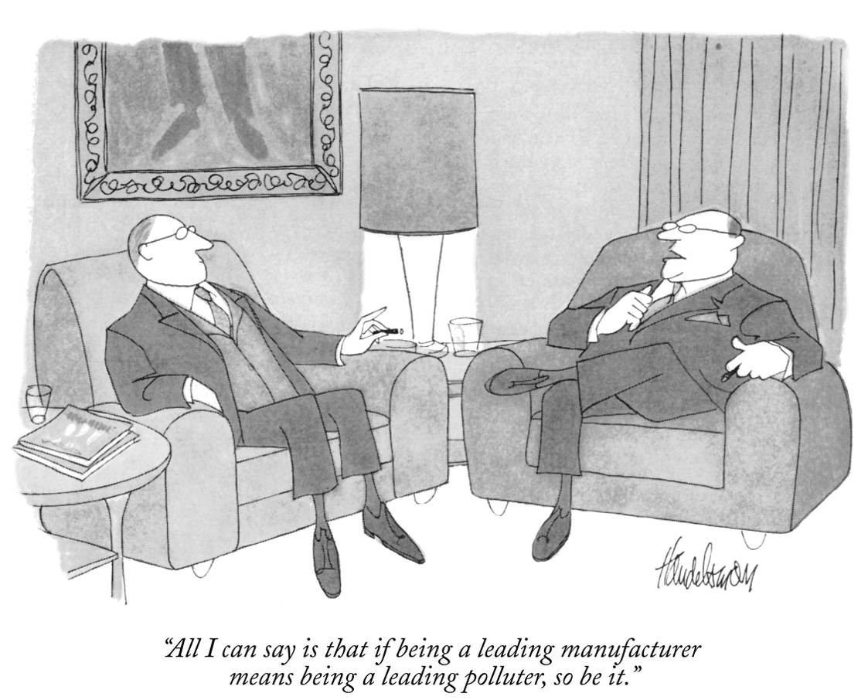

Publication Date: 1970-02-07
Economic Component | Legal Component | Ethical Component
Yes | No | No

Summarizing: The cartoon depicted in Figure 1 shows two middle-aged men. Based on their appearance and the setting in which they are placed, it is apparent that they are wealthy. Furthermore, based on their conversation, it can be assumed that they are corporate businessmen. One of the men mentions that if “being a leading manufacturer means being a leading polluter,” then “so be it.” The message delivered in this cartoon is clear: the two businessmen appear to be careless about the state of the environment. Given their ambitious attitude towards being leading manufacturers and given their carelessness about polluting, one can conclude that these businessmen’s main concern is being profitable.

Contextualizing: The 1970s was a prime time in the U.S. as far as the environmental movement is concerned. As mentioned earlier, 1970 was the year in which President Nixon proposed the establishment of the U.S. EPA. Furthermore, this was the year in which the CAA was enacted. President Nixon recognized the CAA of 1970 as a “beginning:” “I think that 1970 will be known as the year of the beginning, in which we really began to move on the problems of clean air and clean water and open spaces for the future generations of America” (EPA, 2010). The year 1970 was also the year in which Milton Friedman publicly stated his view of CSR when he suggested that the one and only social responsibility of business was to use its resources and engage in activities designed to increase profits (Friedman, 1970).

Inferring: As suggested by President Nixon, 1970 marked a pivotal year with respect to the environmental movement in the U.S. Figure 1 suggests otherwise. As mentioned in the “summarizing” portion of the analysis, the two men, who presumably are corporate businessmen, appear to be careless about their companies’ share of pollution to the environment. This fact further suggests that these two business executives are not compliant with the CAA, which established a set of regulations limiting the amount of pollutants to specified levels and which set deadlines for industries to meet standards. Furthermore, it appears that the two men have adopted Friedman’s view with regards to the responsibilities of business – purely economic. In addition, from an ethical standpoint, it can be inferred that, based on the overall attitude and the nature of the conversation of the two men, these men are not fulfilling what would be expected from them from a societal perspective. The two men, rather than attempting to achieve environmental sustainability, appear to be doing just the opposite. Based on the above analysis, the economic component is “yes,” the legal component is “no,” and the ethical component is “no.”
Figure 2 presents TCB-38913, another cartoon from the 1970s.

Figure 2: TCB-38913

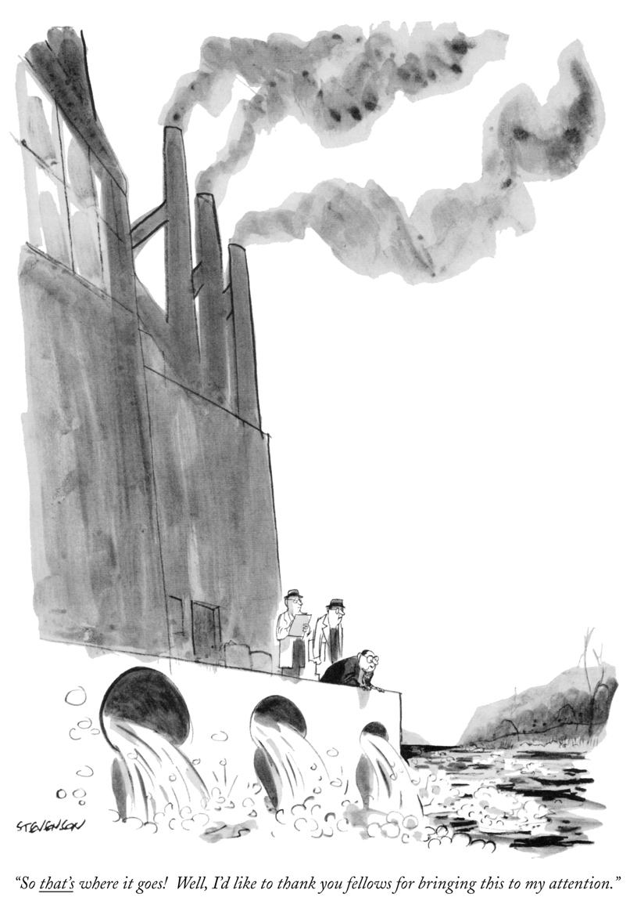

Publication Date: 1970-11-07
Economic Component |  | Legal Component |  | Ethical Component
 | Yes |  | No |  | No

Summarizing: The cartoon depicted here alludes to both air and water pollution – the large factory in the cartoon is releasing smoke from its smoke stacks and is dumping water into the ocean. One of the individuals illustrated in the cartoon and who appears to be associated with business, and thus the factory, is looking out at the ocean, as a large quantity of water from the factory is being dumped into the ocean. He says: “So that’s where it goes! Well, I’d like to thank you fellows for bringing this to my attention.” Behind him, are two men who appear to be observing the businessman. Given their nature of observation and note-taking, it can be reasonably assumed that they are either environmentalists, auditors, or inspectors.

Contextualizing: There are two primary environmental laws that can be readily associated with this cartoon: the CAA of 1970 and the CWA of 1972. Both the CAA and the CWA continue to be two of the most highly influential environmental laws in existence. This is because these two laws are fundamental not only to the sustainability of our planet, but also to human health. This cartoon displays a rather important issue that occurred in the U.S. during the 1970s: the emergence of tall factory smoke stacks. In the early 1970s, power plants commonly installed tall stacks to reduce concentrations of harmful gasses at ground level and to help attain the National Ambient Air Quality Standards (NAAQS) (GAO, 2011). EPA began establishing NAAQS as a means to regulate emissions of hazardous air pollutants in the early 1970’s. This proved to be an effective solution for corporations because the tall smoke stacks allowed them to remain compliant with NAAQS; yet, the stacks contributed to the formation of acid rain because of the presence of pollutants in the upper atmosphere.

As to ocean dumping, a report to the President from the Council on Environmental Quality on Ocean Dumping described that in 1968, 4.5 million tons of industrial waste were dumped in the oceans by the U.S (CEQ, 1970). EPA records indicate that more than 55,000 containers of radioactive waste were dumped at three ocean sites in the Pacific Ocean between 1946 and 1970 (Ibid.). The uncontrolled ocean dumping caused severe depletion of oxygen levels in some ocean waters.

Inferring: A further analysis of the cartoon demonstrates that there is an element of irony in it. After a careful consideration of the historical context of the year is which this cartoon was published, the assumption that can be made is that some businessmen during this period were aware about their legal expectations with respect to the CAA and the CWA. Despite this, the businessman depicted in the cartoon, makes it seem like he is not aware of the fact that the potentially toxic waste, released from the factory, is dumped into the ocean. This suggests that the man is most likely attempting to act oblivious of this fact as a means of not getting into some sort of trouble. Furthermore, this suggests that most likely the corporation depicted in the cartoon was not doing business in a manner consistent with environmental laws and was not fulfilling its ethical responsibilities dictated by societal expectations. In sum, as can be observed and inferred from this cartoon the values of the economic component, legal component, and ethical component are “yes,” “no,” and “no,” respectively.

Figures 3 and 4 depict cartoons from the 1980s.

Figure 3: TCB-36851
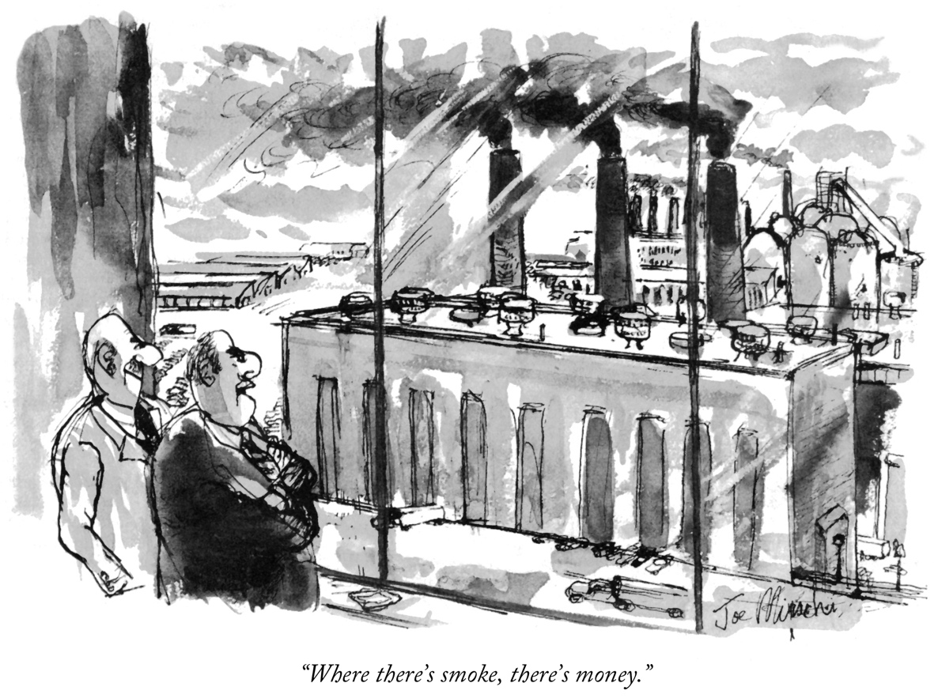

Publication Date: 1985-04-01
Economic Component | Legal Component | Ethical Component
Yes | No | No

Summarizing: The cartoon depicted in Figure 3 illustrates two men looking out of an office building’s window. The two men are facing a factory that is releasing an excessive amount of smoke from its smoke stacks. This, certainly, alludes to air pollution. One of the men says to the other: “Where there’s smoke, there’s money,” while the other man smiles.

Contextualizing: During the early 1980s, there was an increased attention to the release of toxic chemicals into the air. A 1988 report by the United Nations Environment Program (UNEP) and the World Health Organization (WHO) provides a rather extensive and detailed view of the global spread of sulfur dioxide and other pollutants (French, 2000). Of the 54 cities which had data available on sulfur dioxide pollution in 1980-1984, 27 were on the border line or in violation of the WHO health standard. Furthermore, in the U.S., factories reported 1.3 million tons of hazardous emissions in 1987, including 118,000 tons of carcinogens. According to the EPA, these emissions cause about 2,000 cancer deaths a year (Ibid.).

Inferring:
Further analysis of this cartoon demonstrates that in the caption “Where there’s smoke, there’s money,” there is a linguistic violation of the commonly used proverb “Where there is a will, there is a way.” This commonly used proverb refers to the idea that determination will overcome any obstacle. The assumption that can be made from this cartoon, then, is that the two men appear to be determined to make money at any cost, including causing pollution. Further analysis shows that despite growing attention to the effects of environmental degradation on human health, during the 1980s, business executives, as depicted in Figure 3, appeared to be rather careless about this issue. The business executives in Figure 3 prove to be greedy and ambitious. The sight of a factory in the process of burning fossil fuels is a pleasant sight in their eyes. This is ironic. As suggested by the caption of the cartoon, these men seem to be solely profit driven. In sum, the economic component is “yes,” the legal component is “no,” and the ethical component is “no.”

Figure 4: TCB-37798
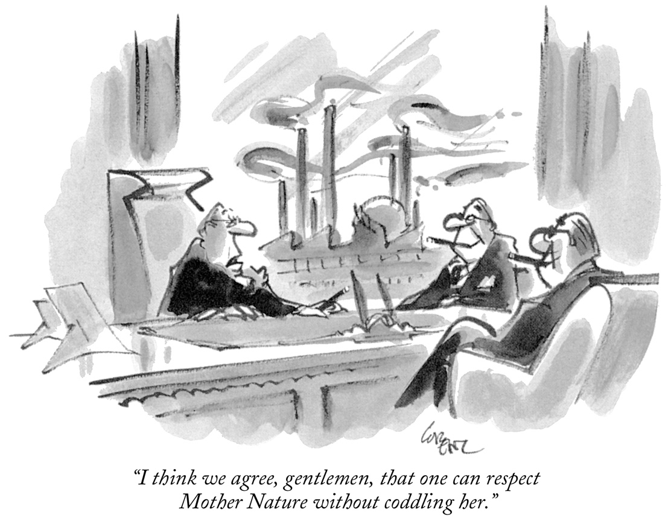

Publication Date: 1986-04-21
Economic Component | Legal Component | Ethical Component
Yes | No | No

Summarizing: The cartoon depicted in Figure 4 illustrates three elderly individuals dressed in suits. The three men converse, while sitting in an office from whose window a factory is clearly visible. One man says to the others: “I think we agree, gentlemen, that one can respect Mother Nature without coddling her.” Two elements of figurative language can be noted in this cartoon caption – personification and irony. In stating that “one can respect Mother Nature without coddling her,” the man personifies nature and, more specifically, he gives her a female identity. This assumption can be made not only because of the use of the female “Mother Nature,” but also because of the words “respect” and “coddling.” Many may agree that these words are more readily associated with women than with men. What is quite ironic about this cartoon is that the men appear to be doing the opposite of respecting Mother Nature based on the amount of pollution seen in the background.

Contextualizing: 1986 marked the year in which the term “greenwashing” came into existence. Greenwashing, according to Investopedia, occurs when “a company, government or other group promotes green-based environmental initiatives or images but actually operates in a way that is damaging to the environment or in an opposite manner to the goal of the announced initiatives” (Investopedia, 2017). Not surprisingly, many corporations were associated with this term at the time. Chevron, for example, commissioned a series of television and print ads to convince the public of its good faith environmental initiatives. However, while it was running the ads, it was also violating the CAA and the CWA and was spilling oil into wildlife refuges (Watson, 2016). Several other corporations did the same. In 1989, for example, the highly recognized chemical company DuPont implemented its new double-hulled oil tankers to further “safeguard the environment.” It did so by creating ads that portrayed animals as happy and living in healthy conditions. However, data from the EPA suggests that in 1989 DuPont and its subsidiaries discharged more than 348 million pounds of pollutants in the land, air, and water. Furthermore, it was found that DuPont may have exposed people to illegal levels of lead in the U.S. In 1988, the U.S. Department of Justice filed a lawsuit against DuPont for illegally blending excessively high levels of lead into gasoline between 1983 and 1985 (Doyle, 1991).

Inferring: Based on the context analysis, one can see that at the time, some corporations were acting in ways that were harmful to the environment. It appears that, during this time, some corporations attempted to make themselves seem like they were respecting the environment, while in fact they were doing the opposite. This is a classic example of hypocrisy. In the cartoon, “coddling” is what they associated with keeping the environment safe. The word “coddling” has negative connotations – excessive pampering. The way the three men in the cartoon wanted to treat nature was by not excessively pampering her. They made their bad actions seem like good ones. In sum, the economic component is “yes,” the legal component is “no,” and the ethical component is “no.”

Figures 5 and 6 depict cartoons from the 1990s.

Figure 5: TCB-30732

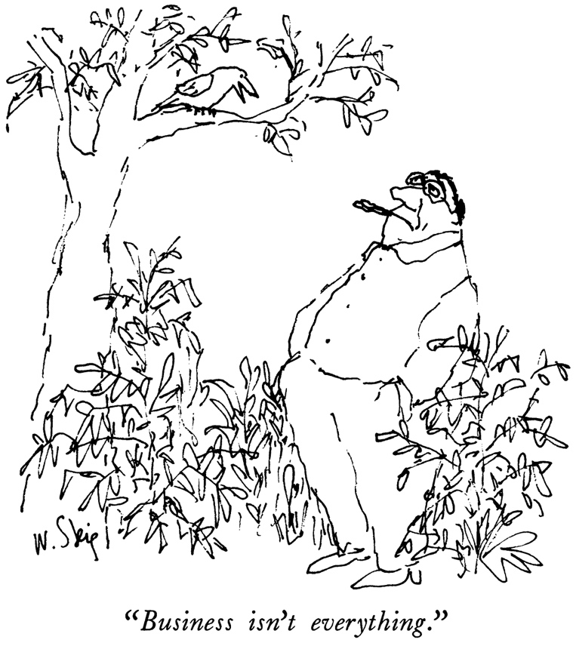

Publication Date: 1990-05-07
Economic Component | Legal Component | Ethical Component
N/A | N/A | No

Summarizing: The cartoon depicted in Figure 5 illustrates a middle-aged man who is smoking a cigar in a forest-like setting, looking up at a small bird which tells him: “Business isn’t everything.” The bird is personified, i.e. it is given human-like characteristics – speech and reasoning. The assumption is that the bird is speaking on behalf of nature. Given the topic of the conversation and the fact that the man is dressed in a collared shirt, it can be further assumed that the man is a businessman. The man stands in a relaxed manner with hands in his pockets and appears to be oblivious to what the bird is telling him. This suggests that some businessmen at the time were ignorant of their companies’ polluting operations, so much so that nature began to manifest itself with human qualities and speak to them in hope of protection.

Contextualizing: The 1990s proved to be a decade of major environmental awareness in which issues, such as climate change became very popular. A Gallup poll released after the 1988 presidential election determined that the environment was the number one concern of the voting public. Moreover, the poll indicated that the U.S. could elect a president based solely on the candidate’s environmental agenda (Kemp, 1990). Perhaps, this growing attention to the environment in the early 1990s can be associated with the Exxon Valdez oil spill of 1989 in Alaska. This oil spill, to this day, continues to be one of the most damaging environmental events. There were eleven million gallons of oil spilled into the Prince William Sound when the ship carrying the oil hit a reef. The aftermath was catastrophic. Five hundred square miles of the Prince William Sound were polluted, killing millions of fish, birds, and wildlife. Furthermore, the fishing industry was greatly impacted. Before the accident, the fishing industry in Prince William Sound amounted to nearly $100 million per annum worth of revenues (Pojman, et al., 2017). Upon careful analysis of the catastrophic event, it was determined that the ship’s captain, Joseph Hazelwood, was found guilty of negligence by operating the ship under the influence of alcohol. An ad, published by Greenpeace, with the face of Hazelwood stated the following: “It wasn’t his driving that caused the Alaskan oil spill. It was yours. The spill was caused by a nation drunk on oil. And a government asleep at the wheel” (Ibid.).

Inferring: The content analysis helped to further put this cartoon into perspective: nature is talking to us. As stated in the Greenpeace ad, this “nation [is] drunk on oil.” Unfortunately, business and profit do appear to be everything in our society. It is not until unprecedented and catastrophic events, such as the Exxon Valdez oil spill occur that people begin to realize how little attention is paid to nature and the environment. As depicted in the cartoon, there are two varying perspectives: this of nature and that of business. Nature is calling for a change – and this change must begin by first realizing that “[b]usiness isn’t everything.” In sum, the economic component is “n/a” the legal component is “n/a” and the ethical component is “no.”

Figure 6: TCB-25071
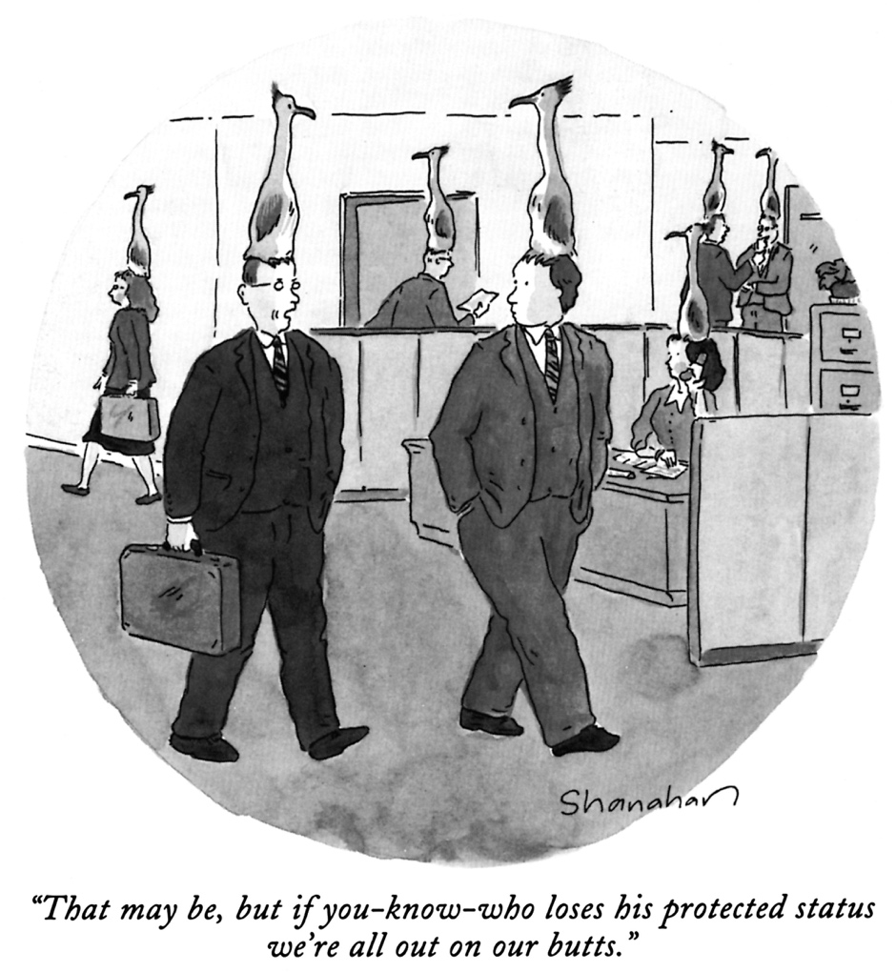

Publication Date: 1993-03-22
Economic Component | Legal Component | Ethical Component
Yes | No | No

Summarizing: The cartoon depicted in Figure 6 illustrates two men in suits walking alongside each other in what appears to be an office. The two men and the other individuals seen in the background all have large birds resting on their heads. One man says to the other: “That may be, but if you-know-who loses his protected status we’re all out on our butts.” Based on the illustration and the nature of the conversation, one can conclude that in mentioning “you-know-who,” the man refers to the bird on his head/mind. The term “protected status” is used to indicate the likelihood that an organism or species may become extinct. The assumption that can be made is that this cartoon is alluding to the topic of endangered species.

Contextualizing: In years prior to 1993, the year of this cartoon, Congress had worked diligently to establish a law that carefully considered the rights of animals, especially of those animals who were in danger of extinction. In 1973, the Endangered Species Act (ESA) was enacted. Numerous amendments to this Act were made in 1992. This Act provided a program for the conservation of endangered plants and animals and described the habitats in which they were found. In addition, ESA required federal agencies to ensure that the actions they authorized, funded, or carried out were not likely to jeopardize the continued existence of any listed species. This legislation also prohibits any action that causes a “taking” of any listed species of endangered fish or wildlife. Likewise, import, export, interstate, and foreign commerce of listed species were all generally prohibited (EPA, 2017).

Numerous countries have taken an interesting approach to endangered species preservation. For example, from 1970 to 1992, Africa’s population of black rhinos fell from 65,000 to less than 2,500 (Sandel, 2012). Although hunting endangered species is illegal in most countries, most African countries have been unable to protect their rhinos from poachers. Poachers sell rhinos’ horns for large amounts of money in Asia and the Middle East. As a result, in the 1990s and early 2000s, some wildlife conservation groups and South African biodiversity officials began to consider using market incentives to protect endangered species. The theory behind this was that if private ranchers were allowed to sell hunters the right to shoot and kill a limited number of black rhinos, then the ranchers would have an incentive to breed rhinos, care for them, and fend off poachers. In 2004, the South African government won approval from the Convention on International Trade in Endangered Species to license five black rhino hunts. The first legal hunt in decades commanded the high fee of $150,000, which was paid by an American hunter from the financial industry (Ibid.). Furthermore, it has been estimated that protected wildlife has a net worth of $20 billion; yet, most people are unaware of this fact (Good, 2015).

Inferring: The analysis of this cartoon demonstrated that perhaps the industry and individuals depicted in this cartoon were involved in this illegal trade of endangered species. Because of this, if the bird they were referring to were to become extinct, they would be left without a job. This would also suggest that most likely the corporation for which these two men were working was not compliant with the ESA. A rather interesting observation is that the ESA was amended in 1992 with new and stricter regulations. This is a year prior to when this cartoon was published. In sum the economic component is “yes,” the legal component is “no,” and the ethical component is “no.”

Figures 7 and 8 depict cartoons from 2000-2010.

Figure 7: TCB-52410
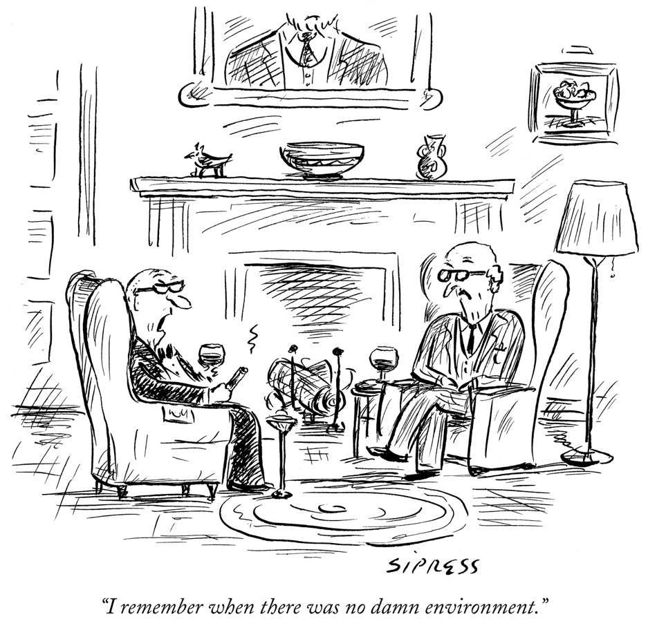

Publication Date: 2002-07-29
Economic Component | Legal Component | Ethical Component
N/A | N/A | No

Summarizing: The cartoon depicted in Figure 7 illustrates two elderly men dressed in suits sitting by a fireplace in what appears to be a comfortable an office, living-room or hotel lobby. The two men are drinking wine and one of them is smoking a cigar. One man says to the other: “I remember when there was no damn environment.” Given the nature of the setting and the conversation of the two men, it may be assumed that the two men are either retired businessmen or shareholders. Furthermore, it can be reasonably assumed that the men hold relatively unfavorable views of the environment. This is suggested from the use of the word “damn.”

Contextualizing: In May 2002, the United Nations Environment Program (UNEP) released a report which stated that “there was a growing gap between the efforts to reduce the impact of business and industry on nature and the worsening state of the planet” (Shah, 2002). Furthermore, during this period, scientists stated that the condition of the environment was worsening due to the excessive amount of carbon dioxide and other greenhouse gasses released into the air from cars and business operations (Roach, 2005). This was alarming because by the 20th century, there were already several enacted laws – the CAA, the CWA, the Nuclear Waste Policy Act (NWPA), etc.– that limited the amount of pollution that companies could create.

Inferring: As determined by the United Nations, there was a growing gap between business efforts and the state of the environment (Shah, 2002). From Figure 7, one can infer that some corporations at the time were lax about their legal responsibilities towards the environment and that they did not regard the environment as an important matter. This inference is made based on the fact that two men (who have been labeled as either retired businessmen or shareholders) in the cartoon appeared to acknowledge the environment; however, they cursed it with the word “damn.” The concerning part is that these men may have been shareholders of a corporation, and shareholders have a major influence on business decisions such as a businesses’ ability to be environmentally friendly. That is because in order for a corporation to be environmentally friendly, shareholders must support the initiative, considering the fact that “more sustainable” typically means incurring higher costs and, potentially, realizing smaller returns for the shareholders. In sum, if the shareholders do not agree on environmental sustainability on the corporation’s behalf, then there may be a growing gap between business efforts and the state of the environment. With regard to the cartoon, the economic component is “n/a,” the legal component is “n/a,” and the ethical component is “no.”

Figure 8: TCB-123946

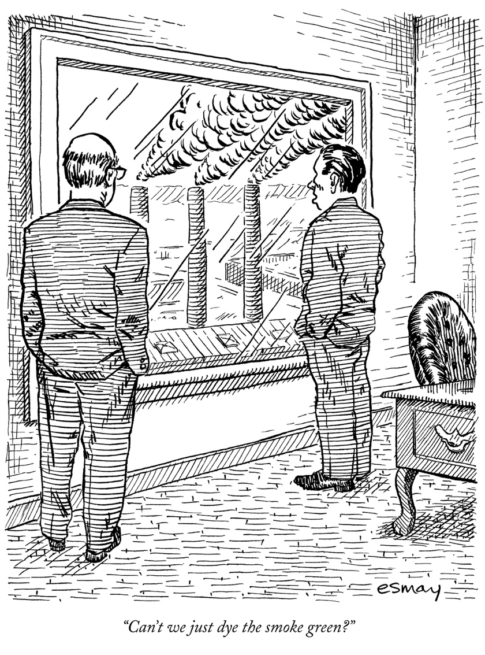

Publication Date: 2007-05-14
Economic Component | Legal Component | Ethical Component
Yes | No | No

Summarizing: The cartoon depicted in Figure 8 illustrates two men in suits standing in an office from which they see tall smoke stacks releasing smoke. The men stand, hands in their pockets, facing the window. One man says to the other: “Can’t we just dye the smoke green?” In stating this, the man is metaphorically referring to lying about the quality of the gas released. The word “green” is typically symbolic in nature – it refers to the cleanliness and purity of nature. What can be understood from this cartoon is that the two men recognized that “going green” is important to society; however, they appear to not be doing anything about it. All they do is plan a lie – the smoke is not dirty; it is pure.

Contextualizing: Upon President George W. Bush becoming president in 2001, he began an environmental movement with respect to energy and its usage in the U.S. In 2005, Bush firmly supported the Energy Policy Act. This Act addressed energy production in the U.S., including, but not limited to, energy efficiency, renewable energy, oil and gas, coal, vehicles and motor fuels, and climate change technology. Moreover, this Act provided loan guarantees for entities that developed or used innovative technologies that avoided the by-production of greenhouse gases (EPA, 2017). In 2007, the Energy Independence and Security Act was enacted. This Act aims to move the U.S. toward greater energy independence and security, increase the production of clean, renewable fuels, and increase the efficiency of products, buildings, and vehicles, amongst others (EPA, 2016).

Inferring: In a time in which the use of renewable sources was highly called upon, it is no wonder why the men depicted in Figure 8 felt compelled to “dye the smoke green…” Based on the contextual analysis of the cartoon, it appears that this decade marked the decade of stricter regulations towards the mitigation of nonrenewable sources. Furthermore, corporations were given incentives to do so, as can be observed in the Energy Policy Act. Despite this fact, as can be seen in Figure 8, it appears that some corporations had yet to implement initiatives to minimize their usage of fossil fuels and become more environmentally friendly. In sum, the economic component is “yes,” the legal component is “no,” and the ethical component is “no.”

Findings

This study examined the way The New Yorker cartoonists view the CSR components of Carroll’s (1991) framework from 1970 to 2010. More specifically, it examined the following components of environmental CSR – economic, legal, and ethical. The economic component dealt with identifying whether the individuals/corporations depicted in the cartoons worked hard to increase wealth for the company and shareholders. The legal component dealt with identifying whether the individuals/corporation depicted in the cartoons seemed to be compliant with environmental laws. The ethical component dealt with identifying whether the individuals/corporation depicted in the cartoons were consistent with societal and ethical expectations from corporations with respect to the environment. A summary of the quantitative and qualitative analysis is outlined below, based on each component:

Economic Component: In all cartoons in which the economic component was identified, the economic component appeared to be present, i.e. positive, as described in the methodology section. “Positive” means that the corporations or individuals in the cartoons were depicted as committed to fulfilling their responsibility of profitability. An interesting observation, though, was that in all cartoons in which the economic component was identified, the men portrayed appeared to be greedy and careless towards the environment. Furthermore, in all the cartoons in which the economic component was identified, there was an element that alluded to pollution. In other words, there was a clear message that if a corporation were to be profitable, it would cause pollution. As the quantitative analysis suggested, the economic component was mainly present in the 1970s and 1980s. This can be associated with the fact that during the 1990s and early 2000s, there was a growing attention to ethical matters, a result of the numerous cases of corporate environmental negligence that occurred during this time. Such were the Exxon Valdez’s oil spill in the Prince William Sound, Alaska and BP’s oil spill in the Gulf of Mexico. The economic component analysis is summarized in Table 4.

Table 4: Results of Quantitative Analysis

Decade | Economic Component | Legal Component | Ethical Component
1970s | Present, Positive | Present, Negative | Present, Negative
1980s | Present, Positive | Present, Negative | Present, Negative
1990s | Mixed | Mixed | Present, Negative
2000-2010 | Mixed | Mixed | Present, Negative

Legal Component: In all cartoons in which the legal component was identified, the legal component was negatively associated with the expectations of government and law.
This means that the corporations or individuals in the cartoons were depicted as not fulfilling their responsibility to pact in a manner consistent with legal expectations. Based on a thorough analysis of the environmental laws applicable in 1970-2010, the cartoons primary alluded to the CAA, the CWA, and the ESA. In all instances in which these laws were alluded to, it was determined that the individuals or corporations depicted in the cartoons seemed to not be complying with these laws. For example, most cartoons had an element of air or water pollution. The assumption was that these kinds of pollution were likely in violation with the CAA or the CWA. Furthermore, as the quantitative analysis suggested, the legal component was mainly present in the 1970s and 1980s (please refer to Table 4). This may be so because the 1970s and 1980s was the time when the U.S. environmental movement began. Furthermore, the 1970s and 1980s was the time when two widely known environmental laws were enacted and amended – the CAA and the CWA, respectively.

Ethical Component: As the quantitative analysis suggested (please refer to Table 4), the ethical component was identified in all cartoons. It was determined that the ethical component was negative in all of them. This means that the corporations or individuals in the cartoons were depicted as not fulfilling their responsibility to perform in a manner consistent with societal expectations and ethical norms. In all cartoons, the characters were portrayed as being rather careless about the state of the environment – be it by polluting the environment, by being involved in illegal trading of endangered species, or by “damning” the environment. One cartoon that stood out was TCB-123946. In it, one man says to another, while looking out the window at a factory releasing excessive smoke: “Can’t we just dye the smoke green?” What can be inferred from this cartoon is that the two men had a good understanding of what society’s expectations were – corporations to reduce their use of nonrenewable sources and pollute within certain limits only. However, the men chose to just mask reality by “dying” it green – a much cheaper option.

Further Analysis and Closing the Gaps
The scope of the quantitative analysis of the present study was rather small – only eight cartoons. Cartoon artists’ views on any subject matter may be considered a reflection of societal views on it. In an attempt to identify whether the results of this study’s analysis can be considered an actual depiction of the public’s views of CSR, the researcher compared the results of this study to those of another study conducted in a similar way – a paper by Sun Lee and Craig Carroll, entitled “The Emergence, Variation, and Evolution of Corporate Social Responsibility in the Public Sphere, 1980-2004: The Exposure of Firms to Public Debate” (Lee and Carroll, 2011). Lee and Carroll examined the way the news media (considered the “public,” for the purpose of their paper) portrayed CSR over time. Their study also adopted Carroll’s definition of CSR. The results of their analysis demonstrated that in the early 1980s, the economic component of CSR was emphasized the most. In the mid-1990s, the legal and philanthropic dimensions became more prominent, while the economic dimension weakened. The study found that the ethical dimension of CSR continuously increased over time. The authors also studied whether CSR was positively or negatively mentioned in their data. Based on 460 pieces of news, it was determined that the topic of CSR was mentioned 704 times, of which 416 times negatively. This is more than half of the instances.

Surprisingly, by adopting a different method from Lee and Carroll’s – a visual method – the present study had similar results. What can be concluded from this is that, overall, the cartoonists and the public (parties external to the company) held similar views of CSR – it appears that these views were primarily negative. Furthermore, it can be concluded that the economic component was the most popular one during the 1970s and 1980s, the legal component was the most popular one in the late 1980s, and the ethical component has been relatively consistent over time.

Conclusion:
As determined by this study, The New Yorker cartoons effectively provide a realistic representation of events occurring in the world. Furthermore, cartoonists in the midst of including humor and forms of figurative language in their cartoons, effectively portray their views. With regard to the topic of environmental CSR and Carroll’s (1991) components of CSR, it was determined that during the specified time frame, 1970-2010, cartoonists viewed and portrayed corporations and corporate executives as primarily profit driven, disregarding of ethical societal expectations, and rather careless about complying with existing environmental laws.

Considering the fact that the state of our environment is deteriorating and that corporations have a lot to do with the fact, the expectation is that corporations should be involved with initiatives that help to benefit the environment. However, as determined by the cartoons, during the specified time period, and the historical events analyzed, i.e. Exxon Valdez Oil Spill and BP oil spill, this is not the case. Undoubtedly, there is no guarantee that all corporations will perform in a gracious and respectful manner towards the environment, but the expectation is for corporations to, at the very least, comply with environmental laws established by governments. As mentioned earlier in this study, though, nowadays, those internal to the company as well as those external to the company have higher expectations with regard to corporate actions. The expectation is that corporations will not only comply with environmental laws, but also go above and beyond- as to create numerous initiatives that benefit the environment. It will be interesting to see, in a few years, how the public views environmental CSR.

Appendix A: Environmental Laws in the United States

Year Enacted | Environmental Laws | Summary
1970 | Clean Air Act (CAA) | The comprehensive federal law that regulates air emissions from stationary and mobile sources. This law, also, authorizes the Environmental Protection Agency (EPA) to establish National Ambient Air Quality Standards (NAAQS) to protect public health and public welfare and to regulate emissions of hazardous air pollutants.
1970 | Occupational Safety  and Health Act | This Act was passed to ensure worker and workplace safety. It ensures that employers provide their workers a place of employment free from recognized hazards to safety and health.
1948;  Amended in 1972 | Clean Water Act | This law establishes the basic structure for regulating discharges of pollutants into the waters of the U.S. and for regulating quality standards for surface waters.
1973 | Endangered Species Act | This law requires federal agencies to ensure that the actions they authorize, fund, or carry out are not likely to jeopardize the continued existence of any listed species or their habitats. This law also prohibits the import of, export of and interstate or foreign commerce with any listed species.
1974 | Safe Drinking Water Act | This law focuses on all waters designed for drinking, whether from aboveground or underground sources.
1976 | Resource Conservation and Recovery Act | This law gives EPA the authority to control hazardous waste. This includes the generation, transportation, treatment, storage, and disposal of hazardous waste.
1976 | Toxic Substances Control Act | This law provides EPA with the authority to require reporting, record-keeping and testing requirements related to chemical substances and/or mixtures.
1980 | Comprehensive Environmental Response, Compensation, and Liability Act (Superfund) | This law provides EPA with the authority to seek out those parties responsible for any uncontrolled or abandoned hazardous-waste sites, as well as accidents, spills, and other emergency releases of pollutants and contaminants into the environment. The EPA is granted the power to make sure that the parties at fault cooperate in the cleanup process.
1982 | Nuclear Waste Policy Act | This Act supports the use of deep geological repositories for the safe storage and/or disposal of radioactive waste. Furthermore, this act establishes the procedures necessary to evaluate and select sites for geological repositories.
1986 | Emergency Planning and Community Right-to-Know Act | This law is designed to help local communities protect public health, safety, and the environment from chemical hazards.
1988 | Marine Protection, Research, and Sanctuaries Act (Ocean Dumping Act) | This law prohibits the transportation of material from the U.S. with the purpose of ocean dumping, transportation of material from anywhere for the purpose of ocean dumping by U.S. agencies, and the dumping of material transported from outside the U.S. into the U.S. territorial waters.
1988 | Shore Protection Act | This law prohibits the transportation of municipal or commercial waste within coastal waters by a vessel without a permit.
1990 | Oil Pollution Act | This law provides EPA with the ability to prevent and respond to catastrophic oil spills.
1990 | Pollution Prevention Act | This Act focused the attention of industry, government, and public on reducing the amount of pollution through cost-effective changes in production, operation, and raw materials use.
1996 | National Technology Transfer and Advancement Act | This Act promotes economic, environmental, and social well-being by bringing technological innovation into the marketplace.
1999 | Chemical Safety Information, Site Security and Fuels Regulatory Act | This Act is an amendment to the CAA. It pertains to regulations with regard to flammable fuels and public access to Off-Site Consequence Analysis data.
2005 | Energy Policy Act | This law addresses the energy production in the U.S. (e.g. renewable energy, oil and gas, coal, tribal energy, nuclear matters, vehicles and motor fuels).
2007 | Energy Independence and Security Act | This law reinforces the energy reduction goals for federal agencies put forth in Executive Order 13423, and further introduces more aggressive requirements. The three key provisions enacted are the following: (1) Corporate Average Fuel Economy Standards, (2) the Renewable Fuel Standard, and (3) the appliance/lighting efficiency standards.

Source: Adapted from https://www.epa.gov/

Appendix B: 30 Cartoons Initially Selected

Year  Published | The Cartoon Bank (TCB)  Image Number | Artist | Keywords
1970 | TCB-39268* | J. B. Handelsman | Nature, environment, ethics, psychology, problems, politics, government
1970 | TCB-38913* | James Stevenson | Business, environment, pollution, ethics, factories
1976 | TCB-41417 | Stan Hunt | Introductions, economics, urban, nature, communications
1983 | TCB-40653 | Charles Saxon | Nature, money, poor, greed
1985 | TCB-36851* | Joseph Mirachi | Business, nature, environment, pollution, greed, factories, envy, factories industry,  industrial corporate corruption
1986 | TCB-37798* | Lee Lorenz | Environment, nature, business, greed, relationships
1987 | TCB-36544 | Bill Woodman | Nature, characters, technology, consumerism, salesmen
1987 | TCB-36166 | Donald Reilly | Road signs, workers
1989 | TCB-34118 | Ed Fisher | Technology, religion, business, environment, nature
1989 | TCB-34020 | Leo Cullum | Executives, energy, nature
1990 | TCB-29997 | Eldon Dedini | Nature, environment, depletion, urban, architecture, skyscrapers, traffic
1990 | TCB-30732* | William Steig | Nature, ethics, environment
1991 | TCB-31393 | Charles Barsotti | Leisure, relaxation, stress, business, nature
1992 | TCB-29500 | Dana Fradon | Government, bureaucracy, nature, environment, politics
1992 | TCB- 29036 | Lee Lorenz | Religion, money, environment, consumerism, business
1993 | TCB-25405 | Peter Steiner | Executives, office, business, office environment, interiors, nature
1993 | TCB-25071* | Danny Shanahan | Animals, wild, endangered, nature, environment, politics, business, management, downsizing, economy, government
1993 | TCB-24945 | Michael Crawford | Psychology, arrogance, ego, nature, environment, money, rich, interiors, business, office, regional, New York
1993 | TCB-24085 | William Hamilton | Business, workers, planes, nature, environment, pollution, depletion, mines
1993 | TCB-22718 | Leo Cullum | Dolphins, endangered, animals, environment, nature, interview, personnel, business
1994 | TCB-28025 | Mike Twohy | Business, interiors, executives, nature, gardens
1997 | TCB-29659 | Frank Cotham | Business, meetings, executives, environment, weather, government, men, talking, office, executives, snow, winter
1999 | TCB-41889 | Mick Stevens | Global warming, floods, Washington, water, pollution, thought, serious, environment, politics, incompetents
2001 | TCB-46477 | Mick Stevens | Autos, shopping, consumerism, psychology, guilt, environment, depletion, nature
2002 | TCB-52410* | David Sipress | Old age, modern life, nature, depletion
2003 | TCB-68449 | Jack Ziegler | Business, management, hierarchy, nature, seasons, autumn
2005 | TCB-121386 | David Sipress | Government, politics, problems, motivation, ethics, failure, dishonesty
2005 | TCB-121684 | Charles Barsotti | Problems, nature, business, architecture
2007 | TCB-124652 | Robert Mankoff | Carbon footprint, environment, women, bar, men
2007 | TCB-123946* | Rob Esmay | Ecology, global, warming, factory, pollution, contamination, air, greenhouse

*An asterisk means that these cartoons were selected for data analysis in this research.
Source: Adapted from https://cartoonbank.com

References:
Andriof, J. and McIntosh, M. eds., 2001. Perspectives on Corporate Citizenship. Sheffield, UK: Greenleaf Pub.

Aupperle, K., Carroll, A., and Hatfield, J., 1985. An Empirical Examination of the Relationship between Corporate Social Responsibility and Profitability. The Academy of Management Journal, 28(2), 446-463. Available through: Salem State University Library website <http://www.jstor.org/stable/256210 >

Bowen, H. R., 1953. Social Responsibilities of the Businessman. New York: Harper

Bowen, H. R., Bowen, P. G., and Gond, J., 2013. Social Responsibilities of the Businessman. Iowa City: University of Iowa Press.

Brown, H. S., 2011. Global Reporting Initiative. In: T. Hale and D. Held eds. 2011. The Handbook of Transnational Governance: Institutions and Innovations. Cambridge: Polity. pp. 281-289.

Carroll, A. B., 1991. The Pyramid of Corporate Social Responsibility: Toward the Moral Management of Organizational Stakeholders. Business Horizons. pp. 39-48.

Carroll, A.B., 2008. A History of Corporate Social Responsibility: Concepts and Practices. In A. Crane, A. McWilliams, D. Matten, J. Moon, and D.S. Siegel, eds. 2008. The Oxford Handbook of Corporate Social Responsibility. New York: Oxford University Press Inc. Ch.2.

CEQ, 1970. Ocean Dumping, A National Policy. A Report to the President Prepared by the Council on Environmental Quality, [online] Available at: < https://files.eric.ed.gov/fulltext/ED055891.pdf>

Clarkson, M. E., 1995. A Stakeholder Framework for Analyzing and Evaluating Corporate Social Performance. Academy of Management Review, 20(1). Abstract only. Available at < http://amr.aom.org/content/20/1/92.short>

CSRWire, 2008. KPMG International Survey of Corporate Responsibility Reporting 2008. The Corporate Social Responsibility Newswire, [online] Available at: <http://www.csrwire.com/press_releases/13790-KPMG-International-Survey-of-Corporate-Responsibility-Reporting-2008>

CSRWire, 2010. Even as Cause Marketing Grows, 83 Percent of Consumers Still Want to See More. The Corporate Social Responsibility Newswire, [online] Available at: < http://www.csrwire.com/press_releases/30556-Even-as-Cause-Marketing-Grows-83-Percent-of-Consumers-Still-Want-to-See-More->

Dahlsrud, A., 2006. How Corporate Social Responsibility is Defined: An Analysis of 37 Definitions. Corporate Social Responsibility and Environmental Management, 15, 1-13. Available at: http://onlinelibrary.wiley.com/doi/10.1002/csr.132/epdf

Dictionary.com., 2017. Cartoon. Retrieved December 18, 2017, from http://www.dictionary.com/browse/cartoonist

Doyle, J., 1991. DuPont's Disgraceful Deeds. Multinational Monitor, [online] Available at: <http://www.multinationalmonitor.org/hyper/issues/1991/10/doyle.html>

EPA, 2010. 40th Anniversary of the Clean Air Act. United States Environmental Protection Agency, [online]. Available at: https://www.epa.gov/clean-air-act-overview/40th-anniversary-clean-air-act

EPA, 2016. Summary of the Energy Independence and Security Act. United States Environmental Protection Agency, [online] Available at: <https://www.epa.gov/laws-regulations/summary-energy-independence-and-security-act>

EPA, 2017. Summary of the Clean Air Act. United States Environmental Protection Agency, [online] Available at: https://www.epa.gov/laws-regulations/summary-clean-air-act

EPA, 2017. Summary of the Clean Water Act. United States Environmental Protection Agency, [online] Available at: < https://www.epa.gov/laws-regulations/summary-clean-water-act>

EPA, 2017. Summary of the Endangered Species Act. United States Environmental Protection Agency, [online] Available at: < https://www.epa.gov/laws-regulations/summary-endangered-species-act>

EPA, 2017. Summary of the Energy Policy Act. United States Environmental Protection Agency, [online] Available at: <https://www.epa.gov/laws-regulations/summary-energy-policy-act>

Financial Times. (n.d.). Definition of Corporate Social Responsibility (CSR). Available at: http://lexicon.ft.com/Term?term=corporate-social-responsibility--%28CSR%29

French, H., 2000. You Are What You Breathe. In Environmental Ethics: Readings in Theory and Application (pp. 781-788). Cengage Learning.

Friedman, F., 1970. A Friednzan doctrine‐ p. 17. The New York Times, [online]. Available at:
<http://www.nytimes.com/1970/09/13/archives/a-friedman-doctrine-the-social-responsibility-of-business-is-to.html>

GAO., 2011. Information on Tall Smokestacks and Their Contribution to Interstate Transport of Air Pollution. United States Government Accountability Office, [online] Available at: <https://www.gao.gov/assets/320/318175.pdf>

Good, K., 2015. How You Can Stop These 4 Industries from Killing the World’s Most Endangered Species. One Green Planet, [online] Available at: http://www.onegreenplanet.org/environment/industries-that-are-causing-species-extinction/

Investopedia., 2017. Greenwashing. Available at: <https://www.investopedia.com/terms/g/greenwashing.asp>

Jowit, J., 2010. World's Top Firms Cause $2.2tn of Environmental Damage, Report Estimates. The Guardian, [online] Available at: <https://www.theguardian.com/environment/2010/feb/18/worlds-top-firms-environmental-damage>

Kemp, B., 1990. Environmental Issues Come of Age in the 1990's. Northern Illinois University Libraries, [online] Available at: <http://www.lib.niu.edu/1990/ii900413.html>

Lawrence, A. T., and Weber, J., 2017. Business and Society: Stakeholders, Ethics, Public Policy. 15th edition. New York, NY: McGraw-Hill Education.

Lee, M. P., 2007. A Review of the Theories of Corporate Social Responsibility: Its Evolutionary Path and the Road Ahead. International Journal of Management Reviews, 10(1). Abstract only. Available at: < http://onlinelibrary.wiley.com/doi/10.1111/j.1468-2370.2007.00226.x/full.>

Lee, S. Y., and Carroll, C. E., 2011. The Emergence, Variation, and Evolution of Corporate Social Responsibility in the Public Sphere, 1980–2004: The Exposure of Firms to Public Debate. Journal of Business Ethics, 104(1).

Mankoff, R. ed, Remnick, D., and Gopnik, A., 2006. The Complete Cartoons of The New Yorker. New York: Black Dog & Leventhal.

McWilliams, A., & Siegel, D., 2000. Corporate Social Responsibility and Financial Performance: Correlation or Misspecification? Strategic Management Journal, 21(5), 603-609. Available through Salem State University website < http://www.jstor.org/stable/3094143>

NCSU. (n.d.). How to Analyze Political Cartoons. Available at: https://cwnc.omeka.chass.ncsu.edu/exhibits/show/tutorial-cartoons/how

NPR, 2015. ‘New Yorker’ Cartoon Editor Explores What Makes Us Get It. National Public Radio Inc, [online] Available at: < https://www.npr.org/2015/12/04/458441670/new-yorker-cartoon-editor-explores-what-makes-us-get-it>

Pojman, L. P., Pojman, P., & McShane, K., 2017. Chapter 12: Pollution. In Environmental Ethics: Readings In Theory and Application (pp. 779-780). Cengage Learning.

Ripton, J., 2014. 6 Companies that Have Great Environmental Initiatives. Renewable Energy World, [online] Available at:< http://www.renewableenergyworld.com/ugc/articles/2014/03/6-companies-that-have-great-environmental-initiatives.html>

Roach, J., 2005. As Arctic Ice Melts, Rush Is on for Shipping Lanes, More. National Geographic News, [online] Available at: <https://news.nationalgeographic.com/news/2005/02/0225_050225_arctic_landrush.html>

Sandel, M. J., 2012. What Money Can't Buy: The Moral Limits of Markets. New York: Farrar, Straus and Giroux.

Schneider, G., 2017. If Corporations Are People, What Kind of People Are They? Dollars & Sense, (331), 17, pp. 17-22. Available through: Salem State University website < http://eds.a.ebscohost.com/eds/pdfviewer/pdfviewer?vid=5&sid=59a8aa4f-1bc2-4aeb-bbf7-8290abfa6861%40sessionmgr4006>

Shah, A., 2002. Corporations and the Environment. Global Issues, [online] Available at: <http://www.globalissues.org/article/55/corporations-and-the-environment>

Shruti, G., 2011. Consumer stakeholder view of corporate social responsibility: a comparative analysis from USA and India'. Social Responsibility Journal, 3, p. 363. Available through: Salem State University Library website <http://www.emeraldinsight.com/doi/10.1108/17471111111154518>

Virginia Tech. (n.d.). SCIM-C: Historical Inquiry. Virginia Tech, [online] Available at: <http://historicalinquiry.com/>

Wartick, S. L., and Cochran, P. L., 1985. The Evolution of the Corporate Social Performance Model. Academy of Management Review, 10(4). Abstract only. Available at: <http://amr.aom.org/content/10/4/758.short>

Watson, B., 2016. The Troubling Evolution of Corporate Greenwashing. The Guardian, [online] Available at: <https://www.theguardian.com/sustainable-business/2016/aug/20/greenwashing-environmentalism-lies-companies>

Please refer to the “Theoretical Framework” section of this thesis to see how exactly Carroll’s (1991, p. 39-48) framework was partially adopted for data analysis.
Reference Appendix A for a list of the environmental laws enacted between 1970 and 2010 in the U.S. by the EPA.
The thirty cartoons are listed in Appendix B and can be easily accessed on https://cartoonbank.com by searching with their unique image TCB number.
The SCIM-C model was originally created to help students acquire the knowledge and skills necessary to interpret historical sources (Virginia Tech, n.d.). This model has also been framed as a means to analyzing other sources, such as cartoons.
The definition of CSR adopted by their study was not limited to environmental CSR

