Salem State University
The Graduate School
Department of Psychology

Browsing in Disequilibrium: How Media Behaviors are Influenced by Excess and Deficit Conditions

A Thesis in Behavior Analysis
by
Brian Klapak
Copyright 2023

Submitted in Partial Fulfillment of the
Requirements for the Degree of Master of Science

May 2023

Abstract
The widespread use of smartphones has made it easier to browse the internet and consume various forms of media, including videos and advertisements. This study aimed to investigate the effects of restricting video access while increasing exposure to advertisements. Specifically, we examined whether participants would watch fewer videos when exposed to more advertisements and whether they would tolerate more ads to gain additional video-watching time. We recruited four students from Salem State University to participate in an experiment designed to manipulate their video and advertisement viewing behavior. Baseline levels of advertisement and video viewing behaviors were measured to create two conditions of disequilibrium: Deficit and Excess. Deficit conditions restricted access to videos while Excess conditions bombarded participants with more advertisements than they viewed during baseline. The results demonstrated that disequilibrium could alter participants' media consumption habits by increasing or decreasing time spent watching advertisements and videos. The current study also examined the nature of “browsing” during disequilibrium. Noncontingent browsing was available to determine whether or not participants would engage in this alternative behavior during disequilibrium conditions. Lastly, the current study highlights the ethical implications of disequilibrium, as companies could potentially exploit it for profit.

Keywords: advertisements, disequilibrium, response deprivation, social media, online behavior, reinforcement, punishment

Browsing in Disequilibrium: How Media Behaviors are Influenced by Excess and Deficit Conditions
Modern technology encompasses a range of activities, from sending a quick text to a loved one to scrolling through various social media platforms on a daily basis. The Pew Research Center (2022) estimates that 72% of adults use at least one form of social media. The top three most popular social media sites according to Pew were YouTube, with 81% of adults saying they use it; Facebook, with 69% of adults saying they use it; and Instagram, with 40% of adults saying they use it. Additionally, Pew showed that more than 50% of adults reported using Facebook, Snapchat, Instagram, and YouTube on a daily basis. Behavior analysts have started conducting research on these trends to signal policymakers, organizations, and individuals about their effects (see Kyonka, 2021, for a special section on behavioral science and cell phone use).
One of the basic assumptions in the science of behavior is that human behavior is selected by its reinforcing or punishing consequences (Skinner, 1984). According to a recent survey, Americans check their phones 344 times a day on average and use their phones for more than 2 hours per day on average (Wheelwright, 2022). Such high usage rates suggest that potent contingencies of reinforcement are in effect. For instance, Reed (2017) suggests that “likes” on social media are a new form of reinforcement. Lindström et al. (2021) confirms this by showing how social media users change their posting behavior based on the rate of reward from “likes”. This research is consistent with the behavior analytic view that social media platforms are like Skinner Boxes, where schedules of reinforcement are arranged to keep users engaged.
From a behavior analytic perspective, high rates of behavior are due to certain schedules of reinforcement (Skinner, 1974). Modern day behavior analysts have singled out schedules of reinforcement for their “addictive” effects in games (Morford et al., 2014) and in gambling (Ledoux, 2014). Additionally, authors outside of behavior analysis have identified schedules of reinforcement as the cause of engagement or high rates of behavior on social media. On the one hand, Lanier (2018) mentions schedules of reinforcement but focuses mainly on the release of dopamine. Gigerenzer (2022), on the other hand, focuses on the behavioral effects of the schedule of reinforcement itself. According to Gigerenzer (2022), “Social approval works best for getting users hooked if it comes in small, distinct units, like the food pellets in Skinner’s experiments” (p. 176). “Likes” are an example of the distinct units that can be used to reinforce behavior on certain schedules. Based on gambling research in behavior analysis, the schedules that produce the highest rates of behavior are intermittent schedules such as the use of variable schedules of reinforcement on slot machines (Dixon, 2007). Identifying schedules of reinforcement, and how they are involved in problem gaming and problem social media is important (see, Hassan & Kyonka, 2021), but it is crucial to understand why these schedules increase or decrease these behaviors in particular.
One approach to understanding the effects of schedules of reinforcement is the response deprivation hypothesis (Timberlake & Allison, 1974). The response deprivation hypothesis is as follows: An instrumental response will increase when access to a contingent activity is restricted below its typical baseline level (Adams, 2000). For example, if playing video games is restricted and contingent on doing homework, then doing homework will increase to get access to video games. In this case, homework is the instrumental behavior that increases. An extension of the response deprivation hypothesis is Timberlake’s (1980) disequilibrium theory. Jacobs et al. (2017) provided a tutorial on disequilibrium theory and its predictions. Disequilibrium is when there is a response deficit or response excess in relation to paired baseline levels of responding across two behaviors. When there is a deficit in a contingent activity, the instrumental response will increase (reinforcement). When there is an excess in a contingent activity, the instrumental response will decrease (punishment). For example, Heth and Warren (1978) showed that a deficit in audio listening resulted in an increase in instrumental video watching while an excess in audio listening resulted in a decrease in instrumental video watching. In the applied setting, Dowdy and Jacobs (2019) showed disequilibrium to be effective with children with autism, using independent seatwork as the instrumental behavior and iPad as the contingent behavior. The results of the study showed a significant increase of independent seat work when there was a deficit in using the iPad.
The purpose of the current study is to use the disequilibrium approach as an analog for understanding the effects of contingent advertisements and videos on social media platforms. Valkenburg et al. (2021) defined social media behavior as “active (e.g. posting) or passive (browsing). Private (one-to-one) or public (one to many) usage of SM [social media] platforms such as Snapchat, Facebook, We Chat, and WhatsApp” (p.59, abbreviation added). With the use of disequilibrium theory described by Jacobs et al. (2017), we can define these social media behaviors as instrumental or contingent activities. For example, viewing an advertisement could be the instrumental behavior that results in access to the contingent video watching behavior. However, according to disequilibrium theory, video watching could also function as the instrumental behavior that produces contingent access to advertisements. In the case of watching videos on YouTube, viewers are inundated with advertisements before, during, or after the video. These advertisements are a form of disequilibrium that may affect how much video watching users do on the platform. Another feature of watching videos online is browsing, as mentioned in Valkenburg and colleagues’ definition of social media usage. Therefore, another behavior of interest is how much browsing a person may do while exposed to the conditions of disequilibrium.
The current study seeks to answer the following research questions: First, if we restrict access to videos by making them contingent upon advertisements, then how much advertisement viewing will participants exhibit? Second, if we provide an excess of advertisements, upon viewing a video, then how much video watching will participants exhibit? Third, if a noncontingent activity such as browsing is freely available during disequilibrium, then how will this interact with the instrumental behavior of viewing advertisements or watching videos?
Methods
Participants and Setting
Four Salem State University undergraduate students were recruited through the SONA research participation system. Participants were 18 years of age or older and were not deaf or blind. The setting was an isolated office on campus in order to minimize the number of distractions. All procedures were approved by the Institution Review Board (IRB) at Salem State University.
Apparatus and Materials
The apparatus was built using PsychoPy, a coding software that uses python to present stimuli and measure responses (Peirce et al., 2019). The software was run on a MacBook Pro (13-inch, 2017) using the laptop’s built-in speakers to deliver audio and a Dell mouse for making responses. The apparatus included three color coated and labeled buttons—red for Ads, blue for Vids, and green for Browse. The button locations on the screen were randomized on each trial. Figure 1 is an illustration of the apparatus. The Ads button produced advertisements, the Vids button produced video, and the Browse button produced thumbnails from the videos. Videos automatically played after clicking the Vids button, while participants could use a “Next Ad” or “Browse Next” button to click through ads or thumbnails (i.e., after clicking Ads or Browse buttons).
The materials in the experiment included approximately 100 advertisements (ads), 5 videos (vids) about 4 to 5 min long, and about 100 video thumbnails for the Browse option. The ads were selected from different social media platforms and websites such as Twitter, Instagram, Facebook, and Yahoo. Three laboratory members contributed Ads appearing on their socials in order to expand the pool of possible advertisements. Advertisements were categorized as follows: Food, Diet, and Health; Cars; Entertainment; Fashion; Legal and Financial; and Technology. The videos were selected from a YouTube channel called @CleanVideosYoutube that compiles the “best of” TikTok videos. The thumbnails for Browse were screenshots of the first frame of every TikTok used for Vids. The use of authentic ads, vids, and thumbnails was meant to increase the ecological validity of the experiment. However, it should be noted that stimuli do not have any inherently reinforcing or punishing value according to the disequilibrium approach (Jacobs et. al., 2019).
Experimental Design
The experiment was a repeated measures design with a familiarization phase, 3 baselines, and two experimental conditions that lasted approximately 30 min in total. Participants experienced the excess or deficit condition first or second depending on their random assignment. Figure 2 shows the random assignment to each sequence of conditions. Half the participants received Deficit first while the other half received Excess first and Deficit second.

Procedure
Participants were greeted and read a disclosure statement describing the experiment, their voluntary participation, and their confidentiality. The participants were given a random number to ensure confidentiality and were randomly assigned to one of two sequences of conditions to control for order effects.
Familiarization
This part of the experiment lasted 3 min and was meant to get participants familiar with the apparatus and its functions. Participants were given the following instructions:
“Let's get you familiar with the setup. On the next screen you will be able to do the following:
-Click on 'Vids' to view video.
-Click on 'Ads' to view advertisements.
-Click on 'Browse' to view the catalog of videos.
If you understand, then press the purple button to continue getting familiar.”
Participants were able to press each button in order to familiarize themselves with the apparatus. Additionally, the experimenter guided the participants to click each button to experience each function.
Baseline
In baseline, the participants were able to click on any of the three buttons; Ads, Vids or Browse. Participants were given the following instructions: “Now that you are familiar with the setup, we can get started. On the next screen, you can view advertisements, videos, or browse the video catalog. If you understand, then press the gold button to continue.” Participant button clicks would take them to another screen on which they would see either videos for 5 s, ads for 5 s, or thumbnails of the videos for 5 s. After 5 min of Baseline, participants were transferred into Excess or Deficit.
Excess
During the excess condition, participants were shown an excessive number of ads for 15 seconds after accessing the video. Five seconds of Vids was the instrumental behavior that produced 15 s of contingent ads. After viewing 15 s of ads, participants could then access 5 s of video, again, followed by 15 more seconds of ads. This was a reciprocal schedule. The instructions to participants were as follows: “In this part of the experiment, the Ads button has been DISABLED. If you press the Vids button, you will be able to view the advertisements after the video. If you understand, then press the black button to continue.” The Ads button was disabled during this period of excess in order to create the contingency of having to see ads after watching videos. Browse remained available in order to serve as a noncontingent option for participants. The purpose of Browse was to determine if participants would engage in this alternative behavior during excess. If they clicked on Browse, they could view thumbnails for 5 s at a time. The excess condition lasted for 5 min before returning to one of the baselines.
Deficit
During the deficit condition, participants were able to access 2 s of video. In order to watch more video, participants had to click on Ads which lasted 5 s after each click. This was also a reciprocal schedule. Participants were given the following instructions: “In this part of the experiment, the Vids button has been DISABLED. If you press the Ads button, you will be able to view the video after the advertisements. If you understand, then press the black button to continue.” The contingency required participants to view ads before watching videos. Like the Excess condition, the Browse option was noncontingently available to determine the occurrence of any alternative behavior such as browsing during deficit. After 5 min of deficit, the participant returned to baseline.
Data Analysis
Randomization tests of statistical significance were used to analyze any differences between baseline and contingency phases of the experiment. Randomization tests for windows (RT4WIN) was used to conduct the nonparametric equivalent of a repeated measures analysis of variance (Huo & Onghena, 2012). Randomization tests were used because they are nonparametric and only require that participants were randomly assigned (Jacobs, 2019).
Results
Table 1 includes the instrumental to contingent (I/C) requirements and the instrumental to contingent baselines (Oi/Oc) for all participants in Excess and Deficit conditions. As can be seen, all participants met the criterion for disequilibrium in each condition. Four out of the 4 participants met the I/C > Oi/Oc criterion for our Deficit condition as well as the I/C < Oi/Oc for the Excess condition. One thing to note in Table 1 is the Error under p646’s Oi/Oc column. Participant 646 had 0 s of ad viewing, which resulted in a divide by zero error. However, the mathematical equivalent (I*Oc ~ Oi*C) of the formula used in Table 1 indicates that p646 was in disequilibrium during the Excess condition (0.00 < 2804.31). Additionally, any presentation of ads would be considered an excess because it is above the baseline level of zero. Overall, all participant behavior changed in the expected direction during Deficit and Excess conditions. Instrumental advertisement viewing increased in Deficit while instrumental video watching decreased for participants in Excess. This is consistent with the I/C and Oi/Oc discrepancies in Table 1.
Table 2 includes the individual data across all baseline and contingency periods. In Baseline 1, p370 had a total of 35 s of ad watching, 111 s of video watching, and 59 s of browsing. Participant 370 was exposed to the Excess condition first, so when they transitioned into excess their instrumental video watching decreased to 20 s and their contingent ad watching increased to 51 s. Notably, their browsing increased to 142 s during this Excess condition. When returning to Baseline 2, p370 watched about 140 s of video and engaged in some browsing for 45 s. At this point there was 0 s of ad watching, which is shown in Figure 3. When transitioning to the Deficit condition the participants increased their instrumental ad watching to 112 s while their contingent video watching went down to 48 s, with 20 s of browsing. During the final Baseline 3, participant 370 decreased their browse viewing to 35 s while their video watching increased to 100 s and ad viewing decreased to 9 s.
Participant 645 exhibited similar durations as p370, except they received the Deficit condition first and Excess condition second (Figure 4). Beginning with Baseline 1, ad watching was at 5 s, video watching was at 167 s, and browsing was at 15 s. When participant 645 entered Deficit, their instrumental ad watching increased to 89 s while video watching decreased to 42 s and browse increased to 50 s. When entering Baseline 2, ad viewing went down to 4 s and video watching returned to Baseline 1 levels at 187 s. Browsing, however, decreased to 0 s. When in the Excess condition, ad viewing increased to 95 s while instrumental video watching decreased to 45 s. Browse increased to 80 s during this condition but would soon go down to 0 s in Baseline 3, with ad viewing following suit at 0 s. Participant 645 would only engage in video watching with 195 s of video watching in the last baseline.
In Figure 5, p646 started Baseline 1 with 16 s of ad watching, 155 s of video watching and 20 s of browsing. Like p645, they received Deficit first, where they viewed 94 s of instrumental ads, 52 s of contingent videos, and 14 s of non-contingent browse thumbnails. When returning to Baseline, their ad viewing and browsing was similar to participant 645 in which they engaged in 0 s of ads and browse while their video watching was at 187 s. When transitioning to the Excess condition, p646 viewed 107 s of contingent ads, which was the second highest amount of viewing among all participants in this phase. Their instrumental video watching was 60 s and browsing was 14 s. When transitioning back to Baseline 3 they engaged in 0 s of advertisement viewing, 0 s of browsing, and 175 s of video watching.
Participant 913 engaged in 56 s of ad viewing, 98 s of video watching and 45 s of browsing in Baseline one (Figure 6). Their first contingency period was Excess, where they had the highest ad watching out of all the participants with 139 s. This 139 s was an excess in ads compared to Baseline 1. Participant 913 also decreased their video watching to 50 s in Excess, while browsing in Excess was at 36 s. In Baseline 2, p913 had the highest duration of advertisement watching at 9 s as well as the highest duration of browsing at 79 s. When transitioning to the deficit condition, their ad viewing increased to 135 s, which was the highest out of all the participants in regard to instrumental ad viewing during this stage. They also had 56 s of contingent video watching and 25 s of thumbnail browsing. When entering Baseline 3, the participant had 0 s of ad watching, 180 s of video watching, and 24 s of browsing thumbnails.
Figure 7 is a visual display of the mean durations across baseline and contingency periods. The mean baseline values represent the baseline durations that came before Deficit or Excess for each participant. The average values of participants in Baseline before Deficit in Figure 7 were 7 s of ad watching, 131 s of video watching and 40 s of browsing. In Deficit, the average of all the participants was 108 s for instrumental ad watching, 50 s for contingent videos, and 27 s for non-contingent browsing. The average values for the Baseline preceding Excess in Figure 7 were 24 s of ad watching, 146 s of video watching, and 26 s of browsing. In Excess, participants had an average of 98 s for contingent ads, 44 s of instrumental video watching, and 68 s of non-contingent browsing. For the final Baseline in Figure 7, the average of the values among all participants during this stage were 2 s of ad watching, 163 s of video watching, and 15 s of browsing. Randomization tests revealed that there was a statistically significant difference for ad viewing (p = 0.000096, F = 30.5286) and video watching (p = 0.001184, F = 12.1071) across baseline and contingency periods. There was no significant difference for browsing (p = 0.160752, F = 1.8347) across baseline and contingency periods.
Discussion
Overall, each of the participants experienced disequilibrium and increased their instrumental ad viewing and decreased their instrumental video watching as a result. Each of the participants responded to the disequilibrium condition as predicted by the I/C and Oi/Oc discrepancies. Interestingly, participant 913 had a noticeable amount of browsing during baseline 2, after having went through excess. This browsing during baseline 2 overtook video watching, which was freely available with no restrictions. Most notably, all participants decreased their instrumental video watching due to an excess of advertisements and increased their instrumental ad viewing due to a deficit of videos.
During the experiment the participants had options to view ads, watch videos, and browse through thumbnails of the videos. A potential concern is that participants may not be “viewing ads” whenever they are made available to them. In order to address this concern, data were collected on which ads the participants saw and how many times they clicked on the “Next Ad” button while “viewing ads” for 5 or 15 seconds. Figures 8-11 show the count of “Next Ad” button clicks for each participant in each phase of the experiment. It was shown that some participants, such as p913, viewed 124 ads during the excess condition while p646 engaged in 707 “Next Ad” button clicks during their 5 min of being in excess. Both participants 370 and 645 also engaged in clicking through the advertisements, but at a lower frequency during excess. All participants clicked through advertisements during deficit as well, with a range from 81 to 468 clicks.
At all levels of the independent variable, participants were given options with conditions of looking through ads and watching videos. At all stages of the experiment, however, the Browse button was available to them for 5 s of browsing after each click. The purpose of this button was to serve as another option for participants during all stages. Interestingly, it appears to have served as a substitute for some participants in the Excess condition. The cost of watching the videos during Excess was high due to the 15 s ad-viewing requirement. The average increase in Browsing during Excess—compared to Baseline—can be seen in Figure 7. This substitution effect may be similar to ordering tea when coffee is too expensive to purchase (see Allison, 1983). The tea is the substitute, and like Browse is to video watching, it may have a similar function as coffee. In other words, Browsing may be similar enough to video watching to serve as a substitute. However, this substitution effect appears to have only occurred for 2 out of the 4 participants (p370 and p645).
While this research sheds light on an important topic, it is subject to certain limitations. One of the main limitations is the small sample size of only four participants, which is not representative of the general population. Additionally, participants could have benefited from a faster and more efficient computer to load videos on the PsychoPy program. Improved speeds, along with modifying the user interface to resemble modern social media platforms, could facilitate or inhibit the effects found in the current experiment. Despite these limitations, the current research suggests that social media companies could potentially use behavior analysis to increase user engagement with advertisements. It is important for the public to be aware of these potential implications and to develop a better understanding of how behavior analysis may be used by companies (cf. Lanier, 2018). The current research also confirms the influence of disequilibrium conditions on media behavior. This is consistent with previous research because it shows that disequilibrium is responsible for the effects of certain schedules of reinforcement (Timberlake, 1980, Allison, 1983). Knowing the effects of disequilibrium could enhance recent research on applications to reduce social media usage (Stinson & Dallery, 2023). The concept of disequilibrium can be leveraged to encourage more desirable social media behaviors and discourage less desirable ones, such as prioritizing posts from certain people and reducing exposure to advertisements. However, this research also serves as a warning to the public about how companies can use disequilibrium to manipulate their time spent browsing and consuming certain media online.

References
Allison, J. (1983). Behavioral economics. Praeger.
Adams, M. A. (2000). Reinforcement theory and behavior analysis. Behavioral Development Bulletin, 9(1), 3–6. https://doi.org/10.1037/h0100529
Dixon, M. (2007). Why behavior analysts should study gambling behavior. Analysis of gambling behavior, 1(1). https://repository.stcloudstate.edu/agb/vol1/iss1/1
Dowdy, A., & Jacobs, K. W. (2019). An empirical evaluation of the disequilibrium model to increase independent Seatwork for an individual diagnosed with autism. Behavior Analysis in Practice, 12(3), 617–621. https://doi.org/10.1007/s40617-018-00307-4
Gigerenzer, G. (2022). How to stay smart in a smart world: Why human intelligence still beats algorithms. The MIT Press.
Hassan, M., & Kyonka, E. G. (2021). A behavior analytic perspective on treatment of problem gaming and problem social media use. The Psychological Record, 71(2), 219–235. https://doi.org/10.1007/s40732-021-00465-y
Heth, C. D., & Warren, A. G. (1978). Response deprivation and response satiation as determinants of instrumental performance: Some data and theory. Animal Learning & Behavior, 6(3), 294–300. https://doi.org/10.3758/bf03209617
Huo, M., & Onghena, P. (2012). RT4Win: a windows-based program for randomization tests. Psychologica Belgica, 52(4), 387–406.
Jacobs, K. W. (2019). Replicability and randomization test logic in behavior analysis. Journal of the Experimental Analysis of Behavior, 111(2), 329–341. https://doi.org/10.1002/jeab.501
Jacobs, K. W., Morford, Z. H., & King, J. E. (2019). Disequilibrium in behavior analysis: A disequilibrium theory redux. Behavioural Processes, 162, 197–204. https://doi.org/10.1016/j.beproc.2019.02.006
Jacobs, K. W., Morford, Z. H., King, J. E., & Hayes, L. J. (2017). Predicting the effects of interventions: A tutorial on the disequilibrium model. Behavior Analysis in Practice, 10(2), 195–208. https://doi.org/10.1007/s40617-017-0176-x
Kyonka, E. G. E. (2021). Behavioral psychology and cell phone use: a matter of opportunity. Psychological Record, 71(2), 189–190. https://doi.org/10.1007/s40732-021-00476-9
Lanier, J. (2018). Ten arguments for deleting your social media accounts right now. Vintage.
Ledoux, S. F. (2014). Chapter 15: Basic Schedules of Reinforcement . In Running Out of Time- Introducing Behaviorology to Help Solve Global Problems (p. 340). BehaveTech.
Lindström, B., Bellander, M., Schultner, D. T., Chang, A., Tobler, P. N., & Amodio, D. M. (2021). A computational reward learning account of social media engagement. Nature Communications, 12(1), 1–10. https://doi.org/10.1038/s41467-020-19607-x
Morford, Z. H., Witts, B. N., Killingsworth, K. J., & Alavosius, M. P. (2014). Gamification: The Intersection between Behavior Analysis and Game Design Technologies. The Behavior Analyst, 37(1), 25. https://doi.org/10.1007/S40614-014-0006-1
Peirce, J., Gray, J.R., Simpson, S. et al. PsychoPy2: Experiments in behavior made easy. Behav Res 51, 195–203 (2019). https://doi.org/10.3758/s13428-018-01193-y
Pew Research Center. (2022, November 16). Social Media Fact sheet. Pew Research Center: Internet, Science & Tech. Retrieved November 21, 2022, from https://www.pewresearch.org/internet/fact-sheet/social-media/#panel-3814afe3-3f3c-4623-910b-8a6a37885ab8
Reed, P. (n.d.). Do 'likes' cause social media addiction? Psychology Today. Retrieved October 13, 2022, from https://www.psychologytoday.com/us/blog/digital-world-real-world/202102/do-likes-cause-social-media-addiction
Skinner, B. F. (1974). About behaviorism. Alfred A. Knopf.
Skinner, B. F. (1984). Selection by consequences. Behavioral and Brain Sciences, 7(4), 477–510.
Stinson, L., & Dallery, J. (2023). Reducing problematic social media use via a package intervention. Journal of Applied Behavior Analysis, 56(2), 323–335. https://doi.org/10.1002/jaba.975
Timberlake, W. (1980). A molar equilibrium theory of learned performance. The Psychology of Learning and Motivation, 14, 1–58.
Timberlake, W., & Allison, J. (1974). Response deprivation: An empirical approach to instrumental performance. Psychological Review, 81(2), 146–164. https://doi.org/10.1037/h0036101
Valkenburg, P. M., Meier, A., & Beyens, I. (2021). Social media use and its impact on Adolescent Mental Health: an umbrella review of the evidence. https://doi.org/10.31234/osf.io/y8zdg
Wheelwright, T. (2022, January 24). 2022 cell phone usage statistics: How obsessed are we? Reviews.org. Retrieved October 27, 2022, from https://www.reviews.org/mobile/cell-phone-addiction/

Table 1
Response Criteria for Deficit and Excess Conditions in Seconds of Ads (A) and Vids (V)
Participant |  | Deficit
 |  | I (A) | C (V) | Oi (A) | Oc (V) | I/C | > | Oi/Oc
p370 |  | 5 | 2 | 0 | 140 | 2.5 |  | 0.00
p645 |  | 5 | 2 | 5 | 167 | 2.5 |  | 0.03
p646 |  | 5 | 2 | 16 | 155 | 2.5 |  | 0.11
p913 |  | 5 | 2 | 9 | 60 | 2.5 |  | 0.14
Participant |  | Excess
 |  | I (V) | C (A) | Oi (V) | Oc (A) | I/C | < | Oi/Oc
p370 |  | 5 | 15 | 111 | 35 | 0.33 |  | 3.15
p645 |  | 5 | 15 | 187 | 4 | 0.33 |  | 43.85
p646ª |  | 5 | 15 | 187 | 0 | 0.33 |  | Error
p913 |  | 5 | 15 | 98 | 56 | 0.33 |  | 1.77
Note. Baseline (Oi/Oc) values were taken from the baseline immediately preceding the contingency period.
ªThe current formalization does not accommodate the zero in the Oi/Oc denominator, but the equivalent formalization (I*Oc ~ Oi*C) demonstrates that p646 does meet criterion for Excess (0.00 < 2804.31).

Table 2
Total Seconds of Ads (A), Vids (V), and Browse (B) Activated by Participants in Baseline, Deficit, and Excess
Participant | Baseline 1 |  |  |  | Deficit |  |  |  | Baseline 2 |  |  |  | Excess |  |  |  | Baseline 3
 | A | V | B |  | A | V | B |  | A | V | B |  | A | V | B |  | A | V | B
p370ª | 35 | 111 | 59 |  | 112 | 48 | 20 |  | 0 | 140 | 45 |  | 51 | 20 | 142 |  | 9 | 100 | 35
p645 | 5 | 167 | 15 |  | 89 | 42 | 50 |  | 4 | 187 | 0 |  | 95 | 45 | 80 |  | 0 | 195 | 0
p646 | 16 | 155 | 20 |  | 94 | 52 | 14 |  | 0 | 187 | 0 |  | 107 | 60 | 14 |  | 0 | 175 | 0
p913ª | 56 | 98 | 45 |  | 135 | 56 | 25 |  | 9 | 60 | 79 |  | 139 | 50 | 36 |  | 0 | 180 | 24
Mean | 28 | 133 | 35 |  | 108 | 50 | 27 |  | 3 | 144 | 31 |  | 98 | 44 | 68 |  | 2 | 163 | 15
Note. Ads were instrumental in Deficit, while Vids were instrumental in Excess.
ªParticipants 370 and 913 were exposed to Excess after Baseline 1 and to Deficit after Baseline 2, while participants 645 and 646 received the Deficit first and Excess second order of conditions.

Figure 1
Illustration of the PsychoPy Apparatus
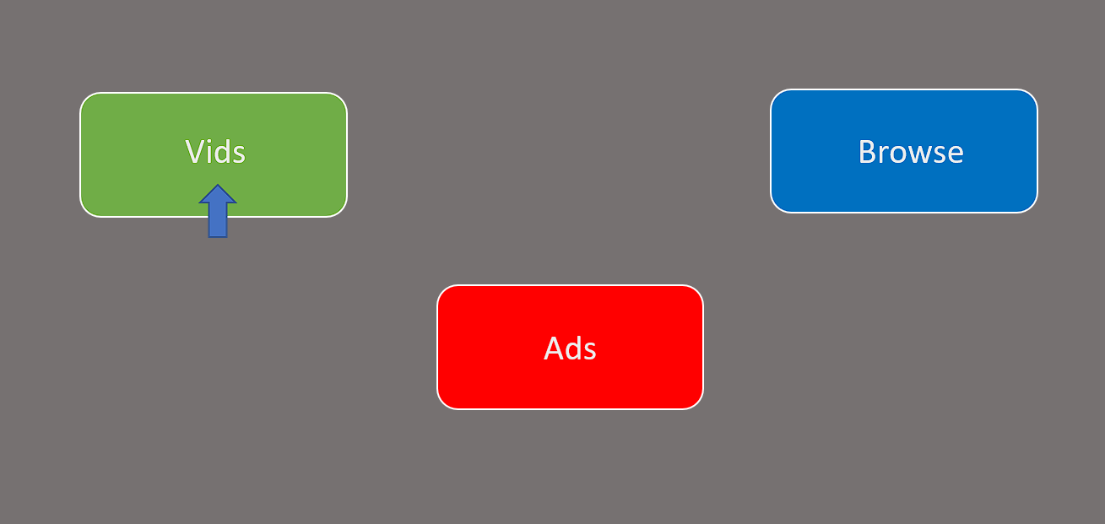
Note. The Vids button produces video, the Ads button produces advertisements, and the Browse button produces thumbnails of the videos used throughout the experiment.

Figure 2
Depiction of the Repeated Measures Experimental Design
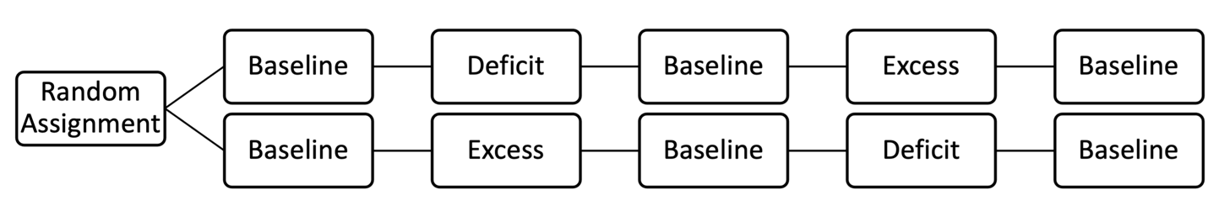
Note. All four participants were randomly assigned to one of the two sequences.

Figure 3
Total Durations of Vids, Ads, and Browse across Conditions
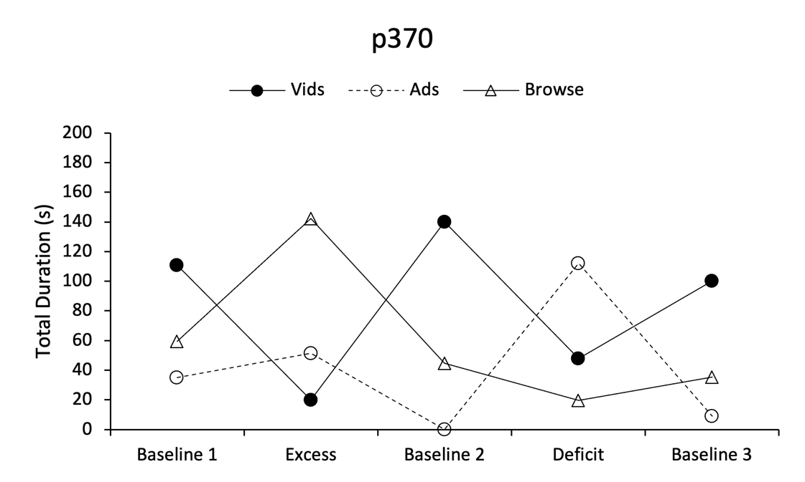
Note. Total duration is the sum of Vids, Ads, and Browse activated during each 5 min condition.

Figure 4
Total Durations of Vids, Ads, and Browse across Conditions
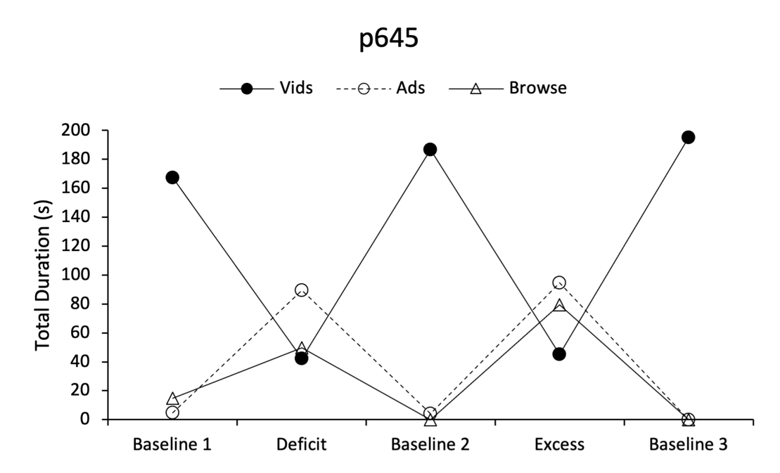
Note. Total duration is the sum of Vids, Ads, and Browse activated during each 5 min condition.

Figure 5
Total Durations of Vids, Ads, and Browse across Conditions
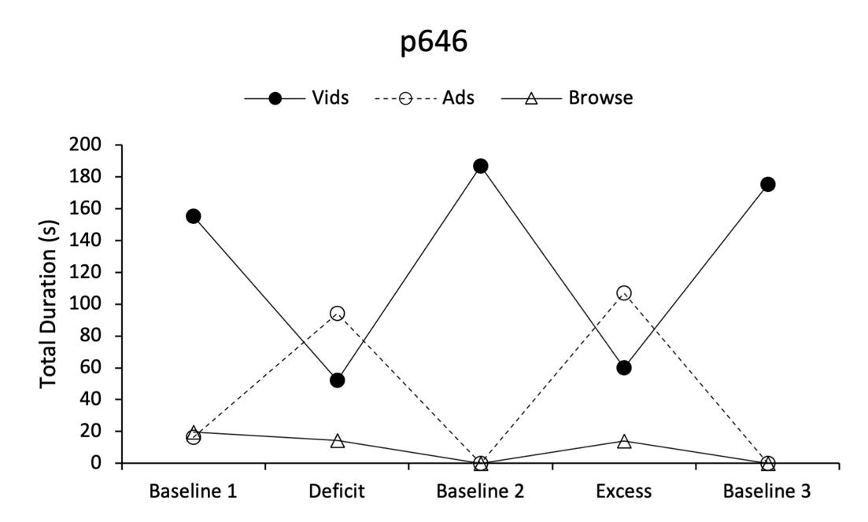
Note. Total duration is the sum of Vids, Ads, and Browse activated during each 5 min condition.

Figure 6
Total Durations of Vids, Ads, and Browse across Conditions
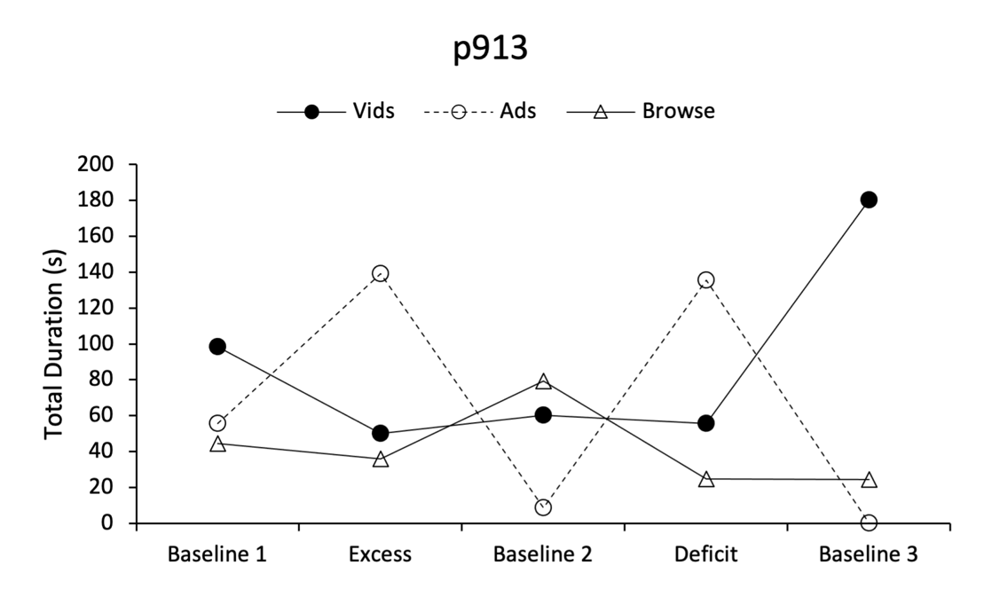
Note. Total duration is the sum of Vids, Ads, and Browse activated during each 5 min condition.

Figure 7
Mean Duration of Vids, Ads, and Browse Across Baseline and Contingency Periods
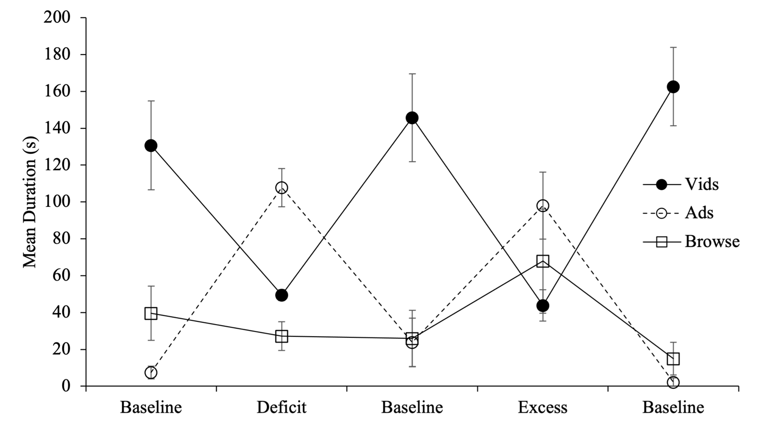
Note. Baseline means represent the average of the total durations that immediately preceded either Deficit or Excess conditions for each participant.

Figure 8
Count of “Next Ad” Button Clicks across Conditions

Note. Count was based on number of mouse clicks on a “Next Ad” button.

Figure 9
Count of “Next Ad” Button Clicks across Conditions

Note. Count was based on number of mouse clicks on a “Next Ad” button.

Figure 10
Count of “Next Ad” Button Clicks across Conditions

Note. Count was based on number of mouse clicks on a “Next Ad” button.

Figure 11
Count of “Next Ad” Button Clicks across Conditions

Note. Count was based on number of mouse clicks on a “Next Ad” button.

