FACT OR FICTION: INVESTIGATING WHETHER THE CSI EFFECT IS A VALID CONCERN OR POPULAR MYTH

Honors Thesis

Presented in Partial Fulfillment of the Requirements

For the Degree of Bachelor of Science in Criminal Justice
In the College of Human and Health Services
at Salem State University

By

Anthony Santana

Dr. Gina Curcio
Faculty Advisor
Department of Criminal Justice

***

Commonwealth Honors Program
Salem State University
2022

Abstract
Prosecutors and other criminal justice professionals have attributed an increase in juror expectations and demands for more scientific evidence (i.e., DNA, fingerprints) in criminal trials to the CSI effect. To investigate this claim of a rise in expectations and demands for scientific evidence as a result of crime TV shows like CSI, this research study conducted an anonymous, self-administered, online survey consisting of 17 questions administered to Salem State University undergraduate and graduate students from all different disciplines (n = 90). The survey collected demographic data as well as more specific information about students’ crime-based TV show (both fiction-based and reality-based) viewing habits and their demands for scientific evidence in certain cases. Comparisons were then made between viewers of fiction-based crime TV shows and reality-based crime TV shows to see if there was any significant difference regarding their expectations and demands for scientific evidence. Results indicated that both viewers of fiction-based crime TV shows and viewers of reality-based crime TV shows had very similar expectations and demands for scientific evidence in criminal trials. Therefore, as hypothesized, no support for a correlation between watching fiction-based crime shows and higher demands for scientific evidence was found as most respondents understood the inaccuracies portrayed in fiction-based TV shows.
Keywords: CSI effect, scientific or forensic evidence, crime TV shows, criminal trials, juror expectations

Table of Contents
Acknowledgements iv
List of Tables and Figures v
Introduction 1
Research Questions and Hypotheses 2
Literature Review 3
Method and Procedure 8
Results 10
Descriptive Statistics ….…………………………………………………………………11
Survey Respondent Viewing Habits……………………………………………………..14
Survey Respondent Perceptions of Accuracy of Crime TV Shows ……...…………...…17
Discussion 21
Conclusion 27
Limitations and Ideas for Future Research 28
References 29
Appendix A Study Recruitment Flyer 31
Appendix B Disclosure Form 32
Appendix C Survey Instrument 33

Acknowledgements
I would like to express my deep and sincere gratitude to my faculty advisor, Professor Gina Curcio, for making this project possible and for providing invaluable guidance throughout this research. Her vision, sincerity, and immense knowledge and experience in this field of study have deeply motivated me and encouraged me all the way throughout this long journey of developing this research study. Her willingness to meet every time I asked her to, her quick and effective responses to my countless emails, her creative and innovative skills, her words of encouragement, her passion and dedication to the research study, and her countless hours of research just to provide me with the necessary help on this project were only a few of the things that made this research study come to life. It was a great privilege and honor to work under her guidance. I am extremely grateful and satisfied with what we have achieved.
I would also like to thank Professor Scott Nowka, Chair of the Commonwealth Honors Program, for his amazing support and mentoring throughout this research process. For not only guiding me but thousands of other Honors students each year. His dedication, knowledge, openness, and willingness to help students are greatly appreciated. I am very grateful for all the help provided and all the positive messages and words I got from him.
I also thank Professor Kimberly Poitevin for all her support and guidance during the first stages of this research study, when this was only an idea. I thank her for providing all the help necessary so that what was first just an idea could become a more concrete and feasible project.
Thank you to my family and friends for all the support on this project and for always believing in me.
Last but not least, I would like to thank all those who participated in this study. Without you, this project would not have been possible.
List of Tables and Figures

Table 1. Descriptive Statistics of Study Participants 12
Figure 1. % of Respondents Who Watch Specific Fiction-Based Crime TV Shows 15
Figure 2. % of Respondents Who Watch Specific Reality-Based Crime TV Shows 15
Figure 3. Respondent Frequency of Watching Fiction-Based Crime TV Shows 16
Figure 4. Respondent Frequency of Watching Reality-Based Crime TV Shows 16
Figure 5. Respondent Perception of Accuracy of Fiction-Based Crime TV Shows 17
Figure 6. Respondent Perception of Estimated Time an Investigation Should be Completed 19
Figure 7. Respondent Expectactions of Scientific Evidence in Criminal Trials by Case Type 20
Figure 8. Respondent Participation in Jury Duty 20
Figure 9. % of Respondents Demanding Scientific Evidence as a Condition for a Guilty Verdict……………………………………………………………………………………………21
Figure 10. Respondent Perception of Crime TV Shows Influence on Knowledge of Criminal Investigations 21

Introduction

The CSI effect is a phenomenon in which forensic science used in criminal investigations has been exaggerated by fiction-based crime TV shows and movies (i.e. CSI, Law and Order, Criminal Minds, etc.), which has influenced public perception of what to expect from real criminal investigations. These TV shows have portrayed an image of what criminal investigations should look like and the type of evidence that is presented in television courtrooms far from what is actually done in reality. This has made it very difficult, especially for prosecutors and investigators to conduct investigations and present cases.
In the early 2000s, there were many complaints from police officers, judges, and lawyers about this increase in jurors’ expectations for more scientific evidence in criminal trials. They quickly attributed this change in jurors’ desires to the rise of a new television show titled “CSI” or Crime Scene Investigation (Wise, 2010). They called this phenomenon of rising expectations for more scientific evidence the “CSI effect.” They did so because they believed that TV shows like CSI have influenced public perceptions of how criminal investigations are carried out and their understanding of evidence, which have resulted in higher demands for scientific evidence in the courtroom. This has led many researchers to conduct some empirical research on the topic and find out whether this phenomenon has, in fact, impacted public and juror perceptions. Most of the research that has been done in this area has found no correlation between watching crime-based TV shows like CSI and higher expectations and demands for more scientific evidence. These researchers have found evidence demonstrating an increase in expectations and demands for evidence, but this has not necessarily been due to people’s viewing habits of crime-based TV shows. Thus, although people working in the criminal justice system have blamed the CSI effect for a change in perception, there have not been a lot of empirical studies demonstrating this. This study, therefore, will help to further investigate this topic and see whether the CSI effect is a valid concern or just a popular myth.
Research Questions and Hypotheses
In the present research study, more empirical research on this topic of major concern about the CSI effect within our justice system was carried out. The research question that was trying to be answered with this study was: has the way popular media portrayed criminal investigations raised people’s expectations and demands for scientific evidence in the courtroom? More, specifically, is there a correlation between watching fiction-based crime TV shows and higher demands for scientific evidence? By answering this question, the study would also get information on whether fiction-based TV shows, in particular, have misled or misinformed people about the ways criminal investigations and court procedures are supposed to be carried out (e.g., the estimated time an investigation should be completed, how fast detectives are supposed to respond to a crime scene, etc.). The study also tried to determine whether there was a significant difference in the levels of demands for evidence between viewers of fiction-based crime shows and viewers of reality-based crime shows given the recent rise in popularity of reality-based crime TV shows (which although are heavily edited, tend to portray criminal investigations in a more accurate manner than fiction-based crime TV shows).
Considering that most of the research done on this topic has shown no correlation between watching fiction-based crime TV shows and higher demands for scientific evidence in criminal trials, it will be expected that this study would also find no support for such correlation between the two variables. Thus, it will be hypothesized that watching shows like CSI will not have a significant influence on expecting and demanding to collect more scientific evidence during investigations and present them in court. Finally, it is also be hypothesized that there will be a slightly significant difference between those viewers of fiction-based shows and viewers of reality-based shows in their levels of demand for scientific evidence (with viewers of fiction-based crime TV shows showing slightly higher demands for evidence in criminal trials), but this will not be significant enough to conclude that their TV show viewing habits are the main factors causing this difference.
Literature Review
In an article written by James Trainum, a retired from the Metropolitan Police Department in Washington D.C, the positive and negative impacts of the CSI effect are discussed. His article is not intended to be an academy study of this issue, as it relies more on anecdotal evidence and the experience of the author and others but rather, the purpose of the article is to generate further discussion and research with the goal “of improving the investigative process” of criminal cases (Trainum, 2019). This journal article talks about how crime-based TV shows have influenced public perceptions of criminal investigations and court procedures. The author argues that fiction-based TV shows have shown techniques that real forensic scientists do not really use when investigating a case, however, because of the public perception, they have had to implement many of these techniques, which has brought both positive and negative effects. This implementation of what is often seen on TV in real-life investigations has made the analysis of evidence at a crime scene more accurate and reliable by using more techniques and resources. However, this has also created some misconceptions on how a criminal investigation is performed and what kind of information and evidence is expected from these investigations. Prosecutors have blamed the CSI effect as “creating greater expectations about forensic science that can be delivered.” This effect “creates exaggerated faith in the capabilities and reliability of the forensic sciences” (Trainum, 2019). With all the information gathered in this article, the author concluded that the public is not the only one being influenced by this phenomenon but also the investigators as well, for which he suggested that “departments invest in training in areas such as critical thinking and training that emphases the limitations of the forensic sciences and experts,” in order to counter the effect.
Shelton, Kim and Barak (2006) conducted one of the first empirical studies of jurors designed to investigate the existence and extent of the CSI effect. With their research, they wanted to either validate or disregard the claim that watching television programs such as CSI has caused jurors to wrongfully acquit guilty defendants when the prosecution presents no scientific evidence in support of the case. In their study, the authors surveyed 1,027 people who had been called for jury duty in Washtenaw County, Michigan, during a nine-week period in June, July, and August 2006. The subjects were surveyed before they had been selected to sit on a case or “expose to any voir dire” (the process in which potential jurors are questioned by either the judge or a lawyer to determine suitability for jury service). The survey examined the summoned “juror’s demographic information, television viewing habits, their expectations that the prosecutor would present scientific evidence in the courtroom in various types of cases, and whether that expectation would convert into demands for scientific evidence such as DNA, and fingerprints, as conditions for a guilty verdict.” This survey assessed the television watching experiences of the jurors related to various categories of crime-related shows to determine whether their expectations or demands were specifically related to watching any of these types of programs (CSI, Cold Cases Files, The First 48, Law and Order, and others). The results of this study found that specifically, watching CSI or a similar show did not have a “causative impact on the juror demands for scientific evidence as a condition of a guilty verdict in most criminal case scenarios.” (Shelton, et al., 2006). In other words, they found that jurors frequently expect to see forensic evidence in a case, however, they could not find any clear indication that this was a direct result of watching crime shows such as CSI.
Podlas (2006) did also conduct one of the first empirical studies of the effects of CSI effect on juror deliberations. Her focus was based on the definition of the CSI effect that emphasized a heightened burden on the prosecution. Her study was designed to determine whether guilty verdicts of those who frequently watched CSI based their decision on CSI-oriented reasons and if “frequent viewers of CSI would rely on these same reasons in reaching ‘not guilty’ verdicts to a greater degree than would non-viewers” (Podlas, 2006). In this research, a mock jury study of 306 American undergraduate and graduate students was conducted. Respondents were identified as either “frequent viewers of CSI,” or “non-frequent” viewers of CSI. This was done in order to test directly the argument that jurors who watched CSI were more likely to convict where there was forensic evidence, and less likely to convict in an absence of this evidence. Respondents were given several hypothetical cases, one of them involving a sexual assault in which intercourse was not disputed. For each case, they were asked to deliver a verdict in the matter and select reasons that played a role in their decision. Some of the reasons they could select relied on the lack of forensic evidence. In the sexual assault case, “since sexual contact was not disputed, the scenario relied on witness credibility rather than forensic evidence to determine if the lack of forensics would sway deliberations despite this form of evidence being irrelevant to the case” (Podlas, 2006). For this study to be valid, the results would have to show that CSI viewers are influenced by CSI-marked reasons and that they are more likely to acquit when there is a lack of forensic evidence than non-viewers. Well, Podlas found the opposite. The results did not support the hypothesis that viewers of CSI were influenced by CSI-marked reasons any more than non-viewers may be. She then concluded that despite this assumption of the CSI effect affecting juror’s demands for more scientific evidence, “there is little evidence to support this conclusion.”
Regarding this claim that jurors who are influenced by fiction-based TV shows are more likely to acquit when there is a lack of forensic evidence than jurors who are not influenced, Cole and Dioso-Villa (2009) examined acquittal rates between 1986 and 2008. Their study made 132 observations over nine jurisdictions including eight different states and the federal criminal justice. These observations included a total of 22,878 trials (Cole & Dioso-Villa, 2009). They tested the change in acquittal rates between two groups: pre-CSI and post-CSI, to determine whether the independent variable (watching CSI) caused any changes after it was introduced. After completing the study, analysis of data showed a statistically insignificant 1% increase in acquittals from the time before the introduction of CSI and after such introduction. The researchers then concluded that this insignificant increase may have occurred due to chance or by coincidence and not so much because of the introduction of CSI.
In 2009, Donald Shelton, Young Kim, and Gregg Barak as part of a larger investigation of the changing nature of juror behavior in the context of technology development, conducted another study that examined important questions unanswered by previous studies on the CSI effect. For this study, they wanted to focus on an urban setting, thus they conducted a similar study using 1,219 individuals summoned to jury duty in Wayne County, Michigan. This study applied multivariate and path analyses for the first time. With this study, researchers wanted to answer the following questions: 1) Does the CSI effect exist, after controlling for demographic variables or personal characteristics such as age, gender, education, income, and political orientation? 2) Do CSI watching patterns interact with any of the juror’s personal characteristics to produce different verdicts in specific types of cases? and 3) What is the causal process in terms of how exposure to the CSI dramas may affect jurors’ decision-making? The results showed that 1) watching CSI dramas had no independent effect on juror’s verdict, 2) the exposure to CSI dramas did not interact with individual characteristics, and 3) CSI watching had no direct effect on jurors’ decisions.
Brewer, P.R, and Ley, B.L. (2010) performed another, but abstract, study on a large scale in which they administered a phone survey to 908 residents of the Milwaukee area. This research study focused mainly on DNA and how such evidence was relevant to the CSI effect. With such research, they wanted to find out the extent to which participants 1) had a clear understanding of DNA; 2) believed DNA evidence to be reliable; 3) would be influenced, if serving as a juror, by the presence of DNA evidence; and 4) would be influenced by the absence of DNA evidence. They found that the time participants spent watching real and fictional portrays of criminal investigations “positively predicted a clear understanding of DNA and that this evidence was reliable” (Brewer, & Ley, 2010). However, they did not find a statistically significant correlation to participants being influenced by the presence or absence of DNA evidence. In simpler terms, this study suggests that those who view CSI regularly have a better understanding of forensic evidence and believe these are reliable. CSI watchers, however, did not differ from non-watchers in how they expected they would interpret forensic evidence if serving as a juror.
A study with quite different results from what has been discussed here was conducted by Call, Cook, Reitzel, and McDougle in 2013. In this study, five cases were examined, with post-verdict surveys being conducted with each of the 12-member juries. Each of the cases involved trials where forensic evidence would be crucial to determine guilt or innocence. The survey consisted of seven questions regarding jurors’ attitudes about the necessity of evidence. These include “whether forensic evidence should always be found, their willingness to convict with or without said evidence, and their television viewing habits,” the latter referring to the CSI television program (Call, et al., 2013). Viewers of this program also gave information on whether they believed this program accurately portrayed the techniques and procedures used by real police departments. After analyzing all the data, researchers found some support for the theory that viewing CSI was affecting juror decision-making processes. “Specifically, a juror’s belief in the television program’s realism provided a significant indicator whether individual jurists voted not guilty” (Call, et al., 2013). The researchers then concluded that they “cannot isolate the true significance of the CSI effect in comparison to other influences.” This study is very important because it is the only one, out of all the others already discussed, that found a correlation between the CSI effect and jurors’ demands and expectations for forensic evidence.
Method and Procedure
To collect data and information from all the participant subjects, the study used an anonymous, self-administered, online survey that consisted of 17 questions ranging from demographic questions such as race, gender, and level of education to more specific questions about students’ crime-based TV shows viewing habits and their demands for scientific evidence in certain cases. A copy of this survey instrument, as well as a disclosure form, and recruitment flyer, can all be found in Appendices A-C.
The survey was administered through Survey Monkey to Salem State University undergraduate and graduate students across all disciplines (n = 90). The survey, which took approximately 5 minutes to take, was available for about a four-week span during the Spring 2022 semester so that the researcher could get as many respondents as possible. An anonymous, self-administered online survey was selected for a variety of reasons. First, the survey was anonymous so that it did not include any identifying information (i.e., name, email address, phone number, home address, etc.) that would be associated with any of the subjects participating in the study. This was done to protect subjects’ interests and well-being. The survey was also required to only be filled out by people who were 18 years old or older, as any person below this age would be considered underage and thus, a “special population,” which would require extra considerations and a more in-depth review by the IRB. Secondly, it was decided to have this survey online because they are very convenient to carry out as respondents are only asked to click on a link that would eventually take them to a questionnaire application. Responses would then be automatically recorded in computer files, saving time and money.
When taking the survey, respondents were presented with a disclosure form that outlined 1) a brief introduction of the study and main purpose; 2) participation; 3) risks; 4) benefits; 5) anonymity: and 6) contact information. As respondents proceeded, they were asked demographic questions (questions 2-6) and then questions regarding the matter being studied (questions 7-18). Most questions were close-ended questions accompanied by a list of choices from which respondents chose their answers, except for one open-ended question (question 13), in which respondents were asked to give their opinion about whether they believed crime TV shows had altered criminals’ behavior based on what they learn from these TV shows. The survey also included an “other” section in the case respondents had a different answer than what was given.
Data collection for this study was accomplished by several factors. First, a study recruitment flyer of the research study was created, in which a description of the study; requirements; participation; benefits, and risks; as well as a link to take the survey were provided (see Appendix A for this flyer). A QR code was also provided so that respondents could scan the code that would take them directly to the survey. Another factor that made possible the data collection for this study was publishing the flyer and survey link on the Salem State University Facebook page for the Class of 2022. This allowed for the survey to be disseminated to a wider population. Finally, I also reached out to students in my classes this semester (mostly Criminal Justice majors) to recruit additional respondents. This had a significant impact on response rates. Before sending the emails to classmates, the total responses for the survey were 56, and after the emails were sent, the total number of respondents increased to 90.
The data obtained was analyzed from two perspectives: that of viewers of fiction-based crime TV shows and that of viewers of reality-based crime shows, data that was then compared between the two groups to see if there was any significant difference regarding their levels of expectations and demands for scientific evidence. If a correlation between people’s viewing habits of fiction-based crime shows and higher demands for evidence is found, in comparison with those who only watch reality-based crime shows or with those who do not watch any crime shows at all, then this will provide support for the impacts of the CSI effect, making it a valid concern. If no evidence is found, which is what is expected based on previous research, the correlation will then not be supported. If the results demonstrate a correlation between these two variables, this will also prove that the way popular media has portrayed these crime TV shows has changed people’s perceptions and raised their expectations and demands for evidence.
Survey Results
After the data collection was completed and all responses were turned in, the data were analyzed in three different sections. The first section contains the analysis of the survey results regarding the demographic questions asked in the survey, which includes questions 2 through 6; the second section contains the analysis of the results obtained for questions 7 through 10 regarding respondent crime TV shows viewing habits; and the third section composes statistics about how realistic respondents think fiction-based crime shows are and their level of demands for scientific evidence in order to convict.
Descriptive Statistics
The survey consisted of five demographic questions that measured demographic variables, such as gender, age, race/ethnicity, level of education completed, and degree program, which served to determine the characteristics of the type of respondents who participated in the study. Based on the results, 65.28% of the respondents were female, 31.94% were males, and 5.56% identified themselves as non-binary. Regarding the age of respondents, people were given the option of choosing between the following age groups: a) 18-29; b) 30-39; c) 40-49; and d) 50+ years old. Approximately 81.94% of the participants were between the ages of 18 and 29 years old, only a 4.17% were between 30-39 years old, the same percentage (4.17%) was within the range of 40 and 49 years old, and 9.72% reported that they were 50+.
The study showed that 66.20% of respondents were White; 18.31% were Hispanic or Latino; 9.86% were Black or African American; 5.63% identified as Asian/Pacific Islander; 1.41% were Native American/Alaska Native; and 4.23% identified as Other. Generally, the participants in this study fairly represented the school population. Out of all the 7,706 students enrolled, 62.4% are White, 17.4% Hispanic or Latino, 8.25% Black or African American, 3.06 Asian, 2.85% of two or more races, 0.13% American Indian or Alaska Native, and 0.0519% Native Hawaiian or other Pacific Islanders (Data USA, n.d.).
When asked about their highest degree or level of school completed, 43.06% said they have completed some college credit, no degree, which would make sense since most participants were still in college and had not obtained their degrees yet. About 34.72% answered they had a high school diploma, GED, or equivalent, which also made sense to have one of the higher percentages since all college students are supposed to have one of the formers. Approximately 13.89% of respondents had a bachelor’s degree, which would apply to graduate students getting their masters; 12.50% had an associate degree (transfer students); 4.17% had a master’s degree (those graduate students graduating in the Spring of 2022); 1.39% reported holding a doctorate; and none of the participants had a trade or technical vocational training (0.00%).
Considering that the topic being studied is a criminal justice-related topic, it was expected that most participants would be Criminal Justice majors, which is exactly what was obtained. 42.62% of participants were either a Criminal Justice, Sociology, or other social science majors; 14.75% were in the Humanities (English, Foreign Languages, History); 13.11% were Psychology students; 8.20% were Business and Education, 9.84% were Physical Sciences majors; 4.92% were Social Workers; and 3.28% of participants were Nursing or Healthcare students; there were not any Art, Music, or Dance majors. Table 1. below provides more details regarding the demographics of the study participants.
Table 1. Descriptive Statistics of Study Participants
Demographic Variable | Frequency | Percentage
Gender
Female | 47 | 65.28%
Male | 23 | 31.94%
Non-binary | 4 | 5.56%
Age
18-29 years old | 59 | 81.94%
30-39 years old | 3 | 4.17%
40-49 years old | 3 | 4.17%
50+ years old | 7 | 9.72%
Race/Ethnicity
Asian/Pacific Islander | 4 | 5.63%
Black or African American | 7 | 9.86%
Hispanic or Latino | 13 | 18.31%
Native American/Alaska Native | 1 | 1.41%
White | 47 | 66.20%
Other | 3 | 4.23%
Level of education
High school diploma, GED or  equivalent | 25 | 34.72%
Trade/technical/vocational  training | 0 | 0
Some college credit, no degree | 31 | 43.06%
Associate’s degree | 9 | 12.50%
Bachelor’s degree | 10 | 13.89%
Master’s degree | 3 | 4.17%
Doctorate | 1 | 1.39%
Majors
Art, Music, or Dance | 0 | 0
Business | 5 | 8.20%
Criminal Justice, Sociology, or  other Social Science | 26 | 42.62%
Education | 5 | 8.20%
Humanities | 9 | 14.75
Nursing or Healthcare | 2 | 3.28%
Social Work | 3 | 4.92%
Physical Sciences | 6 | 9.84%
Psychology | 8 | 13.11%

Survey Respondent Viewing Habits
Questions 7 through 10 on the survey instrument collected information regarding people’s crime TV show viewing habits including the type of shows they watched for each category (fiction-based and reality-based). It is important to note that when selecting an answer for each of these questions, respondents were given the opportunity to select all the TV shows that applied. First, among the fictional crime TV shows provided from the list were CSI, Criminal Minds, Law and Order, NCIS, Lie to Me, and a section where respondents were able to provide any other fictional crime shows was given as well. Out of these crime TV shows, Criminal Minds was the most-watched as 57.35% of all respondents stated they watched this TV show. Law and Order was the second most-watched TV show with 48.53% of viewers. 35.29% of respondents said they watched CSI; 29.41% of respondents watched NCIS; 7.35% watched Lie to Me; and 30.88% stated they watched shows like How to Get Away with Murder, The Stranger, Broadchurch, Safe, The Rookie, Dexter, Mindhunter, SVU (Law and Order: Special Victims Unit), Blind Spot, Lucifer, Bones, and some other stated that they had not watched any of the listed TV shows (Figure 1).
Respondents were also provided with some more realistic crime TV shows including The First 48, See No Evil, Forensic Files, Cold Cases, and Homicide Hunter. 55.17% of respondents said they watched Forensic Files; 50% had watched Cold Cases; The First 48 had 37.93% of viewers; 17.24% of respondents watched Homicide Hunter; and 6.90% watched See No Evil. 24.14% of respondents, on the other hand, stated they had watched other TV shows such as Catching a Killer, Unsolved, Crimes, Murder Documentaries, and True Crime Documentaries, but most of the respondents within this percentage said they had not watched any of these reality-based crime shows (Figure 2).
Figure 1. % Of Respondents Who Watch Specific Fiction-Based Crime TV Shows
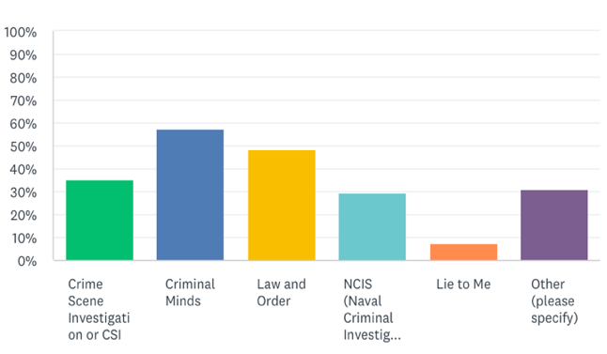
Figure 2. % Of Respondents Who Watch Specific Reality-Based Crime TV Show
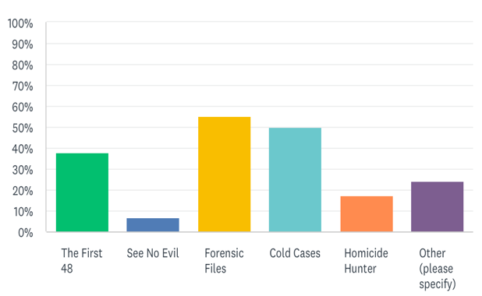

When asked about the frequency of watching these TV shows, 5.63% said they watched fictional crime shows every day, and 4.23% said they watched reality-based shows every day. 8.45% stated they watched the fictional shows almost every day compared to a 5.63% for reality-based shows. Most respondents (36.62%) claimed that they have watched fictional crime shows about 2-3 times a week, and 28.17% said they have watched reality-based shows about the same amount of time during the week. 29.58% watched fictional shows once a month; 18.31% rarely watched these shows, and 8.45% never watched these TV shows. On the other hand, 25.35% claimed to have watched reality TV shows once a month; 22.54% rarely watched these shows; and 18.31% have never watched any of these shows (Figures 3 and 4).
Figure 3. Respondent Frequency of Watching Fiction-Based Crime TV Shows
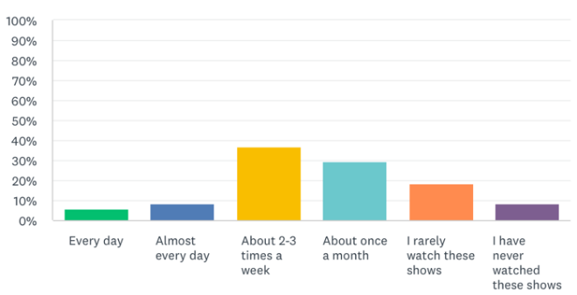
Figure 4. Respondent Frequency of Watching Reality-Based Crime TV Shows
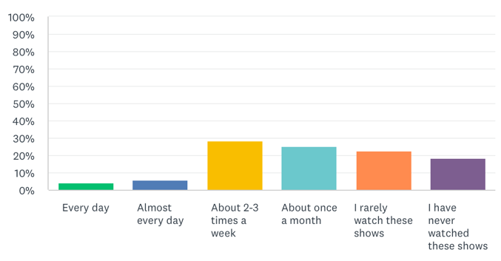
Survey Respondent Perception of Accuracy of Crime TV Shows
This section is perhaps, one of the most, if not the most, important sections throughout this research study. This section of the study collected information on how accurate respondents believed fiction-based crime TV shows are portrayed, whether they expect scientific evidence to be presented in court in criminal trials, whether they would demand this type of evidence as a condition for a guilty verdict, and whether they believed these fictional shows have altered criminal behavior based on what they learn from these TV shows. On a scale of 1 through 5, 1 meaning “not at all” and 5 being “extremely realistic,” more than half of the respondents, 2.9, believed fictional crime TV shows are somewhat realistic. Within this rating, 11.27% believed these shows were not realistic at all; 26.76% thought they were somewhat not realistic; 23.94% were neutral; 36.62% believed these shows are somewhat realistic; and only 1.41% thought they were extremely realistic. When asked about whether these television dramas accurately described what happened in the criminal justice system, the percentages were a bit different. For instance, 18.06% of the respondents strongly disagreed with this statement; 38.89% (most respondents) slightly disagreed; 22.22% were neutral or not sure; and 25% slightly agreed that these fiction-based crime shows are realistic. None of the respondents strongly agree with such a statement (Figure 5).
Figure 5. Respondent Perception of Accuracy of Fiction-Based Crime TV Shows
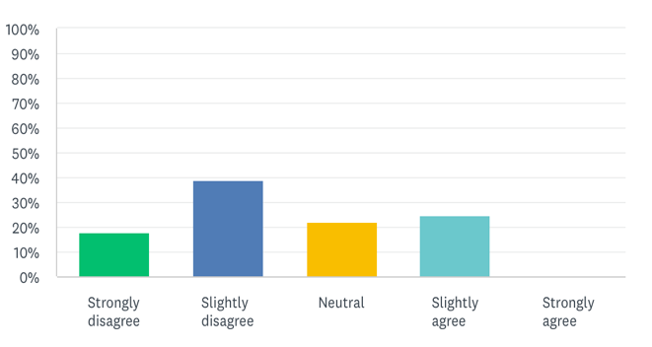
The majority of respondents believed that the way the popular media has portrayed these fiction-based crime shows has altered criminals’ behavior based on what they see on TV. Some of the answers provided by respondents included:
- “Criminals think of ways to get away with crimes they see on these TV shows”
- “They can learn to be smarter about committing crimes, what to do, and what not to do”
- “They take what other shows used and try to implement these strategies that worked and probably do not include the ones that did not work before”
- “These shows teach criminals right and wrong ways of committing a crime”
- “It helps them better formulate plans to attack, helps them understand how the system works”
- “Criminals learn to be more careful about not leaving DNA”
- “It shows criminals how to get away with crimes much easier”
- “If they see the way investigators collect evidence like fingerprints, fiber from clothes, and body fluids, they can learn to be careful and try not to leave anything that can expose them”
Among all these answers, there were some other respondents who, on the other hand, believed that these TV shows did not affect the ways criminals carry out their crimes.
A common misconception often portrayed by fictional crime shows is the estimated time in which an investigation is completed, and a case is closed. Regarding this matter, 2.78% said they believed an investigation should be completed in one or two days; 8.33% believed either in a week or in a year; 9.72% believed it should be completed in a month; and finally, almost all respondents (93.06%) believed that the time depended on the type of case it is (Figure 6). Another misconception about these TV shows is the expectation of scientific evidence to be presented in
Figure 6. Respondent Perception of Estimated Time an Investigation Should be Completed
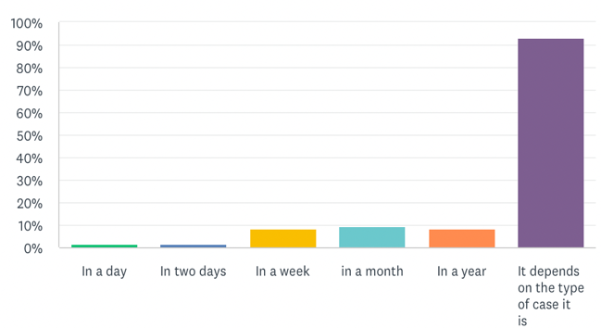
court by the prosecution. When respondents were asked whether they expected the prosecution to present evidence such as DNA, fingerprints, or bite marks in court and in which cases, 70.83% of them said they would expect the prosecutor to present scientific evidence in all criminal cases; 61.16% stated that evidence should be presented in murder or attempted murder and rape or other criminal sexual conduct cases; 20. 83% in crimes involving a gun; 18.06% in physical assault; 16.67% in breaking and entering; 12.50% in theft; and 2.785 did not expect any scientific evidence to be presented in court (Figure 7).
About 93.06% of all respondents had not participated on jury duty, whereas only 6.94% had (Figure 8). When asked whether if they were to participate in a jury duty they would demand scientific evidence as a condition for a guilty verdict, 26.76% said that they would; 7.04% said no; and 76.06% stated that it depended on the type of case it is and what other types of evidence is available (Figure 9). The last question on this survey instrument asked whether respondents believed their knowledge about criminal investigations had been influenced by these fiction-based or reality-based crime TV shows they watched. 40.28% of respondents said that their knowledge
Figure 7. Respondent Expectations of Scientific Evidence in Criminal Trials by Case Type
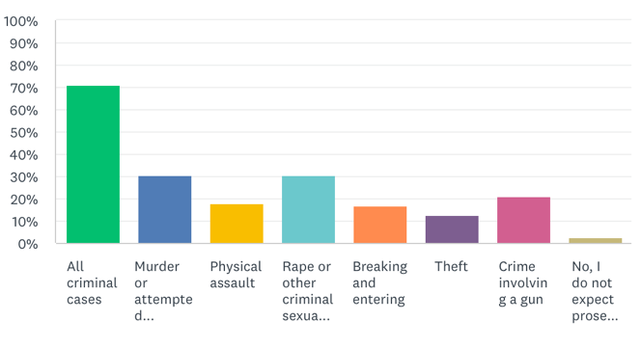
Figure 8. Respondent Participation in Jury Duty
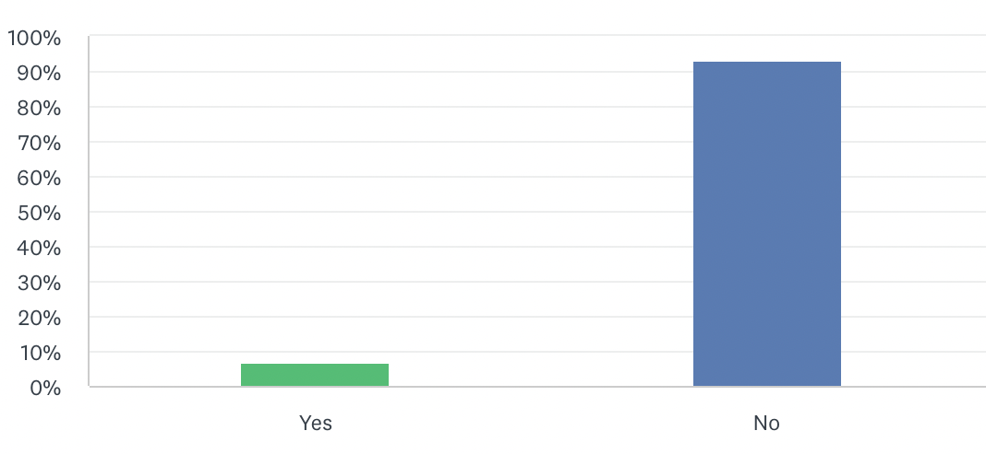
had been influenced by fiction-based crime shows, and the same percentage of respondents (40.28%) said that their knowledge had been influenced by reality-based crime shows; the rest were not influenced by either of these two categories of crime shows (Figure 10).

Figure 9. % Of Respondents Demanding Scientific Evidence as a Condition for Guilty Verdict
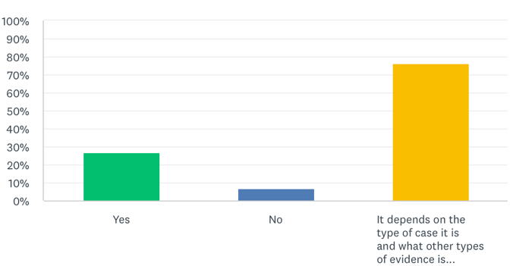
Figure 10. Respondent Perception of Crime TV Shows Influence on Knowledge of Criminal Investigations
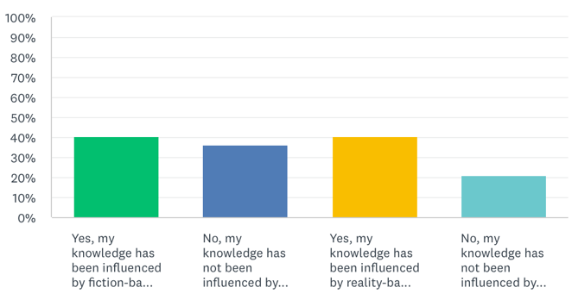
Discussion
The main purpose of this study was to investigate whether the CSI effect was a valid concern or a popular myth. This study examined respondents’ perceptions of whether watching crime TV shows has raised expectations and demands for more scientific evidence in criminal trials. More specifically, the study tried to investigate whether there was a correlation between watching fiction-based crime TV shows and higher demands for evidence by analyzing the difference in the levels of demands for evidence between viewers of fiction-based crime shows and viewers of reality-based crime TV shows. By investigating this, the study also tried to get information on whether these fiction-based TV shows have, in fact, misled or misinformed people about the ways criminal investigations and court procedures are supposed to be carried out (e.g., the estimated time an investigation should be completed, how fast detectives are supposed to respond to a crime scene, etc.) and the type of forensic evidence that should be presented in criminal trials.
While analyzing the results obtained for each question included in this study, there was a noticeable pattern between those respondents who watched fiction-based crime TV shows and those who watched reality-based crime shows. Most of the results revealed that both groups had very similar answers and thus, showing not a very significant difference between both groups. For instance, while looking at Figures 3 and 4, statistics showed that respondents watched both types of TV shows at a similar frequency- about 2-3 times a week- which means that they usually spend about the same number of days during the week watching these crime TV shows. This finding is somewhat different from what would be expected because fiction-based crime shows tend to be more popular than reality-based shows due to their exaggerated and interesting ways of portraying things, thus it would be expected that people would have a higher tendency to watch these fictional TV shows more often than these realistic crime shows, however, this data analysis revealed that this frequency of watching either category of these TV shows was about the same.
One of the most important questions asked in this study to determine the accuracy of fiction-based crime TV shows was how realistic respondents believed these TV shows were. The data analysis revealed that most respondents believed that these TV shows were somewhat realistic, but when asked whether they believed these shows accurately described what happens in the criminal justice system, most of them slightly disagreed. These findings are somewhat contradictory and show that although people think these shows are somewhat realistic, this does not mean that they accurately portray what happens in our justice system, which then may support our hypothesis that the CSI effect has not changed people’s perception of how things work in our justice system. These are very important findings because if the CSI effect has really changed people’s perceptions of how the criminal justice system work, especially criminal investigations and criminal trials, then it would be expected that respondents would think that these fictional TV shows accurately portray things and not the opposite. However, obtaining such results may just indicate that the CSI effect might just be a popular myth and not so much something that people in the criminal justice system should be concerned about. If there was something that most respondents agreed upon was that these fictional crime TV shows have altered criminals’ behavior based on what they learn from these TV shows. In other words, they believed that the way things are portrayed such as the type of evidence prosecutors and investigators collect, and the way they conduct criminal investigations just teach criminals how to become better at committing crimes by knowing how to cover their tracks and not leaving behind any trace of evidence that might identify them. Perhaps, conducting a study focusing on whether criminals have actually learned some of their crime skills from these fiction-based TV shows would be a great idea for future research.
The current study also inquired about participant expectations for an estimated time in which an investigation should be completed and whether they would demand scientific evidence as a condition for a guilty verdict. The former revealed that respondents’ estimated time depended on the type of case it is. This finding is very important because, in these fictional crime TV shows, the popular media often portray how cases and investigations are almost always done in a day or two, which results in prosecutors and investigators always finding the suspects and convicting them. This finding demonstrates that respondents generally seem to understand that crime TV shows do not usually provide an accurate timeline for real criminal investigations. Regarding the question about demanding evidence as a condition for a guilty verdict, as seen in the previous section, over 75% of the respondents said that this demand would depend on the type of case it is and what other types of evidence is available. These findings suggest that the public (and prospective jurors) do not have blanket expectations for scientific evidence in all criminal cases but more reasonable expectations of forensic evidence in certain types of cases. These results also suggest no support for the CSI effect.
Furthermore, while the CSI effect essentially argues that jurors put a high value on forensic evidence, it is equally important that jurors also understand the limitations of forensic science techniques in criminal investigations as the misuse of these techniques have led to false and wrongful convictions. According to the National Registry of Exonerations, which tracks both DNA and non-DNA based exonerations in the United States, “the misapplication of forensic science contributed to 52% of wrongful convictions in Innocent Project cases, and 24% of all wrongful convictions nationally” (National Registry of Exonerations, n.d.). These statistics included convictions based on forensic evidence that was unreliable or invalid and expert testimony that was misleading, and mistakes made by practitioners, and in some cases misconduct by forensic analysts.
While there are many examples of cases where unvalidated forensic evidence has resulted in wrongful convictions, one particularly egregious case is the wrongful conviction of Warith Habib Abdal. On May 18, 1982, Leslie Werner, a white woman was raped and robbed in an Erie County, New York, nature preserve where she had been birdwatching with her husband. When he was describing her attacker, she described him as a “black man between five feet eight and five feet ten with a space between his upper front teeth and a ‘tenor-type’ voice” (The National Registry of Exonerations, n.d.). Abdal did not fit this description as he was six feet two inches tall, had no gap between his teeth, and had a deep voice. Nonetheless, he was picked up for questioning about the crime, but Werner failed to identify him as the attacker during the first one-man show-up. However, after viewing a photograph of him that was four years old, “she returned to the show-up and identified him.” A forensic analyst did also testify that he had compared a “Negroid” eyelash recovered from Werner at the hospital where she was treated after the attack and found it was different from Abdal’s eyelashes, but he said it was “not unusual for different hairs to come from the same person,” which was a claim that had no scientific basis (The National Registry of Exonerations, n.d.). Abdal was convicted then sentenced to 20 years to life. However, following the advent of DNA forensic technology, a DNA test of vaginal swaps and slides collected from Werner at the hospital was ordered, but the results came up as inconclusive. This same evidence was later sent to a different laboratory and the evidence was lost in transit. After some other attempts, another laboratory was able analyze the DNA and the results showed that Abdal was innocent.
This case clearly showed how the mishandling of forensic evidence and false testimony of a forensic analysts led to Abdal being wrongfully convicted of a crime he did not commit. Although DNA was used to prove his innocence, it is essential to reiterate that it is also important for people and jurors to know about these limitations of scientific or forensic science evidence (e.g. error rates, etc.), which the CSI effect claims to be so accurate.
Finally, the data analysis on the last question regarding whether respondents’ knowledge about criminal investigations had been influenced by either fiction-based or reality-based crime shows revealed that half of the respondents’ knowledge had been, in fact, influenced by these fictional TV shows, and the other half by the more realistic shows, which again, shows that these two groups of viewers had very similar expectations all throughout the study. This finding suggests that there is not a statistically significant difference between these two groups in their levels of demand and expectations for scientific evidence in criminal trials and thus, do not support the existence of the CSI effect as a valid concern. Here, our hypothesis about expecting to a slightly significant difference between both groups in their levels of demand for scientific evidence was not supported.
All these results are not very different from what most studies on this topic have found about the existence of the CSI effect. However, there is one possible theory that could be used to explain the results of this specific study. As was mentioned in the descriptive statistics of demographic variables section, all respondents were college students and most of them were Criminal Justice majors. Although this may not seem important, these two factors may have influenced the overall results of this research study. College students, specifically, Criminal Justice students have a broader understanding and knowledge of how the criminal justice system actually works due to their exposure to criminal justice courses and research in this area. Criminal Justice students, in their classes, learn about how this phenomenon of the CSI effect inaccurately portrays how our criminal justice system deals with criminal investigations and criminal trials. They already know how these things work and what to and not to expect and demand during investigations. There are two particular courses in the criminal justice curriculum at Salem State University (CRJ250 Criminal Investigations and CRJ260 Introduction to Forensic Science and Criminalistics) that focus on forensic science and the entire investigative process, which offers students a more in-depth view of how criminal investigations are carried out. Thus, it is fair to say that perhaps, the results did not support the existence of the CSI effect and did not find a correlation between watching fiction-based crime TV shows and higher demands and expectations for scientific evidence due to respondents being already exposed to all these factors mentioned above.
Conclusion
The results indicate that both viewers of fiction-based crime TV shows and viewers of reality-based crime TV shows had very similar expectations and demands for scientific evidence in criminal trials. There was no significant correlation between watching fiction-based crime shows and higher demands for scientific evidence as most respondents understood the inaccuracies portrayed in fictional TV shows. The findings suggest that the way that popular media has portrayed criminal investigations has not unrealistically raised expectations and demands for scientific evidence, especially as a condition for a guilty verdict. Thus, no support for the CSI effect was found in the present study, which may suggest that rather than being a valid concern for people working in the criminal justice system, the CSI effect might just be a popular myth.

Study Limitations and Ideas for Future Research
This study had a few limitations that could be improved upon in future research to get more accurate and representative results. First, the findings of this study were limited to one state university in the Northeast. Expanding this research across multiple universities across a variety of geographic areas around the country would allow for more representative and inclusive results. Furthermore, another limitation of the present study was some missing data. While analyzing the results, it was noted that some respondents did not answer some questions and just skipped them. This contributed to less accurate results and perhaps some inconsistencies in the study. This is a limitation that is very difficult to control or improve for future research, especially when the survey instrument is administered online, and researchers are not there to monitor respondents.
Another limitation was that the sample size was relatively small (N= 90). A Larger sample size would allow for conclusions to be more representative and generalized. Finally, the study was composed of mostly criminal justice major students, which as already explained, could have influenced the overall results. A more diverse sampling population would allow for more inclusiveness and, in this case, less bias.

References
Brewer, R., Paul, & Ley, L., Barbara. (2010). Media use and public perceptions of DNA evidence. Retrieved from https://academic.csuohio.edu/kneuendorf/frames/phx/creativegeography/brewer&ley_10.pdf

Call, Corey, Cook, K., Amy, Reitzel, D, John, and McDougle, Robyn. (2013). Seeing is believing: the CSI effect among jurors in malicious wounding cases. Journal of Social, Behavioral, and Health Sciences. Walden University. Retrieved from https://scholarworks.waldenu.edu/cgi/viewcontent.cgi?article=1102&context=jsbhs

Cole, A., Simon, and Dioso-Villa, Rachel. (2009). Investigating the ‘CSI effect’ effect: media and litigation crisis in criminal. Stanford Law School. Retrieved from https://heinonline.org/HOL/P?h=hein.journals/stflr61&i=1348

Chin, M., Jason. (2016). The CSI effect. Retrieved from https://papers.ssrn.com/sol3/papers.cfm?abstract_id=2752445

Data USA. Salem State University. Retrieved from https://datausa.io/profile/university/salem-state-university
Eatley, Gordon, Hueston, H., Harry, & Price, Keith. A Meta-Analysis of the CSI effect: The Impact of Popular Media on Jurors’ Perception of Forensic Evidence. Retrieved from https://api.semanticscholar.org/CorpusID:167215183

Innocent Project. Overturning Wrongful Convictions Involving Misapplied Forensics. Retrieved from https://innocenceproject.org/overturning-wrongful-convictions-involving-flawed-forensics/

Kim, Y., S., Barack, G., & Shelton, D.E. (2009). Examining the “CSI-effect” in the case of circumstantial evidence and eyewitness testimony: Multivariate and path analyses. Journal of Criminal Justice. Retrieved from. https://doi.org/10.1016/j.jcrimjus.2009.07.005
Podlas, Kimberlianne. (2006). The CSI effect and other forensic fictions. HeinOnline. Retrieved from https://heinonline.org/HOL/P?h=hein.journals/laent27&i=95

Shelton, E., Donald, Kim, S., Young, and Barak, Gregg. (2006). A study of juror expectations and demands concerning scientific evidence: does the “CSI effect” exist? Vanderbilt Journal of Entertainment and Technology Law. HeinOnline. Retrieved from https://heinonline.org/HOL/P?h=hein.journals/vanep9&i=339

The National Registry of Exonerations. Warith Habib Abdal. Retrieved from https://www.law.umich.edu/special/exoneration/Pages/casedetail.aspx?caseid=2978
Trainum, L., James. (2019). The CSI effect on cold case investigations. Forensic Science International. Retrieved from https://doi-org.corvette.salemstate.edu/10.1016/j.forsciint.2019.05.020

Wise, Jenny. (2010). Providing the CSI Treatment: Criminal Justice Practitioners and the CSI effect. HeinOnline. Retrieved from https://heinonline.org/HOL/P?h=hein.journals/cicj21&i=395

Appendix A Study Recruitment Flyer
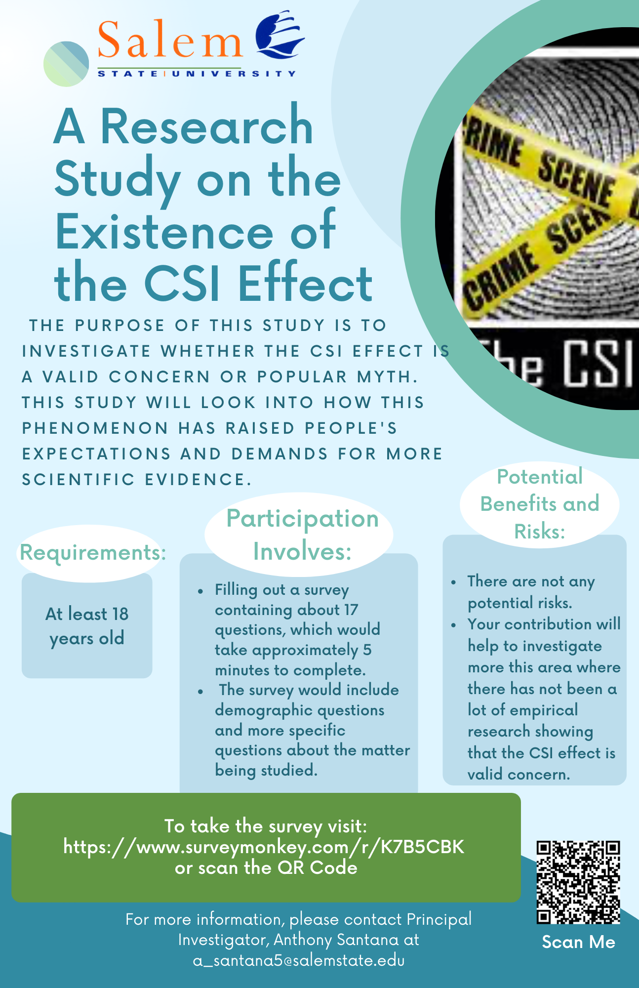
Appendix B Disclosure Form

INTRODUCTION: This research will investigate the impacts of the CSI effect and the misconceptions that have been developed by crime-based TV shows, specifically fiction-based TV shows such as CSI, Law and Order, Criminal Minds, and others. With this study, it is hoped to carry out some more empirical research on this topic of major concern within our justice system. The intended purpose of this study is 1) to find out whether the way popular media has portrayed criminal investigations has raised people’s expectations and demands for scientific evidence in the courtroom; 2) whether these fiction-based TV shows have misled and misinformed people in the ways criminal investigations and court procedures are supposed to be carried out; and 3) whether there is a significant difference in the levels of demands for evidence between viewers and non-viewers of these shows. In order to achieve these goals, this research will ask you about your crime-show-viewing habits and your expectations and demands for scientific evidence (i.e., DNA, fingerprints) in certain cases.

PARTICIPATION: Taking part in this survey is completely voluntary. You may stop your participation at any time. You are free to decline to answer any question you do not wish to answer. There are no right or wrong answers. All answers will remain completely anonymous.

RISKS: There are no foreseeable risks involved in participating in this study other than those minimal risks encountered in day-to-day life.

BENEFITS: The research itself does not present any individual benefits, however, participation will help to investigate more this area of our Criminal Justice System where there has not been a lot of empirical research showing that the CSI effect is a valid concern.

ANONYMITY/CONFIDENTIALITY: The research will not collect any identifying information that could be associated with you; therefore, your name or identity will not be used in reports or presentations of the findings of this research. Information provided to the researchers will be kept anonymous. This research project has been approved by the Institutional Review Board at Salem State University. Thank you for your help.

An analysis of the results and an explanation of the study will be available on the Digital Commons page of the Commonwealth Honors Program at Salem State University by May 2022.

CONTACT INFORMATION: For questions or concerns about the research, please contact student researcher, Anthony Santana at a_santana5@salemstate.edu or faculty investigator, Gina Curcio at gcurcio@salemstate.edu

ELECTRONIC CONSENT: Continuing with this survey indicates that you have read the above information, that you are voluntarily agreeing to participate, and that you are 18 years of age or older.

Appendix C Survey Instrument

You are invited to participate in this anonymous, self-administered, online survey investigating the impacts of the CSI effect on how criminal investigations are carried out and how this has raised people’s expectations and demands for scientific evidence in the courtroom. This is an Honors Program research project being conducted by Anthony Santana, a Criminal Justice student at Salem State University. It should take approximately 5 minutes to complete.

Your participation in this survey is voluntary. You may refuse to take part in the research or exit the survey at any time. You are free to skip any particular question you do not wish to answer for any reason.

Thank you very much for your participation and input! If you have any questions, please contact Principal Investigator, Anthony Santana at a_santana5@salemstate.edu

This study has been approved by the Salem State University Institutional Review Board (IRB) under Application ID # 6012. For concerns about your treatment as a research participant, please contact the SSU IRB, Sponsored Programs and Research Administration, Salem State University 352 Lafayette Street, Salem, MA 01970. You may also contact the SSU IRB via email at irb@salemstate.edu or via phone at (978) 542-7556 or (978) 542-7177.

By clicking on the “Agree” button, you indicate that:

- You are at least 18 years-old
- You have read the above information
- You voluntarily agree to participate

Agree
Disagree

- What gender do you identify as?
Female
Male
Non-binary

- What is your age?
18- 29 years-old
30- 39 years old
40- 49 years old
50+ years-old

- Please specify your ethnicity: Select all that apply
Asian/Pacific Islander
Black or African American
Hispanic or Latino
Native American/Alaska Native
White
Other

- What is the highest degree or level of school you have completed?
High school diploma, GED, or equivalent
Trade/technical/vocational training
Some college credit, no degree
Associate’s degree
Bachelor’s degree
Master’s degree
Doctorate

- If you have a bachelor’s degree OR are currently enrolled in a bachelor’s degree program, what is your major?
Art, Music or Dance
Business
Criminal Justice, Sociology or Other Social Science
Education
Humanities (English, Foreign Languages, History, etc.)
Nursing or HealthCare
Social Work
Physical Sciences
Psychology

- Do you watch any of the following fiction-based crime TV shows? Select all that apply.
Crime Scene Investigation or CSI
Criminal Minds
Law and Order
NCIS (Naval Criminal Investigative Service)
Lie to Me
Others

- Do you watch any of the following reality-based crime TV shows? Select all that apply.
The First 48
See No Evil
Forensic Files
Cold Cases
Homicide Hunter
Others

- How often do you watch these fiction-based shows?
Every day
Almost every day
About 2-3 times a week
About once a month
I rarely watch these shows
I have never watched these shows

- How often do you watch these reality-based shows?
Every day
Almost every day
About 2-3 times a week
About once a month
I rarely watch these shows
I have never watched these shows

- On a scale of 1-5 with 1 meaning “not at all” and 5 being “extremely realistic,” how realistic do you think these fiction-based shows are?
1 2 3 4 5

- Do criminal television dramas accurately describe what happens in the criminal justice system?
Strongly disagree
Slightly disagree
Neutral
Slightly agree
Strongly agree

- Do you believe that crime TV shows have altered criminals’ behavior based on what they learn from these TV shows?
Yes No If yes, in what ways?

- What is an estimated time you believe an investigation should be completed?
In a day
In two days
In a week
In a month
In a year
It depends on the type of case it is

- In a criminal trial, do you expect prosecutors to present scientific evidence?
Yes No. If yes, in which cases:
All criminal cases
Murder or attempted murder
Physical assault
Rape or other criminal sexual conduct
Breaking and entering
Theft
Crime involving a gun

- Have you served on a jury?
Yes
No

- If you were to serve on a jury, would you demand scientific evidence as a condition for a guilty verdict?
Yes
No
It depends on the type of case it is and what other types of evidence is available

- Do you believe your knowledge about criminal investigations has been influenced by those fiction-based or reality-based crime TV shows you watch?
Yes, my knowledge has been influenced by fiction-based crime shows
No, my knowledge has NOT been influenced by fiction-based crime shows
Yes, my knowledge has been influenced by reality-based crime shows
No, my knowledge has NOT been influenced by reality-based crime shows

