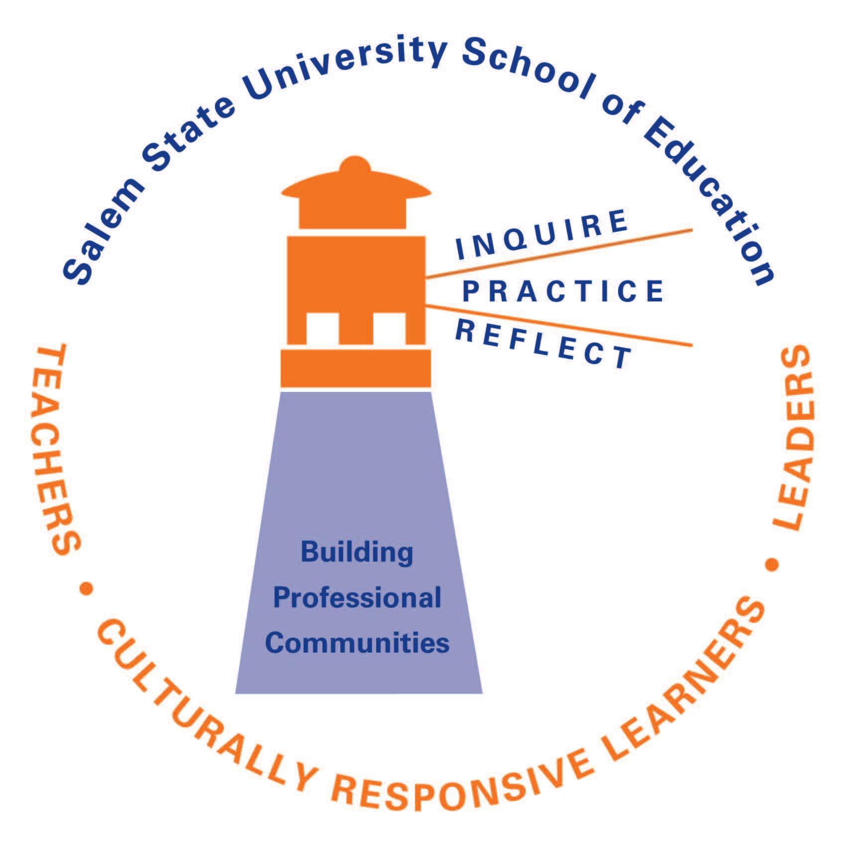

SALEM STATE UNIVERSITY Education Department
Department of Childhood Education and Care
Fall 2020
EDC 810-S1 Technology Methods in the Early Primary and Elementary Grades
Assistant Professor Youn Jung Huh Office: Sullivan Building, Room 205B
Office hours: Tuesday and Wednesday 5:00-6:00 p.m. or by appointment
Telephone: (978) 542-2920 E-mail: yhuh@salemstate.edu
Semester credits: 1.5

COURSE DESCRIPTION: This course is designed to provide early childhood and elementary students with an introduction to common educational technology while they are in their full practicum. Through hands-on experience with computer hardware, software, and web-based tools, participants will gain experience-based knowledge and confidence in using technology to facilitate learning appropriate for the needs of diverse learners and across varied subject areas in early primary and elementary grades. This course covers topics including best practices in classroom technology and instructional design, age appropriate lesson planning with technology, and ethical concerns. One and a half lecture hours per week. Field-based assignments are required.
NOTE ON ONLINE, BLENDED COURSES
This course is fully online and requires regular engagement with asynchronous course discussions and synchronous class meetings. We are using Canvas (https://elearning.salemstate.edu) as our course platform, and the course home page contains important information to help you successfully complete the course. The course is not self-paced; you will need to complete the course assignments week-by-week. Each week, you will need to visit the course module and read the welcome note, which contextualizes our work for the week and gives you a checklist of your assignments for the week. Please do not rely solely on the “To Do List” function in Canvas, or you may miss important information or assignments. Our synchronous meetings will take place via Zoom. Additional information about Zoom is available on the Read Me First Guide on Canvas under "Synchronous Meeting Etiquette."
COLLABORATIVE ONLINE INTERNATIONAL LEARNING (COIL)
Collaborative Online International Learning (COIL) connects students and professors in different countries for collaborative projects and discussions as part of their coursework. This course uses COIL to give you new opportunities and global connections. Specifically, you will have opportunities to work with students at a university abroad on a cross-cultural digital photo essay assignment.
GLOBAL COURSE GOALS:
This course has specific learning outcomes related to each goal. Students will be able to:

Goal 1: Develop comfort using hardware and technology tools to enhance teaching and a willingness to explore technologies that are new to them.

Goal 2: Demonstrate familiarity with best practices in educational technology.

Goal 3: Develop and implement disciplinary and developmentally appropriate uses of technology

COURSE LEARNING OBJECTIVES
The state of Massachusetts has implemented Professional Standards for teachers (PST). This course utilizes these standards in identifying course goals/objectives, course instructional activities, assigning course requirements, and creating assessments. The following outline identifies how these standards are incorporated in this course

PST Table for EDC 810
Learning Outcome | PST | Assessment Type
Collaboratively design well-structured technology-based activities, lessons, and assignments with measurable outcomes that build on candidates’ knowledge of their content area, reflect candidates’ high expectations for and understanding of student development and learning, and demonstrate candidates’ awareness of meeting the needs of students from diverse and linguistic backgrounds. | 1a Curriculum Planning (practice)  1 SEI a (practice)  1 SEI c (practice)  2a Instruction (practice) 2c Cultural Proficiency (practice)  2d Expectations (practice) 4c Collaboration (intro) | Online activities, postings, and assignments  Technology integrated lesson planning  Online formative assessment
Collaboratively develop and practice using a variety of informal and formal assessment methods employing technology, analyzing data collected from the assessments, and describing their conclusions and plans for improving future instruction. | 1b Assessment (practice) 1c Assessment (practice) 4c Collaboration (intro) | Online activities, postings, and assignments  Technology integrated lesson planning  Online formative assessment
Apply educational technology theories in the field, using the activities and assessments they have designed, and reflect on the effects of technology on their practice, student learning, and classroom management with their supervising practitioner and fellow candidates. | 1a (practice)  2a (practice)  2b (practice)  2d (practice)  2f Classroom Management (practice)  4a Reflection (intro)  4b Professional Growth (intro) 4f Professional Responsibilities (intro) | Online activities, postings, and assignments  Technology integrated lesson planning  Online formative assessment  Technology fair
Draw on educational technology theories and experiences applying technology-based teaching practices in the field to articulate a philosophical approach to teaching with technology that emphasizes development of safe and collaborative learning environments for students and takes into account the social-emotional competencies that students need when engaging with technology. | 2b Learning Environment (practice)  2e Social and Emotional Learning (practice)  2 SEI d (practice) | Online activities, postings, and assignments  Digital photo essays  Technology fair

COURSE REQUIREMENTS FOR ASSESSMENT
(Linked to the corresponding numbered objectives above)
This is a professional preparation program and it is expected that all work submitted will be of professional quality. Unless specifically stated, all assignments are to be typewritten in 12 font, double-spaced and carefully edited for grammar, punctuation, and spelling. As a professional, you are expected to use assigned readings and other literature in all written work, including discussion board posts.
You are also expected to know how to cite the references used to inform your scholarly work. Professionals in the field of education use the citation format from the American Psychological Association (APA). If you are not familiar with APA Citation Style Guidelines, please see the Salem State University Library web page at: http://www.salemstate.edu/library/6556.php
TOPICAL COURSE OUTLINE:
- What does “using” technology to facilitate teaching and learning really mean?
- Using technology in your classroom to enhance content delivery
- Using technology in your classroom enhance student engagement
- Using technology in your classroom to enhance collaboration and connections
- Using technology in your classroom to meet the needs of diverse learners
- Using technology to assess your students’ learning.
- Designing your lessons: Weaving in technology appropriately
- Technology and ethical behavior - yours and your students’
- Keeping your technology toolkit up to date

REQUIRED TEXTS:
- No need to purchase texts for this class. Reading materials for this class can be found on the course canvas page.
- ‘2016 MA Science and Technology/Engineering Curriculum Framework’ from the linked website: http://www.doe.mass.edu/frameworks/scitech/2016-04.pdf
- ‘2016 MA Digital Literacy and Computer Science (DLCS) Curriculum Framework’ from the linked website: http://www.doe.mass.edu/frameworks/dlcs.pdf
- NAEYC Position Statement (2012) Technology and Interactive Media as Tools in Early Childhood Programs Serving Children from Birth through Age 8. Retrieved from: http://www.naeyc.org/content/technology-and-young-children

Canvas: The schedule and assignments are subject to change due to unforeseen circumstances which may arise. All assignments listed here will also be posted on Canvas, which will be accessible only to members of our class. Canvas student accounts are automatically created. If you have problems with your SSU email or Canvas account please call the IT Help Desk at 978 542-2036
Determination of Final Grade
Objective | 1 | 2 | 3 | 4
Online Activities, Postings, and Assignments (35% of grade) | X | X | X | X
Digital photo Essays (15% of grade) |  |  |  | X
Technology Fair (10%) |  |  | X | X
Technology Integrated Lesson Planning (30%) | X | X | X
Online Formative Assessment with Video Instruction (10%) | X | X | X

- Online Activities, Postings, and Assignments (35% of grade)
- Digital photo Essays (15% of grade)
- Technology Fair (10%)
- Technology Integrated Lesson Planning (30%)
- Online Formative Assessment with Video Instruction (10%)

Final Grade
A 95-100%
A- 90-94%
B+ 88-89%
B 84-87%
B- 80-83%
C+ 78-79%
C 74-77%
C- 70-73%
D+ 68-69%
D 64-67%
F 63% or below

ASSIGNMENT DESCRIPTORS:

- Online Activities, Postings, and Assignments (35% of grade)

Weekly activities are provided every week. They include activities such as comprehension checks on the readings, discussions, video analyses, and other applied activities.

For the additional readings and videos, students will be completing Reflection Papers. These include a 1-page summary of the readings/ websites/videos for that class as well as a ½ page reflection that may include personal application, insights, questions, and concerns about education/teaching. Reflection papers and other assignments will be graded using the following rubric. These assignments are graded for completion and effort.

- Digital Photo Essays-COIL Project (15% of grade)
This assignment uses digital photos as an effective method to assess and expand students’ understanding of how COVID-19 pandemic transformed the ECE or ELEM education and the role of technology for children’s learning and development during the crisis. Additionally, it is designed to help students jump-start their digital narrative writing that focuses on real life problems. For this assignment, students will choose/ review and respond to at least THREE digital photos that describe common issues of the use of technology encountered by ECE or ELEM educators in a classroom setting.

This assignment consists of five parts including digital photo workshop, digital photo essays, creating collective photo essays, international exchanges, and final discussion. For the first part, students will learn about how to effectively use digital images for digital writing. For the second part, students will need to write a digital photo essay that describes both what they witnessed about the use of technology in ECE or ELEM in their practicum and provides concrete examples of the classroom practices with technology for children’s learning and development. Digital photos will be utilized to support their statement. In the third part, students will need to review their classmates’ digital photo essays and develop a collective photo essay. The collective digital photo essays will be shared with ECE teacher candidates in Korea. In the last part, students will participate in a final group discussion to identify best practices in using technology for education.

- Technology Fair (10% of grade)

Students will introduce educational technology (e.g., online applications, websites, media) to audiences. Students will share resources and ideas for incorporating the educational technology into the current Massachusetts Curriculum. Students will need to do the followings for their presentation;

- Explain your choice of educational technology and justify why it is a useful tool for student learning.
- Describe the educational technology (you can demonstrate how to use it or include the images of the technology in your handout)
- Describe the rules/directions to use the technology.
- Explain any teaching ideas with the technology.
- Create a handout that has all required information about the technology.

- Technology-Integrated Lesson Planning (30% of grade)
Students will develop detailed technology-integrated lesson plans for their target students. Students should meet with their supervising practitioner to identify lessons that they will be able to plan and teach during their practicum. Be sure to discuss with him/her the subject standards, essential questions, and goals she/he has set out for the unit from which this lesson comes.
5. Online Formative Assessment with Video Instruction (10% of grade)
Students will create one online formative assessment (e.g., Quizzes, online presentations, discussions, creating video) as a tool to support their target students’ learning. Students will also create a 3-5 min short instructional video, which explains how to do the online formative assessment that they created.

STANDARDS FOR ALL WORK: Students are responsible for completing all course requirements. It is the expectation that all work will be turned on the date due and all written work will contain proper spelling, punctuation, syntax and references.

APPEALING A GRADE: Students and instructors may sometimes disagree on a grade awarded for an assignment. I am open to discussing such situations. However, we will not discuss grades either before or after a class period because such discussions do not respect the privacy of either student or instructor and there is never enough time to fully consider whatever the issue may be. To facilitate discussions about grades, students must submit the following in writing: 1) a reason why the grade should be reconsidered; 2) a detailed explanation of why you believe your work met the requirements of the assignment; 3) and evidence, for example from class readings or discussions, supporting your appeal. Appeals should be made no later than one week after an assignment is returned.

LATE PAPERS AND ASSIGNMENTS: All assignments are to be submitted, and presentations completed, on the dates due. Papers and presentations that are late will be penalized depending on the lateness and the individual circumstance. A 10% per day penalty (weekends count as 2 days) will be applied to LATE final notebooks, final papers, posters, project proposals, and any other assignments. Part of what you are learning here is how to be a responsible teacher! Numerous late submissions indicate a lack of commitment. If medical or family circumstances require an extension PLEASE SEE ME so we can work things out. I want you to succeed!

FINAL EXAM: There is no final examination for this course.

NON-DISCRIMINATION POLICY: Salem State University is committed to providing equal access to the educational experience for all students in compliance with Section 504 of the Rehabilitation Act and The Americans with Disabilities Act, and to providing all reasonable academic accommodations, aids and adjustments. Any student who has a documented disability requiring accommodation, aid or adjustment should speak with the instructor immediately. Students with disabilities who have not previously done so should provide documentation to and schedule an appointment with the Office for Students with Disabilities (Meier Hall, Room 102) and obtain appropriate services.

COVID 19 PANDEMIC STATEMENT: Students must comply with the Covid-19 Health and Safety Protocols for the 2020-2021 Academic Year. This includes wearing masks in class and on campus in public spaces, practicing physical distancing where possible, including in class, engaging in a daily symptom check, notifying Counseling and Health Services at 978-542-6413 if they have any symptoms associated with COVID-19, and not coming to campus or to an in-person class if they have any of the symptoms related to COVID-19, until cleared by the Student Life Wellness Area. Students who have documented disabilities that may prevent them from complying with these policies are required to contact the Disability Services office.

EMERGENCY: In the event of a university declared critical emergency, Salem State University reserves the right to alter this course plan. Students should refer to Salem State for further information and updates. The course attendance policy stays in effect until there is a university declared critical emergency. In the event of an emergency, please refer to the alternative educational plans for this course located at/in [faculty member determines this]. Students should review the plans and gather all required materials before an emergency is declared.

The Mary G. Walsh Writing Center (L 113) offers writing support to the entire Salem State University community. Writing Center tutors are required to complete successfully the Writing Center Practicum, familiarizing themselves with process-based, student-centered writing instruction. Tutors can identify and address a wide array of writing-related issues and other forms of mediated communication. Working with Writing Center tutors offers students a chance to grow as writers, helps them foster the ability to communicate skillfully and professionally, and provides them the satisfaction of developing their own successful writing processes and strategies, especially for completing research projects.
Campus Resources
Center for Academic Excellence: The Center for Academic Excellence (CAE) helps students achieve academic success by providing a variety of academic services, including: advising, tutoring, mentoring, supplemental instruction, reading and test-taking strategies, and collaborating with other departments to ensure that students have the appropriate academic supports to be successful at Salem State. Location: Frederick E. Berry Library and Learning Commons Ground Floor
Disability Services: Disability services promotes an accessible educational and campus-wide experience by coordinating services and accommodations for students with disabilities. Location: Frederick E. Berry Library and Learning Commons, room 20
BIBLIOGRAPHY:
Adams, M. J. (2011) Technology for developing children’s language and literacy: Bringing speech recognition to the classroom. New York: The Joan Ganz Cooney Center at Sesame Workshop. http://joanganzcooneycenter.org/Reports-30.html
Barron, B., Cayton-Hodges, G., Bodderding, L., Copple, C., Darling-Hammond, L., & Levine, M. H. (2011). Take a giant Step: A blueprint for teaching young children in a digital age. New York: Joan Ganz Cooney Center at Sesame Workshop. www.joanganzcooneycenter.org/reports-31.html
Birch, L. L., Parker, L., & Burns, A. (2011). Early childhood obesity prevention policies. Washington, DC: National Academics Press. www.iom.edu/Reports/2011/Early-Childhood-Obesity-Prevention-Policies.aspx
Blake, S., Winsor, D., & Allen, L. (2012) Child Development and the Use of Technology: Perspectives, Applications and Experiences. Hershey, PA: IGIGlobal.
Buckingham, D. (2007). Beyond Technology. Cambridge, MA: Polity Press
Buckingham, D., & Scanlon, M. (2001). Parental pedagogies: An analysis of British ‘edutainment’magazines for young children. Journal of Early Childhood Literacy, 1(3), 281-299. doi: 10.1177/14687984010013003
DeLoache, J. S., Chiong, C., Sherman, K., Islam, N., Vanderborght, M., Troseth, G. L., Strouse, G. A., & O’Doherty, K. (2010). Do babies learn from baby media? Psychological Science, 21(11), 1570-1574. http://pss.sagepub.com/content/21/11/1570
Donohue, C. (2010a). There’s an app for (almost) everything: New technology tools for EC professionals – part 2. Exchange, 195, 40-44. https://secure.ccie.com/library/5019540.pdf
Edutopia (2007). What is successful technology integration? Well-integrated use of technology resources by thoroughly trained teacher makes twenty-first century learning possible. www.edutopia.org/technology-integration-guide-description
Edutopia (2011). Home-to-school connections guide: Tips, tech tools, and strategies for improving family-to-school communication. Rafael, CA: The George Lucas Educational Foundation. www.edutopia.org/home-to-school-connections-guide
Huh, Y. J. (2014, August 3-6). What makes young children active game players; Ethnographic case study. Paper presented at the DiGRA 2014 Conference:< Verb that ends in ‘ing’> the< noun> of Game< plural noun>. Snowbird, UT: DiGRA.
Huh, Y. J. (2015). Making sense of gender from digital game play in three-year-old children’s everyday lives: An ethnographic case study. Journal of Comparative Research in Anthropology and Sociology, 6(5), (in press)
NAEYC (2009a). Developmentally appropriate practice in early childhood programs serving children from birth through age 8. Position statement. Washington, DC: Author. www.naeyc.org/files/naeyc/file/positions/position%20statement%20Web.pdf
NAEYC (2009b). NAEYC standards for early childhood professional preparation programs. Position statement. Washington, DC: Author. www.naeyc.org/files/naeyc/file/positions/ProfPrepStandards09.pdf
Rowsell, J. (2014). Toward a phenomenology of contemporary reading. Australian Journal of Language and Literacy, 37(2), 117-127.
Tobin, J., & Henward, A. (2011). Ethnographic studies of children and youth and the media. In B. Levinson, & M. Pollock (Eds.), Companion to the Anthropology of Education, Oxford: Wiley-Blackwell.

