COLLATED MODULE FOR COIL PROJECT – MCO 303 – MEDIA AND RACE – SPRING 2022
Prepared by Rebecca Hains

A screenshot of the COIL module as presented on Canvas for students to work through. Each item from the module follows in the same order within this document.

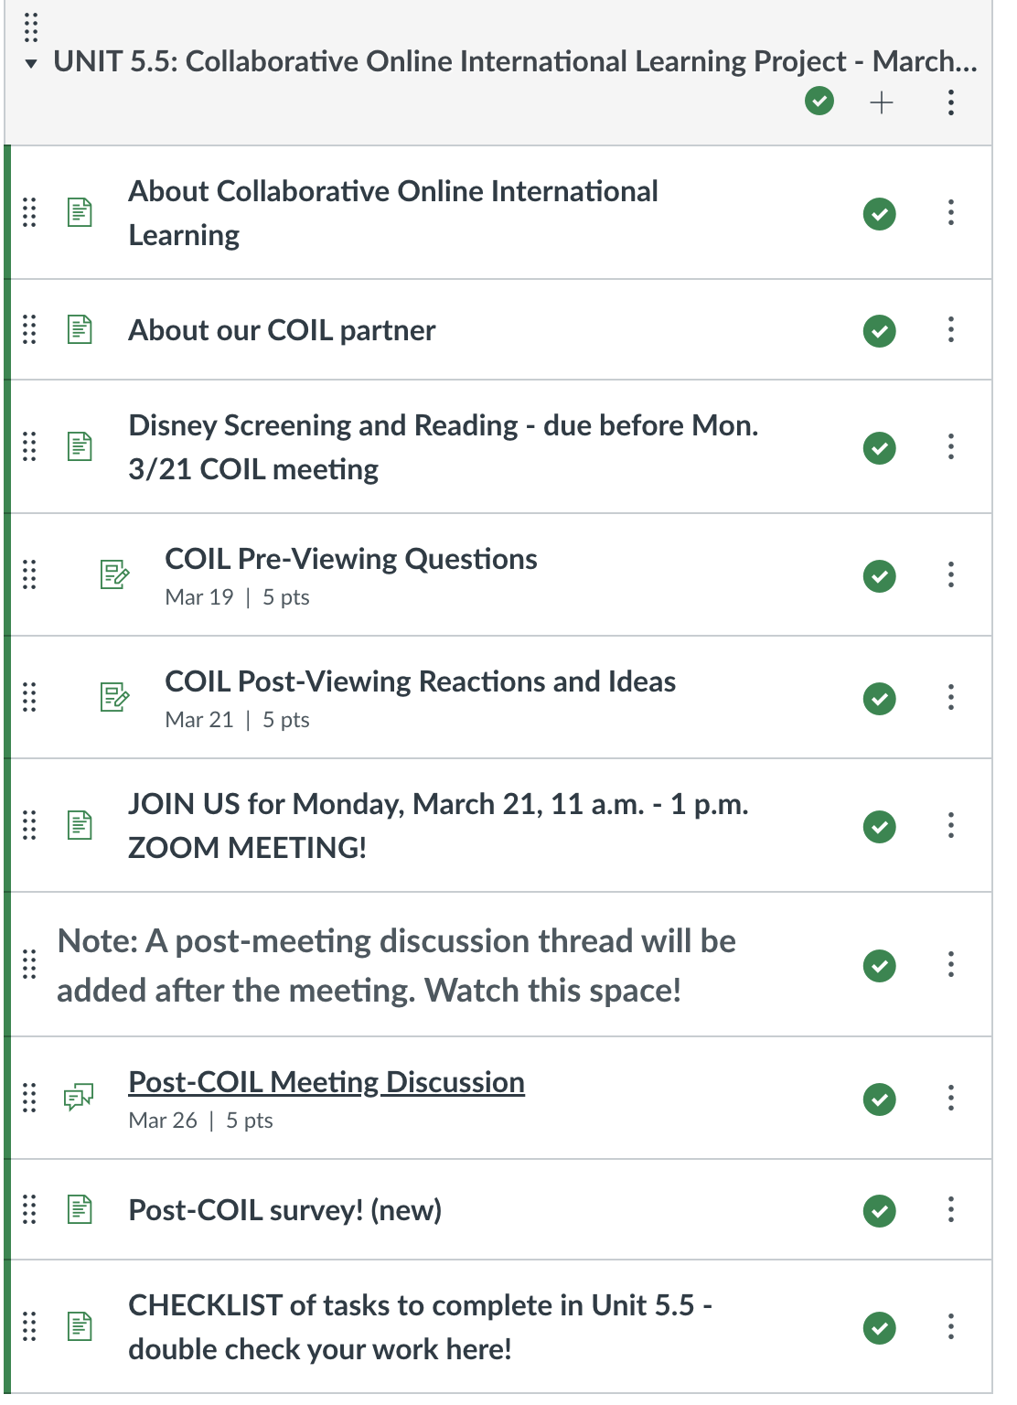

About Collaborative Online International Learning
In this class, we will participate in Collaborative Online International Learning. On Monday, March 21 at 11 a.m., we will have a Zoom meeting (details to come) with students at Jagiellonian University in Krakow, Poland. It is the only synchronous component of this class, and I hope you will find it valuable and enjoyable.
But first, you may be asking: What is Collaborative Online International Learning?
Often called COIL for short, Collaborative Online International Learning is a form of "virtual exchange." It provides students an opportunity to connect with and learn from international peers in an online context. Or, as SUNY puts it, (Links to an external site.) "COIL is about connecting across difference." It's a way for students and professors to engage "across cultures to work together on collaborative projects and discussions, making international and intercultural experiences within reach of every student at every institution."
SUNY's Intro to COIL - Intercultural Learning page (Links to an external site.)explains the initiative as follows:
Supporting the development of intercultural competence is an important aspect of COIL collaborations. For many students, a COIL collaboration is the first opportunity they have to engage with peers from another country. It is likely that students have engaged with people from other cultural backgrounds in their home communities, but most students have not been asked to reflect on cultural differences at home, therefore, COIL is frequently the first intentional intercultural communication activity they will undertake.
Eva Haug from the Amsterdam University of Applied Sciences in the Netherlands explains the concept of culture.
Cultural awareness and cultural competencies are essential in today’s world. Modern societies, groups and organizations are becoming increasingly multicultural, where people from different cultural backgrounds live and work together. Our understanding of culture depends on many factors, including our own worldview, academic background, and experiences. Technology makes it possible for people in different places in the world to meet and share online.
Globalization – characterized by increasing interconnections and integration between economies, nations, businesses and societies – has an impact on the context in which most people live and work. Globalization is accelerated through information and communication technologies such as special interest websites, social media, messaging apps, videos, and conferencing systems. These technologies have given rise to networks and communities involving individuals from a diverse range of cultural backgrounds who share common interests and purposes.
Helping students develop intercultural competence (skills that facilitate effective and appropriate interactions with people from other cultures) is important for 21st century higher education. COIL represents an effective approach to developing these skills through intentional online academic collaboration with peers around the world.
SUNY's "Perspectives on COIL" page (Links to an external site.) features some student testimonials that may be of interest, as well:
“It shrinks the globe for you. Now I might take the chance and study abroad because I know someone from overseas.”
“I would love to have at least one COIL class every semester. It really changed my whole academic experience and my personal life. I’ve been so eager to have that experience again… It really broadened my horizons.”
“I would definitely do this again given the opportunity because this is great for people like me who kind of just stick to their circle and don’t really branch out and talk to new people, I think that’s important but I don’t do it enough. I learned to not be so shy and just speak up.”
“I feel that doing this course collaboratively with our international partners really added a more hands on experience to our class. It is one thing to just talk about how to use online marketing in class, but this course required that we take what we learned and apply it.”

About our COIL partner
For our COIL experience, we are partnering with a seminar class at Jagiellonian University. Here is some information from the professor, Dr. Michał Choiński, for your reference:
- About Jagiellonian:
Jagiellonian is widely regarded as the best Polish university. Established in 1364, it is the 13th oldest university in the world, and counts among its famous graduates Nicolaus Copernicus. It is a seminar class.
- About the class we are partnering with:
The seminar class includes 3rd year students of the BA program in English and German Studies. The seminar members are currently working on their BA projects which are dedicated to American literature.
- About the professor whose class we are partnering with:
Michał Choiński is Associate Professor in the Institute of English Studies at the Jagiellonian University, Kraków Poland. Choiński is the author of two books: Rhetoric of Revival (Yale University) and Southern Hyperboles (Louisiana State University Press, 2020).
Choiński has been a visiting scholar at five universities in the US, including Yale University, University of South Carolina, Salem State University, College of Charleston. In 2022, he will be a senior Fulbright Fellow at Yale University.
Choiński also writes poetry – his latest volume is entitledGifts Without Wrapping and it came out with the Hedgehog Press in the UK in 2019. His poems were published in literary journals in the UK, USA and in Canada.
In his free time, Choiński is also a music manager and concert organizer, having worked with the metal and alternative music scene, including such bands as Slipknot, Wardruna or Blaze Bayley (former Iron Maiden vocalist).

Disney Screening and Reading - due before Mon. 3/21 COIL meeting
On Monday, March 21 from 11 a.m. - 1 p.m., we will have our synchronous COIL meeting with a class of students at Jagiellonian University in Krakow, Poland. I am excited to get together with you and students from Eastern Europe to exchange ideas, and I hope you're looking forward to it, too!
The topic of our discussion will be Disney and race representation. It's a great topic because Disney films are popular globally, and are viewed by children around the world. This makes them good fodder for conversation with our peers from Jagiellonian!
INSTRUCTIONS
To prepare for this meeting, please do the following:
1. Before viewing, please answer the following questions and submit them in the assignment drop box here:
- What are your impressions of Walt Disney films and characters and stories? Did you grow up with them? If so, was this in the U.S., or elsewhere? What are your memories of Disney as a kid?
- What sorts of values would you say Disney embodies? What kinds of messages does Disney send kids? Do you think these messages are interpreted differently or similarly by kids in the U.S. and internationally?
- Do you think the fact that Disney is a massive, profit-driven corporation has any effect on the kinds of stories it tells? Why or why not, and in what ways, if any?
- Is there anything you're curious to discuss or talk about with the Jagiellonian students in relation to Disney specifically or US media and race / racism more broadly?
2. Watch the 2002 documentary film Mickey Mouse Monopoly. It's available on YouTube at a low resolution here (Links to an external site.), and a full-resolution, high-quality version is available from the SSU library via Kanopy here: https://salemstate.kanopy.com/video/mickey-mouse-monopoly-0 (Links to an external site.) .
Note that it's a little dated: Many newer recent Disney films are likely to interest us, as well, but they're not included here. That said, the analysis of the films included in this documentary are undertaken from a critical point of view that is still relevant and timely, even today. I'm eager to see what you think!
3. Read this Download this (Links to an external site.) Rolling Stone article about the Disney film Song of the South.
The article, published in 2019, is a look back at a Disney film that has been so problematized for its portrayals of Black people that Disney no longer makes it available to viewers.
4. Jot down your reactions to the film and the reading, and think about what you would like to learn from your peers at Jagiellonian, and upload them here:
What are your main reactions to the film and reading?
What are the top thoughts or ideas that you would like to share during our meeting?
What questions would you like to pose during the COIL -- e.g., are you curious about how Disney films are received internationally? Any questions about specific films, or broader questions about U.S. media and representation in a global context?
Be prepared to discuss these points and ask thoughtful questions about the perspective of the peers who will be joining us from Poland during our COIL meeting.
5. Join us by Zoom on 3/21/2022 11 a.m. - 1 p.m.
Rebecca Hains is inviting you to a scheduled Zoom meeting.
Topic: COIL Zoom: Jagiellonian + Salem : Disney Media & Race
Time: Mar 21, 2022 11:00 AM - 1:00 P.M. Eastern Time (US and Canada)
Join Zoom Meeting

[Zoom link Redacted[

COIL Pre-Viewing Questions
In an attachment or in the space below, please answer the following questions:
- What are your impressions of Walt Disney films and characters and stories? Did you grow up with them? If so, was this in the U.S., or elsewhere? What are your memories of Disney as a kid?
- What sorts of values would you say Disney embodies? What kinds of messages does Disney send kids? Do you think these messages are interpreted differently or similarly by kids in the U.S. and internationally?
- Do you think the fact that Disney is a massive, profit-driven corporation has any effect on the kinds of stories it tells? Why or why not, and in what ways, if any?
- Is there anything you're curious to discuss or talk about with the Jagiellonian students in relation to Disney specifically or US media and race / racism more broadly?
Thank you for doing this pre-screening preparation work!

Points: 5
Submitting: a text entry box or a file upload

COIL Post-Viewing Reactions and Ideas
In an attachment or in the space below, please answer the following questions:
- What are your main reactions to the film and reading?
- What are the top thoughts or ideas that you would like to share during our meeting?
- What questions would you like to pose during the COIL -- e.g., are you curious about how Disney films are received internationally? Any questions about specific films, or broader questions about U.S. media and representation in a global context?
Be prepared to discuss these points and ask thoughtful questions about the perspective of the peers who will be joining us from Poland during our COIL meeting.
Thank you for doing this pre-COIL-meeting preparation work!
Points: 5
Submitting: a text entry box or a file upload

JOIN US for Monday, March 21, 11 a.m. - 1 p.m. ZOOM MEETING!
Rebecca Hains is inviting you to a scheduled Zoom meeting.
Topic: COIL Zoom: Jagiellonian + Salem : Disney Media & Race
Time: Mar 21, 2022 11:00 AM - 1:00 P.M. Eastern Time (US and Canada)
Join Zoom Meeting
[Link redacted]

Post-COIL Meeting Discussion
Mar 21 at 1:26pm
In today's COIL discussion, we had a robust discussion that went approximately as follows:
- We began by chatting about representation patterns in Disney media, comparing US and Polish perspectives.
- We then discussed other cultural comparison points, ranging from broader patterns in the media to lived experiences (such as politics, housing, and access to guns).
- Finally, with the immediacy of the war in Ukraine on everyone's minds, we talked about our perceptions of and experiences with the war. On the U.S. side, this was mainly regarding understandings we developed from mass and social media. But our Jagiellonian friends shared direct experiences including opening their homes to refugees, having friends and family conscripted into war, and even the lived experiences of a Jagiellonian student who is Ukranian on what her family is enduring right now.
In this discussion thread, I would like to hear more about your perspectives on the COIL. Please post your reactions below. Some post-COIL discussion questions to consider include, but are not limited to, the following:
- What interested you the most about the COIL discussion with the Jagiellonian students?
- Did anything surprise you? If so, what?
- What do you think is the most important/interesting/relevant thing you learned from the COIL?
- Was there anything unpleasant or troubling about the interaction from your perspective?
- What new or unanswered questions do you have as a result of the COIL discussion? Is there anything you'd like to learn more about, or would ask in a follow-up conversations?
P.S. I know that not everyone could attend the meeting, and that some of you could only partially attend due to other commitments such as work, and I do respect this was an issue.
If you were unable to attend and therefore cannot contribute to this discussion, please let me know -- but please do complete the PRE-COIL video screening and discussion for credit, as the video and reading are important course content on their own merits.
Thank you!

