EASING THE EMOTIONAL BURDEN OF FAMILIES WHEN A CHILD HAS CANCER: THE APPLICATION OF EVIDENCE TO NURSING PRACTICE

Honors Thesis

Presented in Partial Fulfillment of the Requirements

For the Degree of Bachelor of Science in Nursing
In the Maguire Meservey College of Health and Human Services
at Salem State University

By

Mary Aliberti

Dr. Nancy Ebersole
Faculty Advisor
School of Nursing

***

Commonwealth Honors Program
Salem State University
2021

Abstract
The nurse’s role in caring for a child with cancer has its challenges, but when done correctly can positively affect the well-being of a patient and their family. Both the patient and family go through major psychosocial shifts from the time that the child receives the diagnosis of cancer. This time of considerable transition can leave families feeling lost during an already uncertain period. Keeping patients and family members involved throughout the course of treatment is essential for the success of effective care. The database CINAHL Plus was used to do a systematic review of the literature to identify common issues in pediatric oncology nursing practice and the toll that this can take on patients and their family’s mental well-being. Common themes identified in the literature are family members are in different developmental stages and each requires a unique approach; caregiver knowledge or lack thereof is a major factor in family well-being; and a child’s ability to communicate and be heard impacts how the need for care is perceived and provided. This is an important topic because nurses must consider the psychosocial needs of the family unit as well the physical needs when it comes to providing optimal care. Dealing with a diagnosis as harmful as cancer is a considerable amount of stress to be put on a young child and the family. Knowledge of what is currently known will lead to more effective communication with patients and family members, resulting in greater health outcomes.

Table of Contents
Abstract…………………………………………………………………………………..i
Acknowledgements………………………………………………………………………iii
Introduction………………………………………………………………………………1
Background………………………………………………………………………………2
Methods………………………………………………………………………………….3
Results……………………………………………………………………………………4
Discussion………………………………………………………………………………11
Conclusion………………………………………………………………………………12
References………………………………………………………………………………14

Acknowledgements
First, I would like to thank my thesis advisor Dr. Nancy Ebersole for helping throughout this journey. I am very appreciative of her advice throughout writing and patience throughout the editing process.
I would also like to thank Professor Scott Nowka for his support throughout the entirety of the Honors Program leading up to this point.
I would like to thank the members of the Student Nurses Association. Together, we were able to advocate and fight for pediatric oncology patients. Involvement in this helped to peak my interest in this subject even further and I could not have done it without the experience and support from these members.
Finally, I would like to thank my family and friends for all of the support they have given me throughout the process. I am extremely grateful to have such amazing people to lean on.

Easing the Emotional Burden of Families When a Child Has Cancer: The Application of Evidence to Nursing Practice
When a child is diagnosed with cancer, it creates an emotional burden for the family from the time of diagnosis, through the journey to remission. A pediatric cancer diagnosis is unfamiliar territory for many families. Family is left feeling lost due to the inability to fully relieve their child’s suffering. Family dynamics play a considerable role in the way that patients and family members deal with the stressors that come with being diagnosed with cancer at a young age. Through different developmental stages of life, children exhibit characteristics that define their coping mechanisms throughout the course of their treatment. Some children may be too young to understand what they are going through whereas adolescent age children may carry a heightened sense of anxiety that comes with a greater understanding of their disease and prognosis. There is a blurred line between the burden on family members and the burden on patients.
Although the patient is the one experiencing physical pain, the emotional pain seen with family members is evident. Even though they are experiencing different symptoms, the overall psychosocial emotions felt by both sides throughout this journey are difficult to navigate. Parents are forced to transition from being a parent to being their child’s medical caregiver at times. Without any prior experience, they transition their lives and take on this new role. Their only focus becomes comforting their child and advocating for them to get the best possible medical care. Siblings of the patient feel helpless, like they can't do anything to make their brother or sister feel better. They can feel that their role in the journey of recovery is insignificant, but they often feel that they need to act strong for the parents and siblings going through this journey. The developmental stage that they are at in their life creates a unique need for each individual family member. Family members need to feel supported by nurses and other members of their loved one’s health care team. There needs to be a greater awareness of how a patient who receives a cancer diagnosis is coping, to ensure adequate support for them throughout their journey.
Background
The incidence of pediatric cancer is rising. Globally, there are about 400,000 new cases of pediatric cancer diagnosed each year. (World Health Organization, 2021). In the United States, cancer is the largest cause of death by disease in children who are between the ages 1 and 14. About 1 in 285 children will be diagnosed with cancer in the United States each year. 1 out of 8 children who are diagnosed with cancer will not survive. 60 percent of those children who do survive will suffer long term side effects (American Childhood Cancer Organization, 2021).
Children with cancer and their families require psychosocial support. The interdisciplinary care team, including the nurse, is in a position where they can assist in assessing the needs and implement interventions to help cope. A cancer diagnosis has a notable impact on a child and their family’s life which is why it is crucial that nurses are able to understand their psychosocial demands. With this understanding, an individualized treatment plan can be implemented in order to provide optimal support geared towards personalized needs of the patient and familial structure.
Nursing staff requires more formal training on psychosocial care in pediatric cancer. Without established training and interventions, nursing staff cannot always feel confident in the care being delivered. Nurses can be reliable in their care of pediatric oncology patients and are in a position to be a solid source of support to family members. However, on the job learning of effective psychosocial strategies makes it difficult to provide the best care. Because nursing plays such a large role in the psychosocial wellbeing of patients and family members, formal training should be established to give exceptional care.
Methods
A systematic review of the literature was conducted using the Cumulative Index of Nursing and Allied Health Literature (CINHAL) Plus Full Text databases in order to obtain relevant articles to review. Several searches were done to find the issues concerning familial burdens in the cases of pediatric oncology patients. A systematic search was done using Boolean terms with the keywords: pediatric oncology and family, pediatric oncology and parents, pediatric oncology and psychosocial, pediatric oncology and coping, pediatric oncology and patient education, childhood cancer and emotional impact, pediatric cancer and nursing care. The years of publication used were 2010 to 2020. Other inclusion criteria were peer reviewed articles written by medical professionals and registered nurses and being written in English. Including peer reviewed journals helped to ensure that all information is factual and has data to support it. 6 articles that met all of the criteria and are used in this systematic review. See Figure 1 below.

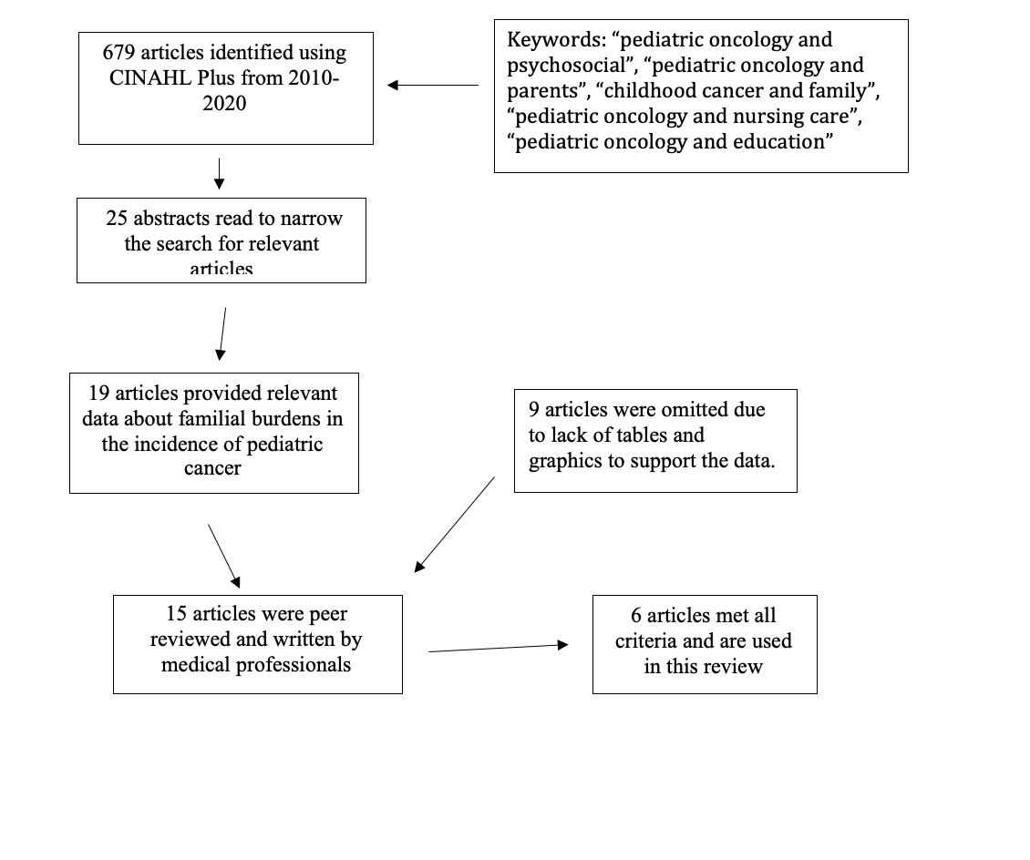
Figure 1: Journal Articles Identification
Results
6 articles met the criteria of identifying the psychosocial needs of families when a child is diagnosed with cancer and how the burden can be eased through nursing care. Within the articles, there were 3 major themes identified; caregiver knowledge and lack thereof is a major factor in family and child well-being; family members come from different stages of growth and development and require unique approaches; and a child’s ability to communicate impacts how the need for care is perceived and how it is given.
Caregiver Knowledge and Lack Thereof Is a Major Factor in Family and Child Well-Being.
Caregivers struggle with knowledge deficits on the topic of pediatric cancer and what this diagnosis entails. This lack of knowledge can have lasting effects on family and child psychosocial wellness. There is a need for an in-depth assessment of family functioning and well- being at the beginning of the child’s cancer diagnosis in order to provide adequate psychosocial support to the entire family throughout the course of treatment. In order for this to be possible, there is a need for formal interventions and care plans for nursing and other members of a child’s medical team, on how to assist children and families in coping with a cancer diagnosis (Kuntz, 2019; Marcus, 2012; Kiernan, 2010).
A cancer diagnosis can often leave parents feeling immense fear. The greatest sense of fear comes from not knowing what is to come in the future. There is no way to guarantee survival for any children diagnosed with cancer, and for a caregiver, this fact can be devastating. (Kiernan, 2010) Caregivers can feel lost, as if they have no idea how to go on from here. Family dynamics can go through major changes during this time concerning living situations and financial stability. This is when they look to their child’s medical team for support.
All members of a pediatric cancer patient’s interdisciplinary team must be involved in the patient’s care in order to ensure the greatest chance at holistic wellness for the patient and their family members. When nurses take a comprehensive approach to caring for their patient, all aspects of care are accounted for. This means, both physical and psychosocial care are considered essential to overall wellness, throughout the patient’s treatment plan (Marcus, 2012). When nurses acknowledge this responsibility, the burden on caregivers decreases substantially. With formal interventions and treatment plans put into place by medical staff that evaluates psychosocial needs of patients, nurses can evaluate the proper way to support family members during this time, based on patient needs.
In many inpatient pediatric oncology settings, there is a need for formal training for nurses who choose to work in this particular field. Nurses learn on the job how to handle psychosocial situations for their patients and patient’s family members. In an interview of 10 pediatric oncology nurses, it was found that there is an expectation of psychosocial support for family members, with no set guidelines on how to successfully give this support. The need for this support on the family’s behalf is evident, which is why the nurses are eager to learn their own ways to support family members throughout this difficult time. Having a professional go in and ease some of the emotional burden that caregivers are feeling can have a positive impact on the psychosocial well-being of an ill child and their family (Kuntz, 2019). It is acknowledged that each member of the care team brings a unique perspective regarding patient care. With a well-rounded approach that caters to each facet of a child’s care (emotional, physical, spiritual, social, etc), it gives caregivers a sense of relief knowing that their child is being well cared for, and their own feelings and emotional wellbeing is also being acknowledged.

Family Members Come from Different Stages of Growth and Development and Require Unique Approaches.
Family members come from various stages of life and have individualized ways that they cope with the stress of a cancer diagnosis of a child, sibling or grandchild (Kiernan, 2010; Kuntz, 2019; Marcus, 2012; Svavarsdottir, 2013)
Within the various roles of the family structure, coping with a loved one’s cancer diagnosis can differ. Although parents are forced to portray a strong aura in a situation where their child is diagnosed with cancer, they often feel an increase in anxiety and a decrease in the ability to cope in a healthy manner. Parents of children who relapse in their cancer can often suffer mentally for years. Signs similar to Post Traumatic Stress Disorder become evident, requiring professional attention (Kiernan, 2010; Marcus, 2012). The role of the mother has shown notable amounts of depression related to the stress of maintaining the family structure while dealing with this devastating diagnosis and treatment journey. Parents can often struggle with role confusion because they are trying to balance their own emotions while trying to help their child through treatments (Svavarsdottir, 2013).
Siblings of the pediatric cancer patient have reported more destruction in family function than other members of the family. This is a difficult position that they are in, where they do not want to take any of the attention away from their sibling, but they are also struggling and require attention themselves. Parents are often consumed with the sick child, remaining at their bedside and catering to all of their needs in the best way they can. This leaves siblings feeling left out. Siblings may have to stay with grandparents of other relatives while the parents are consumed by staying at the hospital with their sick child (Kiernan, 2010; Kuntz, 2019; Marcus, 2012)
Grandparents, aunts and uncles also play roles in having a family member that is diagnosed with cancer. Due to the attention that the sick child requires from the parents, grandparents and other extended family members can step in and be a huge help during this time. They can take on the task of child care of the siblings of the sick child. The siblings are able to lean on these family members for parental guidance and emotional support during these times (Kiernan, 2010)

A Child’s Ability to Communicate Impacts How the Need for Care Is perceived and How It Is Given.
Based on the child’s age, their understanding of their illness will vary. This causes a need for treatment plans geared towards fully assessing a patient's needs and intervening based on those individualized needs. (Erdem, 2017; Kiernan, 2010; Kuntz, 2019; Marcus 2012)
The psychosocial impact that the disease has on a pediatric cancer patient will depend on the intellectual ability and developmental stage of the child. It is crucial that nursing staff recognize and prioritize psychological care just as much as they do physical care (Erdem, 2017). Neglecting mental health throughout this process is where the major emotional burden for patients and families comes in. Throughout all stages of life, it is important for a child that is diagnosed with pediatric cancer to remain engaged with peers and in school life to the best of their ability. This helps patients maintain a sense of normalcy amidst all of the chaos they are facing with their diagnosis (Kuntz, 2019).
Younger children, such as toddlers and preschoolers, will understand that they are sick because it is possible that they may have felt this way in the past from a minor illness such as a cold or seasonal allergies. However, they will not understand why they are sick. They will not know that the cancer in their body and the treatments that they are receiving is what is causing them to be sick. They are not aware of why they are getting all of this medical attention such as intravenous lines, medications, blood draws, etc. Because the care is not being accurately perceived by the toddler or preschooler, the medical team must change the way that care is given to this age group (Marcus, 2012).
School aged children will understand that they are sick. They will know that the medication that they are being given is to make them better. They will ask a lot of questions about their care (Marcus, 2012).
Teenagers are able to understand that they are sick with cancer. They often get their information from the internet and have many questions for members of their care team. Although they can understand that they are sick, they may not be able to fully grasp what this diagnosis means for them and their future. This age group identifies having activity challenges due to being hospitalized during their treatments. (Kuntz, 2019) Oftentimes, feelings of independence are lost. Activities that were once part of a daily routine are put on hold after their diagnosis. Sports and after-school activities become less attainable due to the deficits a child faces throughout treatment. Adolescents struggle with both mental and psychical strength. Being out of school can cause adolescents to feel isolated from their peers and teachers. However, returning to school leaves many patients feeling major fatigue and with an inability to concentrate.
Among the pediatric cancer population, common helpful tactics have been found to assist with coping. Storytelling is a popular intervention used with these patients. A study involving 8 females and 22 males diagnosed with cancer between the ages of 10 and 21 was conducted and investigated the effectiveness of storytelling as a helpful coping mechanism (Kuntz, 2019). Many patients used pictures and memorabilia that they received during their hospital stay (i.e. hospital bracelet) as a mechanism of journaling. This is a way to express emotions and keep track of their journey throughout the course of treatment rather than internalizing all of the emotions that they are feeling. Out of the 30 children involved in the study, 26 found this method useful and 4 did not wish to relive the experiences that they were having (Kuntz, 2019).
Along with storytelling, valuing altruism was a common theme amidst this group of 30 cancer patients. Many looked to use their story to benefit the future of pediatric cancer patients to come. This helped them bring meaning to the diagnosis and the treatment journey. They felt ambitious at the opportunity to help others who may be in similar situations to them in the future. Bringing meaning into the journey creates a more positive outlook on the diagnosis and can ultimately improve psychosocial stability as a whole (Kuntz, 2019).

Discussion
Based on the results found, there is a need for more formal training in the field of pediatric oncology nursing. Due to factors such as developmental age and familial inexperience in situations like this, nurses should be instructed to cater to all aspects of patient and family care. This care comes in the form of concrete interventions that are put in place by hospitals in order to ensure patient and family wellbeing. This care also comes in the form of support from medical staff on how to properly cope and care for a child who has pediatric cancer. Solidifying interventions can help diminish role confusion and help enhance the overall journey of a cancer patient and their family from diagnosis and throughout treatment. All members of the family including siblings, parents and grandparents have psychosocial needs that must be acknowledged. With nurses involving family members in caring for the sick child, family members can gain confidence in their ability to properly parent during this time. A formal training consists of in-depth assessments of both family and patient’s psychosocial wellbeing in order to establish interventions that will be most beneficial to that individual familial unit. Families should have access to a broad range of professionals that can help them in ways beyond the nurse's scope of practice. This includes, psychiatry, case management, etc. This can benefit both patient care as well as family functioning and coping.
By assisting caregivers in gaining confidence, nursing is easing the emotional burden of family members when a child is diagnosed with pediatric cancer.

Conclusion
Understanding the impact that a cancer diagnosis has on the family and the role that the family can play in helping the child adapt to treatments requires interactive interventions from the child’s medical care team. With this, the family can feel well informed; resulting in more effective, evidence-based family care. Nurses are in the position to help children of all ages adapt to the changes that they are experiencing through their treatment journey. Acknowledging the need for these interventions can help family units work through this trauma earlier on. There is a need for more formal training in the medical field on psychosocial issues in pediatric cancer. Formal psychosocial interventions are beneficial to medical staff, patients and family members. Implementation of these interventions is necessary in order to create change in the way that nursing staff is able to ease the burden that families feel when caring for a child with pediatric cancer.
Figure 2 below demonstrates caregiver interventions that are appropriate for a specific age. When nurses make caregivers more aware of these interventions, caregivers can feel more confident that they are helping their child cope throughout this illness. Knowing that they are effectively helping their child cope, aids in their own personal coping mechanism as well (National Cancer Institute, 2015)

Age | Caregiver Interventions
<1 year old | •Bring familiar items from home (blankets and toys) to make child feel more secure in the hospital  •Talk or sing to the child to soothe them  •Maintain normal bedtime routine
1-3 years old | •Prepare child ahead of time if something will be uncomfortable/ will hurt  •Let child make choices such as medicine flavor and band aid color
3-5 years old | •Ask medical team if child can touch machines and supplies (bandages, tubes, etc.) to help the child understand their treatment better  •Read stories or play with stuffed animals during treatment as a method of distraction
6-12 years old | •School aged children can understand that the medicine they are receiving is helping them get better  •Be ready to answer questions or redirect questions to medical team  •Help child stay in touch with friends and family because relationships are of high importance to them
12-18 years old | •Help teens stay connected to peers through texting, pictures, online activities and visits  •Give teen space and freedom and encourage independence  •Take time to observe and listen to the teen because they may be trying to protect others by masking their own psychosocial health

Figure 2: Caregiver Interventions

References
Erdem, E., & Toruner, E. (2017). How Can We Use Symptom Clusters in Nursing Care
of Children with Leukemia? Asia-Pacific Journal of Oncology Nursing, 0(0), 0. doi: 10.4103/apjon.apjon_57_17
Kiernan, G., Meyler, E., & Guerin, S. (2010). Psychosocial issues and care in pediatric oncology.
Cancer Nursing, 33(5). doi:10.1097/ncc.0b013e3181d5c476
Kuntz, N., Anazodo, A., Bowden, V., Sender, L., & Morgan, H. (2019). Pediatric Cancer
Patients Treatment Journey: Child, Adolescent, and Young Adult Cancer Narratives.
Journal of Pediatric Nursing, 48, 42–48. doi: 10.1016/j.pedn.2019.06.003
Marcus, J. (2012). Psychosocial issues in pediatric oncology. Retrieved from
https://www.ncbi.nlm.nih.gov/pmc/articles/PMC3448242/
National Cancer Institute. (2015, September). Children with Cancer, A Guide for Parents.
Retrieved from https://www.cancer.gov/publications/patient-education/children-with-
cancer.pdf
Svavarsdottir, E. K., & Sigurdardottir, A. O. (2013, August 29). Benefits of a Brief Therapeutic
Conversation Intervention for Families of Children and Adolescents in Active Cancer Treatment. Retrieved from https://onf.ons.org/onf/40/5/benefits-brief-therapeutic-conversation-intervention-families-children-and-adolescents

US childhood cancer statistics. (2021, March 03). Retrieved May 10, 2021, from
https://www.acco.org/us-childhood-cancer-statistics/
W. (2021, February 12). Childhood Cancer World Health Organization. Retrieved May 09, 2021,
from https://www.who.int/news-room/fact-sheets/detail/cancer-in-children

