Faculty Name: Chaerin Yun
Course: International Business
My COIL experience is designed for students to understand various aspects of culture in their own country by comparing it to another country context. During the two weeks, students were assigned to a team of four or five members and for the two weeks, teams will identify and discuss a major cultural difference between the United States and South Korea.
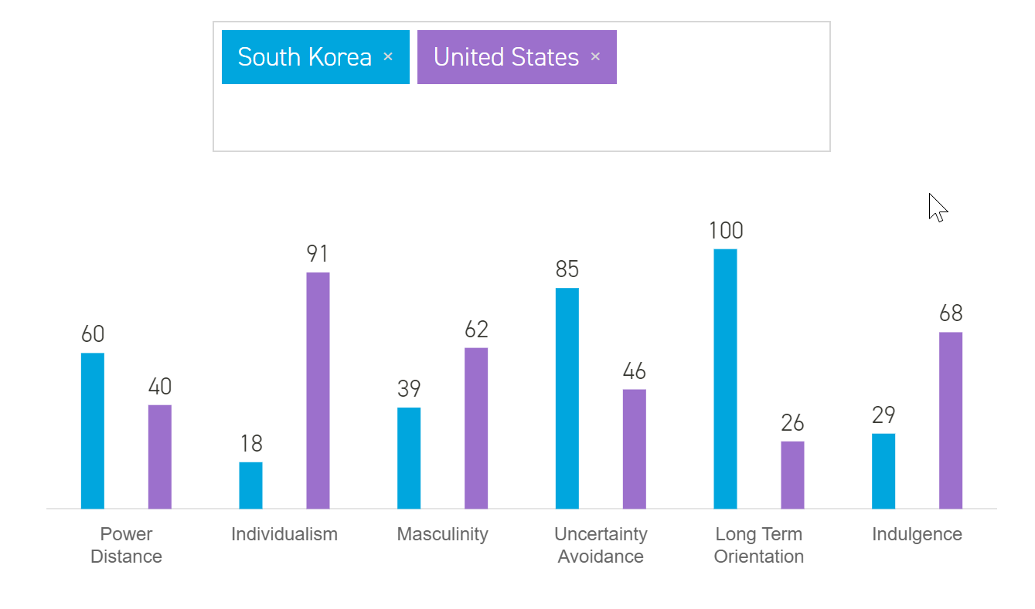
In first week, students will learn the meaning of each dimension and understand what the high scores or low scores means. For example, power distance measures the tolerance of social inequality, the extent to which the less powerful members of institutions and organizations within a country expect and accept that power is distributed unequally. Students first share how they personally understand the power distance and discuss why in general, people in Asia recognize high power distance than people in Western countries. I will also post a few video clips on Canvas to help students understand and compare the difference between the two countries.
Second week, students will discuss major business implication of the cultural difference. More specifically, after choosing a company, students are encouraged to suggest a tentative marketing plan to be successful in the foreign market. For example, students’ group in my international business course will analyze Amazon’s global expansion in South Korean market. They will discuss how Amazon’s marketing mix (product, price, place, promotion) strategy should be adjusted to tailor South Korean customers’ different needs and tastes.

Because of the time zone difference, it wasn’t easy to make students from different countries to communicate with each other. If I join in COIL Program in the future, I probably choose partners from the Universities/Colleges in North America.

