INVESTIGATING FDA-APPROVED ANTI-TUMOR DRUGS FOR EFFECTS ON TEMPLATE-SWITCH MUTAGENESIS (TSM) IN E. coli

Honors Thesis

Presented in Partial Fulfillment of the Requirements
For the Degree of Bachelor of Science in Biology

In the College of Arts and Sciences
at Salem State University

By
Sydney Addorisio

Dr. Laura Laranjo
Faculty Advisor
Department of Biology

***
Commonwealth Honors Program
Salem State University
2021
ABSTRACT
Quasipalindromes (QPs) are imperfect inverted repeats of DNA that are known to form secondary structures (such as hairpins and cruciforms). QPs sites have also been associated with a specific class of mutation known as template-switch mutations (TSM). It is known that TSM can be caused by the addition of drugs such as 5-azaC, AZT, and ciprofloxacin. This study aims to analyze the effects of two FDA approved antitumor drugs, CPT-11 and Doxorubicin hydrochloride for their ability to promote or prevent template-switch mutagenesis and, if there is an increase in mutation rates, we aim to clarify by what mechanism that effect is induced. To do this, we use a previously published TSM reporter in the lacZ gene that provides both a qualitative and quantitative measure of TSM frequencies. Using this established system, we study mutation frequencies and rates in both the leading and lagging strand of DNA to provide possible pathways that lead to TSM. Our data proposes mechanisms of mutations that are correlated to each drug mode of action.

ACKNOWLEDGMENTS
I would like to thank Dr. Laura Laranjo for allowing me to be a member of her lab and, even more so, being my advisor for this Honors Thesis. I will not be able to thank you enough for all of the support you have given me over the last two years I have been a member of your lab. I would also like to thank my friend and colleague within the lab, Rebecca Shteynberg, for helping me collect the data for the controls and Doxorubicin Hydrochloride. I thank the professors of Meier Hall 433 and 440 for allowing me to share the lab with them. I would like to thank my mother, father, and siblings for being my biggest supporters. I would like to thank my grandfather, without whom I would not have been able to get to lab over the summer, my grandmother who is my inspiration for choosing to investigate anti-tumor drugs, and my boyfriend Logan for listening to me talk about this work, despite having no background in biology.

TABLE OF CONTENTS
Introduction………………………………………………………………………………………. 1
Hypotheses and Specific Aims…………………………………………………………………... 7
Experimental Approach………………………………………………………………………….. 8
Results…………………………………………………………………………………………... 11
Discussion………………………………………………………………………………………. 16
Future Research……………………………………………………………………………….... 17
References…………………………………………………………………………………….... 22

LIST OF TABLES AND FIGURES
Figure 1. Quasi-palindrome Template-Switch Mutation Mechanisms……………………..........2
Figure 2. CPT-11 Mechanism of Action…………………………………………………….…...4
Figure 3. Template Switch Mutation Frequency on leading strand and lagging strand after exposure of Doxorubicin Hydrochloride…………………………………………….…………..12
Figure 4. Template Switch Mutation Frequency on leading strand and lagging strand after exposure of CPT-11……………………………………………………………………..............14
Figure 5. Temozolomide (TMZ) Mechanism of Action………………………………………...19

INTRODUCTION
DNA mutations can cause genetic instability. There are multiple classes of mutations, some more known than others. The class of mutation that I focus on in my project involves quasipalindromes (QPs). QPs are imperfect inverted repeats of DNA known to form secondary structures (such as hairpins and cruciforms). These structures have been associated with template-switch mutations (TSM) and these mutations are linked to multiple human diseases^{34, 35} including hereditary angioneurotic edema and osteogenesis imperfecta². Previous research has shown that different chemicals can also influence the rate of TSM¹⁰. It is important that this field be advanced because previously established mutagens of template-switch mutations have been noted as being used in humans as medication. As examples, DPC inducing compounds are noted as being a part of chemotherapy for cancer patients¹⁰. Additionally, AZT is a drug used for patients suffering HIV/AIDS and there is an acknowledgment that cancer chemotherapeutics, other antiviral chain terminators, and other therapies likely induce TSM⁵.
Recent works have begun to analyze template-switch mutagenesis at quasipalindromic (QP) sites including what can stimulate them and the mechanisms behind those mutagens, but more work is needed. Lynn Ripley was the first to propose the two mechanisms for QPMs known as the secondary-structure model and the strand-switching model and notes that, in some cases, the two mechanisms may produce different mutations¹. Template-switching is when a secondary structure forms due to a QP and the nascent strand uses itself as a template for a while before returning to the original template, making the palindrome more perfect^{2–7}. There are acknowledged intramolecular and intermolecular mechanisms of TSM^{2–4, 6}. The long inverted repeats cause a stall in replication in cells of different areas of life including bacteria and mammals due to the secondary structures, namely hairpins, that are formed and the severity of the stall is impacted by sequence homology⁸ (Figure 1).
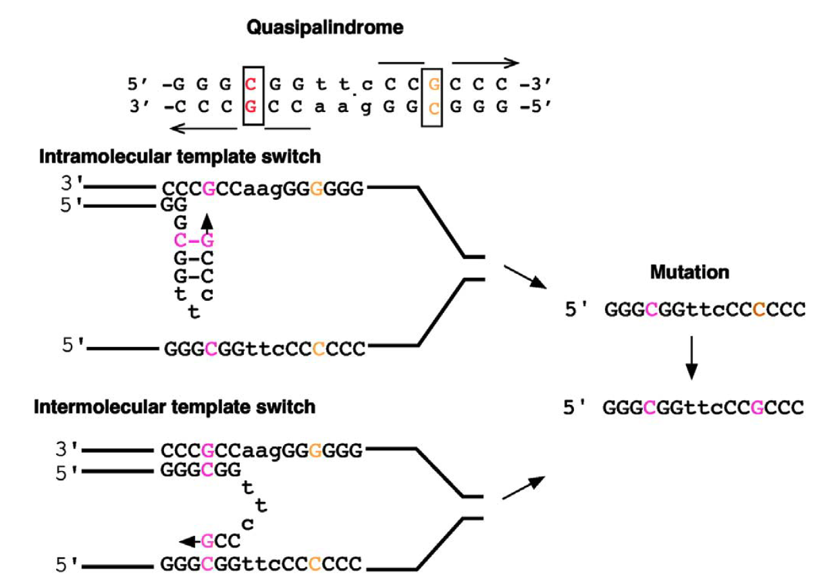
Figure 1. Quasi-palindrome Template-Switch Mutation Mechanisms⁶.
The thyA hotspot in E. coli has been confirmed as seeing TSM³ and being the first natural hotspot for QP associated mutagenesis⁹. Nucleotide 131 of thyA in E. coli is a hotspot for a TA to AT transversion and that region of the sequence contains a QP site detected for hairpin based mutagenesis, including a more complex QP hairpin associated mutation in a region preceding nucleotide 131 in a strain without exonuclease I or VII, during replication and deficiencies in either Exonucleases I, VII, and/or methyl-directed mismatch repair increased the presence of mutation at this location⁹.
There is a strand bias that is noticeable regarding template-switch mutations. It has been seen that TSM is seen on both strands during DNA replication, but the leading strand is more likely to see template-switch mutations than the lagging strand^{3–7,10}. Although both ExoI and ExoVII both work to prevent TSM^{3,9}, ExoI is primarily responsible for the strand bias as it is thought to target TSM on the lagging strand more due to the increased presence of ssDNA during replication as compared to the leading strand^{4,6}. DnaQ also may look out for 3’ ssDNA or limit DNA Polymerase dissociation during replication to prevent TSM⁶.
There are certain compounds that have been discovered as being mutagens and their mechanisms postulated and, thus, can cause template-switch mutations. To begin, 5-azaC is known to induce template-switch mutations in E. coli so long as it is accompanied by DNA cytosine methylase, i.e., Dcm dependent¹⁰. Recent studies, however, indicate that there are some functions of 5-azaC independent of DNA Dcm cytosine methyltransferase that can be mutagenic¹¹. Other compounds, like 5-azaC, that create DNA protein crosslinks (DPCs), namely ciprofloxacin and formaldehyde, have been found to lead to template-switch mutations as DPCs block replication¹⁰. Additionally, AZT and ten fluoroquinolone antibiotics, which are topoisomerase II poisons, were found to induce template-switch mutagenesis in E. coli in their DPC induction while no compounds studied prevented it⁷. Topoisomerase II inhibitor Novo was studied and did not induce QPM and does not result in DPCs indicating that the fluoroquinolones induce QPM via their formation of DPCs⁷. AZT, D4T, and ddI induce template-switch mutagenesis with different levels of potency via their DNA chain terminator functionality and replication stalling⁵. Zebularine and hydroxyurea (HU) both increased QP-associated mutations in the E. coli lacZ gene⁴. QPMs also have an impact outside of being induced by external mutagens. QPMs and template-switch mutagenesis are involved in the formation of complex frameshift mutations in the human p53 tumor suppressor gene¹².
The two drugs I studied are CPT-11 and Doxorubicin hydrochloride. CPT-11, also known as Irinotecan, is a chemotherapeutic drug that works via SN38, the active form of its metabolite, to kill cells that are dividing a lot and inhibits Topoisomerase I by trapping onto the DNA and induce protein-linked DNA breaks that are cytotoxic^{13,14–17}(Figure 2).
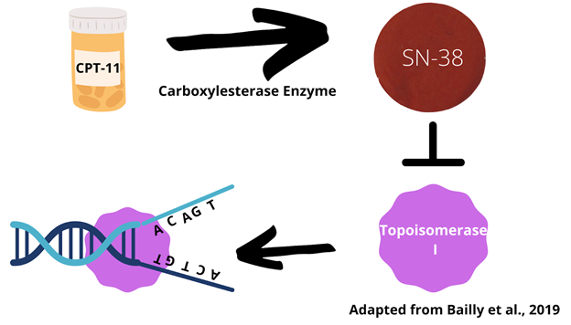
Figure 2: CPT-11 Mechanism of Action.
However, CPT-11 is a derivative of camptothecins that target Topoisomerase 1B in humans^{11,18} and requires carboxylesterase enzymes¹⁶, human carboxylesterase 2 specifically, often found in the liver among other locations, in order for it to be converted into SN-38 at the greatest efficiency^{17,19,20}. Human carboxylesterase 2 has a higher rate of conversion, affinity for CPT-11, catalytic efficiency, and induced cytotoxicity of CPT-11 when with human carboxylesterase 2 than with human carboxylesterase 1¹⁹. Its conversion is important because SN-38 is more potent than CPT-11, 1000-fold¹⁶, and in Xu et al., 2002’s²⁰ study where the enzyme is not purified, there is a connection between the concentration of human carboxylesterase 2 in human liver microsomes, where human carboxylesterases function greater than compared to cytosolic, and CPT-11 conversion to SN-38²⁰. A bacterial homologue, pnb carboxylesterase from Bacillus subtilis, to the efficient rabbit liver carboxylesterase in terms of structure as well as comparable CPT-11 conversion to SN-38 was found and is promoted as a model system for studying mammalian CEs as it can be expressed in E. coli albeit with a 6-fold less catalytic efficiency in in pnb carboxylesterase as compared with that of the rabbit liver¹⁵.
The DNA Topoisomerase I activity and inhibition of said activity has been measured in Escherichia coli, specifically via pBR322, through the relaxation of its supercoiled DNA to determine that cisplatin was able to contribute positively to the Topoisomerase I inhibition of SN-38 and another topoisomerase I inhibitor that also functions as an anticancer drug¹⁴. The methodology of measuring DNA Topoisomerase I activity utilized by Fukuda et al., 1996¹⁴ was originally used by Liu and Miller, 1981²¹.
Doxorubicin hydrochloride is the hydrochloride salt of doxorubicin ²². Doxorubicin (Doxo), also known as adriamycin, can inhibit bacterial topoisomerase IIA¹¹ and is more than just a Topoisomerase II inhibitor as it can produce ROS, intercalate DNA²², and induce autophagy, apoptosis, senescence and necrosis, however its clinical cytotoxic action is primarily from the Topoisomerase II inhibition^{18,23}. Doxorubicin’s concentration is suggested to be the determinant of which mechanism causes the cell death in a given instance^{23,24}. As a Topoisomerase II inhibitor, doxorubicin causes cell death via its stabilization of the intermediates from the complex between Topoisomerase II and DNA in cleavage that halt replication^{11,23}.
Topoisomerases function to avoid replication stalling and the creation of odd DNA structures resulting from supercoiling¹⁸. Type I Topoisomerases cleave one DNA strand whereas Type II Topoisomerases cleave both^{21,25,26} and E. coli have two of Type IA, which are Topoisomerases I and III and two of Type IIA known as gyrase and Topoisomerase IV^{18,27}. E. coli’s Topoisomerase I functions to relax negative supercoils²⁶ while eukaryotic Type 1B relaxes both kinds of supercoiling, positive and negative²⁸ and gyrase can remove both kinds of supercoiling^{18,26}.
There are topoisomerase I’s in bacteria and viruses that are similar in functionality and structure to the eukaryotic type I topoisomerases, namely the vaccinia virus DNA topoisomerase IB^{25,28} which the Pseudomonas aeruginosa topoisomerase I shares sequence homology with²⁵. The P. aeruginosa topoisomerase I, abbreviated as PAT, relaxes DNA slower than the vaccinia virus topoisomerase I and requires Mg²⁺ to relax DNA but it can relax both positive and negative supercoils with a decreased preference for the pentad CCCTT that the vaccinia virus topoisomerase I prefers²⁵. Replacement of the active site tyrosine 292 for phenylalanine also led to loss of catalytic activity in PAT²⁵.
The vaccinia virus topoisomerase I appeared in great amounts from the H7r ORF via T7 RNA polymerase after 3-5 hours and the methods of Shuman et al., 1988²⁸ created 8 mg of topoisomerase per 400 ml of bacteria²⁸. The vaccinia topoisomerase I can relax both kinds of supercoils without divalent cations or ATP although NaCl was required at optimal values between 100 and 250 mM and a temperature of 30-55 degrees Celsius²⁸. The vaccinia virus topoisomerase was not sensitive to camptothecin²⁸. Mutation of the Asp-221 to valine within a conserved sequence between eukaryotic type I topoisomerases and the vaccinia virus topoisomerase I led to camptothecin inhibition of DNA relaxation and enhancement of the cleavage complex between DNA and topoisomerase²⁹.
It is thought that the bacterial, eukaryotic nuclear, and poxviral type IB topoisomerases are from the same lineage as bacterial IB enzymes share the catalytic tyrosine as well as its location and four parts of the catalytic pentad with the vaccinia virus topoisomerase²⁷. D. radiodurans also encodes a type IB topoisomerase that relaxes both supercoils without ATP or divalent cations but requiring the tyrosine and three components of the pentad indicating a similar mechanism to the vaccinia virus topoisomerase I²⁷. Like the vaccinia virus topoisomerase²⁸, the D. radiodurans topoisomerase I was not affected by camptothecin²⁷. It is postulated that the absence of topoisomerase III in the presence of topoisomerase IB may mean that they are incompatible or redundant²⁷.
HYPOTHESES AND SPECIFIC AIMS
I hypothesize that the antitumor drugs CPT-11, a DNA topoisomerase I inhibitor, and Doxorubicin hydrochloride, a topoisomerase II inhibitor, will induce TSM, specifically Doxorubicin hydrochloride if it induces DPCs.
The first research aim is to determine whether CPT-11 and/or Doxorubicin hydrochloride have any effect on TSM. This determination is important to make because drugs relating to cancer chemotherapy¹⁰ and HIV/AIDS⁵ induce TSM and continuing to investigate this possibility for other drugs in this category and others is vital. Methodology will use lacZ gene of E. coli, QP5 and QP6 reporters, and qualitative methodology combined with quantitative fluctuation analysis as used previously^{4,7,10}.
The second research aim is to determine by what mechanism Doxorubicin hydrochloride, and/or CPT-11 have effect(s) on TSM. No molecules studied by Klaric et al., 2020⁷ were found to prevent TSM and a hope to find some was expressed⁷. Methodology for reaching this aim would be in line with the methodology outlined under Aim 1 and compounds under this preventative category would see a decrease in colonies growing on the Lactose Minimal media as compared to a control⁷.
EXPERIMENTAL APPROACH
To investigate whether the drugs have any effect and, if so, by what mechanism that effect is induced, I used CPT-11 and Doxorubicin hydrochloride and the lacZ gene of E.coli with reporters QP5 and QP6 that, upon template-switch mutation, will grow on Lactose Minimal media, followed by fluctuation analysis to determine if the drugs induce TSM, as previously described by many studies within the field^{4–7,10}. Dutra and Lovett, 2006³ use only the fluctuation analysis aspect. Specifically, the reporters of intended use, QP5 and QP6, were created by Seier et al., 201⁴. With this methodology, Klaric et al., 2020⁷ recognizes the limitation of the drug(s) of study needing to have a certain potency for method to work and this study will consider this by using the antitumor drugs at various concentrations⁷. For both drugs, the SbcC nuclease, a protein then cleaves hairpin and cruciforms, will remain active since there was no indicated difference in replication stalling in cells compared to without it⁸.
For CPT-11, I utilized what Humerickhouse et al., 2000¹⁹ defined as concentrations of the drug that are relevant in administration to patients, 0.5 µM and 1.0 µM among the various concentrations for the purpose of keeping consistent with concentrations that may be used in cancer patients¹⁹.
For Doxorubicin hydrochloride, two concentrations were chosen for the purpose of representing two different mechanisms that Doxorubicin hydrochloride may employ. One of the concentrations of use will be 0.025 µM as, using the sensitive accelerator mass spectrometry method, 4.4 ± 1.0 adducts per 10⁷ bp were found to form in breast cancer cells at this concentration of the drug³⁰. Overall, from 10 to 500 nM the number of adducts increased as concentration increased³⁰. The second concentration to be used is 0.4 µM of Doxorubicin Hydrochloride as, at this concentration, it acts as a topoisomerase 2 poison²⁴.
For the analysis of data to obtain mutation rates for the control and each of the experimental conditions, I investigated the tool bz-rates that accounts for two factors: b, the fact that a mutant may have a different growth rate than a non-mutant and z, the fact that not all mutants will be plated, referred to as plating efficiency³¹. The bz-rates tool utilizes the estimator Generating Function (GF) over other ones, including the maximum likelihood (ML)³¹. In comparing GF and ML it has been seen that the two estimators yield similar outputs overall³². However, if the mean number of mutations is smaller ML is preferred as estimates are better whereas for a greater mean number of mutations ML does not work and GF should be used³². The preferred estimator for our purposes that utilized ML and was widely accepted in the field, FALCOR, is no longer available and the consensus of the field has been that there is no comparable replacement. Therefore, for the purpose of this study, mutation rates were not included. However, the bz-rates tool can be accessed at this link: http://www.lcqb.upmc.fr/bzrates³³.

RESULTS
After exposure to Doxorubicin Hydrochloride (Doxo), the average frequency of template switch mutations in the E. coli on the leading strand were 2.74 x 10⁻⁶, 1.59 x 10⁻⁶, 1.51 x 10⁻⁶, for the control, 0.4 μM, 0.025 μM, respectively (Figure 3, panel A). Data suggest that exposure of the E. coli cells to both concentrations, 0.4 μM and 0.025 μM, decreases the frequencies of template switch mutations in the leading strand by 1.7-fold and 1.8-fold respectively (Figure 3, panel A). The data indicates that, on the lagging strand, there is a 1.2-fold increase in template switch mutations when the E. coli cells are exposed to 0.025 μM Doxo (Figure 3, panel B). The average frequency of template switch mutations of the E. coli cells on the lagging strand without exposure to the drug was 1.87 x 10⁻⁶ whereas when exposed to 0.025 μM of Doxo the average frequency was 2.28 x 10⁻⁶ (Figure 3, panel B). When exposed to 0.4 μM, the data indicates that the lagging strand has a 1.3-fold decrease in template switch mutations as the average mutation frequency was 1.49 x 10⁻⁶ (Figure 3, panel B).
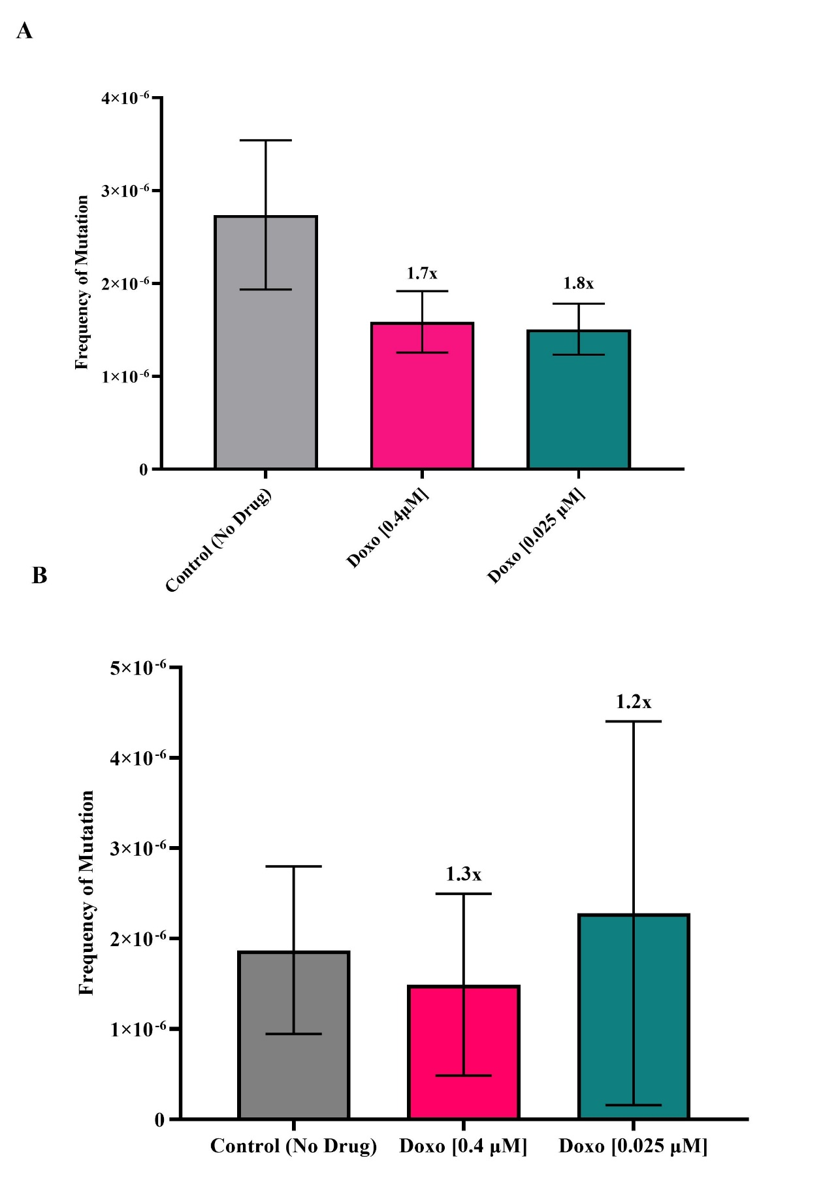

Figure 3. Template Switch Mutation Frequency on leading strand (A) and lagging strand (B) after exposure of Doxorubicin Hydrochloride. (A) Data show a 1.7-fold decrease in mutation frequency at 0.4 μM (n=12). After exposure of 0.025 μM (n=12), we see a 1.8-fold decrease. Error bars represent 95% confidence intervals. (B) Data show a 1.3-fold decrease in mutation frequency at 0.4 μM (n=12). After exposure of 0.025 μM (n=11), we see a 1.2-fold increase. Error bars represent 95% confidence intervals.
For CPT-11, the leading strand had an average frequency of template switch mutations of 2.74 x 10⁻⁶, 1.08 x 10⁻⁶, 9.81 x 10⁻⁷, for the control, 0.5 μM, 1.0 μM, respectively (Figure 4, panel A). This data suggests that exposure of the E. coli cells to both concentrations, 0.5 μM and 1.0 μM, decreases the frequencies of template switch mutations in the leading strand by 2.5-fold and 2.8-fold respectively (Figure 4, panel A). The data indicates that, on the lagging strand, there is a 1.9-fold decrease in template switch mutations when the E. coli cells are exposed to 0.05 μM CPT-11 and a 2.0-fold decrease when exposed to 1.0 μM CPT-11 (Figure 4, panel B). The average frequency of template switch mutations of the E. coli cells without exposure to the drug was 1.87 x 10⁻⁶ whereas when exposed to 0.5 μM of CPT-11 the average frequency was 9.22 x 10⁻⁷ (Figure 4, panel B). When exposed to 1.0 μM, the data indicates that the lagging strand has an average mutation frequency of 9.77 x 10⁻⁷ (Figure 4, panel B).

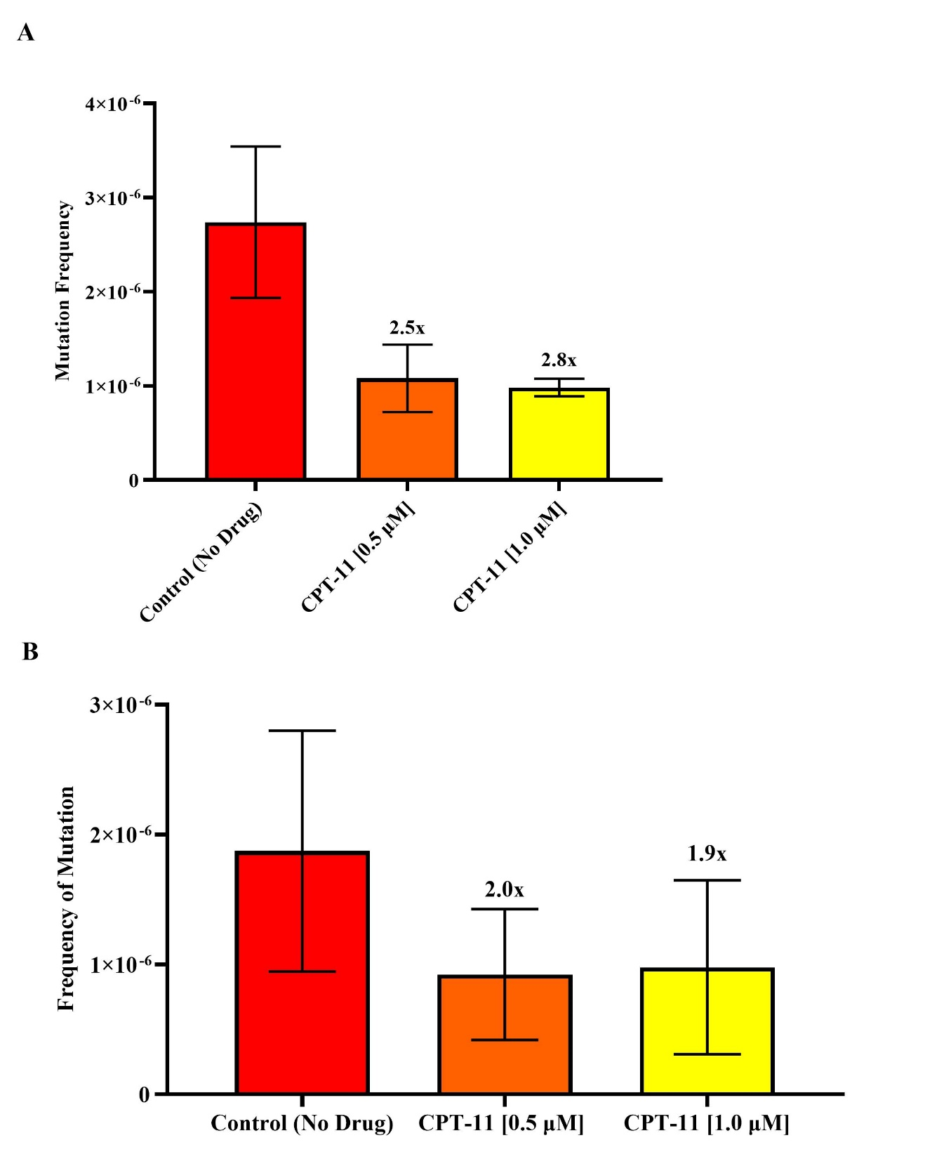
Figure 4. Template Switch Mutation Frequency on leading strand (A) and lagging strand (B) after exposure of CPT-11. (A) Data show a 2.5-fold decrease in mutation frequency at 0.5 μM (n=9). After exposure of 1.0 μM (n=7), we see a 2.8-fold decrease. Error bars represent 95% confidence intervals. (B) Data show a 2.0-fold decrease in mutation frequency at 0.5 μM (n=7). After exposure of 1.0 μM (n=7), we see a 1.9-fold decrease. Error bars represent 95% confidence intervals.

DISCUSSION
This study provides new information regarding the role of anti-tumor drugs in template-switch mutation. CPT-11 has been used for 25 years and is used in the treatment of various different cancer types, sometimes in conjunction with other anticancer medications¹⁷. Doxorubicin is used to treat a wide variety of cancers, however it can be toxic even following treatment²³. In this study, the data indicate that Doxorubicin Hydrochloride and CPT-11 affect TSM. Most of the time, with the exception of exposing the lagging strand of E. coli DNA to 0.025 μM of Doxorubicin Hydrochloride, the frequency of TSM decreases when exposed to these concentrations of Doxo and CPT-11 (Figures 3 and 4). This decrease was not expected and it could be linked to a mechanism of action that instead of promoting, inhibits TSM. If that is confirmed, these drugs could have the potential to prevent TSM. However, given that the fold decrease did not reach the 3-fold threshold, what would be considered to be a significant difference, I propose repeating this experiment under a variety of additional conditions. These new experiments could use higher concentrations of each drug (not compromising viability) for the same amount of time or use the same concentrations but increase the time of exposure. I suggest comparing the effects of CPT-11 and Doxorubicin Hydrochloride on inducing TSM, to a negative control of distilled water and a positive control of 5-azaC as done before⁷. Then, confirm the mutations by DNA sequencing^{3,4,6,7,10}. If these results support a decrease in mutations by CPT-11 and Doxorubicin, it could be a breakthrough on drugs that prevent TSM.

FUTURE RESEARCH
In addition to the work above, I propose investigating CPT-11 under similar conditions as the human carboxylesterase 2. The pnb carboxylesterase from Bacillus subtilis can be inserted into E. coli as done by Wierdl et al., 2004¹⁵ via insertion of the pnbA gene into pTriEx-3 and then into E. coli^{15,19}. This insertion of the pnbA gene will allow for the CPT-11 we study to be converted into the SN-38 that inhibits topoisomerase I. The mutant of the vaccinia virus topoisomerase I from Gupta et al., 1992²⁹ can be used to analyze the effect of CPT-11 on TSM. This can be done because the mutant is inhibited by camptothecin²⁹ and CPT-11 is a derivative that does not require divalent cations. Therefore it allows researchers to know that the relaxation does not come from bacterial topoisomerases²⁸.
Furthermore, I propose assessing the anti-tumor drug temozolomide as a potential mutagenic agent for TSM. Temozolomide (TMZ) is a chemotherapeutic methylating agent that is converted to its active metabolite, MTIC, in aqueous solutions via hydrolysis under specific physiologic pH^{36,37} (Figure 5). Hydrolysis of TMZ to MTIC occurs at pH greater than 7, but MTIC is then rendered inactive if at a pH less than 7³⁶. Then, via its methylation of either the N7 or O6 site guanine or O3 site adenine, induces apoptosis through the inappropriate functioning of the DNA mismatch repair pathway^{36,38} (Figure 5). Although cytotoxic effects are primarily induced by temozolomide action at O6³⁹ and N7 guanine sites ultimately leading to DNA replication inhibition^{36,37}. However, the demethylating enzyme MGMT can undo its effects, via its movement to the nucleus and taking on of the methyl to its own cysteine³⁶, and should be regulated as the efficacy of temozolomide depends on its frequency of methylation³⁸ (Figure 5). Patients who suffered from glioblastoma whose MGMT gene was silenced via MGMT promoter methylation saw an increased survival after treatment of temozolomide and radiotherapy over treatment with only radiotherapy⁴⁰. Temozolomide is the only medication able to increase survival chances for those afflicted by glioblastoma, since 2018³⁸. In patients with glioblastoma, a brain cancer considered to be the most common in adults with a low survival time following diagnosis, temozolomide’s combination with radiotherapy during the ailment’s early stages provides a significant survival advantage in most subgroups of those investigated⁴¹. It can also be used in patients with recurrent anaplastic astrocytomas and is notable for its ability to penetrate the blood-brain barrier and central nervous system, even if only at a low concentration^{36–38}. Therefore, further studies on mechanisms of actions and effects of TMZ in mutagenic pathways are important to explore.
Base excision repair (BER) also plays a role in the functionality of temozolomide as BER can repair other methyl adducts, namely N3 at adenine, to improve the function of cytotoxic drugs like temozolomide via BER inhibition by PARP inhibitors^{36,39} (Figure 5). TMZ combined with PARP-1 inhibitor GPI 15427, that can cross the blood-brain barrier like TMZ, increased survival to O6-alkylguanine DNA methyltransferase (AGT) deficient melanoma, glioblastoma multiforme, and brain lymphoma cells³⁹. In vivo, growth inhibition of tumor cells was increased by inclusion of the PARP-1 inhibitor³⁹. In vivo, antimetastatic activity was increased, tumor growth reduced and survival time increased by the PARP-1 inhibitor in melanoma. The lymphoma survival time increased due to inclusion of the PARP-1 inhibitor; the presence of neoplastic infiltration and tumor size was decreased in glioblastoma multiforme³⁹.
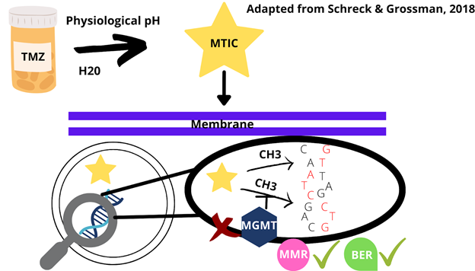
Figure 5. Temozolomide (TMZ) Mechanism of Action.
In E. coli, the ada gene regulates an adaptive response that protects against alkylation via, partly, a O⁶-methylguanine-DNA methyltransferase that repairs a O⁶-methylguanine^{42–45} and this can be also isolated as a 19-kDa protein through cleavage^{44,45}. The Ada protein also activates the transcription of the ada and alkA genes⁴⁴ as well as alkB and aidB^{46,47}. Each Ada protein as studied in E. coli K-12 takes a methyl group from the methylated O⁶ guanine in DNA and possess the following characteristics: it is 354 amino acids long and purified at 38-kDa, begins transcription at adenine bp 80, has a Shine Dalgarno sequence from position 92 to 95, beings translation at position 102 (ATG), and has promoters of TTGCGT and TAAAGG⁴³. The C-terminal of the Ada protein from E. coli B is 178 amino acids long, contains a helix-turn-helix whose binding region is far from the active site targeting O⁶-methylguanine lesions, and has the active site recognized for other O⁶-alkylguanine-DNA alkyltransferases⁴⁵. The active cysteine that takes on the methyl group from DNA is also buried within the Ada protein³⁶ structure indicating a need for a conformational change in order for the protein to function⁴⁵.
For Ada mutants that are deficient in adaptation, there is a greater mutation frequency as induced by alkylating agent MNNG⁴². Ada5 sees a lot of O⁶-methyl guanine bases under MNNG when compared to an Ada⁺ strain, but it is questioned whether this means more of these methylated bases were present or they were simply repaired slower in the Ada5 mutant⁴². Ada3 and Ada5 both saw reduced rates in their ability to repair O⁶-methylguanine DNA lesions with Ada5 being more deficient than Ada3, with the time for half repair taking over twice as long and a rate that is up to 4000-fold slower in the case of Ada5⁴⁴. Both mutants also do not successfully activate ada and alkA genes⁴⁴. Ada3’s mutation has been determined to be the replacement of Ala¹³⁶C with valine leading to an effect on conformational change ability⁴⁵.
Another DNA methyltransferase that can repair O6-methylguanine lesions in DNA by taking the methyl group onto a cysteine of its own, like ada with Cys³²¹, although not an induced protein, is ogt^{45,46,47}. Spontaneous mutations increase in the absence of both ada and ogt in non-dividing E. coli, namely in five different base substitutions with the exception of the G:C to T:A transversion, whereas the absence of ada and ogt in dividing cultures saw an increase in the spontaneous mutations of the G:C to A:T transitions G:C to C:G transversions, indicating that the methyltransferases produced by these genes each have the capacity to repair the same lesions and work together⁴⁷. Mutants of just ogt, just ada, and both ada and ogt were more susceptible to mutation by alkylating agent MNNG comparatively, with the double mutant having a greater rate in cells not actively dividing, to when both genes are fully functional in the wild-type⁴⁶. The methyltransferase from ada takes approximately 20 minutes to cause an effect and, thus, the ogt melthyltrasferase provides protection from the alkylation killing E. coli. Once the concentration of MNNG surpasses 0.3 µg per ml, Ogt is no longer available and, without ada, E. coli is defenseless against alkylation since ada has been noted to provide some help even at low alkylation levels. Ogt also provides resistance to killing via alkylation because of its constitutive nature. The double ada ogt mutant was found to have a linearly mutation rate with dose of alkylating agent MNNG⁴⁶.
For Temozolomide, it becomes clear that the ada gene must be either silenced or mutated as is done for the MGMT gene in humans to prevent the removal of methyl groups added by temozolomide^{38,42,43}. To ensure that Temozolomide successfully induces O6 guanine methylation in DNA, Lac revertant colonies will be used as in Mackay et al., 1994⁴⁷ before using the Lac revertant colonies for the sake of determining its effect, if any, on TSM. When this is done, the SOS response should be eliminated via cleavage of the lexA allele in one group and kept intact in the other to determine at what level of alkylation damage the SOS response may be induced and to see the extent of the damage without it. This will be done to accommodate for a limitation mentioned by Mackay et al., 1994⁴⁷ indicating that the induction of increase in transversion mutations may come from SOS and not the alkylating agent. To account for the evidence that E. coli has endogenous sources of alkylation damage⁴⁶, a run will be done with mutated ada and ogt but without temozolomide and then with ada and ogt mutants with temozolomide. Concentrations of temozolomide to be utilized in the experiment will be within the range of 0.1 µg to 1.0 µg to account for the threshold of 0.3 µg even ada⁺ ogt⁺ cells saw to the alkylating agent MNNG⁴⁶.
References
1. Ripley LS. Model for the participation of quasi-palindromic DNA sequences in frameshift mutation. Proceedings of the National Academy of Sciences of the United States of America. 1982;79(13):4128–4132.
2. Bissler JJ. DNA inverted repeats and human disease. Frontiers in Bioscience. 1998;3(4):d408-418. doi:10.2741/A284
3. Dutra BE, Lovett ST. Cis and Trans-acting Effects on a Mutational Hotspot Involving a Replication Template Switch. Journal of Molecular Biology. 2006;356(2):300–311. doi:10.1016/j.jmb.2005.11.071
4. Seier T, Padgett DR, Zilberberg G, Sutera VA, Toha N, Lovett ST. Insights Into Mutagenesis Using Escherichia coli Chromosomal lacZ Strains That Enable Detection of a Wide Spectrum of Mutational Events. Genetics. 2011;188(2):247–262. doi:10.1534/genetics.111.127746
5. Seier T, Zilberberg G, Zeiger DM, Lovett ST. Azidothymidine and other chain terminators are mutagenic for template-switch-generated genetic mutations. Proceedings of the National Academy of Sciences of the United States of America. 2012;109(16):6171–6174. doi:10.1073/pnas.1116160109
6. Laranjo LT, Gross SJ, Zeiger DM, Lovett ST. SSB recruitment of Exonuclease I aborts template-switching in Escherichia coli. DNA Repair. 2017;57:12–16. doi:10.1016/j.dnarep.2017.05.007
7. Klaric JA, Perr EL, Lovett ST. Identifying Small Molecules That Promote Quasipalindrome-Associated Template-Switch Mutations in Escherichia coli. G3: Genes|Genomes|Genetics. 2020;10(5):1809–1815. doi:10.1534/g3.120.401106
8. Voineagu I, Narayanan V, Lobachev KS, Mirkin SM. Replication stalling at unstable inverted repeats: Interplay between DNA hairpins and fork stabilizing proteins. Proceedings of the National Academy of Sciences of the United States of America. 2008;105(29):9936–9941. doi:10.1073/pnas.0804510105
9. Viswanathan M, Lacirignola JJ, Hurley RL, Lovett ST. A novel mutational hotspot in a natural quasipalindrome in Escherichia coli11Edited by J. H. Miller. Journal of Molecular Biology. 2000;302(3):553–564. doi:10.1006/jmbi.2000.4088
10. Laranjo LT, Klaric JA, Pearlman LR, Lovett ST. Stimulation of Replication Template-Switching by DNA-Protein Crosslinks. Genes. 2018 [accessed 2021 Mar 19];10(1). https://www.ncbi.nlm.nih.gov/pmc/articles/PMC6357072/. doi:10.3390/genes10010014
11. Klaric JA, Glass DJ, Perr EL, Reuven AD, Towne MJ, Lovett ST. DNA damage-signaling, homologous recombination and genetic mutation induced by 5-azacytidine and DNA-protein crosslinks in Escherichia coli. Mutation Research/Fundamental and Molecular Mechanisms of Mutagenesis. 2021;822:111742. doi:10.1016/j.mrfmmm.2021.111742
12. Greenblatt MS, Grollman AP, Harris CC. Deletions and Insertions in the p53 Tumor Suppressor Gene in Human Cancers: Confirmation of the DNA Polymerase Slippage/Misalignment Model. Cancer Research. 1996;56(9):2130–2136.
13. Mason‐Osann E, Terranova K, Lupo N, Lock YJ, Carson LM, Flynn RL. RAD54 promotes alternative lengthening of telomeres by mediating branch migration. EMBO Reports. 2020;21(6):e49495. doi:10.15252/embr.201949495
14. Fukuda M, Nishio K, Kanzawa F, Ogasawara H, Ishida T, Arioka H, Bojanowski K, Oka M, Nagahiro Saijo. Synergism between Cisplatin and Topoisomerase I Inhibitors, NB-506 and SN-38, in Human Small Cell Lung Cancer Cells’. Cancer Research. 1996;56(4):789–793.
15. Wierdl M, Christopher L. Morton, Nathan K. Nguyen, Matthew R. Redinbo, Philip M. Potter. Molecular Modeling of CPT-11 Metabolism by Carboxylesterases (CEs): Use of pnb CE as a Model | Biochemistry. Biochemistry. 2004;43(7):1874–1882. doi:10.1021/bi035586r
16. Definition of irinotecan hydrochloride - NCI Drug Dictionary - National Cancer Institute. 2011 Feb 2 [accessed 2021 Apr 7]. https://www.cancer.gov/publications/dictionaries/cancer-drug/def/irinotecan-hydrochloride
17. Bailly C. Irinotecan: 25 years of cancer treatment. Pharmacological Research. 2019;148:104398. doi:10.1016/j.phrs.2019.104398
18. Pommier Y, Leo E, Zhang H, Marchand C. DNA Topoisomerases and Their Poisoning by Anticancer and Antibacterial Drugs. Chemistry & Biology. 2010;17(5):421–433. doi:10.1016/j.chembiol.2010.04.012
19. Humerickhouse R, Lohrbach K, Li L, Bosron WF, Dolan ME. Characterization of CPT-11 Hydrolysis by Human Liver Carboxylesterase Isoforms hCE-1 and hCE-2. Cancer Research. 2000;60(5):1189–1192.
20. Xu G, Zhang W, Ma MK, McLeod HL. Human Carboxylesterase 2 Is Commonly Expressed in Tumor Tissue and Is Correlated with Activation of Irinotecan. Clinical Cancer Research. 2002;8(8):2605–2611.
21. Liu LF, Miller KG. Eukaryotic DNA topoisomerases: two forms of type I DNA topoisomerases from HeLa cell nuclei. Proceedings of the National Academy of Sciences of the United States of America. 1981;78(6):3487–3491.
22. Definition of doxorubicin hydrochloride - NCI Drug Dictionary - National Cancer Institute. 2011 Feb 2 [accessed 2021 Apr 7]. https://www.cancer.gov/publications/dictionaries/cancer-drug/def/doxorubicin-hydrochloride
23. Meredith A-M, Dass CR. Increasing role of the cancer chemotherapeutic doxorubicin in cellular metabolism. Journal of Pharmacy and Pharmacology. 2016;68(6):729–741. doi:10.1111/jphp.12539
24. Gewirtz D. A critical evaluation of the mechanisms of action proposed for the antitumor effects of the anthracycline antibiotics adriamycin and daunorubicin. Biochemical Pharmacology. 1999;57(7):727–741. doi:10.1016/S0006-2952(98)00307-4
25. Jain T, Roper BJ, Grove A. A functional type I topoisomerase from Pseudomonas aeruginosa. BMC Molecular Biology. 2009;10:23. doi:10.1186/1471-2199-10-23
26. Wang JC. A Journey in the World of DNA Rings and Beyond. Annual Review of Biochemistry. 2009;78(1):31–54. doi:10.1146/annurev.biochem.78.030107.090101
27. Krogh BO, Shuman S. A poxvirus-like type IB topoisomerase family in bacteria. Proceedings of the National Academy of Sciences of the United States of America. 2002;99(4):1853–1858. doi:10.1073/pnas.032613199
28. Shuman S, Golder M, Moss B. Characterization of vaccinia virus DNA topoisomerase I expressed in Escherichia coli. Journal of Biological Chemistry. 1988;263(31):16401–16407. doi:10.1016/S0021-9258(18)37607-5
29. Gupta M, Zhu CX, Tse-Dinh YC. An engineered mutant of vaccinia virus DNA topoisomerase I is sensitive to the anti-cancer drug camptothecin. Journal of Biological Chemistry. 1992;267(34):24177–24180. doi:10.1016/S0021-9258(18)35746-6
30. Coldwell KE, Cutts SM, Ognibene TJ, Henderson PT, Phillips DR. Detection of Adriamycin–DNA adducts by accelerator mass spectrometry at clinically relevant Adriamycin concentrations. Nucleic Acids Research. 2008;36(16):e100. doi:10.1093/nar/gkn439
31. Gillet-Markowska A, Louvel G, Fischer G. bz-rates: A Web Tool to Estimate Mutation Rates from Fluctuation Analysis. G3: Genes|Genomes|Genetics. 2015;5(11):2323–2327. doi:10.1534/g3.115.019836
32. Hamon A, Ycart B. Statistics for the Luria-Delbrück distribution. Electronic Journal of Statistics. 2012;6(none):1251–1272. doi:10.1214/12-EJS711
33. Gillet-Markowska A, Louvel G, Fischer G. bz-rates. bz-rates. 2015 May 6 [accessed 2021 Nov 24]. http://www.lcqb.upmc.fr/bzrates
34. Pomponio RJ, Narasimhan V, Reynolds TR, Buck GA, Povirk LF, Wolf B. Deletion/Insertion Mutation That Causes Biotinidase Deficiency May Result from the Formation of a Quasipalindromic Structure. Human Molecular Genetics. 1996;5(10):1657–1661. doi:10.1093/hmg/5.10.1657
35. Bateman JF, Lamande SR, Dahl HH, Chan D, Mascara T, Cole WG. A Frameshift Mutation Results in a Truncated Nonfunctional Carboxyl-terminal Proα1(I) Propeptide of Type I Collagen in Osteogenesis Imperfecta. Journal of Biological Chemistry. 1989;264(19):10960–10964. doi:10.1016/S0021-9258(18)60412-0
36. Marchesi F, Turriziani M, Tortorelli G, Avvisati G, Torino F, De Vecchis L. Triazene compounds: Mechanism of action and related DNA repair systems. Pharmacological Research. 2007;56(4):275–287. doi:10.1016/j.phrs.2007.08.003
37. Definition of temozolomide - NCI Drug Dictionary - National Cancer Institute. 2011 Feb 2 [accessed 2021 Apr 7]. https://www.cancer.gov/publications/dictionaries/cancer-drug/def/temozolomide
38. Karisa C. Schreck, Stuart A. Grossman. Role of Temozolomide in the Treatment of Cancers Involving the Central Nervous System. Cancer Network. 2018 Nov 15 [accessed 2021 Mar 19]. https://www.cancernetwork.com/view/role-temozolomide-cns
39. Tentori L, Leonetti C, Scarsella M, d’Amati G, Vergati M, Portarena I, Xu W, Kalish V, Zupi G, Zhang J, et al. Systemic Administration of GPI 15427, a Novel Poly(ADP-Ribose) Polymerase-1 Inhibitor, Increases the Antitumor Activity of Temozolomide against Intracranial Melanoma, Glioma, Lymphoma. Clinical Cancer Research. 2003;9(14):5370–5379.
40. Hegi ME, Diserens A-C, Gorlia T, Hamou M-F, de Tribolet N, Weller M, Kros JM, Hainfellner JA, Mason W, Mariani L, et al. MGMT Gene Silencing and Benefit from Temozolomide in Glioblastoma. New England Journal of Medicine. 2005;352(10):997–1003. doi:10.1056/NEJMoa043331
41. Stupp R, Mason WP, van den Bent MJ, Weller M, Fisher B, Taphoorn MJB, Belanger K, Brandes AA, Marosi C, Bogdahn U, et al. Radiotherapy plus Concomitant and Adjuvant Temozolomide for Glioblastoma. The New England Journal of Medicine. 2009;352:987–996. doi:10.1056/NEJMoa043330
42. Jeggo P. Isolation and characterization of Escherichia coli K-12 mutants unable to induce the adaptive response to simple alkylating agents. Journal of Bacteriology. 1979;139(3):783–791.
43. Nakabeppu Y, Kondo H, Kawabata S, Iwanaga S, Sekiguchi M. Purification and structure of the intact Ada regulatory protein of Escherichia coli K12, O6-methylguanine-DNA methyltransferase. Journal of Biological Chemistry. 1985;260(12):7281–7288. doi:10.1016/S0021-9258(17)39604-7
44. Demple B. Mutant Escherichia coli Ada proteins simultaneously defective in the repair of O6-methylguanine and in gene activation. Nucleic Acids Research. 1986;14(14):5575–5589.
45. Moore MH, Gulbis JM, Dodson EJ, Demple B, Moody PC. Crystal structure of a suicidal DNA repair protein: the Ada O6‐methylguanine‐DNA methyltransferase from E. coli. The EMBO Journal. 1994;13(7):1495–1501. doi:10.1002/j.1460-2075.1994.tb06410.x
46. Rebeck GW, Samson L. Increased spontaneous mutation and alkylation sensitivity of Escherichia coli strains lacking the ogt O6-methylguanine DNA repair methyltransferase. Journal of Bacteriology. 1991;173(6):2068–2076.
47. Mackay WJ, Han S, Samson LD. DNA alkylation repair limits spontaneous base substitution mutations in Escherichia coli. Journal of Bacteriology. 1994;176(11):3224–3230.

