These Heels Were Made for Working:
Women’s Appearance and Perception in the Workplace

Honors Thesis

Presented in Partial Fulfillment of the Requirements
For the Degree of Bachelor of Business Administration

in the Bertolon School of Business
at Salem State University

By
Alexandra Salazar

Professor Lillian Little
Faculty Advisor
Management Department

***

Commonwealth Honors Program
Salem State University
2016

Table of Contents
Abstract 3
Introduction 4
History 4
Background 5
Medical Findings 7
Psychological Findings 8
Female Executives Leading the Way 9
Gender and Equality 10
Conclusion 12
Works Cited 14
Appendix A 15
Appendix B – Figure 1 16
Appendix B – Figure 2 17
Appendix C 18
Appendix D 19

Abstract

Do women’s choice in apparel, hair, makeup, and overall appearance have an impact in the way they are perceived in the world of business? In careers that are predominantly male, are women not taken seriously based on how they look? We challenge the idea that a woman can’t be attractive, confident, and smart. With research taken from academic journals and prominent magazines, we explore whether or not there is a gender barrier in the workplace. The findings are geared towards young women entering the business world so they can be better prepared for the scene of a male-dominated field.
Introduction

Twitter - home of 140-character status update having to do with everything from the presidential election, the latest box office hit, and anything celebrity-related. It can be used by anyone anywhere in the world, leading to a vast array of opinions on any number of topics.
On October 22, 2013, Twitter was overflowing with the news of the Kanye West and Kim Kardashian engagement announcement– but one tweet (not Kimye related) stood out - Jorge Cortell, CEO of Kanteron Systems, leading open-source software company specializing in Healthcare IT, while attending an industry conference posted: “Event supposed to be for entrepreneurs, VCs, but these heels (I've seen several like this)...WTF? #brainsnotrequired” (Cortell, 2013). He attached a photo he took of the woman standing in front of him at the event, focusing on her stilettos (Appendix A). With this tweet, he sparked an international discussion on women, appearance, and perception. He was called sexist by many, and defended himself by saying that he associated high heels with voluntary self-damage, which he associated with being dumb (Cortell, 2013). Cue the mic drop. Cue the (rightfully) angry mob.
When did a woman’s choice in dress suddenly become measurement of her intelligence?

History

In 1985, the Journal of Applied Psychology published a study called “Influence of Applicant’s Dress on Interviewer’s Selection Decision,” which explored the early red flags of appearance affecting perception. The study focused on “hiring recommendations from 77 personnel administrators [and how] they were used to determine the effect of female applicant’s dress on interviewers’ selection decisions for management positions” (Forsythe, p. 374). When personnel administrators made hiring recommendations for each applicant by viewing the interview recordings, it was confirmed that masculinity of an applicant’s dress had a significant effect on the hiring decisions, as seen in Figure 1 and 2 on Appendix B (Forsythe). Luckily, in the 1980’s, masculine clothing was on trend and padded shoulders and women power suits were all the rage. However, what happens when masculine clothing is no longer popular? What happens when the year is 2016 and feminine feminism is the trend?

Background

This leads to the question: what is professional attire? Is it always the most masculine outfit? The flattest shoes? The least attention-seeking ensemble? In 2012, the International Journal of Hospitality Management put those questions to rest, seeking to understand the correlation between personal presentation to perceptions of competence and capabilities (Ruetzler). The study focuses on the seven attributes associated with favorable interview presentation, such as physical attractiveness, neatness and grooming, clothing color, conservative versus trendy attire, professional versus casual attire, and body modification. Participants (108 students, faculty, and hospitality industry professionals) viewed photos of candidates and decided on the effect of the attributes on each applicant. When it came to attractiveness, it was at times deemed a liability (perhaps a distraction in the workplace), but overall was a desirable attribute for candidates, although it was even more favorable to be average-looking; for neatness and grooming, it was deemed of utmost importance (Ruetzler, p. 938), and rightfully so, as it often exemplifies how well put together someone is and their level of professionalism and responsibility measured by self-care.
One area of the study that was particularly interesting (and that further relates to women in the workplace) is that of clothing appearance – specifically color, level of conservativeness, and levels of professionalism. Color had conflicting findings: “Most recruiters and image specialists recommend wearing traditional colors when interviewing; these colors include navy blue, black, grey, and brown. There is, however, limited empirical research on the impact clothing color has on perceptions of job candidates” (Ruetzler, p. 938). This brings up a good point of color association and perception in professionals – it’s something that varies from person to person and isn’t easy to make measurable. In the study, it was gathered that women in darker jackets were rated more favorably than women in lighter jackets, as the former were considered more forceful, self-reliant, dynamic, aggressive, and decisive (making them more likely to be recommended for hire), while the latter were perceived as more sociable and good – two adjectives that don’t exactly put applicants at the top of hire lists. Interestingly enough, lighter jackets were more favorable than medium-colored jackets (Ruetzler, p. 941), breaking the concept that color perception is a spectrum, but rather based on individual reaction.
Conservativeness versus trendy clothing was a subcategory that also didn’t have empirical evidence, but still yielded considerable concern from the participants. Having something to do with the relaxation of dress codes in corporate America – the trend of a more casual look, traditional attire (blazer, blouse, shirt, tie) wasn’t preferred over trendy clothing, although that was only because approximately 66% of the audience found it to be so – specifically the students (a younger demographic) and industry professionals (in the middle of the shift to more casual attire), while faculty thought the opposite.
The findings show cracks in the conservative way of thinking and give way to a new school of thought – where it’s okay to show personality and individuality, as there’s a movement to prove that it doesn’t necessarily bring down one’s capabilities.

Medical Findings

When Jorge Cortell tried to defend himself and keep from being branded sexist, he stated that he was not exclusively calling women dumb. He went on to further explain that everyone who knowledgeably inflicted harm on themselves was dumb – although if that’s the argument, where’s the mention of boxing or football? Why focus on women and high heels?
Cortell isn’t wrong. High heels aren’t good for you, just ask Sarah Jessica Parker – her feet are basically deformed after wearing them for season after season on the hit show Sex and the City. The Journal of Foot and Ankle Surgery conducted a study to investigate the epidemiology of high-heel related injuries among the nationally representative population of women in the United States and to analyze the demographic differences within this group. An estimated 123,355 high-heel related injuries were treated in emergency rooms from 2002 to 2012, with the overall rate for the 20-29 young adult age group being 10.38 per 100,000 females with the most common injury being sprains and strains to the foot and ankle. Injuries have doubled in the past 10 years (Appendix C) and it leads to an interesting question: why do women wear high heels if it is detrimental to their health?

Psychological Findings

Simply put: it makes women look and feel good. In a 2012, the Evolution and Human Behavior Journal released the article High Heels as a Supernatural Stimuli: How Wearing High Heels Affects Judgements of Female Attractiveness where they dug deep into the association between heels and female sexuality. In this study, females were recorded walking in flat shoes and high heels and then study participants viewed point-light videos (light displays that represent the body with a series of key-placed markers; presented with a pattern of dots on a screen) of the women wearing the two types of shoes (Morris, 2013). The participants rated the females in the heels condition as significantly more attractive than the females in flat shoe condition. Meanwhile, biomechanical analyses revealed that wearing high heels led to increased femininity of gait including reduced stride length and increased rotation and tilt of the hips. The study concluded that high heels exaggerated sex specific aspects of female gait and women walking in high heels could ne regarded as a supernormal stimulus (Morris, 2013).
However, a woman in heels is more than a supernatural stimulus for others. A woman in heels isn’t necessarily looking for attention. Why can’t a woman in heels be a supernatural stimulus for herself? A sort of internal source of confidence that is activated when she feels happy with her appearance and the way she carries herself? Not everything people do is for the sake of others; it’s a case of acceptable selfishness in an industry where women struggle to stake their claim and sometimes need a boost.

Female Executives Leading the Way

Marissa Mayer, the first female CEO of a large tech company, turned Yahoo! around with exciting projects and calculated acquisitions. However, people don’t see her accomplishments, but rather her so-called slipups. She posed for the September 2013 issue of Vogue magazine – the publication’s most important month (Appendix D) and received immediate reactions, ranging from praise to harsh critiques.
In a CNN article, “Sexed Up and Smart: Women Debate Marissa Mayer’s Vogue Photo,” female leaders discuss Marissa Mayer’s choice to pose for the fashion magazine. Wallace, in a sense, predicts the reactions, as she starts off with insightful questions people today should be posing: “Can’t a woman be powerful, strong, and beautiful, all at once? That question drew a range of responses from women on various rungs of the corporate ladder, some supportive of Mayer embracing her femininity and others lamenting the undue pressure on female leaders to soften their image” (Wallace, 2013).
Grace Chan, vice president of product management for Wanderful Media, said she wouldn’t have posed for Vogue as an executive. “This is something I wouldn’t personally do because I believe if you want to be treated equal, you shouldn’t take advantage of your physical assets…I don’t want to get brownie points because I am attractive. I like to separate the fact that I am a woman and I am a professional (Wallace, 2013). While people are allowed to have their own opinions, there’s something troubling about the insinuation that Mayer uses her physical attractiveness to get ahead. Mayer’s ideas and executive ability get her ahead – not her looks. Being in power shouldn’t mean that she should downplay her femininity.
Mary Cook, CEO of CallSockey.com expressed support and said, “So what if Marissa Mayer is in a fashion spread in Vogue? When she ‘took office’ did she also park her sense of fashion, personal interests, and humor at the front door? I hope she had fun on the photo shoot and she looks great to boot!” (Wallace, 2013). Women can be successful and still hold on to their passions, and if that happens to be doing a photo shoot while wearing a Michael Kors dress and Yves Saint Laurent heels, so be it.

Gender and Equality

Women strive to be treated the same way as men, with the feminism movement being in full stride and scandals such as women’s soccer earnings taking the spotlight. Does wearing high heels, while pleasing women in their appearance, set back the movement? Is a footwear choice only available to women further creating a line between the sexes and causing the dream of equality to inch further away? Not if it’s necessary.
The Archives of Sexual Behavior published a study last year, “High Heels Increase Women’s Attractiveness,” which may sound like a bit of an obvious statement – everyone knows high heels make women more attractive. The findings of this study were obtained using height of the heels as the main variable, with the three heights being 0cm., 5cm., and 9 cm. Each high-heeled woman was put in the same three scenarios; scenario 1: the woman confederate asked men to respond to a short survey on gender equality; scenario 2: the confederate asked men and women to participate in a survey on local food habit consumption; scenario 3: men and women in the street were observed while walking in back of the female con- federate who dropped a glove apparently unaware of her loss (Gueguen, 2015). The curious findings were that men’s helping behavior increased with heel height, but women’s helping behavior did not. Gueguen’s findings discussed the possibility of the correlation of foot size to youthfulness. High heels - the higher the heels, the smaller the foot looks, the more youthful a woman is perceived as, the more attractive she is found.
What is the relevance of the study? Attractiveness could often translate into more earnings. The average CEO (mostly male) was 6 feet tall, roughly 3 inches taller than the average American man, as reported by noted journalist Malcom Gladwell of The New Yorker. This inspired The Regional Economist to perform a study on the link between wages and appearance. One of the factors of appearance that was very interesting was the importance of height in people of power. They took findings from Nicola Persico’s “The Effects of Adolescent Experience on Labor Market Outcomes: The Case of Height” which came to the conclusion that after controlling for a number of family characteristics that are generally correlated with both height and wages (parents' education, parents' occupation and number of siblings), white men in the United States see a 1.8-percent increase in wages accompanied by every additional inch of height (as cited in Engemann & Owyang, 2005).
In the United States, the average height of a male is 5 feet 9 inches; women are typically shorter than men, averaging at 5 feet 5 inches in the United States. Simple math lets us know that the average male is approximately 4 inches taller than the average woman. If we multiply that 4-inch gap by the 1.8-percent increase in wages per inch, there’s a 7.2% discrepancy between the wages – and the controversial wage gap (women earn $0.78 on the dollar) hasn’t even been factored in yet. Can society blame women for wanting to wear heels? For needing a little boost?

Conclusion

People, not just women, should be valued by their ideas and what they have to offer for the greater good. High heels should not affect the way women are perceived. Should.
The evidence proves differently. Since 1985 (and probably going back to prehistoric times) women have been judged on appearance rather than intellect. Countless journals and periodicals tell women what to wear in order to fit the corporate mold – a mold made for a man. Even medical and psychological findings tell women to steer clear of heels – it hurts your bones! It arches your back! It sways your hips!
Women in the business industry are in the midst of a breakthrough and the heel of a shoe may just shatter it. High-powered executives such as Marissa Mayer and Sheryl Sandberg are ditching the power suit and calling up Carolina Herrera for a custom dress. The rest of women in the industry – those not owning Yahoo! or not responsible for everyday Facebook operation – they’re in a limbo when it comes to appearance in the workplace. A choice between suppressing or embracing femininity proves to be difficult, but the latter is being more and more exercised. High heels increases confidence and add a spring to one’s step. High heels allow women to be eye-to-eye with men in the workplace and make their case for equality. High heels are an accessory – a piece of iconography used to express individual identity. And they’re pretty.

Works Cited

Cortell, J. (2013, October 23). @HonoriaCrummles @mattaningram @miixxy @chaffro Forget "events". Just saying: high heels = voluntary self damage = DUMB. Retrieved May 12, 2016, from Twitter: https://twitter.com/jorgecortell/status/393129362951663616

Cortell, J. (2013, October 22). Event supposed to be for entrepreneurs, VCs, but these heels (I've seen several like this)... WTF? #brainsnotrequired. Retrieved May 12, 2016, from Twitter: https://twitter.com/jorgecortell/status/392776392750149632

Engemann, K., & Owyang, M. (2005, April). So Much for That Merit Raise: The Link between Wages and Appearance. The Regional Economist.

Forsythe, S. Influence of Applicant's Dress on Interviewer's Selection Decisions. Journal of Applied Psychology, 70 (2), 374-378.

Gueguen. (2015). High Heels Increase Women's Attractiveness. Archives of Sexual Behavior, 44 (8), 2227-2235.

McKenna, A. (Writer), & Frankel, D. (Director). (2006). The Devil Wears Prada [Motion Picture]. United States.

Moore, J. L. (2015). Epidemiology of High-Heel Shoe Injuries in U.S. Women: 2002 to 2012. The Journal of Foot and Ankle Surgery, 54 (4), 615-619.

Morris, P. W. (2013). High Heels as Supernormal Stimuli: How Wearing High Heels Affects Judgements of Female Attractiveness. Evolution and Human Behavior , 34 (3), 176-181.

Ruetzler, T. T. (2012). What is Professional Attire Today? A Conjoint Analysis of Personal Presentation Attributes. International Journal of Hospitality Management, 31 (3), 937-943.

Turner, J. (2009, September 19). High Heels Won't Help Achieve High Ambitions. The Times.

Wallace, K. (2013, August 21). Sexed up and smart: Women debate Marissa Mayer's Vogue photo. Retrieved from CNN: http://www.cnn.com/2013/08/20/living/marissa-mayers-vogue-photo-women/

Appendix A



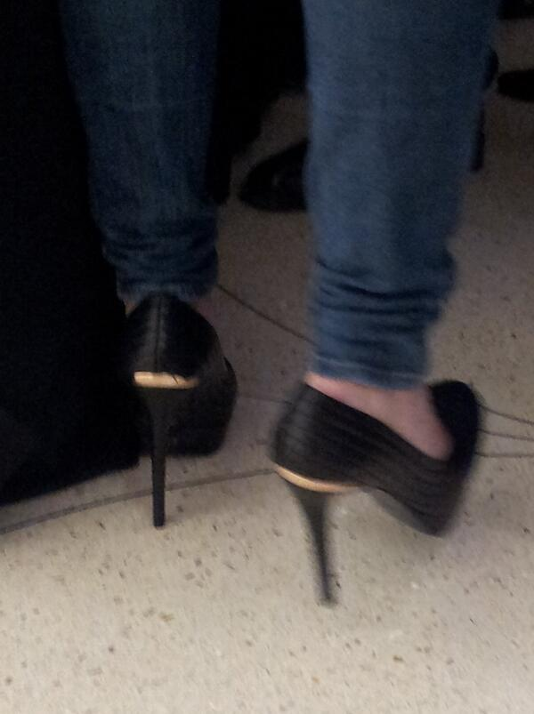

Source: https://twitter.com/jorgecortell/status/392776392750149632

Appendix B – Figure 1

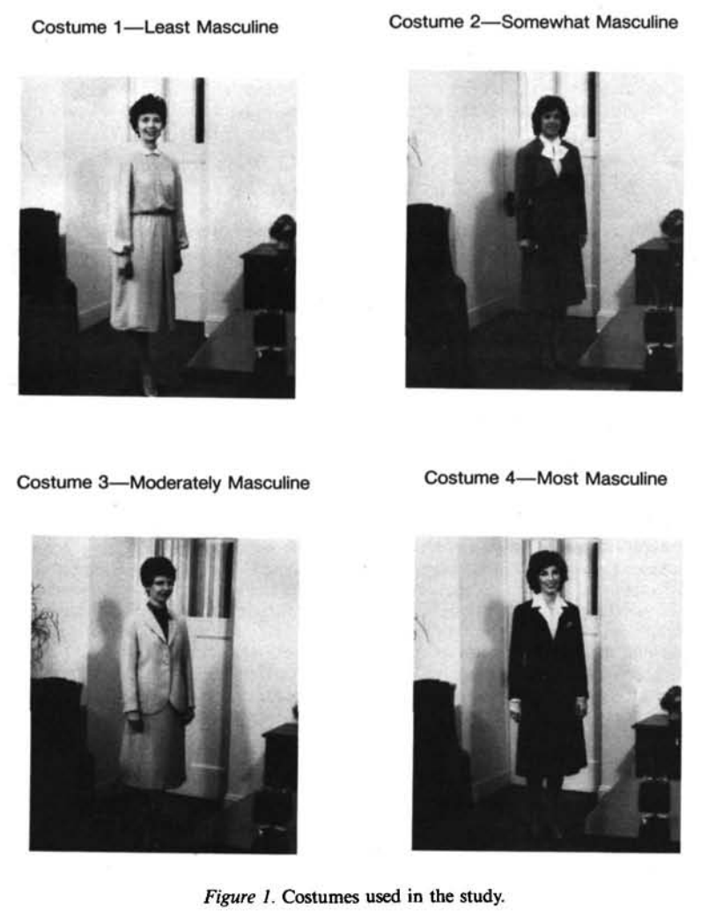

Source: Journal of Applied Psychology

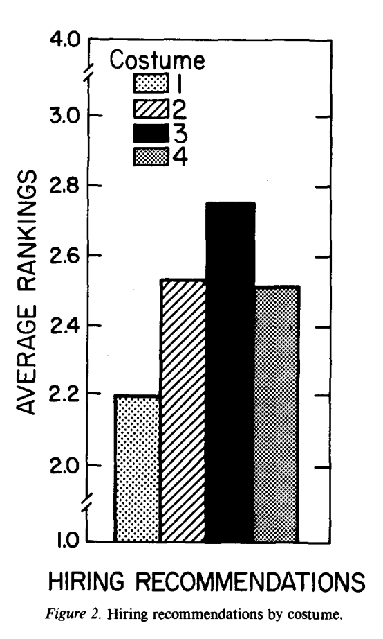
Appendix B – Figure 2

Source: Journal of Applied Psychology

Appendix C

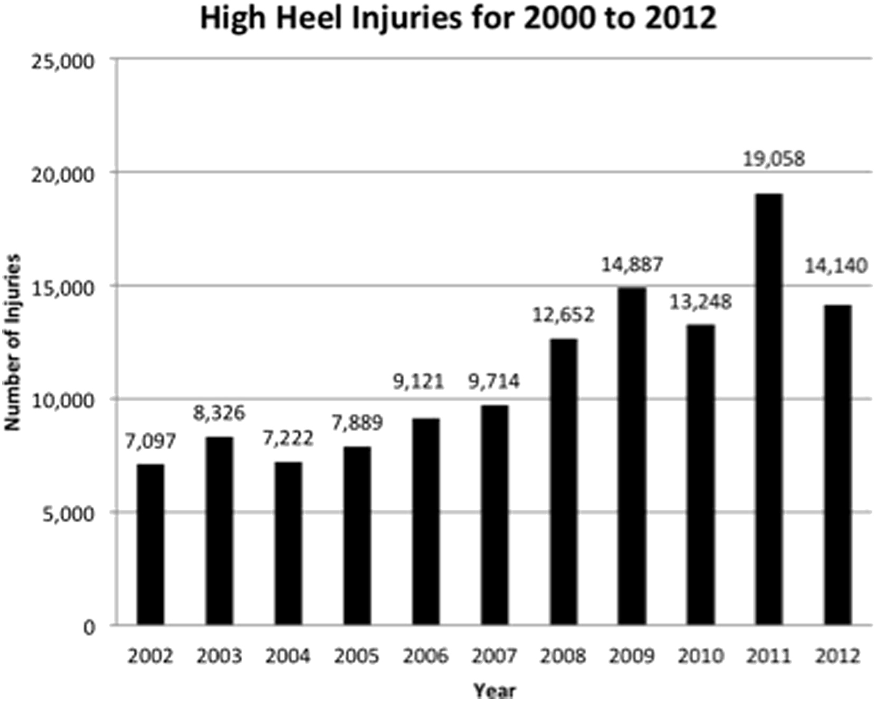

Source: The Journal of Foot and Ankle Surgery

Appendix D

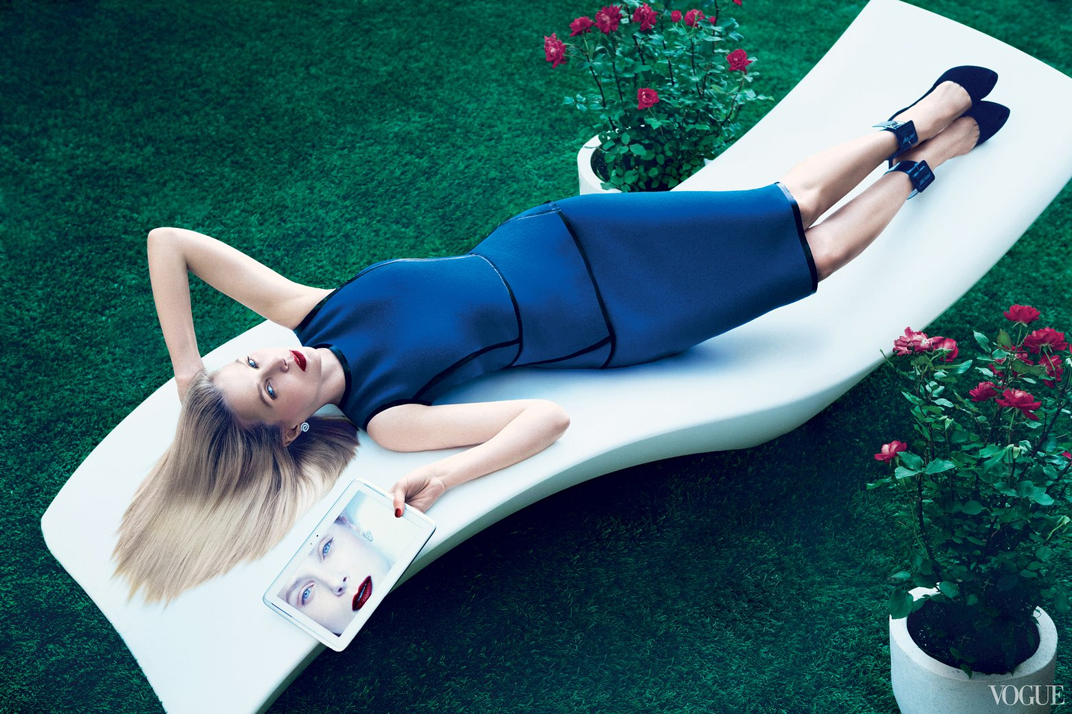

Source: www.vogue.com

