IS VEGAN FOOD REALLY THAT BAD? THE RELATION BETWEEN MORAL IDENTITY THREAT AND FLAVOR PREFERENCE

Honors Thesis

Presented in Partial Fulfillment of the Requirements

For the Degree of Bachelor of Science
In the College of Arts and Sciences
at Salem State University

By

Paul Hennigan

Dr. Sophia Evett
Faculty Advisor
Department of Psychology

***

Commonwealth Honors Program
Salem State University
2016

Abstract
Vegans often report finding themselves and their diets as the subjects of ridicule and disparaging attitudes. These attitudes could be due to moral identity threat, a self-defense mechanism that preserves one’s concept of being a good person in the face of perceived moral exemplars. The present study tested this hypothesis by having participants sample the same cookie from two baskets, with one basket being labelled as “vegan” and the other being labelled as “classic.” Moral identity threat and attitudes towards vegans were measured using surveys adapted from prior moral psychology studies. The results show that those with high moral identity threat show a statistically significant preference for the cookie labelled as “classic” and no preference for the same cookie labelled as “vegan”. Furthermore, high scores of moral identity threat were correlated with negative vegan attitudes. These results show that negative attitudes towards vegan food and vegans may be influenced by internal self defense mechanisms rather than the actual quality of the food and people being judged.

Is Vegan Food Really That Bad? The Relation between Moral Identity Threat and Flavor Preference
Introduction
Moral disagreement is nothing new. For millennia, philosophers have espoused vastly different moral philosophies without any sign of agreeing on what we ought to do (Gowans, 2013). The widespread rejection of the moral values held by others is not unique to philosophers, but exists among activists, politicians and laymen alike. The view that one’s own code of behavior is “right” and that others are “wrong” has led to a history of conflict, war, and suffering (Walzer, 2006). What psychological mechanisms lead people to paint the values held by others in such a negative light?
Vegans are an example of a group that holds a very specific moral philosophy that is in conflict with the values of others. The Vegan Society defines veganism as “A philosophy and way of living which seeks to exclude—as far as is possible and practicable—all forms of exploitation of, and cruelty to, animals for food, clothing or any other purpose” (2015). A vegan will not eat any food derived from animals which is very different from the common view held by most people that eating animal products is morally acceptable. The philosophers Peter Singer and Tom Regan have both developed intricate theories as to why one should follow a vegan diet (Regan, 2004; Singer, 1990), yet encounter much difficulty in selling their ideas as the vast majority remain omnivores. Anecdotal evidence suggests that those who reject veganism often do so with the claim that vegan food simply does not taste as good.
It may not be too surprising then that vegans often find themselves and their diets as being the subject of ridicule and disparaging attitudes (Cole & Morgan 2011; Povey, Wellens, & Conner 2001). Recent research suggests that such derogatory attitudes are often a response to a perceived moral superiority brought about by the fear of anticipated moral reproach (Monin, 2007; Minson & Monin 2012; Cramwinckel, van Dijk, Scheepers, & van den Bos, 2013). Monin, Sawyer, and Marquez (2008) further propose that “the very fact of taking a moral stance should be perceived as an implied reproach against (and implicit rejection of) those not making the same choice”. Vegans’ rejection of the acceptability of eating animal products can be interpreted as a threat to one’s own sense of moral worth or, in other words, a threat to their moral identity. But can this psychological mechanism possibly lead to the rejection of vegan food as not tasting as good? Is vegan food really that bad?

Moral Identity and its Role in the Rejection of Others
Most people hold their moral identity to be very important (Aquino & Reed, 2002; Blasi 2004; Monin, 2007). While older definitions of moral identity include the idea of it is a self-regulatory response that motivates moral behavior (Bandura, 1999), Aquino & Reed add that it has a social component, in that moral identity is used as a form of social identification that builds one’s self-concept on a set of beliefs, attitudes, and behaviors (2002). It may be that a perceived threat to one’s moral self-perception may trigger a defensive response as it is viewed as an attack on one’s identity.
Monin, et al. (2008) conducted several studies that documented this effect. In the first study, participants were told to read and record a speech that was counter to their held values. Those who did read the speech expressed dislike for a person who refused to go along with the experiment on principle, yet outside observers expressed like for that same person. Likewise, in a second study, participants expressed dislike for one person who refused to go along with their racist discussion while outside observers liked that person more compared to those who did go along. Monin et al. suggest that individuals show dislike when they feel threatened by a moral advocate’s implicit reproach as it threatens their self-image.
This effect is also apparent when omnivores are confronted with the moral choices of vegetarians. Cramwinckel, et al. (2013) showed that participants who had just eaten a sausage showed increased dislike for a confederate who refused to eat the sausage on moral grounds compared to a confederate who refused to eat the sausage because they dislike the taste of meat. Interestingly, the participants’ who were exposed to the confederate who refused on moral grounds exhibited cardiovascular responses consistent with threat exposure when asked to send the confederate a recorded message.
Minson & Monin (2012) showed that they could trigger a moral identity threat response by asking 225 students how moral they view themselves and then asking them how moral they believe vegetarians view them. Non-vegetarians showed a distinct gap between how they rated themselves (which was more positive) and how they believed vegetarians would rate them (which was more negative). Participants also completed a survey which measured their attitudes towards vegetarians on several items such as “kind-mean” and “stupid-intelligent” on a Likert scale. When asked the morally threatening questions first, participants rated vegetarians more negatively on the attitude survey than if they rated their attitudes towards vegetarians prior to being exposed to the threatening moral questions. This finding suggests that moral identity threat may cause negative attitudes towards vegetarians.

The Effects of Extrinsic Cues on Flavor Perception
The above research shows that moral identity threat generates negative attitudes towards moral advocates who hold different values, but can it also influence flavor preference, such as that of vegan foods? Existing research shows that flavor perception can be greatly influenced by extrinsic cues. Okamoto and Dan (2013) review the literature to determine how extrinsic cues such as packaging design, prices, and brands can affect perceptions of taste and flavor. Studies frequently show that expectation modifies one’s perception of flavor to match what they expect. Interestingly, neuroimaging studies shows that cortical areas associated with flavor experience are functionally affected by extrinsic cues, suggesting that these cues may truly change flavor perception rather than just cause a superficial stereotyped response.
Several studies have focused on how food labels affect taste perception. Okamoto, et al. (2009) examined the influences of food-name labels on perceived tastes. Participants were presented with taste solutions containing 2-3 of the 5 basic tastes in various ratios with labels such as “lemon”, “coffee jelly”, “caramel candy”, and “consommé soup,” or with labels that consisted of a random number. Participants who tasted samples with food name labels rather than numbers rated tastes with significantly higher liking and familiarity scores.
Wansink et al, (2005) examined if menu names suggestively influence taste perception in restaurants. In an observational study, six target menu items were set up with a rotation of the descriptive words, (Traditional, Succulent, Tender, Homestyle, Satin Chocolate, and Grandmas) before the usual name of the food item versus no description. During the Tuesday and Friday lunch of each of the six test weeks, two of the items were presented with their regular name while two items were presented with their descriptive name and two items were not offered. In each week all items in all conditions were rotated so that each was presented in all conditions. A one-page survey designed to measure flavor preference was given to anyone who ordered one of the target items. The results show that descriptive menu names led to an increase in participants’ preference for the flavor of that item.
While these studies have focused on how food labels affect taste perception, very few have focused on food labels with moral connotations as opposed to flavor or health labels. Schuldt and Hannahan (2013) investigated negative inferences from ethical food claims. The study asked if the ethical claim of “organic” would cause low pro-environmental consumers to rate the taste of food negatively. A sample of 215 students were asked “Compared to other foods, please rate how healthy organic foods tend to be” and “Compared to other foods, please rate how tasty organic foods tend to be” on a scale from 1 (less) to 7 (more). Afterwards the participants filled out a survey which measured environmental concern. The results showed that those with a low environmental concern rate taste quality of organic food as lower than those with high environmental concern. The healthfulness of organic food, however, was rated equally by both groups.
The studies above reveal how moral identity threat can affect attitudes towards moral advocates and how food descriptions can affect flavor perception, but none have attempted to measure how moral food labels affect flavor perception in those who experience moral identity threat. Schuldt and Hannahan’s (2013) study may have revealed preconceived expectations, but it did not actually measure flavor perception. In addition, the “organic” label does not necessarily represent an ethical claim. One may choose to eat organic simply for personal health reasons, without any moral or ethical considerations.
The goal of the present study is to build upon the above research and to discover if negative attitudes generated by moral identity threat extend not only towards moral advocates such as vegans, but if they also they influence the perception of vegan food itself. Another important goal of this study is to collect data from a broader representation of participants from various regions and age groups rather than from local college students. Does moral identity threat have an influence on the flavor perception of vegan food?

Method
Participants
For this study, I recruited 104 participants from a busy tourist area during peak tourist season in a small city in Massachusetts. I recruited participants by advertising “Free cookie taste test” on a large sign by the study area. Thirty-five males, 64 females, and 4 participants who did not identify themselves as either gender were recruited with an age range of 18 to 88 (M = 35.27, S = 15.87). Out of the 88 participants who identified themselves as residents of the United States, 37 identified themselves as residents of Massachusetts, and 41 identified themselves as residents from other US states. Twelve participants were visiting from various other countries, and the remaining 4 did not state their nationality.

Design and Procedure
A table was set up with two baskets filled with identical 365 brand Sandwich Cookies. Despite containing the same cookie, one basket was labelled with a sign that said “Classic” while the other was labelled with a different sign that said “Vegan.”
Using a double-blind method, participants were given randomly assigned surveys with instructions that directed them to one of several conditions. As in Minson & Monin’s study (2012), the participants in the Threat First condition answered morally pointed questions designed to both trigger, and measure moral identity threat before sampling and rating cookies from each basket. The participants in the Threat Last condition sampled and rated cookies from each basket before answering the same morally pointed questions. These particular questions asked participants to compare how moral they consider themselves to be with how moral they think vegans view them. The surveys also randomly assigned the order in which the participants would sample and rate the “Vegan” labelled cookie and the “Classic” labelled cookie. Finally, participants rated their general attitudes towards vegans.
The study was a 2 (label: classic vs vegan) x 2 (threat: first vs last) x 2 (order: vegan vs classic cookie first) mixed design. The label variable was within subjects and the threat and order variables were between subjects. The key dependent variables were the preference of cookies and participants’ attitudes towards vegans. The measurement of moral identity threat was also considered as a correlational variable.

Measuring and Triggering Moral Identity Threat
The following two survey items were adapted from Minson and Monin (2012) and were designed to trigger moral identity threat in the Threat First condition and to measure moral identity threat in all conditions. Participants rated themselves and how they believe vegans view them on a 9 point Likert scale ranging from 1 (Extremely Immoral) to 9 (Extremely Moral). The survey prompts were “I would say I am…” and “If they saw what I normally eat, most vegans would think I am…” The measurement of moral identity threat was taken from the numerical difference between these answers for each participant with the idea that moral identity threat is the perceived disparity between how moral someone views themselves compared with how they believe others view them. Thus, taking the numerical difference between these two scores reveals the level of perceived threat.

Measuring Labelled Cookie Preference
After being instructed to sample either a “Vegan” labelled or “Classic” labelled cookie, the participants were presented with five survey items adapted from Schutz & Cardello (2001) designed to measure their preference of that cookie on a 9 point Likert scale. The answers for the first four items ranged from 1 (Worst Imaginable) to 9 (Best Imaginable) and included the taste, texture, aroma, and appearance of the cookie. The fifth item asked how likely they are to purchase this type of cookie from a store. This last question’s answer ranged from 1 (Absolutely Won’t) to 9 (Absolutely Will). These five answers were averaged for each labelled cookie to create the Classic Cookie Preference variable and Vegan Cookie Preference variable respectively.

Measuring Attitudes Towards Vegans
After sampling and rating both cookies, attitudes towards vegans were measured using a questionnaire adapted from Monin, Sawyer, & Marquez (2008). Participants rated the personality of vegans on 9-point semantic differentials ranging from 1 to 9 and anchored at stupid-intelligent, weak-strong, selfish-generous, insecure-confident, immature-mature, rude-polite, cruel-kind, awful-nice, and low self-esteem-high self-esteem. These scores were averaged to create the Attitudes Towards Vegans variable.

Results
The Effects of Triggering Moral Identity Threat on Labelled Cookie Preference
After removing participants who identified themselves as vegan from the analysis, I used a mixed design two-way ANOVA and found that there is no significant Threat Group X Cookie Label interaction, f(1, 95) = 1.332, p = .251. These data seem to suggest that introducing moral identity threat as a trigger does not have a causative effect on labelled cookie preference (Figures 1 & 2).

The Effects of Triggering Moral Identity Threat on Attitudes towards Vegans
After removing participants who identified themselves as vegan, I also conducted an independent samples T-Test between Threat Groups on Attitude towards Vegans. There is no statistical difference between Attitudes towards Vegans in the Threat First condition, M=6.27, S=1.49, N=49, when compared to the Threat Last condition M=5.9, S=1.19, N=47, t(90.91) = 1.482, p = .144 (Figures 3 & 4). In this case, I was unable to recreate the causative results of Minson & Monin (2012).

Correlates between Moral Identity Threat and Labelled Cookie Preference
Interestingly, there is a correlation between Moral Identity Threat (M=2.6, S=2.56, N=99) and Classic Cookie Preference (M=6.5, S=1.13, N=101) of r = .227, p = .026 (Figure 7). This is in contrast to the relation between Moral Identity Threat and Vegan Cookie Preference (M=6.8, S=1.28, N=104) where there is none, r = .007, p = .947 (Figure 8). This seems to suggest that a high subjective feeling of moral identity threat is associated with a preference for non-vegan food.

Correlates of Attitudes towards Vegans
Also of note, there is a moderate negative correlation between Attitudes towards Vegans (M=6.2, S=1.43, N=101) and Moral Identity Threat of r = -.3, p = .003 (Figure 9). There appears to be a relation between lower positive attitudes towards vegans and higher levels of moral identity threat.
In addition, Attitudes towards Vegans is moderately correlated with Vegan Cookie Preference, r = .385, p < .001 (Figure 10). This is in direct contrast to the relation between Attitudes towards Vegans and Classic Cookie Preference where there is no significant correlation, r = .095, p = .352 (Figure 11). This suggests that holding a favorable attitude towards vegans is strongly related to having a preference for vegan-labeled food.

Discussion
The results of this study reveal several phenomena. First, merely labelling a cookie as vegan causes someone with high moral identity threat towards vegans to perceive it as tasting worse. Secondly, those who harbor positive attitudes towards vegans also display a preference for vegan labelled cookies. Interestingly, participants were unable to recognize that they were eating the same cookie and perceived these differences despite sampling from each condition within moments of each other. Thirdly, those who experience high threat to their moral identity also harbor negative attitudes towards vegans. This is consistent with previous studies that show a relation between moral identity threat and the rejection of moral advocates. The results also show that extrinsic cues with moral labels have an effect on flavor perception for those who experience high moral identity threat. These findings may be cross-cultural as the participants ranged from many different regions and age groups.
It is important to note that although Minson and Monin (2012) were able to demonstrate that triggering moral identity threat caused decreased attitudes towards vegetarians, this study was unable to replicate the same effect for vegans. This may be due to the confounding variable of eating cookies prior to measuring attitudes towards vegans or perhaps the lack of familiarity with vegans as opposed to vegetarians. Similarly, triggering moral identity threat did not show a causative effect on flavor perception. Moral identity threat may not be the force that causes a preference for non-vegan food despite being correlated with it. One possibility is that omnivores may already have preconceived expectations that vegan food tastes bad which not only influences their flavor perception, but also increases their unwillingness to eat vegan food which may in turn increase their moral identity threat.

Implications
The results of this study are useful for those who are interested in marketing vegan food to the general public. It may be beneficial to downplay labels that have moral connotation in order to prevent driving away potential customers who have high levels of moral identity threat. Similarly, vegan activists could also make use of this data by being careful to avoid making someone feel morally inferior if they want to promote the general acceptance of vegan food.
Alternatively, vegan activists could benefit from these results by using this data to show that vegan food isn’t as bad as many may make it out to be. Once becoming aware of the psychological mechanisms that are influencing their flavor perception, an omnivore may become more apt to try vegan food if they are able to recognize their own moral identity threat as an obstacle to overcome. Vegans may be able to incorporate these findings into designing more effective methods of promoting vegan food without accidentally instigating unwanted backlash.

References
Aquino, K., & Reed, A. II. (2002). The self-importance of moral identity. Journal of Personality and Social Psychology, 83, 1423-1440.
Bandura, A. (1999). Moral disengagement in the perpetration of inhumanities. Personality and social psychology review, 3(3), 193-209.
Blasi, A. (2004). Moral functioning: Moral understanding and personality. In D.K. Lapsley & D. Narvaez (Eds.), Moral development, self and identity: Essays in honor of Augusto Blasi. Mahwah, NJ: Lawrence Erlbaum & Associates.
Cole, M., & Morgan, K. (2011). Vegaphobia: derogatory discourses of veganism and the reproduction of speciesism in UK national newspapers. The British Journal of Sociology, 62(1).
Cramwinckel, F. M., van Dijk, E., Scheepers, D., & van den Bos, K. (2013). The threat of moral refusers for one's self-concept and the protective function of physical cleansing. Journal of Experimental Social Psychology, 49(6), 1049-1058.
Definition of veganism. (2015). The vegan society. Retrieved from: https://www.vegansociety.com/go-vegan/definition-veganism
Gowans, C. W. (Ed.). (2013). Moral disagreements: Classic and contemporary readings. Routledge.
Lee, W., Shimizu, M., Kniffin, K. M., & Wansink, B. (2013). You taste what you see: Do organic labels bias taste perceptions?. Food Quality And Preference, 29(1), 33-39.
Minson, J. A., & Monin, B. (2012). Do-gooder derogation: disparaging morally motivated minorities to defuse anticipated reproach. Social Psychological and Personality Science, 3(2), 200-207.
Monin, B. (2007). Holier than me? Threatening social comparison in the moral domain. Revue internationale de psychologie sociale, 20(1), 53-68.
Monin, B., Sawyer, P. J., & Marquez, M. J. (2008). The rejection of moral rebels: resenting those who do the right thing. Journal of personality and social psychology, 95(1), 76.
Okamoto, M., & Dan, I. (2013). Extrinsic information influences taste and flavor perception: A review from psychological and neuroimaging perspectives. Seminars In Cell & Developmental Biology, 24(3), 247-255.
Okamoto, M., Wada, Y., Yamaguchi, Y., Kimura, A., Dan, H., Masuda, T., & Dan, I. (2009). Influences of food-name labels on perceived tastes. Chemical Senses, 34(3), 187-194.
Povey, R., Wellens, B., & Conner, M. (2001). Attitudes towards following meat, vegetarian and vegan diets: an examination of the role of ambivalence. Appetite, 37(1), 15-26.
Schuldt, J. P., & Hannahan, M. (2013). When good deeds leave a bad taste. Negative inferences from ethical food claims. Appetite, 6276-83.
Schutz, H. G., & Cardello, A. V. (2001). A labeled affective magnitude (LAM) scale for assessing food liking/disliking. Journal of Sensory Studies, 16, 117-159.
Walzer, M. (2006). Just and unjust wars: A moral argument with historical illustrations. Basic Books.
Wansink, B., van Ittersum, K., & Painter, J. E. (2005). How descriptive food names bias sensory perceptions in restaurants. Food Quality & Preference, 16(5), 393-400.

Figures

Tests of Within-Subjects Effects
Measure: MEASURE_1
Source |  | Type III Sum of Squares | df | Mean Square | F | Sig. | Partial Eta Squared | Noncent. Parameter | Observed Powerª
classic_vs_vegan | Sphericity Assumed | 1.694 | 1 | 1.694 | 2.764 | .100 | .028 | 2.764 | .377
classic_vs_vegan | Greenhouse-Geisser | 1.694 | 1.000 | 1.694 | 2.764 | .100 | .028 | 2.764 | .377
classic_vs_vegan | Huynh-Feldt | 1.694 | 1.000 | 1.694 | 2.764 | .100 | .028 | 2.764 | .377
classic_vs_vegan | Lower-bound | 1.694 | 1.000 | 1.694 | 2.764 | .100 | .028 | 2.764 | .377
classic_vs_vegan * ThreatConditionLabel | Sphericity Assumed | .817 | 1 | .817 | 1.332 | .251 | .014 | 1.332 | .208
classic_vs_vegan * ThreatConditionLabel | Greenhouse-Geisser | .817 | 1.000 | .817 | 1.332 | .251 | .014 | 1.332 | .208
classic_vs_vegan * ThreatConditionLabel | Huynh-Feldt | .817 | 1.000 | .817 | 1.332 | .251 | .014 | 1.332 | .208
classic_vs_vegan * ThreatConditionLabel | Lower-bound | .817 | 1.000 | .817 | 1.332 | .251 | .014 | 1.332 | .208
Error(classic_vs_vegan) | Sphericity Assumed | 58.233 | 95 | .613
Error(classic_vs_vegan) | Greenhouse-Geisser | 58.233 | 95.000 | .613
Error(classic_vs_vegan) | Huynh-Feldt | 58.233 | 95.000 | .613
Error(classic_vs_vegan) | Lower-bound | 58.233 | 95.000 | .613
a. Computed using alpha = .05
Figure 1. Tests of Mixed Design Effects. This figure illustrates the results from the two-way mixed-design split-plot ANOVA analysis of Threat Groups and Labelled Cookie Preference.

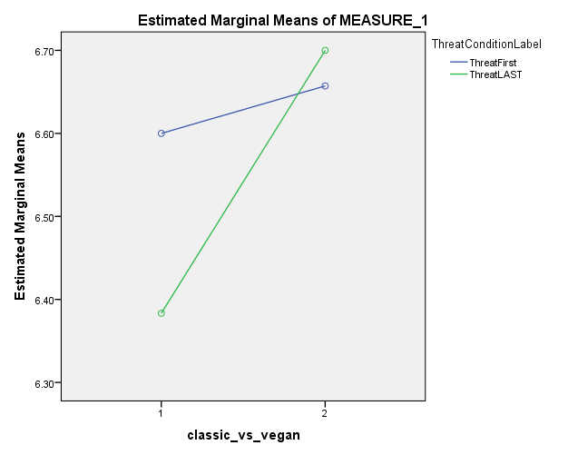
Figure 2. Estimated Marginal Means between Labelled Cookie Preference and Threat Groups. This plot shows the effects of introducing moral identity threat first or last on labelled cookie preference.

Group Statistics
 | ThreatConditionLabel | N | Mean | Std. Deviation | Std. Error Mean
AttitudeAvg | ThreatFirst | 49 | 6.2676 | 1.49346 | .21335
AttitudeAvg | ThreatLAST | 47 | 5.8603 | 1.18753 | .17322
Figure 3. Descriptive Group Statistics of Attitudes towards Vegans by Threat Group.

Independent Samples Test
 |  | Levene's Test for Equality of Variances |  | t-test for Equality of Means
 |  | F | Sig. | t | df | Sig. (2-tailed) | Mean Difference | Std. Error Difference | 95% Confidence Interval of the Difference
 |  |  |  |  |  |  |  |  | Lower | Upper
AttitudeAvg | Equal variances assumed | 8.770 | .004 | 1.475 | 94 | .144 | .40729 | .27612 | -.14096 | .95554
AttitudeAvg | Equal variances not assumed |  |  | 1.482 | 90.916 | .142 | .40729 | .27482 | -.13860 | .95318
Figure 4. Independent Samples T-Test. This figure shows the lack of a statistical difference between means of the Threat First and Threat Last conditions.

Descriptive Statistics
 | Mean | Std. Deviation | N
MoralIdentityThreatSelf | 2.5808 | 2.55721 | 99
AttitudeAvg | 6.1836 | 1.42626 | 101
ClassicAvg | 6.5327 | 1.12544 | 101
VeganAvg | 6.7885 | 1.27890 | 104
Figure 5. Descriptive Statistics. This figure displays the descriptive statistics for Moral Identity Threat, Attitudes towards Vegans, Classic Cookie Preference, and Vegan Cookie Preference.

Correlations
 |  | MoralIdentityThreatSelf | AttitudeAvg | ClassicAvg | VeganAvg
MoralIdentityThreatSelf | Pearson Correlation | 1 | -.300** | .227* | .007
MoralIdentityThreatSelf | Sig. (2-tailed) |  | .003 | .026 | .947
MoralIdentityThreatSelf | N | 99 | 99 | 96 | 99
AttitudeAvg | Pearson Correlation | -.300** | 1 | .095 | .385**
AttitudeAvg | Sig. (2-tailed) | .003 |  | .352 | .000
AttitudeAvg | N | 99 | 101 | 98 | 101
ClassicAvg | Pearson Correlation | .227* | .095 | 1 | .584**
ClassicAvg | Sig. (2-tailed) | .026 | .352 |  | .000
ClassicAvg | N | 96 | 98 | 101 | 101
VeganAvg | Pearson Correlation | .007 | .385** | .584** | 1
VeganAvg | Sig. (2-tailed) | .947 | .000 | .000
VeganAvg | N | 99 | 101 | 101 | 104
**. Correlation is significant at the 0.01 level (2-tailed).
*. Correlation is significant at the 0.05 level (2-tailed).
Figure 6. Correlations. This figure shows the correlations between Moral Identity Threat, Attitudes towards Vegans, Classic Cookie Preference, and Vegan Cookie Preference.

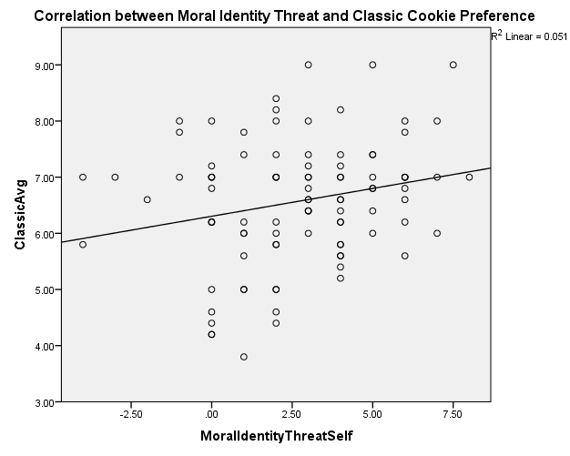
Figure 7. Correlation between Moral Identity Threat and Classic Cookie Preference. This figure shows a significant correlation of r = .227, p = .026.

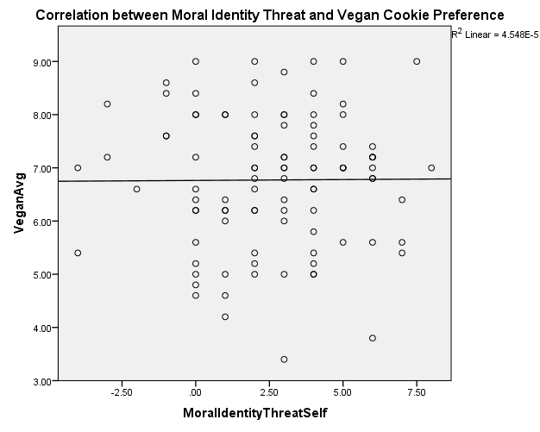
Figure 8. Correlation between Moral Identity Threat and Vegan Cookie Preference. This figure shows a non-correlation of r = .007, p = .947.

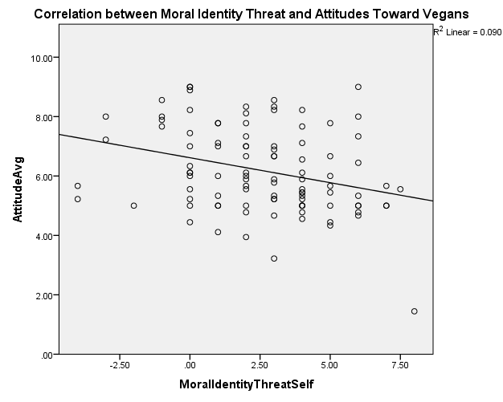
Figure 9. Correlation between Moral Identity Threat and Attitudes Towards Vegans. This figure shows a significant negative correlation of r = -.300, p = .003.

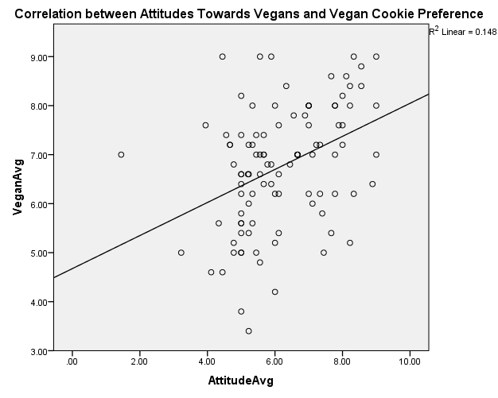
Figure 10. Correlation between Attitudes Towards Vegans and Vegan Cookie Preference. This figure shows a significant correlation of r = .385, p < .001.

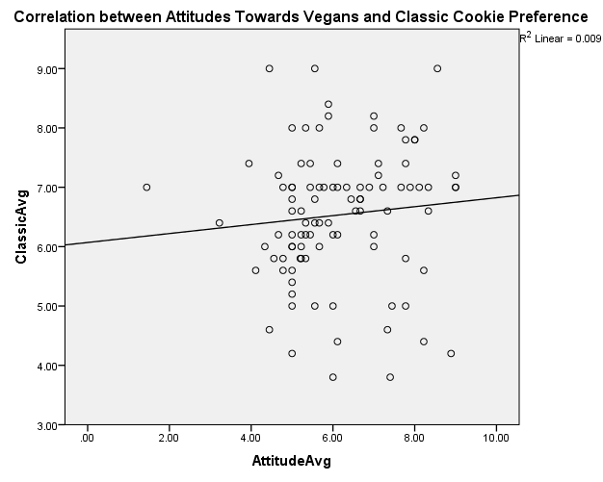
Figure 11. Correlation between Attitudes Towards Vegans and Classic Cookie Preference. This figure shows a non-significant correlation of r = .095, p = .352.

