FACTORS AFFECTING THE QUALITY OF LIFE OF RESIDENTS IN NURSING HOMES; KNOWLEDGE AND STRATEGIES FOR THE NOVICE NURSE

Honors Thesis

Presented in Partial Fulfillment of the Requirements
For the Degree of Bachelor of Nursing
In the College of Health and Human Services
at Salem State University

By
Katelin Angel

Dr. Robin R. Leger
Faculty Advisor
Department of Nursing

***

The Honors Program
Salem State University
2016

Table of Contents

Abstract………………………………………………………………………………………… 3
Introduction……………………………………………………………………………………..4-5
Background and Significance…………………………………………………………………...5-6
Figure 1……………………………………………………………………………………6
Literature Review……………………………………………………………………………….6-9
Interventions…………………………………………………………………………………...9-12
Table 1…………………………………………………………………………………...12
Conclusion……………………………………………………………………………………….13
Select References...……………………………………………………………………………....14

Abstract

Background and Significance: Quality of Life (QOL) is a major focus of practice in all areas of nursing, including promoting QOL for the elderly. New graduate Registered Nurses (RNs) have the option of working in a nursing home for their first career opportunity. The significant increase in the Baby Boomer population (nearly tripling between 1980 –2030) will cause an influx of nursing home residents as they require nursing home services.
Review of the Literature: Quality of Life (QOL) is important to providing quality, holistic care. Many factors encompass QOL. It is necessary for the new graduate RN to learn about interventions that positively impact nursing home residents’ QOL. The literature review speaks only about first-hand studies focusing on nursing home residents’ own interpretations of QOL factors. Several QOL domains were identified including promoting comfort, meaningful relationships, and maintaining autonomy and dignity. Undergraduate nursing education and new graduate orientation programs offer little information on the nurse’s role in promoting QOL in the elderly.
Implications for Novice Nurse Education: A table was adapted to show the QOL domains for the Elderly and possible RN Interventions to positively impact nursing home residents QOL. Provided with education focused on competencies for promoting QOL in the elderly, the new graduate RN will be able to use the interventions presented in the table to realize ways to positively impact QOL of nursing home residents during their first nursing experience as a novice nurse.
Introduction
Quality of Life (QOL) is a multidimensional term that encompasses several aspects of a person’s life. It can be measured by physical, mental, social, economic, or other factors that an individual finds important in life. Nursing care is sometimes aimed at just treating the patient’s illness or physical complications. However, so many other factors can affect a patient’s quality of life. Nursing should focus on holistic care. Holistic care “recognizes the totality of the human being - the interconnectedness of body, mind, emotion, spirit, social/cultural, relationship, context, and environment” (Thornton, 2016). These factors of holistic care have become the cornerstone for examining QOL in patients of all settings.
New graduate RNs (novice nurses) can usually find a job in a nursing home following graduation. Many hospitals want six months to a year of experience before hiring a new graduate. Many nursing homes allow the new graduate to work as a RN without prior experience. This means that many new graduates will end up working in a nursing home following graduation, some by choice, and some because it is the place they could first find a job. Even if it is not their “dream job,” the new graduate should be able to grow and learn from their experience in the nursing home. A good way to make a job a meaningful experience is to positively impact the lives of patients. Instead of strictly focusing on nursing interventions and providing excellent quality of care, the novice nurse can focus on improving the QOL of their patients.
Following review of the literature, I was able to identify QOL domains that affect the quality of life of nursing home residents. I then developed a table to show interventions that the new graduate RN can implement to help improve the QOL of their nursing home patients in addition to providing the standard quality of care.
Background and Significance
One of the options for new graduates in nursing is to work as a Registered Nurse (RN) in a nursing home. “The over-65 population will nearly triple between 1980 and 2030 as a result of the aging Baby Boomers” (Cable News Network, 2013). The aging Baby Boomers create an even larger need for the nurses in the nursing home setting. In addition, many of the Baby Boomers are currently nurses. This creates a double-sided problem in the health care industry. Not only will more nurses be needed to care for the Baby Boomers, but even more nurses will be needed to fill the positions currently held by Baby Boomer nurses. The implication of this increase for the health care industry is to improve nursing home care, in addition to preparing for the influx of residents. Teaching new graduates (novice nurses) the skills to improve quality of life in nursing home residents through thoughtful interventions is largely important. The novice nurse will not only learn to effectively make a positive influence on quality of life of nursing home residents, but also feel that their skills are validated and improved during their first nursing job. The graph below shows the increase in percentage of U.S. citizens over the age of sixty-five from 2010 to 2035. The graph shows that in 2010, approximately 14% of U.S. citizens are older than sixty-five. This percentage increases to 20% of the population over 65 by 2035 (Figure 1). If every new graduate nurse can learn how to effectively and compassionately care for elderly patients, the elderly patients will enjoy a more positive quality of life.

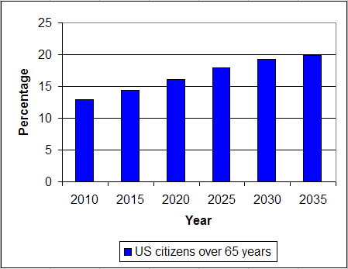

Figure 1 : Growth of 65+ US Population from http://www.w3.org/WAI/presentations/aging/

Literature Review
The review of the literature yielded information about Quality of Life (QOL) in general, Health-Related Quality of Life (HRQoL), the relationship between QOL and Aging, and the relationship between QOL and nursing home residents. “Quality of life (QOL) is a broad multidimensional concept that usually includes subjective evaluations of both positive and negative aspects of life” (Center for Disease Control, 2011). The definition encompasses various aspects of a person’s life. QOL perception can change based on experiences and conditions.
One major aspect of QOL significantly impacts overall QOL perception. Physical QOL or Health-Related Quality of Life (HRQoL) “includes physical and mental health perceptions and their correlates—including health risks and conditions, functional status, social support, and socioeconomic status” (CDC, 2011). It is important to realize that HRQoL significantly impacts overall QOL. For example, health-related problems such as COPD, heart disease, arthritis, incontinence, and others can hinder a person’s ability to do all the activities they want to do, therefore bringing down their individual perception of their own QOL. It is important to distinguish between quality of care and QOL. Quality of care refers to the patient’s physical needs being met. Essentially, quality of care refers to whether or not the patient received the right services, medications, tests, procedures, interventions, and outcomes. “The distinction between quality of care and QOL is perhaps spurious because the former contributes to the latter” (Kane et al, 2003). Although impossible to explain QOL without mentioning HRQoL, there are so many factors besides HRQoL (comfort, dignity, relationships, autonomy, etc.) that impact overall QOL.
Elderly people face QOL challenges related to aging that the younger population does not experience. “Factors of particular concern for elderly patients included sleep disturbances, limitations of mobility, loss of vital energy, and the presence of painful ailments” (Muszalik, 2015). As people age, they can begin to experience a wide range of physical limitations. These limitations impact their ability to carry out functions of daily living and other pleasurable activities. It may be harder for a person to do every day activities like showering or dressing themselves if they are experiencing limitations of mobility. An aging person experiencing the loss of vital energy might not have the energy to do a sport or group activity that they would typically enjoy doing. Painful ailments and other diseases may limit an elderly person’s ability to walk, drive, or fly in a plane. Because of these age-related issues, QOL for elderly patients includes factors aimed at helping the individual retain as much independence and functional ability as possible while staying safe.
The elderly population can be split into two groups: those that remain living at home and those that live in a nursing home. Elderly people who live at home are able to retain almost all of their independence and privacy in the home. At times, they may hire nurses or aides to assist with house-hold tasks or ADLs, but they still get to remain in the comfort of their own home. Elderly people who become nursing home residents face potential privacy and independence issues. At a nursing home, there may be set times for meals, bedtime, wake time, activity time, shopping time, etc. Nursing homes provide care for multiple patients at a time. It is necessary for the nursing home to have these set times for meals in order to provide for the number of residents there. However, this can feel like a limit on independence for nursing home residents who may want to have a late lunch or an early dinner, for example. Loss of independence and privacy are huge concerns for nursing home residents. Independence and privacy are two of the factors identified as either positively or negatively impacting overall QOL. "From the perspective of the individual resident, the concept of QOL refers to their perceptions of their own lives, as a function of their own personal preferences, personality, and life history as experienced in the daily environment of a nursing facility" (Degenholtz, 2014). Another challenge that a nursing home faces is catering to the needs of individual people. People have different traditions, preferences, and values depending on their backgrounds. There may be only three choices of meals for each dinner, and there might not be something that each individual wants that day. Another issue is availability of activities. It could be poker day, but an individual might want to do aerobics. Nursing homes have the challenge of trying to keep each individual happy, despite the standardization of nursing home routines.
The literature is saturated with studies focusing on QOL of the elderly. Some studies examine the nursing home residents’ QOL from the perspective of the residents’ family members, caregivers, nursing home staff, etc. However, there were only limited studies that examined QOL from the view of the resident themselves. These studies yielded several factors that are essential to QOL of nursing home residents. More research needs to be done to confirm the importance of the factors affecting quality of life. Additional research needs to be done to show how specific interventions affect the quality of life of nursing home residents.
Since many new graduate nurses can work in a nursing home for their first career, it is necessary for them to learn about factors that affect the QOL of their patients in a nursing home setting. This knowledge can also be applied in a hospital setting on a more short-term basis, since 20% of the population will be over the age of 65 by the year 2035. In addition to learning about factors that affect QOL of nursing home residents, it is also necessary for new graduate nurses to implement effective interventions to positively affect QOL.
“Beginners have no experience with the situations in which they are expected to perform tasks. In order to give them entry to these situations, they are taught about them in terms of objective attributes. These attributes are features of the task that can be recognized without situational experience” (Benner, 1984).
It is difficult for the new graduate nurse to go “above and beyond” their nursing duties and try to positively affect QOL, because they are taught to do their specific job duties and provide effective quality of care. As mentioned before, there is a difference between quality of care and QOL. A novice nurse would be able to provide good quality of care by following the rules and tasks learned in school, but they might not learn about affecting QOL in school.

Interventions
After reviewing the literature, it became clear that several QOL domains were identified as important. One table from (Kane et al, 2003; Table 6) clearly presented the quality of life domains with the specific items that affect those domains. Using the table (adapted from Kane et al, 2003; Table 6), I adapted a new table that included a column for "Nursing Interventions" that will positively address and fix the specific items, and therefore positively affect the quality of life domain. I found the “Interventions” for each domain from my nursing textbook. For example, under the "Comfort" domain, patients were saying that they spent "Too long in the same position", were "In physical pain", and "Get a good night's sleep". These three things were the top factors that affected the comfort domain. The nursing interventions I added to help patients feel more comfortable are: Reposition at least every two hours, assess pain levels frequently and medicate appropriately, and provide PM care (wash face, back, brush teeth, etc). Although these interventions may seem simple, it is necessary to remind a novice nurse that simple interventions are sometimes the most important. Instead of only worrying about medication administration and assessments, it is necessary for the new graduate RN to assess the patient for comfort. The novice nurse should make sure that repositioning is occurring every two hours to prevent ulcers, check for incontinence, and promote comfort.
Another major quality of life domain on the chart I adapted is "Dignity". The specific items that go along with dignity are "Staff treats you politely", "Staff handles you gently", and "Staff listens to you". The interventions I came up with to positively impact these items are: Always use manners with patients (please, thank you, excuse me), be patient and handle everyone with care, know the patients' limits, use proper body mechanics and necessary tools when performing ADLs or transfers, take time to listen to each patient, and show empathy and compassion. Some of these interventions may be common sense, but while reviewing the literature, I was surprised to find that many patients did not feel respected by nursing staff. It comes back to quality of care vs. quality of life in this domain, too. Many new graduate RNs may feel overwhelmed with a full assignment. Instead of rushing from patient to patient, it is necessary to take time to listen to each patient and not rush them. It is necessary to know about a patient’s limitations before trying to move them in any way. A new graduate RN should ask about each patient’s mobility if he/she is not told about it in report. Another important intervention for preserving dignity is always covering a patient as much as possible when performing procedures or assessments, pulling the curtain or closing the door, and knocking before entering a room.
The other two QOL domains are “Relationships” and “Autonomy” (Table 1).

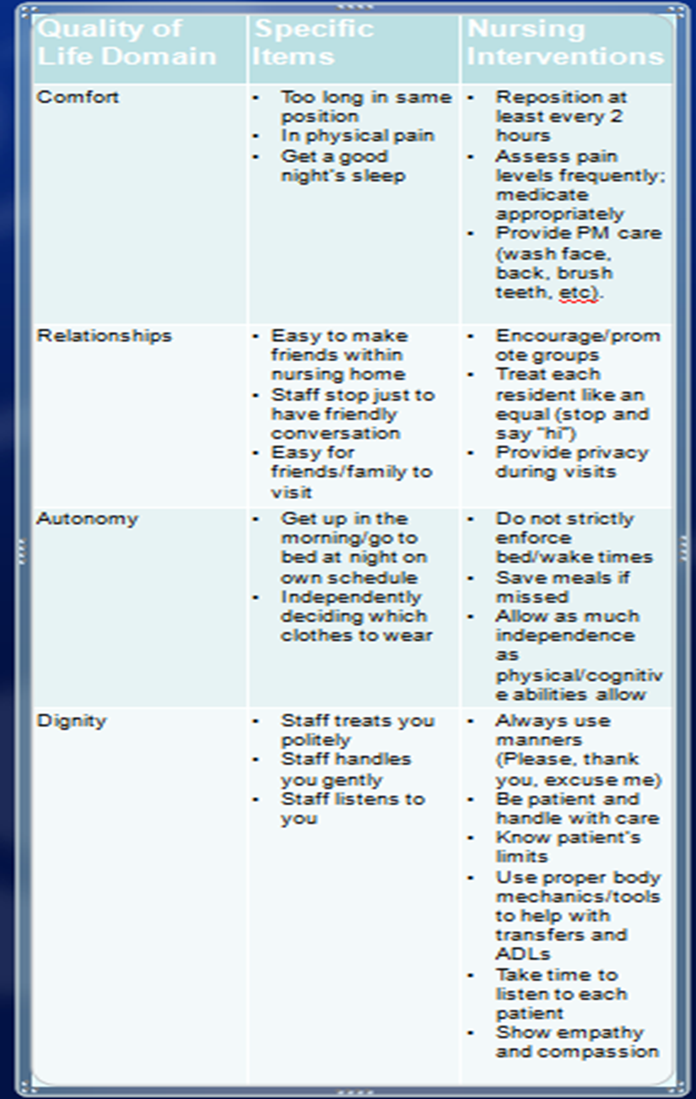

Table 1: Quality of Life Domains with Specific Items and Interventions. (Adapted from Kane et al, Table 6, 2003)
Conclusion
The novice nurse as a new graduate RN has a lot to learn in terms of time management and gaining experience. However, it is so crucial that the new nurse remembers to treat the whole person, and not just the illness or physical complication. The role of a RN might be overwhelming at first, but the nurse cannot forget to always work towards improving the quality of life of their patients. Simple interventions such as listening and knocking before entering a room are so important to helping nursing home residents feel respected and cared for. In school, the QOL interventions are not always talked about unless they have a medical purpose, but this does not mean they are not important. Quality of care is part of QOL, but it is only just one part of the greater QOL definition. Promoting comfort, forming relationships, and maintaining autonomy and dignity are necessary in improving a nursing home resident’s QOL. The new graduate RN can make a positive difference in a nursing home residents’ lives by thinking outside the box and treating the resident as a whole and equal person. Nursing faculty and nurse educators within the clinical environment should provide a curriculum for novice nurses to gain competencies in strategies for promoting QOL in older adults.

Select References
- Baby Boomer Generation Fast Facts (n.d.). In CNN. Retrieved November 8, 2015, from http://www.cnn.com/2013/11/06/us/baby-boomer-generation-fast-facts/index.html
- Benner, P. (1984). From novice to expert: Excellence and power in clinical nursing

practice. Menlo Park, CA: Addison-Wesley Pub. Co., Nursing Division.

- Degenholtz, H. B., Resnick, A. L., Bulger, N., & Chia, L. (2014). Improving Quality of Life in nursing homes: The structured resident interview approach. Journal of Aging Research. doi:http://dx.doi.org/10.1155/2014/892679
- Muszalik, M., Kornatowski, T., Zielińska-Więczkowska, H., Kędziora-Kornatowska, K., & Dijkstra, 2015. A Functional assessment of geriatric patients in regard to health-related quality of life (HRQoL). Clinical Interventions in Aging, 10, 61–67.. (2015). Retrieved February 8, 2016, from http://doi.org/10.2147/CIA.S72825
- Centers for Disease Control and Prevention. HRQoL (n.d.).. Retrieved February 8, 2016, from http://www.cdc.gov/hrqol/concept.htm
- Kane, R. A., Kling, K. C., Bershadsky, B., Kane, R. L., Giles, K., Degenholtz, H. B., & Liu, J. (2003). Quality of Life measures for nursing home residents [Electronic version]. Journal of Gerontology: Medical Sciences, 58A(3), 240-248.
- Thornton, L. (2016). What is Holistic Nursing? American Holisitic Nurses Association. Retrieved February 8, 2016, from http://www.ahna.org/About-Us/What-is-Holistic-Nursing

