CREATIVE SALEM: A PUBLIC RELATIONS REPORT

Honors Thesis

Presented in Partial Fulfillment of the Requirements
For the Degree of Bachelor of Science in Communications

In the College of Arts and Sciences
at Salem State University

By
Alyse Diamantides

Professor Cindy Vincent, Ph.D.
Faculty Advisor
Department of Communications

***
Commonwealth Honors Program
Salem State University
2018

Abstract

This project serves to clarify and simplify the brand identity of Creative Salem –– an integral organization that connects creative individuals, community and commerce in the city of Salem under owner and chief creator, John Andrews. After extensive background research and planning, a proposal report was created to highlight what Creative Salem is and how it helps the community. The goal was to lay the foundation of the brand from a public relations lens in order to help the business grow and continue to become more financially sustainable as it expands into more communities across the North Shore. For this project, I began by conducting background research on my client and establishing a PR plan with deadlines. As the timeline progressed, I created materials such as a mission statement, elevator pitch and media relations kit that included a backgrounder, news release, fact sheet, staff biographies, illustrated designs, and media links, along with other supporting documents. From then, I organized and conducted a focus group of 10 people to present the information I created and receive feedback. As a result, I listened and took into consideration their advice and presented the final materials to my client for ultimate review.

Table of Contents
Acknowledgements iv
Introduction 1
Literature Review 2
Research 6
Planning 15
Proposal Report 16
Implementation 19
Evaluation 32
Conclusion 35
Bibliography 36

Acknowledgements
I first want to thank the person who has been with me since the start, providing incredible feedback and advice every step of the way, my advisor, Cindy Vincent. Without her guidance over the past semester, this project would have never been completed. She helped me approach situations with a critical eye, while enabling me to think of the best possible ways to cope with setbacks and solve problems in a professional manner. Thank you for being part of this journey with me to help make a difference, even the smallest of ones, for a community organization and resource that is beyond crucial to the city of Salem.
I want to thank my communications professors who instilled in me the skills and tools needed to complete a project of this scale. Without their guidance over the years, I would have never been able to create and execute a proposal report such as this. I also want to thank Scott Nowka and the rest of the honors faculty for helping me become a more serious student as well as a creative and analytical thinker. Their encouragement facilitated this thesis project and saw me through it until the end.

Introduction

During my college career, professors have defined public relations as the strategic communication process that builds mutually beneficial relationships between organizations and their publics. But what does that really mean? And more importantly, how can it be used in day-to-day life? Many examples reference case studies, journals or other articles highlighting certain companies that are important to take note of and use as inspiration to construct your own successful public relations campaign. But even after reading those, nothing was relatable.
During the fall, I met John Andrews, the owner and chief operator of a unique organization in the city –– Creative Salem. His business helps support the growing arts community in Salem, Massachusetts by promoting artistic events around the city and providing the tools local, creative professionals need to connect with audiences across the North Shore. He and his associates work to better Salem’s economic community and artistic growth. At that time, Andrews was looking to expand his business, but Creative Salem’s brand identity was inconsistent and confusing. He needed an outside voice and perspective to offer feedback and advice regarding his company. This inspired my thesis, and I began looking into how beneficial a partnership between myself and Creative Salem could become. How could I use the skills I’ve acquired so far to help an organization that is vital to the city where I go to school? This report summarizes current best practices in public relations, specifically focusing on campaigns, and serves as a toolbox I used to conduct my own public relations report for Creative Salem.

Literature Review

“Public relations at its core is developing compelling messages and delivering those messages to key audiences to shape opinion or influence behavior” (Powers, 2017). From my readings and the information I’ve learned in college seminars, public relations is all about creating and maintaining relationships. This can be done by influencing attitudes and building brand trust in a variety of ways, but it is commonly accomplished through press kits, articles, websites, news releases, press conferences and other written material (Moody, 2012). PR practitioners help communicate a specific message from a client or organization to the public through a strategic, organized campaign process. But what is a public relations campaign? In an article published on Chron Houston Business and Financial News, the author defines three characteristics that are essential in running a successful PR campaign: identifying an objective, finding the message that will help you achieve that objective, and communicating that message to the appropriate audience (Lister, 2017). Successful campaigns start with a strong objective that will make the planning, implementation and evaluation of a campaign that much easier and more effective.
Next, it’s necessary to decide which message you’re trying to communicate to audiences (Lister, 2017). But determining your target audience can be difficult, and Lister suggests to focus your efforts on those that are most likely to respond to your message. In terms of my project with Creative Salem, it was essential to keep in mind audiences who already established a relationship with the organization and who would consider becoming more involved, possibly with their membership program.
Current Public Relations Practices
The study titled “Integrating Public Relations with Advertising: An Exercise for Students in the College Public Relations Campaigns Course” highlights ways to research, analyze, plan and execute a campaign for a real client. The author discussed that more and more recently, PR and advertising have joined together and created an integrated marketing communication approach because at the core, both strive to change or persuade the public’s attitudes or behaviors (Moody, 2012). While PR aims to deliver messages to audiences, advertising aims to attract the audience’s attention and has more ultimate control over their key messages through paid media (Moody, 2012). Moody concluded that the “marriage” of PR and advertising techniques proved to be the most successful for the campaigns.
In a similar study involving undergraduate students, the author observed students as they conducted their own campaigns for nonprofit and for-profit organizations. According to “Assessing Public Relations Student Learning and Performance in Real World Client Campaigns and Projects,” past research showed that employers are becoming more and more dissatisfied by the work produced by current undergraduate students after they leave school and find them “unprepared for the realities of the workplace” (Swanson, 2014). To help with this, the study exposed students to real-workplace elements, like working with clients, similar to what I am working on with Creative Salem. The students were divided into teams, assigned a client and asked to create a campaign proposal. Students began gathering research, conducted a SWOT Analysis of their organization's strengths, weaknesses, opportunities and threats, set realistic goals and objectives, established their target audiences, set strategies, established a proposed budget, and outlined outcomes and tools for measuring the effectiveness of the overall campaign (Swanson, 2014). As I work with Creative Salem, I’ll be closely following the same steps as these students before launching my own endeavor.
What Businesses can learn from Nonprofit Organizations
When the article “Managing Public Relations in Nonprofit Organizations” was written, there were over 1.5 million nonprofit organizations in the United States (Buell, Dyer, Harrison & Weber, 2002). And these nonprofits use and need PR. Although Creative Salem is a for-profit organization, it has close similarities to those described in this article. Nonprofits are trying to meet the needs of the community but are realistically operating with a small staff of usually one person who has the responsibility of handling all the PR (Buell, Dyer, Harrison & Weber, 2002). This is very much the case at Creative Salem where the majority of work falls on John Andrews. For nonprofits, the biggest challenge is spreading the word. Efforts are devoted to communicating to stakeholders what their organization is because “if the public does not know what the organization is and what it does, then the public does not donate money” (Buell, Dyer, Harrison & Weber, 2002). Creative Salem is facing similar challenges with spreading the word about what they do. Practitioners from nonprofits all over the country defined PR as “your visibility in the community,” or “community awareness of what our organization is” (Buell, Dyer, Harrison & Weber, 2002). These practitioners face constraints when it comes to time, money, resources and people-power, but also have difficulty defining their target audience. The study showed it’s also critical to identify the stakeholders, who are “any group or individual who affect or is affected by the achievement of the organization’s objectives” (Buell, Dyer, Harrison & Weber, 2002). For small businesses, like Creative Salem, with limited time, money and resources, those working there like Andrews are faced with tackling multiple responsibilities.
Digital Age of Public Relations
In an article published by the New Hampshire Business Review, the author discussed how there are more opportunities than ever for businesses to share their messages and shape their brands. Today’s digital revolution gives PR practitioners more channels to communicate their client’s messages, but it also brings up some of the negative consequences of “going viral” (Powers, 2017). For example, the video of a passenger being dragged off a United Airlines plane shows the possibilities that arise when disseminating information. News travels fast and millions of people saw the video and witnessed the company’s insincere apology (Powers, 2017). Today integrated communications techniques are deployed across multiple channels, which still include traditional written materials, but added social and online elements that shows real-time analysis of a campaign's impact, reach and interaction with influencers (Powers, 2017). But despite this digital age, Powers stressed how real, personal connections are still essential to PR firms. It will always be of top priority to develop relationships with reporters and editors, further establishing and maintaining that human interaction –– all of which Creative Salem hopes to facilitate moving forward in the future (Powers, 2017).

Research
The goal of this project is to clarify and simplify Creative Salem’s brand identity by clearly defining what it is and how it helps the community. It’s an incredibly unique organization to Salem and has an established brand trust around the city, but the company needs to grow and become more financially sustainable, especially as it expands into communities across the North Shore through its umbrella company, Creative Collective. This research section includes the following: project overview, SWOT Analysis, membership information, target audience, Salem demographics, social media use, psychographics and public perception and testimonials.
Project Overview
This public relations proposal serves to reinforce Creative Salem’s brand identity in order to highlight how it benefits the community of Salem and how residents and community members can support and join the organization. In order to accomplish this goal, a media relations kit was created that includes a backgrounder, fact sheet, press release, video clips, images and media links. An elevator pitch, revised mission statement and staff biographies are also included in order to get a better sense of Creative Salem’s brand identity and mission.
SWOT Analysis
First, I conducted a SWOT Analysis –– or analyzed Creative Salem’s internal strengths and weaknesses and external opportunities and threats. Internally, Creative Salem is a completely unique organization in the Salem community –– no one else is doing what they’re doing. Andrews is great at promoting art and culture to both community members and local businesses, and the business would not be here today without Andrews’ tireless efforts. He and his team help promote the creative scene of Salem, in addition to hosting events and being a resource for people to go to in order to find out what’s going on locally. But there are also internal weaknesses, including major areas of improvement relating to spreading the word about Creative Salem, solidifying the company’s brand identity and clearly deciding what the brand should and shouldn’t be. Inconsistent brand messaging and overall confusion could be perceived as a weakness by people, especially non-residents. In terms of external opportunities, Andrews is expanding and moving in the right direction with his umbrella company, Creative Collective. He’s working with sponsors and increasing his brand’s digital growth on social media.
But like any organization, there are also external threats. For Creative Salem, this includes financial stability and major areas of competition, such as the Salem Chamber of Commerce and the Peabody Essex Museum. There’s also the threat of public perception of Creative Salem, or how everyday community members, visitors and new residents to the area view the organization and what they do. Regardless of any company’s established brand trust, there’s always the possibility of how they’re being depicted in real life, online and on social media that influence people’s opinions and thoughts. Creative Salem’s relationship with the museum is one of necessity, and although PEM is not a direct competitor, the museum dominates the city in terms of arts funding and collection of resources from those who have an interest in the arts.
Membership
Creative Salem operates on the support of its membership program. It’s community membership, which is $65 a year, now has over 350 members and provides a way for people to support the arts, save money on events and gain early access to tickets and other promotional events. Creative Salem also has over 30 business memberships, who pay $40 a month for promotional advertisements, banners and other marketing resources.
Target Audience
Creative Salem’s target audience includes artists, creatives and event organizers who care about the health and vitality of Salem. This primarily includes Salem residents who enjoy their community and are involved in local events. But the organization extends its reach to those who are new to the area as well as local businesses and community partners who can benefit from Creative Salem’s membership program perks. The organization also primarily narrows in on women between the ages of 21 to 40 years old in terms of its marketing materials.
Salem Demographics
Salem is a unique city, where history, art, culture, community, restaurants and interesting people all combine. Creative Salem links up the best parts the city has to offer, making it known to not only Salem residents but also to the local community.
- Statistics (Data USA, 2017)
  - Population: 42, 499
  - Median age: 36.5
  - Median household income: $60,700
  - Poverty rate: 14.4%
  - Median property rate: $308,800
- Demographics
  - White: 31,316 (about 78%)
  - Hispanic: 7,025
  - Black: 1,915
  - Median native-born citizens age: 35
  - Median foreign age: 41
    - Median Male Age: 34
    - Median Female Age: 37
    - 21.8% of population is under 20
    - 18% are in 20s
    - 14.5% are in 30s
- Population: 42,499
  - Compared to 2014––when average was 37, Salem residents are getting younger
  - 40% population married, 44% unmarried
  - Average family size: 3 (smallest compared to surrounding towns)
  - Most common birthplace origin: Dominican Republic, Brazil, Italy
  - Military veterans: large population of citizens who served in Vietnam
- Economy
  - Number of employees: 22,558 (1.72% growth)
  - Most common job groups: Management, Business, Science & Arts; Sales & Office; Service
  - Occupation: Arts & Recreation 3.3% (one of most specialized)
  - Industry level: Arts, Entertainment & Recreation: 3.7%
  - Salem has an unusually high number of Arts, Entertainment and Recreation industries
- Education
  - Most common concentration for bachelor’s degree: Registered Nursing
  - Also high number of students obtaining bachelor’s in Mass Communication & Media Studies
  - Salem State University graduates: 700 men to 1,500 female
- Borders Beverly, Danvers, Lynn, Peabody, Marblehead and Swampscott
- Salem has largest population of people ages 20–29 years old compared to surrounding communities
- Median female age: 37
Audience Social Media Use
Social Media Use Women ages 21 to 40 Years Old, (Duggan, 2015)
- Facebook
  - Most widely used platform: 70% of American users
  - 82% (women ages 18–29)
  - 79% (women ages 30–49)
  - Suburban Facebook use 72%
- Instagram
  - 55% (women ages 18–29)
  - 28% (women ages 30–49)
  - Suburban Instagram use: 28%
- Twitter
  - 32% (women ages 18–29)
  - 29% (women ages 30–49)
  - Suburban Twitter use: 21%
- Daily Usage
  - Facebook: 70% users
  - Instagram: 59%
  - Twitter: 38%
- Snapchat Statistics
  - 71% are under 34 years old
  - 45% users between 18–24
  - 70% of users are female (Aslam, 2017).
- 80% of time spent on social media happens on mobile device
- Women generally prefer visual platforms while men gravitate toward text-oriented mediums. Facebook, Instagram and Pinterest have a larger female user base (Atanasova, 2016).
  - Women are more prone to producing and sharing more visual content and are drawn to visual platforms, share more personal information and use emojis frequently.
  - Men primarily use social media to find information, focusing on more text-based platforms and forums to find out more about abstract topics. Posts from men usually include more text and fewer selfies.
Psychographics
Psychographics is the classification of people in terms of their attitudes, activities, values and aspirations. This includes individual opinions, music tastes, religious beliefs, personality traits, lifestyle choices, and places they congregate on and offline. For example, Creative Salem can keep this in mind when gearing marketing content towards their target audience. In the future, the organization could use more in-depth surveys, interviews or public opinion polls to get a better understanding of the mindset of who they’re trying to reach in order to successfully promote events, artists and creative endeavours happening around the city.
Public Perception & Testimonials
- People come to Salem from all over the world to see the great show of an amazing mix of culture, art, history, and wonderful people. If Salem is the circus then Creative Salem is the ringmaster. Creative Salem is a touchstone for those who want to know what's shaking in Salem whether is be a classic tradition, a new hot music spot, or a festival full of fun for the whole family. And when Creative Salem throws a party it is an unbelievably well planned and glorious thing! The recent Venetian masquerade ball at the Hawthorne Hotel started off as a crazy idea from the genius behind Creative Salem and ended as one of the most beautiful evenings I have ever had the honor of being a part of. Creative Salem links up all the best parts of this city so that the residents can revel in this gorgeous place, but also knows exactly how to share all that excitement with the rest of the world through ingenious marketing that's clever, fun, and approachable.
- We are so fortunate here in Salem to have Creative Salem working so hard to make our city vibrant, beautiful and fun! Whether they are creating and running a cool masquerade ball or interesting festival; bringing attention to all corners of the arts scene around town; photographing an event so strikingly; or thinking outside of the box to help push our city forward in a unique, inclusive way - they are a treasure here in Salem! They are my own first stop whenever I need to think about a challenge in a new way and I highly recommend them!
- Creative Salem provides valuable services to our city. By connecting creatives and facilitating creative projects, CS has imbued Salem with a vibrancy and energy that is unique to our community. As a jazz vocalist, I have booked paying gigs due solely to my connection with the Creative Salem network. As the co-founder of a non-profit historical organization, CS has provided me with marketing services and helped to spread the word about our mission. In a national political climate in which the importance of the arts and the humanities is belittled or denied, Creative Salem's services ensure that Salem maintains a creative economy that is absolutely essential to the health and well-being of our community.
- John is a delight to work with. Quick grasp of the situation. Knows what to do. Easy going. Good-natured. Funny. Quick follow-up/turnaround. He also REALLY knows Salem. Who is who. What shots are important, etc. No matter who is running around taking pictures at any given event, John's are invariably the best and most-used. If John is on the job, I don't worry. As an event planner, that's pretty important!
- Creative Salem has been a huge benefit in many ways...They are great at making us aware of all the cool goings on in Salem. They also have excellent programs that we constantly take advantage of, getting discounts at our favorite eateries and entertainment venues. They also catalog so much of what's Salem and capture the spirit and energy of the City and people. Thanks Creative Salem!
- Creative Salem beats to the pulse of the arts on the North Shore. They support and promote the creative community and small businesses, host amazing events, and should be your go-to resource to find out about amazing things happening locally.
- Creative Salem is an amazing venue for promoting the local creative arts scene. John works tirelessly at this unending and sometimes thankless task. Without his efforts, the creative arts scene would not be nearly so prolific.
- Professional, passionate problem solvers with a strong sense of community and social involvement. Also, they are just cool peeps.

Planning
After conducting extensive background research, I established a public relations project proposal for Creative Salem 2.0. The goal I outlined was to reinforce who Creative Salem is, what it does, how it benefits members of the community and how Salem residents and community members can support and/or join the organization. My proposed objective to be completed by December 2017 was to show an increase in public perception of the Creative Salem brand identity by 10 percent by holding a focus group and showing those present what the brand looked like before and after. The first strategy I proposed was to create a clear and concise mission statement. I accomplished this by collaborating with Andrews to decide what must be included in the main mission statement and what can be more in-depth on the “About” page; and by asking some of Creative Salem’s closest supporters to describe the organization in one sentence. The second proposed strategy toward achieving my goal was to create an elevator pitch for Creative Salem. This would be accomplished by adapting the pitch from the recently-made mission statement and condense it into a 30-second (75 word) speech. The final strategy was to create a media relations kit by December 2017. This would include composing an easily accessible digital media kit that contains resources and information that is easily made available to future investors, reporters and media outlets. I’d then create a backgrounder for Creative Salem, containing all pertinent facts and figures, brief staff biographies, pictures, videos and other related articles published about Creative Salem in the news.

Proposal Report

Project Specifications: Media Kit
Creative Salem needs to add an additional, crucial tab to their website –– one specifically intended for the media that includes all press coverage. It could be placed as an additional sub-tab under “Resources,” or a new “About” page could be added specifically for this purpose. Everything created and included in this report will serve to clarify and further explain the necessary materials to begin using immediately and how to use them. The wordle design is intended to be used as the banner ad to represent Creative Salem’s “Press & News” page.
A media kit is a pre-packaged set of materials that can be distributed to news media, which typically includes backgrounders, press releases, fact sheets, video clips, images and media links. This includes every piece of information an organization or brand would want to have the media pick up and use for future news article coverage. This media kit can be compiled digitally and presented on Creative Salem’s website as part of a new tab under “Resources” titled “Press & News.”
- Backgrounder
A backgrounder is a section of the media kit that briefly summarizes the history and key information about a company for the press and media. It is often provided with press releases. For example, if Creative Salem hires a new employee, freelancer, intern or begins working with a new business associate or partner, this piece of information can be presented to give a better overview of who Creative Salem is and what they do.
- Fact Sheet
A fact sheet is a tool that provides a quick-glance view of a company and is used to supplement a news release or website. The fact sheet created targets community members and potential business investor relationships. It provides a clear and concise visual image of who Creative Salem is and what they do. It could either be printed and handed out during events or around town or remain digital and spread online via social media.
- Media Links
As part of the media kit, links to articles, blog posts and other sources where a company’s name is mentioned or featured is included. For Creative Salem, the compiled list of links will offer media a glance of its news coverage and will be included under the new tab of their website, under Resources, titled “Creative Salem in the Media.”
- Suggested Items:
  - News Releases
A news release, or press release, is a written form of communication used to announce something newsworthy to members of the media. For example, Creative Salem has written news releases in the past to highlight new initiatives and most recently drafted one to announce the launch of its umbrella company, Creative Collective. Once written, future news releases can be published under the tab added to Creative Salem’s website, further highlighting the company’s extended news and press coverage.
  - B-roll video clips & Images
As part of a media kit, extra pieces like b-roll clips and eye-catching, high-quality images can be included to help enrich the story a company is aiming to tell. Creative Salem has numerous videos and images that can be further utilized by posting them as part of this larger media kit on their website.

Implementation
In order to implement what I was working on, these pieces were created to help reinforce Creative Salem’s brand identity. A backgrounder was drafted to summarize the history of the company and relay key information. Creative Salem’s current mission statement was revised and simplified into distinct sections of who Creative Salem is, what they do, how they do that and how you can get involved. The elevator pitch was then crafted to concisely describe Creative Salem in under 30 seconds, which will help John and his team when pitching the company to new clients or potential business partners. Staff biographies for John and Robyn were written to add a more personal side to the business. For example, the revised mission statement, backgrounder, elevator pitch and biographies can be featured under the new tab of Creative Salem’s website on the main page under “Press & News” to give news media a concise, quick glance of the company. A visual fact sheet and illustrated wordle design were also designed with the public in mind.
  - Backgrounder
  - Mission Statement
  - Elevator Pitch
  - Website
  - Staff Biographies
  - Visual Fact Sheet & Wordle Design
  - Media Links
  - News Release


BACKGROUNDER
Creative Salem
Based in Salem, Mass., Creative Salem celebrates the city by connecting the local community with creativity. It works to capture the spirit and energy of Salem by fostering an appreciation for the arts and helping local artists and businesses thrive in this close-knit creative community. This is accomplished by facilitating the growth of the local arts scene by supporting creative organizations, artists and collaborators in and around Salem. The organization connects creative professionals with audiences across the North Shore in order to expand creative initiatives through online marketing, media coverage, advocacy and consultations with artists, nonprofits and small businesses.

Organized in 2014, Owner and Chief Creator John Andrews leads a team of professionally driven problem solvers who are passionate about the arts scene of the city and have a strong sense of community. Andrews built an extensive network over the years, both with city officials and community members, especially from his consulting work as a professional photographer. Andrews frequently works one-on-one with artists, often traveling to see their pieces and making the necessary steps to have their artwork displayed in Salem through discussions with city officials as well as online and word-of-mouth advertising initiatives. For example, Creative Salem worked with the city of Salem and Salem Public Art this year to help bring the pop-up art installation, “Neo Dream,” to Artists’ Row in November. Over 1,500 people visited the temporary exhibit.

Key Attributes
One aspect Creative Salem is widely known for is its detailed calendar listings and descriptions of events. The events calendar is the most comprehensive Salem events listing that shows an array of community, art, music, performance, fundraising and workshops happening in and around Salem. Residents, visitors and community leaders have come to view Creative Salem as a resource to find out what’s happening locally.
Community Impact
Salem is a unique cultural destination where history, art and community combine. Bordering the communities of Beverly, Danvers, Lynn, Peabody, Marblehead and Swampscott, Salem has a population of over 42,000 residents. The work being done by Creative Salem continues to provide beneficial and valuable services to the city. Over the last four years, the organization has infused the city with an energy that’s completely unique to the local community, showcasing Salem’s beautiful and unique assets. The city has unusually high numbers of arts, entertainment and recreation industry jobs. Creative Salem draws on that and works to increase revenue for local businesses by bringing people to all corners of the arts scene, especially Artists’ Row, which helps boost the local economy and visitor foot traffic. Its ultimate goal is to maintain the creative economy of Salem that’s essential to the health of the city.
North Shore Expansion
Creative Salem recently launched its business expansion initiative, Creative Collective, LLC. This newly established umbrella company will further promote and support existing creative communities across the North Shore. It aims to be a chamber for creative professionals by serving as consultants as well as an event and lifestyle marketing company. Creative Collective affirms that a healthy, creative scene ensures better economics and quality of life in all communities.
Membership
Creative Salem financially operates on the support of its membership program, which now includes over 350 individuals and local businesses. Members receive local restaurant, event and retail discounts. Currently, 350 community members pay $65 a year to gain early access to events, promotional ticket access and other discounts at local restaurants. Seventy percent of these community members actively use their membership cards at places and events around the city. Creative Salem also has 30 business members who pay $40 a month for advertisements, banners and other promotional marketing material.

Social Media Presence
The organization has an active online presence on various social media platforms. Over 80 percent of its target audience uses Facebook, and Creative Salem has over 13,000 likes and followers, reaches over 1 million people a year, and has a rating of 4.9 out of 5 stars. The organization currently has 8,768 followers on Instagram, a platform which has recently been showing strong growth with over 31,000 weekly impressions. Creative Salem also publishes an online newsletter with over 1,600 subscribers and a 70-percent open rate via email.
Mission Statement
“Creative Salem connects creatives, community and commerce in Salem”

Who We Are
We’re locals driven by creativity and innovation and are your go-to resource to find out what’s going on locally.
What We Do
We work every day to help creative professionals access the business community, connect residents to events, sources of culture and creative businesses, and provide a platform that showcases all of this to drive commerce and culture to the Salem community.
How We Do That
We provide online marketing, detailed calendar listings, media coverage, advocacy and consultations to help promote local artists, nonprofits and small businesses and our membership program.
How To Get Involved
Shop at local creative businesses, come to our next event, or buy a membership that supports local businesses and gives you discounted access to all that is amazing in Salem.

Elevator Pitch
Creative Salem connects you to the creativity of Salem. We work to help creative professionals access the business community in Salem, connect residents to events and other sources of fun within the city, and provide detailed documentation of what’s going on locally for people to use as a resource. This helps drive commerce and culture to the city of Salem by promoting local artists, nonprofits and small businesses. Shop at local creative shops, come to our next event or buy our membership program that gives you discounted access to all that is amazing in Salem.

Website
Page design created for Creative Salem “Press & News”
https://spark.adobe.com/page/d8WteZ8dPQx1u/
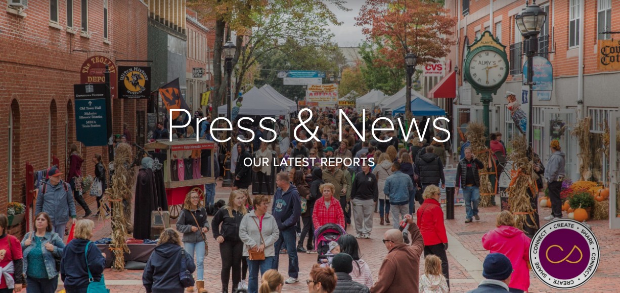

Staff Biographies
John Andrews | Owner, Chief Creator
After 16 years working as a professional chef, John left the culinary world to pursue a different career –– Creative Salem. He transformed the concept of the business into the invaluable resource it is today by tirelessly working to build connections between creative professionals across the North Shore. He loves seeing someone’s creative career flourish or business grow because Creative Salem gave them the boost they needed. Originally from Stoneham, Mass., John is now a proud Salem resident and loves the people and community life. He’s developed a keen eye for knowing where to look to find creative talent in the city. When he’s not working with creative professionals or planning events, you can find John out with his camera, photographing and capturing the spirit of Salem, exploring new avenues of tech-based media creation or cooking tasty new dishes.

Robyn Giannopolo | Director of Memberships
Robyn first connected with John and Creative Salem through Essex Heritage. The two became Facebook friends, and Robyn was invited to do a history podcast. She was then hired as Director of Memberships & Creative Growth at Creative Salem. Robyn has over 10 years experience in fundraising and public relations and will help facilitate Creative Collective, the newly established umbrella company of Creative Salem. Having grown up in the Berkshires, Robyn now calls Salem her home and has fallen in love with the community, culture and history of the city over the last 16 years. She enjoys connecting with so many creative people through Creative Salem. When she’s not working or writing, Robyn spends time with her husband and 4-year-old, enjoys walking through bookstores and tarot reading.

Visual Fact Sheet
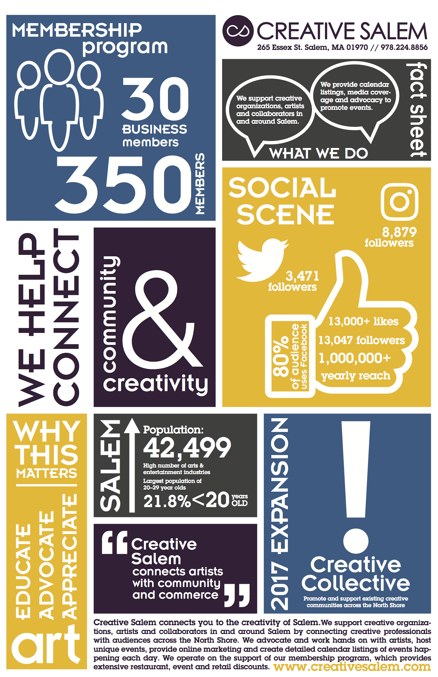
Wordle Design
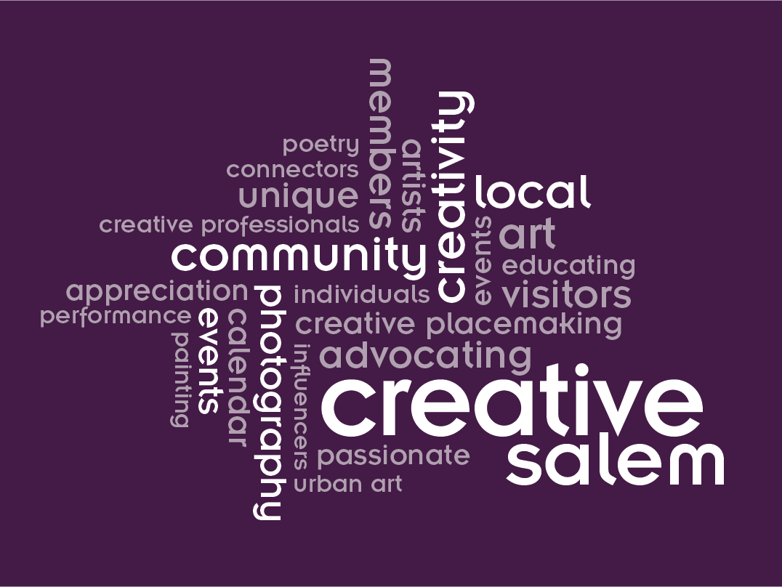

Media Links

- http://www.wickedlocal.com/news/20171018/social-media-halloween-heats-up-in-salem
- http://salem.wickedlocal.com/news/20171003/3rd-annual-howl-o-ween-pet-parade-is-sunday-oct-8
- http://salem.wickedlocal.com/news/20171005/in-salem-octocog-opens-new-derby-street-outfit
- http://www.salemnews.com/news/local_news/events-hope-to-put-salem-on-the-cosplay-map/article_c6611c83-6577-5d87-b601-278586538683.html
- http://www.salemnews.com/news/business/business-briefcase/article_ca0a4012-7a5f-5eb5-8cf1-39bb621b5f27.html
- http://salem.wickedlocal.com/news/20171114/creative-salem-announces-north-shore-expansion
- http://www.salemnews.com/news/local_news/fourth-of-july-events-on-the-north-shore/article_4f059984-5bd5-5334-a17d-c9b5d07f836b.html
- http://www.salemnews.com/news/local_news/pop-up-drive-in-a-big-hit-at-winter-island/article_388c0922-3e07-529e-9563-aa67bb4f2ef9.html
- https://patch.com/massachusetts/salem/new-years-eve-events-salem
- https://patch.com/massachusetts/salem/halloween-going-dogs-cats-salem-0
- http://www.salemnews.com/news/lifestyles/haunted-happenings-calendar/article_3538c622-f385-5da2-a8b9-7b06eedb3e6d.html
- http://www.salemnews.com/news/lifestyles/a-feast-on-wheels/article_cfe938ff-9aca-5155-a301-841ef23e836e.html
- http://www.salemnews.com/news/business/jaho-fuels-peabody-s-coffee-experiment/article_5eba25f1-e104-5c2c-aecb-06fdff0f1f4c.html
- https://www.monstersandcritics.com/smallscreen/ink-master-angel-kelly-doty-creepy-cute-with-a-side-of-helheim/
- http://www.salemnews.com/news/business/celebrate-salem-award-winners-announced/article_5f7dd773-1da4-5e12-a4d3-96279606721a.html
- http://fox61.com/2016/06/17/salem-mass-crosswalk-painted-with-rainbow-colors-for-lgbt-pride/
- http://www.wbur.org/artery/2016/04/29/mass-poetry-festival
- https://patch.com/massachusetts/salem/photos-second-annual-howl-o-ween-dog-parade-derby-square
- https://www.bostonglobe.com/metro/regionals/north/2014/01/05/changes-aplenty-restaurants-north-boston/tIzGA0E0Vdbtj8eagRJm3K/story.html
- http://www.salem-chamber.org/salem-chamber-street-fairs
- https://www.newbedfordguide.com/organizer/creative-salem

News Release

Creative Salem
265 Essex Street
Salem, MA 01970

For Immediate Release:

Creative Salem Announces North Shore Expansion
Organization that connects local communities to the creative economy expands its reach.

Salem, MA: Organized in 2014, Creative Salem has been partnering with the the best local professionals to grow and expand all manners of creative initiatives around Salem and is now expanding its reach throughout the North Shore. From partnering with the City of Salem, hundreds of local artists/creatives, and dozens of local businesses and institutions, Creative Salem is known for unique events, unparalleled online marketing, and a deep understanding of the challenges faced in the creative community in this day and age. Given these successes in Salem, the organization is launching Creative Collective, LLC - a newly established umbrella company to further promotion and support of the existing creative communities across the North Shore.

“Creative Salem has fostered the arts and creative community here in Salem since our inception. We’ve helped hundreds of local artists, nonprofits, festivals, and small businesses by providing resources, coverage, consultations and advocacy,” said John Andrews, Creative Salem Owner & Chief Creator. “We are at a point where it is essential for us to take our services beyond Salem into the neighboring communities creating bridges between cultural communities.”

To facilitate this growth, Creative Salem/Creative Collective welcomes Robyn Giannopolo to the team. Giannopolo brings with her a decade of fundraising and public relations experience and will serve as the Director of Membership & Creative Growth. “Memberships, partnerships, and increased community support are becoming an integral part of the creative economy here on the North Shore,” said Giannopolo, “and I am thrilled to be working to find ways to further the sustainability of the creative community.” Giannopolo joins the collective that already includes an extensive team of passionate and invested local supporters.

A revamped and re-energized website for Creative Salem/Creative Collective will launch later this year. Site upgrades will feature enhanced member content and a redesigned format including a new membership portal, and will enhance the company's already well-established position as a leading creative firm. In 2018 the events that have become audience favorites continue including the Hawthorne Masquerade Ball, partnerships with all the major cultural festivals, and the Winter Island Drive-In series with all new additions in and beyond Salem under the Creative Collective umbrella - including an exciting partnership with Beverly Main Streets as Creative Collective helps envision the future of the Beverly Arts District.

Creative Collective, LLC welcomes the opportunity to meet with artists, organizations, nonprofits, and local businesses around the North Shore to discuss their creative and event planning needs, and can be reached at by email robyn@creativesalem.com.

###

About Creative Salem
Creative Salem is an organization of like minded creative individuals and organizations with the mission of ensuring creativity and the arts are a relevant part of daily community and small business life and educating people on the importance arts and creativity play in the community. By serving as the Creative Hub in Salem, MA, Creative Salem has access to the top talent in
artistry, design, development, and creativity.

About Creative Collective, LLC
Creative Collective LLC, the evolution of Creative Salem, is a North Shore collective of creative professionals whose mission is to connect the dots between creativity, community, and business counterparts. Through a series of events, traditional and non-traditional marketing initiatives, resources and initiatives, Creative Collective works to define why creativity matters in aspects of life. The collective truly believes that a healthy creative scene ensures better economics and quality of life in all communities.

Media Contact:
Robyn Giannopolo, Director of Memberships & Creative Growth
Robyn@CreativeSalem.com

Evaluation

There are significant findings I’ve learned from this project that have the potential to impact Creative Salem’s future endeavours. After holding the focus group, it became clear how necessary clear communication is in order for audiences to receive your message. From the 10 people present at the focus group held in December 2017, the majority actively participated and voiced their feedback and concerns, while some in the room remained silent. Although I wouldn’t label it as completely unsuccessful, it did bring up some vital points of discussion that needed to be talked about in a group setting, especially with Andrews present. I handed out copies of the revised mission statement I created for Creative Salem and opened the discussion to feedback. What became clear rather quickly was how much the people present focused in on one word or phrase used, rather than looking at the overarching, broad view of the statement. It was heavily dissected, which is what I wanted, but the discussion centered heavily on this one aspect and took up most of the hour. Although I anticipated some to over-talk or go off on tangents, it became evident how quickly topics can run wild in a room.
I then took out laptops and iPads and presented the digital mock-up web design of the page I created for Creative Salem’s newly designed tab, “Press & News.” Although the focus group attendees were impressed with the overall design and feel for the web page, they were confused of its intended purpose. It was challenging placing myself in their position and trying to understand what I was explaining. But after scrolling through the website and getting a better feel for it, the discussion became stronger and more valuable. The intent behind the mock-up page was to show what Creative Salem’s website could look like in the future –– once a vital tab was added that included all information regarding press and news that’s easily accessible for reporters and other news media. But Andrews was impressed, and at the end of the session, he was appreciative of the final design and layout.
Next, I presented large, printed versions of the wordle and visual fact sheet to the group. Everyone present was very responsive to these two pieces of art and emphasized their approval of the colors, design and overall look of the pieces. I explained how these items would be used, and the room was pleased. There were no pressing requests or suggestions to change.
After this point, I was planning on handing out further copies of materials I created, including staff biographies and the backgrounder, but there was no time remaining. Looking back, it was definitely a learning experience for me. I’ve never held or moderated a focus group on my own, and even with Andrews and Professor Vincent speaking up, it was challenging for me as a whole. But I appreciate the advice I did receive, and I collected what everyone was writing down, compiled my own notes and revised the mission statement based on that feedback. Certain parts were condensed, while others were eliminated completely. The revised version was sent to Andrews, in addition to the website mock-up login information for him to use at his disposal.
In the future, I think more focus groups are necessary for Creative Salem. If I held another one, I would limit the number of participants to around five or six people, and I would choose the attendees more selectively. During the December focus group, I wanted a full room of people with varying careers, ages and knowledge of Creative Salem –– and that’s who showed up. But looking back, I would choose some who know a bit more of the brand. This would have been particularly helpful when presenting the website design. The consensus was that many present liked it but weren’t fully understanding its purpose, and that uncertainty makes for a confusing and sometimes frustrating discussion.

Conclusion
Looking at this project and finished report, public relations can definitely be a necessary and effective tool in all areas of a business –– both internal and external. This experience showed me firsthand how challenging, ever-changing and forever unpredictable working with a client can be in this field. Creating clear, concise information to share with others appears simple at first, but is actually one of the most difficult tasks to accomplish. Language and meaning differs from person to person and doesn’t always translate well across platforms and audiences.
From a personal standpoint, the intended goal was accomplished and a report was created for my client. Even though the focus group didn’t run as smoothly as I anticipated, I was able to work with Andrews, offer outside advice on how to help his brand and contribute pieces that helped solidify his brand identity. Some feedback was difficult to give, but from an outside public relations perspective, it was all information he had to see and hear firsthand. I feel I made even the smallest of differences that will positively impact Creative Salem, and Andrews was appreciative and impressed of the work put into the final report, graphic designs and webpage. Communication is forever changing and growing, which is why public relations is so critical across all businesses to ensure messages are created and spread to all audiences –– whether that’s the creative community of Salem or the world.

Bibliography

Aslam, S. (2017). Snapchat by the Numbers: Stats, Demographics & Fun Facts.
Omnicore. Retrieved from https://www.omnicoreagency.com/snapchat-statistics/

Atanasova, A. (2016). Gender-Specific Behaviors on Social Media and what they
mean for Online Communications. Social Media Today. Retrieved from https://www.socialmediatoday.com/social-networks/gender-specific-behaviors-social-media-and-what-they-mean-online-communications

Buell, T., Dyer, S., Harrison, M. & Weber, S. (2002). Managing Public Relations in
Nonprofit Organizations. Public Relations Quarterly 47.4. P13. From Business Collection. Copyright 2002 Public Relations Quarterly.

Duggan, M. (2015). The Demographics of Social Media Users. Pew Research Center's
Internet & Technology. Retrieved from http://www.pewinternet.org/2015/08/19/the-demographics-of-social-media-users/

Lister, J. (2017). Three Characteristics of a Public Relations Campaign. Chron Houston
Business and Financial News. Retrieved from http://smallbusiness.chron.com/three-characteristics-public-relations-campaign-24956.html

Moody, R. F. (2012). Integrating Public Relations with Advertising: An Exercise for
Students in the College Public Relations Campaigns Course. Communication Teacher, 26(4), 203-206. doi:10.1080/17404622.2012.668201

Powers, E.J. (2017). The digital evolution of PR: there are more opportunities than ever
for businesses to share their messages and shape their brands. New Hampshire Business Review. 39.15, p12. From Business Collection. Copyright 2017 Business Publications, Inc.

Salem, MA. (2017). Data USA. Retrieved from
https://datausa.io/profile/geo/salem-ma/#category_industries

Swanson, D. A. (2014). Assessing Public Relations Student Learning and Performance in
Real World Client Campaigns and Projects.

