UNCOMMON WOMEN AND OTHERS AND THE STORY TOLD WITHOUT WORDS

Honors Thesis

Presented in Partial Fulfillment of the Requirements

For the Degree of Bachelor of Fine Arts in Theatre Design
In the School of Arts and Sciences
at Salem State University

By

Rachel Rose Burke

Professor Michael M. Harvey
Faculty Advisor
Department of Theatre and Speech Communication

***

Commonwealth Honors Program
Salem State University
2019

Abstract

This project is a documentation of the scenic design process for the Salem State University production of Uncommon Women and Others by Wendy Wasserstein. The production ran between February 14th and February 24^{th,} 2019 in the Callan Studio Theater at Salem State University and was directed by Brianne Beatrice, with assistance from Allyson Kinch. The director’s concept was to force focus on the dialogue within the play by creating a sense of realism and comfort in the environment. This would emphasize the realistic nature of the strong female characters as they attempt to plan their lifelong goals upon their graduation from Mount Holyoke. As the play takes place in the late 1970s as well as the flash-forwards in the early 1980s, the females of the time feel obligated to break their gender norms and become the “uncommon women” who excel in both their education and career choices. The audience watches intimately as they not only attempt to figure out their goals, but as they begin to figure out themselves as empowered individuals. This thesis project will demonstrate step-by-step how I achieved an effective design for this production, as well as exhibit the impact that the scenic environment of a production has on the overall experience of both the audience and the performers.
Table of Contents

Abstract | i
Table of Contents | ii
Acknowledgements | iv
Introduction | 1
Pre-Design
Concept Meeting | 3
Research | 5
Inspirations | 9
Design
“Starter Thoughts” | 12
Initial Sketches | 13
Building the Design Packet | 17
The Design Packet | 19
The 3D Model | 23
Design Execution
Budgeting | 26
Production Meetings | 32
Designer Presentations | 34
Props- Swatching & Pulling | 35
Building Process | 37
Painting Process | 38
Designer Concept Statement | 39
Result
KCACTF Respondent | 41
Pre-Show Discussion | 42
Reviews | 44
Interviews | 46
In Conclusion | 50
Appendices
Imagery Index | 52
Uncommon Women and Others by Wendy Wasserstein | 53
Interview Manuscripts | 81
Works Cited | 95

Acknowledgments

I would like to thank the entire cast, crew and production team of Uncommon Women and Others for all of their dedication and creativity. You are the ones who make my career path not feel like a job, but rather a mere passion, which I enjoy.

I would like to thank Michael Harvey for being not only my faculty advisor throughout this process, but for mentoring me throughout my entire undergraduate career and guiding my way to get to where I am now. I am forever grateful for everything you have done for me; I couldn’t have done it without you.

Last but not least, I would like to thank my family and friends for all of their love, kindness, and support over the past many years. I am truly blessed to have all of you in my life.

Introduction

In the Spring of 2018, I was appointed the task of designing the scenery for the Spring of 2019 production of Uncommon Women and Others by Wendy Wasserstein (Wasserstein, Uncommon Women and Others). It was to be directed by Brianne Beatrice, a graduate of the Salem State University Theatre program, who also acted as a current adjunct professor within the department. The entire assigned production team is listed below.
Director: Brianne Beatrice
Assistant Director: Allyson Kinch
Stage Manager: Jenna Glass
Assistant Stage Managers: Cassie Lebeau & MaryEllen Conway
Scenic Designer: Rachel Rose Burke
Technical Director: Stu Grieve
Assistant Technical Director: Katrina Tuck
Costume Designer: Jerry Johnson
Assistant Costume Designer: Lindsey Collins
Lighting Designer: Mathias Cardona
Sound Designer: Ethan Dunford
Props Master: Liam Conlon
Assistant Props Master: Abby Hopple
Wig, Hair, and Make-Up: Charlie August Kellogg

The assignment was to act as my senior capstone project, as a graduating senior from the program, as well as my focus for my Commonwealth Honors Thesis. I first read the script over the summer as a “joy read” to simply and clearly develop my own thoughts about the story. My first reaction to the script was that it felt abruptly relatable to my current position as someone who was also about to graduate from a university. All of the characters within the play were female, and in their own individual processes of finding out who they were going to be in society once they left the comfort of their friends at Mount Holyoke. It was astonishingly similar how the mindsets were of the girls in the late 1970s compared to collegiate females today. Thoughts of career development versus settling down with a partner and family were and still are extremely prevalent and weighing on the early twenty-year-old woman. I knew from that first reading that I was in for a very personal and important process for my education, my career, my peers and myself.

Pre-Design

Concept Meeting

On October 26th the designers, the stage manager, and the directors gathered in the conference room to go over the director’s concept and overall artistic vision of the play. We began be greeting each other and running briefly over all our positions as to remind each other who was responsible for what, and to introduce those who had not met.
Brianne began then by expressing how she wanted to keep the design elements within a realistic style as to support the audience’s focus on the words in the script. She liked the idea of an intimate setting so that the audience could form a deeper connection with the characters; creating a stronger sense of trust and comfort throughout their experience. We were going to keep the setting and time period as implied in the script, since there were many scripted references to the time, and the overall themes and meanings in the play were still very relevant to today as they were written in the 1970s.
Jerry Johnson’s costumes as well as Charlie Kellogg’s designs for hair and make-up were to assist the actors in reflecting the silhouette and style that would have been seen in that era, while also emphasizing the personalities of those characters. The sound design, tended to by Ethan Dunford, would consist of music that wasn’t necessarily created at the time, but rather the music that was popular to the age group of the women in those years. The set was to house the production, by providing an environment for all other elements to live within and around, making the whole piece make sense. It should resemble the architectural style of Mount Holyoke, imply the surroundings to be a university, and fit in the small black box theater that was the “Callan.” The lighting design of Mathias Cardona would light the space and create the mood within the scenes, and the properties, chosen and placed by Liam Conlon, would provide objects and furniture that the actors could interact with, and fill the space.
Research
Most of the research that I conduct as a scenic designer is based on imagery. While it is important to also have a good understanding of events that were happening at the time of the play, as well as period and geographic references, the design of the space is primarily formed from relative and inspired imagery.
Interestingly enough, one of the first things I do when I begin researching for a design is create a board on the famous app, Pinterest™. This method is extremely useful as Pinterest™ consists of all sorts of imagery from different periods of art, to step-by-step examples on “how to churn butter.”
Allyson Kinch, the assistant director, also helped my research process a great deal as she also acted as our dramaturge (dedicated person who researches the world in which a play was written). She shared all of her findings with the cast and production team in order to create a more cohesively educated team. One very helpful timeline (Mount Holyoke College) showed the entirety of Mount Holyoke’s history in comparison to world events, and provided the cast and production team with much important information. In 1961 it was written in the Mount Holyoke College handbook, that

“Although dressing up may be a nuisance at times, it is a quiet reminder that after all, we are all still feminine-a fact far too often obscured by Bermudas, sneakers, and shirt-tails.”

The same source also explains that in 1966 an organization called “NOW,” or the “National Organization for Women” was established in order “to take action to bring women into full participation in the mainstream of American society.”
All of this is important in order to understand the world of the play in which one is designing the environment for. Understanding the formality of this time period, and the overarching idea that women are trying to break free from the comfort of their suppressed history was imperative to my design. Much of my image research is also depicted below.
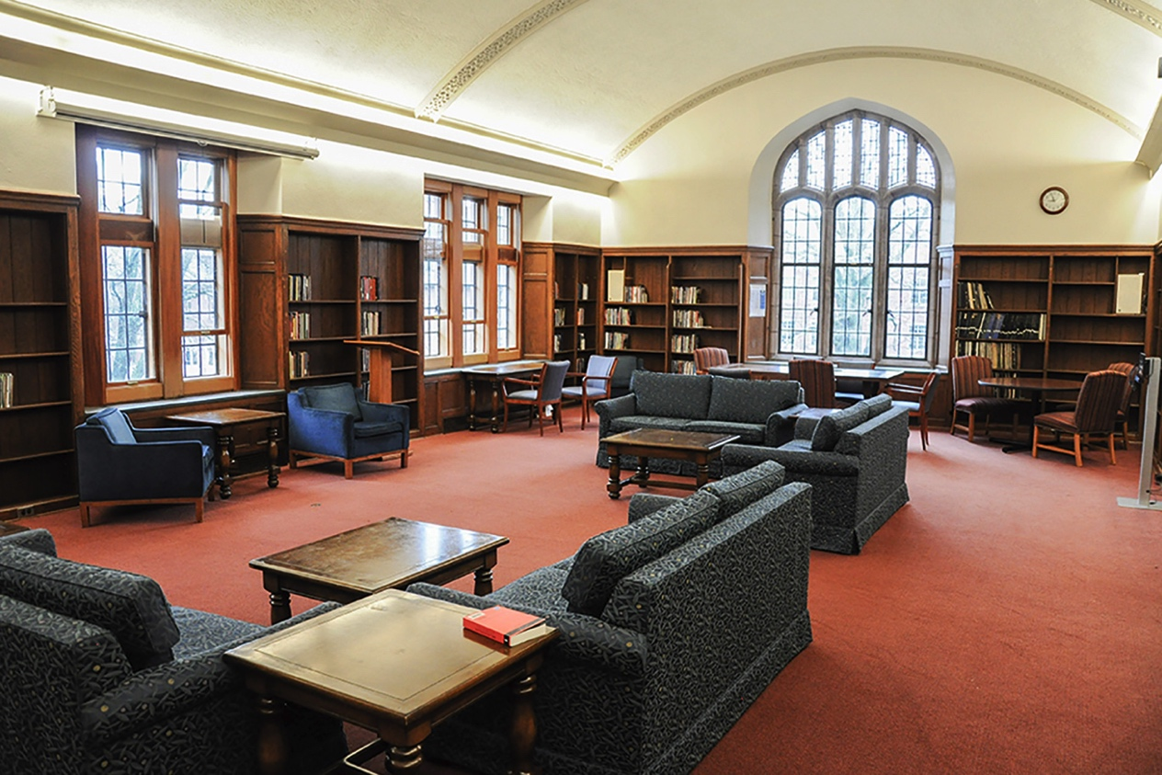
Figure 1

Figure 1 (above) is probably my most influential research photo from Mount Holyoke College (MHC) that contributed to my design. As the primary location for the play was described as a college common room, where the girls often hung around discussing romantics and pop culture, I wanted to go for a comfortable atmosphere with “nooks” of sorts to provide the characters with different spaces and the ideal ability to wonder. Specifically, I liked the magnificently arched windows throughout Mount Holyoke and the built-in bookcases in this room were especially interesting to me. I also enjoyed how there were separate areas with furniture and tables for students to spread out. Figure 2 (below) had a similar color scheme and a similar yet more distinguished arched window. In this photo I discovered that many of the main MHC common rooms had especially tall ceilings and intricately carved flying buttresses.
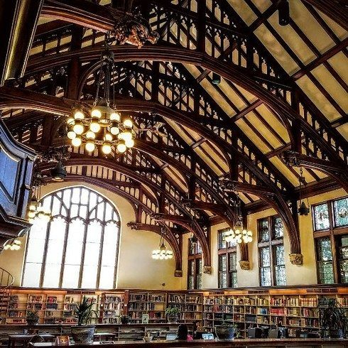
Figure 2
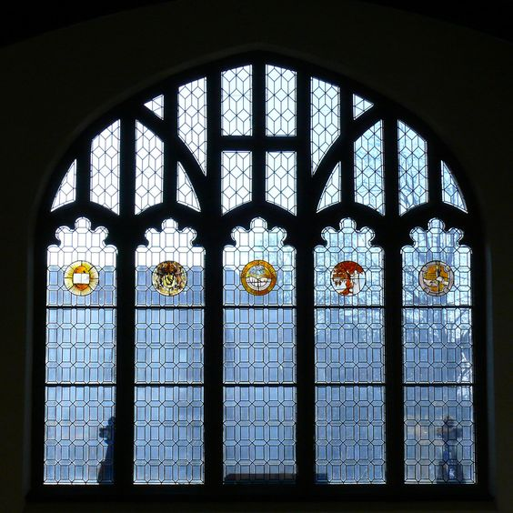
Figure 3

Figure 3 (above) shows a closer look at the window in figure 2. This image specifically influenced the idea for the window within my design. In order to slightly generalize the environment as to allow the audience’s imagination to excel, I opted to have a simpler stained glass pattern contrary to the specified symbols above. I used the school colors of Mount Holyoke (red, yellow, green, blue and violet) but left them in a horizontal linear pattern to give off a sense of ease and relativity.

Inspirations
Inspirational images contrast with research images in the sense that they may not directly relate to the historical facts of the world of the play, however they may reflect an important theme or message that also resides in the script. Inspirations provide another way of seeing the environment that supports the ideas and the concept. Some of my inspirational images are shown below.
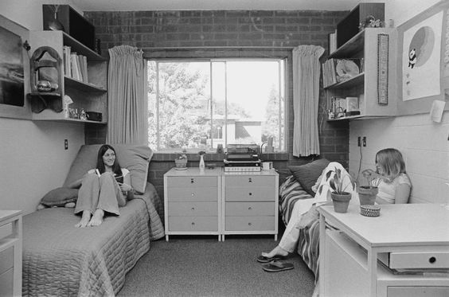
Figure 4

Figure 4 (above) portrays two college females “hanging out” in their dorm room. Their shoes are off, and they are simply enjoying each other’s company in the freedom of their own tiny space. A specific note on this photo is that they are indeed wearing pants, as if they are quietly contesting the gender norms of their time from their beds. This evokes an emotion that inspired me to take a “loungy” route with the scenery. I wanted to allow for the girls to spread and claim different aspects of the space that made them feel at ease.
Many times when looking for inspiration, I will come across quotes by historical (or even modern) figures that happen to speak volumes about what I am also trying to say as a designer. Figure 5 (below) features the oh-so-powerful Michelle Obama saying, “Success isn’t about how much money you make, it’s about the difference you make in people’s lives.” One of the struggles that the girls in the play are dealing with is what to do with their “newly found feminine pride” and how to use it to create a successful career. As this image pointed out however, maybe just being supportive towards your “women friends” can be enough to declare yourself an “uncommon woman.”
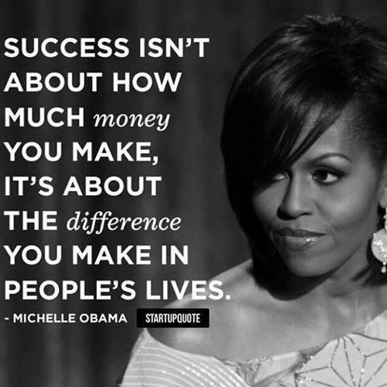
Figure 5

Another powerful female figure is the historically famous “Rosie the Riveter” (figure6). She is referenced several times in the script, mostly by the character, Muffet, as she craves to be a considered a “strong woman.” Muffet admits to enjoying to companionship of men, and desperately wants to “find her prince” but she fears that those facts make her reliant on the male species, and not independent “like Rosie.” However in the end when she realizes how-since she hasn’t found her prince-she has been supporting herself, she truly is a strong and independent woman.

Figure 6

Design
“Starter Thoughts”
Based on all the information, research and inspirational images that I had gathered, I began to see the ideas in my head come together into a “sort of” cohesive picture. As the play starts, it is the early 1980s and the girls are reuniting after they had graduated six years prior. They begin to reflect back on their time at MHC, leading to the next scene-and the bulk of the play-where they are back in college and constantly together talking about “women things.” The set had to be able to signify the element of “going back” to a time that reflected youth, hope and wonder.
The main technical challenge was designing a set that could effectively act as both the early 1980s restaurant as well as the late 1970s college common room with as little and smooth changes as possible to create a “magical memory-like” transition. I decided that starting with a smaller acting area for the present to show the remaining intimacy despite the loss of imagination and exploration, and then opening up to the college with a wide implied hallway and elaborate window piece would essentially be the way for me to explore. The idea of a large frosted and stained glass window evokes a sense of future-wonder as well as self-reflection that I wanted to really express to the audience.

Initial Sketches
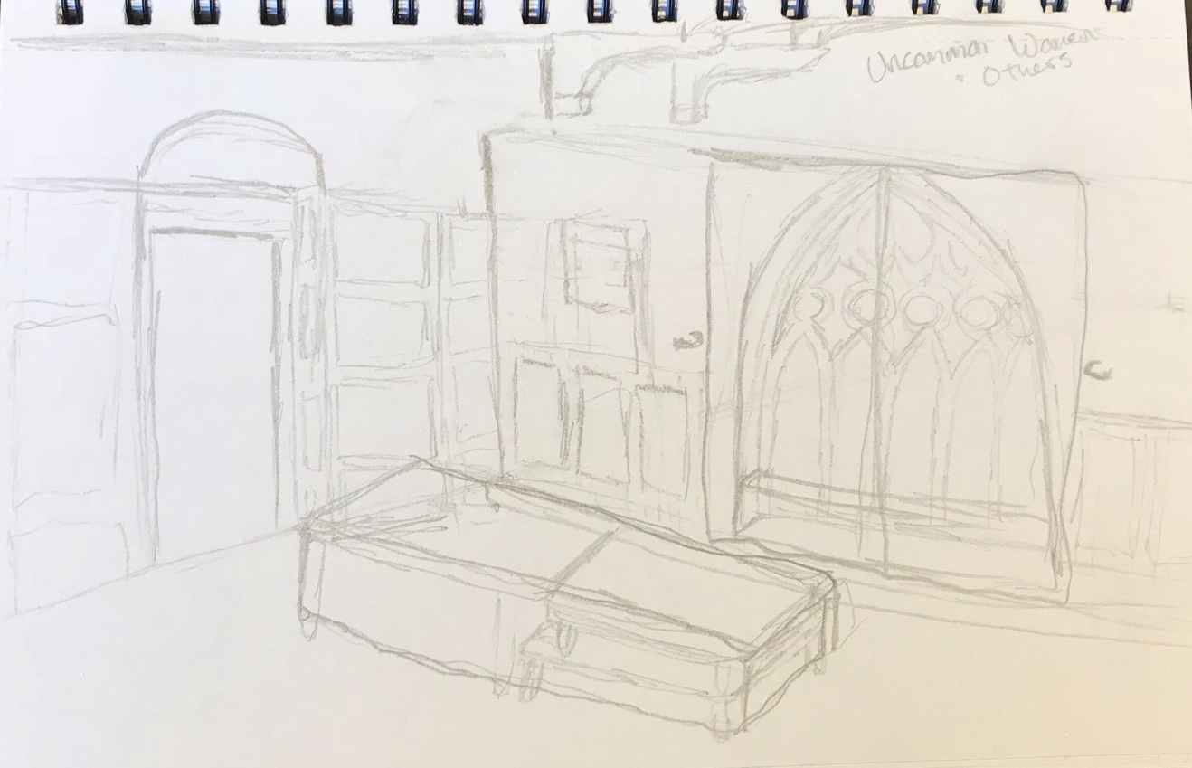
Figure 7
My first sketch drew out my ideas for an arched window and window seat that could be covered with a curtain to suggest different times. I also added a wall built forward from the theater wall that would allow for built-in shelves and arched over the doorways. Rather than carrying on completely new furniture between locations, I wanted to opt for a tablecloth suggesting the restaurant that can be simply removed from the lounge tables for the college common room. In this sketch I also thought about trying to build implied flying buttresses over the window to truly include as much of Mount Holyoke as I could. The walls would have a formal wooden wainscoting on the bottom third that matches the shelves and trimming.
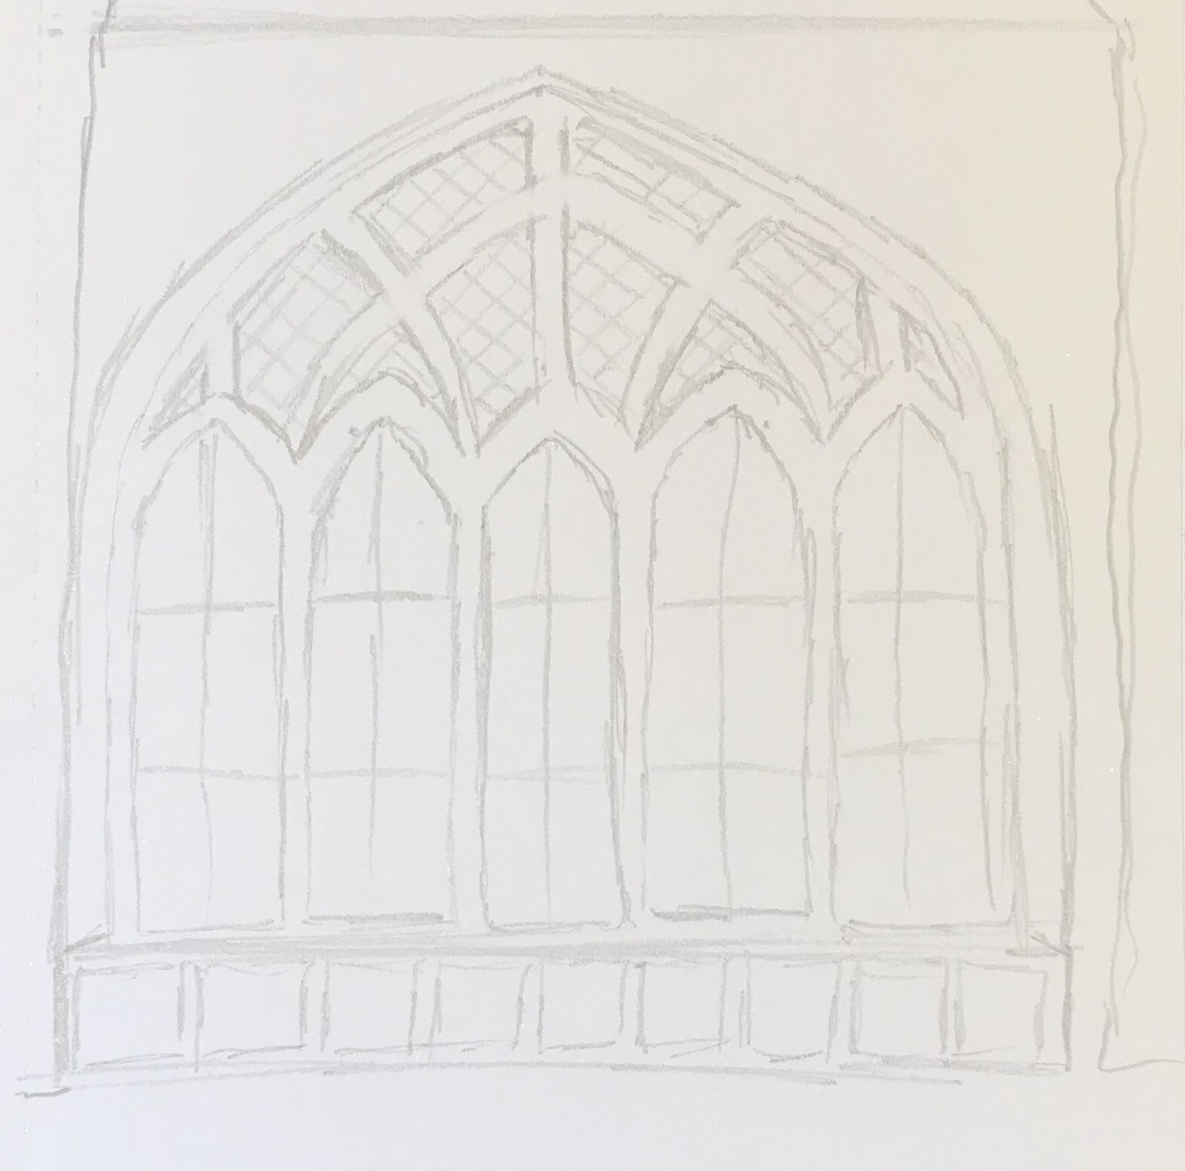
Figure 8
This rough sketch was my initial idea for the arched window. I included a smaller version of the wainscoting along the front of the window seat and opted to have the window pushed back into a wall nook, rather than adjacent with the rest of the wall and having the bench stick out.
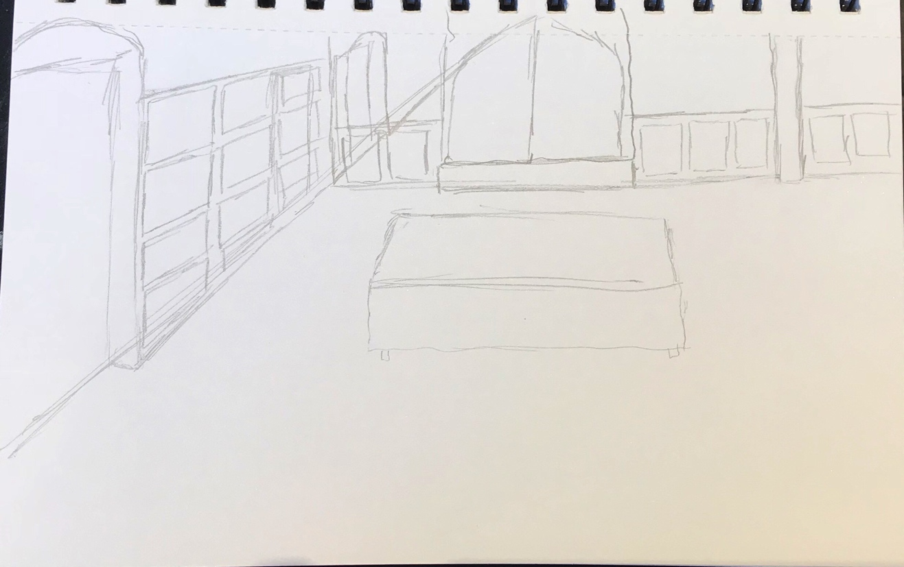
Figure 9
I often find it funny that even after knowing the space you are designing in very well, initial sketches rarely fit within the dimensions of the theater. I drew this sketch as a reprise of my earlier sketches, but while I was actually in the Callan Studio Theater in order to gain a better perspective. It reminded me of an obnoxious vertical I-beam in the upstage left section of the space that remains a force to be reckoned with. I was also reminded of how much space there really was along the left sidewall of the theater, as well as an extra door.
On November 20th I emailed my ideas to Brianne and Allyson for what I call “thoughts,” and got a fast response of “I am 100% in agreement with your design and thoughtful attention to specificity. I would like to move forward with your design.” It is extremely beneficial for a designer to work with trusting directors as it allows us to remain confident and focused on the task. Brianne was an absolute joy to work with, and she never once expressed any doubt in my abilities, making it both a healthy, exciting, and efficient design process on all ends. Brianne had given me to “go-ahead” to start the design packet, which would essentially begin the actual formation of the set.

Building the Design Packet
The design packet is the collection of information that the scenic designer creates for the technical team. It should consist of a ground plan, renderings, detail drawings, reference images, and paint elevations. It also often helps to build a 3D scale model, and provide a full Vectorworks™ file of the set as well. These are meant to work as a way of communicating the design to the technical director so they may organize the construction and installation of the set into the space. The paint elevations do the same for the scenic charge.
Vectorworks™ is a computer-aided drawing software that is often used by theatre designers in communicating their ideas. It is very similar to the also-popular software AutoCAD™, however it allows for many more devices specific to working in the theater such as lighting instruments, soft goods, and USITT standard title blocks. It often takes much practice and usage to sufficiently learn the “Vectorworks language” and I definitely still don’t know how to use the majority of it’s functions, however I have personally found it to be the most helpful to complete my jobs as a scenic designer.
I began my process by acquiring the blank Callan Studio Theater Vectorworks™ drawing from the department, and creating a file for the show. I then drew all of my ideas in the space (but with much straighter lines and accurate dimensions) and included many more specific details (such as the shape of the molding and the preferred materials). This is usually the time consuming portion of the design process, and it becomes very difficult to declare yourself “finished.” I do believe as I was handing it over to our technical director, Stu, I was still adjusting minor details.
Once the set is virtually drawn in the space, I can then convert copies of different angles of the scenery to line drawings, making aspects easier to interpret by the technical director. I do this to create a pdf copy of the ground plans, and a specific detail drawing for every piece of the scenery. At this point, I was also going to be in charge of the painting of the set, and did not yet need to provide elaborate paint elevations. I did however still include reference images for color within the drawings as well.
On November 30th, I presented Stu with my acquired design packet, so he could then begin pricing out the materials and developing the plan for construction.

The Design Packet
All of the drawings below came from the Vectorworks™ file “Uncommon Women.vwx.”
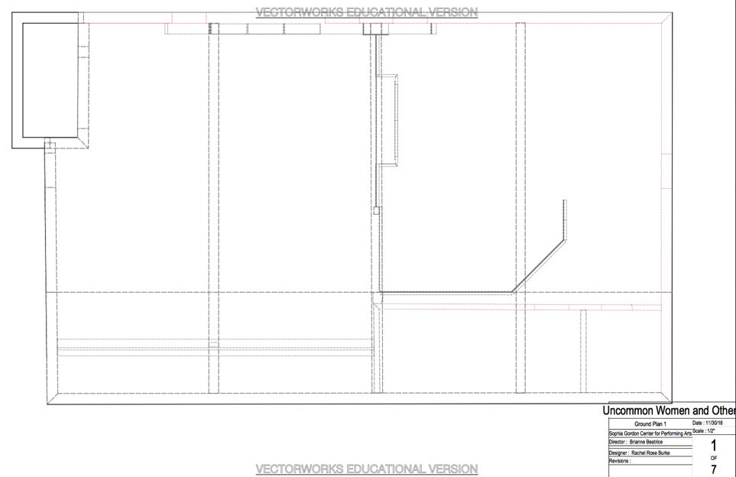
Figure 10
The ground plan for the first and last scenes of the play, taking place in the restaurant in the early 1980s.
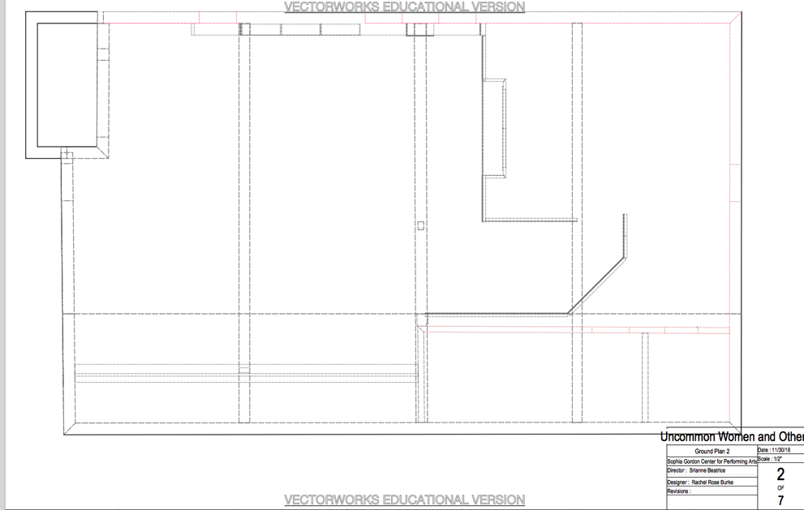
Figure 11
The ground plan for the bulk of the play, taking place in the college common room in the late 1970s. The window wall has pushed backwards, the hallway has opened up.
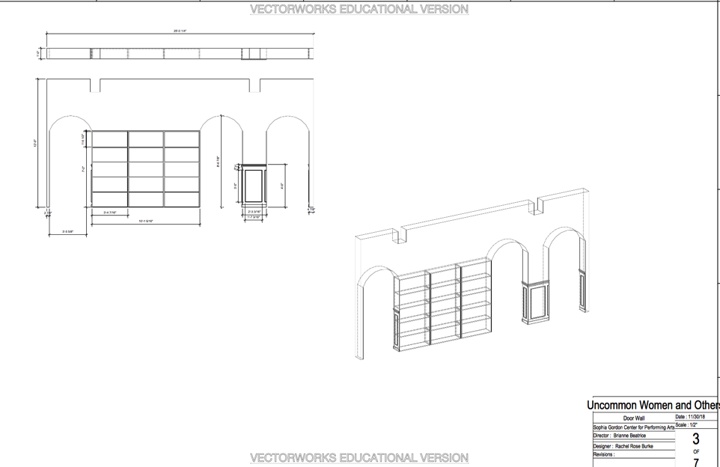
Figure 12
A detailed drawing and a perspective drawing of the “door wall.” This contains the arched doorways and the built-in shelves.
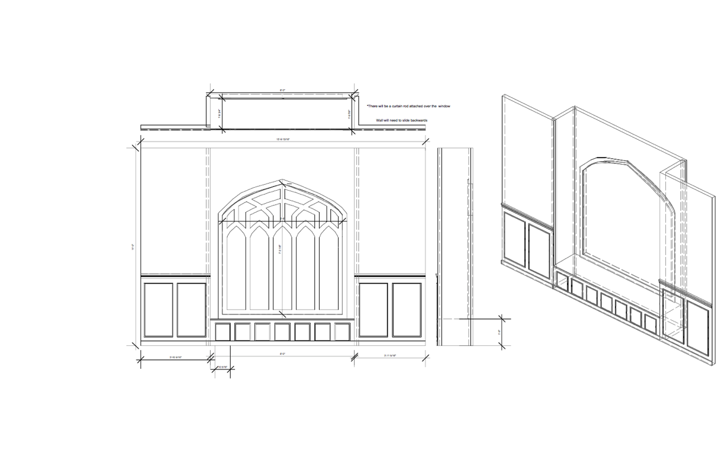
Figure 13
A detailed drawing and a perspective drawing of the “window wall” showing the window detail, window seat/nook, and the trimming.

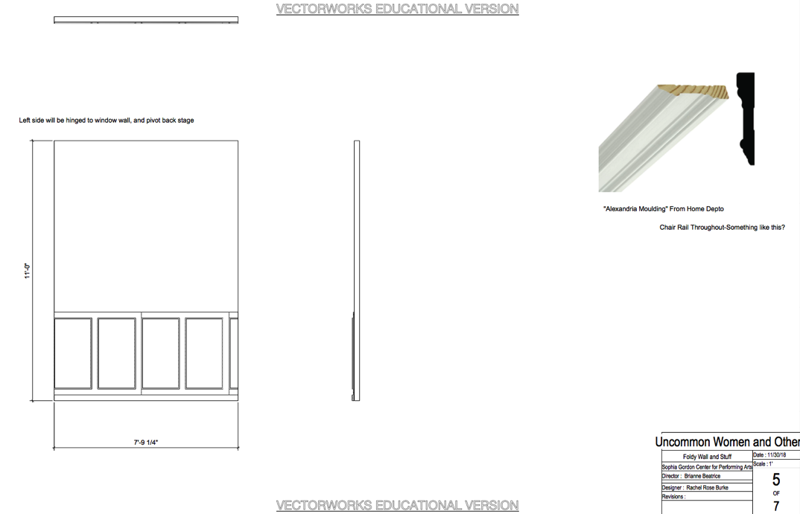
Figure 14
A detailed drawing of the “foldy wall” as well as a reference image for the shape of the molding.
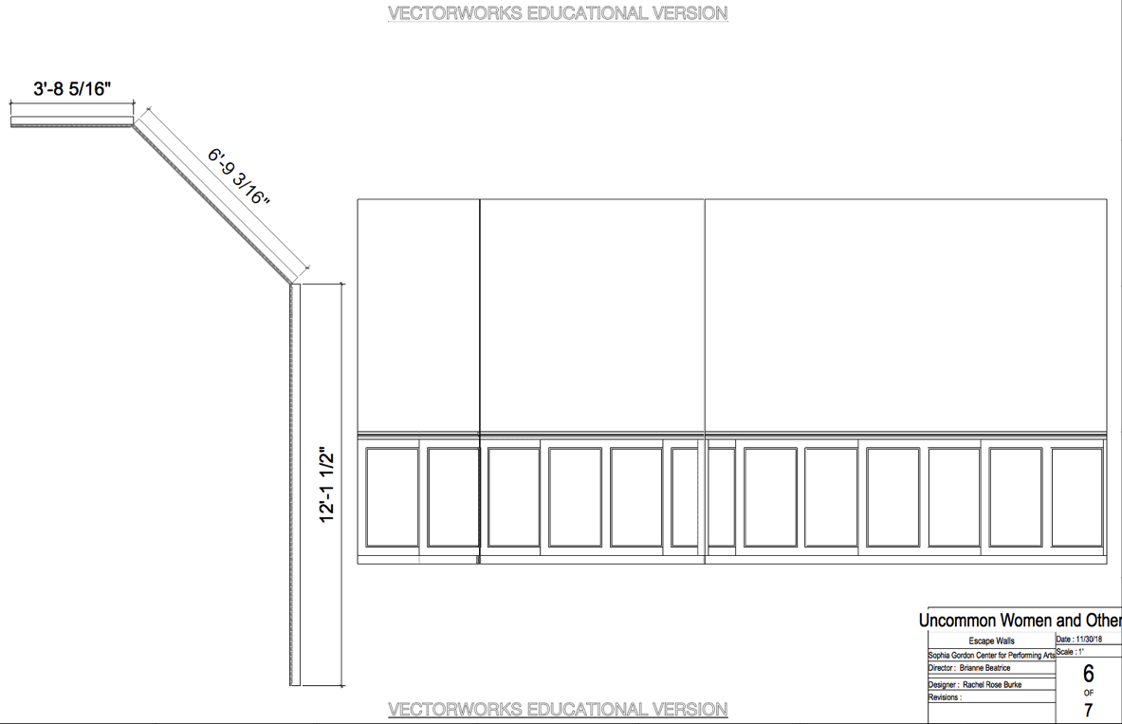
Figure 15
A detailed drawing of the layout of the “escape walls” lining the side of the hallway.

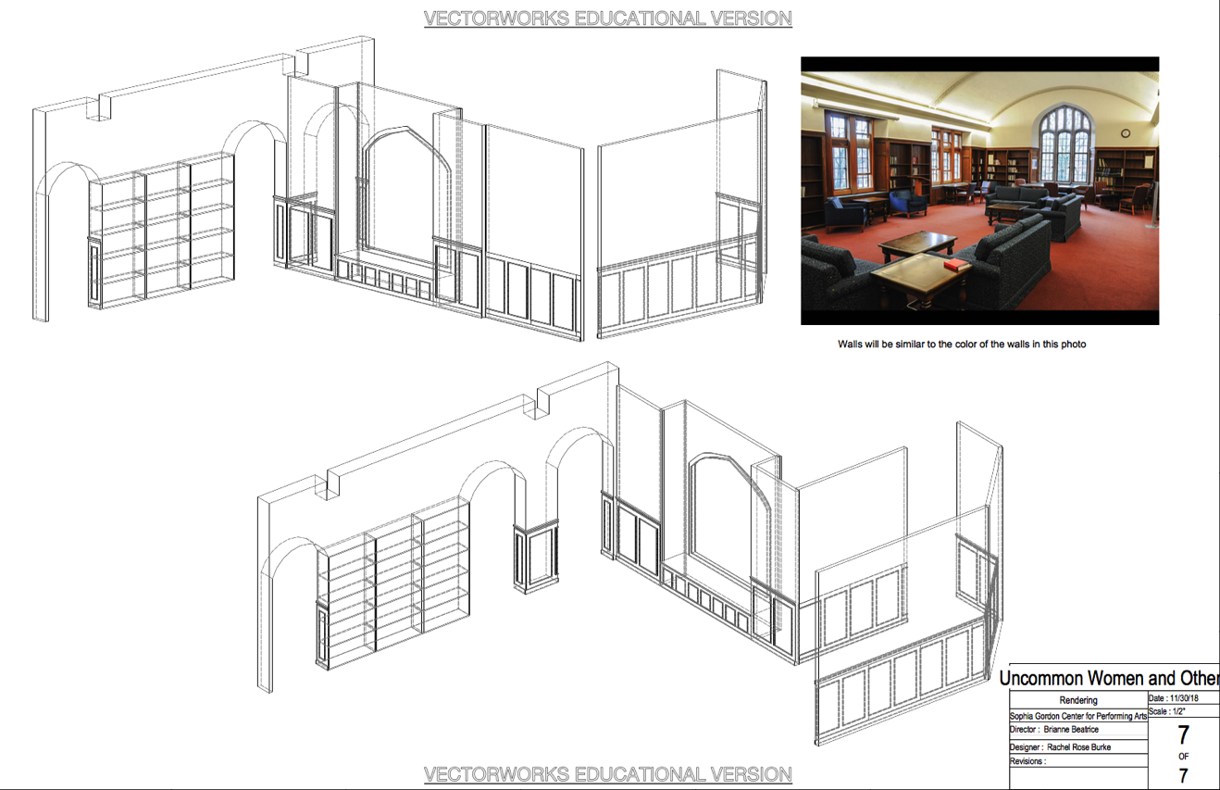
Figure 16
A perspective drawing of both ground plans, showing the overall design of the set and a reference image for color.

The 3D Scale Model
A 3-dimensional scale model is another effective tool to communicate the scenic design for a given production. As this was my capstone project, I opted to build a fully painted ¼” scale model to use as both a tool for the construction, and an added piece of work for my portfolio. Constructing the model took approximately 14 hours of labor that was completed between January 6th and 7th.
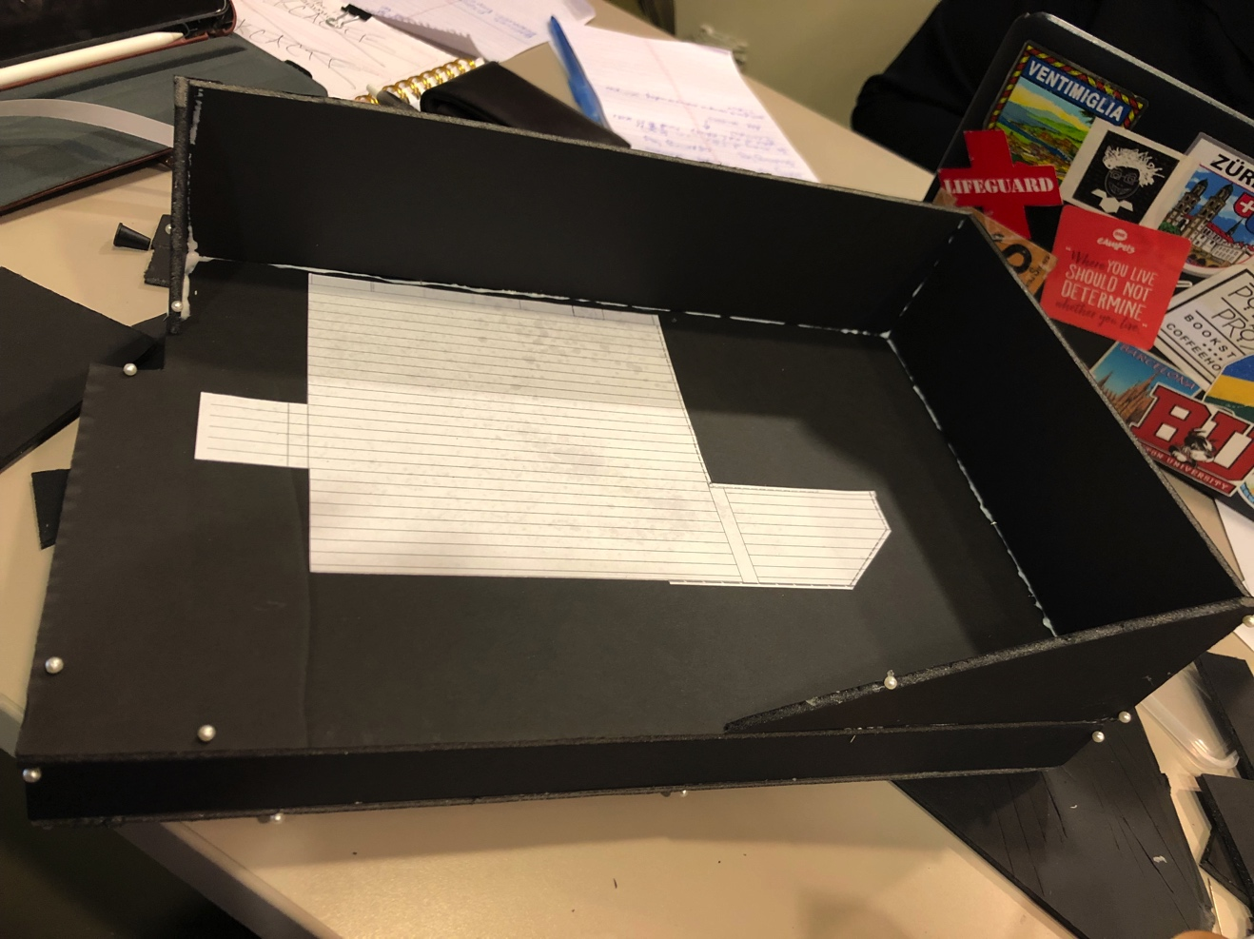
Figure 17
The proportions of the Callan Studio Theater at Salem State University
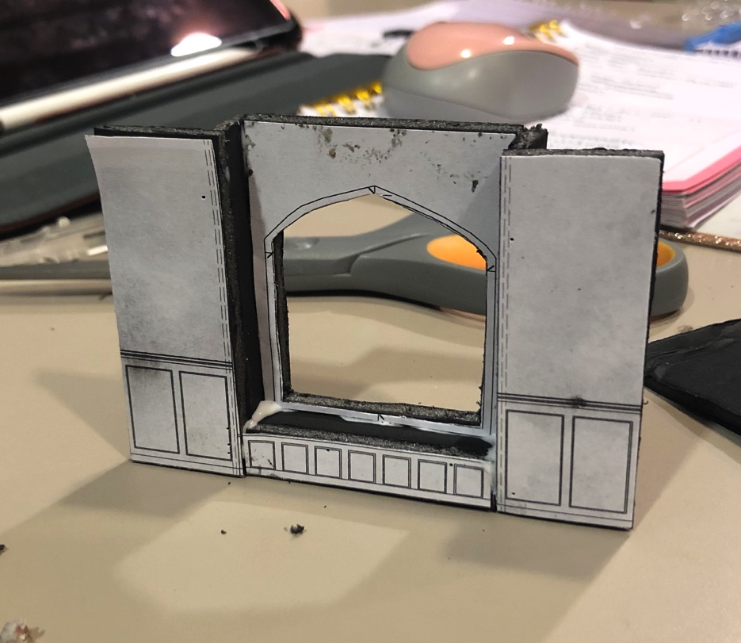
Figure 18
A mock-up model piece of the window wall, before being painted.
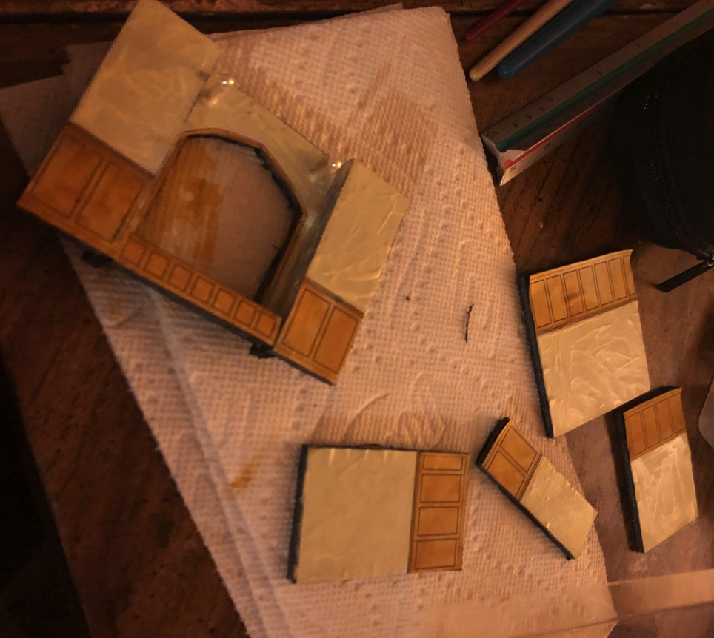
Figure 19
The model wall pieces in the process of being painted.
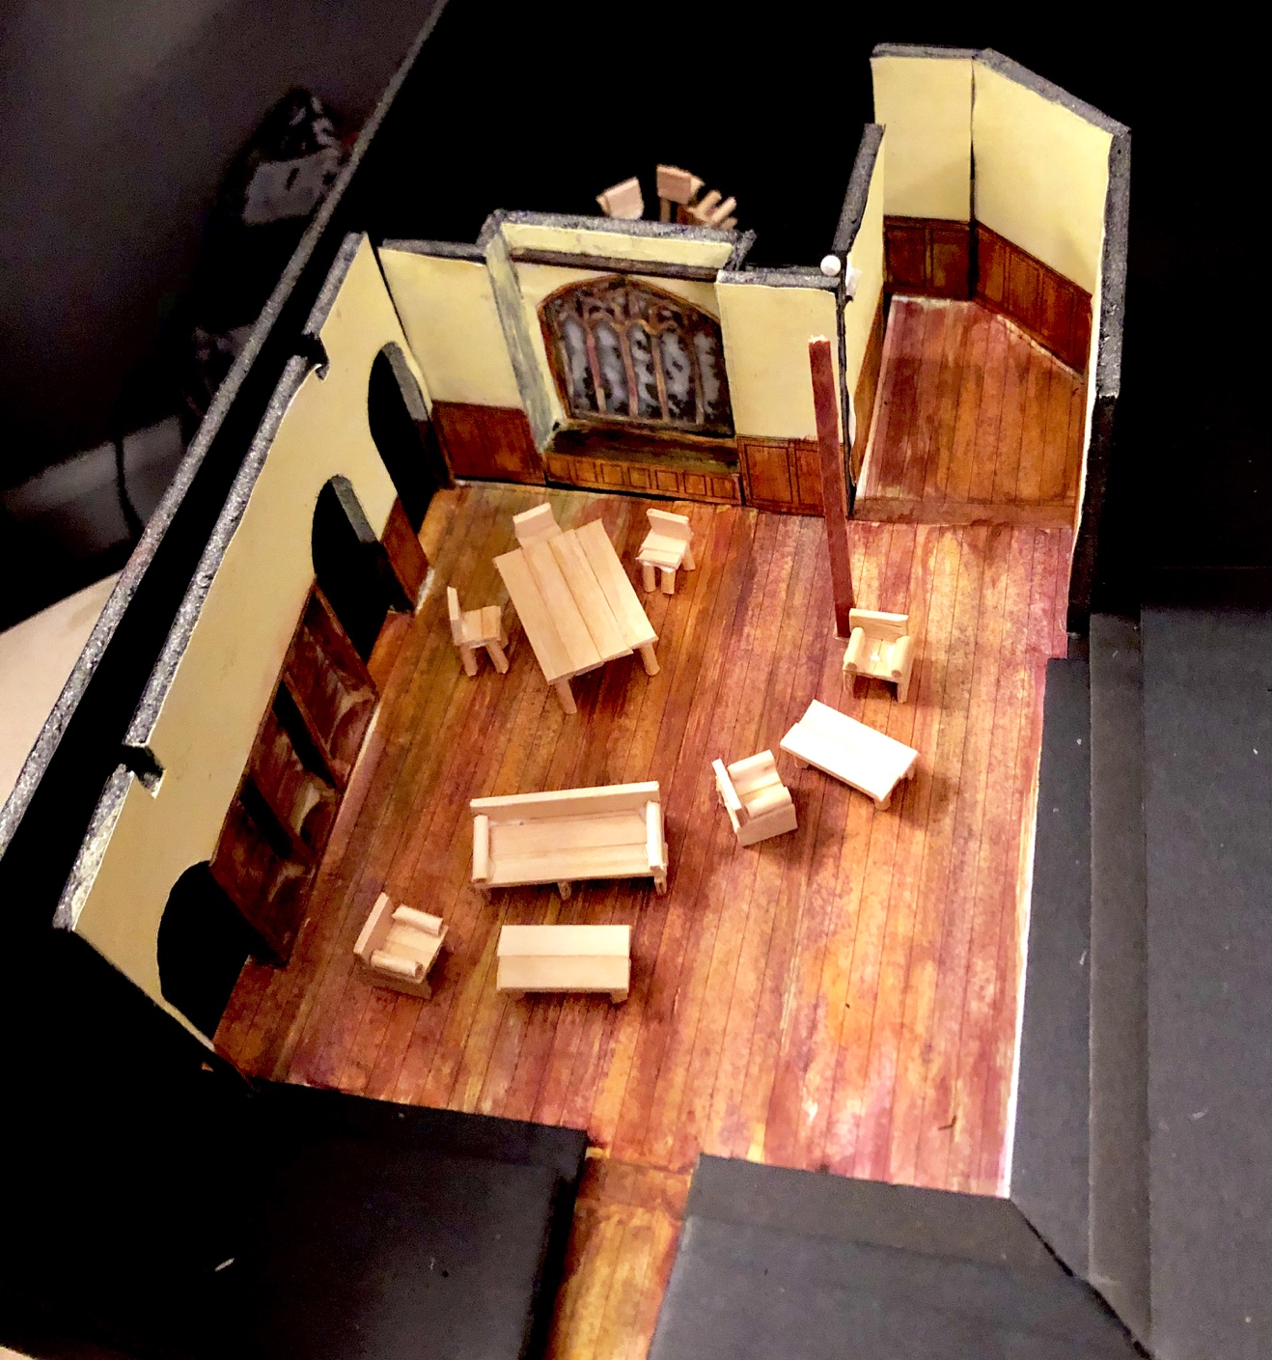
Figure 20
The finished model with the furniture in place for the college setting.

Design Execution
Budgeting
At the beginning of the process I was informed that I had a budget of $2,000 in order to execute the design of the scenery. After I handed the design package to the technical director, it became Stu’s job to interpret to cost of the design as well as how many production hours it will take to construct and install the set in the space. On December 17th, we held the official scenic budget meeting with Brianne, Allyson, Michael Harvey as my advisor, Stu, Peter Sampieri as the production manager, and myself. Stu had broken down the cost of every material needed as well as how many hours it would take to build every piece depending on different skill levels. The informational budget packet, including the labor estimate, is shown below.
Figure 21

Figure 22

Figure 23
Figure 24

Figure 25
Figure 26
From these numbers it was apparent that the set would cost about $30.72 less than our budgeted amount, and Stu strongly believed that the hours of labor were within our timeline. Everyone was pleased with the information, and Peter, as the production manager and chair of the department, officially approved the design to be completed.

Production Meetings
Production meetings are regularly scheduled meetings that include all members of the production team of a given show. The goal is to go around the table to each department in order to check in on how the process is going. It is essential that all persons involved with a production have open lines of communication and remain on the same page as far as timeline and scheduling. The production manager of the theater typically runs these meetings; therefore Peter Sampieri would begin and go around to each department.

The following are my notes and action steps from each production meeting:

Production Meeting on January 16th, 2019
- Schedule a meeting with Mathias to find out when he needs to hang and focus lights
- Attend a props meeting with Liam and Stacey on Friday the 18th to discuss props and furniture needs
- Meet with assigned scenic charge, Erin Shine
Production Meeting on January 23rd, 2019
- Schedule and announce times for Paint calls
- I will be attending the rehearsal tonight (1/23)
- When will the plexi-glass be delivered?
- Inform the department that the paint sink keeps clogging
- Allyson would like if I contribute some items (model, sketches, design concept statement) for the lobby display
- The program bio deadline is February 1st
Production Meeting on February 6th, 2019
- Please deliver design concept statement to Allyson as soon as possible
- There will be a production meeting on the 9th at 1:30PM
Production Meeting on February 13th, 2019
- Have a wonderful opening night!

Designer Presentations
The objective of designer presentations is to share the design aspects with the cast of the production. In order to help them get into their characters as soon as possible, the design presentations are usually held relatively early in the rehearsal schedule. It allows for the cast to envision the world of their characters so they may delve deeper into their individual processes. For my presentation, I brought in the scale model as well as a PowerPoint presentation that displayed all of my research, sketches and renderings.
The designer presentations were held at the start of rehearsal on January 15th. Overall the presentations were successful and provided a positive and rejuvenating atmosphere for the entire cast and production team. Seeing all the designs come together in such a cohesive manner allowed for all persons involved to envision the true nature of the play.

Props – Swatching & Pulling
On January 18th, I sat down with both Liam and Stacey Horne-Harper (the faculty props master) and discussed all of the needed props and furniture pieces for the show. We decided to use a couch that we already had on hand, but it would need to be re-upholstered along with three missing lounge chairs and five missing dining chairs. There would be a larger “study/dining” table and two smaller matching coffee tables. The coffee tables needed to be able to hide beneath or beside the larger table, for when it would be under the tablecloth in the first and final scene. Other needed props consisted of a period telephone, a record player, records, a typewriter, books, blankets, curtains, and miscellaneous set dressings.
On January 24th, the three of us ventured to a downtown fabric store in search of the right material for the couch and lounge chairs. I wanted to find a solid color, as was shown in my research, that would suggest the type of commonly found furniture in education settings. Colors that typically work are neutral blues, maroons, or in that time period; orange. While many general research images I had found showed bright orange faux-leather couches, orange was one color that never existed in my research specific to Mount Holyoke. Even their official school colors consisted of quite literally every color but orange. With that in mind, and with the fact that the wood treatment would consist of a reddish tone, I opted to go with a darker, neutral blue (shown below).

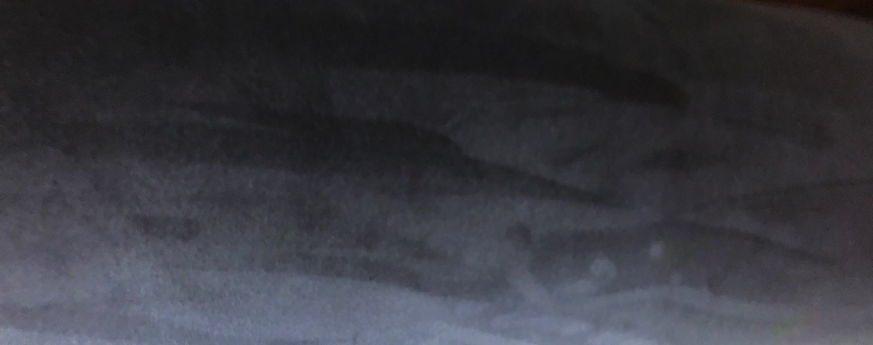
Figure 27
While many props were pulled from our own stock, we borrowed some larger pieces from the stock at Emerson College. On January 28th, the three of us again ventured to their warehouse and managed to find three matching lounge chairs, five dining chairs, extra records, two period telephones, and even a few menus for the restaurant scene. These trips proved to be very successful, and I was very lucky to work with such an efficient properties team.
Final Touches
Toward the end of the process, as time drew closer to opening night, I worked with Stacey and Liam to fill the space with final touches known as “set dressing.” Stacey suggested a large bulletin board for the hallway to fill with period and scripturally relevant flyers. Liam was able to fill the bookshelves with many books and period educational items. We later opted to add another sideboard at the end of the hallway with some “school awards” placed on top to fill the gaps and suggest a further history of the environment. Stacey and Liam worked with me to hang paintings on the walls, and add the last-minute hand props from the director and cast-members, as that is a typical occurrence during tech weeks.
Building Process
Before the final touches go up however, the set has to be constructed, installed and painted. Stu Grieve as the technical director and Katrina Tuck as his assistant were primarily responsible for the building aspect of the set. It is certainly not unusual for the technical director to have several questions for the designer throughout the build, and therefore Stu and I kept a constant flow of communication. Questions such as “can the escape wall be 15/16” wider in order to use a stock flat?” are very common, and are more times than not responded to with an “of course!” I would consistently check in with Stu for any other pieces of information that he may need, and I would make sure he was always able to work on what was prioritized by not painting any piece that was in-progress.

Painting Process

As a scenic designer, it is very common to also work as the scenic charge, or “lead scenic painter.” Later in the process Erin Shine did join us as the official charge, which allowed me to focus on more of the “designer duties.” I did however; proceed to paint much of the set. Back in December I had pre-mixed all of the paint that would be needed, in order to get a better idea of how much more paint would need to be purchased. I used the paint to quickly develop a paint sample (shown below) that would be easy to follow for all other painters.
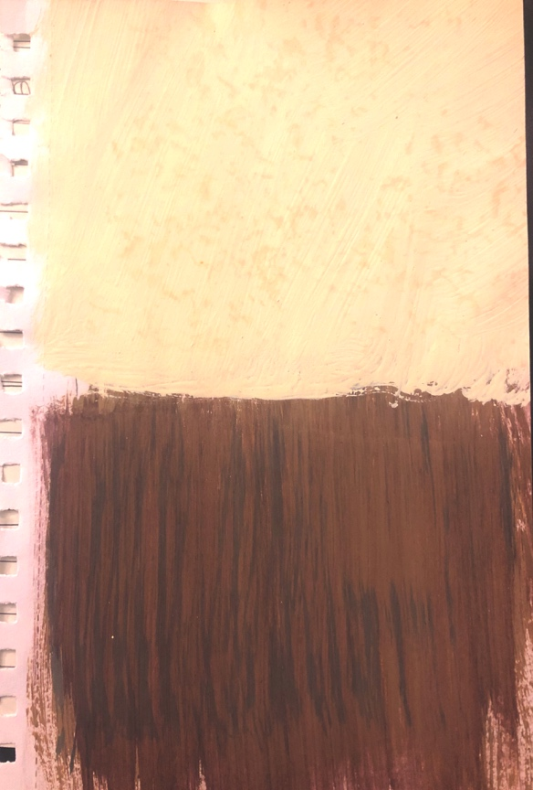
Figure 28
Overall the painting process went smoother than anticipated, as I actually had to step out for a week in the middle to attend the Kennedy Center’s American College Theatre Festival. When I had come back, the set was close to completion, and only a few paint notes were left.
Designer Concept Statement
A “designer’s concept statement” is truly just that. Allyson, as she was preparing the lobby display, asked if I could post one for the audience to potentially read while waiting for the show to begin. Often it simply and briefly expresses the ideas behind the designer’s visual conception. My statement went as,
“Mount Holyoke College was the first of the “Seven Sister” schools that helped to pave the way for women’s education. Founded in 1837, MHC has much history and notability for producing highly educated and intelligent young women, otherwise referred to as “uncommon.” Designing the scenery for Uncommon Women and Others by Wendy Wasserstein has proven to be my absolute favorite and most impactful opportunity to date, and I could not be more honored to have such a part in this process. After much imagery research of the architecture and décor on the grounds of the college, the set for the show started to develop. Many rooms in MHC included large romanesque windows that while seeming at first like a simple element of aesthetic, also provided a sense of hope and wonder as the uncommon women in the show look forward into their potential futures. The question of whether to feel pleased with “settling” down with a husband and kids, or to fight to pursue uncommon and riveting goals in business or law, haunts the students as they feel their time quickly running out and their worlds caving in to pressure them into whatever norm and social role they’re “supposed” to play. My intention with the design was to build a realistic and intimate set that allowed the characters to spread out independently while bonding with their fellow intellectuals to question our society that pushes against the idea that women are just as capable, confident and intelligent as any other human being, and should be taken seriously in all fields of study. While the play takes place mostly in the late 1970’s, there are still many relevancies between the way women were perceived then to how we are perceived now. And while it is still perfectly acceptable for a female to decide that she would like to focus on raising a family; the ability to choose her ambitions, her companions, and her course of life should always remain hers.”

Result
KCACTF Respondent
On February 15th, we had a respondent from region one of the “Kennedy Center American College Theatre Festival,” or KCACTF, see the show and respond to it in a conversational atmosphere with the cast, crew and production team. Dale Young enjoyed the show tremendously and commented on every aspect of the production. He expressed that the set really “did its job” and he adored how the wall pushed back and opened up in order to make the transition. Young also commented a lot on the set dressing, which was collaborated between the props team and I, saying that they were extremely “creative” and really “able to put him in the world of the play.” He especially liked the bulletin board with the relative flyers pinned on it, representing different events that were mentioned in the script.
After the discussion, I introduced myself further and asked him specifically what his thoughts were on the window in the set. He expressed that he had several ideas as to what it “meant” and stood for, and believed that it would evoke a very different and effective emotion on every individual audience member. I explained how I wanted to suggest the passage of time and the “wonder of our own individual futures” as we move from one chapter to the next, and that I liked how windows both show the outside world, while reflecting our own images, as if they are helping us use our past to build our future. He expressed that he really enjoyed this idea and was very please with the thought that I had put into not only the window, but the whole set.
Pre-Show Discussion
The Salem State University Theatre department holds either a “talk-back” or “pre-show discussion” before or after a performance during each show run of the season. For Uncommon Women and Others we had decided to hold a “pre-show discussion” on Thursday, February 21st. The panel consisted of the assistant director Allyson Kinch, costume designer Jerry Johnson, lighting designer Mathias Cordona and myself. We had a larger audience than expected, at around 35 people, who were both very active listeners and participants. Without having seen the set, I received many questions about my process and way of thinking while designing the show. It was truly very heartening to hear so many people genuinely interested in the work that had gone into the production.
While there were many technical questions for the panel, there was also much interest and discussion about the themes within the play. One of the audience members had also been very excited to announce how she had performed in the same play back in the 1990s, but commented on the fact that her performance had no actual set, and she was extremely excited to see a “fuller” production that could really bring the audience into the “world.”
That evening also happened to be the theater’s “Alumni Night” and was completely sold out. After the first scene when the set was transitioning into the college setting, something happened that was almost magical. The audience that night was so involved and into the world that the set transition triggered a sense of intrigue and enthusiastic applause that I had never heard in during any show in that space prior to that night. Everything I had worked for truly felt worth it in that moment.

Reviews
There were two written reviews of the production throughout the run. The first was written by Keith Powers with GateHouse Media, published on February 18th (Powers), and the second was from Shiela Barth with the Winthrop Sun Transcript in the February 28th paper (Barth).
Powers mostly focuses on the performances and direction, however he comments very briefly on the design elements. He wrote “Sets were simple: rooms with chairs” as well as “The well-rehearsed set transitions-accented by some out-of-control dancing in the background-were crisp.” As a designer I have become very aware of the importance of the performance aspect in any production. One of the most important jobs as a scenic designer is to not distract from the dialogue within the story. The set needs to make sense and support the ideas within the play. If the set is too minimal, it will both make the actor’s jobs more difficult, as well as force the audience to not be distracted by the all-black background of the musical taking place in an apparent wealthy 1930s mansion. On the other end, if the set is too busy and contrasting, the audience has to work harder to focus on the dialogue. If the reviewer has not spent their entire experience recording every minute detail of the scenery, it is a compliment in itself.
Similarly, Barth writes on the performance of each actress and comments much on how well the production was received by the audience who had “waited in line” for the once again “sold out house.” She writes about the ideas in the play and how they are still relevant to today’s society with how the girls’ “future was limited, mostly to achieving part-time jobs and marrying the right man…Wasserstein’s play remains relevant, because we haven’t, overall, achieved equal raises and salaries for women.”
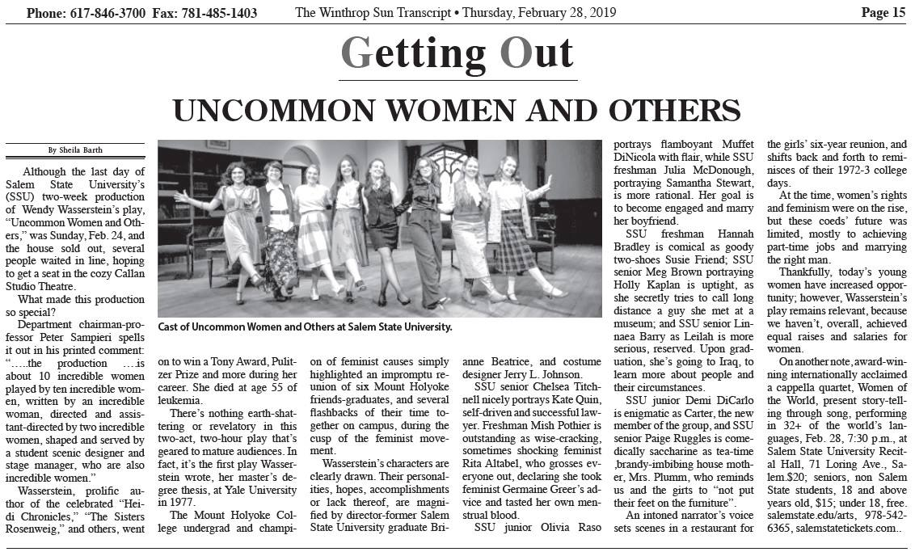
Figure 29
This proves that the overall production did its job by shining light on these issues that Brianne wanted to bring up in our audience. Barth does however call the Callan Studio Theater “cozy” which also comments on my goal to provide a comfortable environment for the characters to study and discover themselves as both women and individuals.

Interviews
After the show opened, I conducted several discussions with volunteers who had either worked on the show, or saw the show as a member of an audience. My goal was to retrieve honest information about how they felt the scenic elements affected their experience, as well as what I, as a designer, could have done better. I conducted these discussions with people from different categories such as performers, educated audience members, non-educated audience members, fellow designers, and the director and my faculty advisor. By hearing from people with different focuses and backgrounds, I hoped to receive a well-rounded overall opinion of the design, as well as the role of scenic design as a whole in any production.
Since theatre is a very collaborative art, the job of the scenic designer directly affects the process of several other members of the production team. When asked, “In what ways did the set design affect your process?” Allyson responded that the set gave her and the performers “much to play with” and “lots of room for creativity.” She explained how it helped her to place the performers in the world of the play, opening them up to settle into their characters. However before the set can be their for the performers, it must first be built by the shop which was run by technical director, Stu Grieve and his assistant, Katrina Tuck. Katrina expressed how their job was directly dependent on the scenic designer’s, as they had to simply “build what was designed.” I asked her how that process went, working with me as the designer, and she responded that since we had effective communication, the process was “relatively easy to execute” other than the fact that the theater was old and full of interesting surprises. Liam Conlon, the props master, also had direct communication with me throughout much of the process. I asked him, “Did your job ever depend on the job of the scenic designer at any time? How so?” Liam responded with “yes, I needed to match the era and style of the furniture and set dressing to that of the overall design of the set.” In order to create a whole cohesive design in the space, all elements including props, costumes, and even sound had to blend well to establish a trustworthy bond with the audience.
Besides the technical elements, I also wanted to know how my process had affected those of the performers. I asked actresses Lynnaea Barry and Paige Ruggles, “Did the set affect your process as an actress? How so?” Lynnaea expressed that it “created different ways for [her] to live throughout [her] character… the set affects [her] process by its ability to enhance ones performance, and creates an opportunity for ones character to move gracefully and confidently between doorways, hallways, and of course the moving set pieces.” She also said that the set “gave a familiar energy to walk into, one that makes someone feel comforted or welcome.” Answering the same question, Paige expressed that the set was “a huge part of getting into character…and gave Mrs. Plumm an added layer of character development.”
In order to establish the effectiveness of my design for shaping the world of the play, I also conducted interviews with theatrically educated audience members Stephen Zubricki, Claudia Marchionda and Caitlyn Buja, as well as a non-theatrically educated audience member named Theresa Soldan. I asked them, “How would you say the set design affected your experience of the production? How did it affect your mood in the environment?” Answering this question Stephen Zubricki said, “There was a variety of acting locations which worked well for giving each character their own specific place of comfort… also helped to make the audience feel comfortable with them, in their space.” Claudia Marchionda responded with, “the realism of the set-the details of the books, the aging and the scuffs on the floor boards-really made me feel like I was there.” She expressed how she liked that the set “molded to the Callan theater.” Similarly, Caitlyn Buja added that, “it helped transform the play in where it takes place…it was easy to understand where they were.” In order to try and achieve a different point of view, I asked the same question to Theresa Soldan, who is a political science major rather than another theatrically educated opinion. She responded, “It made everything seem more fluid to me. The movement of the scene changes were smooth and made the story continue to progress in a comprehensive way.” She also stated that, “when the wall moved back and forth, the window curtains closing made it clear that we were in a different time period and helped myself as an audience member make that transition.”
My overall goal as a scenic designer is to effectively help tell the story of the play, in collaboration with the vision of the director, for the benefit of the audience. In order to establish how well this was accomplished in the process of Uncommon Women and Others, I also interviewed my faculty advisor and professional scenic designer, Michael Harvey. Michael has been designing scenery for the theatre for over 30 years. After he saw the show, I asked him, “what effect did the set for Uncommon Women and Others have on your overall experience of the production?” Michael responded, “It was evocative of the period in time and location and gave off a mood of comfort and education. It did its job in terms of storytelling and seemed very believable.” I then asked, “Was there any aspect in particular that took your mind out of the world of the play? Was there anything that held you in?” He explained how technically, while the furniture was from the same time period, it likely would have been older furniture in that space, as it was a historic college. He also would have preferred if I had incorporated practicals, or light sources, on the walls in the design. However, he did “love the paint treatments and texture” which is often difficult in a small black-box type space, as the audience sits relatively close to the scenery. I asked, “What parts of the design, if any, were strong? What parts were weak?” Michael responded that, “the window was very strong” and he was “glad it wasn’t completely stained-glass” but rather a mix of frosted glass with stained pieces. He concluded in the end that the overall design, in his opinion, “did its job in effectively helping to tell the story.”

In Conclusion
In conclusion, this experience was extremely valuable to my career as a scenic designer. I was blessed to be assigned a project where the story was so close to my current circumstances, where I was able to freely conduct the job which I love, on a piece of art that also evoked its meaning on my own mentality. The process completely rejuvenated my passion for scenic design at a time when I needed it most. The stress of graduating from a university, right before stepping into the “real world” as a female not knowing where my next chapter will lead, was extremely overwhelming. However it was through this project that I was able to find my confidence and pride in not only my art, but myself as an individual, which has filled me with nothing but love for life. Simultaneously, I have learned to accept every experience as an opportunity to learn and grow, and that failures are never actually “failures” but “chances” to do better the next time.
Uncommon Women and Others was a story written by Wendy Wasserstein, and directed by Brianne Beatrice with assistance from Allyson Kinch. Designing the set for this show along side the rest of our “uncommon” family was an experience that will stay with me forever, not only as a growing scenic designer, but as an “uncommon woman” herself. This process was a mere demonstration of the challenges and progresses of the job of a scenic designer, as well as the impact the work leaves on the audience and the “others” who helped bring the story to life.
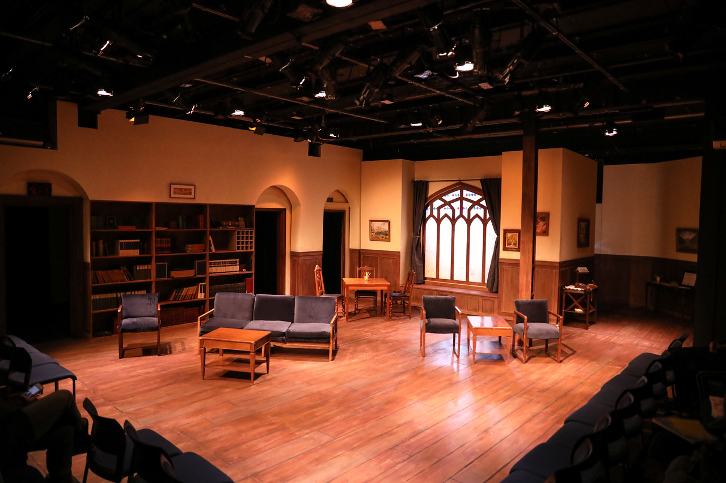
Figure 30-Photography Credit to Benjamin Rose Photography

Appendices
Imagery Index
Figure 1-Reference image of MHC study room (Skelley) 6
Figure 2-Reference image of MHC study room (Skelley) 7
Figure 3-Reference image of MHC study room window (Gray) 8
Figure 4-Women's college dorm room ([Unknown]) 9
Figure 5-Inspirational quote from Michelle Obama (Unknown) 10
Figure 6-Poster of Rosie the Riveter (Collection, Print) 11
Figure 7-Initial sketch for scenic vision 13
Figure 8-Rough sketch of window design 14
Figure 9-2nd Sketch for scenic vision 15
Figure 10-Ground plan for first and last scene 19
Figure 11-Ground plan for middle of show 19
Figure 12-Vectorworks drawing of "door wall" 20
Figure 13-Vectorworks drawing of "window wall" 20
Figure 14-Vectorworks drawing of "foldy wall" 21
Figure 15-Vectorworks drawing of "escape wall" 21
Figure 16-Vectorworks drawing of the set in perspective 22
Figure 17-3-Dimensional model of the callan 23
Figure 18-Model piece of "window wall" 24
Figure 19-Process photo of painting the model pieces 24
Figure 20-Finished model of the set 25
Figure 21-Budget and labor summary 26
Figure 22-Budget and labor of the slipstage 27
Figure 23-Budget and labor of the "window wall" 28
Figure 24-Budget and labor of the "hinged wall" 29
Figure 25-Budget and labor of the "door wall" 30
Figure 26-Budget and labor of the "escape wall" 31
Figure 27-The color swatch of the fabric used to upholster the furniture 36
Figure 28-Small paint sample of the treatment 38
Figure 29-News article by Shiela Barth 45
Figure 30-Final Production Photo of the Set…………………………………………….51

(Wasserstein, Uncommon Women and Others)

Interview Manuscripts
Allyson Kinch
Q: As a director, what are your general expectations of the scenic designer?
A: They should help the cast get into the world. The actors need to be able to step on stage, and also step into a whole new environment, I personally like when designers include even the smaller details to remind the actors where they are.
Q: What part do you believe the set has in telling the story?
A: It plays a crutial part! The set is the first thing the audience sees; it sets the tone for the whole show. In “Uncommon” the tone was very homey, and as if the actors had been in that space forever.
Q: In what ways did the set design affect your process?
A: It gave a lot to play with, there was a lot of room for creativity. The window seat specifically was fun to play with, with the actors, it really changed how the cast moved.
Q: Did you feel as though this set did its job?
A: One hundred percent.
Q: What changes would you have made in our process working together? What could I have done better?
A: It may have been more on the props side, but it would have been nice to have the furniture sooner.
Q: How was it working with an all female cast, female director, female scenic designer, and female stage management team on a play written by a female playwright?
A: It was very nice! It made everything easier to connect to. We were our own resources and everyone was very comforting and respectful.
Lynnaea Barry
Q: What part do you believe the set design has in telling the story?
A: As an actress in this generation, the set design has an multiple ways in showing the story of the playwright. Scenic designers and their specific visions of the show capture all the energy of each performance, allowing performers to create and identify character choices and how each character may go about their specific transitions and blocking. Creating a “pathway” - for lack of better words, lets the audience want to live the life of the character, letting the story be told while walking through an artistic, comfortable space.
Q: Did the set affect your process as an actress? How so?
A: Of course. In the best way possible, the set created different ways for me to live throughout my character. I was actually extremely lucky to be able to be on the set as it was moving, which gave me the opportunity to connect my character with Mount Holyoke, and the beautiful stain-glasses window I was able to gaze out of. The set affects my process as an actress by its ability to enhance ones performance, and creates an opportunity for ones character to move gracefully and confidently between doorways, hallways, and of course, the moving set pieces.
Q: Have you ever performed without a set? How would you compare that experience with this one?
A: I’ve actually performed without a set a few times, but not anything as long as this production of Uncommon. Uncommon was something that really hit home with me, and made me proud to be a woman. I don’t think an experience like that should be compared to one without a set, especially when Uncommon’s set was such an amazing opportunity.
Q: Was there any point where the Uncommon set “threw you off?”
A: No, actually. The set gave a familiar energy to walk into, one that makes someone feel comforted or welcome.
Q: What would you have liked the designer to do differently?
A: Not necessarily differently, but: to never stop challenging themselves. Set designing, or any artistic process rather can be held back by an ingrown critic in the back of our heads, and it’s easy to get caught up. Keep challenging yourself and don’t be afraid to push yourself. Set designs border the entire story, and thankfully this one was an active experience every night.
Q: How was working on an all-female cast with female directors and a female designer on a play written by a female?
A: How was it? It was, undoubtedly, one of the most surreal moments of my life seeing all the woman around me smile after opening night of Uncommon Women and Others. The positive, supportive people within this process made it wonderful to walk into the space everyday and create something powerful for people to see. As women, we have to look out for one another. This show showed me hardworking, funny, beautiful women within each character, and helped many women I know see those qualities within themselves. We all helped each other create something that we and many others will always remember, something that stirred up conversation and created joy as well as love between women and others.

Paige Ruggles
Q: What part do you believe the set design has in telling the story?
A: For me, the set cements so many elements of storytelling in theatrical performance. Through the set, the actors and audience are immersed in the time period and world of the play. A good set can also provide clues to a character’s state of mind and socioeconomic status based on how messy or clean it is and how it’s decorated. For Uncommon Women, the common room was clean and organized because the setting was a well-to-do college with a housemother obsessed with image.
Q: Did the set affect your process as an actress? How so?
A: For Uncommon Women specifically, I found the set was a huge part of getting into character. Because my character, Mrs. Plumm, was so obsessed with image, my focus as an actor onstage was to keep the set as tidy as possible. It motivated busy work I had to perform during scenes when I wasn’t speaking and gave Mrs. Plumm an added layer of character development.
Q: Have you ever performed without a set? How would you compare that experience with this one?
A: Performing without a set is certainly possible, but in my opinion, it’s just not the same. Theatre is such an amazing art form that it can be done anywhere, but performing without a set is like a ballerina performing without shoes. It’s technically okay to do, but I’d rather not.
Q: Was there any point where the Uncommon set “threw you off?”
A: The only complaint I ever had with the entire process of Uncommon Women was getting the tea cart into the room from my doorway, but that had more to do with the construction of the Callan.
Q: What would you have liked the designer to do differently?
A: I could not have asked for a more perfect set for this play. It only added to the performances, especially the stained glass window. It really captured what the houses at seven sisters colleges looked like (a lot of them still look like that too).
Q: How was working on an all-female cast with female directors and a female designer on a play written by a female?
A: I think it’s a little cheesy to say that the process for this show was “sacred”, but it really was almost spiritual in a way for me. I will say that the lack of issues the process had is a testament to how wonderful art can be when women come together to create. We all understood that this play was important for the audience to see, and it really encapsulated my experiences as a young woman in our world. It’s unfortunate that we’re in a place where not a lot has changed from 1972 to now, but I think this play has shown all of us that being a woman is a universal experience.

Stephen Zubricki IV
Q: What part do you believe the set has in telling the story?
A: It gives the location of the play and really aids my imagination in picturing the world of the characters. It also gives information about the characters themselves and sets the mood in the atmosphere.
Q: Did the “Uncommon” set play its part?
A: Yes
Q: How would you say the set design affected your experience of the production? How did it affect your mood in the environment?
A: It did a good job of giving the girls their own specific areas. There was a variety of acting locations that made them feel comfortable with where they were. The actors were comfortable in the space, which made the audience feel comfortable as well.
Q: Did anything in the set cause you to be confused? Were you ever “not in the world of the play?”
A: Not really, when the set transitioned into the last scene it took a little longer than I would have liked. The book cases also looked similar to a stock photo, there were lots of large books but no novels, which was interesting.
Q: As someone who has worked in theater, is there anything that you would have liked to see done differently?
A: Just the timing of the transitions and maybe some more molding.

Claudia Marchionda

Q: What part do you believe the set has in telling the story?
A: It immerses the audience and actors into the world of the play. It should create a real and tangible environment to help the actors.
Q: Did the “Uncommon” set play its part?
A: Oh yes.
Q: How would you say the set design affected your experience of the production? How did it affect your mood in the environment?
A: I liked how the set was molded to the space that was the Callan. It looked like it was meant to be there. I really liked the realistic details like the aging and scuffs on the floorboards. It really made me feel like I was there.
Q: Did anything in the set cause you to be confused? Were you ever “not in the world of the play?”
A: The last transition didn’t really feel like we were going forward in time.
Q: As someone who has worked in theater, is there anything that you would have liked to see done differently?
A: I wish that the transitions were faster, and the crew walked with more purpose.

Caitlyn Buja
Q: What part do you believe the set has in telling the story?
A: It gives the setting of the play, which is very important.
Q: Did the “Uncommon” set play its part?
A: Yes.
Q: How would you say the set design affected your experience of the production? How did it affect your mood in the environment?
A: It helped transform the play in where it took place. It was easy to know where they were.
Q: Did anything in the set cause you to be confused? Were you ever “not in the world of the play?”
A: I don’t think so.
Q: As someone who has worked in theater, is there anything that you would have liked to see done differently?
A: Conceptually no. I think it would have been cool if the couch was a futon that turned into a bed, and the hanging picture was slightly crooked.

Theresa Soldan
Q: How did the set design affect your experience of the production as a whole?
A: It made everything seem more fluid and made the story come to life for me. The movement of the scene changes were smooth and made the story continue to progress in a comprehensible way.
Q: Did the set help you understand any specific aspect of the play?
A: Specifically, when the wall moved back and forth and the curtains closing made it clear that we were in a different time period and helped myself as an audience member make that transition.
Q: Have you ever seen a staged reading? How was that experience different? How was it similar?
A: Yes! The set added the sense of realism that you don’t get in a staged reading. With staged readings each audience member walks out with a different interpretation of what the scene/set would look like. It was similar because some things were left up to interpretation which can be fun but not as much as a staged reading.
Q: What would you say is the job of a scenic Designer based on your experiences?
A: To work off what is being said and done by the actors and directors. To make it more of a rounded experience for the audience and to foreshadow certain motifs that are throughout the play.
Q: Do you believe this design did it’s job?
A: Yes 100%
Q: What should the designer have done differently? Did anything on the set take you “out of the world of the play?”

A: Not really! It was really well done and I felt as if I was really stepping into a college like mount Holyoke. I throughly enjoyed the set!

Liam Conlon
Q: What was your job on this production?
A: The properties master.
Q: How close did you have to work with the scenic designer throughout the process?
A: Very close.
Q: Did your job ever depend on the scenic designer’s job at anytime? How so?
A: Yes; I needed to match the era of the furniture and set dressing to the era of the set.
Q: What do you think the scenic designer did well? What could the scenic designer have done better?
A: The way the space was used was done very well. It felt like we were in a large school setting, but still intimate. I think the designer could have delegated more efficiently during the post-design process.
Q: Overall, do you believe all the design aspects worked cohesively?
A: Yes, all aspects contributed to the overall mood and vibe.
Q: In your opinion, did this set help to tell the story?
A: Yes.

Katrina Tuck
Q: What was your position on the show?
A: The assistant technical director.
Q: Was your job dependent on the job of the scenic designer?
A: Yes.
Q: How so?
A: We had to build what was designed by the scenic designer.
Q: Did you have any major difficulties? Explain.
A: Not really. It was a relatively easy design to execute. The space in the Callan was weird though.
Q: How important is communication with the designer?
A: Very.
Q: Did you have good communication?
A: Yes.

Michael Harvey
Q: What would you say is the job of the scenic designer?
A: To help tell the story.
Q: How many years have you been designing scenery?
A: A little over thirty years or so.
Q: What was your proudest design? How was the process?
A: I designed the set for a show called The Shape of Things. It was about a girl who was a masters student, and she transforms her boyfriend as an art project. The show ends in a gallery, and all the objects that had been slowly left on stage built her gallery display. It was simple but seamless and I loved the concept and the storytelling aspect.
Q: What affect did the set for Uncommon Women and Others have on your experience of the production?
A: It was evocative of a period in location and it really set the mood. It did its job in terms of storytelling and it was believable.
Q: Was there any aspect that took your mind out of the world of the play? Was there anything that held you in?
A: The furniture should have been much older as the school was old and used at that time. The furniture also should have matched more of the late Victorian architecture that was used within the set. There was also a lack of practicals but I loved the paint treatments.
Q: What parts of the design (if any) were strong? What parts were weak?
A: The window was really strong. I am also glad that it wasn’t completely made of stained glass, but rather fogged with some stained pieces.
Q: Did the design tell the story?
A: Yes it did.

Works Cited
Information Citations

Barth, Sheila. "Uncommon Women and Others." The Winthrop Sun Transcript (2019).
Mount Holyoke College. "Timeline." 24 August 2012. Mount Holyoke. November 2019 <www.mtholyoke.edu/175/timeline?fbclid=IwAR33jcN-GMRIFWJaQpCJXDOeDNJNSbPnjxMHdZd0jFkKs2fxWzrRHrD4oU#>.
Powers, Keith. "Exploring Wendy Wasserstein." Wicked Local (2019).
Uncommon Women and Others. By Wendy Wasserstein. Dir. Brianne Beatrice. Perf. Chelsea Titchenell, et al. Callan Studio Theater, Salem. 14-24 February 2019.
—. Uncommon Women and Others. Dramatists Play Service Inc., 1977.

Image Citations
Collection, Print. “Print Collection - ‘We Can Do It’ Rosie the Riveter.” Printcollection.com, www.printcollection.com/products/we-can-do-it-rosie-the-riveter?utm_campaign=Pinterest%2BBuy%2BButton&utm_content=pinterest-buy-button-06afd91da-07c9-41ab-ad87-636d612e062d&utm_medium=Social&utm_source=Pinterest#.XMdlB2aZOCR.
Gray, Peter. “Mount Holyoke Library Window VI.” Flickr, Yahoo!, 2 Apr. 2007, www.flickr.com/photos/peter_gray/443404031/in/photolist-Fbyz6-8zhZFA-FbCeJ-FbDUF-bmCTXP-4UAEPY-atqtyR-7JK9dQ-77yBNv-7JKa8w-7JK8th-7JK8H9-7JK9Nj-77yBJB-2bpfJF-2bpkc8-BT8eB-2bpfJt-hPF8XP-BT6wf-BT7i9-BT7id-2bucoS-7JFdQP-77yCf2-77Cyy5-7Eh8gA-77CyHh-4QCPXn-xNRAK-xNRz8-2bpfJi-2bpfHF-2bpfGM-32KVbK-2bpfHv-5n3dW6-7Eh8sN-8zhZp5-2bpkdP-BT6wd-K3WbG-8qd9wH-9wrVXs-jLi9Wi-5n3d1i-6qu5N4-FaXqM-7LgrbS-BT7i1.
Skelley, Jemima. “16 University Campuses That Might Secretly Be Hogwarts.” BuzzFeed, BuzzFeed, 15 Nov. 2016, www.buzzfeed.com/jemimaskelley/colleges-that-look-like-hogwarts?utm_term=.eoOGoOP3E&utm_medium=email&utm_campaign=BuzzFeed%2B1116&utm_content=BuzzFeed%2B1116%2BCID_4e91e18013d1cf57aa9d202bc82838aa&utm_source=BuzzFeed%2BNewsletters#.xozr6YodZ.
Unknown. “Believe. Imagine. Create.” Believe. Imagine. Create., 1 Jan. 1970, lifeontheflycounselor.blogspot.com/2014/06/believe-imagine-create.html.
[Unknown]. “Dorm Life in Washburn Hall, San Jose State College, Early 1970s.” Calisphere, San José State University, Special Collections and Archives, calisphere.org/item/ark:/13030/kt738nc7m3/.

