HEART RATE VARIABILITY AS A MEASURE OF CARDIOVASCULAR HEALTH IN INDIVIDUALS WITH SPINAL CORD INJURY

Honors Thesis

Presented in Partial Fulfillment of the Requirements

For the Degree of Bachelor of Science in Sport and Movement Science
In the College of Arts and Sciences
at Salem State University

By

Olivia Ademi

Supervisor:
Dr. Brett R Ely
Sports and Movement Science Department

***

Commonwealth Honors Program
Salem State University
2021

TABLE OF CONTENTS

ACKNOWLEDGEMENTS ii

ABSTRACT iii

- INTRODUCTION/BACKGROUND #1

- METHODOLOGY #3

- RESULTS #5

- DISCUSSION #8

- CONCLUSION #10

- REFERENCES #11

ACKNOWLEDGEMENTS

This research was supported by the sports and movement science department. First and foremost, I would like to thank my family and my boyfriend Oresti Hoxha for their love and support throughout my undergraduate school. They were always ready to cheer me up and provide inspiration when thesis writing seemed too much to handle. I would like to express my most profound appreciation to my research supervisors, Dr. Brett Ely and Dr. Scott Nowka, for their dedicated and relentless help throughout the process. Thank you to my tremendous mentors for always being willing to give insights and a significant amount of assistance; I would have never accomplished this research thesis. I would like to extend my sincere thanks to Dr. Joseph Gallo, Dr. Anthony D’Amico, Dr. Jason Gillis, and my former research partner Jack O’Brien from Salem State University, who helped embolden me through their positivity and encouragement. Without any of you, I wouldn’t be where I am right now.

ABSTRACT

The purpose of this study is to examine the acute responses to exercise alone, heat therapy alone, and both exercise and heat therapy on leg blood flow, blood pressure, and heart rate variability in patients who have an injury below T6 thoracic vertebrae. Due to their inability to perform full-body exercises, they tend to have lower heart rate variability and a higher chance of cardiovascular disease. Briefly, medically stable men and women with spinal cord injury (SCI) will be recruited to take part in 3 trials consisting of matched exercise (Heart rate monitored during 20 minutes of rowing) with a post-exercise treatment of 45 minutes of hot (42C) leg bathing, matched exercise (Heart rate monitored during 20 minutes of rowing) with a post-exercise treatment of 45 minutes of thermoneutral (36C) leg bathing, and no exercise with a post-exercise treatment of 45 minutes of hot (42C) leg bathing. HRV will be tracked for 24 hours pre-trial, 12 hours post-trial, and overnight (rMSSD). Leg blood flow and blood pressure will be measured pre-trial and during 45 minutes into leg bath. Tympanic temp, HR, and brachial BP will be measured pre-trial and 5 minutes during leg bath. A validation study will be conducted and will measure overnight HRV for five continuous days to be compared to the first-morning HRV. This study highlights the importance of tracking the heart rate variability while finding alternatives (exercise; heat therapy) for patients with SCI because it serves as a critical pointer for any cardiovascular risk. This study will help the people with SCI and be used as a base study for future researchers.

- INTRODUCTION /BACKGROUND

Individuals who have suffered from spinal cord injury (SCI) have impaired or absent cardiovascular sympathetic control (Abreu 2016). Due to the sedentary lifestyle and their inability to participate in whole-body exercises, they have impaired heart rate variability (HRV), impaired blood pressure control, and a 40% risk of death from cardiovascular disease (Abreu 2016). Heart rate variability is the primary variable for this study used as a measure of autonomic function. In addition to that, HRV measures the variation in time between each heartbeat by assessing the cardiac autonomic nervous system and positive adaptations after exercise (Buker 2018). Heart rate, heart rate variability, and blood pressure are controlled by a balance of sympathetic (fight or flight response) and parasympathetic nervous system (rest and digest) activity. The parasympathetic system is accountable for increasing HR variability and decreasing heart rate and blood pressure; the sympathetic system is responsible for increasing heart rate, blood pressure, and decreasing HR variability. Prior research has indicated that exercise training shows better HRV data and a lower risk of cardiovascular disease (Solinsky 2021). In addition, exercise increases body temperature and blood flow in able-bodied populations (Buker 2018). People with spinal cord injury that will participate in the study will have an injury below T6. Subjects will have paraplegia with control of the torso but the loss of function below the waist. Injuries to the lower motor neurons within the lower extremities are displayed that exhibit reduced exercise capacity, increased heart rate responses, and circulatory limitations within the paralyzed tissues (Jacobs 2004). Due to their inability to perform the full-body exercise, alternatives are needed to be found. Functional electrical stimulation (FES) activates paralyzed tissues in people with SCI, allowing exercise movements that mimic full-body exercises such as FES rowing, recumbent cycling, and upright ambulation (Jacobs 2004).
Another alternative that has helped patients with spinal cord injury improve their cardiovascular health and autonomic function in prior research is repeated passive heat exposure, using hot baths or sauna (“heat therapy”). Heat therapy has been seen in able-bodied individuals (Thomas et al., 2016) and those with SCI to increase temperature and blood flow (Coombs 2019) similar to moderate-intensity exercise. There have been positive effects of acute leg heating in aged adults, including a noticeable decrease of arterial blood pressure (Engelland 2020). This decrease in blood pressure may be due to changes in autonomic activity, including reduced sympathetic nervous system activity (Ely et al., 2019). In addition, heat therapy has resulted in increased flow-mediated dilatation, reduced arterial stiffness, and diastolic blood pressure (Brunt 2016), which result in reduced cardiovascular risk. The magnitude of changes in autonomic and cardiovascular health that heat therapy caused is larger than observed with 16 weeks of exercise training in patients with SCI (Pelletier, Totosy De Zepetnek, Macdonald, & Hicks, 2015). However, the impact of heat therapy, alone or in combination with exercise in people with SCI, has not previously been studied. In addition to that, a validation study will be conducted and will analyze overnight and first morning HRV for five continuous days. This project examines the day-to-day variability of HR and HRV, and the relationship between overnight and first-morning HRV as a research tool.

- METHODOLOGY
Subject Selection:
There would be 16 individuals that will be anticipated in the study. Individuals will be medically stable, aged 18-50 years, body mass index (BMI) 18-30 kg/m^2 that include normal to overweight but not obese individuals, and with a complete injury below T6 thoracic vertebrae in the spine. This population will have a full hand function, but paraplegia with loss of function below the waist. Since the spinal cord injury population is predominantly male (about 75%), it is expected that the majority of the subjects in the study will be male. Exclusion criteria will include any signs or symptoms of heart disease, hypertension, coronary disease, diabetes, renal disease, any neurological disease that affect individuals’ ability to follow directions, cancer and history of clotting or bleeding disorders.

Procedure:
To begin with, subjects will undergo a 30-minute screening process that includes obtaining informed consent, health history, height, and weight measurements. During this randomized study, the subjects will perform three different trials: exercise alone, exercise + heat therapy, and heat alone performed in the Exercise for Persons with Disabilities lab (ExPD) at Spaulding Rehabilitation Hospital in Cambridge, MA. The exercise alone trial will involve 20 minutes on an adaptive rowing machine at a moderate intensity. On the other side, the heat-alone therapy will involve lower-leg hot water baths (40C) for 45 minutes. The exercise + heat therapy consists of a combination of 20 minutes on an adaptive rowing machine at a moderate intensity and lower-leg hot water baths (40C) for 45 minutes. All subjects will be given a heart rate monitor (chest strap), brachial blood pressure cuff, Finometer finger cuff and wrist unit, and a doppler probe behind the knee. Their lower legs will be placed in plastic bags for skin protection when immersed in a water bath to mid-calf. Heat therapy is efficient for subjects with spinal cord injury because since it requires only lower leg hot water immersion, it will not require them to transfer from their wheelchair. The heat therapy will slowly increase the body temperature and blood flow to the paralyzed limbs. The randomized and counterbalanced study will show proof of work on the safety and efficacy to improve cardiovascular health in individuals with spinal cord injury.

Data Analysis:
Variables such as blood pressure, heart rate, temperature, and heart rate variability will be monitored continuously for the safety of subjects who suffer from spinal cord injury. They will be given a Biostrap wrist monitor and be instructed to wear it overnight before each study day. The wrist-based monitor will record heart rate and heart rate variability. We will use a clinical-grade tympanic temperature monitor to monitor internal temperature every 5 minutes during heating. The Doppler flow velocities will estimate whole limb blood flow during heating or post-exercise seated rest. An arm cuff (Dash 2000, GE) will be used to measure brachial blood pressure, whereas the Finapres Blood Pressure System will be used to track the arterial waveform in a finger. In addition to that, subjects will rate the thermal sensation of the hot water and the degree of thermal comfort on a scale of -4 to 4, where -4 is very cold and 4 is very hot.

Validation Study:
Three healthy subjects participated in the validation study. Two females and one male had an age range of 21- 42 years old. The subjects wore their Biostrap for five continuous days and traced their heart rate (HR) and heart rate variability (HRV). After collecting these data, CV%, standard deviation, and mean were calculated to observe any differences between HR and HRV. The coefficient of variation is calculated as the ratio of the standard deviation of the sample to the mean of the sample, expressed as a percentage. Only one of the subjects recorded the first morning HRV. Patterns or any correlation between these data were analyzed by using linear regression.

- RESULTS
Data collection was delayed for the SCI study due to COVID - 19, but results from the validation study (%CV, regression of overnight vs. morning HRV) are presented. The mean heart rate (HR) for subjects 1 was 44 bpm, whereas the mean HRV was 63 ms. The second subject showed a mean HR of 54 bpm and a mean HRV of 34 ms. Subject 3 had a mean HR of 63 bpm and a mean HRV of 53 ms. The average calculation of coefficient of variation for heart rate variability was 14.99%, whereas the CV% for heart rate was 3.04%. The data shows that HR is the variable with the lower level of dispersion around the mean. When comparing the CV% of HRV in these subjects (CV1% = 15.2%; CV2% = 13.0%; CV3% = 16.8%) with the CV% of the first morning HRV (42.3%), it is apparent that the higher the coefficient of variability in first morning HRV, the greater the level of dispersion around the mean due to external factors. The data passed the normality test (P = 0.770). Even though the variables showed a strong relationship between them (R = 0.800), the data was not significant (P = 0.104).

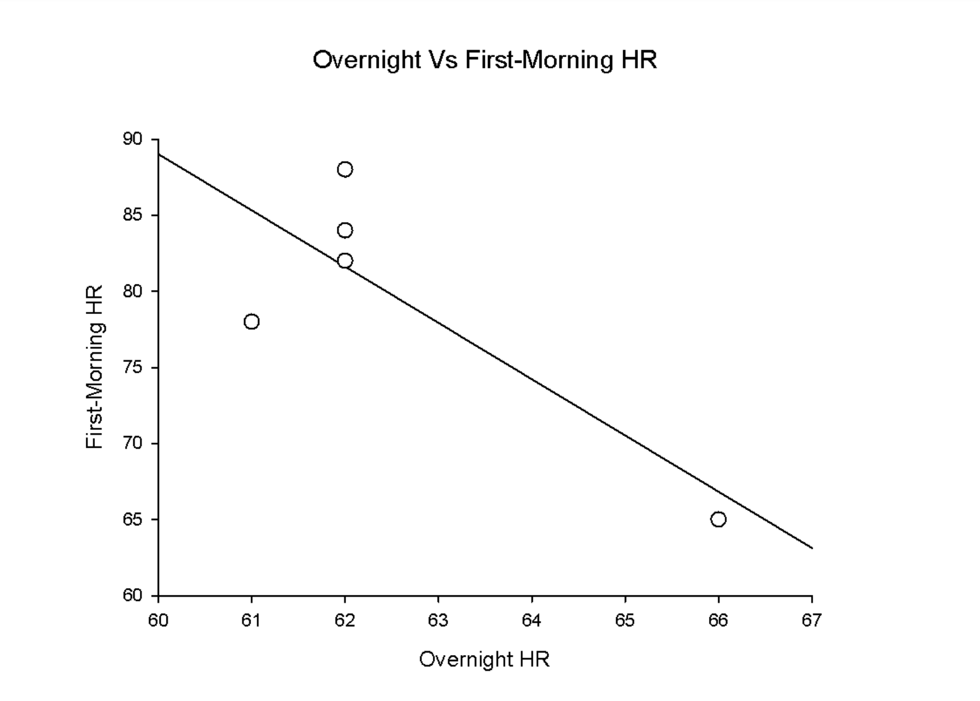
(r = 0.817) (p = 0.09)

Fig 1: Relationship between Overnight Vs. First-Morning HR in subject 3.

The trendline shows that when overnight HR is low, the First-morning HR is low as well. The R-value between these two variables is close to +1, which shows that these two variables are closely related. The P-value indicates that the relationship is not significant (p > 0.05).

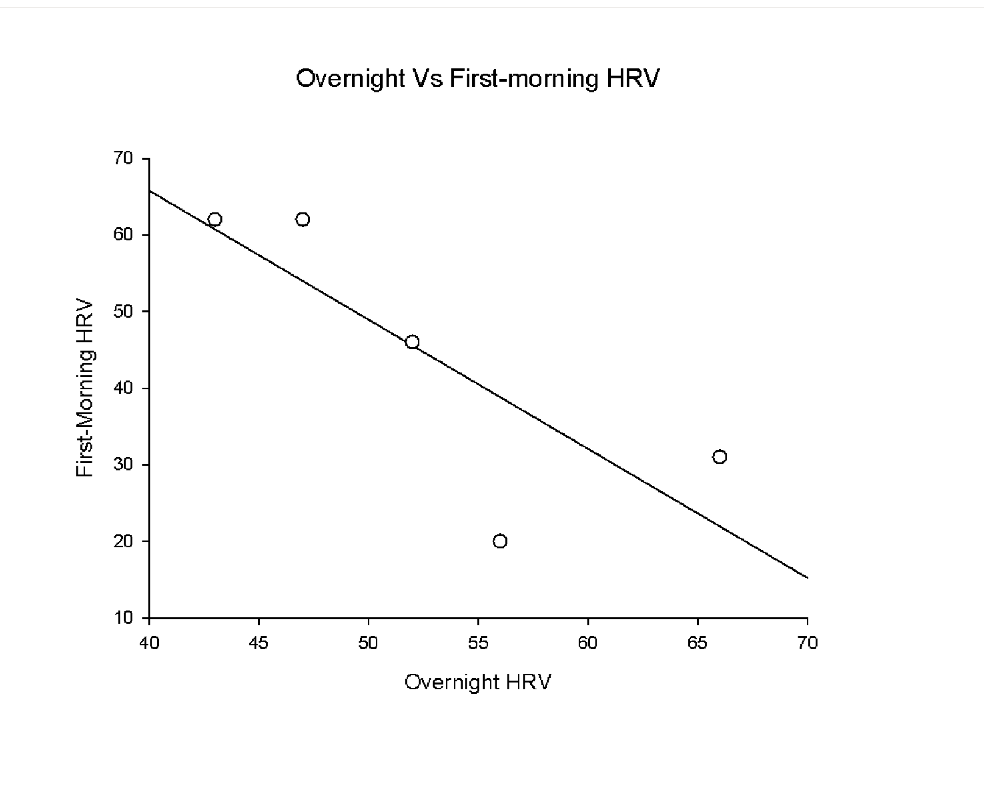
(r = 0.800) (p = 0.104)

Fig 2: Relationship between Overnight Vs. First-Morning HRV in subject 3.

The trendline shows that when overnight HRV is low, the First-morning HRV is low as well. The R-value between these two variables is close to +1, which shows that these two variables are closely related. The P-value indicates that the relationship is not significant (p > 0.05).

- DISCUSSION
HRV is a non-invasive and comfortable way of checking for any autonomic nervous system (ANS) imbalances. If an individual's body response is similar to fight-or-flight mode, the variation between heartbeats is low, so their HRV is lower. A low HRV is associated with depression, anxiety, increased risk of death, and cardiovascular disease (Marcelo 2019). Tracing your HRV provides personal feedback about your lifestyle. Heart rate variability is a health indicator not only for people who suffer from spinal cord injury but also for able-bodied people. A scientific study shows that healthy elderly and middle-aged people who have a lower HRV rate tend to have a higher chance of developing a stroke (Binici 2011). Tracking our overnight heart rate variability would make us cautious of any cardiovascular problems and cure it in time. On the other hand, patients with spinal cord injury have lower HRV than able-bodied individuals (Kyriakides 2019). Variables such as high frequency (HF), low frequency (LF), and the LF/HF were higher in individuals with paraplegia than those who suffer from tetraplegia. It highlights the importance of assessing the heart rate variability and differentiating between healthy subjects and those with SCI (Kyriakides 2019).

When looking at the relationship between the first morning and overnight HRV, we see that the trendline shows the correlation that when overnight HRV is low, the first-morning HRV is low as well. Even though these variables are closely related, (r = 0.800), the relationship is not significant (p = 0.104). The second and fourth data for the first-morning HRV in subject 3 (HRV2 = 78 ms; HRV4 = 88) was distinctly low due to external stressors (alarm clock). When CV% was calculated for first morning and overnight HRV, it is visible that CV% of first morning HRV (CV% = 42.3%) was higher that overnight CV% (CV% = 16.8%). All these data show that first-morning HRV appears to be least precise and with a higher level of dispersion around the mean caused by external factors.

The expected results in patients with spinal cord injury have a higher overnight HRV after exercise, heat therapy, and combined exercise + heat therapy as compared to control (no exercise or heat). Otherwise, a lower heart rate variability is correlated to a lower sympathetic nervous activity. By using exercise trials, we expect a higher HRV in patients with SCI because is previously proven that exercise training shows better HRV data by lowering the chance of any cardiovascular diseases (Solinsky 2021). Not only have shown higher data as related to HRV, but also exercise training has shown an increase in body temperature and blood flow in able-bodied populations (Buker 2018). In addition to that, heat therapy has been used as an alternate therapy to mimic full-body exercises (Jacobs 2004). Prior research has shown that repeated passive heat exposure has improved the cardiovascular health and autonomic function in able-bodied individuals (Thomas et al., 2016). In addition to that, heat therapy has shown an increase in flow-mediated dilatation, reduced diastolic blood pressure (Brunt 2016), and a higher number of changes in cardiovascular health as compared to 16 weeks of exercise training alone in patients with SCI (Pelletier et al., 2015). Even though this research has not previously been studied, the expectancy for a higher overnight HRV is surpassing due to the research done listed above.
- CONCLUSION
Research supports that HRV is closely related to HR, even though both data showed no significance. HRV tends to be a more sensitive variable when compared to HR due to external factors. SCI research was delayed due to COVID-19; therefore, the hypothesis was not proven. An expectancy for a higher overnight HRV underlies when prior research based on previous theses is done.

- REFERENCES
Abreu, Elizângela Márcia de Carvalho et al. “Autonomic cardiovascular control recovery in quadriplegics after handcycle training.” Journal of physical therapy science vol. 28,7 (2016): 2063-8. doi:10.1589/jpts.28.2063

Binici, Zeynep, et al. “Decreased Nighttime Heart Rate Variability Is Associated with Increased Stroke Risk.” Stroke, 15 Sept. 2011.

Brunt, Vienna E., Howard, M. J., Francisco, M. A., Ely, B. R., & Minson, C. T. (2016). Passive heat therapy improves endothelial function, arterial stiffness and blood pressure in sedentary humans. The Journal of Physiology, 594(18), 5329–5342.

Buker, Daniel Bueno et al. “Effects of Spinal Cord Injury in Heart Rate Variability After Acute and Chronic Exercise: A Systematic Review.” Topics in spinal cord injury rehabilitation vol. 24,2 (2018): 167-176. doi:10.1310/sci17-00028
Coombs, Geoff B et al. “Acute heat stress reduces biomarkers of endothelial activation but not macro- or microvascular dysfunction in cervical spinal cord injury.” American journal of physiology. Heart and circulatory physiology vol. 316,3 (2019): H722- H733.
Ely, B. R., Francisco, M. A., Halliwill, J. R., Bryan, S. D., Comrada, L. N., Larson, E. A., … Minson, C. T. (2019). Heat therapy reduces sympathetic activity and improves cardiovascular risk profile in obese women with polycystic ovary syndrome. American Journal of Physiology-Regulatory, Integrative and Comparative Physiology, ajpregu.00078.2019. https://doi.org/10.1152/ajpregu.00078.2019

Engelland, Rachel E et al. “Neural control of blood pressure is altered following isolated leg heating in aged humans.” American journal of physiology. Heart and circulatory physiologyvol. 318,4 (2020): H976-H984. doi:10.1152/ajpheart.00019.2020

Jacobs, P.L., Nash, M.S. Exercise Recommendations for Individuals with Spinal Cord Injury. Sports Med34, 727–751 (2004). https://doi.org/10.2165/00007256-200434110-00003
Kyriakides A, Poulikakos D, Galata A, Konstantinou D, Panagiotopoulos E, Chroni E. "The not macro- or microvascular dysfunction in cervical spinal cord injury.” American journal of physiology. Heart and circulatory physiology vol. 316,3 (2019): H722- H733.
Marcelo Campos, MD. “Heart Rate Variability: A New Way to Track Well Being.” Harvard Health, 22 Oct. 2019, www.health.harvard.edu/blog/heart-rate-variability-new-way-track-well-2017112212789.
Pelletier, C. A., Totosy De Zepetnek, J. O., Macdonald, M. J., & Hicks, A. L. (2015). A 16-week randomized controlled trial evaluating the physical activity guidelines for adults with spinal cord injury. Spinal Cord, 53, 363–367.

Solinsky, R., Vivodtzev, I., Hamner, J.W. et al. The effect of heart rate variability on blood pressure is augmented in spinal cord injury and is unaltered by exercise training. Clin Auton Res 31, 293–301 (2021).

Thomas, K. N., van Rij, A. M., Lucas, S. J. E., Gray, A. R., & Cotter, J. D. (2016). Substantive hemodynamic and thermal strain upon completing lower-limb hot-water immersion; comparisons with treadmill running. Temperature, 3(2), 286–297.

