ONE THEATRE ARTIST’S JOURNEY TO AND THROUGH
BFA RECITAL

Honors Thesis

Presented in Partial Fulfillment of the Requirements
For the Degree of Bachelor of Fine Arts
In the College of Arts and Sciences
at Salem State University

By

Caitlyn Jones

Professor David Allen George
Faculty Advisor
Department of Theatre and Speech Communications

***

Commonwealth Honors Program
Salem State University
2016

Table of Contents
Cover Letter..................................................................................................................................................................2
Actor’s Manifesto........................................................................................................................................................3
Actor’s Business Plan................................................................................................................................................4
Letter of Intent.............................................................................................................................................................5
Prompt Book.................................................................................................................................................................8
Nocturama.....................................................................................................................................................9
God of Carnage...............................................................................................................................................11
Random Black Girl....................................................................................................................................13
Headshot......................................................................................................................................................................15
Résumé.........................................................................................................................................................................16
Written Work from Class......................................................................................................................................17
Intro Paper..................................................................................................................................................18
An Actress I Admire................................................................................................................................20
Progression: A Visual Journey............................................................................................................................23
Twelfth Night.............................................................................................................................................24
Cabaret.........................................................................................................................................................26
As Bees in Honey Drown......................................................................................................................28
Spring Awakening....................................................................................................................................29
The Comedy of Errors............................................................................................................................31
Medea............................................................................................................................................................33
BFA Acting Recital...................................................................................................................................35

Cover Letter
Dear Reader,
Whether you are a professor or faculty member, a relative or friend, a stray honors student searching through theses, or none of the above, thank you. Thank you for taking the time to look through this thesis and, in essence, look through me. What you have in your hands (or on your computer) explains much about who I am as a person and who I am as an actor.
I started at Salem State University with the dream of many a young actor: to dazzle on stage and ultimately end up on the Great White Way. To be honest, I still want that. I still hope to “dazzle” the audience when I’m acting, and I’d love to get to Broadway. But my dream is so much more than that now. Five years of being a student of acting at SSU have taught me that there is so much more to my craft than simply wooing the audience. Entertaining, while valuable, isn’t my only objective when acting. I want to be able to know the deepest wants and needs of a character. I want to be able to understand why and how my character makes decisions. With this understanding, I want to be able to tell a story. I want to be truthful. I want to connect.
I’ll be the first to acknowledge that I still have a lot to learn about theatre and acting. I don’t think I’ll ever stop learning. That possibility, the possibility to continuously learn and grow, is what truly excites me about a career in the theatre. I don’t think I could ever get bored with a job like that. I fully realize that it will in no way be easy. But isn’t it worth it? To be horribly cliché, if I choose a job I love, I’ll never work a day in my life.
I hope you find whatever it is you’re looking for in these pages.
Thank you kindly,

Caitlyn Jones
Actor’s Manifesto

Manifesto (noun): a written statement declaring publicly the intentions, motives, or views of its issuer

Art is an important, valid, and necessary part of society.
Theatre is used to explore what it means to be human.
Entertainment for entertainment’s sake is not inherently bad; laughter is good.
Artists (including actors) should be compensated for their work.
Diversity (gender, racial, and ideological) is essential.
Film/TV acting is not “less” than acting for the theatre; it is simply different.
Theatre is and always will be a collaborative art form.
“The task of any artist is not to learn many, many techniques but to learn the most simple technique perfectly.” – David Mamet
“Acting is behaving truthfully under imaginary circumstances.” – Sanford Meisner
“Acting is a question of absorbing other people’s personalities and adding some of your own experience.” – Jean-Paul Sartre

Actor’s Business Plan

Year 1 | - Audition, audition, audition.  - Only audition for PAYING shows.  - If less than $500/show, be selective about it. Who is working on the show? What connections will be made? Where is the show?  - Continue working as a server at the 99. Possibly get second serving job at fine dining.  - Be trained on the bar at the 99.  - Save up $12,000 for travel/moving to NYC.
Year 2 | - Audition, audition, audition.  - Get bartender license and/or non-99 bartending job.  - Be in at least 3 professional shows.  - Travel to the UK for 2-3 weeks in April 2016.  - Backpack Europe mid-August to mid-November 2016.  - Visit/make connections at European theatres.  - Move to NYC Winter 2016/17.
Year 3 | - Audition, audition, audition.  - Get involved with WEBroadway through previous connections.  - Get at least 2 day-jobs. One theatre-related, one server/bartender.  - Become Equity.  - Become Sag/AFTRA  - See at LEAST one show a week
Year 4 | - Audition, audition, audition.  - No longer need two day jobs.  - Land an off-Broadway gig.
Year 5 | - Audition, audition, audition.  - Be on Broadway.

Letter of Intent
To the Salem State University Faculty of the BFA Acting Track:

On the evening of Saturday, May 14th and the afternoon of Sunday, May 15th, 2016, I had the honor and privilege to perform in the 2016 BFA Acting Recital: The Last Supper. The scenes I acted in included August: Osage County, God of Carnage, Nocturama, Random Black Girl, It’s a Wonderful Life, and We Both Reached for the Gun.
In August: Osage County, I played Karen, the flighty youngest daughter of the Weston clan. Karen was the first character I read for when as a class we chose to do this scene. I immediately resonated with her quirkiness and eagerness. Bringing it back to Acting I, this scene challenged my active listening skills, skills that are clearly paramount to a good actor. With so much happening and multiple conversations going on at once, if even one of us weren’t listening to the others, the scene would fall flat. I needed to focus on my relationships with each other the 8 other characters on stage, the objects on the table (of course including the plate of chicken), and the characters that weren’t present (mainly the diseased Bev).
God of Carnage was also a challenge when focusing on relationship of characters. The scene is like a tennis match where the characters are constantly switching partners. As Veronica I was focused on keeping my husband in line, while also maintaining a polite front for the adversarial couple in my house, which of course is quickly destroyed. I chose this scene because 1) I loved the dynamic between the characters and 2) I knew it would be a challenge to my ability to self stage. Using the skills I learned in Directing I, I came up with a ground plan that I thought would lend itself well to showing off the relationships between the characters. The single armchair was used as an alienating device, while the couch was used to both force characters together and show who was on whose side. Self-staging is definitely a difficult part of acting for me (I would not claim to be a director), so I had some trouble with that (especially for parts of the scene being to congested upstage), but I hope that I was able to tell the story without being too on the nose with my staging.
The scene I used from Nocturama happened to be the same one I used during Applied Stage Movement. I was excited to do the scene again in a very natural and realistic context without added stage combat. I first heard about the play from a friend who loves Annie Baker’s work and told me I had to play the character of Amanda at one point. This echoes another thing I’ve learned in acting school: trust those who know you best. This scene and character just fit me, and I just knew I had to have David Meredith play Skaggs. He breathes that character. This scene was both fun and easy to perform because David was both fun and easy to work with. Our chemistry worked well together and we were able to really inhabit our characters. Using skills learned in Acting II, we played off the other and that’s what made the scene work.
I’ve known since arriving at SSU that I wanted to sing during my final showcase. The question then was what I would sing. I related to the character singing in Random Black Girl, as both in high school and in college I’ve often been the only person of color in a class or cast. While I think diversity is important for understanding ourselves and the world around us, making diversity for diversity’s sake is unhelpful, and sometimes harmful. Adding in the character of a “random black girl singing the soul” whose only lines “yes’m, and yessuh, and no’suh” just to have that diversity aspect is actually insulting. I appreciated being able to air my frustration in this song. I was also able to showcase my singing talent and show the technical singing skills I’ve built upon with classes like Voice Class, Women’s Chorale, and University Chorus (which I was able to do in the final song, We Both Reached for the Gun).
I was happy that Sam Lewis asked me to act in It's a Wonderful Life with him. Some lighthearted romance was needed in a recital that was rather dark. This piece echoed what I think about theatre and entertainment. Not every theatre piece needs to be “deep” and “life-affirming” in order to be meaningful. Theatre can be fun and still be good theatre. The challenge in this scene was telling a story that was light and simple truthfully, and not overly sappy. I hope we were able to tell that story.
I'll be applying what I’ve learned in classes at SSU to my acting for the rest of my career, whether I do it consciously or not. Ideally, I’ll be getting better and better so that I won’t need to even think about the technique, but I know I can always come back to the basics.

Thank you kindly,

Caitlyn Jones

Prompt Book
The scenes that I chose to bring to Recital (so not the scenes I was asked to be in) are Nocturama, God of Carnage, and Random Black Girl. In this following section of my thesis, you will see selected images from my copies of the scripts with some blocking and acting notes as well as the ground plan of each scene. Due to potential copyright infringement, I have not included the full script.

Nocturama
by Annie Baker

In this scene, Skaggs has just returned to The Pines, the historical home of poet Elizabeth Collins where Amanda gives tours. Skaggs is a depressed 26-year-old living with his mother. And Amanda is an unassuming 27-year-old who finds joy in the quaint and (arguably uninteresting) history of Shirley, Vermont.

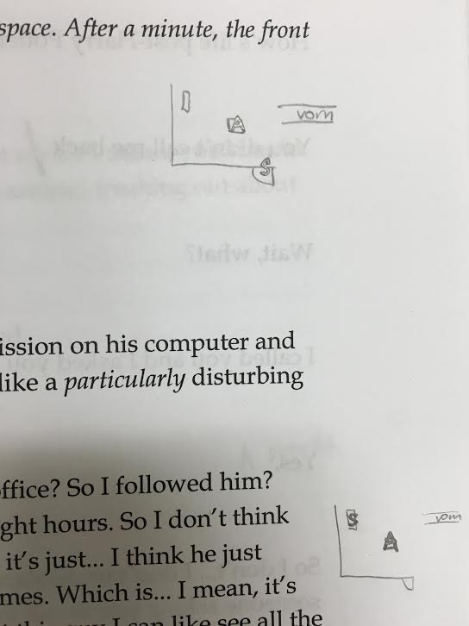

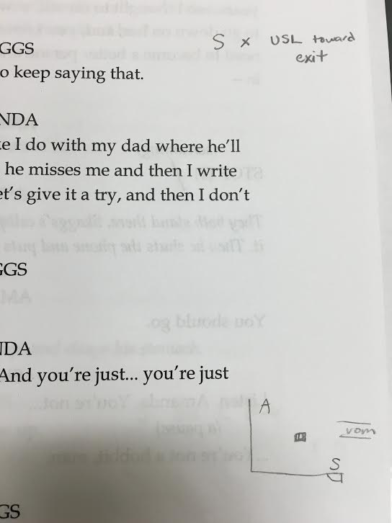

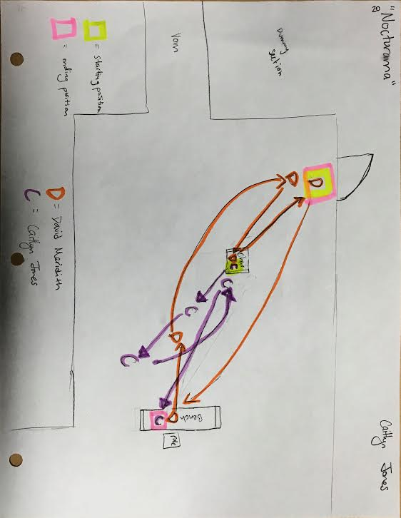

God of Carnage
by Yasmina Reza

Michael and Veronica are a well-off married couple with two children living in New York city. They have invited Annette and Alan, another well-off couple, over to their home to discuss an incidence of playground violence between their 11-year-old sons.

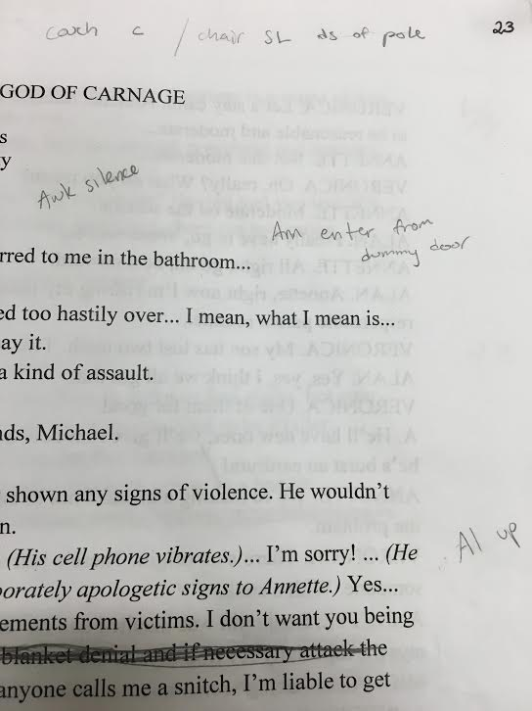

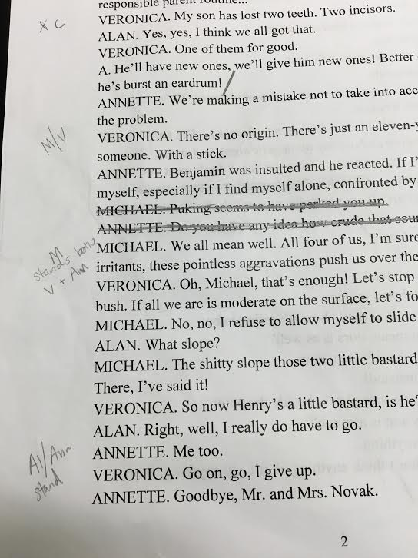

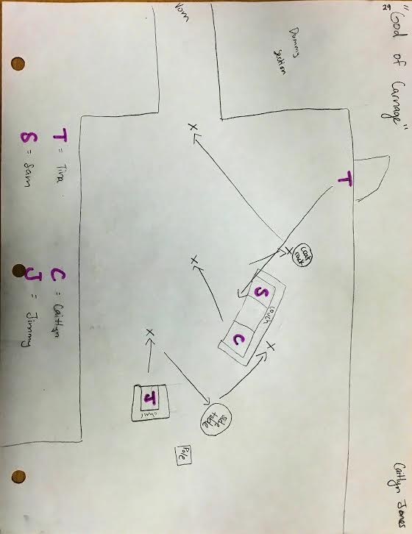

Random Black Girl
by Kooman and Dimond

“Random Black Girl” is a song written by contemporary musical theatre composers Michael Kooman and Christopher Dimond as a part of their show Homemade Fusion, a “series of musical snapshots ranging from the absurd to the sublime.”

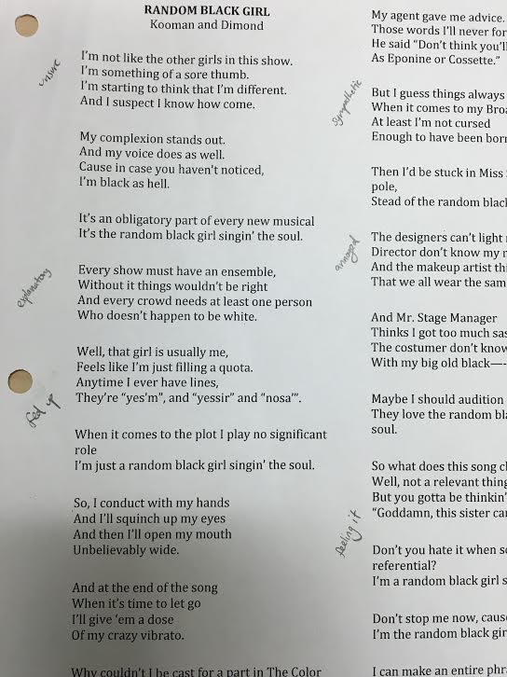

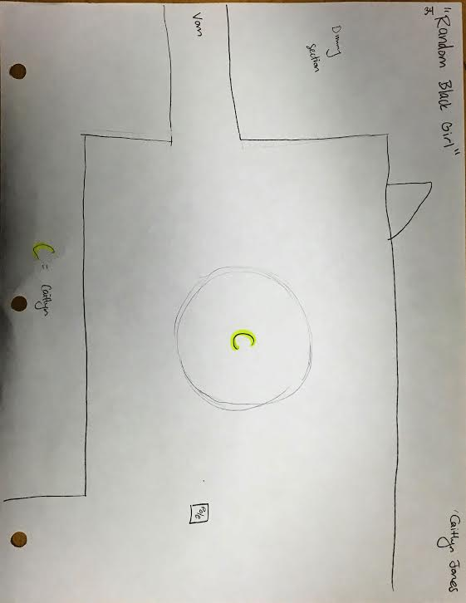

Headshot

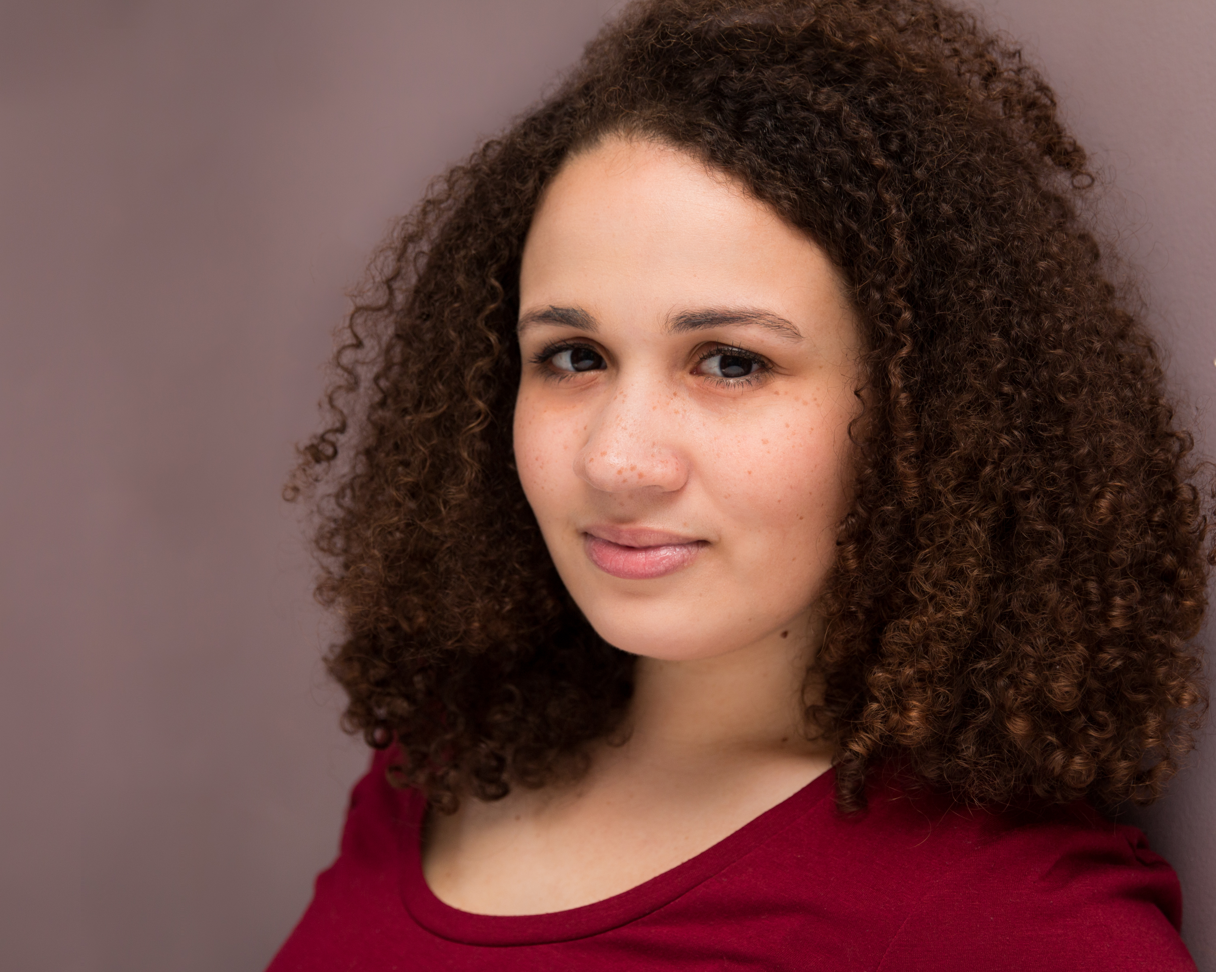

Caitlyn Jones

Résumé

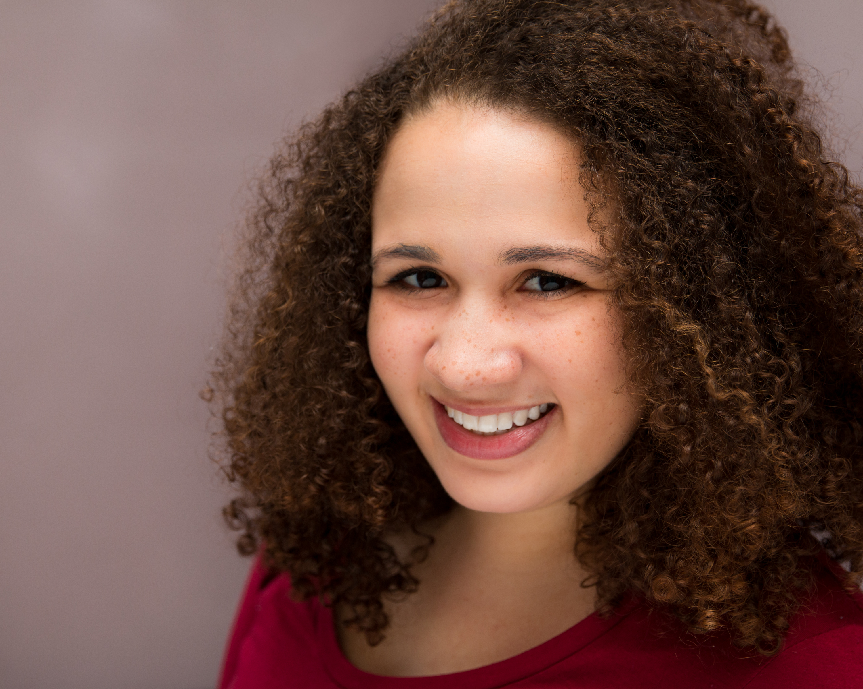
CAITLYN JONES

Non-union
caitlynejones@gmail.com
(978) 987-2529
Ht: 5’0” Wt: 135
Eyes: Dark Brown Hair: Brown
Vocal Range: Chest E3 to C5; Mix to F5; Head voice to A5

THEATRE

MEDEA | Chorus Leader | Salem State University | David Allen George
COMEDY OF ERRORS | Luciana | Salem State University | Kate Kohler Amory
AS BEES IN HONEY DROWN | Amber/Secretary | Salem State University | David Allen George
BURT’S CROSSING | Lila | UMass Lowell | Alexander Cronis
LEGACY OF THE HANGING JUDGE | Elizabeth Hubbard | House of Seven Gables | Anne Lucas
TWELFTH NIGHT | Ensemble | Salem State University | Peter Sampieri

MUSICAL THEATRE

MOTEL RASDELL: A NEW MUSICAL | Eve | Lowell Mem. Auditorium | Kim Cook
SPRING AWAKENING | Thea | Salem State University | Bill Cunningham
CABARET | Mitzie, u/s Schneider | Salem State University | Peter Sampieri
ROCKY HORROR PICTURE SHOW | Main Ensemble | SSU Music Society | Ashley-Michelle Cole
THE 25TH … SPELLING BEE | Olive | Waltham Enrichment | Jesse Sinerate Bastarache
HMS PINAFORE | Buttercup | Sprague Per. Arts Collab. | Lauren Sprague
OLIVER | Nancy | Sprague Per. Arts Collab. | Lauren Sprague

FILM

HARMON V. REILLY’S | Martha Cummings (Supporting) | E & H Productions | Peter Sampieri
THE WORD: A BFA FILM | Mary Cruz (Lead) | Emerson College | Corey Lopez

EDUCATION/TRAINING

BFA Theatre Performance – Salem State University, Salem, MA – NAST Accredited
Minor in Music; Commonwealth Honors Program
Acting – David Allen George, Peter Sampieri
Voice – Celena Sky April, Lynn Shane, Pat Mclean
Movement Based Acting – Kate Kohler Amory
Voice-Over Intensive – Dorothy Gallagher and Brian McKeever C.P. Casting, Boston, MA Ssockapella – Alto Section Leader Salem State University, Salem, MA

Special Skills:
A cappella experience, beginner ballet, beginner modern, house management, glassblowing, rock climbing, beginner Spanish, can raise one eyebrow, valid MA driver’s license, valid US passport

Written Work from Class
The following is a selection of required work from the Recital class used to help us think about our careers and goals.

Caitlyn Jones
THE 501 – BFA Acting Recital
Professor David Allen George
22 January 2016
In my final term at Salem State, I want to really solidify where I fit in as an actor. I want to leave SSU with a firm knowledge of what my strengths and weaknesses are and with pieces in my morgue that are truly me and make me stand out in an audition room.
To be honest, I tend to rely on others who know me well to find good pieces. And while there’s nothing wrong with this per se (my friends can often see things about me that I can’t), I know that part of being a successful actor is being able to see these things myself, and having the ability to quickly and efficiently identify what roles are “right” for me. I think part of this comes with voraciously reading plays, which I don’t really do. If I only ever see reading plays as “work” I’ll be rather miserable in this career.
One of my current setbacks is that I don’t trust myself enough. For example, I tell myself I am bad at improv, and thus don’t let myself get better at it. Why do I think I’m bad at improv? Mostly because I’m not quick enough. I think I could be witty enough and clever enough, but not when I’m put on the spot as I am in improv. So instead of just saying “oh I’m bad at this” as I have been, this is something that I’d like to actively improve on as it’s an important skill to have as an actor, period, and it would open doors to many acting opportunities that require improve skills.
When I started at SSU, one of my weaknesses was that I was constantly in my head. This is something that I have drastically improved on, thank god. I think I’m always going to have a slight problem with this, as that’s just how my brain operates, but it’s not holding me back as it used to. I’m able to analyze a character without getting so caught up in every little detail of their lives. I can’t act every little detail, I can only act what they want right NOW. Yeah, it’s a basic of acting, but it took me a while to get there and I’m proud that I have.
At SSU I’ve been cast only as supporting and ensemble roles. I’ve come to accept that and I don’t view it as a bad thing. I’m good at being a supporting actress. I take pride in successfully being able to be part of an ensemble. The ensemble isn’t always made up of the people who “aren’t good enough” to be leads. Have I been cast in an ensemble because I didn’t have the chops to be a lead? Yes. But I honestly believe I’ve grown past that. So because I’m good at being a supporting actor, does that make me a character actress? I don’t know. I’m still not entirely sure what my “type” is. I definitely want to pinpoint that before I graduate.
Another thing that I’ve struggled with during my time at Salem State is where I fit in on the colored-people spectrum. I have often felt (and still feel to an extent) “too white” for black roles, and “too black” for white roles. And then I feel too disingenuous in Hispanic roles. A visiting professional actor actually once told me that I should have copies of my headshot that say “Caitlyn Rodriguez” or something similar on them because if casting directors are looking to fill a Hispanic role, they’re more likely to choose an actress that seems more Hispanic. That one threw me for a loop. At this point in my career, I’m just letting myself be black AND white (and sometimes Hispanic), none of this “either or” business. If I want to audition for black roles, white roles, or any roles in between, I will. I can only put myself out there; if casting directors don’t like me for whatever reason, that’s there problem.
So! What do I want for this semester? I want to READ MORE PLAYS and just enjoy reading again. I want to hone my improv skills. I want to figure out my type. Let’s do this.

Caitlyn Jones
BFA Recital
Professor David Allen George
5 February 2016
An Actress I Admire...
Anne Hathaway. Anne Hathaway is one of many actresses whose careers I admire and would love to emulate myself. The daughter of a stage actress, she was encouraged from a young age to pursue acting and singing. While known for her films, she was actually trained and started as a theatre actress. Closer to the start of her career in 2006 (about 5 years after she gained success from The Princess Diaries) she even claimed that she still wasn’t comfortable doing movies; being in the theater was what she knew how to do. She said, “Although I'm still terrified of [making movies] — and I freely admit that I am — I've kind of grown to love it, and it is it's own art form. It's a lot harder I think than people realize. [I am] just getting to understand it better” (“Anne Hathaway Learns). I would love to make the transition to film at some point. But theatre is all I really “know” how to do. Seeing this successful and talented actress admit that she’s scared and uncomfortable is quite inspiring to me. It’s okay to acknowledge my fears and misgivings, as long as I’m able to use and grow from them.
In the same interview from 2006, Anne Hathaway was asked what she wanted to happen with her career. This was her response:
“I'd like to be a working actor. I know it sounds very simple, but the importance of that cannot be overstated. It sounds really trite, but there really are no small parts, only small actors. And so as long as I'm a working actor, I can improve. I want to work with people that frighten me and excite me, and characters that I don't believe I'm the best person for the part but I'm still gonna try anyway. Those are my favorite roles” (Anne Hathaway Learns).
Yes. Yes yes yes. Do I know exactly what I want to happen with my career? No, not at all. I know I want to work though. I want to be an actor. And not only do I want to be an actor, I want to be a good actor. And that comes with consistently working. Working with, like Ms. Hathaway states, people who frighten and excite me. People who push me to be better.
Anne Hathaway has also had the opportunity to do some voiceover work. It started with her voicing the audiobooks for The Princess Diaries novels and continued to her voicing characters in several animated features. She even received an Emmy award in 2010 for outstanding voice-over performance in episodes of The Simpsons. She’s also been nominated for an Audie Award (Best Solo Narration by a Female) for her audiobook recording of The Wonderful Wizard of Oz. I cannot state enough how much I’d love to do voice-over work. Ms. Hathaway has managed to balance theatre work with film work with voiceover work and that’s something I’d love to accomplish.
A trained soprano, Anne Hathaway also continued to used her singing skills in her career. Though she had to drop the role because of scheduling conflicts, she was cast as Christine in the 2004 Phantom of the Opera film. She sang in the film and for the soundtrack of Ella Enchanted. And most notably, she received Academy, Golden Globe, SAG, and BAFTA awards for her portrayal of Fantine in the 2012 film Les Miserables. Singing. Another aspect of my own life I’d love to incorporate into my acting career.
There are many other reasons I admire Anne Hathaway and her career (how she presents her personal relationships, the scope of her career, her stance on religion and gay marriage, her intelligence and articulation) but I’m hitting my page length. I strive to achieve a versatile career like the one Anne Hathaway has and the poise she presents herself with.

Works Cited
"Anne Hathaway Learns from a Legend in ‘Prada’." TODAY.com. Associated Press, 27 June 2006. Web. 6 Feb. 2016.
Progression: A Visual Journey
The following is a collection of photos following my five-year journey as an actor with the Salem State University Theatre Department.

Twelfth Night
By William Shakespeare
Directed by Peter Sampieri
Spring 2012
Role: Ensemble
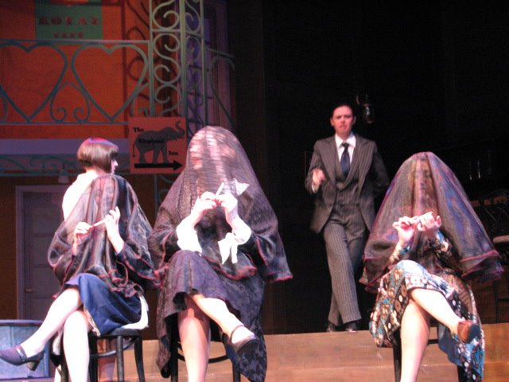

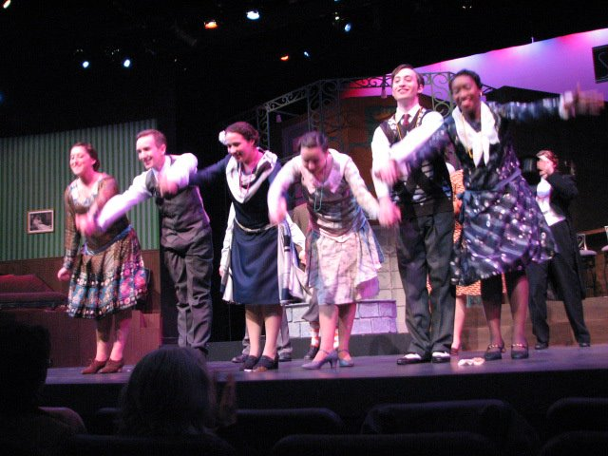

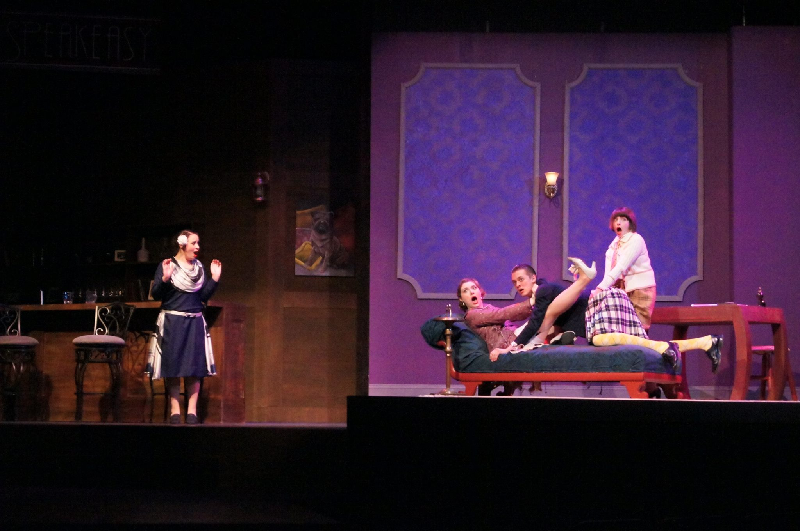

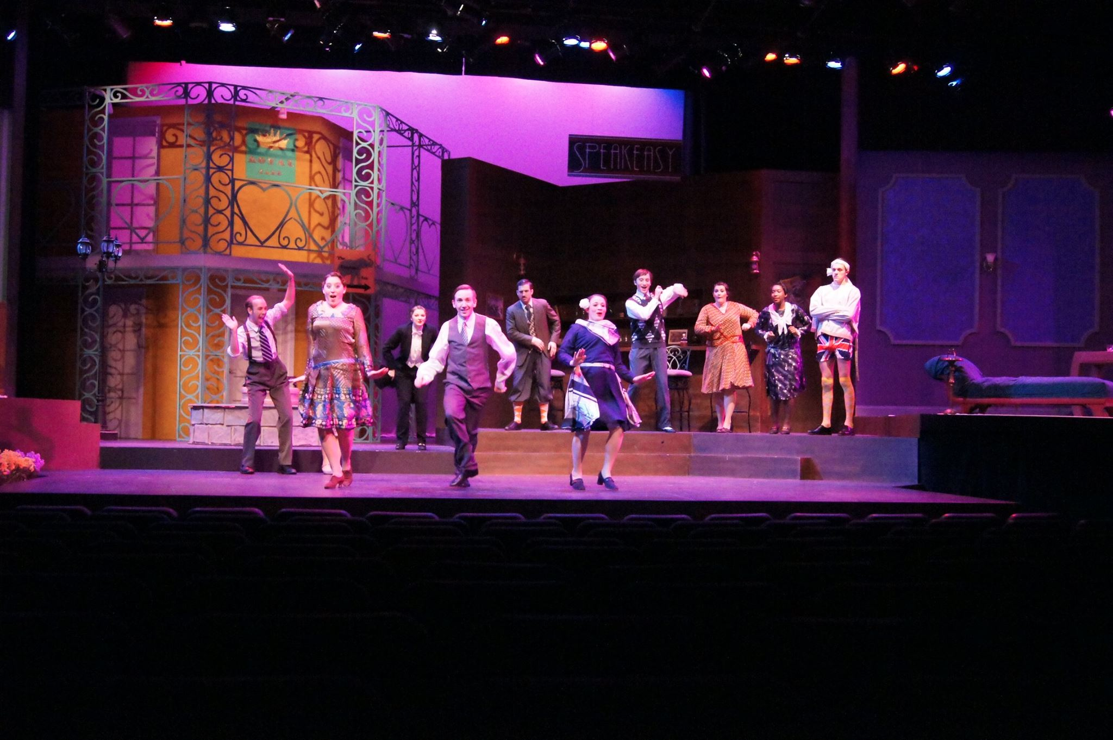

Cabaret
By Kander and Ebb
Directed by Peter Sampieri
Fall 2012
Role: Mitzie (u/s Schneider)
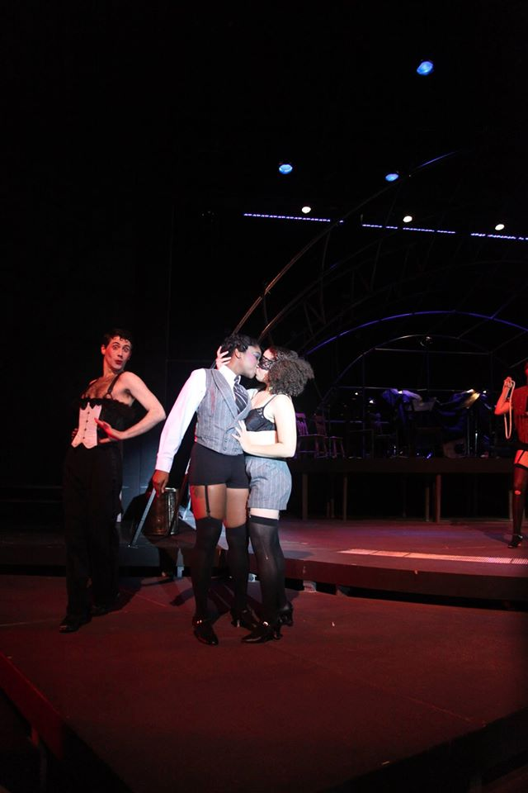
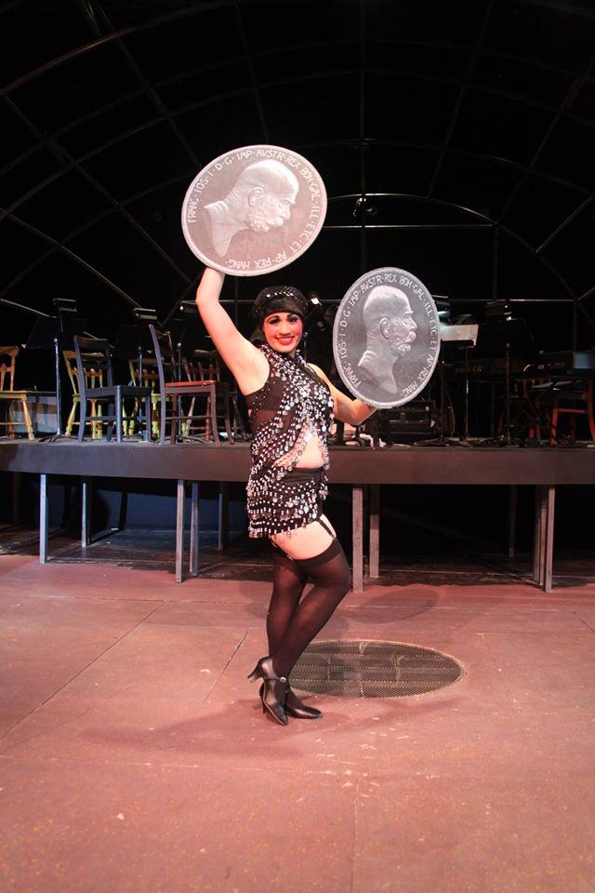

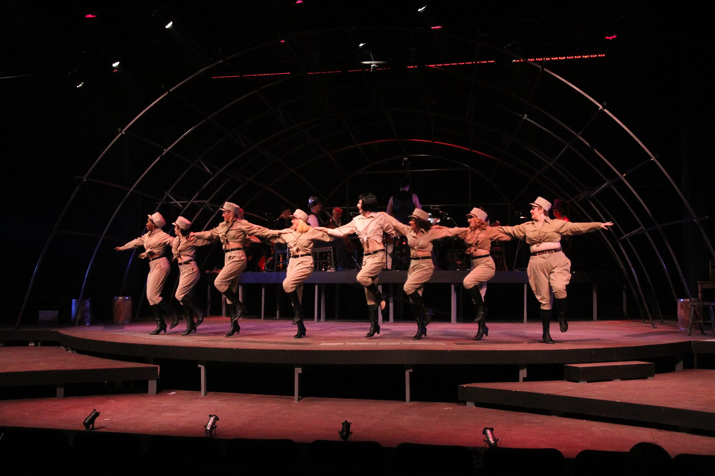
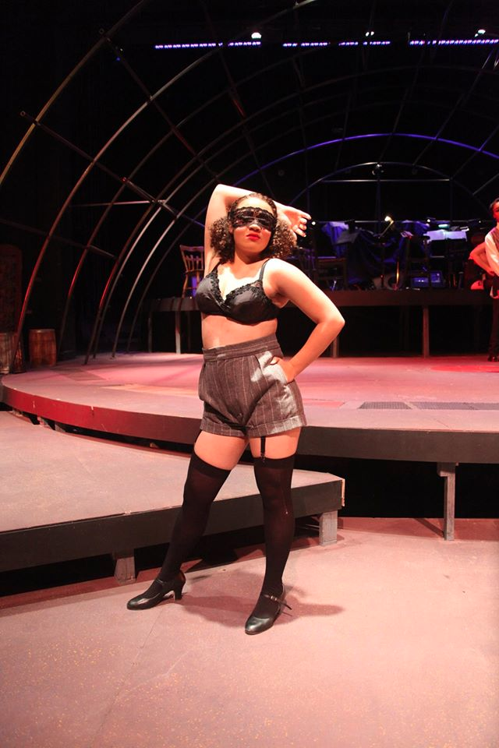

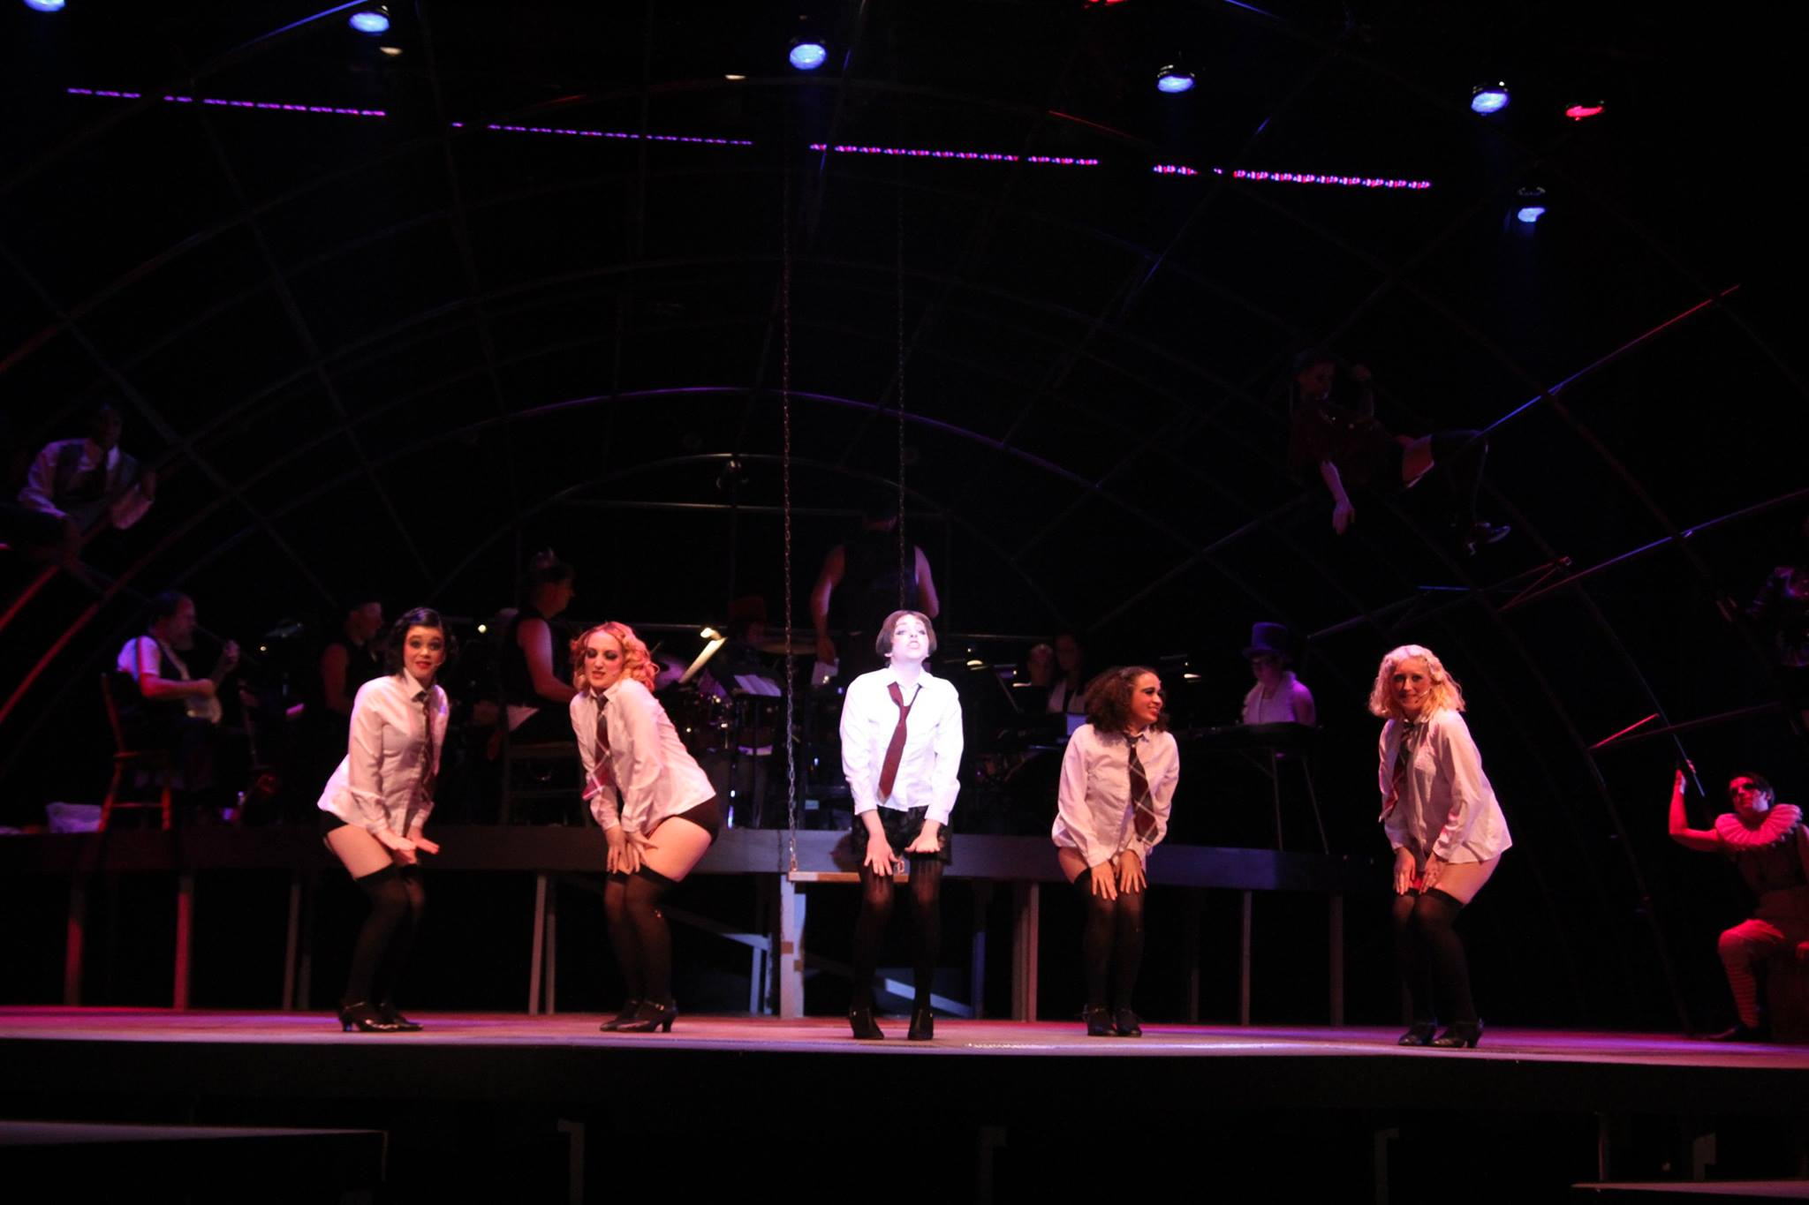

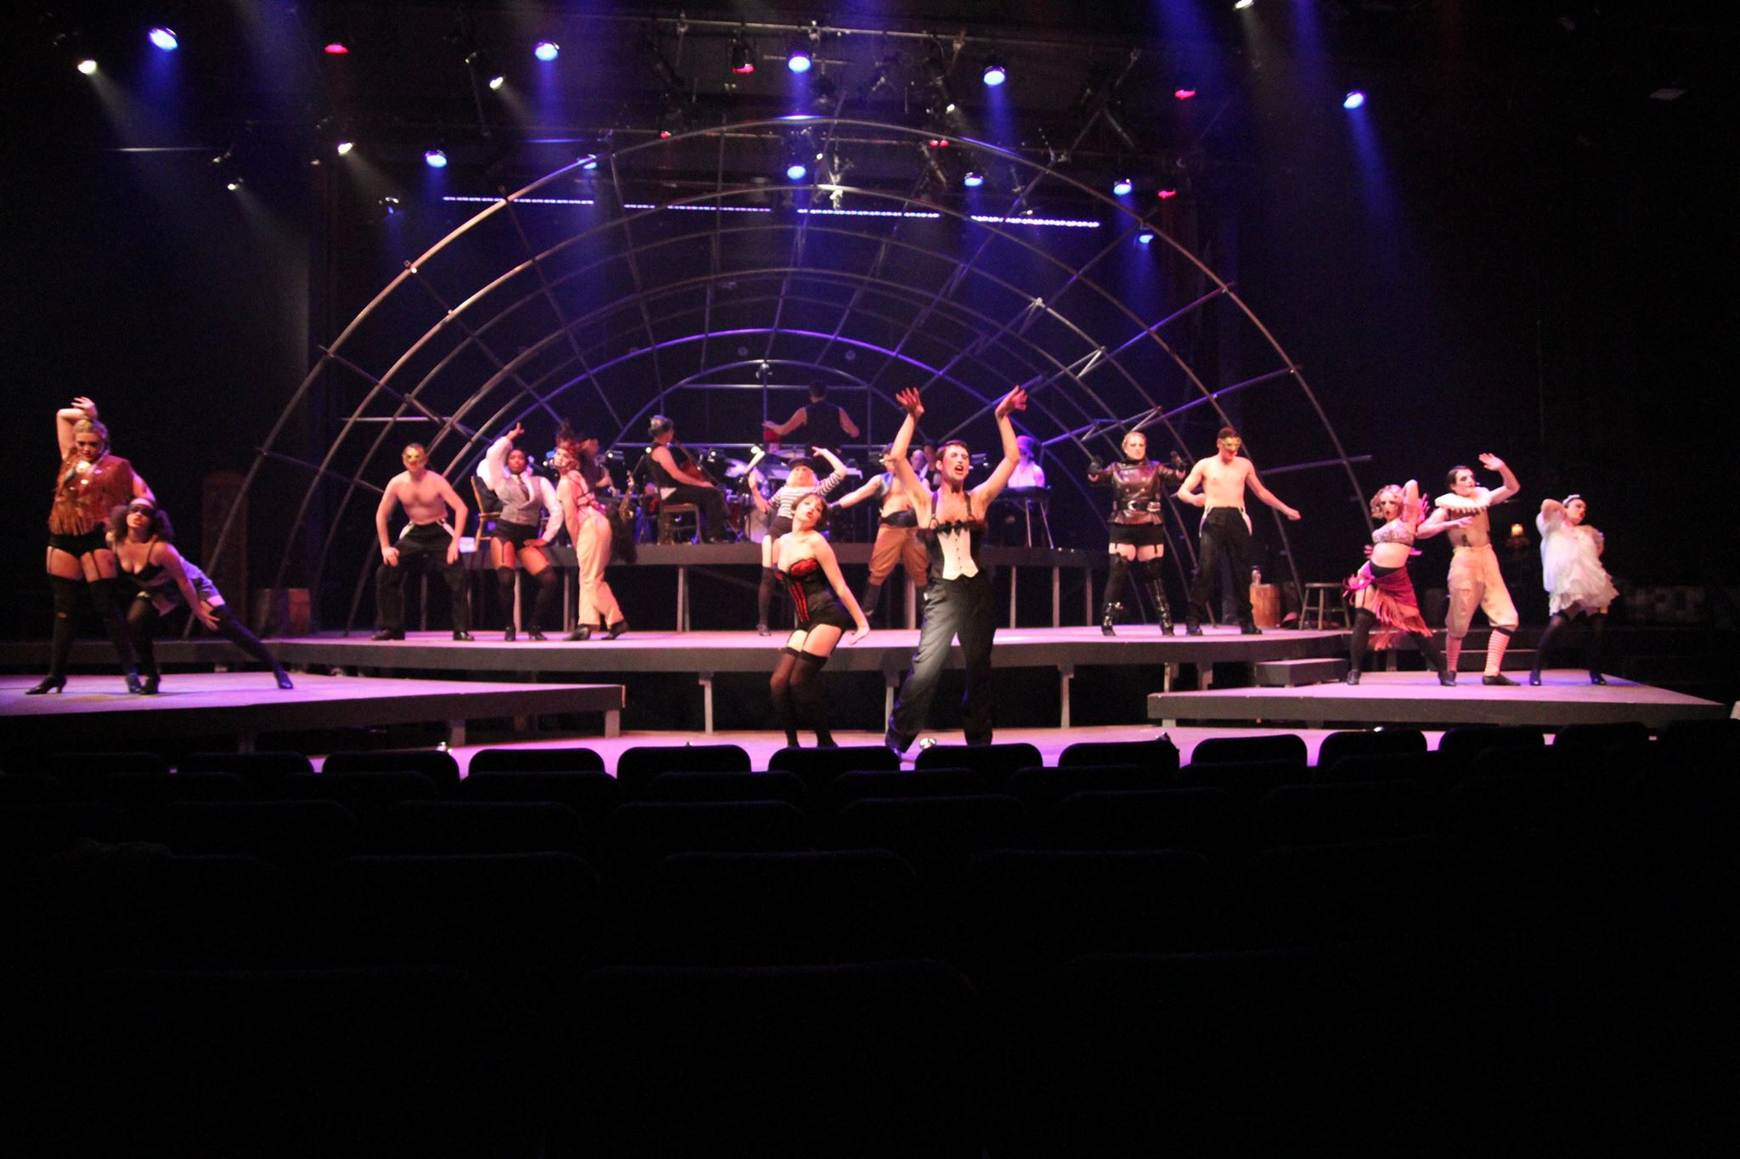

As Bees in Honey Drown
By Douglas Carter Beane
Directed by David Allen George
Fall 2014
Role: Amber/Secretary
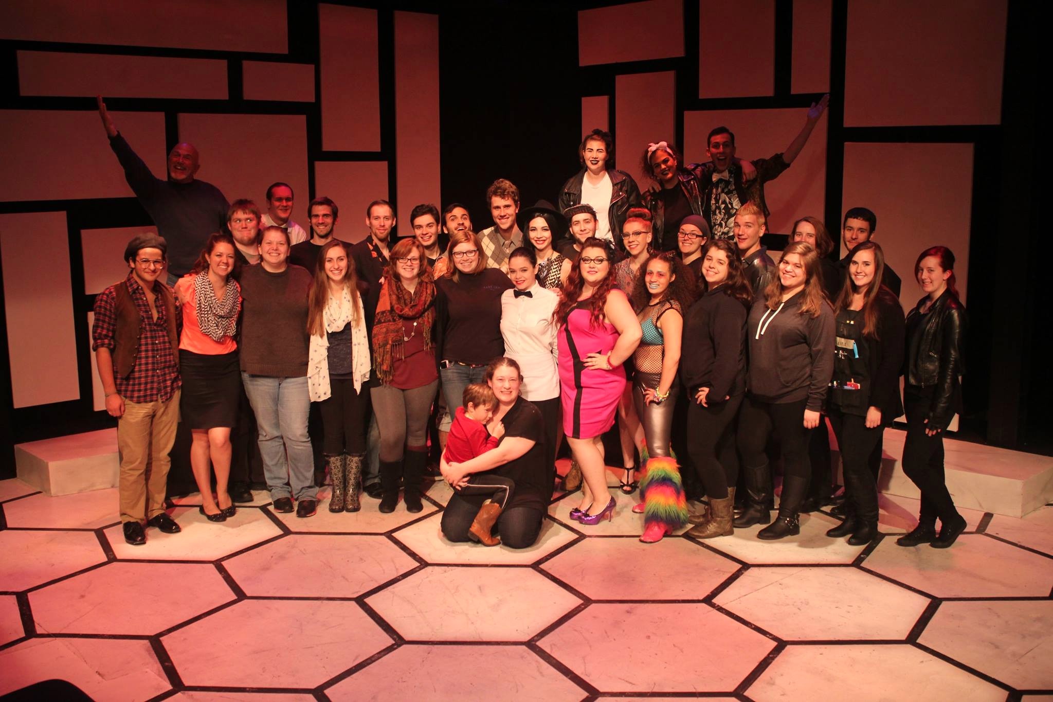

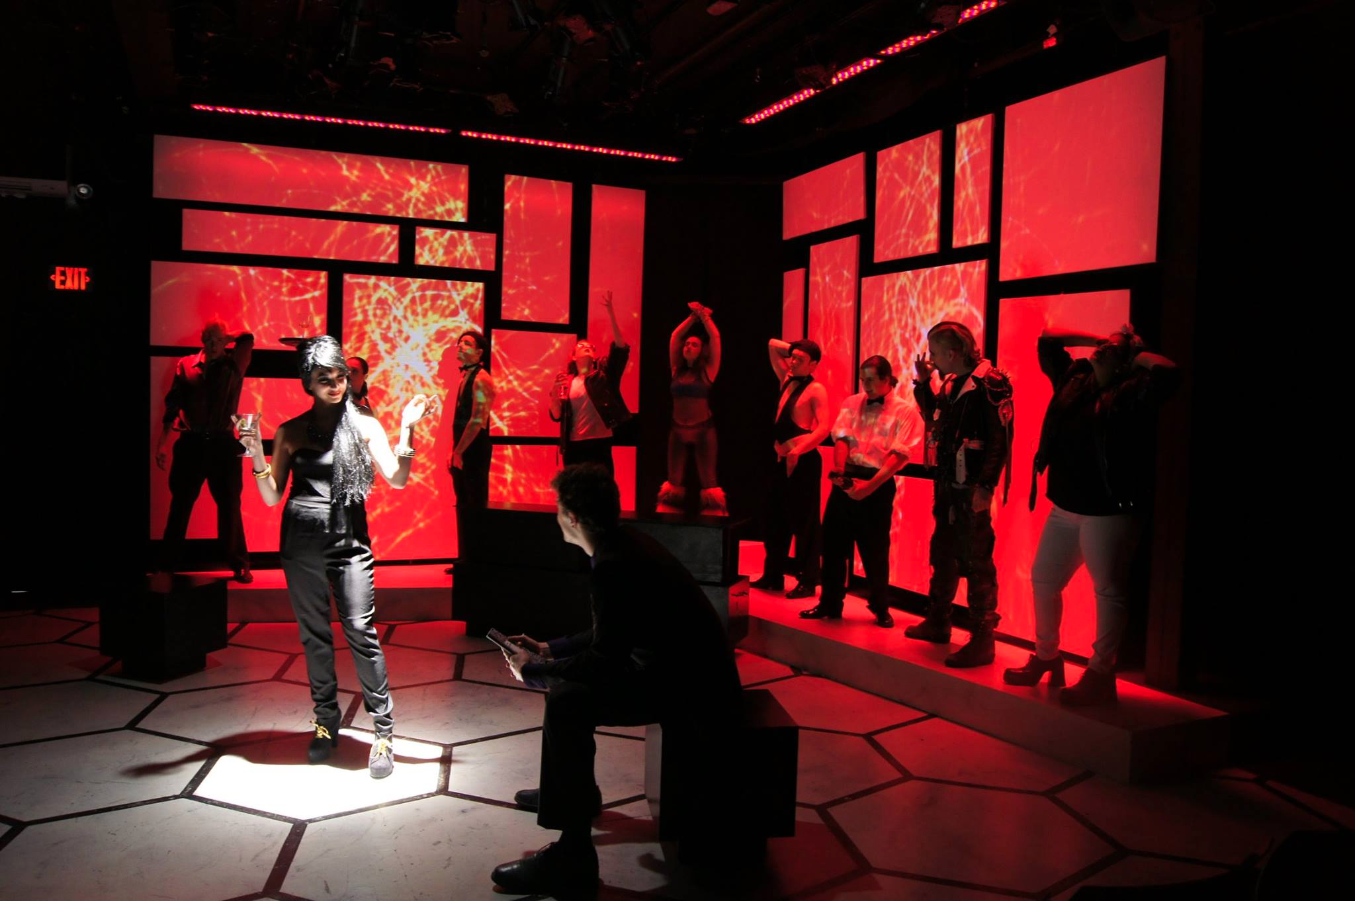

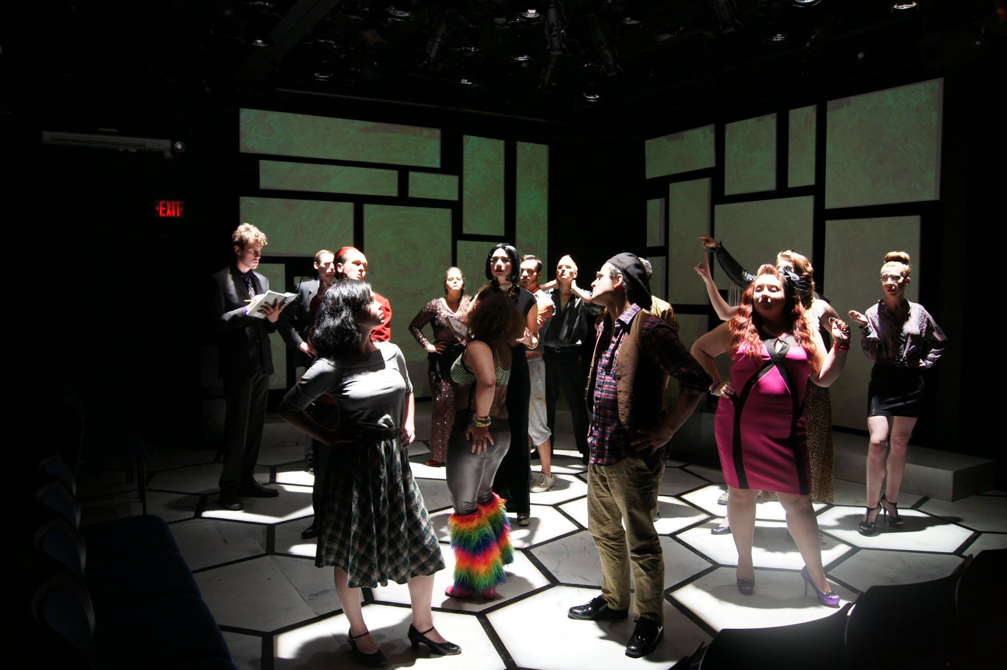

Spring Awakening
By Sater and Sheik
Directed by Bill Cunningham
Spring 2015
Role: Thea

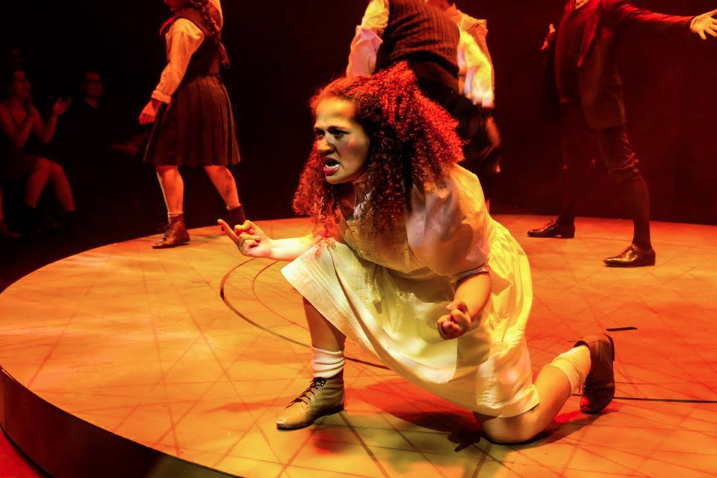

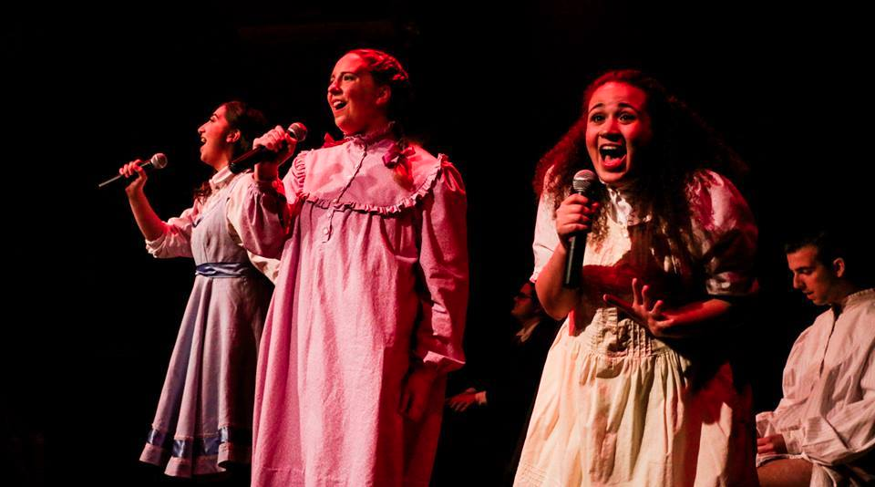
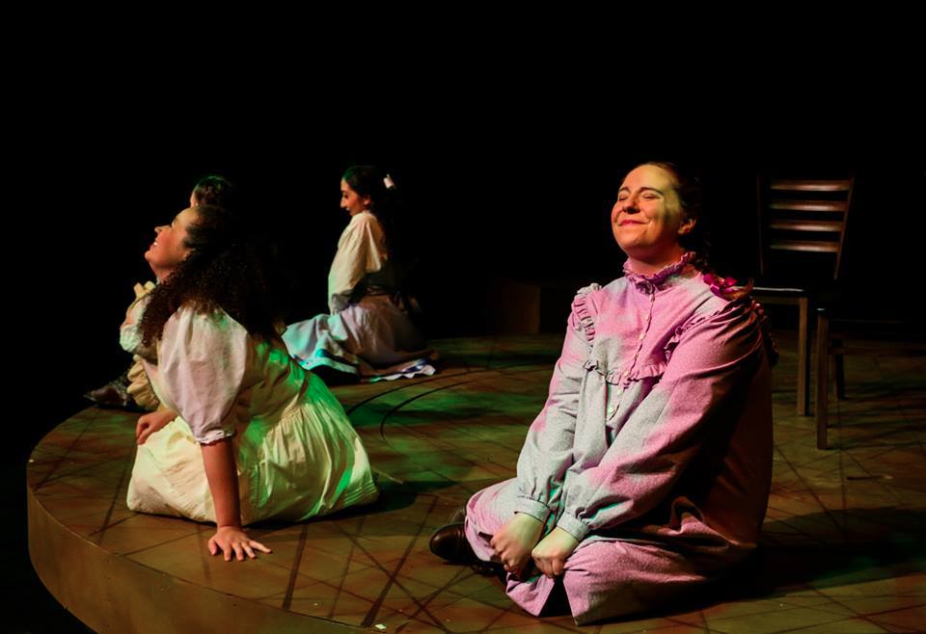

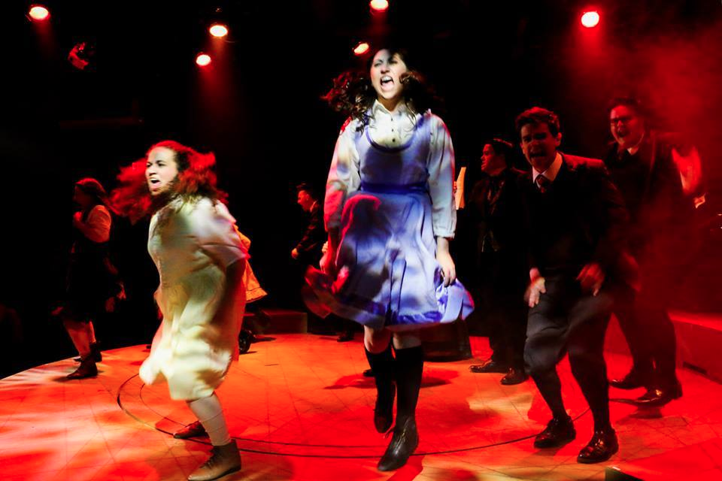

The Comedy of Errors
By William Shakespeare
Directed by Kate Kohler Amory
Fall 2015
Role: Luciana
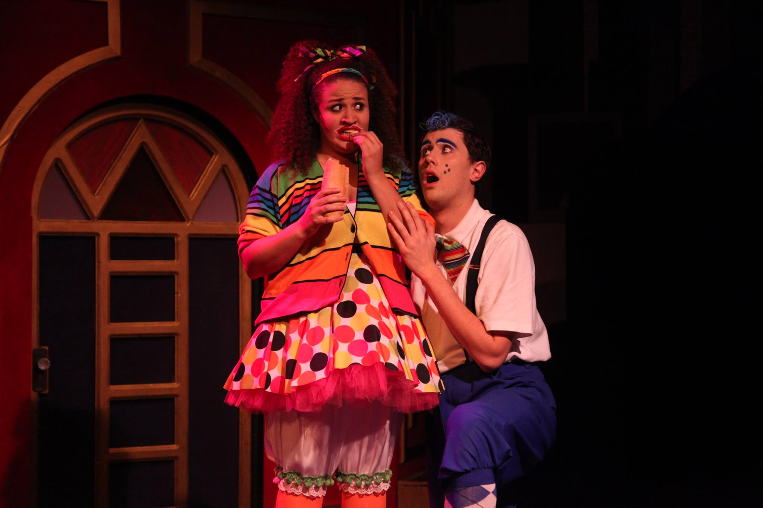
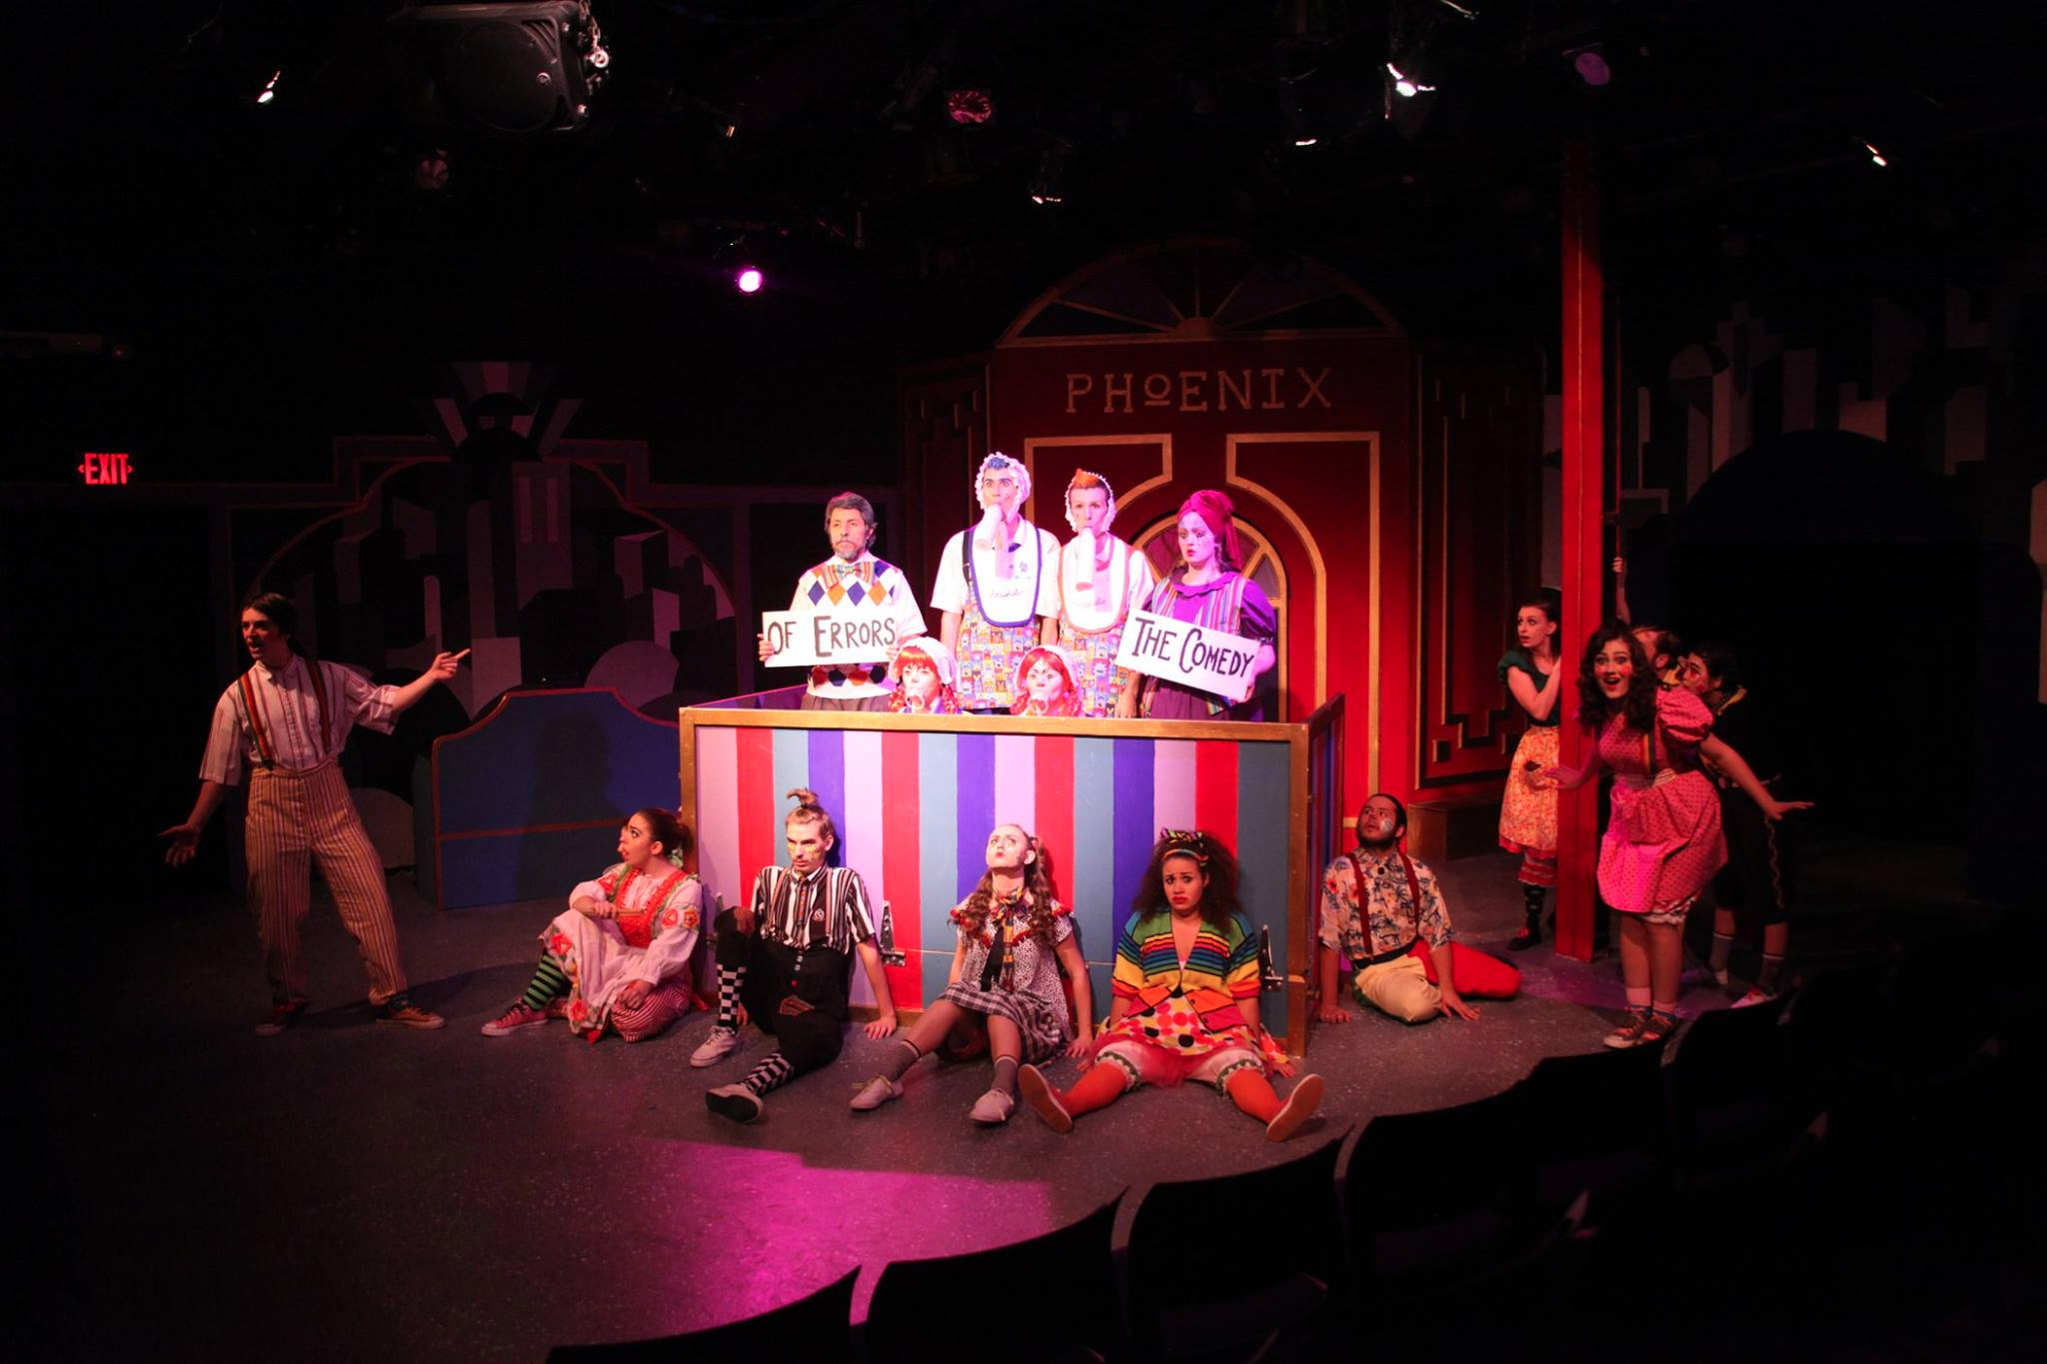

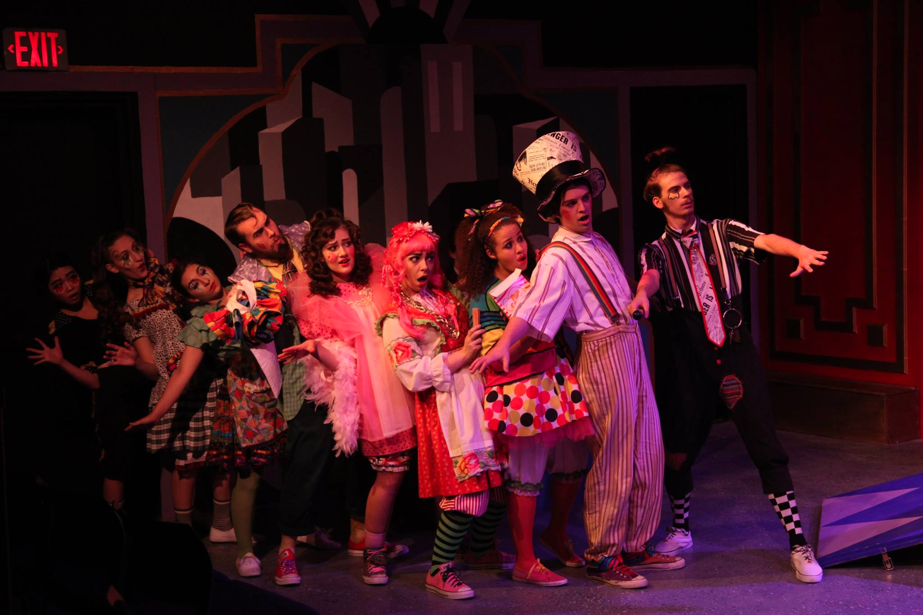
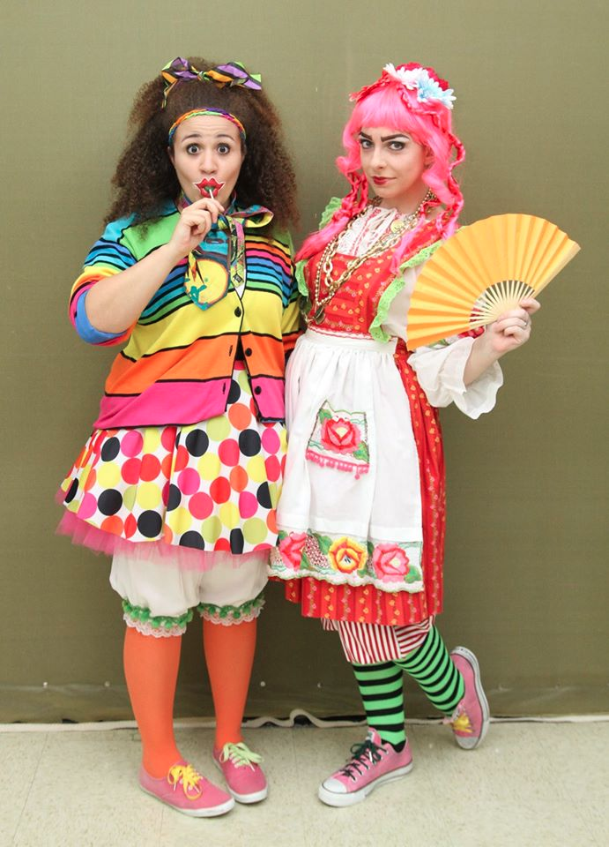

Medea
By Euripides
Directed by David Allen George
Spring 2016
Role: Chorus Leader

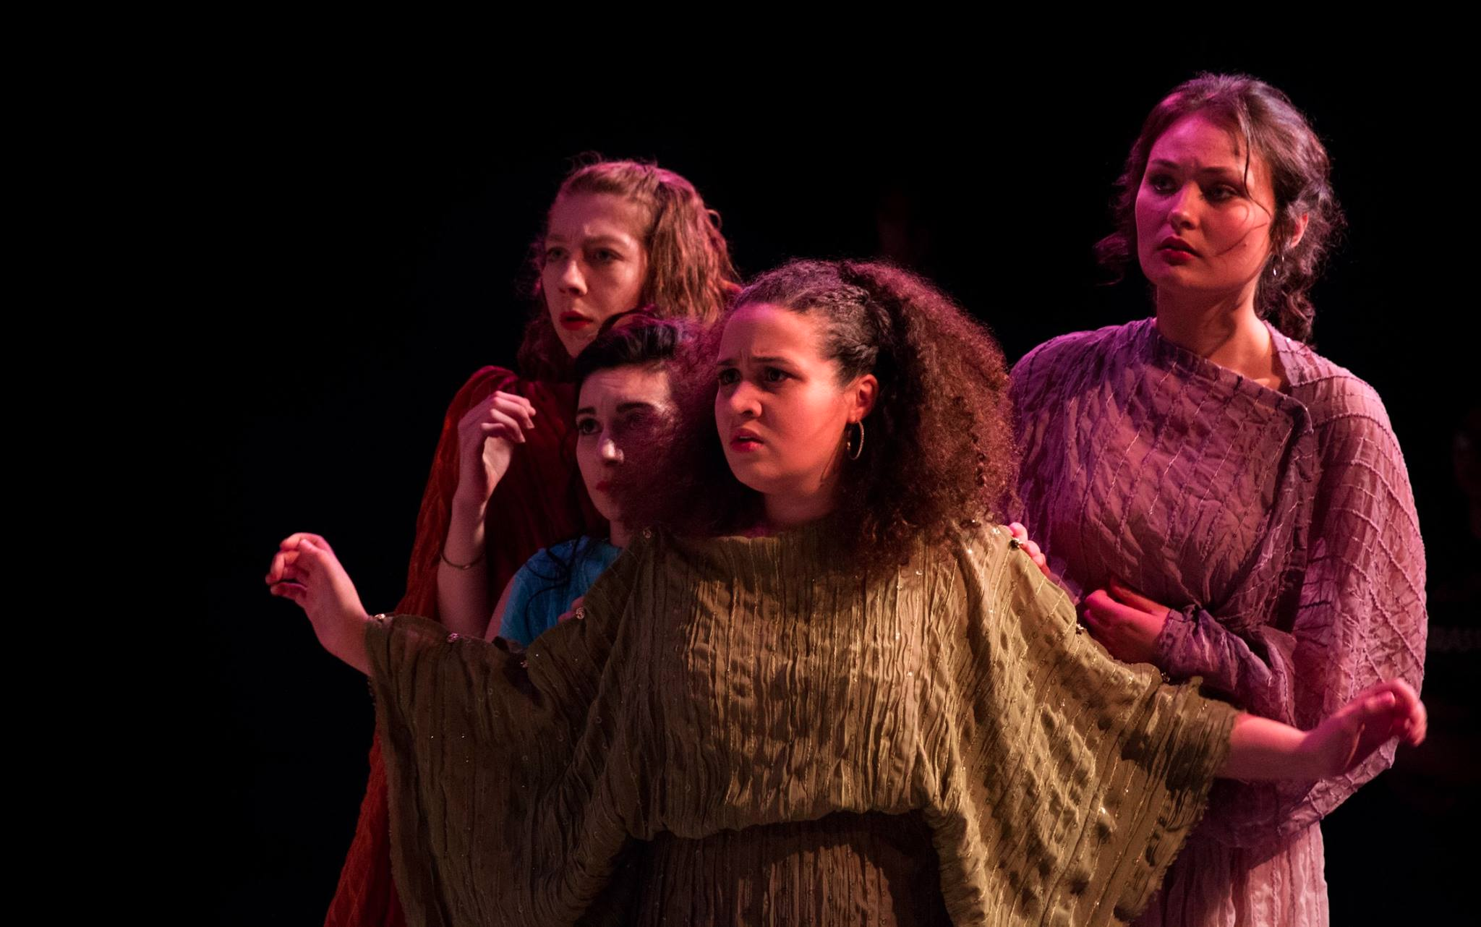

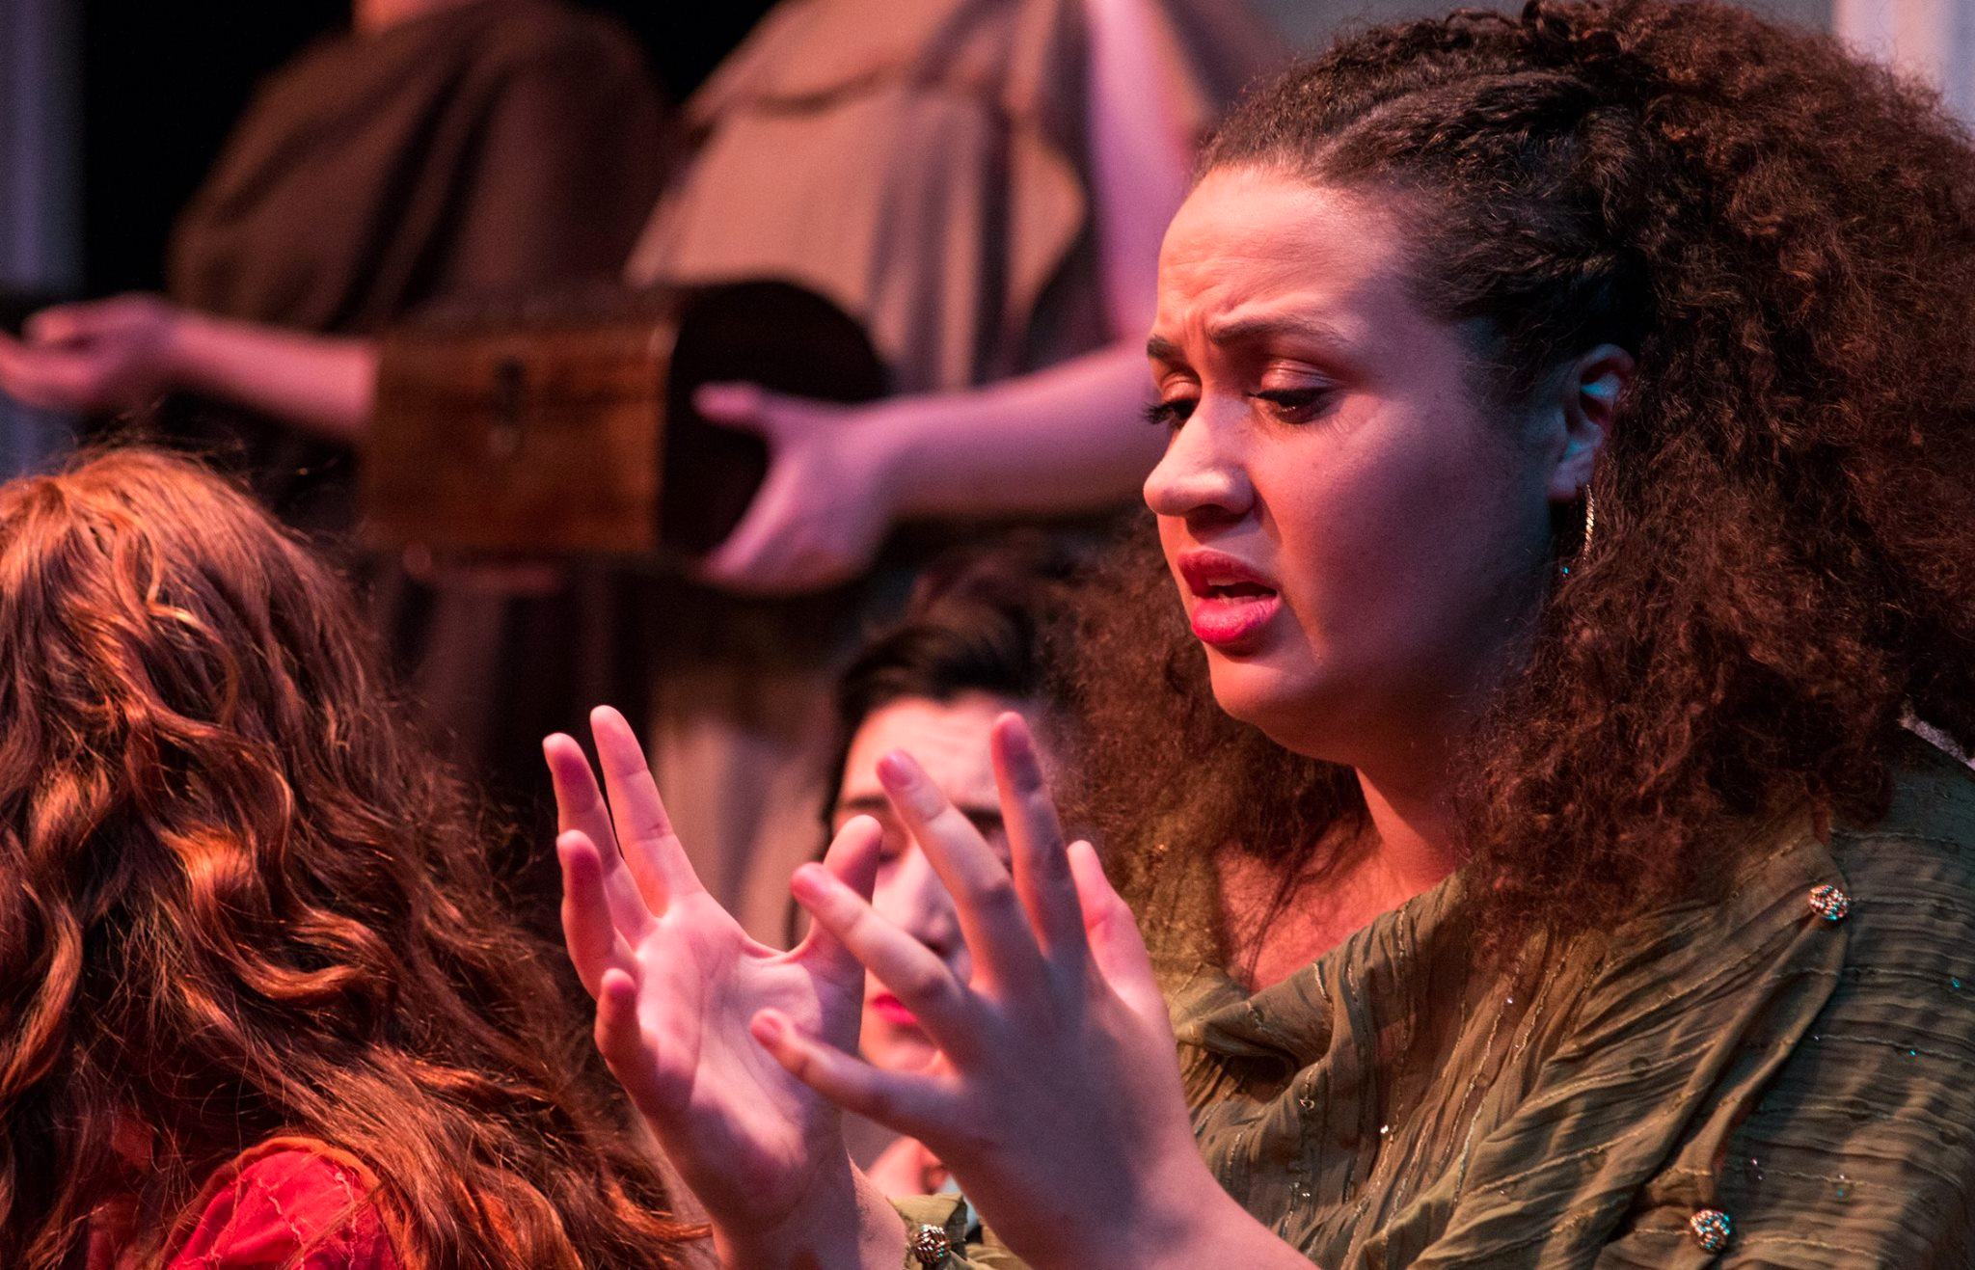

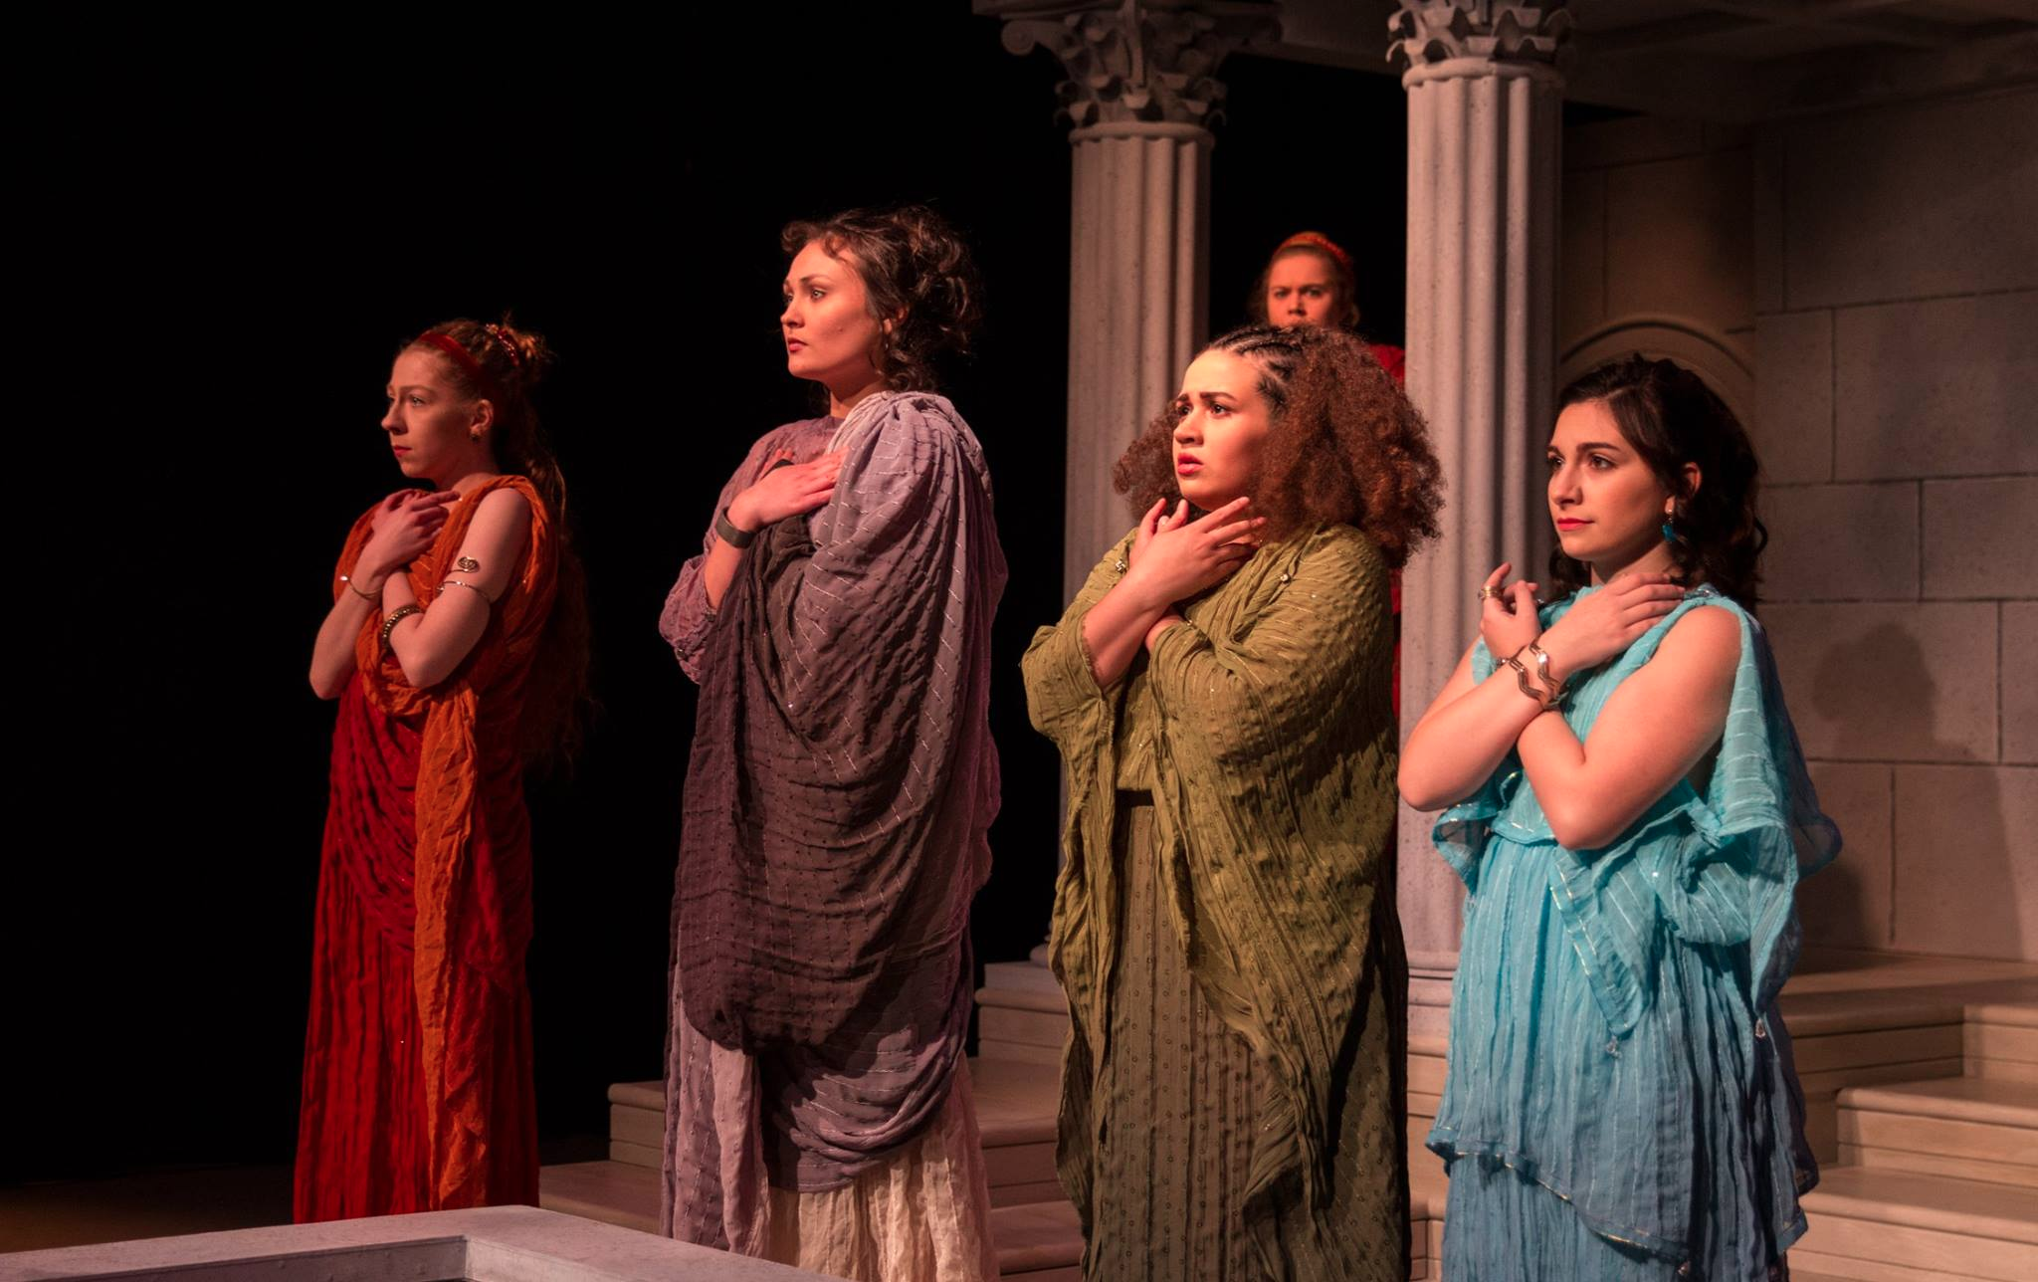

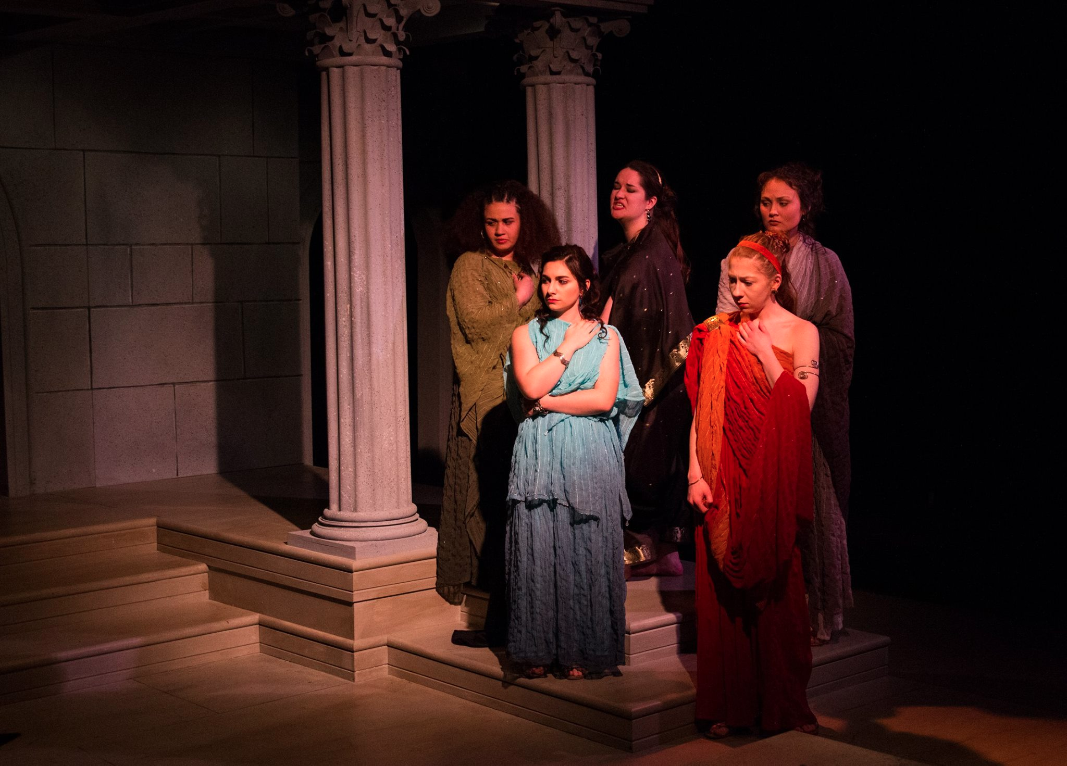

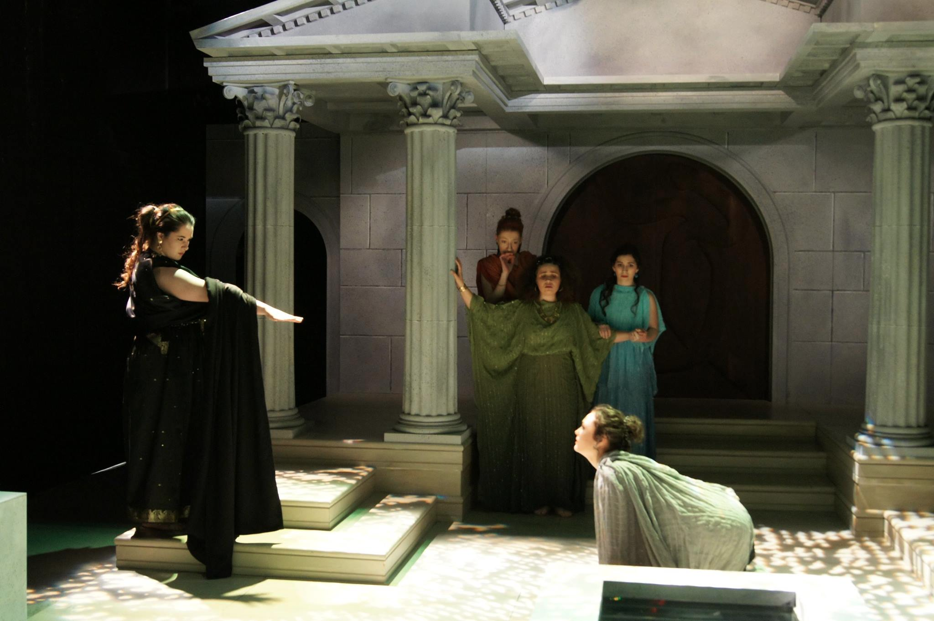

BFA Acting Recital
Spring 2016

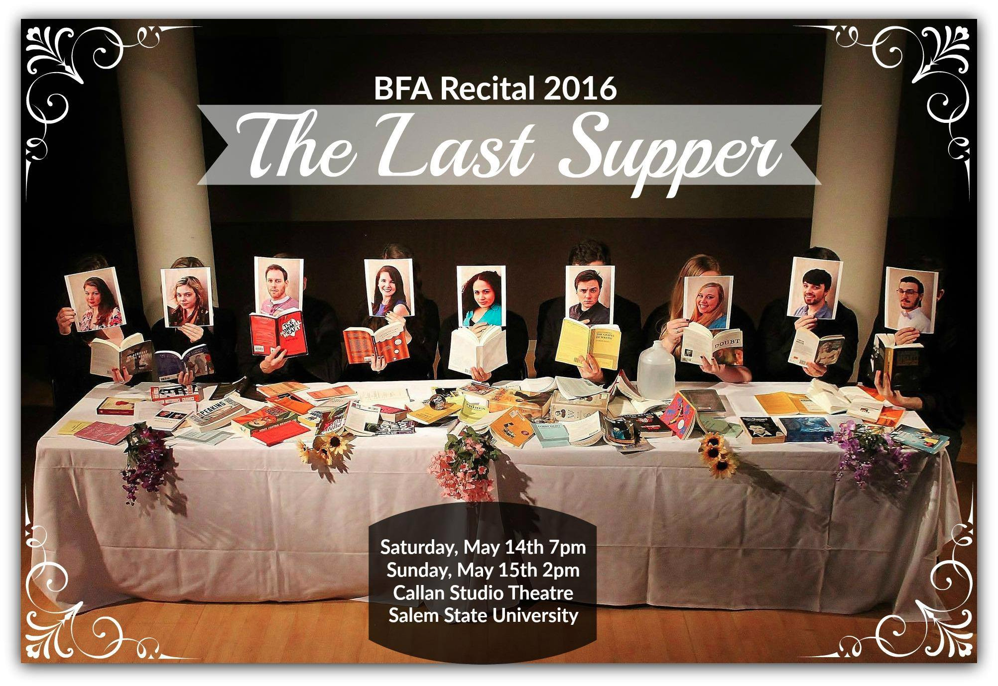

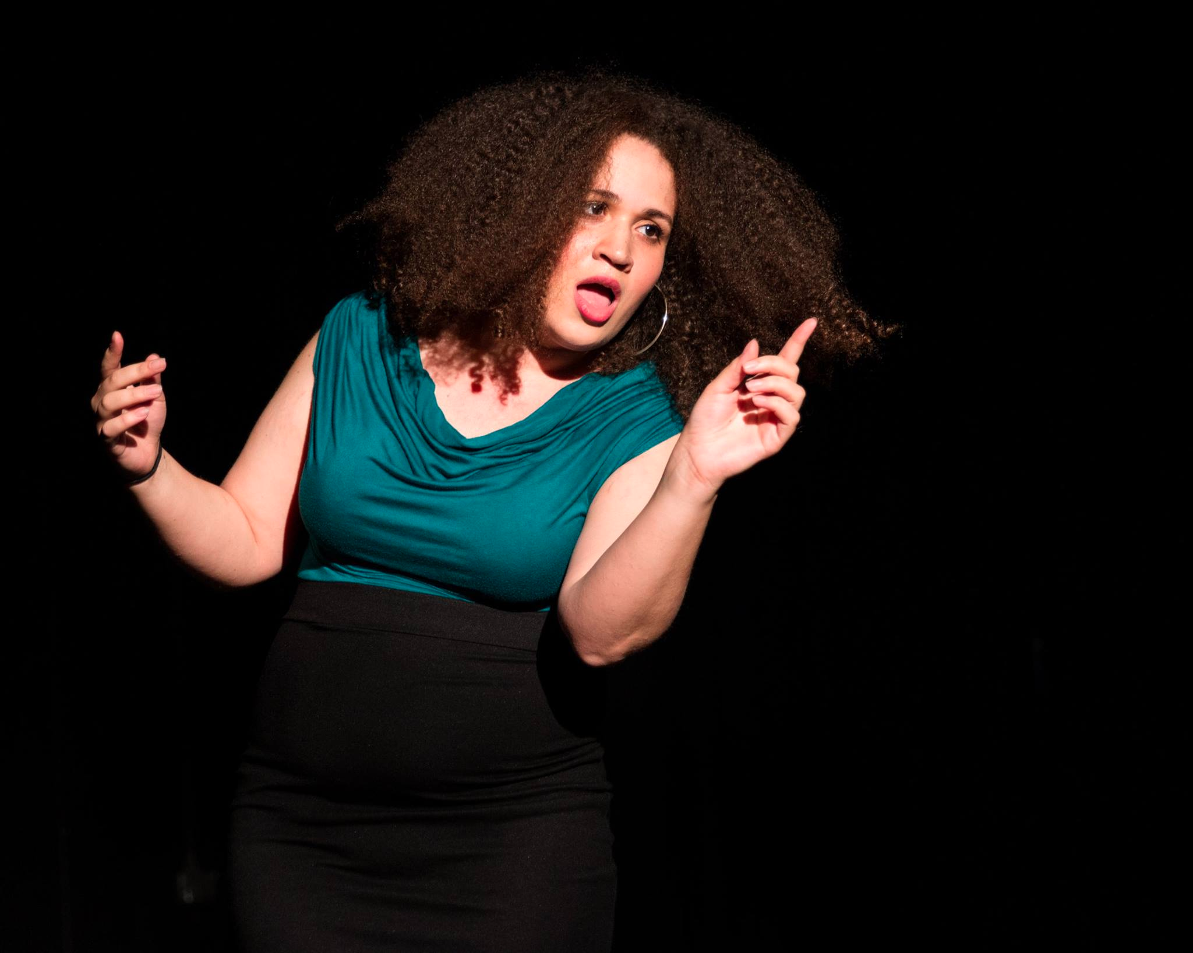

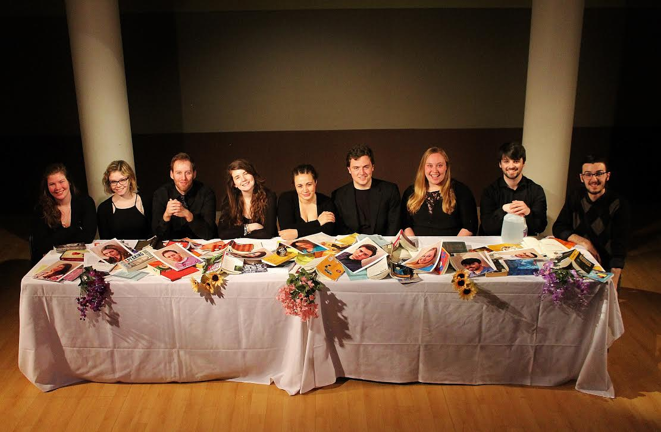
END SCENE

