BREATHE YOUR WAY COUCH TO 5K

Honors Thesis

Presented in Partial Fulfillment of the Requirements

For the Bachelor of Science Degree in Psychology
In the School of Arts and Sciences
at Salem State University

By

Olivia Brothers

Dr. Darlene E. Crone-Todd
Faculty Advisor
Department of Psychology

***

Commonwealth Honors Program
Salem State University
2017

Table of Contents
Acknowledgements----------------------------------------------------------------------------------4

Abstract------------------------------------------------------------------------------------------------5

Introduction
Stress and Wellbeing---------------------------------------------------------------------------------6
Meditation---------------------------------------------------------------------------------------------8
Brisk Walking/Jogging-----------------------------------------------------------------------------10

Method
Participants and Setting----------------------------------------------------------------------------14
Materials---------------------------------------------------------------------------------------------15
Measures---------------------------------------------------------------------------------------------16
Procedure--------------------------------------------------------------------------------------------17

Results
Heart Rate--------------------------------------------------------------------------------------------19
Overall Health and Wellbeing Questionnaire---------------------------------------------------21
Health and Wellness--------------------------------------------------------------------------------21
Spiritual Wellness----------------------------------------------------------------------------------22
Positive Self-Image---------------------------------------------------------------------------------23

Discussion
Main Findings---------------------------------------------------------------------------------------23
Limitations of this Study---------------------------------------------------------------------------26
Further Research------------------------------------------------------------------------------------27
Implications------------------------------------------------------------------------------------------27

References-------------------------------------------------------------------------------------------29

Appendix A:
Gassett Fitness Center Member Registration Form--------------------------------------------32

Appendix B
Informed Consent-----------------------------------------------------------------------------------33

Appendix C
PAR-Q & YOU-------------------------------------------------------------------------------------34

Appendix D
Rate of Perceived Exertion------------------------------------------------------------------------35

Appendix E
Overall Health and Wellbeing Questionnaire---------------------------------------------------36

Appendix F
The Couch to 5k Training Program--------------------------------------------------------------40

Appendix G
Heart Rate Form------------------------------------------------------------------------------------42

Acknowledgements
There are many people that I would like to acknowledge, as it took many to make this research project successful. I would first like to acknowledge Ms. Katie Dollard for her extensive support and hard work as a graduate mentor and partner in this project. She was present at every session held during the study, and contributed greatly during each phase of this project. I would also like to thank Dr. Darlene Crone-Todd as my faculty mentor, committee member, and faculty adviser for this project. She offered great knowledge and experience, and was always available to help. I would like to acknowledge Mr. Mike Wong as the overseer of the treadmill sessions, a member of my committee, and collaborator. He gave great insight into the exercise portion of this study. I would also like to thank the Gassett Fitness Center for allowing the meditation and exercise sessions to take place in their facility. I would like to acknowledge Dr. Martin Krugman as an important part of my committee, as he gave many suggestions and information throughout the length of my research and study. Finally, I would like to thank the Salem State Wellness U Research Grant that supported this research.

Abstract
Dealing with stress in our busy lives impacts wellbeing. In this study, a “Breathe Your Way Couch to 5K” program was used to assess whether meditation, treadmill exercise, or both result in lower levels of stress and overall higher well-being. Stress and wellbeing were measured using an Overall Health and Wellbeing Questionnaire, and perceived exertion was measured using the Rating of Perceived Exertion (RPE) scale. It was hypothesized that physical exercise would have a more beneficial outcome when compared with meditation and that both would result in beneficial outcomes. Participants (n=17) were asked to engage in a seven-week meditation and exercise program. Following an initial week of meditation only, every two or so weeks the participants were invited to either engage in a meditation or exercise session twice per week. Following each 20-minute session, participants filled out the RPE scale. Participants recorded their average heart rates before, immediately after the session, and two minutes after the session concluded, and also filled out the Overall Health and Wellbeing Questionnaire after they completed a meditation or exercise rotation. The results suggest that there are increased scores on overall health and wellbeing, and that the treadmill couch to 5k program had a positive impact on health and wellbeing, positive self-image, and spirituality. These results will have implications for ways for people to decrease stress and increase overall wellbeing through the use of these strategies employed in this study.

Introduction
Stress and Wellbeing
Everyone experiences stress, and it is important to find ways to eliminate stress. However, the definition of stress varies. For example, according to Pomfrey (2016) “Hans Selye coined the word, ‘stress,’ back in 1936. He defined it as the ‘non-specific response of the body to any demand for change’” (p. 1). After looking at the different aspects of stress, Selye changed his definition of stress to, “the rate of wear and tear on the body” (Pomfrey, p. 1). Another definition describes stress as a psychological and biological response to an occurrence or occurrences that we do not feel that we can cope with (McLeod, 2010). Currently, while there is no one definition of stress, there is agreement on the effects of stress. Pomfrey suggests that a flight or fight response is experienced when the body undergoes stress, and when this occurs, neurotransmitters are secreted, heart rate increases, the body sweats, and the body prepares to protect itself. During this flight or fight response, the hypothalamus sends signals the pituitary gland and adrenal medulla to help the body respond to the stress (McLeod).
Although stress can often be perceived as detrimental, it can also be beneficial. This is called “eustress” and is defined as stress that “gives you a sense of fulfillment” (Pomfrey, 2016, p. 1). “Although a certain level of stress may result in improved performance, too much stress can adversely affect physical and mental health” (Rajakumari, Soli, & Malathy, 2015, p. 199). Even though stress can be healthy and have its benefits, it can have a cumulative effect. When stress occurs, the stimulus evokes bodily responses in an attempt to reduce the stress. If the reduction in stress does not occur, bigger problems can arise such as a weakened immune system and increased risk of cardiovascular disease.
The present study is important because of the impact stress has on overall wellbeing. A person’s wellbeing depends on every aspect of his or her life (Wellbeing, 2016), and while important it can be difficult to measure because it is subjective. According to Well-Being Concepts (2016), there are several important aspects to consider about well-being. As a subjective measure, it is usually assessed through indirect measures such as self-report in addition to observation, physiological measures, and so on. Second, wellbeing is correlated with other measures of good health, such as diet, positive relationships, and adequate shelter and food. Also, life satisfaction and mood (e.g. happiness, depression, etc.) are correlated with wellbeing. In order to live life to its fullest, wellbeing is important, which means that managing and diminishing stress is important.
Throughout the years, college institutions have applied different stress interventions, but few have experimentally tested their effectiveness (Rajakumari et al., 2015). The purpose of the present study is to attempt to do just this. In this study, different ways in which wellbeing can be achieved and stress can be diminished are evaluated. Well-being indicates that people believe that their lives are successful and going well (Well-Being Concepts, 2016). With the rise in depression, mental illness and anxiety, it is vital to find methods by which people can improve their wellbeing (Twenge, 2015).
In many cases, stress can be overwhelming and unavoidable. One way to avoid stress is to try avoiding the stressor, since the stressor is what causes the stress (Pomfrey, 2016). One example of this is avoiding crowds if crowds are something that stresses someone out. For example, a person may shop really early or really late to avoid the stressful situation of being surrounded by a crowd. However, it can be difficult to eliminate the stressor, which is when stress management techniques are used. Some of these techniques include getting more sleep and meditation (Pomfrey, 2016). It has also been found that exercise can reduce stress and have positive benefits on wellbeing (Berger & Owen, 2013). One question that naturally arises is: what works best to diminish stress and increase wellbeing?
The purpose of the current study is to evaluate the relative effects of aerobic exercise in the form of brisk treadmill walking/jogging versus meditation on stress and overall wellbeing. The effects will be measured in terms of heart rate and an Overall Health and Wellbeing Questionnaire. Depending on the results of this study, the implications will indicate a more beneficial approach to support better overall wellbeing in a university community.
Meditation
A popular way to reduce stress and increase a sense of wellbeing is through the use of meditation. (Manocha, Gordon, Black, Malhi, & Seidler, 2009). While meditation originated in religion, it is now more widely used as a secular tool to strengthen the mind, sustain attention, reduce stress and manage a variety of chronic diseases (Winzelberg & Luskin, 1999). Thus, meditation is now popular as both a religious and secular practice. As Lederer and Middlestadt (2014) explain,
Meditation is generally seen as an inwardly oriented, personal practice, which individuals can do by themselves. Meditation refers to the actions involved in a quieting the mind and body to allow one to become aware of the self. Meditation may involve cultivating a feeling or internal state or attention to a specific focal point or following the breath. The term can refer to the state itself as well as the practices or techniques employed to cultivate the state. Meditation can take various forms, including mindfulness, transcendental, movement, mantra, and spiritual meditation. For some, meditation is a religious or spiritual practice; for others it is a wellness practice. (p. 361)
Lederer and Middlestadt identified different types of meditation, including mindfulness meditation, and they provide extensive information about the varieties of meditation practice that are beyond the scope of this project. For the present purpose, “mindfulness meditation” is the most relevant form. Mindfulness meditation is a practice that focuses on deepening awareness of a particular moment, but refraining from acting on the thoughts and emotions that arise during that moment. This practice is used to gain focus and emulate positive thoughts, feelings, and emotions (Rajakumari et al., 2015).
Meditation affects the body in a way opposite to that of stress: it lowers the heart rate, slows down breathing, and oxygen becomes more efficient (Rajakumari et al., 2015). Mohan, Sharma, and Bijlani (2011) found that meditation had a relaxing effect on the participants, when compared with a quiet setting. Also, they looked at the impact meditation had on stress, and found that the order of the mediation intervention was significant. If meditation was implemented before the stress, it did not seem to have a significant impact. Instead, stress seemed to increase. Meditation was more effective if it was used following a stressful situation. Also, Koole, Govorun, Cheng, and Gallucci, (2009) found that meditation led to more congruence between indirectly assessed versus self-reported self-esteem measures. Thus, participants’ actions and self-perceptions were more in line with each other following meditation.
Lederer and Middlestadt (2014) stated that meditation has been shown to reduce the stress that college students experience. They suggest that meditation practice decreased over the years due to the lack of a quiet place and a scheduled time to dedicate to meditation. In a university setting, this is a relatively easy to overcome, by having meditation sessions initiated throughout the day on campus or around the community. In the present study, in order to increase meditation and see its effects on overall wellbeing, quiet place is provided and scheduled sessions to practice guided meditation.
Some of the advantages of meditation are that it is free, always available, and has been deemed effective in treating short-term stress (Rajakumari et al., 2015). As Manocha et al. (2009) pointed out, once meditation is learned, it can be used independently and whenever desired to both prevent and reduce acute and chronic stress. They also remind us that while meditation is simple, it can be very effective to improve general health.
Brisk walking/jogging
If we think of the problem of stress among college campuses, often the first thought is whether there is a fix in terms of medication for that. However, exercise is a natural remedy that can promote health as well as prevent future illness. While there are risks associated with participating in exercise, the risks of remaining sedentary are more likely to increase both stress levels and depression (Kesaniemi, 2001). Making a lifestyle change from a sedentary to active lifestyle is one of the first steps that can help decrease stress. The Better Health website suggests engaging in regular physical activity to achieve wellbeing, which is also what this study evaluated (Wellbeing, 2016).
Malcolm et al. (2013), studied whether physical exercise was linked to better mental wellbeing. At the beginning of the study, there were almost 50,000 participants, and by the end of the three-month period, there were only 531 participants. There were so little participants because of the length of this study. The participants filled out a baseline questionnaire, and they were only allowed to fill out the follow-up questionnaire if they had continued to exercise for the entire three-month study period. The researchers (2013) used the WEMWBS to evaluate changes in wellbeing. Overall, the study showed a significant increase in participants’ well-being scores, along with increasing levels in physical activity.
Additionally, Fox’s (1999) narrative review and summary of the literature found evidence that exercise can be effective in treating clinical depression, reducing anxiety, and led to improvements in both self-esteem, physical self-perception, and mood, which supports this study’s claim that exercise will increase participants’ overall wellbeing. One question is whether pre-existing experience and expectations versus teaching positive expectations might lead to positive benefits. In one study to date on this topic (Mothes, Leukel, Jo, Seelig, Schmidt, & Fuchs, 2017) induced versus previous, habitual expectations about the benefits of exercise did lead to some differences in terms of psychological and neurophysiological benefits after one bout of exercising. They found that both induced and habitual expectations of the benefits of exercise led to similar increases in brainwave activity. However, only those with the highest pre-existing habitual beliefs about the benefits of exercises showed more psychological benefits from the exercise bout, such as increases in mood, reduction in anxiety, and more enjoyment of the activity. This research is important in that it is direct experience with exercise and understanding its benefits that leads to more favorable outcomes.
Bartels et al., (2012) evaluated the effect of exercise on the wellbeing of twins and non-twins. The children (with their parents’ consent and help) filled out surveys throughout their life, and at ages 14, 16, and 18, they independently filled out a self-report survey, which included questions about their behavior, exercise, lifestyle, and wellbeing. The results indicated that if a twin exercised more than his or her co-twin, he or she did not show any decreases in internalizing problems or increased wellbeing. These results differ greatly from other findings, which makes this current study much more important and prominent. Considering the mixed reviews, it is important to determine experimentally whether or not exercise has any affect on bettering overall health and wellbeing.
Malcolm et al. (2013) point out there is a link between physical activity and mental health/wellbeing regardless of mental health status. In their review, Tkachuk and Martin (1999) looked at the effect of exercise therapy on mental health patients. Some of the mental disorders included psychiatric disorders, depression, anxiety, developmental disabilities, schizophrenia, substance abuse, and somatoform. While little or no research has been conducted for some of these mental disorders, there was one controlled study that showed symptoms decreased significantly for people diagnosed with anxiety disorders. In less controlled studies for schizophrenia, self-reported symptoms, psychotic symptoms, and hallucinatory symptoms decreased when treated with exercise therapy. It would be important to replicate these effects in order to test the reliability and validity of the results. New controlled research needs to be conducted in order to determine whether the results can be replicated. Tkachuk and Martin also found that for substance abuse, there were mixed reviews. Exercise treatment for alcoholics did have some positive effects, but there are only two studies, which made it difficult to determine a clear relationship between exercise and alcoholism. On the other hand, people who smoke seemed to smoke more when they increased exercise. Again, there needs to be more research concerning this disorder because of the lack of controlled experiments.
Tkachuk and Martin (1999) did find that exercise treatment had the biggest impact on depression. Depression symptoms seemed to decrease in as short as five weeks of treatment. The researchers postulate that one reason why exercise has such a strong impact on depression patients is that physical exercise can be a form of meditation. If so, this could be the case for other aspects of wellbeing that are improved due to physical exercise. This leads to the over-arching question of this study; which program, meditation or physical exercise, is more effective in bettering overall health and wellbeing?
Kirkcaldy, Shephard, and Siefen (2002) indirectly studied German adolescents through surveys, and found a strong relationship between regular exercise and self-perception of self-image. These improved self-perceptions and exercise practice were also correlated with higher psychological and physical well-being scores, and with a reduced likelihood to become addicted to drugs or alcohol. Therefore, this study hypothesized that there would be more of an increase with participants’ Positive Self-Image scores due to exercise, and in particular with a Couch to 5K program, which shapes the amount of relative time spent in brisk walking versus jogging or running. The decision to use a Couch to 5k program instead of having participants for 20 minutes straight was done to avoid any negative effects from over-exercising or over-training. A review by Peluso and de Andrade (2005) supports the advantages of physical activity in terms of its positive effects on both physical and mental health functioning. However, they also warn that there can be harmful effects when exercise is performed incorrectly, or in an excessive (e.g., overtraining) manner.
The present study compared these two programs and took measures of stress levels, heart rate and other aspects of wellbeing. Based on the findings in the literature, it was anticipated that heart rate would go down in both meditation and brisk walking/jogging programs, but that people could experience longer effects with the brisk walking/jogging program. The empirical question referred to the fact that both activities might improve overall wellbeing and stress. Also, it was hypothesized that meditation may help participants breathe during the subsequent exercise sessions. Could wellbeing increase by engaging in both exercise and meditation at the same time, or do the activities have different effects?
On the contrary, van der Zwan, de Vente, Huizink, Bőgels, and de Bruin (2015) found no different on measures of stress reduction as a result of engaging in either physical activity, mindfulness meditation, or through the use of heart rate variability biofeedback. Thus, it is possible that both exercise and meditation in this study will lead to similar results in overall wellbeing.
Methods
Participants and Setting
Salem State University’s (SSU) Institutional Review Board approved the study. Students, faculty, and staff were recruited through university e-mail, flyers distributed to undergraduate classrooms and a graduate research group, and through word-of-mouth. All recruitment material included a link to an online sign-up on Survey Monkey. At this point the student, faculty or staff member registered via survey monkey for the study by providing their name, email address, and phone number. The only two inclusion criteria were being at least 18-years-old and a member of the SSU community. The participants were invited to read and ask any questions about the informed consent prior to the start of the study. If they felt comfortable with the form and participation of the study, they were then invited to sign it. Of the 40 people who signed up on Survey Monkey, n=22 agreed via email or text to attend the first meeting. Of those who agreed to attend, n=17 participants (M=4, F=13) attended and signed informed consent. The participant’s ages ranged from 19 to 60 years old. All participants of the study had a signed liability form on file.
Materials
Exercise and meditation sessions took place at the Gassett Fitness Center on SSU’s campus. Materials needed for the exercise and meditation phases included treadmills, exercise mats, Rate of Perceived Exertion surveys, Couch to 5k (C25K) program and other data taking materials such as SPSS and excel. The meditation sessions took place in a room that had mirrors covering the walls. The floor was wooden and the lights were dimmed. There was soft calming music playing in the background. This room was attached to the main part of the gym where the treadmills were. The treadmills used were Cybex 770T Treadmills. There was water available via the fitness center as well as the assistant director of Fitness & Wellness to answer any questions. Dr. Crone-Todd oversaw and led the meditation sessions.
Measures
PAR-Q & YOU. To decrease the risks associated with starting an exercise program, a self-guided questionnaire was provided and assessed by a staff member at the Gasset Fitness Center. The Physical Activity Readiness Questionnaire (PAR-Q) was administered after the participants gave consent for participating in the study and prior to any physical activity starting. The questionnaire identified whether participants had conditions or risk factors that require further assessment before starting the exercise program. The participants who required further assessment were directed towards the Gassett Fitness Center staff on alternative exercise routines. The participants were seen as at risk if they answer yes to all of the questions (Jonas & Phillips, 2009).
Rating of Perceived Exertion (RPE). To ensure that participants were exercising at a safe and healthy pace, the rating of perceived exertion (RPE) scale was used by participants to self-regulate their treadmill speed and intensity. The RPE scale was administered at the end of each session to indicate perceived cardiovascular exertion, and was used to determine whether exercise intensity stayed within a given range throughout the training.
Overall Health and Wellbeing Questionnaire. The overall health and wellbeing questionnaire is used to evaluate emotional, physical, intellectual, social, spiritual, and occupational components of wellness. This questionnaire uses the five point Likert Scale to evaluate all of these aspects of wellbeing. The questions range from asking about the participant’s health to how confident they feel they can complete an activity to how strongly they feel that prayers provide emotional support. These specific aspects of wellness were addressed due to the research grant requests that needed to be met.
Procedure
The participants were invited to read and ask any questions about the informed consent prior to the commencement of the study. If they felt comfortable with the informed consent form, then they were invited to sign it. After the informed consent was signed, participants were invited to fill out two questionnaires, the PAR-Q and the Overall Health and Wellbeing Questionnaire. A trained member of the Gassett Fitness Center administered the PAR-Q scale and evaluated each one for any risk factors. During the first stage of the program, which lasted one week, participants were asked to engage in a meditation session that met twice per week, for thirty minutes each. Dr. Darlene Crone-Todd led the meditation sessions, using vocal guided prompts. The night before each session, participants received an email and text reminding them of their upcoming session. Throughout the study, participants recorded their heart rate before the session, immediately after the session, and two minutes after the session. At the end of the session, they completed the RPE scale. After the first stage was complete, the participants were invited to fill out the Overall Health and Wellbeing Questionnaire. At the end of the first stage, participants were matched according to heart rates and RPE, and then randomly assigned to either Group A or Group B for the remainder of the study. During the next stage of the program, depending on the group assignment, the participants were asked to either engage in treadmill C25K exercise, Group B, or continue in the meditation practice, Group A, twice per week for twenty minutes each. Group B members were asked to meet for a treadmill session twice a week for twenty minutes each, following the C25K program. The rate at which the participants walked or ran on the treadmill was self-selected by the individual participant based upon their self-reported RPE scale. The RPE scale was administered during each meditation and treadmill session. The Overall Health and Wellbeing Questionnaire was administered to all participants at the end of each phase. During the third stage, during weeks four and five, the groups were asked to switch activities, Group A was assigned the treadmill sessions and Group B was assigned the meditation sessions, and the procedures remained the same as described above. During final stage, during weeks six and seven, both groups were asked to choose whether they would like to attend either treadmill or meditation sessions. After the final session was completed, the participants were asked to fill out the final Overall Health and Wellbeing Questionnaire. The procedure is shown in Table 1.
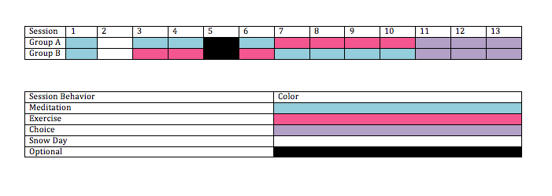
Table 1. The procedure the participants went through during the course of the study.
Results
Heart Rate
Figures 1, 2, and 3 indicate the changes from initial, immediately after, and two minutes after the session ended from the beginning of the study to the end of the study for all the participants. A negative score means there was a decrease in the heart rate as the study progressed. Note that in Figure 1, all but one of the participants in Group A show decreases in heart rates, whereas in Group B the heart rates either stayed the same or increased.

Figure 1. Change in initial heart rates, by participant, from first to last session.

Figure 1 shows that most heart rates increased immediately after the session, which would be expected in the running session. However, there is great variability in this measure, which might be due to factors such as jogging versus meditation during the final phase of the program.

Figure 2. Change in heart rate, by participant, immediately after the session from the first to last session.
In Figure 3, Group A participants show either no change, or large decreases in their heart rate two minutes after the session concluded as the study went on. Group B shows either no change or an increase in their heart rate two minutes after the session concluded.

Figure 3. Change in heart rate two minutes after the session concluded from the first to last session.

Overall Health and Wellbeing Questionnaire
Figure 4 represents the participants’ final overall health and wellbeing score subtracted from their first overall health and wellbeing score, such that positive scores indicate improvement from their initial score. Note that only one participant had a decreasing score. Participants in Group B seemed to have a greater increase, but there were a few instances where Group A had a larger increase than their designated partners. All other participants either had no change (n=14) or improved (n=14).

Figure 4. Change in Overall Health and Wellbeing Questionnaire scores from the first session to the last session.
Health and Wellness
All of the participants’ Health and Wellness scores either stayed the same, or increased as the study progressed shown in Figure 5. (A positive score means that the final score was higher than the initial score.) While Group B generally showed larger increases, some Group A partners increased on this measure more their comparison partner.

Figure 5. Change in Health and Wellness scores for each participant from the first to last session.
Spiritual Wellness
The results shown in Figure 6 suggest that Group A (started with meditation) increased their spirituality scores more than Group B. Instead, Group B tended to decrease their spirituality scores as the study progressed. (In Figure 6, a positive score means that the final score was higher than the initial score.) Ralph Piedmont’s spirituality scale was used to evaluate participants’ spiritual wellness.

Figure 6. Change in Spirituality score for each participant from the first to last session.
Positive Self-Image
Figure 7 shows that all of the participants’ Positive Self-Image scores either stayed the same or increased as the study progressed. Group A had a larger increase when compared to Group B, but there were a few instances where Group B partners had a larger increase over their counterparts.

Figure 7. Changes in participants’ Positive Self-Image scores from the first to last session.
Discussion
Main Findings
The main findings were that for the most part participants’ scores generally improved by the end of the study, although for Group B it seems that the spirituality scores did not improve. Also, this group had the highest level of absenteeism during the study. It is not clear why this is the case.
Group A had the greatest decrease in heart rates including during the jogging sessions. This suggests that the meditation sessions may have helped participants develop effective breathing techniques that they not only used in the meditation sessions, but also during jogging. Anecdotally, several participants in Group A mentioned that they were using the skills learned in the meditation sessions in their everyday life. Some of the participants in Group B expressed relief when it was time to switch back to meditation and that they “hated jogging.” Thus, there appears to have been an interaction between the experience once participants were randomized into the two conditions, their attendance and their overall measures of health and wellbeing.
All of the participants increased their Health and Wellness score, but it seemed that Group B had a more substantial increase. This could be due to the fact that they began with exercise sessions. The participants in Group A resulted in more profound increases in positive self-image scores than Group B. Since Group A began with meditation sessions, the experiences could have resulted with the participants feeling more relaxed and comfortable, therefore feeling more confident and positive about themselves and their images.
The Spirituality scores are the only scores where the majority did not increase as the study progressed. Group B seemed to decrease, which is interesting since Group A began with meditation sessions. One would expect that meditation sessions could help increase higher spiritual wellness.
When looking at the results, it is important to keep in mind all of the variables that could affect the results. One of these variables included the different instructors in the meditation and exercise sessions. Dr. Crone-Todd led the meditation sessions and helped Group A become comfortable in her sessions at the beginning of the study because they continued with meditation with her rather than switching to exercise with someone new. On the other hand, Mr. Mike Wong led the exercise sessions, and had to start fresh with Group B when they made their first switch. Also, participants in Group B may have had anxiety during the first rotation because of the unfamiliarity and unknown of what was to come. Group A got to stay with meditation, which they had already experienced. This could have affected the results and how valid these questionnaire scores are.
The first hypothesis was that participants would demonstrate improvements in their scores in all aspects of the Overall Health and Wellbeing Questionnaire, which was true according to this study’s results. There seemed to be an increase in the participants’ scores on the Overall Health and Wellbeing Questionnaire. Another hypothesis was that the treadmill Couch to 5k (C25k) program would have a stronger impact than the meditation sessions on the participant’s health and wellbeing and positive self-image scores. This was difficult to determine based on the study’s results. It seemed that for overall health and wellbeing, Group B, the group that began with exercise, had more significant increases in their scores. On the contrary, Group A had more significant increases in both the spiritual and positive self-image aspects of wellness. This makes it hard to deem one activity better in terms of increasing overall wellbeing. There must be more research completed before coming to a conclusion. A final hypothesis was that the meditation sessions would have a stronger impact than the treadmill C25k program on the participant’s spirituality scores. The results of this study supported this hypothesis. The participants who began with meditation (Group A) increased their spirituality scores immensely more than Group B, who started the program in the treadmill sessions.
The present study’s results have been very similar to past research. Manocha, Gordon, Black, Malhi, & Seidler (2009) found that meditation could be a good way to reduce stress and increase wellbeing, which is what this study suggests. Rajakumari, Soli, & Malathy (2015) found that meditation lowers heart rate, counteracting stress that increases heart rate. During this study, Group A, the group that began with meditation, had much higher decreases in resting heart rate than Group B, the group that began with treadmill exercise, did. This study supports Rajakumari, Soli, & Malathy (2015) claims.
Malcolm et al. (2013) found that exercise had increased participant’s wellbeing. The results of the present study support this finding. Overall, participants increased their wellbeing scores after completing exercise sessions. Although most experimental studies deemed a positive correlation between wellbeing and exercise, in a study conducted by Bartels et al., (2012), there was no significant findings between the two variables. During this study, there did seem to be a positive correlation between the two variables, which differs from Bartels et al., (2012) study. There is a definite need for further research due to these opposing views.
Limitations of this Study
Some limitations that we faced were sample size due to attrition and attendance rates. For example, this study began with 22 committed participants, with only 17 attending to the first session, the last session, only 8 participants showed up. For the most part, this study averaged about 9 participants per session, although there was one session that only had four participants. Absenteeism seemed to correlate with spring break, in climate weather, and (for Group B) being assigned to the jogging condition first.
Another possible limitation was that this study is not long enough to see significant results. It could take longer for participants to feel that the meditation or exercise sessions have an impact on their overall wellbeing and stress levels. Although this could be considered a limitation, another study (Ouellette, 2017) found that meditation reduces heart rate in just a week or two. Further, there could be a follow-up study to eliminate this limitation.
Further Research
In future, researchers could also look at a nutritional component to see whether it has an impact on wellbeing. Also, further research could be done looking at one of these interventions that shows more of an increase in overall wellbeing. An experiment could be conducted that looks solely at one specific intervention, either meditation or treadmill exercise. Further, researchers could lengthen the meditation phase at first, which could help participants learn to control their breathing during the following jogging phases. In addition to lengthening the first meditation phase, researchers may also want to lengthen all the other phases as well. To avoid attrition, researchers could offer this program later in the day, as this study took place at 6:00 AM. Another recommendation to avoid attrition would be to offer this program not only two days a week, but four. Participants could choose which two days they would be able to attend based on their schedules.
Implications
The goal of this study was to see whether meditation or running sessions better participant’s overall health and wellbeing. This study is an initial step in showing that both exercise and meditation improves overall health and wellbeing. Between the various limitations and small sample size, it is evident that more studies need to be conducted to see significant results. Based on this information, universities could implement more meditation and exercise classes at schools to encourage students to live healthier lives. As stated earlier, a person’s wellbeing depends on every aspect of his or her life (Wellbeing, 2016).
If society is educated on what can better their wellbeing, they may live a happier, more fulfilling life. People may take more time to meditate at home if they understand the benefits meditation has on their daily life. They may also go for a jog or brisk walk, after discovering the benefits of doing so. These results imply that meditation and treadmill jogging would not only be beneficial for people 18 years or older, but also for children under the age of 18, especially for students in grades K-12. Meditation techniques could be implemented into the classroom and work places very easily to help students and employees cope with everyday stress and hardships. With the increasing cases of depression and a decline in mental health, the search for ways to achieve a healthy lifestyle is more prominent now than ever before.

References
Wellbeing. (2016) Better Health Channel, Victoria State Department. Retrieved May 1,
2017 from https://www.betterhealth.vic.gov.au/health/healthyliving/wellbeing
Well-Being Concepts. (2016). Centers for Disease Control and Prevention. Retrieved
April 29, 2017 from https://www.cdc.gov/hrqol/wellbeing.htm#four
Bartels, M., de Moor, M.H.M., van der Aa, N., Boomsma, D.I., & de Geus, E.J.C. (2012).
Regular exercise, subjective wellbeing, and internalizing problems in adolescence: causality or genetic pleiotropy? Frontiers in Genetics, 3(4), 1-12.

Berger, B.G. & Owen, D.R. (2013). Stress reduction and mood enhancement in four

exercise modes: swimming, body conditioning, hatha yoga, and fencing. Research Quarterly for Exercise and Sport, 59(2), 148-159.
Ciolac, E.G., Mantuani, S.S., Neiva, C.M., Verardi C.E.L., Pessôa-Filho, & D.M.,
Pimenta, L. (2015). Rating of perceived exertion as a tool for prescribing and self regulating interval training: A pilot study. Biology of Sport. 32(2), 103-108.
Fox, K. R. (1999). The influence of physical activity on mental well-being. Public Health Nutrition, 2(3a), 411-418.
Jonas, S., & Phillips, E. M. (2009). ACSM’s exercise is medicine: A Clinician’s guide to exercise prescription. Pennsylvania: American College of Sports Medicine.
Kirkcaldy, B. D., Shephard, R. J., & Siefen, R. G. (2002). The relationship between physical activity and self-image and problem behavior among adolescents. Social Psychiatry and Psychiatry Epidemiology, 37, 544-550.

Koole, S. L., Govorun, O., Cheng, C. M., & Gallucci, M. (2009). Pulling yourself together: Meditation promotes congruence between implicit and explicit self-esteem. Journal of Experimental Social Psychology, 45, 1220-1226.
Lederer, A. M, Middlestadt, S. E. (2014). Beliefs about meditating among university students, faculty and staff: A Theory-based salient belief elicitation. Journal of American College Health, 62(6), 360-369.
Malcom, E., Evans-Lacko, S., Little, K., Henderson, C., & Thornicroft, G. (2013). The impact of exercise projects to promote mental wellbeing. Journal of Mental Health. 22(6), 519-527.
Manocha, R., Gordon, A., Black, D., Malhi, G., & Seidler, R. (2009). Using meditation
for less stress and better wellbeing: A seminar for GPs. Australian Family Physician. 38(6), 454-458.
McLeod, S. (2010). What is the Stress Response? Simply Psychology. Retrieved May1,
2017 from http://www.simplypsychology.org/stress-biology.html#
Mohan, A., Sharma, R., & Bijlani, R.L. (2011). Effect of meditation on stress-induced
changes in cognitive functions. The Journal of Alternative and Complementary Medicine. 17(3), 207-212.
Mothes, H., Leukel, C., Jo, H., Seelig, H., Schmidt, S., & Fuchs, R. (2017). Expectations affect psychological and neurophysiological benefits even after a single bout of exercise. Journal of Behavioral Medicine, 40(2), 293-306.

Ouellette, R. (2017) Learn to meditate: Breathe in calm, breathe out stress. Unpublished
manuscript, Department of Psychology, Salem State University, Salem, MA.
Peluso, M. A. M., & de Andrade, L. H. S. G. (2005). Physical activity and mental health: The association between exercise and mood. Clinics, 60(1), 61-70.
Piedmont, R., Ciarrochi, J. W., Dy-Liacco, G. S., & Williams, J. E. G. (2009). The empirical and conceptual value of the Spiritual Transcendence and Religious Involvement Scales for personality research. Psychology of Religion and Spirituality, 1(3), 162-179.
Pomfrey, E. (2016). What is Stress? Transcendental Meditation. Retrieved April 28, 2017
from http://www.tm.org/resource-pages/222-what-is-stress
Rajakumari, A.G., Soli, T.K., & Malathy, D. (2015). Meditation lowers stress
forgiveness among nursing students: A randomized controlled study. International Journal of Advances in Scientific Research. 1(4), 199-202.
Twenge, J.M. (2015). Are Mental Health Issues on the Rise? Psychology Today. Retrieved May 1, 2017 from https://www.psychologytoday.com/blog/our-changing-culture/201510/are-mental-health-issues-the-rise
van der Zwan, J. E., de Vente, W., Huizink, A. C., Bőgels, S. M., & de Bruin, E. I. (2015). Physical activity, mindfulness meditation, or heart rate variability biofeedback for stress reduction: A randomized controlled trial. Applied Psychophysiological Biofeedback, 40, 257-268.
Winzelberh, A. J., Luskin, F. M. (1999). The effect of a meditation training in stress levels in secondary school teachers. Stress Medicine, 15, 69-77.

Appendix A: Gassett Fitness Center Member Registration Form
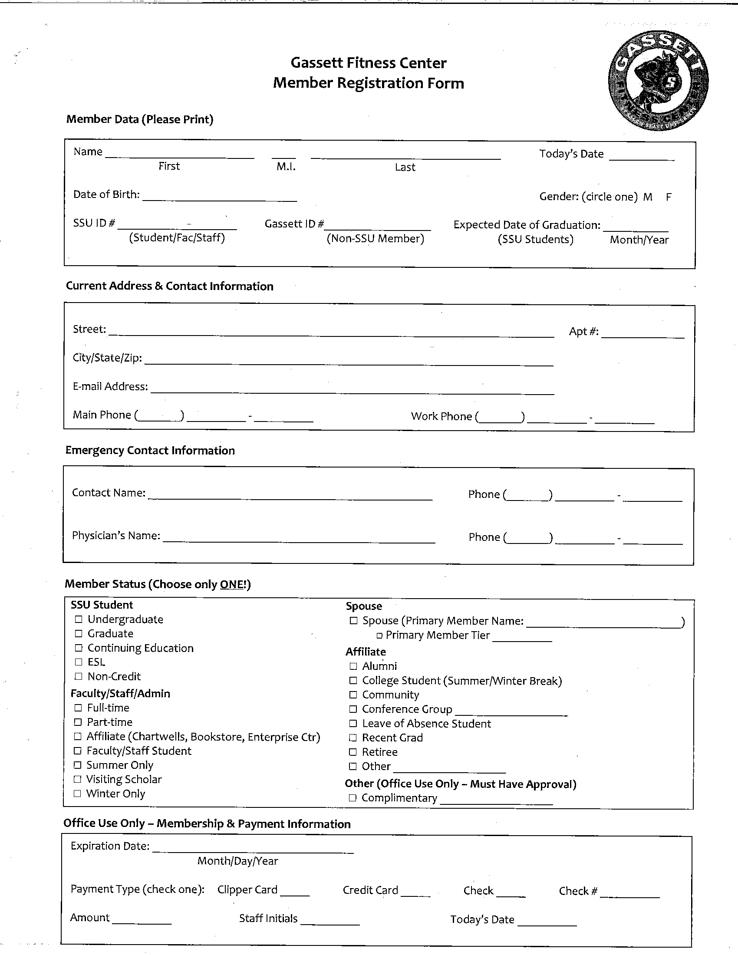

Appendix B: Informed Consent

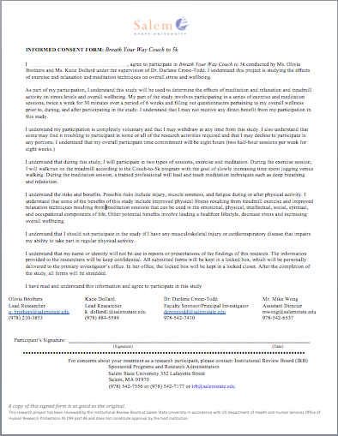

Appendix C: PAR-Q & YOU

Appendix D: Rate of Perceived Exertion
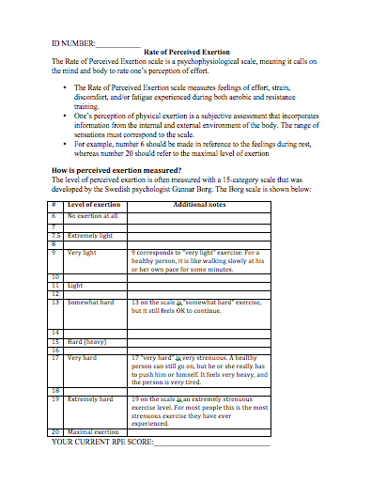

Appendix E: Overall Health and Wellbeing Questionnaire

Overall Health and Wellbeing

You are invited to answer the following questions by checking one box that most closely describes your situation.

1. In general, would you say your health is:

- Excellent | - Very Good | - Good | - Fair | - Poor

2. In general, would you say your quality of life is:

- Excellent | - Very Good | - Good | - Fair | - Poor

3. In general, how would you rate your physical health?

- Excellent | - Very Good | - Good | - Fair | - Poor

4. In general, how would you rate your mental health, including your mood and your ability to think?

- Excellent | - Very Good | - Good | - Fair | - Poor

5. In the past 7 days, how much did pain interfere with your day-to-day activities?

- Not at all | - A little bit | - Somewhat | - Quite a bit | - Very much

6. Over the last 2 weeks, how often have you been bothered by the following problems?

 | Not At All | Several Days | More Than Half the Days | Nearly Every Day
a. Feeling anxious, nervous or on edge
b. Not being able to stop or control worrying

7. Do you have problems related to your sleep, including falling asleep or staying asleep?

- Never | - Rarely | - Sometimes | - Often | - Always

8. How many days per week do you usually do moderate to strenuous physical activity, like a brisk walk?

- 0-1 days | - 2-3 days | - 4-5 days | - 6+ days

9. On the days that you do physical activity, how long do you exercise on average?

- Over 2 hours | - 1-2 hours | - 1 hour | - Under an hour

10. How many servings of fruits and vegetables do you eat in a typical day?

- 0 | - 1 | - 2 | - 3 | - 4 | - 5+

11. Do you eat fewer than two meals a day? (Circle one) YES NO

For the following questions check one option.

12. I find inner strength and/or peace from my prayers and/or meditations.

- Strongly agree | - Agree | - Neutral | - Disagree | - Strongly disagree

13. My prayers and/or meditations provide me with a sense of emotional support.

- Strongly agree | - Agree | - Neutral | - Disagree | - Strongly disagree

14. In the quiet of my prayers and/ or meditations, I find a sense of wholeness.

- Strongly agree | - Agree | - Neutral | - Disagree | - Strongly disagree

15. There is no higher plane of consciousness or spirituality that binds all people.

- Strongly agree | - Agree | - Neutral | - Disagree | - Strongly disagree

16. Although individual people may be difficult, I feel an emotional bond with all of humanity.

- Strongly agree | - Agree | - Neutral | - Disagree | - Strongly disagree

17. I sometimes worry so much that it affects my day-to-day life.

- Never | - Rarely | - Sometimes | - Often | - Always

18. In the last 12 months I have experienced stress, change or loss.

- Not at all | - A little Bit | - Somewhat | - Quite a bit | - Very much

19. If I need emotional support, I have someone who could help me.

- Not at all | - Rarely | - Sometimes | - Often | - Very much

20. I use relaxation techniques to manage stress.

- Strongly agree | - Agree | - Neutral | - Disagree | - Strongly disagree

21. I consider myself a spiritual person.

- Strongly agree | - Agree | - Neutral | - Disagree | - Strongly disagree

22. I have a positive body image.

- Strongly agree | - Agree | - Neutral | - Disagree | - Strongly disagree

23. I engage in self-reflection.

- Strongly agree | - Agree | - Neutral | - Disagree | - Strongly disagree

24. I engage in spiritual practices.

- Strongly agree | - Agree | - Neutral | - Disagree | - Strongly disagree

25. I am confident that I can learn new skills.

- Strongly agree | - Agree | - Neutral | - Disagree | - Strongly disagree

26. I feel that my education is a priority.

- Strongly agree | - Agree | - Neutral | - Disagree | - Strongly disagree

27. I was able to manage my academic workload during my most recent academic term.

- Strongly agree | - Agree | - Neutral | - Disagree | - Strongly disagree

28. I am confident that I can exercise regularly.

- Strongly agree | - Agree | - Neutral | - Disagree | - Strongly disagree

29. I am confident that I can maintain a nutritious diet.

- Strongly agree | - Agree | - Neutral | - Disagree | - Strongly disagree

30. I get at least 8 hours of sleep per night.

- Strongly agree | - Agree | - Neutral | - Disagree | - Strongly disagree

31. How often have you meditated in the past?

- Regular basis | - Back and forth between regular basis and stopping | - Several times | - Once or twice | - Never

32. How often have you exercised in the past?

- Regular basis | - Back and forth between regular basis and stopping | - Several times | - Once or twice | - Never

Appendix F: The Couch to 5k Training Plan

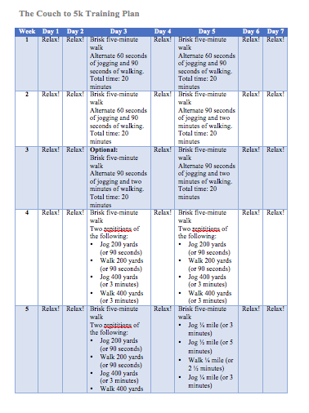
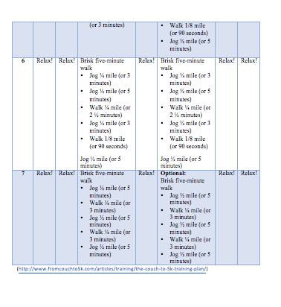

Appendix G: Heart Rate Form
