INFLUENZA: THE CHANGES TO THE FLU SEASON

Honors Thesis

Presented in Partial Fulfillment of the Requirements

For the Degree of Bachelor of Science in Biology
In the College of Arts and Sciences
at Salem State University

By

Kara Fonseca

Dr. Sheila Marie Schreiner
Faculty Advisor
Department of Biology

***

Commonwealth Honors Program
Salem State University
2019

Abstract

In this paper, the changes in flu season were examined. Additionally, reasons for changes to the flu season were explored. Data gathered from the Influenza Research Database was used to form graphs that show the changes in influenza cases yearly from 2008-2009 flu season to the 2018-2019 flu season in Massachusetts. A background for H1N1 and H3N2 including the difference between neuraminidase (N) and hemagglutinin (H), the excepted current timeline of flu season is provided. There are a number of factors that play a role in the changing flu season length, such as vaccination rates, effectiveness of that particular year’s flu vaccine, as well as the changing length of season and temperature. Other factors, such as signs and symptoms of influenza, affected population clusters, how the disease spreads from person to person, average temperature in Boston from US Climate Data, as well as the role herd immunity plays in protecting the general population could contribute to changes in flu season. This information is useful for human health, as we can develop new ways of protecting ourselves against influenza, as well as preventing a future pandemic.
Acknowledgements

A thank you to the Commonwealth Honors Program and the Biology Department.
A special thank you to Dr. Sheila Marie Schreiner. I couldn’t have done it without your help.

A thank you to friends, Mom, Dad and family members for their support.
Table of Contents

What is the Flu, Exactly? 1
What is Hemagglutinin? 3
What is Neuraminidase? 4
Protein Sequences from IRB 5
Vaccination 7
Climate Change 11
Final Conclusions 15
References 17

What is the Flu, Exactly?
Everyone knows about the flu. We are constantly reminded as fall begins to get our flu shots, wash our hands, and cover our mouths when we cough or sneeze. These precautionary measures help minimize our risk of contracting the influenza and spreading it to another person. The CDC states of influenza, “Influenza (flu) is a contagious respiratory illness caused by influenza viruses. It can cause mild to severe illness. Serious outcomes of flu infection can result in hospitalization or death” (CDC 2018). Viruses are microbes that require a host cell in order to reproduce or replicate. In general, viruses are pathogen or infectious agents that cause disease or illness. The various surface proteins lead viruses to infect specific organisms. In this particular instance, there will be a focus on influenza in human hosts. Yet the flu can survive in a number of other hosts.
Influenza is a rapidly spreading illness, as the mechanism of transmission is liquid droplets that form by air. Basically, liquid droplets formed by speaking, coughing or sneezing can enter the body of the host through their mucosa. The mucosa of the body is membranous and lines the body cavities as a layer of protection. The virus will enter through the mouth or any other membranous orifice. This virus is also extremely contagious due to the fact that direct contact with contaminated surfaces or fomites, such as touching a doorknob that someone with the flu sneezed on, and subsequent mouth-nose contact can then cause the virus to replicate in the host cell, infecting the person with the virus (Killingley, Nguyen-Van-Tam 2013). The length of time that flu can be transmitted by contact is described as, “The virus can survive for 6 hours on a dry surface; when touched by hands it can be retransmitted” (Al-Muharrmi 2010).
After the infection, the virus will begin to replicate in nasal and laryngeal mucosa, affecting the lower respiratory system as the virus progresses. It is important for the general public to be concerned about the flu because it is spread so quickly and has caused many pandemics throughout history (CDC 2018).
There are a variety of symptoms associated with the influenza virus. This should not be confused with a cold, though many are unsure of the difference. The CDC writes common symptoms include fever or chills, cough, sore throat, runny nose, muscle aches, fatigue, headaches and sometimes vomiting and diarrhea (CDC 2019). It is also said to come on suddenly. Influenza not only causes these symptoms in infected individuals; it can also cause secondary complications that may arise as a result of contracting the virus. The CDC states of the normal length of the virus as well as complications, “Most people who get flu will recover in a few days to less than two weeks, but some people will develop complications (such as pneumonia) as a result of flu, some of which can be life-threatening and result in death” (CDC 2019). If a person is said to be a “high risk” individual, they are likely to have complications that arise from the flu virus. Influenza can also trigger sinus and ear infections, myocarditis, encephalitis, multi-organ failure, and even sepsis (CDC 2019). Many of these conditions can be life-threatening. “High risk” individuals that contract the flu virus and are at risk for complications are those such as, "... people 65 years and older, people of any age with certain chronic medical conditions (such as asthma, diabetes, or heart disease), pregnant women and children younger than 5 years, but especially those younger than 2 years old” (CDC 2019). These individuals are at a higher risk due to the fact that their immune systems are not working to their full capacity or are weaker than normal.
The influenza virus is a member of the Orthomyxoviridae family, whose genome consists of segmented negative-sense single-strand RNA (Blumel 2007). There are four genus groups associated with the flu called Type A, Type B, Type C and Thogotovirus respectively (Arbeitskreis Blut 2009). The groups associated and relevant to human health are Type A and Type B influenza. The influenza has a number of proteins that encase the virus as well as surface receptors on the protein. These surface receptors on the influenza A virus are called hemagglutinin and neuraminidase. The particular type of influenza that will be focused on is Type A influenza. The CDC states of Type A influenza, “The emergence of a new and very different influenza A virus to infect people can cause an influenza pandemic” (CDC 2017). It is important for both health professionals and the general public to be aware of not only that influenza is highly contagious, but can be fatal, causing widespread damage. H1N1 and H3N2 are two strains that circulate each flu season in human hosts of Type A influenza. The most recent pandemic caused by a Type A influenza was the 2009 H1N1 influenza (CDC 2018). The average flu season is stated to be the following, “In temperate climate regions, influenza epidemics display a distinct seasonality, with widespread infection typically occurring during the winter season months: November to March in the Northern Hemisphere and May to September in the Southern Hemisphere” (Fuhrmann 2010).

What is Hemagglutinin?
Hemagglutinin is a glycoprotein located on the surface of influenza. This particular glycoprotein has a function in causing red blood cells to aggregate or clump together (Sino Biological 2019). Hemagglutinin has a role in specificity of binding. Gamblin states of hemagglutinin, “The specificity of virus attachment to target cells is mediated by hemagglutinin, which acquires characteristic changes in its receptor binding-site to switch its host from avian species to humans (Gamblin, Skehel 2010). Both hemagglutinin and neuraminidase bind to cells in the human host’s body to infect the cell with influenza, where it can then replicate, infecting the host. Gamblin continues to describe the role of hemagglutinin in virus infection stating, “Initiation of virus infection involves multiple HAs binding to sialic acids on carbohydrate side chains of cell-surface glycoproteins and glycolipids” (Gamblin et al. 2010). When the virus first infects the cell, hemagglutinin binds to sialic acid, which allows the flu to infect the cell and replicate. It is the variation of the HA that results in the different subtypes of influenza such as H1 in H1N1, or H3 in H3N2.

What is Neuraminidase?
Neuraminidase is an enzyme. Enzymes catalyze a particular reaction. Gamblin states of neuraminidase’s role in infection, “Following virus replication, the receptor destroying enzyme, NA, removes its substrate, sialic acid, from infected cell surfaces so that newly made viruses are released to infect more cells. (Gamblin et. al 2010). Without neuraminidase, the virus would not be able to continually re-infect new cells because the replicated virus would be unable to emerge from its cell. It is the variation of this protein that plays a role in the subtypes of influenza such as N1 in H1N1 and N2 in H3N2.

Protein Sequences from Influenza Research Database (IRB)
The length of flu season changes year by year, with a different number of cases. The database has numerous information collected on influenza in a number of hosts. The methodology used was to search for protein sequences collected by the database. The information that the Influenza Research Database (IRB) collects is on a variety of areas, but in particular, there is a focus on Massachusetts as a geographical region since it was too much information to focus on the United States as a whole. Data was limited by the presence of the HA and NA proteins in human hosts in Massachusetts. Then, data was compiled by flu season, starting with the 2008-2009 Flu season and ending with data collection to the recently passed 2018-2019 season (Figure 1). Common influenza strains with the HA and NA proteins, are H1N1 and H3N2, which were the only strains of the Type A virus that infected human hosts in Massachusetts.
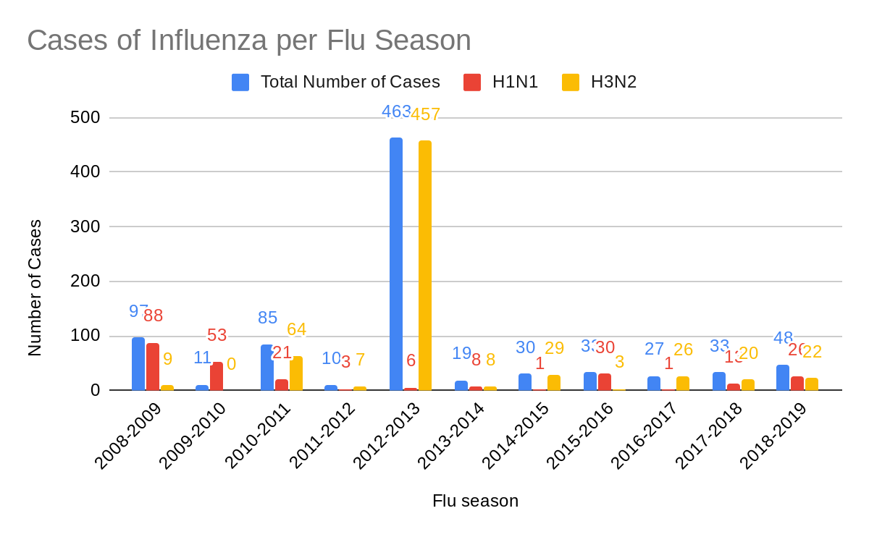
Figure 1: Number of Type A influenza cases per Flu season in terms of H1N1 and H3N2 viruses, as well as a combined total number of cases in Massachusetts. Data gathered from Influenza Research Database.

Flu Season | September | October | November | December | January | February | March | April
2008-2009 | 0 | 1 | 2 | 2 | 15 | 51 | 18 | 6
2009-2010 | 0 | 7 | 39 | 4 | 0 | 1 | 2 | 0
2010-2011 | 0 | 0 | 0 | 2 | 27 | 37 | 18 | 1
2011-2012 | 0 | 0 | 1 | 0 | 2 | 2 | 3 | 2
2012-2013 | 0 | 2 | 5 | 184 | 229 | 34 | 5 | 4
2013-2014 | 0 | 0 | 2 | 1 | 4 | 5 | 2 | 5
2014-2015 | 0 | 1 | 4 | 8 | 12 | 2 | 2 | 1
2015-2016 | 0 | 2 | 1 | 1 | 3 | 7 | 14 | 4
2016-2017 | 0 | 4 | 2 | 5 | 4 | 6 | 4 | 2
2017-2018 | 0 | 3 | 3 | 2 | 9 | 9 | 5 | 2
2018-2019 | 0 | 3 | 3 | 6 | 8 | 9 | 11 | 8

Table 1: Number of cases per month per flu season. Data gathered from Influenza Research Database.

In Massachusetts, the average flu season had 81 cases over a total of 11 flu seasons. An indication that flu seasons are becoming longer is an increase in the number of cases in April as shown in Table 1. The general trend shows an increase in the number of cases in both October and April. Overall flu season data collected, the months December saw 215 total cases, January had 313 cases, and February had 163 cases, indicating that these were the harshest months of flu season in Massachusetts.
The changes observed in each flu season have a correlation with vaccination rate for that particular flu season, effectiveness of that season’s vaccine, and the changing length of season’s as due to climate change.

Vaccination
Public health officials and health professionals alike agree that vaccination is crucial to avoid pandemics and limit the spread of influenza. Yet many people are hesitant to vaccinate for a number of reasons, despite many diseases becoming eradicated due to the advent of vaccination. There are also many misconceptions about the flu vaccine that lead to a lower vaccination rate. Yet vaccines are a preventative measure, decreasing the likelihood that one will get a certain disease or illness. The CDC states how flu vaccines work as follows, “Flu vaccines cause antibodies to develop in the body about two weeks after vaccination. These antibodies provide protection against infection with the viruses that are used to make the vaccine” (CDC 2019). The injected ‘dead’ viruses that compose the vaccine allow the body to develop an immune response to the virus, creating memory B cells that will recognize that particular strain with a greater strength upon the second encounter of that particular strain of flu virus.
The caveat that comes with any vaccine is that scientists must prepare the vaccine ahead of time. They must predict which strains of the influenza virus are likely to appear in that particular year’s flu season. More often than not, scientists are pretty accurate at predicting these changes in the flu virus. Vaccination against the flu is also important every year. Flu viruses are constantly changing and mutating. This is why flu vaccines are updated yearly. The CDC states another reason to vaccinate yearly, “...a person’s immune protection from vaccination declines over time, so an annual vaccine is needed for optimal protection” (CDC 2019). One cannot use the excuse that they were vaccinated last year since immune response to a pathogen from vaccination decreases.
Herd immunity also plays a role in the effectiveness of vaccination. The more people that vaccinate against the flu virus the better. Rhea Boyd, MD., states of the definition, “Herd immunity is the protection from contagious disease that an individual benefits from as a result of living in a community where a critical number of people are vaccinated” (Boyd 2016). This is the protection that we as a community obtain when a large number of people vaccinate. This even protects those who are not vaccinated or cannot vaccinate as the majority is protected against the contagious disease. H.Cody Meissner, MD., writes of herd immunity’s impact, “The greater the proportion of a population that is immune or less susceptible to a disease, the lower the probability that a susceptible person will come into contact with an infected person. If a sufficient number of people (herd) are immune, the infection will no longer circulate” (Meissner 2015).

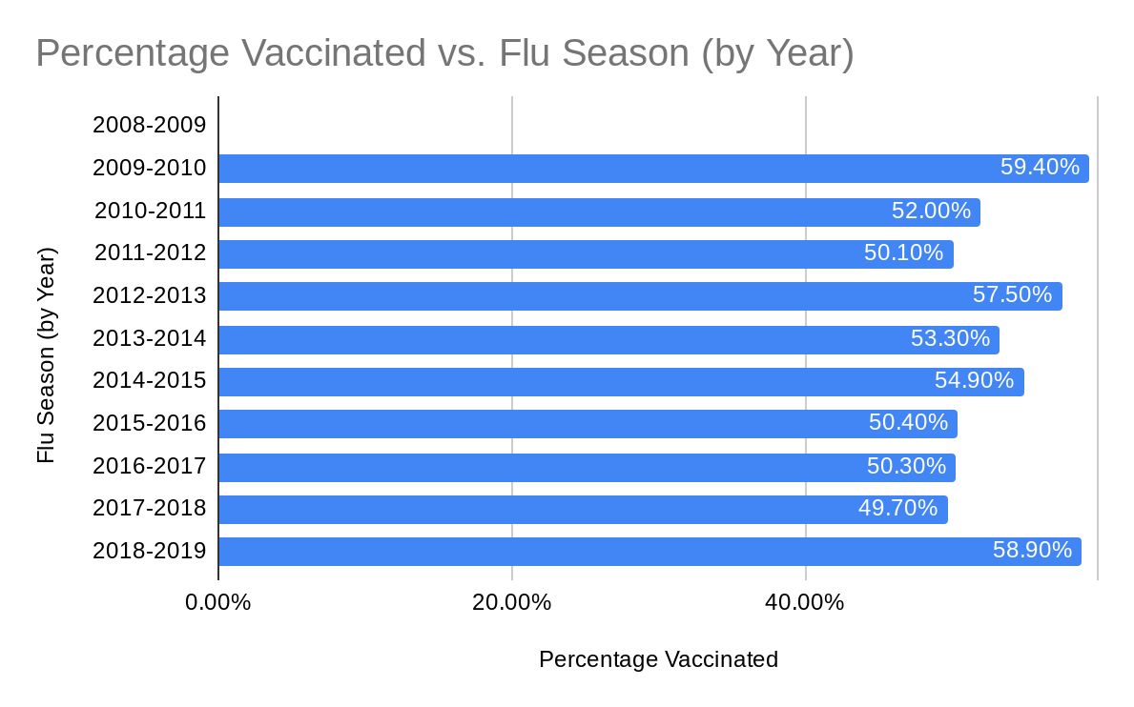
Figure 2: Vaccination rate data for age 6 months and older for the Northern Hemisphere. Information gathered from CDC FluVaxView.

Figure 2 shows that an increase vaccination rate for 2018-2019. It does not make sense that there would be more cases if there is a higher vaccination rate, yet the rate of protection for this year’s particular vaccine is only 29%. There was no data collected for the 2008-2009 Flu season on CDC’s FluVaxView. For example, the 2012-2013 season saw 57.5% of the nation vaccinated, yet the rate of protection of the vaccine was 49%.

Flu Season | Rate of Protection | Dominant Strain | Influenza Strains Observed | Vaccine Composition
2008-2009 | 56% | H1N1 | H1N1, H3N2 | A/Brisbane/59/2007 (H1N1 like virus), A/Brisbane/10/2007 (H3N2)
2009-2010 | 56% | H1N1 | H1N1 | A/Brisbane/59/2007 (H1N1 like virus), A/Brisbane/10/2007 (H3N2)
2010-2011 | 60% | H3N2 | H1N1, H3N2 | A/California/07/2009 (H1N1 like virus), A/Perth/16/2009 (H3N2)
2011-2012 | 47% | H3N2 | H1N1, H3N2 | A/California/07/2009 (H1N1 like virus), A/Perth/16/2009 (H3N2)
2012-2013 | 49% | H3N2 | H1N1, H3N2 | A/California/07/2009 (H1N1 like virus) A/Victoria/361/2011 (H3N2)
2013-2014 | 52% | H3N2 | H1N1, H3N2 | A/California/07/2009 (H1N1 like virus) A/Victoria/361/2011 (H3N2)
2014-2015 | 19% | H1N1:H3N2 | H1N1, H3N2 | A/California/7/2009 (H1N1 like virus) A/Texas/50/2012 (H3N2)
2015-2016 | 48% | H1N1 | H1N1, H3N2 | A/California/7/2009 (H1N1 like virus) A/Switzerland/9715293/2013 (H3N2)
2016-2017 | 40% | H3N2 | H1N1, H3N2 | A/California/7/2009 (H1N1 like virus) A/HongKong/4801/2014 (H3N2)
2017-2018 | 38% | H3N2 | H1N1, H3N2 | A/Hong Kong/4801/2014 (H3N2 like virus) A/Michigan/45/2015 (H1N1)
2018-2019 | 29% | H1N1 | H1N1, H3N2 | A/Michigan/45/2015 (H1N1) pdm-09 like virus A/Singapore/INFIMH-16-0019 (H3N2)
Table 2: Information on rate of protection from CDC’s Seasonal Influenza Vaccine Effectiveness, Dominant Strain of Flu Season and Type A influenzas collected from Influenza Research Database, Vaccine Composition information gathered from Influenza Research Database and WHO recommendation.

Another factor affecting vaccine effectiveness is the vaccine’s composition accuracy. The caveat that comes with any vaccine is that scientists must prepare the vaccine ahead of time. This means they must predict which strains of the influenza virus are likely to appear in that particular year’s flu season. More often than not, scientists are pretty accurate at predicting these changes in the flu virus. As shown in Table 2, the rate of protection ranges from 19% to 60%. The 2014-2015 vaccine yielded poor protection as its rate was 19%.
It is important to note that vaccination against the flu required every year. Flu viruses are constantly changing and mutating. This is why flu vaccines are updated yearly. The CDC states another reason to vaccinate yearly, “...a person’s immune protection from vaccination declines over time, so an annual vaccine is needed for optimal protection” (CDC 2019).

Climate Change
The world’s changing climate plays a role in the changing length of flu season. A study that also looked at the role of city size and method of transport, looked at the role of temperature and humidity. Plautz states of the role of temperature, “When an infected person coughs or sneezes, the virus-laden moisture droplets create what Dalziel calls a “moving cloud of risk.” In less humid winter conditions, those droplets can stay in the air longer” (Plautz 2018). As we know, influenza thrives in optimum cold conditions. Yet, interestingly enough, the study discovered, “Dalziel and his co-authors found that pockets of high population density connected by organized movement in larger cities actually lessened the impact of humidity, so a change in the weather doesn’t make as big a dent” (Plautz 2018). In bigger cities, the method of transportation brings people together in close contact, which helps influenza spread more easily, regardless of temperature. As climate changes, the influenza viruses impact on people will also change. Fuhrmann states of the role of changing humidity, “The ambient humidity is important in the transmission of influenza because it can affect the size of the respiratory particle” (Fuhrmann 2010). This is important because the amount of humidity in the air has an effect on the size of the respiratory droplet that will be expelled and held in the air. They state of air that is dry, or seen as relatively not humid, “When the air is dry, large drops partially evaporate, creating smaller, lighter drops that are more likely to remain airborne for extended periods of time” (Fuhrmann 2010). This allows the larger droplets that would normally dissipate after a period of time, to break down into smaller droplets that can remain in the air for a longer time. This will allow the droplets to infect more of a wide range of people since they are held in the air for a longer period. Yet more surprisingly, studies found, “Based on studies of aerosol dynamics, a typical respiratory particle exposed to an ambient relative humidity of 80% can remain airborne for up to 1 h. When the relative humidity is decreased to 20%, the same particle is able to remain airborne for more than 24 h” (Fuhrmann 2010). If the air is drier or not as humid, it is better for the influenza virus to infect more people since it can remain in the air for up to 24x longer than normal.
Transmitting influenza virus also has a role in temperature. We know that influenza thrives in cold environments. So what will happen to the way influenza spreads as average temperatures increase? A study with guinea pigs explored the role of temperature in spreading the flu virus. Fuhrmann writes of the study, “Lowen et al. (2008) found that increasing the ambient temperature of guinea pig cages during transmission experiments appeared to prevent airborne transmission but not contact transmission” (Fuhrmann 2010). Increasing temperature did have a role in preventing airborne transmission of the influenza virus, however, contact transmission of influenza between the guinea pigs was still possible. They state of the experimental conditions, “To simulate airborne transmission conditions, both inoculated and recipient guinea pigs were placed in separate cages in a chamber held at a temperature of 30 C. After a week of exposure, no recipient guinea pigs were infected” (Fuhrmann 2010). Both influenza infected guinea pigs and noninfected guinea pigs were kept separate to simulate airborne transmission, however, they discovered no new guinea pigs were infected with the flu. When keeping the guinea pigs (both infected and noninfected) in the same cage, they discovered something different. Fuhrmann states of the results of close contact simulation, “when placed in the same cage to simulate contact transmission conditions at 30 C, between 75% and 100% of the recipient guinea pigs became infected” (Fuhrmann 2010). Though influenza survives optimally in cold temperatures, this study corroborates the idea that the flu virus will still infect humans as climates change, yet the mode of transmission will be a bit different.
Another study discusses climate change’s role in the severity of flu seasons. The study which utilized data from a CDC database states of temperature changes, “It appears that fewer people contract influenza during warm winters, and this causes a major portion of the population to remain vulnerable into the next season, causing an early and strong emergence” (Science Daily 2013). Researchers hypothesizing “that warm winters are more likely to be succeeded by early and severe influenza seasons due to fewer people being infected due to the warm weather, thereby leaving an unnaturally large fraction of susceptible individuals in the population going into the next season” (Towers, Chowell, Hameed 2013). These warmer winters in the previous flu season, lead to less people becoming infected with the flu virus, due to a lower ability for airborne transmission of the virus. This low number of infected people then leaves a large number of individuals who do not develop memory cells for the virus, leading to a worse flu season the next year, as many people do not have immunity. Another issue that relates to the changing climate is when the colder temperatures come back potentially earlier than normal. The researchers in the study state, “The severity of the next season could potentially be exacerbated by the early onset, if the onset occurs before most of the population has had the opportunity to be vaccinated” (Towers et. al 2013). If the seasons start changing and becoming longer, for example it gets colder earlier in the year than normal, then there is a risk that the flu virus will be able to spread before people would normally get vaccinated against the flu virus. Climate change is a definite concern for preventing future pandemics.

Flu Season | Sept. | Oct. | Nov. | Dec. | Jan. | Feb. | March | April
2008-2009 | 65.35 | 53.35 | 43.4 | 35.65 | 24.85 | 32.95 | 37.45 | 50.5
2009-2010 | 63.2 | 51.85 | 48.85 | 33.15 | 29.6 | 33.15 | 43.9 | 53.0
2010-2011 | 68.65 | 55.6 | 44.75 | 32.65 | 27.6 | 30.5 | 38.9 | 50.1
2011-2012 | 67.3 | 57.5 | 50.35 | 40.0 | 34.15 | 37.5 | 46.65 | 53.15
2012-2013 | 64.7 | 56.45 | 42.1 | 38.4 | 31.55 | 31.55 | 37.7 | 48.95
2013-2014 | 64.65 | 56.65 | 42.75 | 33.35 | 27.55 | 29.05 | 33.55 | 48.1
2014-2015 | 66.25 | 56.35 | 42.5 | 38.25 | 26.2 | 19.1 | 33.3 | 48.05
2015-2016 | 69.2 | 54.0 | 48.55 | 45.25 | 32.6 | 34.05 | 42.55 | 47.1
2016-2017 | 67.5 | 55.3 | 46.2 | 35.35 | 35.15 | 36.65 | 34.05 | 51.65
2017-2018 | 67.1 | 61.35 | 43.75 | 30.75 | 28.7 | 38.1 | 37.3 | 45.35
2018-2019 | 69.0 | 54.45 | 43.0 | 36.1 | 30.8 | 33.65 | 39.1 | 51.7
Table 3: Average monthly temperature in Boston, Massachusetts. Temperature in Fahrenheit. Data gathered from U.S. Climate Data.

The 2012-2013 flu season in Massachusetts was particular harsh, seeing a large number of cases. The study found that a particularly warm previous season would then cause a harsh season the next flu season. As shown in Table 3, the 2011-2012 temperatures in Boston were higher than normal temperatures and corroborate the idea that a particularly warm previous season would cause a harsh next flu season, the 2012-2013 season in this case. A limit to this data is that the US Climate Data is only about average temperatures in Boston and the cases on the Influenza Research Database span the state of Massachusetts. There is a need for further analysis to see if this indication holds true for other flu seasons, as well as a further breakdown of cases per city, and analysis of average temperature of the city at the particular cases of interest.
Final Conclusions
The changes to the flu season are due to a large variety of factors. Though the general population is constantly reminded about the flu as fall begins, a lot of the population is unaware of the basic components of the flu virus, as well as how to protect themselves against it.
Some of the factors that may lead to changes to the flu season are the vaccination rate, accuracy of the flu vaccine, and effect of climate change. Clearly there are other factors at play, however, they were not examined in this paper. The number one way to prevent the flu is to get vaccinated. Vaccination is necessary to maintain herd immunity, which protects even those who are not vaccinated against the flu virus. The accuracy of each year’s vaccine also has a role in preventing cases of the flu. Scientists must accurately predict the viruses that will circulate that particular season, in order to effectively be able to fight against that year’s flu virus. The changing length of seasons and temperature changes due to climate change lead to new main methods of transmission, as well as harsher flu seasons after a particular warm previous year. As a population, people must be prepared for another influenza pandemic.

References

Arbeitskreis Blut, Untergruppe «Bewertung Blutassoziierter Krankheitserreger». (2009, February). Influenza Virus. Retrieved from https://www.ncbi.nlm.nih.gov/pmc/articles/PMC2928832/.

Boyd, R. (2016, April 18). It Takes a Herd. Retrieved from https://www.aap.org/en-us/aap-voices/Pages/It-Takes-a-Herd.aspx.

CDC Seasonal Flu Vaccine Effectiveness Studies. (2019, November 5). Retrieved from https://www.cdc.gov/flu/vaccines-work/effectiveness-studies.htm.

Flu Symptoms & Complications. (2019, September 18). Retrieved from https://www.cdc.gov/flu/symptoms/symptoms.htm.

Fuhrmann, C. (2010). The Effects of Weather and Climate on the Seasonality of Influenza: What We Know and What We Need to Know. Geography Compass, 4(7), 718–730. doi: 10.1111/j.1749-8198.2010.00343.x

Gamblin, S. J., & Skehel, J. J. (2010, September 10). Influenza hemagglutinin and neuraminidase membrane glycoproteins. Retrieved from https://www.ncbi.nlm.nih.gov/pmc/articles/PMC2937864/.

Healthy Habits to Help Prevent Flu. (2019, November 7). Retrieved from https://www.cdc.gov/flu/prevent/actions-prevent-flu.htm.

Influenza Hemagglutinin (HA). (2019). Retrieved from https://www.sinobiological.com/influenza-hemagglutinin-function-a-147.html.

Influenza Research Database. (n.d.). Retrieved from https://www.fludb.org/brc/influenza_sequence_search_protein_display.spg?method=ShowCleanSearch&decorator=influenza.

Key Facts About Seasonal Flu Vaccine. (2019, December 2). Retrieved from https://www.cdc.gov/flu/prevent/keyfacts.htm.

Killingley B, Nguyen-Van-Tam J. Routes of influenza transmission. Influenza Other Respir Viruses. 2013;7 Suppl 2(Suppl 2):42–51. doi:10.1111/irv.12080

Meissner, H. C. (2015, May 1). Why is herd immunity so important? Retrieved from https://www.aappublications.org/content/36/5/14.1.

Misconceptions about Seasonal Flu and Flu Vaccines. (2019, September 25). Retrieved from https://www.cdc.gov/flu/prevent/misconceptions.htm.

More severe flu seasons predicted due to climate change. (2013, January 28). Retrieved from https://www.sciencedaily.com/releases/2013/01/130128142847.htm.

Plautz, J. (2018, October 5). How City Size Affects the Spread of the Flu. Retrieved from https://www.citylab.com/environment/2018/10/big-cities-have-longer-flu-seasons-while-small-cities-have-more-intense-ones/572161/.

Recommendations for Influenza Vaccine Composition. (2011, September 19). Retrieved from https://www.who.int/influenza/vaccines/vaccinerecommendations1/en/index3.html.

Seasonal Influenza Vaccine Effectiveness, 2012-2013. (2018, September 4). Retrieved from https://www.cdc.gov/flu/vaccines-work/2012-2013.html.

Towers S., Chowell G., Hameed R., Jastrebski M., Khan M., Meeks J., Mubayi A., Harris G. Climate change and influenza: the likelihood of early and severe influenza seasons following warmer than average winters. PLOS Currents Influenza. 2013 Jan 28 . Edition 1. doi: 10.1371/currents.flu.3679b56a3a5313dc7c043fb944c6f138.

Types of Influenza Viruses. (2019, November 18). Retrieved from https://www.cdc.gov/flu/about/viruses/types.htm.

Vaccine Effectiveness: How Well Do the Flu Vaccines Work? (2019, December 3). Retrieved from https://www.cdc.gov/flu/vaccines-work/vaccineeffect.htm

2010-11 through 2018-19 Influenza Seasons Vaccination Coverage Trend Report. (2019, October 29). Retrieved from https://www.cdc.gov/flu/fluvaxview/reportshtml/trends/index.html.

