A Study of Semi-Strong Form of Market Efficiency: Active vs. Passive Portfolio strategies – with Bloomberg Terminals

Honors Thesis

Presented in Partial Fulfillment of the Requirements

For the Degree of Bachelor of Science in Business Administration - Finance
In the Bertolon School of Business
at Salem State University

By

Klausa Topi

Professor Sanjay Jain
Faculty Advisor
Department of Accounting and Finance

***

Commonwealth Honors Program
Salem State University
2021

Abstract
This research paper gives a detailed analysis of semi-strong form of market efficiency when there are being used Active vs Passive portfolio strategies. This study shows if the market can be outperformed through the comparison of the returns of two portfolios with 20 stocks each. On a daily basis, market efficiency, through the semi-strong form, provides investors and all market participants with the same information and prices which respond respectively to the information given in any market. At this moment no one will have the possibility to outperform and profit anyone, given the same tools. Market efficiency won’t allow investors to make a profit above the average because it gives them the opportunity to be rational and make reasonable choices. Both portfolios used to conduct this study were created through Bloomberg Terminals for a period of 12 weeks. Active portfolio’ stocks are chosen through an extensive analysis in detail as how the market was performing and what stocks were predicted to have the greatest return. On the other hand, the passive portfolio’ stocks were chosen not through an extensive analysis but are expected to have returns as closely as it can be possible. Each portfolio has equity indices; these portfolios will be compared with the market index for better insights and understanding. This study indicates if market is outperformed, or if market is efficient as well as will give the answer to questions like how market efficiency affects the economy, how would the economy be better off.

Table of Contents
Introduction………………………………………………………...……….1
Proposed Hypothesis………………………………………………………..2
Literature Review………..………………………………………………….2
Research Methodology ….………………………………………………….4
Data Analysis …………..……….………………………………………….5
Active Data ………………………………………………………….5
Passive Data………………………………………………………….7
Results ……………………………………………………………………...8
Active Portfolio………………………………………………………8
Passive Portfolio…………………………………………………….10
Comparison………………………………………………………….11
S&P500……………………………………………………………...11
Conclusion …………………………………………………………………13
Bibliography………………………………………………………………..15
Appendix …………………………………………………………………..16

Introduction
The market efficiency hypothesis was created on 1970 by Eugene Fama, which suggests that at any time prices are a reflection of all available information. (Heakal, 2015)
Market Efficiency is defined as an extent to which market prices incorporate all the available data. It provides investors and market participants with all these relevant data and prices as well. Market efficiency also gives an estimate of the investment value as well as information about the intrinsic value of the assets. The difference between the intrinsic value vs the market value is that intrinsic value defines the true value of an asset; while the market value defines the price at which this asset can be sold or bought. Although markets sometimes can be efficient sometimes can vary significantly, when the intrinsic value together with the market value are close or nearly the same, then the market can be defined as efficient. By being efficient, markets have the ability to incorporate data in order to maximize the opportunities for traders and investors so that all market participants have the same information and opportunities. This situation prevents market participants like traders and investors to not be able to outperform the market nor to have returns higher the average market return. (CFA Institute)
There are three forms of market efficiency: weak, semi-strong and strong form of market efficiency. In the weak form of market efficiency, the stock prices fully reflect all past available information as well as the trading volume information. In the semi-strong form of market efficiency, stock prices reflect all the publicly known as well as all available past information. Lastly, in the strong form of market efficiency, prices fully reflect all information which includes public and private known information as well as historical information. (CFA Institute)
In an economy where market is fully efficient, market prices help to determine which companies or organizations obtain capital. In case market are inefficient, then these funds and this capital could be misdirected. On the other hand, market efficiency also plays an important role when it comes to financial managers. It gives financial managers a better understanding on how the market is performing, the stock performance as well as helps them to contribute even more in the development of the economies. Market participants can invest in two ways, through: active and passive investing, which have great impact on investors as well as impact the economy. The question that this paper will examine and perform an analysis is: Are markets efficient? & How does financial stability stand in terms of efficiency?
Proposed Hypothesis
In this research, the hypotheses are provided in order to examine further market efficiency and give a representation of the market impact. Below are the hypotheses:
- Market can be outperformed.
- Market is inefficient.
- Active Portfolio has the highest return.
- Passive Portfolio has the highest return.
Literature Review
As stated above, the purpose of this paper is to find out if the market is efficient, as well as to define the importance of investing through active and passive strategies. Over the past years maybe even decades, investors, money managers, and all market participants have been leaning towards the passive investment strategies. (2018) The objective of active investing is to outperform the index market or a certain benchmark. To do so, the active investing strategies require associated costs such as research costs to an extensive analysis, money managers’ fees, brokers fees, advisory fees and more. Active investing needs a very detailed and organized time commitment as well as a lot of decision making throughout the investing, whether it is to sell, to buy or when to trade and more. On the other hand, there is passive investing, some of them might be managed index funds where usually investors track an index by holding all of its stocks and assets selected. In passive investing strategies there is limited to no research or extensive analysis on stocks or securities. (2020, pp. 1-16) Anadu from the Finance Discussions Series states that sometimes there could be confusion between active and passive investing. This might happen because sometimes active portfolios might behave as passive by following the “closet-indexing” strategies. Yet, there is a shift from active to passive investing which could affect the market efficiency as well as increase the financial stability risks. (2018) Although market might not be perfectly efficient because sometimes there might be anomalies, levels of volatility and more, markets are considered efficient because of the encouragement of capital formation, diversifying the risk and having a large investor participation. Nonetheless, if market is inefficient that might have negative consequences in the economies. According to Sovich and Ringgenberg in 2018, the inefficient markets provide firms the inability to make clear and productive decisions. Binsenberg in 2017 also stated that financial managers are helpful because contribute in the elimination of these mispricing systems too add value to the economy. (2020, pp. 1-16)
Furthermore, Qin and Singal interpreted that passive investing could dislocate the efficiency and could bring a decrease in incentives for data arbitrage and acquisition. This situation might bring a degradation in the market prices during the studied period of 2003-2013. (2020, pp.1-16) Similar research paper was conducted by Hendrawan: Stock portfolio analysis with active and passive strategies. Hendrawan states that what is important for the decision-making process in the stock trading is the ability to select the right stocks, preferably at the right time. As results of these analysis, the comparison of both portfolio strategies indicated that active portfolio had the best performance in semiannual sequence, passed by the passive portfolio strategy. Although, active portfolio strategy in an annual basis followed by with less return. (Hendrawan, 2020)
All in all, past research indicates that there has been a shift from active to passive investing, however it also shows how active investing strategy is the best choice investors and market participants can do in order to decrease the risks of financial stability and show the market efficiency.
Research Methodology
In order to perform the research study and to obtain the results, two portfolios are being analyzed are: active portfolio vs passive portfolio through the Bloomberg Terminals. The research of the stocks was performed through the semi-strong form of market efficiency, where prices reflect all public and past historical information available. Active portfolio was created of 20 stocks of an extensive analysis. On the other hand, the passive portfolio was also created of 20 random stocks without a thorough research analysis. Both portfolios were given the same amount of total value invested and were created on January 17th, 2021 and were followed weekly for a period of 12 weeks, until April 5th, 2021. Both portfolios are compared to S&P 500 market index. Below are presented the portfolio analysis as well as the results respectively to help come to a definite conclusion. (Bloomberg Terminals, 2021)
Data Analysis
Active Data Analysis
Starting with the active portfolio, it consists on 20 stocks that were analyzed thoroughly through the finance key data and ratios as well as through the historical prices. Among these 20 stocks, one of the assets was a bond. Choosing a bond help the portfolio to be less volatile as well as reduce the overall risk. Having a bond in the portfolio also helps with diversification. (Exhibit 1.) In the table below, Fig 1., the active portfolio allocation is given according to the industries. Some elements that helped in the analysis and the decision making of what stocks would be included in the active portfolio were the P/E ratio, beta, dividend yield, debt to equity ratio, market cap, price to book ratio, return on equity, industry search and history performance. When it comes to P/E ratio, it is an important element to analyze the stocks as this helps investors to determine the market value of a stock as compared to the company’s earnings. In other words, what P/E ratio shows is how much the market is willing to pay today for a security based on the future enrings. (Investopedia) CAPM is another important factor that offers opportunity of free risk assets in the short or long term. (Palan, 2004) Through CAPM, the expected return on the security can be divided into the return on the risk-free security and the market portfolio. Hence, beta is also an important key data that gives investors an understanding of what to expect from a security or a stock based on the movements in the overall market. When beta is greater than 1, it shows that the stock is volatile comparing it to the market and when beta is lower than 1, it indicates lower volatility. (Palan, 2004) The volatility is used to measure the risk of the stock compare to its market. The dividend yield ratio shows the investors the amount that the company has paid in the past in dividends over a set period of time and the yield represents the percentage of how much return the shareholders are expecting to get when they invest. When it comes to market cap, it shows the investors how much the company is worth on the open market and kind of gives a better understanding of the future prospects of that company because it shows how much market participants are willing to pay for that particular stock. A large market cap could start at 8B to 10B and up. The debt to equity shows market participants the ratio of the equity and the debt that the company is currently using in order to finance its current and long-term assets. Furthermore, the return on equity ratio or ROE, is one of the most important finance ratios to help in the decision-making process and it gives a perspective on how well the company is performing and it is managing its capital that shareholders have already invested. If the ROE is high, that means that company’s management is efficient and that it is generating growth and income from the financing. (Investopedia) Lastly, the industry research as well as historical performance are two other key data and information that should be always needed when building up a portfolio. The Industry research and the market where this industry lies shows a better understanding of what should be the target market and where are the growth areas. Historical prices show the performance of these industries as well as of companies itself which help the market participants and investors to have a clearer picture and to have it easier to make predictions for the future. For example, if Apple Inc. wouldn’t have a strong past performance, would be less likely to be chosen as part of the active portfolio because of the less chances that there are to perform better in the future. However, past performances are not enough to make a clear decision, and that is why investors should keep in mind to perform an extensive analysis over the stocks that they choose in order to create an active portfolio strategy. This means that financial ratios and other key data are essential in this process.
Fig. 1
Active Portfolio Allocation | Total Value
Fixed Security | $ 11,241.00
Communication Services | $ 55,173.50
Consumer Discretionary | $ 184,253.20
Energy | $ 2,394.50
Finance | $ 37,402.10
Health Care | $ 13,388.20
Technology | $ 23,346.50
Industrials | $ 19,433.00
Total Value | $ 346,632.00

Passive Data Analysis
The passive portfolio, on the other hand, as mentioned prior, it’s a managed index fund portfolio which means that was created not based on the extensive research and analysis. These types of portfolios do not req2uire additional costs such as the money to pay managers, or the brokers fee and more. Passive portfolio was built out of 20 random stocks. (Exhibit 2.) This passive portfolio can also be called “a monkey portfolio”. In other words, the passive portfolio focuses mostly on maximizing diversification with few to none input. Figure 2. shows the portfolio allocation of passive portfolio. Both portfolios, as shown in the tables have the same total value as well as some similar industries.

Fig. 3
Passive Portfolio Allocation | Total Value
Consumer Discretionary | $ 121,660.90
Communication Services | $ 12,568.00
Consumer Staples | $ 14,610.00
Energy | $ 8,491.00
Finance | $ 22,888.50
Health Care | $ 70,968.00
Industrials | $ 76,213.10
Technology | $ 19,232.50
Total Value | $ 346,632.00

Results
Active Portfolio Results
After the data analysis of both portfolios, below are the results and portfolio performance over the period of 12 weeks. Fig 3. shows the active portfolio performance from Jan 17th to April 5th which had given a return of 6.834% on the investment. Looking at the graph below, it is noticeable that the portfolio had experienced ups and downs throughout the time period, with the greatest downward somewhere around end of February and beginning of March. However, towards the end of the period, there is an increase of the return continuously.
Fig 3.
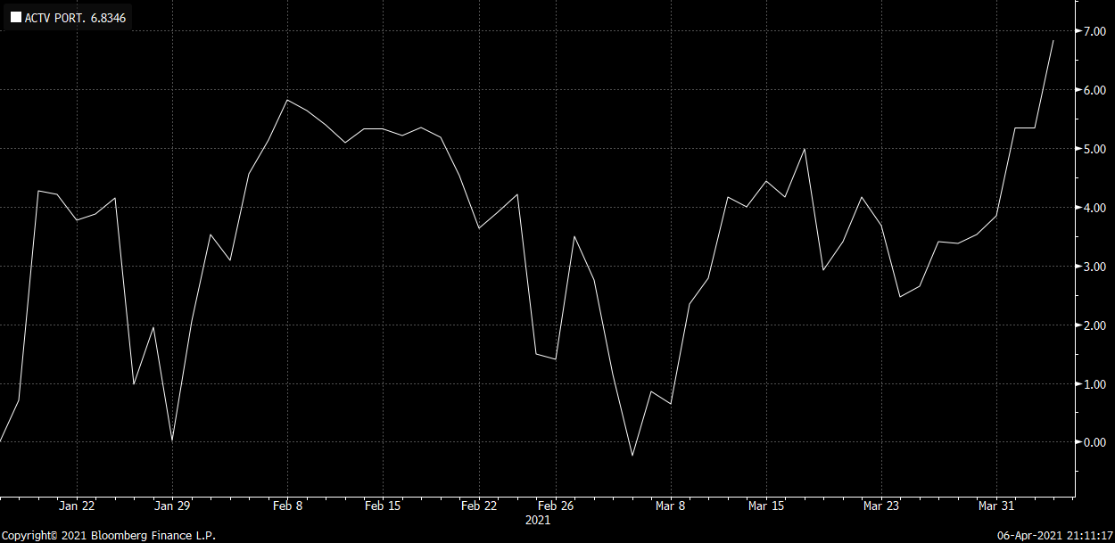
As mentioned above, Fig.1 contains the allocation of industries for the active portfolio which is diversified. Exhibit 1. below also gives a clear picture of the stocks that were invested and their exchange. Beside an extensive analysis of the data regarding the active portfolio, another important step is to keep track of the costs associated with building and following the active investing portfolio. These costs include several components that also affect the return of this investment. Fig. 4 gives a part of the active portfolio strategy as well as it’s associated costs that impact the rate of return. Active Portfolio Risk Is 24.28% and therefore the optimization task and the goal would be to minimize the risk with 20% turnover. The trading strategy is reflected below. Analyzing how the stocks were performing, the decision to sell at some of the companies was essential. For example, there were 6 stocks sold $46,347.12 as well as 2 stocks bought with a value of $29,131.46. Before the costs the rate of return on the active portfolio was 6.83%. However, there are also the costs, the second part of Fig 4. shows estimated costs that should be taken into consideration. Starting with the broker’s fee, which will consist on 1.5% approximately. The trade commission of the strategies and more will get another percentage which will bring around $430.00 on costs. Advisory commission would have an estimate percentage of 0.95%. The advisory commission is not required, although is highly recommended because while building up the portfolio and following it step by step the advice coming from money managers, financial analysis and more is truly beneficial. Lastly, there is also the research expense, which could be around $10,000 (estimated) but it could also be greater depending on the type of research. After calculating all the total costs which were around $15K, then the new return is obtained: 6.55%. The returns have not changed significantly, although there is a viewable change due to these costs.
Fig. 4
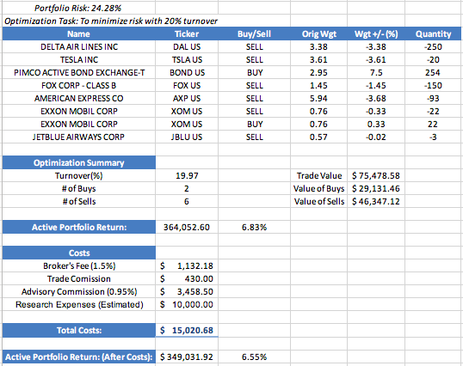

Passive Portfolio Results
Moreover, the performance of Passive portfolio analysis is shown in Fig 5. As discussed, prior, during the passive portfolio no analysis was conducted, and it was just invested to see the market return without any type of trading. As seen in the graph below, passive portfolio had also up’s and downs with the lowest point somewhere end of February beginning of March, just like in the active portfolio performance. The rate of return in this portfolio is 2.667% which turns out the be lower than the active portfolio return.
Fig. 5
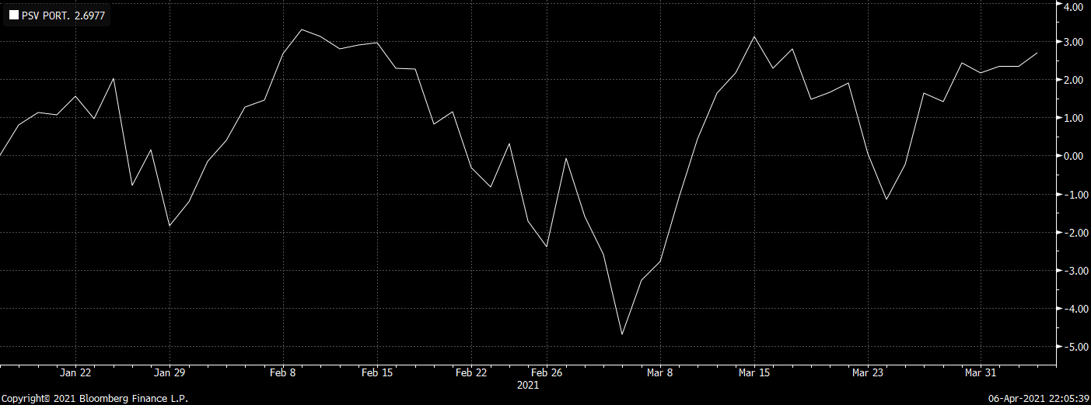

Comparison
Fig 6. represents the results of two portfolios together and shows the positive difference in terms of active and passive portfolio. The performance difference is in green which means there is a positive difference and that active portfolio has the highest return. The orange line is passive return, whereas the white line is the active. In comparing both portfolios, Active Portfolio has a marginally better return than passive portfolio. However, these two portfolios will also have to be compared to the market to see their performance and see if market is truly efficient.
Fig. 6
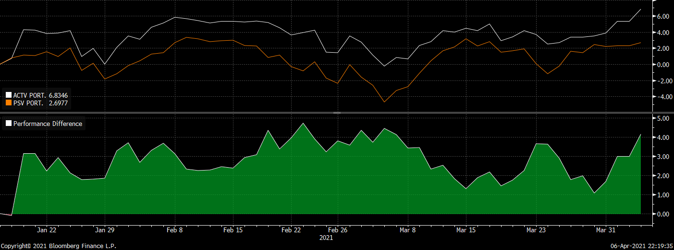

S&P 500
The active portfolio vs. S&P500 are shown in the Fig. 7. In this graph, active portfolio aside with SPX show that the portfolio has very close returns to the market. If close attention is paid to the performance difference between SPX and Active Port; in the first half of the time period, there is a positive excess return and when it comes towards the second half, it switches to negative excess return. Excess return is defined as return that achieves above and beyond the return of a proxy. The change of the excess return through the period from positive to negative kind of does not give a definite answer here.
Fig.7 (Active Portfolio vs. S&P500)
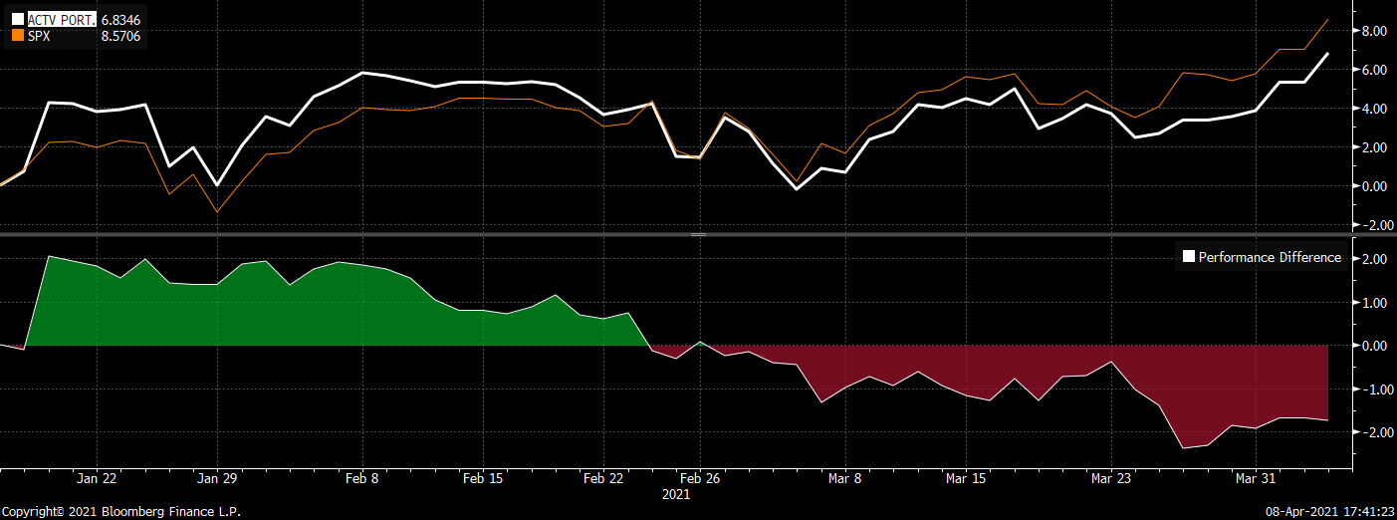

On the other hand, there is passive portfolio vs. SPX analysis. Again, the passive portion returns are also close to the ones in the market. However, in the passive comparison, there is a negative performance difference which means this portfolio has a negative excess return constantly, throughout the period of 12 weeks as reflected in the graph below (Fig. 8)
Fig. 8 (Passive Portfolio vs. S&P500)
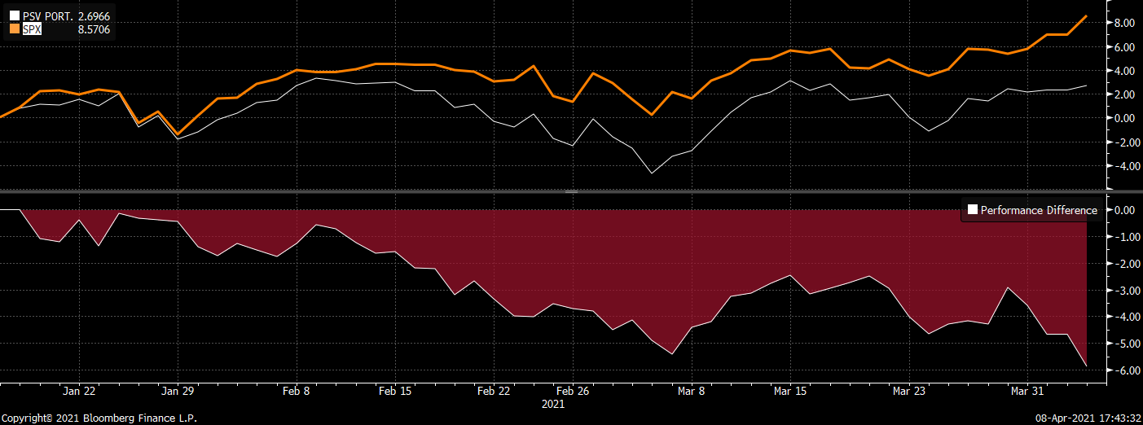

The big picture (Fig. 7&8) of both graphs shows that the active and passive portfolio have very similar returns comparing to the marker S&P500.
Conclusion
In conclusion, going back to the proposed hypotheses, the “market is inefficient” hypothesis is rejected because there are not statistically significant results to state otherwise. When it comes to analyzing the active portfolio investing, according to the results, it is reflected that active management gives higher excess returns. At the same time, active portfolio gave a marginally higher return. However, comparing the results with the benchmark SPX, looks like both portfolios have similar results. This means that there are not significant benefits to show that active portfolio management is better than passive portfolio and vice versa. Although the results clearly state that active portfolio is performing better, there are yet elements that impact these results like the benchmark comparison. For the active portfolio to be a better performer and to be considered a superior investment, there needs to be significant high amount of net return comparing to the passive portfolio management. In this case, although the difference is there it is not significant regarding the active management. This could one of many reasons why shifting from active to passive investing has happened during the last times. As mentioned throughout the paper, there are risks associated with the shift in passive investing that affect the financial stability and investing in the long run. It is recommended that more research should be done in order to conclude better the benefits, advantages and disadvantages of active and passive investing strategies to help further the investors, market participants as well as to maintain a financial stability. Moreover, this paper concludes that market is efficient according to the results. After the extensive analysis, the active investing had similar returns to the market (Spx), as well as passive investing, although more research regarding to this matter should also be done to have a clearer picture of how the market behaves throughout different period of times. Furthermore, in conclusion to these results, there is financial stability. The informative prices, from the semi-strong form of market efficiency, promote economy growth. An actual efficient market where is consistently growing into better and stronger information available tend to eliminate the possibilities of arbitrage as well as the returns above the market. The efficiency in the capital markets is one of the most essential characteristics which show how well functioning financial systems are. To conclude, market efficiency plays a very important role in developing further the economies. The active management has a critical and essential part in the formation of capital as well as economic growth.

Bibliography

Active Management and Market Efficiency: A Summary of the Academic Literature. (2020). Active Managers Council: Investment Adviser Association, 1-16.
Anadu , K., Kruttli, M., McCabe, P., & Osambela, E. (2018, 06). The Shift from Active to Passive Investing: Potential Risksto Financial Stability?
Bloomberg Terminals. (2021). Avice vs. Passive Portfolio .
CFA Institute. (2021). Retrieved from Market Efficiency: https://www.cfainstitute.org/en/membership/professional-development/refresher-readings/market-efficiency
Heakal, R. (2015, November 1). Forbes. Retrieved from What is market Efficiency: https://www.forbes.com/
Hendrawan, R. (2020). Stock Portfolio Analysis: Active and Passive Strategies Formed with Financial Indicators. Research Gate.
Investopedia. (n.d.). Retrieved from https://www.investopedia.com
Palan, S. (2004). The Efficient Market Hypothesis and its Validity in Today's Market. GRIN.

# | Stock | Company name | Industry | Exchange | Price (01-17-21) | N.0 of shares | Total value
1 | AAPL US | Apple | Technology | NASDAQ | $ 127.14 | 100 | $ 12,714.00
2 | AMZN US | Amazon | Consumer Discretionary | NASDAQ | $ 3,104.25 | 30 | $ 93,127.50
3 | AXP US | American Express | Finance | NYSE | $ 122.15 | 150 | $ 18,322.50
4 | BABA US | Ali Baba Group | Consumer Discretionary | NYSE | $ 243.46 | 60 | $ 14,607.60
5 | BAC US | Bank of America | Finance | NYSE | $ 33.01 | 200 | $ 6,602.00
6 | DAL US | Delta Airlines | Industrials | NYSE | $ 39.98 | 250 | $ 9,995.00
7 | DIS US | The Walk Disney | Communication Services | NYSE | $ 171.44 | 150 | $ 25,716.00
8 | FOX US | Fox Corp. | Communication Services | NASDAQ | $ 30.39 | 150 | $ 4,558.50
9 | JBLU US | Jet Blue Airlines | Industrials | NASDAQ | $ 14.93 | 100 | $ 1,493.00
10 | JPM US | JPMorgan Chase&Co | Finance | NYSE | $ 138.64 | 90 | $ 12,477.60
11 | LOW US | Lowe's | Consumer Discretionary | NYSE | $ 171.34 | 150 | $ 25,701.00
12 | MCD US | McDonalds | Consumer Discretionary | NYSE | $ 209.91 | 100 | $ 20,991.00
13 | MSFT US | Microsoft | Technology | NASDAQ | $ 212.65 | 50 | $ 10,632.50
14 | NFLX US | Netflix | Communication Services | NASDAQ | $ 497.98 | 50 | $ 24,899.00
15 | NVS US | Novartis | Health Care | NYSE | $ 95.63 | 140 | $ 13,388.20
16 | SBUX US | Starbucks | Consumer Discretionary | NASDAQ | $ 102.33 | 130 | $ 13,302.90
17 | TSLA US | Tesla | Consumer Discretionary | NASDAQ | $ 826.16 | 20 | $ 16,523.20
18 | UPS US | United Parcel Service | Industrials | NYSE | $ 158.90 | 50 | $ 7,945.00
19 | XOM US | Exxon Mobil | Energy | NYSE | $ 47.89 | 50 | $ 2,394.50
20 | Bond | Pimco Active Bond Exchange -T | Fixed Security |  | $ 112.41 | 100 | $ 11,241.00
Total: |  |  |  |  |  |  | $ 346,632.00
Appendix

Exhibit 1.A (Active Portfolio Allocation)

Exhibit 1.B

Exhibit 2.A (Passive Portfolio Allocation)
# | Stock | Company name | Industry | Exchange | Price (01-17-21) | N.0 of shares | Total value
1 | AAL US | American Airlines Group | Industrials | NASDAQ | $ 15.76 | 350 | $ 5,516.00
2 | BMW GY | Bayerische Motoren Werke | Consumer Discretionary | OCT | $ 69.41 | 363 | $ 25,183.34
3 | BRK/B US | Berkshire Hathaway Inc | Finance | NYSE | $ 233.49 | 50 | $ 11,674.50
4 | BP US | BP PLC-Spons ADR | Energy | NYSE | $ 24.26 | 350 | $ 8,491.00
5 | CAT US | Caterpillar Inc | Industrials | NYSE | $ 194.62 | 100 | $ 19,462.00
6 | CSCO US | Cisco Systems Inc | Technology | NASDAQ | $ 45.43 | 300 | $ 13,629.00
7 | CVS US | CVS Health Corp. | Health Care | NYSE | $ 76.26 | 300 | $ 22,878.00
8 | FB US | Facebook Inc. | Communication Services | NASDAQ | $ 251.36 | 50 | $ 12,568.00
9 | FDX US | FEDEX Corp | Industrials | NYSE | $ 252.56 | 50 | $ 12,628.00
10 | JNJ US | Johnson & Johnson | Health Care | NYSE | $ 160.30 | 300 | $ 48,090.00
11 | KO US | Coca-Cola Company | Consumer Staples | NYSE | $ 48.70 | 300 | $ 14,610.00
12 | LULU US | LuluLemon Athletica | Consumer Discretionary | NASDAQ | $ 344.50 | 100 | $ 34,450.00
13 | M US | Macy's Inc. | Consumer Discretionary | NYSE | $ 13.01 | 350 | $ 4,558.56
14 | NIO US | NIO Inc. | Consumer Discretionary | NYSE | $ 56.27 | 300 | $ 16,881.00
15 | NKE US | Nike Inc. | Consumer Discretionary | NYSE | $ 140.72 | 150 | $ 21,108.00
16 | PLUG US | Plug Power Inc. | Industrials | NASDAQ | $ 60.14 | 365 | $ 21,951.10
17 | SWI US | Solar Winds Corp. | Technology | NYSE | $ 16.01 | 350 | $ 5,603.50
18 | TGT US | Target Corp. | Consumer Discretionary | NYSE | $ 194.80 | 100 | $ 19,480.00
19 | UBER US | Uber Technologies | Industrials | NYSE | $ 55.52 | 300 | $ 16,656.00
20 | WFC US | Wells Fargo & Co. | Finance | NYSE | $ 32.04 | 350 | $ 11,214.00
Total: |  |  |  |  |  |  | $ 346,632.00

Exhibit 2.B

Literature Review by Kruttli & Anadu gives a broader view of the shifting from active investing to passive investing and how it affects the financial stability and its risks,
Systematic mispricing.
Movement of prices that could be caused by outside factors.
Passive portfolio that reflects the market index.
Excess return is dependable on the investment return comparison of portfolios with benchmark with similar level of risks, when it comes to analyzing the investment.
Portfolio Performance Difference in Fig.7 & Fig 8.
As seen in the graphs, Active portfolio has a return of 6.83% while Passive portfolio has 2.69%. Marginally better means the results are marginally(little) above expectations.
A stimulus of trading securities and assets in different markets in order to profit from the variation of prices.

