MUSIC TO OUR EARS: COCHLEAR HAIR CELL ACTION UPON HUMAN PERCEPTION OF MUSIC

Honors Thesis

Presented in Partial Fulfillment of the Requirements
For the Degree of Bachelor of Science in Biology

In the School of Arts and Sciences
At Salem State University

By
Cassandra Joy Soffron

Dr. Harry Pariser
Faculty Advisor
Department of Biology

***

Commonwealth Honors Program
Salem State University
2018

Abstract:
Every day we are inundated with sounds, and we are able to separate noises into language, information, or music. As humans, we have many adaptive auditory features that contribute to our ability to create and understand music. This study is a review of current literature that explores our comprehension and expression of music. The inner structures, and their functions of the inner ear are fundamental to the human perception of music. First, the broad structures and functions of the ear and specifically the inner ear will be addressed. The gross anatomy of the ear will be discussed to understand the complex structures that make hearing possible. The remainder of this review will focus on the specific cellular complexes that enable sound perception within the ear. It is these structures that help translate vibrations produced by musical means, such as vocals and instrumentals, into sounds that we interpret as music. This study will explain how human interpretation of sound originates from the structures and functions of the ear on a molecular level, especially the action of cochlear hair cells.

Table of Contents
Content: Page:
Abstract i
Acknowledgements iii
Introduction 1
Methodology 2
Personal Goal 2
Literature Review 3
- Anatomy of the Ear 3
- Relevant Musical Terms 7
- Perception of Sound 8
Conclusions 12
Discussion 13
References 14

Acknowledgements:
I would like to thank the Commonwealth Honors Program at Salem State University for the opportunity to write this thesis. I thank Scott Nowka Ph.D., chair of the Commonwealth Honors Program for meeting with me throughout all of the stages of my paper. I also thank Harry Pariser Ph.D. for guiding me to my topic, assisting me in all stages of research and writing, offering revisions, and being a wonderful support during my entire academic career at Salem State University.

Introduction:
Music has always been a major part of humanity, and can play a major role in nearly every person’s life, whether they are aware of it or not. Simply vocalizing words can be considered music. When listening to another person speak, one can hear the rise and fall of the voice, or changes in pitch . Singing and playing instruments is a part of humanity that can bring all different types of people together as a whole. Many cultural groups revolve around the practice of music ¹. Though music has changed, the fundamentals of sound have stayed the same. Music is not only based on sound, but also mathematics, communication, and even social interactions ¹. On a simplistic level, music is an interesting and unique form of art. We hear a sound and then it is gone, unlike a painting on a wall and is relatively permanent for viewing ¹⁹. This lumps acoustics into its own category of art and science that deserves to be explored.
The human body has its own built in tool to understand the sounds that inundate us every day, and that tool is the ear. Our ear has evolved into a complex structure that has gives us the power to interpret noises and turn it into music. Hearing is one of our senses that often can be taken for granted. Generally speaking, we don’t hear something and then remember that we heard it, or think about how we were able to hear what was going on. The ear is remarkable and incredibly sensitive as well, allowing us to hear over 10 octaves of pitches ³. An octave contains a set of notes that separate a “top” note and a “bottom note” which sound the same except one is lower, and one is higher. In terms of physics, the top and bottom note are related based on their frequency. The top note is double the frequency of the bottom note, and the notes are separated by twelve semitones that vary in frequency ².
The ear’s ability to distinguish so many frequencies and volumes gives us insight into just how powerful the sensory organs can be to our everyday lives. The structures and functions that make up the ear are essential pieces of knowledge that help us explore actions of sound receptors within us. These sound receptors, which we will soon realize are cochlear hair cells, provide us with the fine-tuned ability to hear music. This study seeks to explore these structures and the specific actions required within the ear that allow us to interpret sounds in the world around us.

Methodology:
For this study I completed a scientific literature review. I searched scientific databases to search for articles pertaining to the human ear, how we process sounds, and specific signalling mechanisms and structures that exist for us to interpret sound. I used both primary and secondary articles, text books, and internet sources. My study is structured in a way that introduces the reader to the anatomy of the ear, then explores the mechanisms specifically of the cochlear hair cells that allow us to perceive sound.

Personal Goal:
I am a senior student at Salem State University and am a member of the Commonwealth Honors Program. I am currently finishing my studies in biology with a concentration in biomedical sciences. My minors include chemistry, physics, and music. As someone who values the sciences, a few key aspects of my academic life include critical thinking, trial and error, and an overwhelming passion for learning. All of these characteristics have led me to my senior thesis for the Commonwealth Honors Program.
Although I study the sciences, I have been a musician since the age of eight years old, and have also studied music throughout my college career. Playing musical instruments has been a source of knowledge, discipline, and happiness in my life. Combining my academic world of biology and my personal world of music in a way that I, and others, can understand is something that I am hoping to accomplish. My initial approach to the topic was from a broad spectrum. I found myself asking questions such as, “Why are humans musicians? How did our ears evolve, and how have we culturally come to a conclusion of what sounds ‘good’ and what doesn’t?” After spending time speaking to my advisor, we decided that the best approach would be have a specific focus. I narrowed my topic down to the mechanisms of sound perception.

Literature Review:
I. Anatomy of the Ear
First, it is important to define the ear and it’s functional purpose in our body. The ear is an organ for two main functions, including sound perception and balance ⁸. While balance is a function of the ear that is vital for our bodies to function properly, balance exceeds the context covered by this review. The main topic is the actions required of the air for sound reception.
The ear can be broken down into three simplified sections: the outer ear, the middle ear, and the inner ear ³. The outer ear is the part of the ear visible to the naked human eye, including the helix, auricle, lobule, and the external acoustic meatus. The helix is the highest point of the auricle, and the lobule (or ear lobe) is the lowest point of the ear. The lobule contains no cartilage and is essentially connective tissue which helps anchor the ear to the head ¹⁴. The auricle’s shape is made by cartilage which makes different raised or lowered surfaces, creating a funnel-like structure for sound to collect ¹². From there, the sound travels further into the ear, via the external acoustic meatus.
The external acoustic meatus bridges the gap between the outer ear and the inner ear. It is a small tube, about 2.5 centimeters in length. The canal is made of cartilage near the outer ear, but is essentially a hollow section of the temporal bone as we move further in. Sound waves pass through the structures of the external ear until they reach the tympanic membrane, which is better known as the ear drum ⁵. The tympanic membrane marks the beginning of the middle ear.
The middle ear consists of the tympanic membrane and three small bones within the cavity of the middle ear. The tympanic membrane is a membrane covered by skin on the portion that faces externally, and by mucosa on the portion facing internally. When sound waves propagate down the external acoustic meatus, they’ll meet the tympanic membrane and cause it to resonate ¹⁴. Directly behind the middle ear lay the auditory ossicles: the stapes, incus, and malleus ⁶. The pharyngotympanic tube connects the middle ear with the nasopharynx. The pharyngotympanic tube allows the pressure of the middle ear cavity to equalize with external air pressure, letting the tympanic membrane to freely vibrate ⁵.
Next is the inner ear, often called the labyrinth because of the winding and twisting structures within. The inner ear consists of many structures, including the bony labyrinth, membranous labyrinth, vestibule, different types of canals, and the cochlea ⁶. The vestibule is a cavity within the bony labyrinth, which are tiny tube-like cavities within the temporal bone. The semicircular canals are located posteriorly and laterally to the vestibule and their main role is to continue vibrations from the tympanic membrane, and also in helping the body figure out its orientation in space ⁶.
Finally, we arrive at the cochlea, which will be the most important structure related to the perception of sound and hearing. The cochlea is a coiled structure of the inner ear which would be about 35 mm in length if it was completely uncoiled ¹⁸. The oval window connects the middle ear and the cochlea. Within the cochlea is the cochlear duct, following all the way through until its end at the cochlear apex ⁶. Within this duct is the spiral organ, which is a duct that acts as the main receptor site for hearing ⁵. The osseous spiral lamina in addition to the cochlear duct separate the cochlea into the scala vestibuli (filled with perilymph), scala media (filled with perilymph), and scala tympani (filled with perilymph) ¹⁸. The vestibular membrane is found at the highest point of the cochlear duct, while the walls secrete endolymph. The bottom of the cochlear duct supports the spiral organ ¹². The basilar membrane weaves its way from the oval window to the cochlear apex. The human cochlea has about 2 and three quarters of a turn ¹⁹.
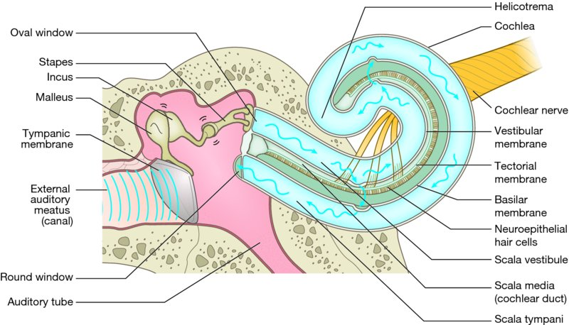
Available from: http://www.wileyessential.com/neuroanatomy/flashcards/c13_1/c13_1.html
Figure 1: Demonstrates the structures of the middle and inner ear.
Within the spiral organ lie the cochlear hair cells. There are two types of hair cells: inner and outer. Inner hair cells are less abundant and in a linear configuration ¹⁷. Outer hair cells are much more abundant and current research shows that their function includes amplification of sound and protection of the inner hair cells. They are typically in a “v” like or “w” like conformation, with the points facing the distally in the cochlea ⁴. The hair cells contain anywhere from 30-100 small projections, ranging from 10 micrometers to 50 micrometers in length ¹⁷. These projections are called stereocilia and are extremely important to our perception of sound. Stereocilia have different stiffnesses based on their location within the cochlea. The closer to the oval opening, the shorter and stiffer the stereocilia. Likewise, the further away from the oval opening, the looser and longer the stereocilia ¹⁰. The stiffness is due to collagen and actin fibers ¹⁰.
The bundles of stereocilia are not in a random arrangement. Rather, they are organized in roughly three rows based on height. The tallest stereocilia is connected to the middle stereocilia, and the middle stereocilia is connected to the shortest stereocilia. These connections are called tip links and they retain tension via myosin motors ⁵. At each tip link connection lies an ion channel. The mechanisms of the ion channel will be discussed in section III.
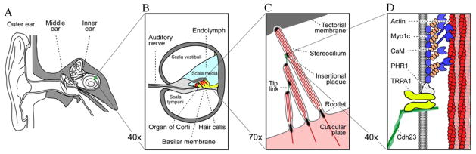
Elliot S, S. C. (2012). "The cochlea as a smart structure." Smart materials & structures 21(6): 1-23.
Figure 2: A: large scale view of the outer, middle, and inner ear. B: cross section of the cochlea showing fluids and location of the organ of corti (houses hair cells). C: individual stereocilia projecting from a cochlear hair cell. D: motors that maintain tension and allow flexion of stereocilia.

II. Relevant Musical Terms
Before moving in to how the structures of the ear, and especially the cochlea, play a part in interpreting musical sounds, it will be beneficial to define musical terms relevant to the study. Sound “is defined to be a disturbance of matter that is transmitted from its source outward...it is a wave” ¹⁵. Our ear allows us to hear, and hearing at its simplest definition is the perception of sound.
With relation to music and hearing, our ear detects certain aspects of musical sounds, and those will be the terms that we look to further explore. Frequency, pitch and volume are a set of musical functions that the ear can hone in on to identify sounds.
When a sound wave is travelling through air, it performs a certain number of oscillations parallel to the direction of the wave, following an up and down motion. The frequency of the sound wave can be defined as the number of cycles per second that the wave makes, also known as a Hertz ⁶. The human ear can hear roughly between 20 and 20,000 Hz ¹⁵. A higher frequency means that the sound produced by the wave will have a higher sounding pitch.
Our ear can interpret the volume of a sound. To classify how loud a sound is, we measure it in terms of decibels (dB). The scale used for decibels is logarithmic, due to the fact that sounds range from essentially nothing to extreme intensity. Virtually no sound is 0 dB. A sound ten times as powerful would be 10 dB, and a sound one hundred times more powerful than no sound would be 20 dB ¹⁵. As mentioned in the introduction, our ear is able to distinguish well over 120 separate pitches, at all different types of intensity. The perception of the sounds inundating our ears is due to the mechanisms of the inner ear processing all of these qualities of musical sounds.
III. Perception of Sound
We’ve discussed the structure of the ear and the aspects of acoustics that are necessary for our ears to recognize music. Now, we will focus on functionality of processing sound and the specific steps taken to turn sound waves into signals our brains can recognize as music.
As a sound wave travels into the ear via the external acoustic meatus, it will then strike
the tympanic membrane, causing the small ossicles to vibrate. If the sound is loud enough to detect, will then cause the vibrations to continue through the ossicles and middle ear structures, through the oval window, and to the basilar membrane. Sound waves of higher frequency will disturb the basilar membrane closer to the oval window, while lower frequencies will travel further into the basilar membrane ¹⁶. The basilar membrane is covered in tiny hair cells, and each tiny section of cells correlates to a specific frequency of sound ¹⁶.
Researchers were interested in how the cochlea develops for this gradient-like set up for pitch perception. They identified that bone morphogenetic protein 7 (Bmp7) followed a gradient like pattern throughout the basilar papilla in chicks, which is essentially the corti in humans ¹³. When this protein gradient was disturbed, the pitch identities in given locations were also disturbed. The researchers also found that retinoic acid was a molecule that had the influence on the length of hair cells, and also was found in a gradient-like pattern throughout the cochlea ¹³.
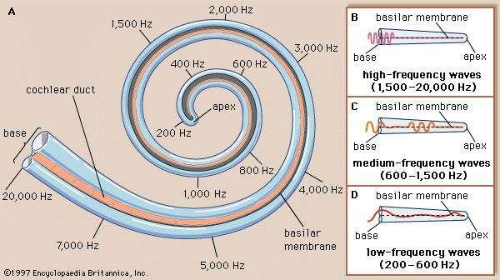
Hawkins E. Joseph. “Human Ear” [Internet]. Encyclopedia Britannica. Encyclopedia Britannica, inc. [updated 2017 July 21; cited 2018 April 28]. Available from https://www.britannica.com/science/ear/Transmission-of-sound-within-the-inner-ear
Figure 3: showing where sound waves will stimulate the basilar membrane based on the frequency of the sound.
The human cochlea has about 12,000 outer hair cells and 3,500 inner hair cells that register the vibrations coming from external noises ¹⁷. When the basilar membrane is vibrating due to incoming sound waves, the hair cells are stimulated and communicate with local nerves ⁵. The vibrations cause the stereocilia to bend, usually in the direction of the tallest stereocilia.
As discussed in section I, the stereocilia are connected via tip links. Previous research suspected that ion channels were located at the top of the stereocilia. However, a current study shows that the ion channels are located at the tip link connections between the stereocilia ¹¹. The researchers forced high pressure water onto rat stereocilia, causing them to bend, and used electron microscopy to view the location of the ion influx ¹¹.
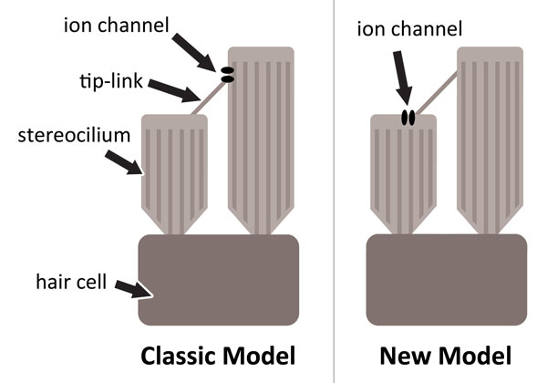
Leggett, H. 2009. "Discovery of ion-pore location on cell alters long-accepted model of
hearing." Standford News.
Figure 4 showing the “classic model” and the “new model” of the location of ion channels on stereocilia.
Endolymph surrounding the cells contains high levels of K⁺, and when the stereocilia bend, the ion channel opens and allows an influx of K⁺ ¹⁰. The cell is depolarized, which then causes Ca²⁺ to enter the hair cell via the cell membrane ¹⁰. The Ca²⁺ influx causes the hair cells to release glutamate, which is a neurotransmitter, and thus sends a signal of sound to the brain ⁵. Cranial nerve VIII, the vestibulocochlear nerve, reaches the cochlear hair cells in a branched network of thousands of neurons ^{12,}
When listening to a musical piece many pitches will be heard. Music is often composed of many pitches produced by different instruments, all happening at the same time, and is constantly changing. For our ears to recognize what’s going on, the reaction of the hair cells must be extremely quick. In fact, the recognition of sound waves and sending a neurotransmitter to nearby neurons happens faster than our other body muscles can react ⁵. The terms we defined earlier such as pitch and loudness play a key role in our ears distinguishing music.
In order to hear music the way that a composer intends it to be heard, we must be able to distinguish pitches. Certain soundwaves of a given frequency will hit a specific location of the basilar membrane and cause those hair cells to stimulate local neurons. When music is being played, in any given moment this process is happening for a multitude of frequencies. Each section of hair cells correlates to a given pitch, and will send a signal to the brain for every frequency, allowing us to hear multiple pitches ⁵. The ear can distinguish between pitches with 97 to 99 percent accuracy ¹⁶.
Volume also is a factor in the comprehension of music. Louder sounds will cause the basilar membrane to vibrate more strongly, thus causing more bending of hair cells. This extreme tension on the cells produces more neurotransmitters, and sends a stronger signal to our brain ¹⁴. Sometimes loud sounds cause damage to the tiny hair cells by forcing them to bend too much. This forces the cation channels to open more than they should, and eventually the tip links can become damaged. Often, the hair cells damaged are those involved in distinguishing high frequency sounds. Damage from loud sounds can lead to permanent hearing loss for sounds of certain frequencies, depending on which sections of hair cells were damaged.

Conclusion:
In summary, all of the anatomical structures of the ear play a role in setting the stage for sound perception. From the auricle funneling sound into the ear, all the way down to the 10 micrometer stereocilia, each structure has an extremely important function. The spiral organ is the home of stereocilia, which are absolutely vital to us interpreting sounds. A few specific aspects of the stereocilia are the factors that have the most influence on perception. First is the location. The proximal locations will perceive higher frequency pitches, while the distal locations will perceive lower frequency pitches. Second is the length and tension of the stereocilia. Shorter and stiffer stereocilia resonate to higher noises, while longer and flexible ones respond to lower noises. Third, the amount of force applied which causes the ion channels to open influences how loud we hear any given sound. The astounding precision and accuracy of the stereocilia give us our ability to perceive music.

Discussion:
There are so many aspects to human hearing and musicality that are left for further explanation. Sound perception is the first way to connect the two topics together. One topic for discussion is the emotions that are often brought up when listening to music. Many listeners have experienced a sense or feeling that is induced by music. Additionally, there a multitude of different keys, scales, and modes that songs can be based on. Even one instrument can sound different in a given situation. A guitar, for example, is a versatile instrument involved in many different genres of music: rock and roll, folk, classical, and the list is endless. Yet with all the diversity in style and induced emotions, the mechanisms of perception remain the same.
Another topic that is often discussed is damage to the ears from loud music. As a musician who played in many different bands and orchestras, I too have suffered from temporary hearing damage. As mentioned earlier, it is possible for the fragile tip links to break when sounds are too loud and disturb the cells to an extreme level. Researchers have now shown that regenerating the tip links after damage is possible, but it is a two step process. At the bottom of the tip link is protocadherin 15 (PCH15), and at the top of the tip link is cadherin 23 (CDH23) ¹³. When tip links break, the first step noted in mouse models for repair is to mend both ends with PCH15. From there, CDH23 may replace the top PCH15 to provide a stronger tip link. This two step repair process opens the doors for research on regeneration of hair cell function in situations of long term damage from the volume of music.

References
1. Ball, P. 2008. Science & music: facing the music. Nature 453: 160-162. Doi:
10.1038/453160a.
2. Benward B, Saker M. 2015. Music in theory and practice. 9th ed. New York, NY:
McGraw-Hill.
3. Blinowska KJ, Kwaskiewica K, Jedrzejczak WW, Skarzynski H. 2012. Musical Ratios in
Sounds from the Human Cochlea. PLoS ONE 7(5): 1-7. DOI:10.1371/journal.pone.0037988
4. Brownell WE. “How the Ear Works” [Internet]. Houston (TX): Baylor College of
Medicine. [updated 1998-2018; cited 2018 April 28] Available from: http://www.cochlea.eu/en/hair-cells
5. Elliot S, S. C. (2012). "The cochlea as a smart structure." Smart materials & structures
21(6): 1-23.
6. Elsea, P. 1996. “Hearing and perception.” Technical Essays, UCSC Electronic Music
Studios.
7. Hoffsetter M, Lugauer F, Kundu S, Wacker S, Perea-Saveedra H, Lenarz T, Hoffstetter P,
Schreyer AG, Wintermantel E. 2011. Middle Ear of human and pig: a comparison of structures and mechanics. Biomedical Engineering 56(3): 159-165. DOI: 10.1515/BMT.2011.011.
8. How does the ear work? [Internet]. 2015. Bethesda (MD): National Center for
Biotechnology Information, U.S. National Library of Medicine. Available from: https://www.ncbi.nlm.nih.gov/pubmedhealth/PMHT0024836/.
9. Indzhykulian AA, Stepanyan R, Nelina A, Spinelli KJ, Ahmed ZM, Belyantseva IA,
Friedman TB, Barr-Gillespie P, Frolenkov GI. 2013. Molecular Remodeling of Tip Links Underlies Mechanosensory Regeneration in Auditory Hair Cells. PLOS Biology 11(6): e1001583. DOI: 10.1371/journal.pbio.1001583
10. Davis LR. 2003. Gradients of neurotrophins, ion channels and tuning in the cochlea.
The Neuroscientist 9(5).
11. Leggett, H. 2009. Discovery of ion-pore location on cell alters long-accepted model of
hearing. Standford News.
12. Marieb KN, Hoehn K. 2012. Human Anatomy & Physiology, Pearson.
13. Mann ZF, Thiede BR, Chang W, Shin JB, May-Simera HL, Lovett M, Corwin JT, Kelley
MW. 2014. A gradient of Bmp7 specifies the tonotopic axis in the developing inner
ear. Nature Communications 5: 1-17. DOI: 10.1038/ncomms4839.
14. OpenStax College. 2013. “Anatomy & Physiology”. Houston, TX: OpenStax CNX.
15. OpenStax College. 2012. College Physics. Houston, TX: OpenStax CNX.
16. Elsea, P. 1996. Hearing and Perception. UCSC Electronic Music Studios-Technical
Essays: 1-5.
17. Pujol Remy, Nouvian Regis & Lenoir Marc. Journey into the World of Hearing (Internet)
2016. “Hair Cells: Structure”.[Updated 2016 Sept. 19: cited 2018 April 28]. Available from: http://www.cochlea.eu/en/hair-cells
18. Purves D, Augustine GJ, Fitzpatrick D, et al., editors. Neuroscience. 2nd edition.
Sunderland (MA): Sinauer Associates; 2001. “Hair Cells and the Mechanoelectrical
Transduction of Sound Waves”. National Center for Biotechnology Information. U.S
National Library of Medicine.
19. Rask-Anderson H, Liu W, Erixon E, Kinnefors A, Pfaller K, Schrott-Fischer A, Glueckert
R. 2012. Human Cochlea: Anatomical Characteristics and their Relevance for Cochlear Implantation. The Anatomical Record 295:1791–1811. DOI: 10.1002/ar.22599.
20. Ruggles DR, Freyman RL,, Oxenham AJ. 2014. Influence of Musical Training on
Understanding Voice and Whispered Speech in Noise. PLoS ONE 9(1): 1-8. DOI: 10.1371/journal.pone.0086980.

