New Constraints on Formation of Orthogneiss in Southern Adirondacks Using Integrated Analysis Methods of, Petrology, Zircon U-Pb Geochronology and Whole Rock Geochemistry

Honors Thesis

Presented in Partial Fulfillment of the Requirements of
the Degree of Bachelor of Science in Geological Sciences

In the College of Arts and Sciences
at Salem State University

By
Kyle McCaffery

Erkan Toraman, Jeffery R. Chiarenzelli
Faculty Advisors
Department of Geological Sciences

***
Commonwealth Honors Program
Salem State University
2022

AKNOWLEDGEMENTS
I would like to acknowledge the help and support from Professor Toraman in completing this research project as well as organizing the analysis. I would also like to acknowledge Professor Chiarenzelli for assistance in the field and so graciously providing room and board during the field work.

TABLE OF CONTENT
AKNOWLEDGEMENT ii
TABLE OF CONTENT iii
TABLE OF FIGURES iv
TABLE OF TABLES vi
ABSTRACT 1
INTRODUCTION 2
Grenville Province: 2
The Adirondack Mountains 2
Southern Adirondacks 2
RESEARCH OBJECTIVES 3
METHODS 3
Field Work 3
Thin Sections 3
Geochronology 4
Geochemistry 4
RESULTS 5
Petrographic Analysis 5
Geochemical Analysis 5
Geochronology and Zircon Structures 5
DISCUSSION 6
REFERENCES 8
APPENDIX A: Figures 10
APPENDIX B: Tables 26

TABLE OF FIGURES
Figure 1: The extent of the Grenville Province its Adirondack outlier. In addition to the Grenville Province Mesoproterozoic inliers within the Appalachian Mountains are also noted. Adirondack Mountains are within the red box after (McLelland et al. 2010). 10
Figure 2: Adirondack Mountains with sample locations indicated on the map. Light blue is SA-21-01, red is SA-21-02, and purple is SA-21-03 modified from (McLelland et al. 2010). 11
Figure 3: This indicated the temporal difference between all segments of the Grenville Orogenic Cycle after (Rivers, 2008). 12
Figure 4: Spider diagram of rare earth elements normalized against chondrites. The gray cloud is additional rare earth element data from (Peck, 2012). Depletion in Eu is consistent across both data sets and flattening of the heavy REE curve is also consistent. Light blue is SA-21-01, red is SA-21-02, and purple is SA-21-03. 13
Figure 5: Spider diagram of Trace elements normalized against primitive mantle. The gray cloud is additional trace element data from (Peck, 2012). Both data sets show similar tendencies for depletion and enrichment. These would indicate a similar formation environment. Separation between two groups in the samples is clean by the depletion in Sr seen in light blue, SA-21-01 and red, SA-21-02 and the enrichment seen in the same element in purple, SA-21-03. 14
Figure 6: AFM diagram used to identify formation environment. Samples plot toward the left edge and have Calc-Alkaline affinities. This is suggesting affinities toward a non-spreading environment. Addition data seen as the gray dot scatter is from (Peck, 2012). This data is consistent with the data I collected indicating a similar formation environment. SA-21-01 is light blue, SA-21-02 is red, and SA-21-03 is purple. 15
Figure 7: Rb, Y+Nb formation environment diagram indicates the formation of granites. This figure indicated further specificity of formation environment of the samples collected. Gray dot scatter is additional data from (Peck, 2012). This data is much more similar in the formation environment to light blue, SA-21-01 and red, SA-21-02. This identified those two samples as Within plate formation environment. SA-21-03, purple is strongly within the volcanic arc formation environment indicating that it formed due to magmatism related to subduction. 16
Figure 8: This comparison diagram is used to identify similarities between samples. My samples SA-21-01, light blue and, SA-21-02, red, are more closely related to data from (Peck, 2012) and SA-21-03 is more closely related to other ADK Highland rocks seen as the green cloud. 17
Figure 9: MALI diagram indicating affinities to compare formation environments and compare data. Addition data from (Peck, 2012) is shown as the gray dot scatter. My samples, SA-21-01 light blue, SA-21-02 red, and SA-21-03 have calc-alkalic affinities. Diagram from (Frost et al. 2001). 18
Figure 10: Concordia diagram for SA-21-01 indicating upper and lower intercept for line of best fit. Best mean age of formation is shown at 1163±8.5 Ma. 19
Figure 11: Concordia diagram for SA-21-02 indicating upper and lower intercept for line of best fit. Best mean age of formation is shown at 1154±18 Ma. 20
Figure 12: Concordia diagram indicating upper and lower intercept for line of best fit. Best mean age of formation is shown at 1343±32 Ma. 21
Figure 13: SA-21-01 thin section in XPL. SA-21-01 has substantial amounts of K-feldspar, plagioclase, and biotite. Biotite and elongate quartz ribbons form the laminae and foliation. Some opaque minor minerals are present. 22
Figure 14: SA-21-02 thin section in XPL. SA-21-02 is majority composed of quartz and feldspar but also has a sizable proportion of pyroxene. Biotite is present but not as significant. SA-21-02 also has high temperature metamorphic structures within the quartz and feldspar crystals. Flame perthites are common in feldspar throughout the thin section and quartz displays checkerboard extinction. 23
Figure 15: SA-21-03 thin section in XPL. SA-21-03 has three majority minerals, feldspar, quartz and biotite. SA-21-03 is coarse grained and has ribbons of quartz that form foliation. 24
Figure 16: Showing the progression of the Grenville orogenic cycle. This image shows the development of the Grenville province during the Grenville Orogenic Cycle. Locations in which my samples were emplaced are indicated by red stars. SA-21-01 and SA-21-02 are associated with the AMCG suite that intruded during the Shawinigan Orogeny. SA-21-03 was emplaced before 1300 Ma as shown at the top of the diagram related to a magmatic arc. Modified after (McLelland et al., 2013). 25

TABLE OF TABLES
Table 1: SA-21-01 U/Pb in zircon geochronology data. 26
Table 2:SA-21-02 U/Pb zircon geochronology data. 27
Table 3: SA-21-03 U/Pb geochronology data. 28
Table 4: Whole rock geochemistry data for major elements. 29
Table 5: Whole rock geochemistry for rare earth elements. 30
Table 6: Whole rock geochemistry for trace elements. 31

ABSTRACT
The Adirondack Mountains (ADK) form the southern part of the Grenville Province, a poly-deformed orogenic complex formed in the Mesoproterozoic during the formation of Rodinia. The ADK is subdivided into two domains, separated by the Carthage-Colton Mylonite Zone. The Lowlands are characterized by upper amphibolite-facies metasedimentary rocks, including marbles, evaporites, and volcanic units, whereas the Highlands are formed by granulite-facies meta igneous rocks and anorthosite-mangerite-charnockite-granite magmatic complex. A large suite of granulite-facies orthogneisses exposed in the Southern Highlands yields the oldest (>1.3 Ga) ages, however, those ages come from a limited number of outcrops. We present new petrological, geochemical, and geochronological results from several quartzofeldspatic orthogneiss units to better document the timing and tectonic setting of these rocks. All samples are mainly composed of quartz, felspar, biotite, pyroxene, and opaque minerals. Foliation and lineation are defined by elongated quartz ribbons and feldspar grains, or biotite laminae. High-temperature microstructures, such as flame perthites in feldspars or checkerboard extinction in quartz are commonly observed in thin sections. Major element analyses show that samples have calc-alkaline affinities, suggesting an arc environment. U-Pb zircon geochronology produced two age groups. 1150 Ma ages which are Shawinigan and 1350 Ma ages which are associated with pre-orogenic magmatism. Based on whole rock geochemistry the Shawinigan age rocks are associated with within plate magmatism and the 1350 Ma pre-orogenic magmatism is associated with magmatic arc activity.

INTRODUCTION

Grenville Province:
The Adirondack Mountains are an outlier and southernmost portion of the Grenville province. Other Grenville age exposers are located throughout the Appalachian Mountains as inliers (McLelland et al. 2010). The Grenville Province exposes the middle-lower crustal rocks of an ancient mountain range that formed from three orogenic events, the Elzevirian Orogeny (ca. 1250-1220 Ma), the Shawinigan Orogeny (ca. 1160-1140 Ma), and the Ottawan Orogeny (ca. 1090-1030 Ma) (McLelland et. al. 2013) see (Fig. 1). The temporal differences of these events are shown in (Fig. 3).

The Adirondack Mountains
The Adirondacks can be separated into two major parts. The Adirondack Highlands and the Adirondack Lowlands and are separated by the Carthage-Colton mylonite zone. The Lowlands are comprised of easily eroded metasediments also minor intrusive volcanics, calcitic and dolomitic marbles, silicious meta-carbonates, evaporites, quartzite, volcani-clastic rocks and distal arc volcanics (Peck et al. 2013) see (Fig. 2).
The Adirondack Highlands are composed of many lithologies. The Highland terrane is dominated by orthogneisses (McLelland et al. 1996). Anorthosite-Mangerite-Charnokite-Granite (AMCG) are some of the most prevalent units in the Adirondack Highlands. One of the most significant units in this group is the Marcy Massif a large Anorthosite unit in the Adirondack Highlands. This unit covers a large area of the northeastern Highlands. AMCG units intruded during the late Shawinigan orogen (McLelland et al. 2004).
The Highlands are dominated by Ottawan phase ages (ca. 1090-1020 Ma), and the lowlands are characterized by Shawinigan phase ages (ca. 1160-1140 Ma). The Highlands are also metamorphosed to higher temperature and pressure conditions than the lowlands (Darling and Peck 2016).

Southern Adirondacks
The Southern Adirondacks contain the oldest rocks in the Adirondack Mountains. These rocks are a suite of 1.35-1.25 Ga tonalitic and granitic plutons (McLelland and Chiarenzelli 1990). The southern Adirondacks are composed of many lithologies that include the AMCG, ca. 1300 Ma pyroxene-hornblende tonalite and charnokite. Pre 1150 Ma charnockites are only known from the southern Highlands ca. 1240 Ma (McLelland et al. 1996).
To understand the relationship between these rocks and other rocks in the Adirondacks and Grenville Province more analysis needs to be done. Identifying more lithologies with complete geochronology, and geochronology will provide more constraints temporally and spatially for events in the Southern Adirondacks, see (Fig.2).

RESEARCH OBJECTIVES
The goal of this research is to identify lithologies in the southern highlands that do not have complete geochronologic and geochemical data on them. Collecting this data will bring new constraints and insights to the formation and distribution of rocks in the Southern Adirondacks. Understanding the relationships between these rocks and other rocks of the same age and composition throughout the Adirondacks and Grenville Province will give a better understanding of the formation and deformation of the region.

METHODS

Field Work
Samples were collected during the summer of 2021 from the Southern Adirondacks. In-situ descriptions of minerals and textures were made in the field, followed by hand sample descriptions. Locations of the outcrops were recorded in latitude and longitude for accurate collection site location using a GPS. Samples were bagged and labeled at each locality. Each sample was then separated into portions to be sent for intended analytical tests. Thin sections, U-Pb geochronology and whole rock geochemistry with trace element testing was completed with the collected samples.

Thin Sections
Thin section preparation began by cutting collected samples into billets of the correct size and orientation. The billet was cut to be the same width of a microscope slide to ensure the fit. The billet was cut perpendicular to foliation creating an ideal surface in order to observe metamorphic textures. The billets were sent to Quality Thin Sections, located in Arizona. The billet went through various stages of grinding to become optically flat. The finishing grind is approximately 1000 grit. The sample was sonically cleaned between each step. The thin section chip is then adhered to a frosted slide. The epoxy used is BUEHLER. After curing time, most of the chip was removed leaving a few thousandths of rock adhered to the slide. 600 carborundum grit was used to then grind the chip to the final thickness. The standard slide thickness is 30 microns. The samples were again cleaned, and a coverslip was applied. After this step the thin sections are ready for textural and compositional analysis.

Geochronology
Geochronologic analysis of the rocks took place at University of Arizona Laserchron Center (ALC). Once instrument settings were optimized, the sequence of standards is five standards at the start, one standard between every four to five unknowns and three standards at the end. U-Pb Geochronology data was collected by laser ablation ICP mass spectrometers, LA‐ICPMS, at ALC. Data was acquired in two steps: an initial measurement of backgrounds with the laser off, followed by measurement of peak intensities with the laser firing. Both acquisitions are about the same duration, ~15 seconds for a beam 30-40 microns in diameter. For analysis of grains, a 30–40-micron beam was used to excavate a pit that is ~15 microns in depth. 238U, 232Th and 208-206Pb are collected simultaneously using Faraday detectors. The data was then corrected using Background and Hg correction as well as Fractionation Correction. Ages are determined for a set of analyses through use of a weighted mean calculation, which weighs each analysis according to the square of its uncertainty. The final age is accordingly controlled primarily by analyses with smaller errors (Gehrels 2010).

Geochemistry
Whole rock geochemistry analysis was done at Hamilton Analytical Lab. A full suite of 44 elements, both major and trace, were analyzed. Using a Thermo ARL Perform an x-ray fluorescence spectrometer to analyze 15-5 mm diameter glass discs, the full record of whole rock geochemistry was completed. To prepare each sample for analysis the rock must first be crushed into pea sized chips and then washed in distilled water. The chips were then powdered in a ball mill. This powder was then sent to Hamilton Analytical Lab where it was mixed with flux and melted in a custom machined graphite crucible at 1000 C. The pellets are reground into a powder and fused again at 1000 C. The doubly fused pellets are lapped flat in four stages to a surface finish of 15 microns (Hamilton Analytical Methods). Data collected through geochemistry analysis was used in discrimination diagrams to identify rock types and magma sources.

RESULTS

Petrographic Analysis
During petrographic analysis it was revealed that all the rocks analyzed are composed of plagioclase, quartz, biotite, orthoclase, clinopyroxene and/or opaques. SA-21-01 mineral composition is 60% quartz, 20% K-feldspar, 10% plagioclase and 10% biotite (Fig. 13). SA-21-02 mineral composition is 70% quartz, 20% plagioclase, 8% pyroxene and 2% biotite (Fig. 14). High temperature metamorphic structures such as flame perthites in feldspar and checkerboard extinction in quartz. SA-21-03 mineral composition is 75% quartz, 20% plagioclase, and 5% biotite (Fig. 15). Throughout all the samples elongate quartz ribbons form the foliation and laminae. All samples show biotite that is clustered together into areas that form foliation.

Geochemical Analysis
REE analysis using primitive mantle normalization shows a clear subduction related signature with depletion in Ta, Th, and Ti. Another significant feature in the REE analysis are the opposing trends. Significant elements include Sr in which SA-21-03 has an enrichment as opposed to a depletion in the other two samples, a strong U peak in SA-21-03 which is not present in the other two samples, and SA-21-03 overall has consistently lower concentrations of most elements (Fig. 5). REE normalized against chondrites shows a depletion in Eu for both (Fig. 4) SA-21-01 and SA-21-02 but not SA-21-03. A much flatter trend is also shown by SA-21-03 indicating a more primitive source and lesser crustal contamination. AFM diagram shows that the samples trend toward calc-alkaline which indicates a non-rifting formation environment (Fig. 6). As seen in (Fig. 9) the samples collected plot in the calc-alkalic range. This plot helps identify formation environment. In the comparison diagram (Fig. 8) SA-21-03 is significantly different having a much lower K20 percentage than SA-21-01 and SA-21-02. The lower K20 percentage is more closely related to other ADK Highland units than the other two samples. However, SA-21-01 and SA-21-02 are closer to data from (Peck, 2012). All geochemistry data can be seen in (Tables 4, 5, and 6).

Geochronology and Zircon Structures
Geochronology results identified two age groups. SA-21-01 has a mean best age of 1160±4 Ma (MSWD=1.06, n=25, U=463±201, U/Th=2.66±1.45). SA-21-02 has a best mean age of 1149±6 Ma (MSWD=1.2, n=28, U=101±73, U/Th=2.40±0.95). SA-21-03 displayed a vastly different mean age that the first two samples with it being much older. The best mean age for SA-21-03 was 1346±14 Ma (MSWD=10.5, n=20, U=468±198, U/Th=6.75±3.06). Core and rim ages for each of the samples are similar. Concordia diagrams show upper intercept indicating age of formation (Fig. 10, 11, and 12). All geochronology data can be seen in (Table 1, 2, and 3).
Zircons from all samples show oscillatory zoning followed by a more homogenous rim. Rims vary between dull and bright. SA-21-01 does not show significant rims that are varying brightness from the rest of the zircon. SA-21-01 is the most consistently elongate crystal shape with lengths between 300 and 500 microns but widths barely exceeding 150 microns. SA-21-02 has extremely bright cores with dull rims. SA-21-02 also shows more embayment and inclusions within the crystals. SA-21-02 zircons lengths are between 300-400 microns and widths between 100 and 200 microns. SA-21-03 had the largest zircon crystals with lengths ranging from 300 to 500 microns and widths ranging from 100 to 300 microns. Very thin, less than 50-micron bright rims are seen in SA-21-03.

DISCUSSION
Geochronology indicates separation in ages for the samples collected. SA-21-01 and SA-21-02 are Shawinigan in age and SA-21-03 is pre-Grenville Orogenic Cycle mathematics. Geochemistry also shows separation into two groups with separation in both major elements and rare earth elements. Petrology showed distinct mineralogical differences between each sample. None of the samples had a minerology that would indicate that they formed from the same source at the same time indicating some temporal or spatial difference in formation. The formation environment for the two groups is also different. SA-21-01 and SA-21-02 have a formation environment that is more closely related to within plate magmatism as seen in (Fig. 7). SA-21-03 is well within the volcanic arc magmatism region as seen in (Fig. 7). Metamorphism did not appear to have affected the zircon crystals that were found within the samples. Rims showed similar ages to the cores.
CONCLUSION
Based on results the various rocks collected all are ferroan in composition see. This points to a significant amount of crustal contamination. Also, the rocks all have calc-alkalic tendencies (Fig. 9) indicating that the formation environment was a magmatic arc. Nb, Ta, Sr, P, and Ti show particularly pronounced negative anomalies (Fig. 5), a hallmark of arc magmatism (Chiarenzelli et al. 2012). Major element analysis shows strong resemblance to other units in the ADK and Grenville Province in Canada. SA-21-01 and SA-21-02 correlate well with data from (Peck 2012) in Quebec, Canada. The chemistry for both major element data and REE align with (Peck, 2012) as seen in (Fig. 4 and 5) the gray cloud behind the spider diagram lines has a similar trend. SA-21-03 aligns in age and geochemistry with other lithologies throughout the ADK Highlands. These 1350 Ma rocks are associated with pre orogenic magmatic arc activity (Fig. 16). These areas can be seen in (Fig. 2) showing which portions of the Southern Adirondacks have similar ages. All samples are consistent in known ages of orogenic activity and magmatism. Samples SA-21-01 and SA-21-02 geochronology ages align with the Shawinigan Orogeny and SA-21-03 align with pre-orogenic magmatism.
Geochronology data shows that SA-21-01 and SA-21-02 are associated with the Shawinigan Orogeny because the age of 1150-1160 Ma aligns with other known intrusions of the event. SA-21-03 is less consistent with ages most likely in the 1350 Ma range. This would be consistent with pre-Grenville orogenic magmatism These magmatics would likely be island arc related and could account for the REE results being more primitive with less crustal contamination as seen in (Fig. 16). The peak in Uranium is an indicator of a more primitive magma. The age difference of cores and rims in the zircon crystals is small to non-existent this means that the rims are likely magmatic or could be from metamorphism very shortly after formation. However, there is a distinct difference between the oscillatory structure of the cores and the solid rim that fills embayment’s and does not have an immaculate euhedral shape. These structures are seen in cathodoluminescence images.

REFERENCES
Academics - hamilton analytical lab - methods and instrumentation Hamilton College, https://www.hamilton.edu/academics/analytical-lab/instrumentation (accessed December 2021).
Darling, Robert S. and Peck, William H. 2016 Metamorphic Conditions of Adirondack Rocks, Adirondack Journal of Environmental Studies: Vol. 21 : No. 1 , Article 7
Frost, B.R., Barnes, C.G., Collins, W.J., Arculus, R.J., Ellis, D.J. and Frost, C.D. (2001) a geochemical classification for granitic rocks. Journal of Petrology, 47, 2033-2048. - references - scientific research publishing, https://www.scirp.org/reference/ReferencesPapers.aspx?ReferenceID=1967066 (accessed May 2022).
Gehrels, G., 2010, U-PB analytical methods-- zircon: Arizona LaserChron center, https://drive.google.com/file/d/0B9ezu34P5h8eMzkyMGFlNjgtMDU0Zi00MTQyLTliZDMtODU2NGE0MDQ2NGU2/view?resourcekey=0-fL7YeK_QPAPRsAlZGZg1Kg (accessed December 2021).
Chiarenzelli, J.R., Hudson, M.R., Dahl, P.S., and deLorraine, W.D., 2012, Constraints on deposition in the trans-adirondack basin, Northern New York: Composition and origin of the Popple Hill Gneiss: Precambrian Research, v. 214-215, p. 154–171, doi: 10.1016/j.precamres.2011.10.024.
Frost, B.R., Barnes, C.G., Collins, W.J., Arculus, R.J., Ellis, D.J. and Frost, C.D. 2001 a geochemical classification for granitic rocks. Journal of Petrology, 47, 2033-2048. - references - scientific research publishing, https://www.scirp.org/reference/ReferencesPapers.aspx?ReferenceID=1967066 (accessed May 2022).
McLelland, J.M., and Chiarenzelli, J., 1990, Isotopic constraints on emplacement age of anorthositic rocks of the Marcy Masiff, Adirondack Mts., New York: The Journal of Geology, v. 98, p. 19–41, doi: 10.1086/629372.
McLelland, J., Daly, J.S., and McLelland, J.M., 1996, The grenville orogenic cycle (ca. 1350-1000 ma): An adirondack perspective: Tectonophysics, v. 265, p. 1–28, doi: 10.1016/s0040-1951(96)00144-8.
McLelland, J.M., Bickford, M.E., Hill, B.M., Clechenko, C.C., Valley, J.W., and Hamilton, M.A., 2004, Direct dating of Adirondack Massif anorthosite by U-Pb shrimp analysis of igneous zircon: Implications for AMCG complexes: Geological Society of America Bulletin, v. 116, p. 1299–1317, doi: 10.1130/b25482.1.
McLelland, J.M., Selleck, B.W., and Bickford, M.E., 2010, Review of the proterozoic evolution of the Grenville Province, its Adirondack Outlier, and the Mesoproterozoic Inliers of the Appalachians: From Rodinia to Pangea: The Lithotectonic Record of the Appalachian Region, doi: 10.1130/2010.1206(02).
McLelland, J.M., Selleck, B.W., and Bickford, M.E., 2013, Tectonic evolution of the Adirondack Mountains and Grenville Orogen Inliers within the USA: Geoscience Canada, v. 40, p. 318, doi: 10.12789/geocanj.2013.40.022.
Peck, W., 2012, Reconnaissance geochronology and geochemistry of the Mont-Tremblant gneiss of the Morin terrane, Grenville Province, Quebec: Geosphere, v. 8, p. 1356–1365, doi: 10.1130/ges00828.1.
Peck, W.H., Selleck, B.W., Wong, M.S., Chiarenzelli, J.R., Harpp, K.S., Hollocher, K., Lackey, J.S., Catalano, J., Regan, S.P., and Stocker, A., 2013, Orogenic to postorogenic (1.20-1.15 ga) magmatism in the Adirondack Lowlands and Frontenac Terrane, Southern Grenville Province, USA and Canada: Geosphere, v. 9, p. 1637–1663, doi: 10.1130/ges00879.1.
Rivers, T., 2008, Assembly and preservation of lower, mid, and upper orogenic crust in the Grenville Province—implications for the evolution of large hot long-duration orogens: Precambrian Research, v. 167, p. 237–259, doi: 10.1016/j.precamres.2008.08.005.

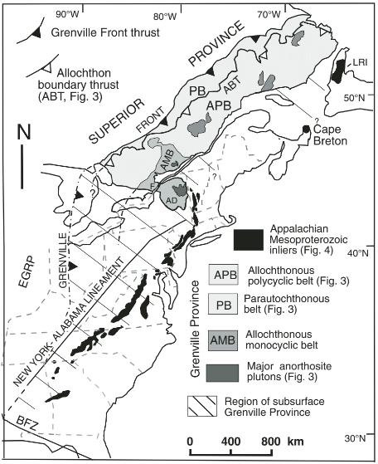
APPENDIX A: Figures
Figure 1: The extent of the Grenville Province its Adirondack outlier. In addition to the Grenville Province Mesoproterozoic inliers within the Appalachian Mountains are also noted. Adirondack Mountains are within the red box after (McLelland et al. 2010).

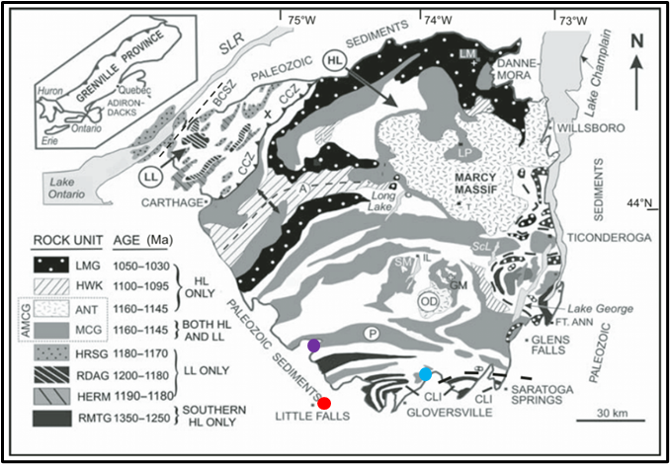
Figure 2: Adirondack Mountains with sample locations indicated on the map. Light blue is SA-21-01, red is SA-21-02, and purple is SA-21-03 modified from (McLelland et al. 2010).

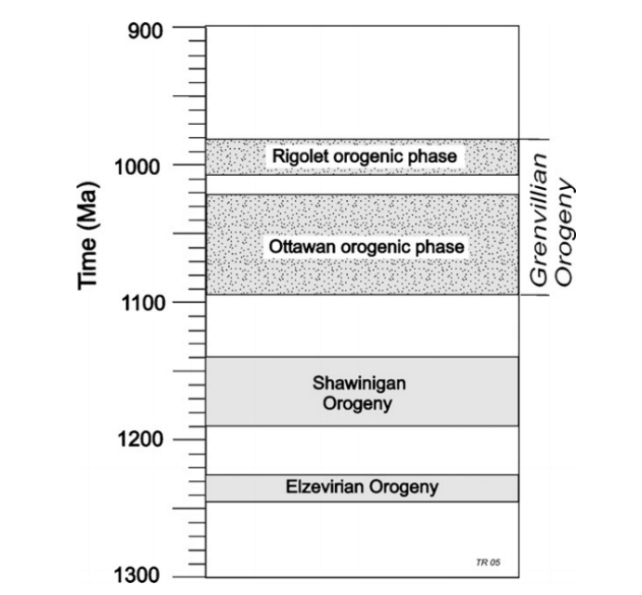
Figure 3: This indicated the temporal difference between all segments of the Grenville Orogenic Cycle after (Rivers, 2008).

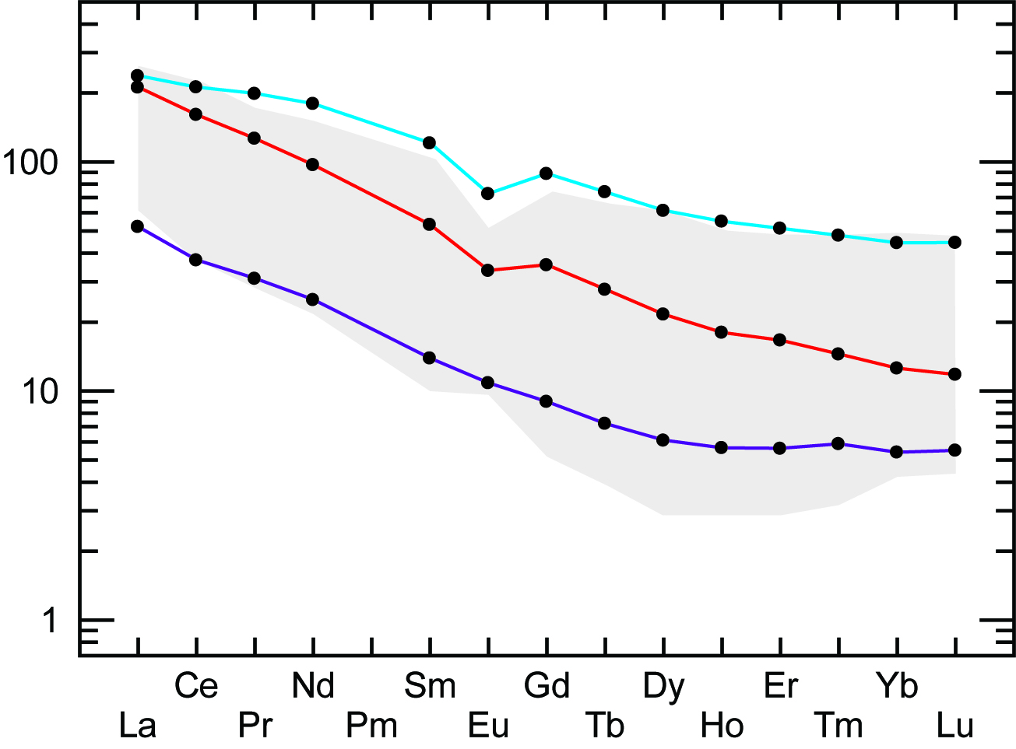
Figure 4: Spider diagram of rare earth elements normalized against chondrites. The gray cloud is additional rare earth element data from (Peck, 2012). Depletion in Eu is consistent across both data sets and flattening of the heavy REE curve is also consistent. Light blue is SA-21-01, red is SA-21-02, and purple is SA-21-03.

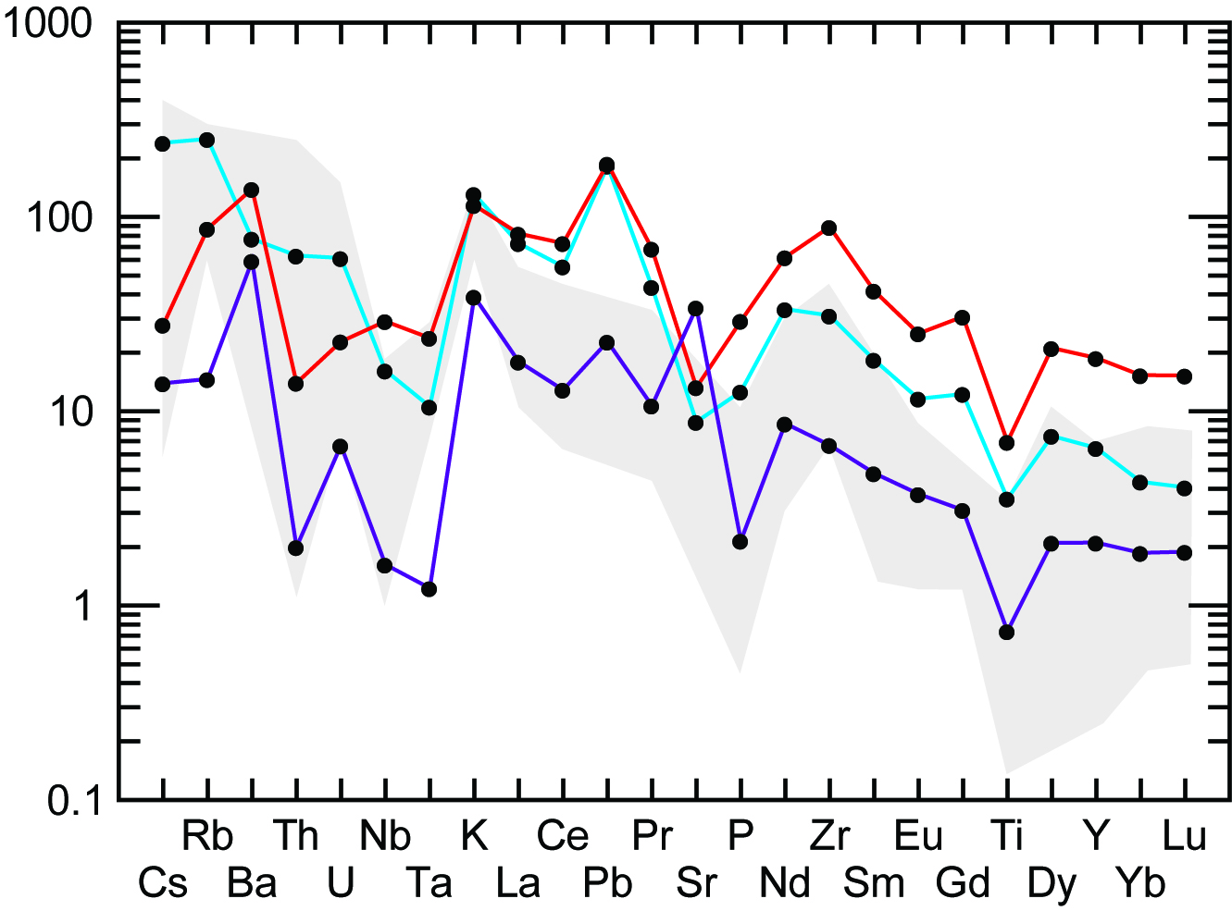
Figure 5: Spider diagram of Trace elements normalized against primitive mantle. The gray cloud is additional trace element data from (Peck, 2012). Both data sets show similar tendencies for depletion and enrichment. These would indicate a similar formation environment. Separation between two groups in the samples is clean by the depletion in Sr seen in light blue, SA-21-01 and red, SA-21-02 and the enrichment seen in the same element in purple, SA-21-03.

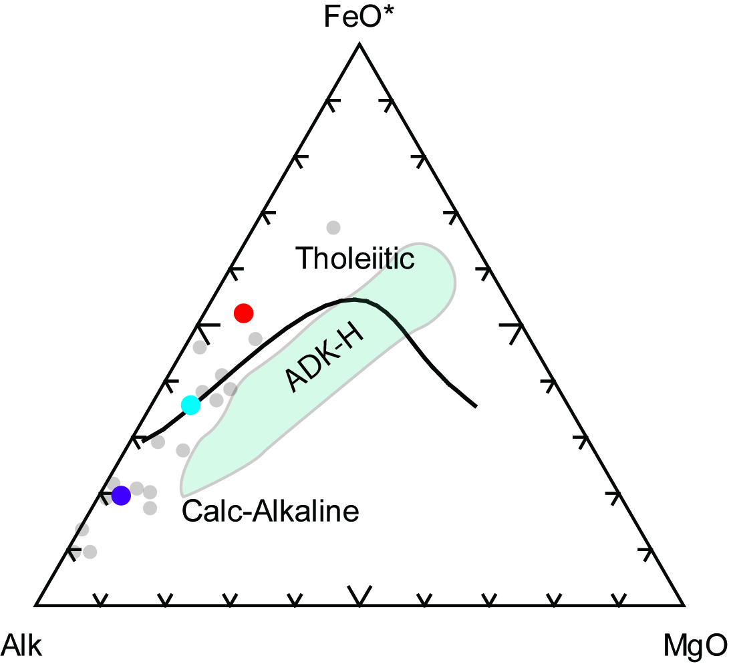
Figure 6: AFM diagram used to identify formation environment. Samples plot toward the left edge and have Calc-Alkaline affinities. This is suggesting affinities toward a non-spreading environment. Addition data seen as the gray dot scatter is from (Peck, 2012). This data is consistent with the data I collected indicating a similar formation environment. SA-21-01 is light blue, SA-21-02 is red, and SA-21-03 is purple.

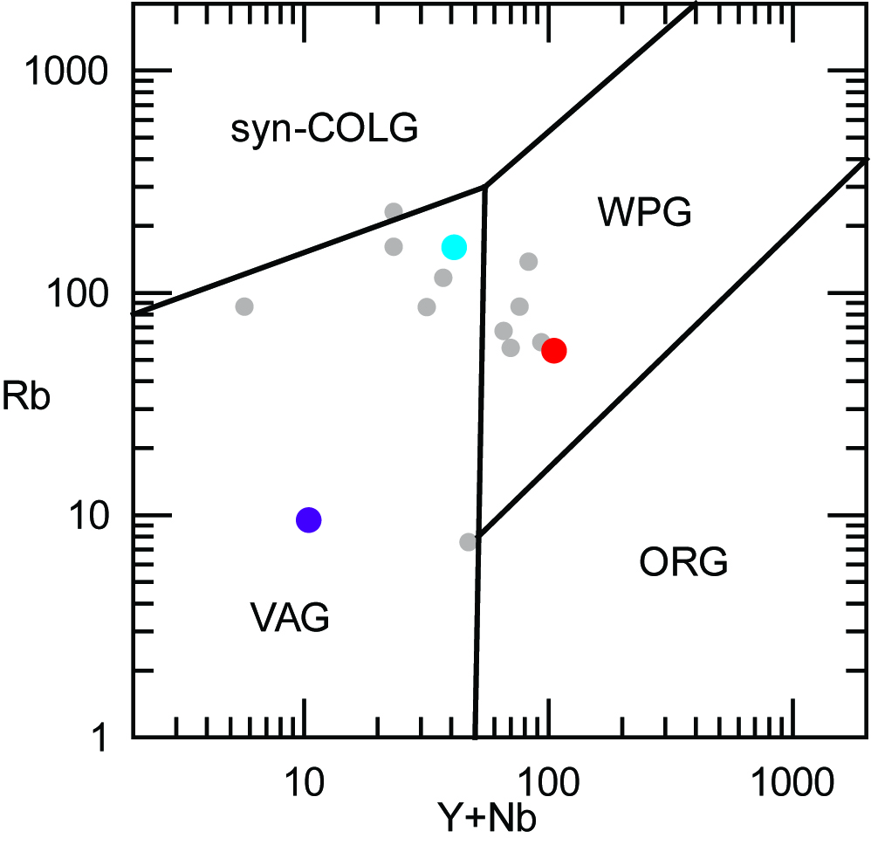
Figure 7: Rb, Y+Nb formation environment diagram indicates the formation of granites. This figure indicated further specificity of formation environment of the samples collected. Gray dot scatter is additional data from (Peck, 2012). This data is much more similar in the formation environment to light blue, SA-21-01 and red, SA-21-02. This identified those two samples as Within plate formation environment. SA-21-03, purple is strongly within the volcanic arc formation environment indicating that it formed due to magmatism related to subduction.

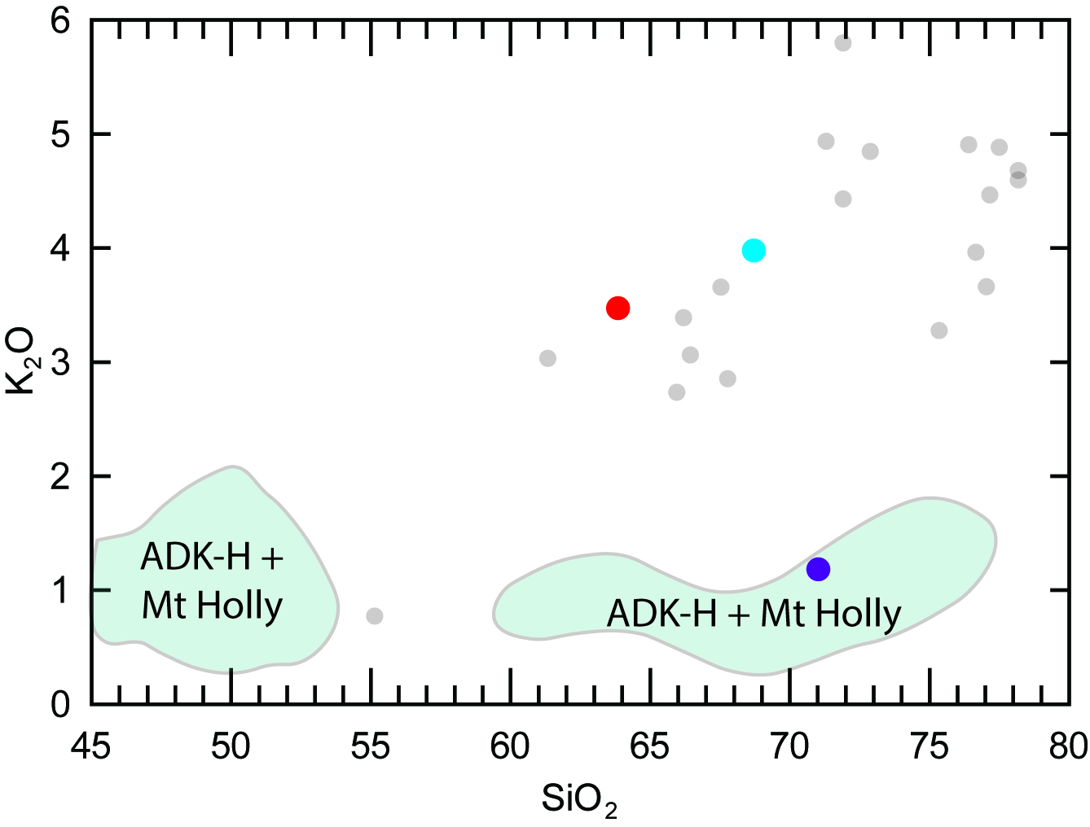
Figure 8: This comparison diagram is used to identify similarities between samples. My samples SA-21-01, light blue and, SA-21-02, red, are more closely related to data from (Peck, 2012) and SA-21-03 is more closely related to other ADK Highland rocks seen as the green cloud.

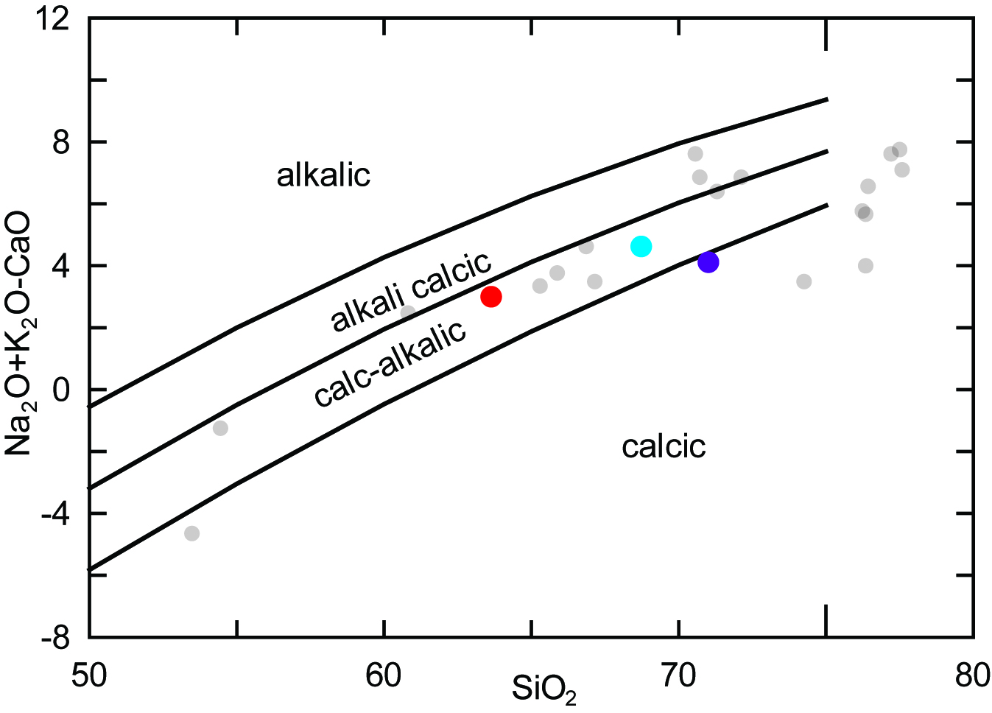
Figure 9: MALI diagram indicating affinities to compare formation environments and compare data. Addition data from (Peck, 2012) is shown as the gray dot scatter. My samples, SA-21-01 light blue, SA-21-02 red, and SA-21-03 have calc-alkalic affinities. Diagram from (Frost et al. 2001).

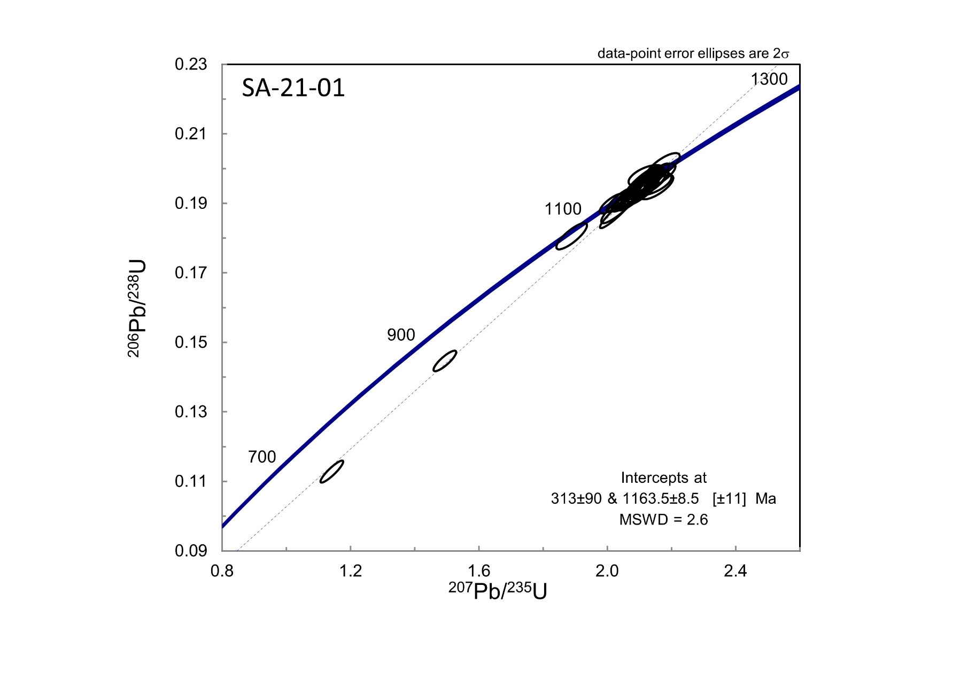
Figure 10: Concordia diagram for SA-21-01 indicating upper and lower intercept for line of best fit. Best mean age of formation is shown at 1163±8.5 Ma.

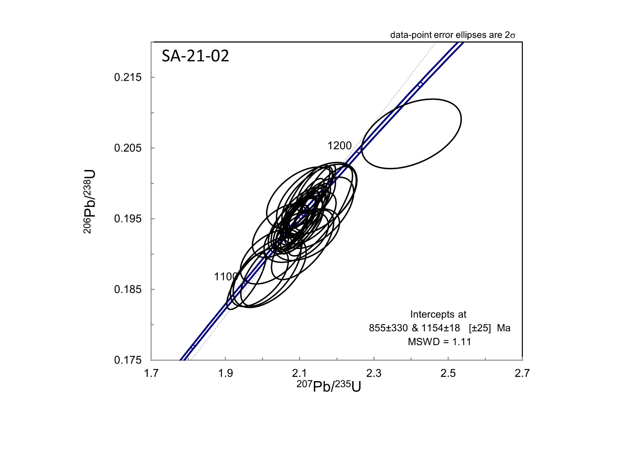
Figure 11: Concordia diagram for SA-21-02 indicating upper and lower intercept for line of best fit. Best mean age of formation is shown at 1154±18 Ma.

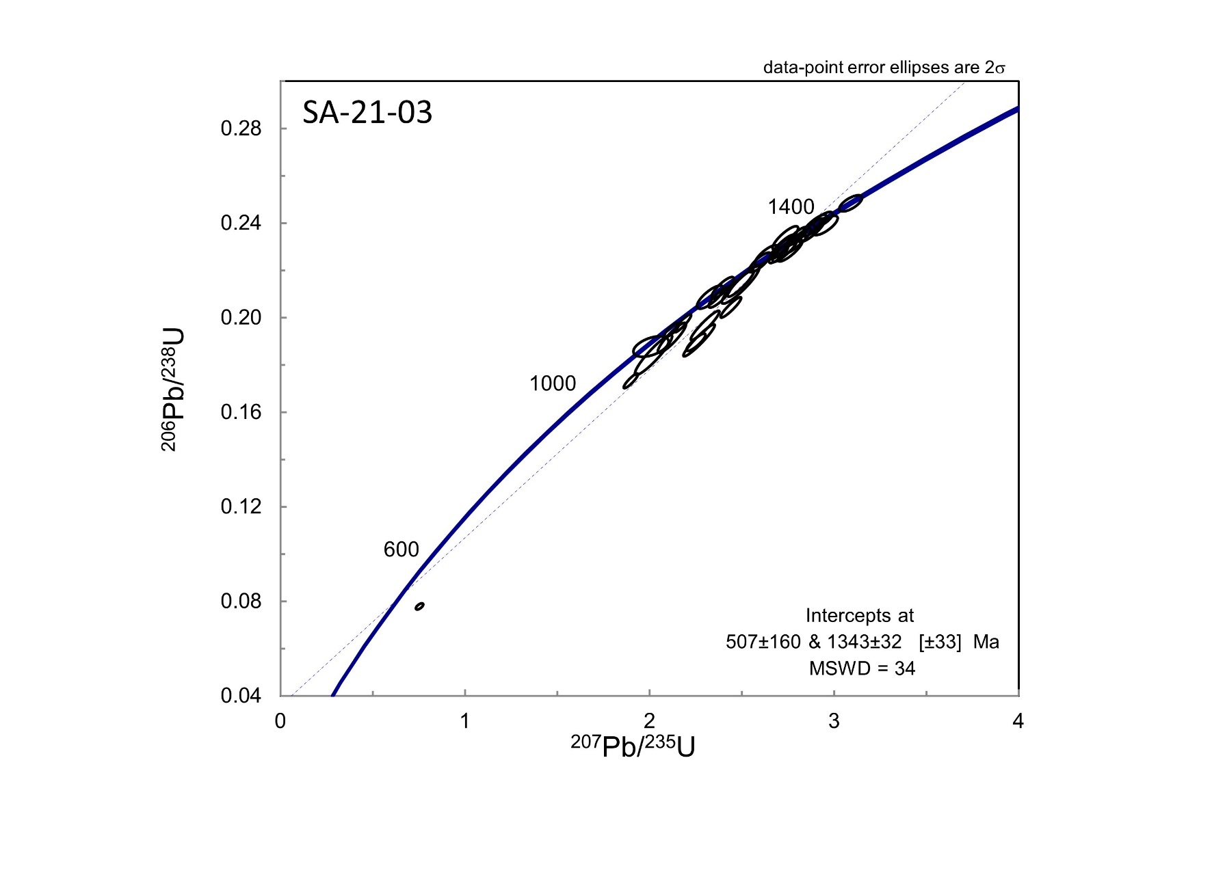
Figure 12: Concordia diagram indicating upper and lower intercept for line of best fit. Best mean age of formation is shown at 1343±32 Ma.

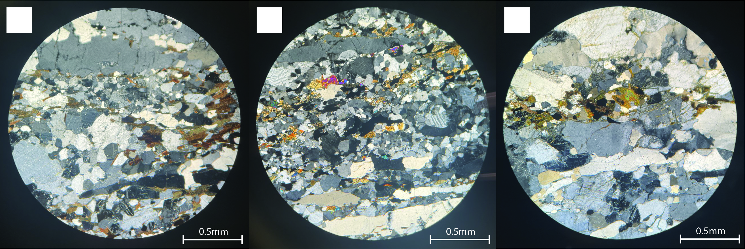
Figure 13: SA-21-01 thin section in XPL. SA-21-01 has substantial amounts of K-feldspar, plagioclase, and biotite. Biotite and elongate quartz ribbons form the laminae and foliation. Some opaque minor minerals are present.

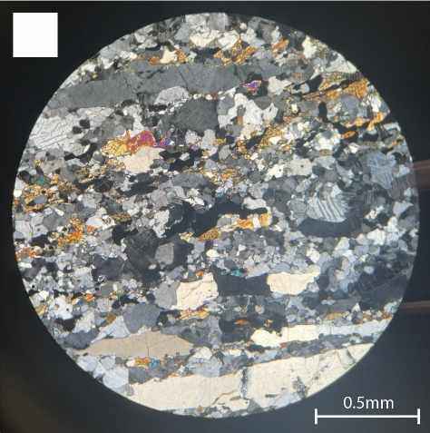
Figure 14: SA-21-02 thin section in XPL. SA-21-02 is majority composed of quartz and feldspar but also has a sizable proportion of pyroxene. Biotite is present but not as significant. SA-21-02 also has high temperature metamorphic structures within the quartz and feldspar crystals. Flame perthites are common in feldspar throughout the thin section and quartz displays checkerboard extinction.

Figure 15: SA-21-03 thin section in XPL. SA-21-03 has three majority minerals, feldspar, quartz and biotite. SA-21-03 is coarse grained and has ribbons of quartz that form foliation.

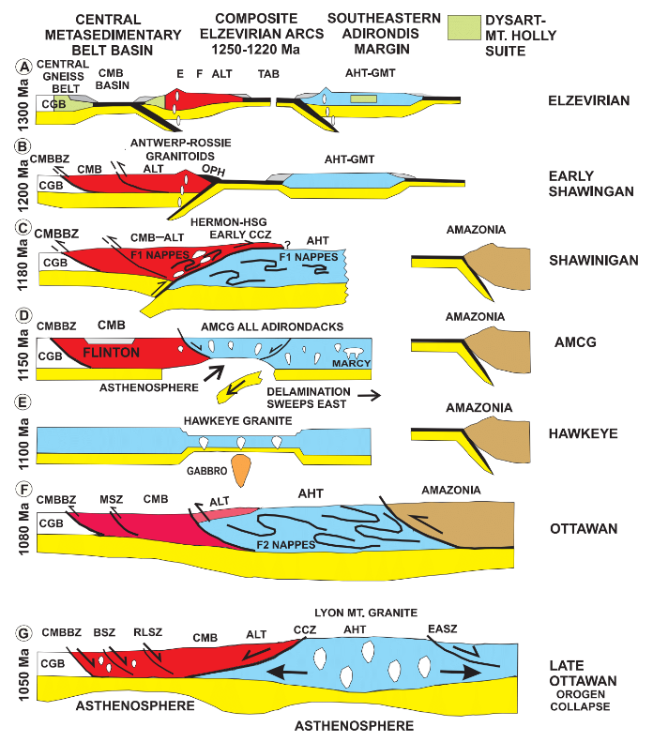
Figure 16: Showing the progression of the Grenville orogenic cycle. This image shows the development of the Grenville province during the Grenville Orogenic Cycle. Locations in which my samples were emplaced are indicated by red stars. SA-21-01 and SA-21-02 are associated with the AMCG suite that intruded during the Shawinigan Orogeny. SA-21-03 was emplaced before 1300 Ma as shown at the top of the diagram related to a magmatic arc. Modified after (McLelland et al., 2013).

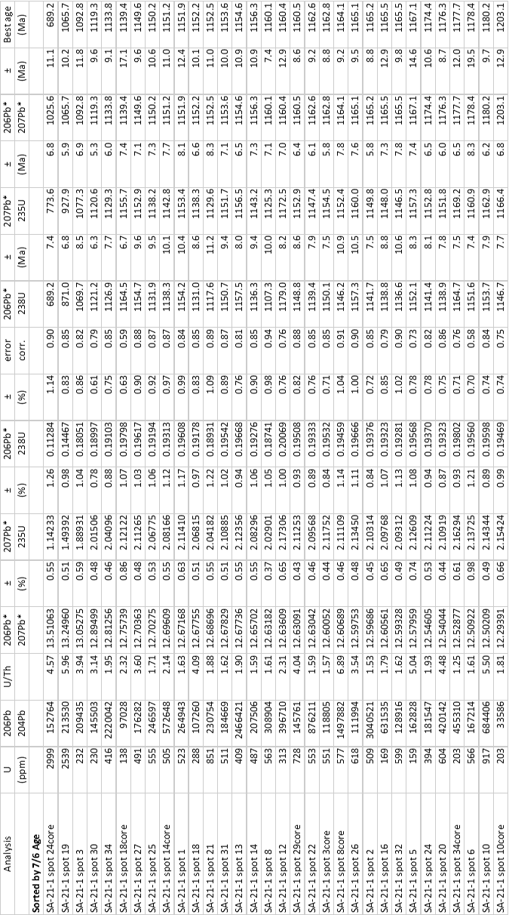
APPENDIX B: Tables
Table 1: SA-21-01 U/Pb in zircon geochronology data.

Table 2:SA-21-02 U/Pb zircon geochronology data.
Table 3: SA-21-03 U/Pb geochronology data.
Table 4: Whole rock geochemistry data for major elements.

Table 5: Whole rock geochemistry for rare earth elements.
Table 6: Whole rock geochemistry for trace elements.

