AN EXAMINATION OF MARINE FOULING ORGANISMS’ PRESENCE ON VARYING SUBSTRATES IN A NEW ENGLAND MARINA

Honors Thesis
Presented in Partial Fulfillment of the Requirements
For the Degree of Bachelor of Science
In the College of Arts and Sciences
At Salem State University

by
Michelle Urh

Dr. Mark Fregeau
Faculty Advisor
Department of Biology

***
Commonwealth Honors Program
Salem State University
2017

Table of Contents
Section Page #
Abstract 2
Introduction 3
Materials and Methods 5
Figure 1
Results 7
Figure 2
Figure 3
Figure 4
Figure 5
Figure 6
Figure 7
Discussion 12
Appendix 16
I-Photo Summary 16
II-Data Tables 18
III-ANOVA Tests for Depth 19
IV-ANOVA Tests for Substrates 22
Acknowledgements 25
Works Cited 26

Abstract
Marine fouling communities are comprised of various marine organisms that begin life as planktonic larvae before attaching to submerged surfaces. The purpose of this study was to develop an understanding of the substrate preferences of marine organisms that commonly foul New England marinas. Two sets of four 14x14cm fouling plates were constructed out of one of four materials: polyvinyl chloride (PVC), fiberglass, concrete or slate. These plates were suspended off a floating dock at 1 and 2 meters below the surface of the water. The 16 plates were placed at the Boston Harbor Shipyard and Marina in East Boston, MA, on 17 July 2016 and photographed every two weeks until 4 December 2016 for a total of 20 weeks. Individual organisms were counted and the percent cover calculated for colonial species to examine what settled and general abundance. It was found that the most common fouling organisms were Ciona intestinalis, Molgula sp., and Botrylloides violaceus. Ascidiella aspersa and Botryllus schlosseri were also present. The two most common solitary species present on all plate materials were C. intestinalis and Molgula sp. with B. violaceus being the most common colonial species. C. intestinalis showed a preference for the concrete plates over the other available surfaces. B. violaceus was most common on the slate plates. All colonial ascidians were observed growing on other organisms showing their involvement in secondary settlement. Understanding the substrate preference of these species develops a baseline for further research and the potential to control the spread of invasive species naturally.

Introduction
The phrase, marine fouling community, refers to the various marine organisms that attach to submerged surfaces such as boat hulls, rocky surfaces, and other hard substrates. These organisms begin life in a planktonic form as larvae, drifting in the water column. They settle and attach to solid surfaces where they mature and develop. Organisms that are planktonic at some stage in their life cycle have been known to exhibit substrate recognition and preference (Tyrrell et al., 2007). Many marine fouling communities are comprised largely of invasive species carried inadvertently to new habitats attached to the hulls of ships or in ballast water (Bax et al., 2003). These fouling communities have major impacts on the local environment and systems that directly affect humans. They inhibit success in the fishing industry by fouling lines and gear as well as interfering with culturing activities in aquaculture systems. Invasive marine fouling organisms alter biodiversity by competing with native organisms (Bax et al., 2003) or by influencing the recruitment of other marine fouling organisms (Dijkstra et al., 2007).
Previous research has focused primarily on members of the class Ascidiacea as the major group of fouling organisms including both colonial and solitary species. Gittenberger and van der Stelt (2011) conducted an experiment in Dutch Harbors of The Netherlands to determine whether non-native ascidians were more abundant on artificial structures than native species. They did not find a significant difference between the abundance of native and non-native species on these structures though. Tyrrell and Byers (2007) examined the settlement differences of exotic and native species on natural and artificial substrates in Wells, Maine finding some differences in the relative abundance on natural and artificial surfaces. A current research project on invasive marine organisms is underway at Hawthorne Cove Marina in Salem Harbor, Massachusetts. This project is conducted by Salem State researchers from Cat Cove Marine Lab and the Salem Sound Coastwatch as part of the SETL Project, a fouling community study looking at marine invasive species (SSU, 2017).
Available literature indicates that invasive fouling organisms are often transported to new environments on the hulls and in the ballast of ships. Once carried to a new area not all species will be able to survive new conditions while others establish themselves successfully and compete with native species (Bax et al., 2003). There are even organisms at this time whose original geographic range is unknown. There are other vectors that carry marine invasive species and these commonly end up in harbors and marinas where boats dock. Over the years, there have been a number of protocols instituted for boat owners to minimize the spread of these organisms. Antifouling paints and coatings have been developed to prevent such settlement and the increased speeds at which vessels can travel reduces hull fouling (Bax et al., 2003).
Recreational vessels can still serves as major vectors of marine fouling organisms though, and therefore, as an initial introduction site, marinas would be ideal locations to examine the spread of native and invasive fouling organisms. Understanding the materials fouling organisms are likely to settle on could provide insights for selection of research materials as well as suggesting better materials to be used in marine construction projects. The purpose of this study was to develop an understanding of potential substrate preferences of marine organisms that commonly foul New England marinas, specifically Boston Harbor. Understanding the natural settlement of these species would provide valuable background information for further experiments on substrate preference and the potential to control the growth of invasive fouling organisms.
Materials and Methods
Data was collected at the East Boston Shipyard and Marina located in Boston, Massachusetts. Individual fouling plates were 14x14cm and constructed out of one of four materials: polyvinyl chloride (PVC), fiberglass, concrete or slate. PVC was selected as the control surface according to the standard procedure used in the SETL Project conducted by Salem State researchers from Cat Cove Marine Lab and the Salem Sound Coastwatch (SSU, 2017). Fiberglass was used as the other artificial surface as it is a common boat material that fouling organisms are known to settle. Two more surfaces, concrete and slate, were selected as more natural materials that are commonly found in New England marinas. The PVC and fiberglass surfaces were scuffed up using sand paper to provide a rougher surface for attachment and settlement as was suggested by researchers at Salem State University. A total of 16 plates were used in sets of four. Each set of fouling plates was attached to a PVC pipe (Figure 1) which was tied to wooden floating docks using nylon paracord rope. This rope was later reinforced with hollow braided polypropylene rope for the winter season. Two sets of four plates were suspended at 1 meter and two sets at 2 meters measured from the surface of the water. Attaching the plates to the PVC pipe kept all four at a uniform depth and suspending them from a floating dock guaranteed the plates remained submerged regardless of the tides.
Plates were placed on 17 July 2016 and examined every two weeks until 4 December 2016 for a total of 20 weeks. Every two weeks of the experimental period, the plates were pulled from the water and photographed before being submerged again. Photographs were taken using an Olympus PEN E-PM1 Camera (see Appendix I). Photos were analyzed using photoQuad, image processing software designed for analyzing photographic samples (Trygonis et al., 2012). Individual organisms were counted on each plate and the percent cover was calculated for colonial species of tunicates to assess what settled as well as general abundance. Comparisons of composition and abundance were made based on depth, substrate and overall using the mean number of individuals of each species counted. Single factor ANOVA tests were performed to identify significant differences in settlement between plate materials for each identified species. Identified solitary species included: Ciona intestinalis, Ascidiella aspersa, Molgula sp., Mytilus edulis, Crepidula fornicate, and Metridium senile. Colonial species included: Didemnum sp., Botrylloides violaceus, and Botryllus schlosseri.

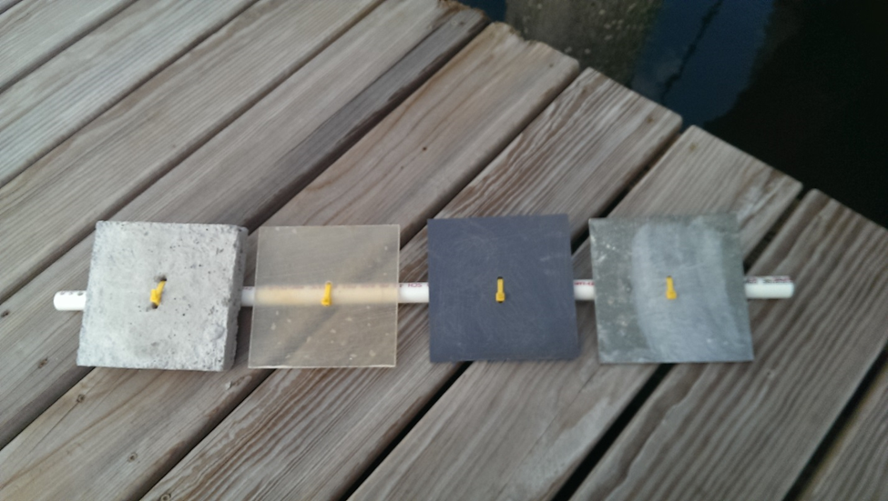
Figure 1. General set up of a set of four 14x14cm fouling plates attached to a PVC pipe with zip ties. Order of plates from left to right: Concrete, Fiberglass, PVC, and Slate.

Results
General Observations
The following data was collected over a period of 20 weeks. The mean number of solitary species counted as well as the average percent coverage of colonial species can be found in Table 1 (see Appendix II). Below, Figure 2 shows the change in the average number of individual solitary organism counted on all fouling plates over this period of time. The greatest changes were seen in C. intestinalis and Molgula sp. while the other identified species showed little change. Molgula sp. showed the earliest settlement peaking around week 3 and declining after that. C. intestinalis was slower to settle, but generally maintained a higher mean number of individuals over the 20 week period. A. aspersa showed slight changes in abundance with peaks around weeks 6 and 10.

Figure 2. A graphical depiction of the change in the average number of identified solitary individuals counted on all plate materials over a period of 20 weeks at the Boston Harbor Shipyard and Marina. Data was collected every two weeks.

Figure 3 displays the change in the average percent coverage for the three identified colonial species of tunicates. Over the experimental period, B. violaceus exhibited the earliest settlement and overall the greatest percent coverage on all plate materials. B. violaceus showed a decrease in abundance around week 3 dropping to a lower abundance and fluctuating afterward from week to week. B. schlosseri was also present on the plates, but with a lower percent coverage compared to B. violaceus. Didemnum sp. was not commonly found on the plates in this experiment and had a very small percent coverage. All three colonial species displayed a slight increase in percent coverage towards the last weeks of the experiment.

Figure 3. Changes in the average percent coverage calculated for identified colonials species on 14x14cm fouling plates overall during a 20 week period at the Boston Harbor Shipyard and Marina. Data was collected every two weeks.

Difference in Depth
Species composition and abundance for solitary organisms at the two experimental depths, 1 meter and 2 meters, are compared in Figure 4. For both C. intestinalis and Molgula sp. there were more individuals counted on the 1m plates while there were slightly more individuals of A. aspersa counted on the 2m plates (see Table 2 of Appendix II). Comparing the actual averages there are only small differences from week to week between the two depths. ANOVA tests were performed for each species resulting in p-values that were all greater than 0.05 (see Appendix III).

Figure 4. A graphical comparison of the species composition and average number of solitary individuals counted over a 20 week period at depths of 1 meter and 2 meters at the Boston Harbor Shipyard and Marina.

Figure 5 shows the comparison of colonial species present and their percent coverage at the two experimental depths. B. violaceus was the most common colonial species at both depths, having a slightly greater percent coverage at 1m. B. schlosseri was also present on plates at both depths and had a similar average percent coverage at each depth. Didemnum sp. showed a greater percent coverage on plates hung at 2m, but this was a low percentage. As was done with the solitary individuals, ANOVA tests were done for these three species yielding p-values greater than 0.05 (see Appendix III).

Figure 5. A comparison of colonial species composition and the average percent coverage calculated over 20 weeks at the Boston Harbor Shipyard and Marina between two experimental depths, 1m and 2m.

Varying Substrates
To compare species abundance and composition among different substrates, the average number of solitary species and average percent coverage for colonial species was collected for each experimental material used. Figure 6 shows the most commonly occurring solitary species on all four plate types were C. intestinalis, Molgula sp., and A. aspersa. C. intestinalis showed its greatest abundance on the concrete plates and the lowest on the slate. Molgula sp. had the greatest abundance on the slate plates, very similar numbers for concrete and PVC, and the lowest abundance on fiberglass. A. aspersa showed little difference in abundance among plate materials, but appeared greater on fiberglass. The other solitary species were not common on the experimental plates and showed little difference in abundance when present (Table 3 Appendix II). The ANOVA tests done for each species using this data resulted in a p-value that was greater than 0.05 for all species except C. intestinalis. The data for C. intestinalis produced a p-value of 1.07E-06 (see Appendix IV).

Figure 6. A graphical comparison of the species composition and average number of solitary individuals counted over a 20 week period on 4 different plate materials at the Boston Harbor Shipyard and Marina. Substrates used include two natural surfaces, concrete and slate, and two artificial surfaces, Fiberglass and PVC (control).

In Figure 7, the average percent coverage of the three colonial species present on the fouling plates is compared among the different plate materials. Overall, B. violaceus was the most common species with the greatest percent coverage on all plates, especially on slate and PVC. B. schlosseri had its highest percent coverage on PVC with concrete being its lowest. Didemnum sp. only showed a significant enough percent coverage on PVC to be included in this graph. The ANOVA tests done with the data for these three species resulted in a p-value greater than 0.05 for Didemnum sp. and B. schlosseri. The p-value calculated for B. violaceus was lower than 0.05 though at 0.007969 (see Appendix IV).

Figure 7. A comparison of colonial species composition and the average percent coverage calculated over 20 weeks on 4 different plate materials at the Boston Harbor Shipyard and Marina. Substrates used include two natural surfaces, concrete and slate, and two artificial surfaces, Fiberglass and PVC (control).

Discussion
General Observations
This study focused on the settlement and abundance of marine fouling organisms on different substrates. It also looked at the difference in species presence and abundance at two depths as well as settlement overall during the 20 week experimental period. The most common fouling organisms were identified to be Ciona intestinalis, Molgula sp., and Botrylloides violaceus. To a lesser extent, Ascidiella aspersa and Botryllus schlosseri were also present. The general observations made suggest a fast growth rate for solitary tunicate species. Molgula sp. settled on the plates the fastest once they were deployed suggesting it may have an earlier settlement period and faster growth rate than other species. C. intestinalis had the second fastest settlement and apparent growth rate. It also declined in abundance slower than Molgula sp. did. The early settlement and fast growth of these species may be the reason other solitary species were observed at lower numbers as the available space would have been occupied.
The presence of colonial invasive ascidians was rather low in this experiment. B. violaceus had the greatest mean percent coverage out of the three observed colonial species. The two other invasive colonial ascidians, B. schlosseri and Didemnum sp., had lower percent coverage. All three displayed a slight increase in percent coverage towards the end of the 20 week period. This increase is likely due to the decrease in solitary organisms also seen at this time, the secondary settlement of colonial species on solitary ones, or a combination of the two. Early examinations of the fouling plates showed B. violaceus was one of the first species overall to settle and grow. It is possible the fast growth of larger solitary ascidians like C. intestinalis and Molgula sp. blocked or prevented the further development of the earlier settling B. violaceus.
Difference in Depth
This experiment used four sets of fouling plates suspended at two different depths, two sets at 1m and two sets at 2m. As was shown in Figures 4 and 5 of the Results section, there was no obvious difference between these two depths. The ANOVA tests performed on the data yielded p-values greater than 0.05 for all species so the null hypothesis that there is no difference in species composition and abundance between 1m and 2m cannot be rejected. The species present, solitary and colonial, and their average abundance did not differ significantly. The use of two different depths was due to experimental design space restrictions. Combining the sets of data collected at the two depths was not an issue in this situation and did not influence the data. The influence depth has on marine fouling communities however, could benefit from further research. Potential questions include how depth influences the species diversity on fouling plates or whether differences in water temperatures at varying depths could impact settlement and growth.
Varying Substrates
Using ANOVA, it is possible to determine the substrate preferences for specific fouling species. Figure 6 shows a greater abundance of C. intestinalis on the concrete plates suggesting a preference for this material. The ANOVA test for Molgula sp. which appeared to show a preference for slate revealed this apparent difference was not statistically significant. The other species to display a statistically significant preference for one material over the others was the colonial ascidian B. violaceus. Figure 7 suggests this substrate preference was in favor of slate where we see the greatest percent coverage for B. violaceus. All other species identified on the fouling plates did not display a significant enough substrate preference to reject the null hypothesis that substrate material has no influence on the settlement and growth of these species. Further research into these species with more replicates to allow for a larger pool of data may result in different conclusions that would be worth looking into.
C. intestinalis and B. violaceus both displayed a preference for the surfaces selected to be representative of more natural substrates in New England marinas. This preference may be due to the surface composition of these materials. Concrete and slate provided a rougher surface than the PVC and fiberglass plates even though they were scuffed up. The composition of these materials may have allowed for better attachment when these species initially settled and increased the species ability to remain attached during the experimental period. Chase et al. (2016) conducted a similar experiment to this one in a laboratory setting where they examined larval settlement of C. intestinalis and B. violaceus on granite, concrete, PVC, and high-density polyethylene. They found that the larvae of these species showed preferences for settlement on high-density polyethylene and concrete suggesting that this was due to the roughness of the material (Chase et al., 2016).
Identifying the substrate preference of Ciona intestinalis and Botrylloides violaceus, two species that are not native to New England, helps to inform further research on marine fouling communities. Concrete is a material commonly used in marine construction and may therefore be contributing to the spread and continued growth of non-native species. Altering our use of concrete in marine construction or focusing on controlling growth on this surface may assist in controlling marine fouling. Understanding the substrate preferences of C. intestinalis and B. violaceus also develops a baseline for further research and experimental design.

Appendix
I-Photo Summary

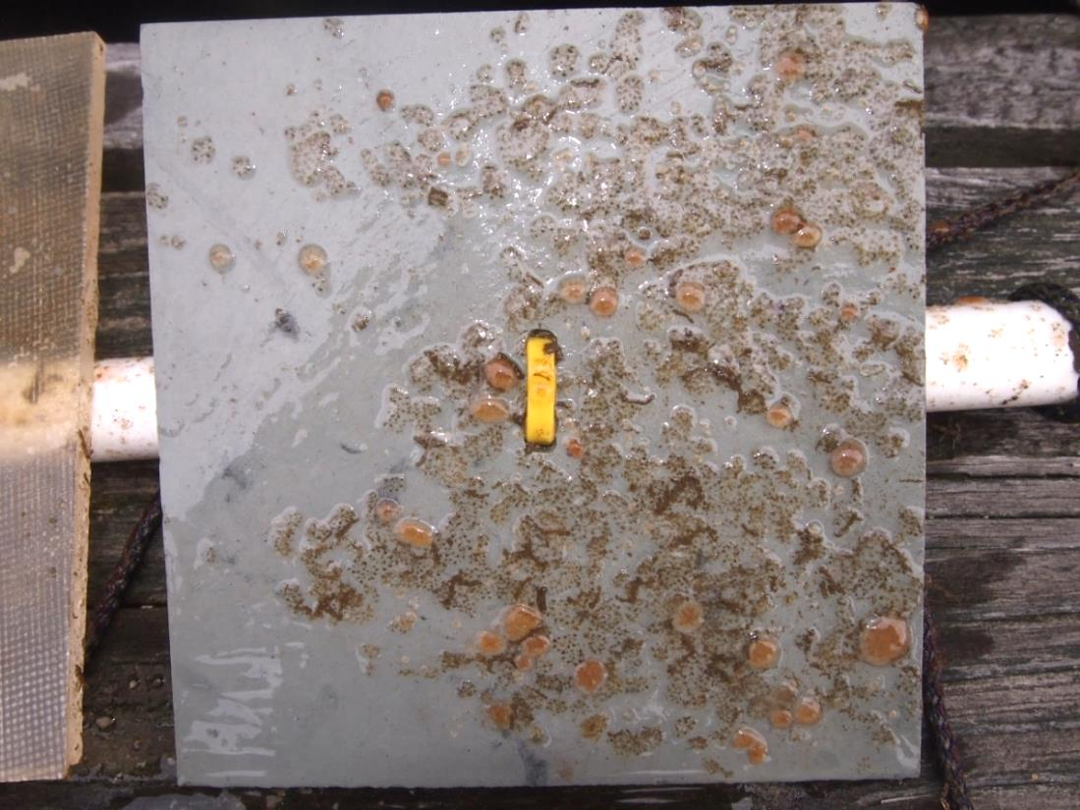
An image of a Slate fouling plate hung at 1m taken on data collection day 1 (31 July 2016).

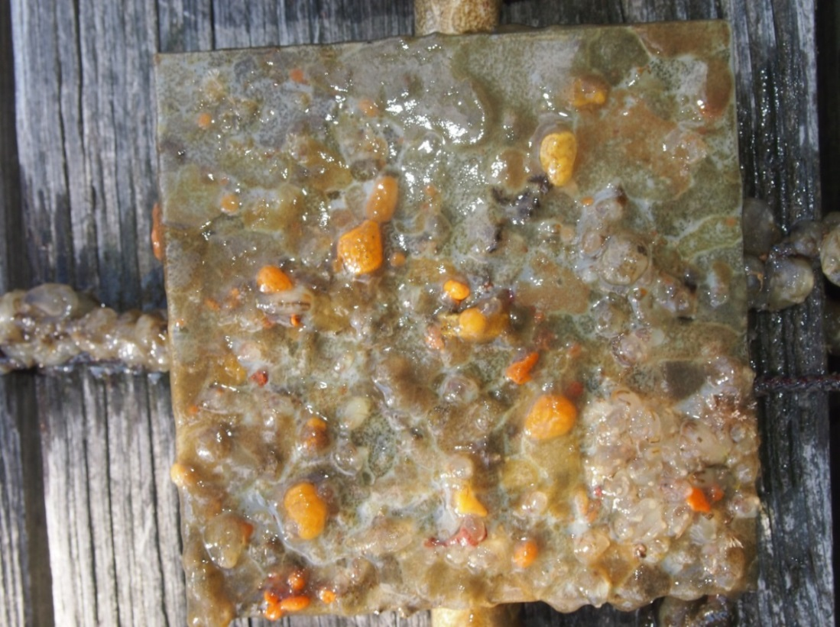
An image of the same Slate fouling plate two weeks later on day 2 (14 August 2016).

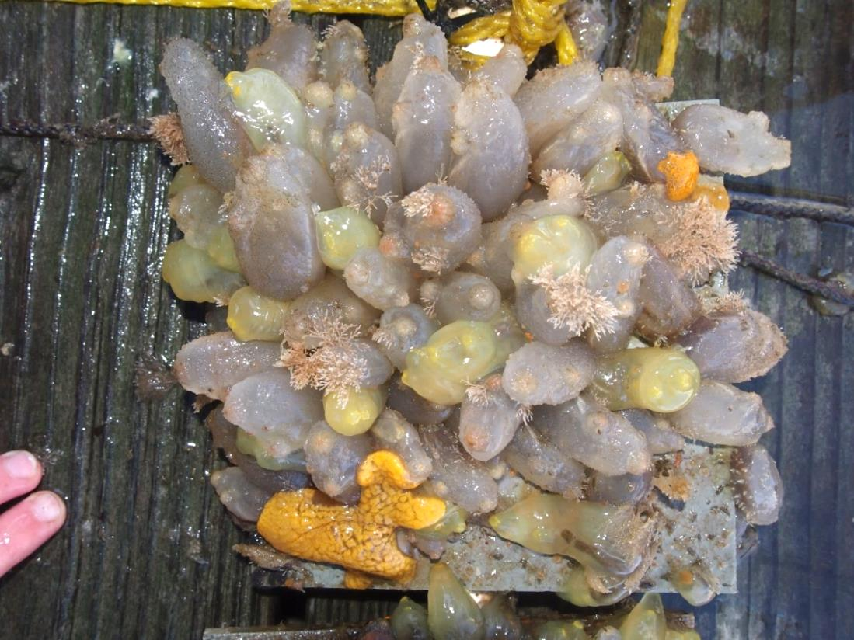
An image of the Slate plate on data collection day 5 (25 September 2016).

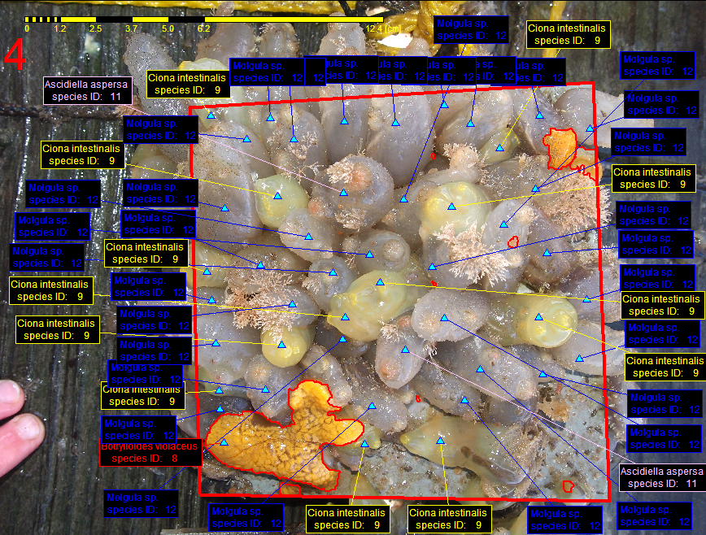
An image of the Slate plate from 25 September 2016 analyzed with photoQuad software.

II-Tables

Table 1. Mean Number of Solitary Species and Percent Coverage of Colonial Species Overall

Table 2. Comparison of Species Averages Between Depths

Table 3. Comparison of Species Averages on Different Substrate Materials

III-ANOVA Tests for Depth

IV-ANOVA Tests for Substrates

Acknowledgements
I would like to thank Dr. Mark Fregeau and Professor Ted Maney for their assistance in designing this project, suggesting background material and providing their feedback throughout this project. I would also like to acknowledge the Boston Harbor Shipyard and Marina where I was allowed to conduct this experiment. I am grateful for the assistance I received on data collection from my family and friends as well. This research was funded by the Edward F. Sweeney Award in Field Biology and the Alan M. Young Award in Marine Biology from the Salem State Biology Department.

Works Cited

Bax N, Williamson A, Aguero M, Gonzalez E, Geeves W. 2003. Marine invasive alien
species: A threat to global biodiversity. Marine Policy [Internet]. 27(4): 313-23. Available from: http://doi.org/10.1016/S0308-597X(03)00041-1.

Chase AL, Dijkstra JA, Harris LG. 2016. The influence of substrate material on ascidian
larval settlement. Marine Pollution Bulletin [Internet]. 106(1-2): 35-42. Available from: http://dx.doi.org/10.1016/j.marpolbul.2016.03.049.

Dijkstra J, Sherman H, Harris LG. 2007. The role of colonial ascidians in altering
biodiversity in marine fouling communities. Journal of Experimental Marine Biology and Ecology [Internet]. 342: 169-171. Available from: http://doi.org/10.1016/j.jembe.2006.10.035.

Gittenberger A, van der Stelt R. 2011. Artificial structures in harbors and their associated
ascidian fauna. Aquatic Invasions [Internet]. 6(4): 413-420. Available from: http://doi.org/10.3391/ai.2011.6.4.06.

Invasive Species Monitoring in Salem Sound [Internet]. 2017. Salem (MA): Salem State
University. Available from: https://www.salemstate.edu/academics/colleges-schools/college-arts-and-sciences/biology/cat-cove-marine-laboratory/cat-cove.

Trygonis V, Sini M. 2012. photoQuad: a dedicated seabed image processing software,
and a comparative error analysis of four photoquadrat methods. Journal of Experimental Marine Biology and Ecology [Internet]. 424-425: 99-108. Available from: http://doi.org/10.1016/j.jembe.2012.04.018.

Tyrrell MC, Byers JE. 2007. Do artificial substrates favor nonindigenous fouling species
over native species? Journal of Experimental Marine Biology and Ecology [Internet]. 341: 54-60. Available from: http://doi.org/10.1016/j.jembe.2006.10.014.

