The Impact of Disparate Treatment on Pregnancy Outcomes in Minority Women

Honors Thesis

Presented in Partial Fulfillment of the Requirements

For the Degree of Bachelor of Science in Nursing
In the Maguire Meservey College of Health and Human Services
at Salem State University

By

Claudia Pueyo-Garcia

Nancy Ebersole PhD, RN
Faculty Advisor
School of Nursing

***

Commonwealth Honors Program
Salem State University
2022
Abstract

Pregnancy is one of the most vulnerable and important events in a woman’s life, however this experience can differ for minority women from disadvantaged backgrounds. The Center for Disease Control and Prevention reports that 700 women die each year in the US because of pregnancy or delivery complications while also reporting that Black women are three times more likely to die from pregnancy than white women. More than half of these deaths and near-deaths are the result of preventable causes, and a disproportionate number of the women suffering are Black women. A review of the literature was done using the CINAHL database, and the articles that were collected will be used to find common themes across multiple author’s findings that link directly to causative factors and their outcomes. The themes are (a) minority women experiencing lower-quality care; (b) minority women experiencing biases in communities; (c) minority women experiencing implicit bias within the health care delivery system; (d) minority women experiencing the effects of systemic oppression. Each of these elements have contributed to the rising prevalence of pregnancy-related morbidities and deaths. Nurses must advocate for high-quality, safe treatment and care for every patient to dismantle racial health disparities and decrease maternal morbidity and mortality rates. The desire to learn and to be aware of the variables influencing racial inequalities in pregnant minority women is the first step to improve health care standards and work to dismantle this growing racial health disparity.

Table of Contents

Abstract………………………………………………………………………………. i
Table of Contents……………………………………………………………………. ii
Acknowledgements……………………………………………………………….......iii
Introduction………………………………………………………………………....... 1
Background…………………………………………………………………………... 1
Methods…………………………………………………………………………….... 5
Results……………………………………………………………………………..… 6
Minority women experiencing lower quality care………………………………….... 7

Minority women experiencing biases in communities………………………………. 8

Minority women experiencing implicit bias within
health care delivery system………………………………………………………….. .9

Minority women experiencing the effects of systemic oppression
in pregnancy outcomes……………………………………………………………… .10

Discussion…………………………………………………………………….……… 11
Conclusion………………………………………………………………....………… 11
References……………………………………………………………………….…… 13

Acknowledgements
I would first like to thank Dr. Nancy Ebersole for offering her expertise and for the continuous support and patience throughout this process. Not only has she shown her support through the thesis project but all throughout a pandemic during nursing school.
I want to also thank Dr. Scott Nowka for his calming words and support through my four years in the honors program. I appreciate your kindness and advice which has motivated me through this process.
Finally, thank you to my loved ones for your love and patience through my college career. I am so grateful for the amazing support system I am surrounded by.

Pregnancy and childbirth are vulnerable times for a woman’s health with various physiological and anatomical changes occurring during pregnancy and after childbirth for women of all backgrounds. Recent research shows how unique and different these experiences may be for women from disadvantaged backgrounds. These unique experiences are in direct correlation with health disparities, which Healthy People 2030 defines as “a particular type of health difference that is closely linked with social, economic, and/or environmental disadvantage... adversely affecting groups of people who have systematically experienced greater obstacles to health”. Black women experience health disparities, more specifically racial health disparities at a disturbingly high rate when compared to other racial and ethnic groups. The Center for Disease Control (CDC) has reported and confirmed that the disparity of higher maternal morbidity and mortality rates in women of diverse ethnicities exists (CDC 2022).
These experiences determine the type of physiologic and social-emotional treatment minority women receive during one of the most vulnerable times in their life, with such disparate treatment affecting the outcomes of their pregnancy and birth. The identification and recognition of the factors impacting racial disparities in pregnant minority women can be used to inform and make changes to the expectations and standards of care in the clinical setting and healthcare system.
Background
The United States has always prided itself as being one of the most innovative, powerful, and accomplished countries in the world. However, the United States has the highest maternal mortality and morbidity rates among other developed, wealthy countries in the world (UNICEF Database, 2022). This could be due to factors such as access to “universal health care, paid maternity leave, and the overall health profile of women in other countries” (Upham 2020). Contrary to other developed nations that have effectively decreased the rate of maternal mortality, the United States has shown an alarming trend of growing maternal deaths and complications compared to other countries such as Italy, Denmark, and Finland which have the lowest maternal morbidity and mortality rates in the world (Lister, 2019). The Center for Disease Control and Prevention reports that 700 women die each year in the US because of pregnancy or delivery complications while also reporting that Black women are 3 times more likely to die from pregnancy than white women. While the United States takes leaps in medical innovation and spending, the trends for minority maternal pregnancy outcomes continue to trend downwards.
There are multiple factors that are contributing to pregnancy-related mortality and morbidity along with racial and ethnic disparities. Previous studies have identified that “for each pregnancy-related death and complication three to four contributing factors were identified in multiple levels, including community, health facility, individual patient and family situations, provider stigmas, and systemic oppression” (Petersen, 2019). The social determinants of health theory, adopted by healthcare agencies across the nation, explains racial inequity as the result of social institutions that systematically disadvantage minorities. Using this theory, Black women are disproportionately subject to unsafe housing, lack of affordable transportation, lack of insurance, and lack of partner support furthering the rippling effect of “limited health-related resources, individual poverty, distressed physical environments, and fragmented social networks” (Kothari, 2016). Though the social determinants of health help us understand some of the psychosocial factors, it is not sufficient in addressing maternal health disparities. While exploring these, we must also examine further the stigmas and discrimination that pregnant minority women face.
The CDC’s Pregnancy Mortality Surveillance System indicates that maternal mortality in the U.S. has increased from 7.2 deaths per 100,000 live births in 1987 to 17.3 deaths per 100,000 live births in 2017. Along with this data, the 2020 CDC Pregnancy Surveillance study also shows that the estimated maternal mortality rate in the US is 17.3 per 100,000 live births for white women, however, it jumps to 43 per 100,000 live births for Black women. The data indicated that not only is the US on the rise for maternal deaths, but there is also a racial health disparity shown with the trend (Singh 2021). Throughout the past decade, there has been growing attention on this topic, extensive studies and research are still studying the findings between maternal racial health disparities and the social determinants of health and why the trends continue downward.
As this literature review investigates racial health disparities, the issues of interpersonal and structural racism continue to be a significant problem. Racism is defined as “a perceived threat formed on an immutable characteristic often central to a person's identity, resulting in unfair treatment based on a person's physical attributes including skin color” (Chambers 2019). Racism can occur at an individual level. Studies have found that 54% to 78% of Black pregnant women report experiencing racism, with the highest proportion of women experiencing racial discrimination at school, on the street, or in a public setting (Chambers, 2019). Racism is also deeply embedded in our systems, laws, policies, health care, and education. This is referred to as systemic racism. Systemic racism is defined as a systematic approach used to influence laws and processes to unequally allocate access to goods, opportunities, and services in society by racial groups (Chambers, 2019). Systematic racism is the driving force behind racial health disparities within the social determinants of health.
In health care, the Institute of Medicine defines racial health disparities as “racial or ethnic differences in the quality of health care that are not due to access-related factors or clinical needs, preferences, and appropriateness of intervention.” Racial health disparities can not only be seen in pregnancy outcomes but in many other areas of the healthcare system. Minority racial groups experience higher rates of illness and death across a wide range of health conditions, including diabetes, hypertension, obesity, asthma, and heart disease (CDC).
To better understand and address these disparities we also must understand the social determinants of health and their interdependencies. The social determinants of health are the conditions in which we are born, live, learn, work, play, worship, and age according to Healthy People 2030. The five domains included are economic stability, education access and quality, healthcare access and quality, neighborhood and built environment, and social and community context (Healthy People 2030). Low economic status, poor education, food insecurity, lack of transportation, neighborhood violence, and lack of healthcare access, are all examples of the five domains that may contribute to the racial health disparities that are seen in maternal morbidity and mortality.
When observing maternal health outcomes, significant racial health disparities can be seen both in maternal morbidity and maternal mortality. Maternal morbidity refers to the rate of women who experience health complications due to unexpected pregnancy or childbirth outcomes. Examples of unexpected outcomes include infection, diabetes, pre-eclampsia, eclampsia, abruptio placentae, placenta previa, and postpartum hemorrhage (Howell 2018). As these unexpected outcomes may be resolved or impact a woman for the rest of her life, we must also be aware that these complications of morbidity can lead to maternal death.
Maternal death is defined by the CDC as “the death of a woman during pregnancy or within one year of pregnancy from a pregnancy complication, a chain of events initiated by pregnancy, or the aggravation of an unrelated condition by the physiologic effects of pregnancy.” Maternal death can be exacerbated by both indirect obstetric causes and by suffering from pregnancy and delivery complications. Listed as the top causes of death by the CDC’s Pregnancy Mortality Surveillance System include sepsis, cardiomyopathy, hemorrhage, emboli, cerebrovascular accidents, hypertension, and anesthesia complications.
The aim of this literature review is to synthesize literature on interrelated determinants and factors impacting maternal health outcomes in minority women with an emphasis on the social determinants of health and its interdependencies with racial health disparities. Understanding these elements will bring an understanding of the disparate treatment of minority women and its impacts. With the purpose of bringing this urgent issue to light, steps can be taken within multiple levels to ease the suffering experienced by minority women in the United States.
Methods

A systematic review of the literature was conducted using the Cumulative Index of Nursing and Allied Health Literature (CINHAL) Plus Full Text databases in order to obtain relevant articles to review. A systematic search was done using Boolean terms with the keywords: pregnancy, black women, disparities, and risk factors. The years of publication used were 2016 to 2021. Other inclusion criteria were full text, academic journals written by professionals and registered nurses and being written in English. Inclusion criteria to select relevant studies includes birth outcomes, risks and racism, while exclusion criteria include specific medical diagnoses, deaths, immigrants and healthy. 7 articles that met all the criteria and are used in this systematic review. See Figure 1 below.
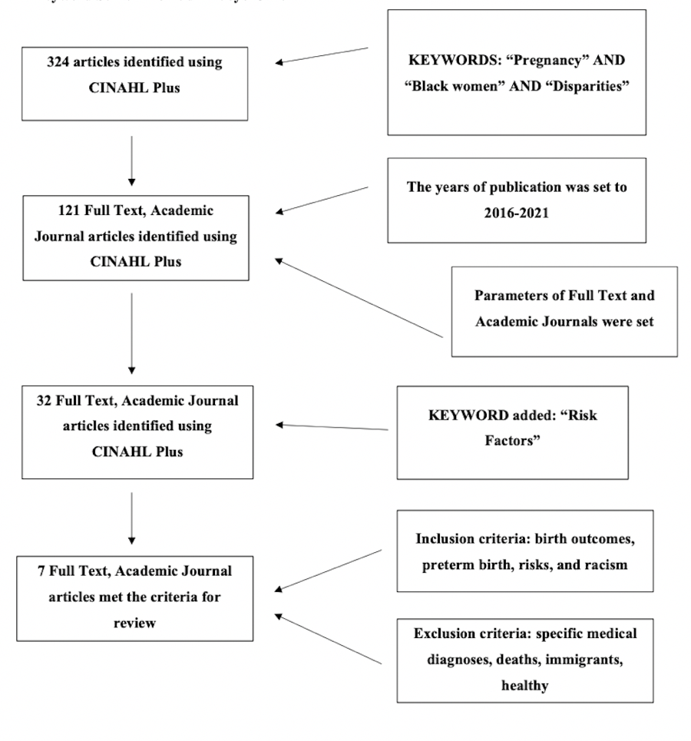
Figure 1 - Article Identification

Results

The results of this systemic review of the literature found that experiences faced by minority women and their disparate treatment impact pregnancy outcomes. Four themes were identified across the articles that were selected. These themes were identified on the basis that multiple authors referred to these experiences. The results that were found include minority women experiencing; lower quality care, biases in communities, implicit bias within the healthcare community system and effects of systemic oppression on pregnancy outcomes.
Minority women experiencing lower quality care

Minority women experience lower-quality care due to lack of education, lack of resources, and lower quality hospitals. A good portion of racial and ethnic disparities can be explained by variations in hospital quality and location (Howell 2018). Howell reported that 75% of black deliveries in the United States occurred in just a quarter of hospitals, where only 18% of whites delivered in those same hospitals (Howell, 2018). Due to the location and resources available in heavily minority populated areas, black women are more likely than white women to get obstetric treatment in hospitals of lesser quality (Petersen 2019).
Education about pregnancy and prenatal care is also a factor that widely affects pregnancy outcomes. There have been reports of low maternal birth satisfaction among minority women due to a gap in prenatal care education and counseling during admission for labor (Hamm 2019). Bower states that “63.6% of non-Hispanic Black women, initiated care in the first trimester, compared with 79.0% of non-Hispanic White women” (Bower 2018). Black pregnant women overwhelmingly indicated that they wanted to establish a close relationship with their prenatal care providers, they also desired to have their providers know and remember them and understand the context of their lives from their prenatal interactions (Lori 2011). This is significant in that provider characteristics influence African American women during prenatal care.
These findings contribute to the fact that women who do not receive adequate care typically have increased medical and psychosocial risks for poor pregnancy outcomes. Minority women do not have the same access to high-quality care or effective prenatal education and care, many times due to inequalities in the social determinants of health such as lack of transportation, support, and education.
Minority women experiencing biases in communities
Throughout this research, a theme that developed was the factors within our communities that contribute to adverse maternal outcomes in minority women. Social determinants of health such as education level, neighborhoods, socioeconomic status, and marital status have been negatively associated with adverse pregnancy outcomes. Data shows that “socially and economically-disadvantaged demographic groups and communities experience 2-to-6 times higher risk of maternal mortality from indirect causes” (Singh 2021). Characteristics like having low education attainment, being unmarried, and living in disadvantaged neighborhoods have been identified to have a correlation with adverse pregnancy outcomes such as diabetes mellitus and hypertensive disorders (Clay, 2018).
The data collected showed that “the Pregnancy-related mortality ratios among black women with a completed college education or higher was 1.6 times that of white women with less than a high school diploma” (Petersen, 2019). Education status is not the only factor contributing to biases within communities. Living in disadvantaged neighborhoods comes with limited access to amenities like sidewalks, parks and playgrounds, public transportation, and healthy affordable foods, all of which promote health and access to a healthy pregnancy (Singh 2021). Having a healthy support system such as marital status and having the father in the household also contributes to pregnancy outcomes (Clay 2018).
As these indirect causes are linked to the adverse outcomes, it must be acknowledged that high concentrations of race and income extremes and experiencing racial discrimination exposes women to chronic stressors that then become a direct cause with pregnancy complications (Chambers 2019).
Minority women experiencing implicit bias within health care delivery system

Implicit bias within the health care delivery system refers to biases found within health care providers, including nurses. Implicit bias is defined as “unconscious and involuntary attitudes which lie below the surface of consciousness, but can influence affect, behavior and cognitive processes” (Maina 2018). During emergencies, in this case obstetric emergencies, health care providers must make fast, hard decisions, which in the moment may not recognize their bias, resulting in poor outcomes.
Minority pregnant women have expressed negative interactions with providers where they were treated with disrespect and judged based on their skin color, which aligns with the fact that African American women are four times more likely than whites to be discriminated against in medical settings (Lori 2011). These experiences result in mistrust of the health care systems and the perception of lower quality care compared to non-minority women. Provider bias has been found to be a significant factor when looking at “patient-provider interactions, treatment decisions, patient adherence to recommendations, and patient health outcomes” all which contribute to healthcare disparities in the United States (Maina 2018, Petersen, 2019). This is important because not only can provider bias affect how a treatment plan is executed but also skews the connection between provider and client which has been found to affect the level of satisfaction within minority women (Lori 2011).
It is crucial for providers and nurses to develop a respectful and trustworthy connection through therapeutic communication to deliver and unbiased optimal treatment plan. Through their respect, communications, actions, and decisions providers have a direct impact on the health outcomes of black maternal patients.
Minority women experiencing the effects of systemic oppression in pregnancy outcomes
Systemic issues that contribute to pregnancy-related problems and mortality include gaps in health care coverage and preventative treatment, a lack of integrated health care, and a lack of social services. Although the circumstances in which individuals born, grow, live, work, play, and age contribute to this disparity, systemic racism is the root of maternal health disparities.
Institutionalized racism perpetuates race, the growing social class divide, and inequities in pregnancy outcomes. Stress produced by institutionalized racism in areas such as inequalities in wealth, jobs, and education prior to childbirth should be addressed in order to diminish the health disparities seen within minority women (Maina, 2018) In a study conducted by Chambers, it was highlighted that “data suggest that women in this study maybe at higher risk for adverse birth outcomes due to high exposures to both interpersonal and structural racism” (Chambers, 2019). In another study by Clay, that focused on risk factors for maternal disparities, the hypothesis was confirmed in that there are racial differences based on racist institutional level stressors. (Clay, 2018).

The findings in this theme focus around the negative effects that public policy, health insurance, insufficient social programs, and a lack of reproductive activism have had on maternal morbidity and mortality among minority women.
Discussion

Findings from this literature review continuously showed that the disproportionate burden of maternal morbidity and mortality among the African American community can be attributed to inequitable access to care, quality of care, communities, biases, and laws. Over the course of a woman's lifespan and pregnancy, each of these elements has contributed to and aggravated the rising prevalence of health morbidities, life stressors, access to health care facilities and preventative treatment, as well as lower quality of care.
The common themes explored in this review overwhelmingly show many interdependent factors that show that minority women are far more likely to experience complications and death due to pregnancy. This issue extends more than one person's lifestyle and choices, as this issue is multifaceted. An unsettling and dangerous health disparity that has no excuse in such a developed country like the United States has been highlighted. To prevent more struggle and heartbreak for pregnant woman in the US, American policies, regulations, laws, and practices can be introduced to fill gaps in health care for all women.
Conclusion
Two in three pregnancy-related deaths are
- Preventable if biases in our communities are deconstructed.
- Preventable if providers recognize warning signs if healthcare professionals provide timely treatment and quality care.
- Preventable if we dismantle structural racism and implicit bias.
Nurses across the US have the power to improve the quality they deliver to all their patients no matter their race or background. Nurses have the ability to recognize early signs of complications and report them. The most important role that nurses have is patient advocacy. Nurses must advocate for high-quality, safe treatment and care for every patient in order to dismantle racial disparities and decrease maternal morbidity and mortality rates. The willingness to learn and to be aware of the variables influencing racial inequalities in pregnant minority women can be utilized to influence and improve clinical setting and healthcare system expectations and standards of treatment.

References

Centers for Disease Control and Prevention. (2022, April 6). Working together to reduce Black Maternal Mortality. Centers for Disease Control and Prevention. https://www.cdc.gov/healthequity/features/maternal-mortality/index.html
Centers for Disease Control and Prevention. (2022, April 13). Pregnancy mortality surveillance system. Centers for Disease Control and Prevention. https://www.cdc.gov/reproductivehealth/maternal-mortality/pregnancy-mortality-surveillance-system.htm
Chambers, B. D., Arabia, S. E., Arega, H. A.,(2020). Exposures to structural racism and racial discrimination among pregnant and early post-partum Black women living in Oakland, California. Stress and health: journal of the International Society for the Investigation of Stress, 36(2), 213–219.

Clay, S., Griffin, M., & Averhart, W. (2018). Black/White disparities in pregnant women in the United States: An examination of risk factors associated with Black/White racial identity. Health & Social Care in the Community, 26(5), 654–663.

Hamm, R. F., Srinivas, S. K., & Levine, L. D. (2019). Risk factors and racial disparities related to low maternal birth satisfaction with labor induction: a prospective, cohort study. BMC Pregnancy & Childbirth, 19(1), 1–9.

Howell E. A. (2018). Reducing Disparities in Severe Maternal Morbidity and Mortality. Clinical obstetrics and gynecology, 61(2), 387–399.

Kothari, C. L., Paul, R., Dormitorio, B., Ospina, F., James, A., Lenz, D., Baker, K., Curtis, A., & Wiley, J. (2016). The interplay of race, socioeconomic status and neighborhood residence upon birth outcomes in a high black infant mortality community. SSM - population health, 2, 859–867.

Lister, R. L., Drake, W., Scott, B. H., & Graves, C. (2019). Black Maternal Mortality-The Elephant in the Room. World journal of gynecology & womens health, 3(1), 10.33552/wjgwh.2019.03.000555.

Lori, J. R., Yi, C. H., & Martyn, K. K. (2011). Provider characteristics desired by African American women in prenatal care. Journal of transcultural nursing : official journal of the Transcultural Nursing Society, 22(1), 71–76.

Maina, I. W., Belton, T. D., Ginzberg, S., Singh, A. (2018). A decade of studying implicit racial/ethnic bias in healthcare providers using the implicit association test. Social Science & Medicine, 199, 219–229.
Melillo, G. (2020, December 19). Racial disparities persist in maternal morbidity, mortality and infant health. AJMC. https://www.ajmc.com/view/racial-disparities-persist-in-maternal-morbidity-mortality-and-infant-health
Oribhabor, G. I., Nelson, M. L., Buchanan-Peart, K. R., & Cancarevic, I. (2020). A Mother's Cry: A Race to Eliminate the Influence of Racial Disparities on Maternal Morbidity and Mortality Rates Among Black Women in America. Cureus, 12(7), e9207.

Petersen, E. E., Davis, N. L., Goodman, D. (2019). Racial/Ethnic Disparities in Pregnancy-Related Deaths - United States, 2007-2016. MMWR: Morbidity & Mortality Weekly Report, 68(35), 762–765.

Singh, G. K., & Lee, H. (2021). Trends and Racial/Ethnic, Socioeconomic, and Geographic Disparities in Maternal Mortality from Indirect Obstetric Causes in the United States, 1999-2017. International journal of MCH and AIDS, 10(1), 43–54.
UNICEF DATA. (2022, January 27). Maternal mortality rates and statistics. https://data.unicef.org/topic/maternal-health/maternal-mortality/
Upham, B., Rapaport, L., Upham, B., Landau, M. D., & Colino, S. (2020, November 18). Maternal death rate in the U.S. is high compared with other countries. EverydayHealth.com. https://www.everydayhealth.com/womens-health/pregnancy-childbirth-and-postpartum-more-dangerous-in-us-compared-with-other-high-income-countries-research-finds/
U.S. Department of Health and Human Services. (2021, April 26). Systemic racism, a key risk factor for maternal death and illness. National Heart Lung and Blood Institute. https://www.nhlbi.nih.gov/news/2021/systemic-racism-key-risk-factor-maternal-death-and-illness

