Maximum Sentencing under Section 35

Honors Thesis

Presented in Partial Fulfillment of the Requirements

For the Degree of Bachelor of Criminal Justice
In the College of Health and Human Services
at Salem State University

By
Chrysta Slayton

Dr. Jeb Booth
Faculty Advisor
Department of Criminal Justice

***

Commonwealth Honors Program
Salem State University
2015

Abstract

The Massachusetts General Law Chapter 123 Section 35 allows a person to be involuntarily committed into a treatment facility for drug/alcohol abuse for a maximum of 90 days if suspected to pose an immediate risk to themselves or others. This law changed on July 1st, 2012 when it was previously a maximum of 30 days. A further look will be taken into what precipitating factors led the legislature to extend the maximum sentence, and what effect this has had on the treatment of the men in the facility. This research takes a step inside a facility where Section 35’s are sent, and breaks down the issues that lead the men into this facility. In addition, survey results will be presented that show which drugs have proven themselves most problematic in leading to the forced detox. Recommendations will be presented on how the Section 35 process could be improved, as viewed from the opinions of the men in the facility, psychologists who recommend the detox, clinicians of the facility, and Senator Jen Flanagan, who recently led a panel discussion on the Section 35 process.

Table of Contents
Honors Thesis……………..……………………………………………………………… I
Abstract……………………………………………………...……………………...…… II
Table of Contents……….………………………………………………………………. III
Acknowledgements...…………………………………………………………………… IV
List of Tables and Figures……………..………..………………………………………. .V
Introduction………….………………...………………………………………………… 1
Literature Review..………………………………………………………………………. 2
The Process behind a Section 35 Commitment…………………………………………. 4
Research Designs and Methods…………………………………………………………. 4
Survey Results…………………………………………………………………………… 6
Quantitative Data…………………………………………………..……….…….6
Qualitative Data………………………………………………………………….7
Conclusions and Implications for Further Research……………………………………. 12
Works Cited……………………………………………………………………………. 14
Appendix A: Consent Form……………………………………………………………. 15
Appendix B: Disclosure Form………………………………………………………… 16
Appendix C: The Survey……………………………………………………………… 17

Acknowledgments

First and foremost, I would like to thank Dr. Jeb Booth for all of his assistance in the process of writing this Honor’s Thesis. Without all of his help and our numerous meetings, this would not have been possible. Also, I would like to thank my parents for supporting me throughout the last few semesters as I worked through the research component. Lastly, I would like to thank the countless advocates for drug treatment and counseling, who day by day work to assist those who can no longer help themselves in their fight against addiction. This is including, but not limited to, Massachusetts Senator Jen Flanagan, Judge Rosemary Minehan of the Plymouth District Court, Janet Barrett of the Brockton District Court, Audrey Banks of the Brockton District Court and all of the counselors at the Section 35 facility who assisted in my research process.

List of Tables and Figures

Table 1: Primary Drug Trend
Table 2: Overall Rating of Section 35 Facility
Table 3: Total Number of Substances Used
Table 4: Courts with Highest Section 35 Referrals
Table 5: Petitioner in Section 35 Commitment

Introduction
This research is a focus on the change in the Massachusetts General Law Chapter 123 Section 35 that allows a person to be involuntarily committed into a treatment facility for drug/alcohol abuse for a maximum of 90 days if suspected to pose an immediate risk to themselves or others. This law changed on July 1st, 2012 when it was previously a maximum of 30 days. Through this research, a deeper look will be taken into the process of a Section 35 commitment, and the treatment that therefore follows. This research will touch on several important foci. This first focus is why it is that the law was changed. The main precipitating factors or events that led the legislature to feel the maximum sentence needed to be increased and the goals of the legislature and public will be discussed. Next, any observed improvements or setbacks that have been observed since the change in the law will be noted. Policy recommendations will be made for the betterment of the section 35 process, from the original request for commitment, through the release of the offender.
There were a few main goals of this research. One goal was to develop a more comprehensive understanding of the section 35 process. Another goal was to determine whether in-patient time actually increased after the extension of the maximum sentence. This could not be determined because the vendor for the facility was changed as well, therefore too many changes in the variable for a valid comparison to be made.

Literature Review
The year 2014 included the most admissions in the history of Massachusetts for drug and/or alcohol treatment for the state’s residents. During admission, clients are asked to name the “primary drug” for which they are seeking treatment. Table 1 shows the primary drug trend, including the total admissions for the state of Massachusetts from 2005 to 2014. This information has been provided by the Bureau of Substance Abuse Services and the Commonwealth of Massachusetts Department of Public Health (2014).
Table 1: Primary Drug Trend
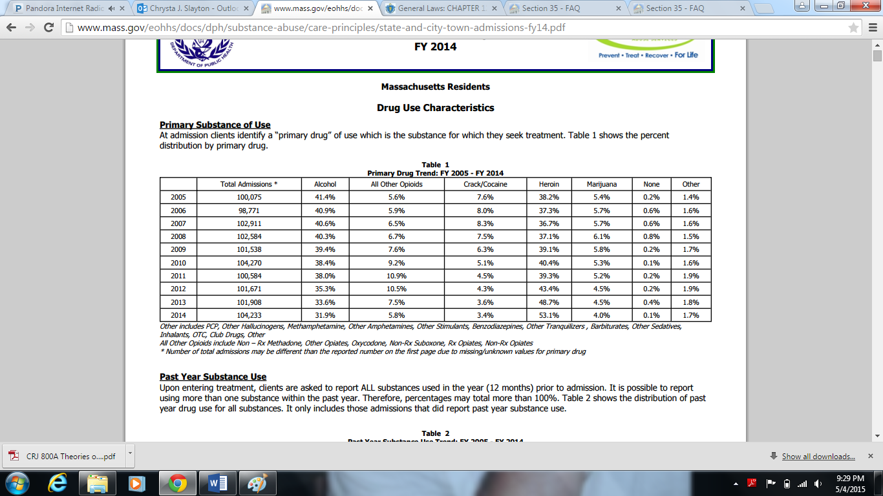
There has been an obvious increase in admissions for treatment in Massachusetts, as there was an increase of over 2,000 admissions from fiscal year 2013 to 2014. Alcohol abuse has held a steady decrease over the past ten years, with only 31.9% of clients naming it as their primary drug use in need of counseling and treatment. On the other hand, heroin abuse has been on the rise, with a high of 53.1% of clients naming heroin as their primary drug abuse in need of services. This trend which shows a decrease in alcohol abuse and increase in heroin use is consistent throughout most cities and towns in Massachusetts.
Drug abuse has reached epidemic proportions throughout the country. In the fall 2014 copy of Your Health magazine, provided by Harvard Pilgrim Health Care, there is a focus on substance abuse and its influence on teens and young adults. This article includes the risk factors that may influence a child’s likelihood of abusing drugs, expert advice for parents, and some statistics regarding the prevalence of drug use in Massachusetts. “Among 8th-, 10th-, and 12th-graders, alcohol and cigarette use has decreased from 1993 to 2013. Illicit drug use, which declined in the late 1990s and early 2000s has been increasing in recent years” (Harvard Pilgrim 2014).
Judge Minehan of Plymouth District Court noted the increase in Section 35 commitments in the last decade and went to the State Senate for help. In early 2014 Massachusetts State Senator Jen Flanagan was chosen to panel a special committee on Section 35. Senator Flanagan announced the successful passage of new legislation to strengthen the access to treatment, forcing insurance to cover at least 14 days of detox. This will hopefully lead to a decreased need for the Section 35 commitment. It was signed by Governor Deval Patrick on August 9, 2014 and its components were implemented in January of 2015.
Through her research, Senator Flanagan documented the drug epidemic through statistics gathered, personal interactions with the families of those suffering from addiction, and through her independent research efforts that have included visiting facilities such as the section 35 facility. She compared the relapse of an addict to a cheat day of a diet, but in the case of relapse leading to potentially fatal consequences. “Addicts think that if they use once it can just be that one time. When you detox and go back. . . . tolerance levels go down and when you try those high levels, this is where it becomes deadly” (Flanagan 2014).

The Process behind a Section 35 Commitment

1. Petition is filed at the courthouse by either family, probation, police or self
2. Warrant is issued (sunset rule, must be picked up before courthouse closes for the day)
3. Client is taken into custody
4. Petitioner is interviewed by clinician at courthouse (15-20 minutes)
5. Person is placed in lockup until they can be interviewed by psychologist (attorney present)
6. Mini hearing to decide if the person will be committed
If committed….
7. Brought to section 35 facility where they will be forced into treatment/counseling

Research Design and Methods
Through the permission of the presiding judge at the courthouse where this research took place, I was able to sit in and observe various court cases where a person may be committed. I was also able to watch the process where a family first came to the courthouse requesting to commit their child. The court refers men who have been civilly committed to the section 35 facility located on the South Shore of Massachusetts. Permission was also granted by the program director at the facility to sit in during daily private meetings between the counselors and the men they would individually meet with, after a consent form was signed by each participant. I attended group sessions, the daily AA meeting at the facility, and was able to administer a survey of my design regarding the men’s experience with drugs and the section 35 process.
All men held in the facility were invited to participate. The facility is divided into four different units. Unit 1 is the Detox unit, where all men begin and usually stay for 3-5 days. For the purpose of this research the survey results of the detox unit have been removed from the overall statistics due to the fact that many of the clients in the detox unit were very volatile and were experiencing withdrawal symptoms so they were less able to adequately participate in the survey. This work will only present the statistics of the more stable units which included 50 men. The survey included various questions regarding number of times in detox, which drugs have been used/abused, ratings of the section 35 process, and additional comments on what the men did and did not like about the way the process was conducted, on both the end of the court and treatment facility. Individual interviews also took place, as well as sit-ins with a counselor and each individual on their caseload. This combination afforded the research the opportunity to further understand the commitment process as well as the actual treatment provided to the clients once they are committed to the treatment programs.

Quantitative Survey Results
The following graphs were developed from the results of the survey administered and reflect the opinions of the men in the three more stable units. On a scale of 1 to 10, the average rating of the facility was a 7 (shown in chart 2).
Chart 2: Overall Rating of Section 35 Facility
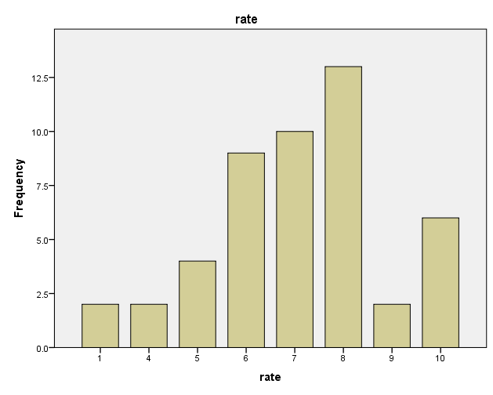
Another important finding from the survey results was the prevalence of men abusing more than one drug. The survey failed to determine whether addictions were co-occurring, but there was a question that requested the men check off from a list which drugs they had used in the past. Some of the men checked multiple substances from the list, which shows that most are not abusing just one drug but multiple, as drugs serve as a gateway to each other. Chart 3 shows a summary of the number of drugs abused by the men housed at the facility. Two men reported that they have used nine different kinds of drugs. The two most abused drugs were alcohol and heroin. Alcohol was abused by 75.862% of the men, while heroin was abused by 74.419% of the men.

Chart 3: Total Number of Substances Used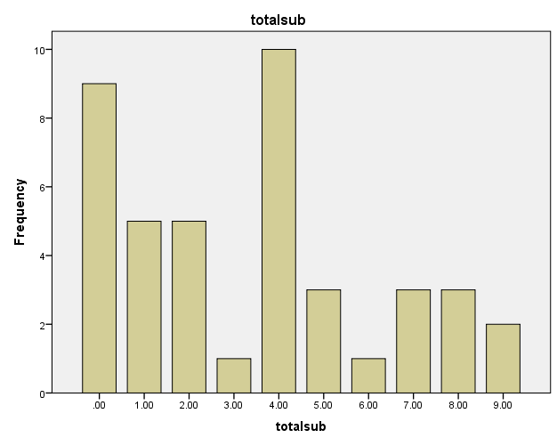

Qualitative Survey Results
The feedback from the participants made it clear that there is a need for change within the process of a section 35. There are many controversial parts of the law, including the wording of the statute as well as how the police and courts execute it. This became evident through interviews with clinicians, psychologist Steve DeLisi located at a local district court, and from a compilation of survey results obtained from the men held at the section 35 facility.
The first controversy occurs during the start of the commitment process. There is a “sunset rule” so once a warrant is issued for the civil arrest, the police only have until the close of the court day (usually between 4 and 5 pm) to pick the person up. If they are not arrested by this time then the petitioner must return to the courthouse the next day and refile the papers, and the whole process starts again. This becomes complicated when the petitioner does not know the exact whereabouts of the named party on the petition. Through interviews conducted with probation officers and court personel it has been found that some judges will extend the warrant until the next day if it is filed by the petitioner late in the day, although not actually permitted by statute.
The next controversy rises in the fact that there has only been one facility in Massachusetts for males and one facility for females that accepts these commitments. This research focused solely on the male facilities. This becomes problematic because there is no way that a 100-bed facility can properly hold and treat all of the men in the state that meet the two-prong standard for the section 35 process. When the section 35 facility is full, the men are sent to a jail-like facility that is also located on the South Shore. Some men in the facility explained in the survey comments that the section 35 facility is a resort compared to the jail-like facility where they could also be sent. Also, the section 35 facility is located on the South Shore which makes it inconvenient to access for the counties that are on the opposite side of the state.
Chart 4 was obtained from DeLisi at the courthouse and it displays the courts with the highest referral rates for the section 35 during fiscal year 2013. The top twenty courts are included. Quincy, Brockton, New Bedford, Fall River and Plymouth are the courts that utilize the statute most often, and they are also the closest to the facility. It’s unlikely that the courts in Western Massachusetts have less need for the statute, but the facility is very far, so they are less likely to use the section 35 statute to get help, as it would require their officers to drive the client all the way to and from the facility when a person be committed for treatment.

Chart 4: Courts with Highest Section 35 Referrals
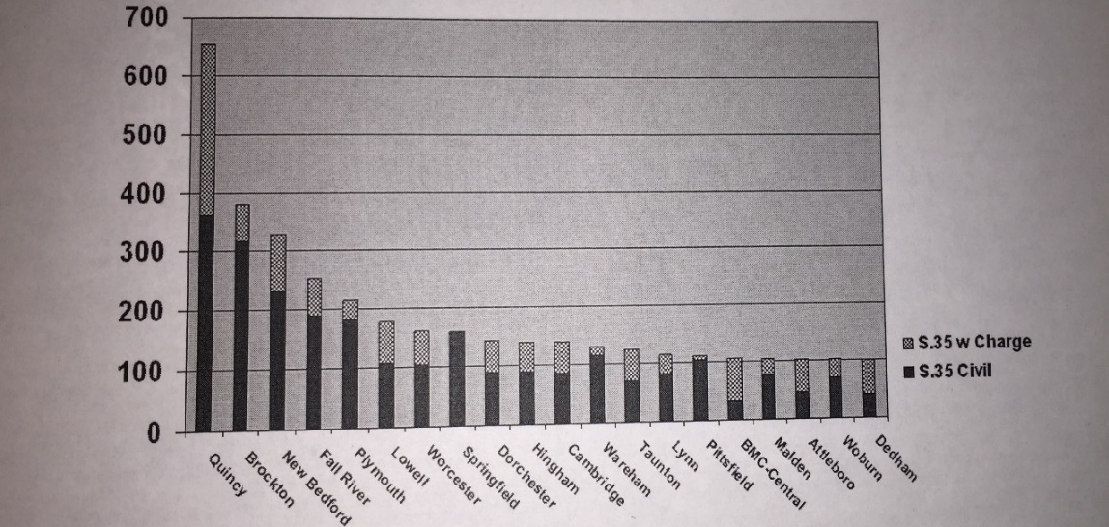
Chart 5 shows the survey broken down to determine who served as the petitioner for each of the clients held in the facility. This leads to the third controversial part of the law. M.G.L. Chapter 123 Section 35 states that a person can voluntarily commit themselves if they feel they are in danger of hurting themselves or others. Many lawmakers and court officials are working to remove this part of the law for a few reasons. First, people are abusing this line of the statute and will use the commitment toward a hidden agenda- ex. if they have an upcoming court date. Secondly, it is rare for a voluntary to not be committed. If the commitment was not accepted, and something was to happen to the client, it would be “blood on the hands” of the court and psychologist who chose not to commit the person requesting immediate help. Psychologist Steve DeLisi explains his opinion of the voluntary commitment: “The option for a voluntary commitment makes the court seem like an emergency room. People are demanding treatment and this isn’t what the law was intended for. Many of the people don’t meet the criteria.” Another issue with the voluntary is that if a person gets into the detox and starts experiencing withdrawals and requests to leave, they have to be allowed to walk out.

Chart 5: Petitioner in Section 35 Commitment
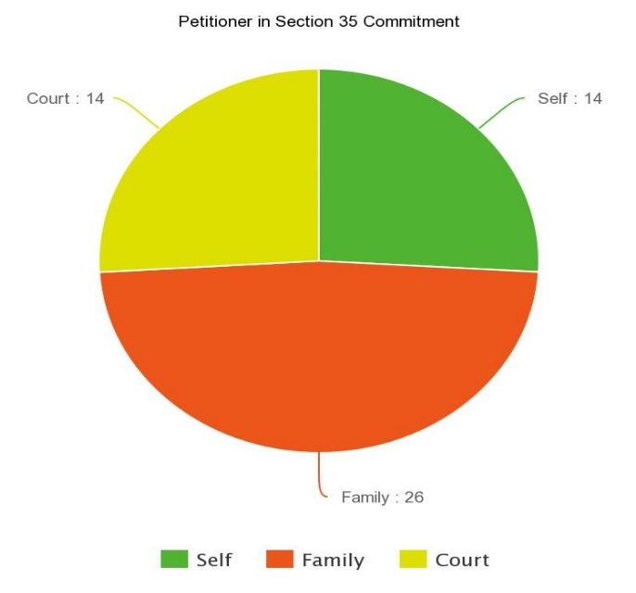
According to the mass.gov site on Section 35 FAQs, under the question “How long will the commitment be for?” the response is “The length of the civil commitment will vary with the severity of the client's addiction and the client's response to treatment. The commitment cannot exceed 90 days.” When interviewing a clinician at the section 35 facility, she explained that she had been working at the facility for almost five years and had only seen one person stay for over thirty days, and this was for medical reasons that required he remain put.
The law states “A person so committed may be released prior to the expiration of the period of commitment upon written determination by the superintendent that release of that person will not result in a likelihood of serious harm” (M.G.L. Chapter 123, Section 35). The problem is that most all people are being released between 10 and 12 days of their commitment date because their insurance companies won’t cover their stay for any longer period of time. After a person is released, they can immediately be re-committed if the process is run through again, and the court deems them a danger. During one interview, a man told me that he had been committed over 10 times. It is likely that each of these stays were less than two weeks. It costs the insurance company more to commit and recommit, rather than to just have the person serve out one longer sentence.
A fifth controversy occurs in the fact that this commitment involves a civil arrest. Most all of the men in the facility agreed that the process could have occurred more appropriately. One man explained that he had been picked up at work and carried out with no explanation whatsoever as to why he had been arrested, leaving his employers and co-workers with no answers. He was then shackled, and later driven to the facility going 65 mph on the highway with no control at all. He described the treatment as “inhumane” and felt violated of his freedom when he hadn’t even broken a law.
Lastly, and as is seen with many laws, education is an issue. People do not understand the purpose of a section 35 and imagine that after their loved one’s release they will no longer use, when in reality a detox is forced sobriety for the length of stay. Senator Jen Flanagan explains, “It’s meant to detox you. . . . the law works- not meant to recover you.” People do not understand the goals of the law, and therefore have unrealistic expectations of its effects.
The second to last question included in the survey asked for a general rating behind the section 35 process as a whole, from commitment at the courthouse to treatment at the facility. The final question asked for a reasoning behind the rating, in addition to any other comments the participant would like to add regarding the process. These comments were widely agreed upon across the board, from the recently added clients who had been in detox no longer than a few days, to the men who were nearing the end of their stay in the facility. There were many surveys that complemented the staff and services available, but most all agreed that they needed more individualized attention from both counselors and doctors. The following includes a list of the negative comments that were raised the most, which therefore serve as areas that need improvement during the section 35 process. 1). lack of individual counseling, 2.) under staffed facility, 3). takes long to see a doctor, 4.) all about insurance.

Conclusions and Implications for Further Research
The present study determined that the Commonwealth of Massachusetts needs to afford more treatment for drug and alcohol abusers. According to research on the topic and the survey results, it is obvious that drug abuse is on the rise, and addiction needs to be taken more seriously. There is controversy in the wording of the M.G.L. Chapter 123 Section 35 statute, and the process leading to and following a commitment. This is an increasingly important topic as alcohol and drugs are intertwined with many offenses within criminal justice. Better understanding of this important topic could have implications for the system both financially and programmatically. ​
There may be some aspects of the current study that affected the survey results, and there are some changes that would need to be made were the study to be replicated in the future. One such aspect is that the survey failed to ask any demographic questions of the men housed in the facility. Another factor is that in the survey section labeled “Which drugs have you been in treatment for abusing?,” the question could have been more effective had it asked which drugs had been used. It would have also been more effective had the men circled the drugs they used, as opposed to checking yes or no, because many men skipped the question entirely, thinking that they only needed to check yes to the drugs they used, ignoring the “no” column. It is difficult to determine whether the findings of the survey could be generalizable, as there were only 50 men held in the stable units who chose to participate, and 16 in the detox units. The researcher’s participant pool was only 66 participants, all of whom were male, which makes it difficult to determine if these results are reflective of the overall population within the Commonwealth of Massachusetts.
The findings of this research suggest that the section 35 statue is one that could use improvements. Since the start of this research is September of 2014, one major change is already underway. According to the M.G.L. Chapter 123 Section 35 “Nothing in this section shall preclude any public or private facility for the care and treatment of alcoholism or substance abuse, including the separated facilities at the Massachusetts correctional institutions at Bridgewater and Framingham, from treating persons on a voluntary basis.” There has been an attempt to remove the “voluntary” aspect completely and although it has not yet passed, there is a committee underway to remove this last statement of the statute.
Alcohol and drug abuse often serve as facilitators for crime. If more efforts were dedicated to not only helping the men get clean, but to also give support finding aftercare programming following their release from the section 35 facility, the men would have a better chance staying clean, which in turn would help to lower recidivism rates for crime.

Works Cited
The Commonwealth of Massachusetts. "Section 35." The 189th General Court of the Commonwealth of Massachusetts. The General Court, n.d. Web. 6 May 2015. <https://malegislature.gov/Laws/GeneralLaws/PartI/TitleXVII/Chapter123/Section35>.
DeLisi, Steve. Personal interview. 15 Sept. 2014.
"Description of Admissions To BSAS Contracted/Licensed Programs FY 2014." Commonwealth of Massachusetts Department of Public Health. Bureau of Subtance Abuse Services, n.d. Web. 6 May 2015. <http://www.mass.gov/eohhs/docs/dph/substance-abuse/care-principles/state-and-city-town-admissions-fy14.pdf>.
Flanagan, Jen, Senator. Personal interview. 2 Dec. 2014.
Harvard Pilgrim Health Care. "Substance Abuse Hits Home." Your Health Fall 2014: 8-9. Print.
"Senate to Appoint Special Committee on Section 35." Jen Flanagan. N.p., n.d. Web. 6 May 2015. <http://www.jenflanagan.com/news>.
"Sen. Flanagan to chair panel studying addiction treatment in Mass. Read more: http://www.sentinelandenterprise.com/breakingnews/ci_24926835/sen-flanagan-chair-panel-studying-addiction-treatment-mass#ixzz3ZQIu3jz0." Sentinel & Enterprise. Fitchburg Sentinel and Enterprise, 16 Jan. 2014. Web. 6 May 2015. <http://www.sentinelandenterprise.com/breakingnews/ci_24926835/sen-flanagan-chair-panel-studying-addiction-treatment-mass>.

Appendix A: Consent Form
Consent Form for Participant Interviews

I, ( ), agree to participate in the Maximum Sentencing under Section 35 project conducted by Chrysta Slayton. I understand this project is studying the effectiveness of the change in the maximum involuntary sentence for drug/alcohol. My involvement in the study involves my court/treatment records being viewed. I understand that I may not receive any direct benefit from my participation in this study. I understand my participation is completely voluntary and that I may withdraw at any time from this study. If you volunteer to be in this study, you may withdraw at any time without consequences of any kind. The investigators may withdraw you from this research if circumstances arise that warrant doing so.
I understand there are no risks to me directly as my confidential information will never leave the security of the treatment facility or court house. Any published research will be confidential and my name will never be released, nor will any information connecting the research back to me. Chrysta Slayton who is leading this research will be the only one with access to my records. This research will begin in July of 2014 and end by December 15, 2014. After the study has concluded, any personal data with my name will either be returned to its proper files at the facilities or properly disposed of to protect my confidentiality. I understand that any information that is obtained in connection with this study and that can be identified with me will remain confidential and will be disclosed only with my permission or as required by law, unless at the end of the interview I grant permission to use my name in association with my views and personal experiences. I understand that a code name or pseudonym will be used in place of my real name in any transcribed material. If the results of the research are published or discussed in conferences, no information will be included that would reveal my identity. The information provided to the researchers will be kept confidential with the exception of information which must be reported under Massachusetts’s law including cases of child or elder abuse. I have read and understand this information and agree to participate in this study. I will be offered a copy of this form to keep.
For questions or concerns about the research, please contact Chrysta Slayton at c_slayton@salemstate.edu or Jeb Booth, professor at Salem State University who will be sponsoring/advising this research project, at jbooth@salemstate.edu.

Participant’s Signature:
Signature:
Date:
********************************************************************************************
For concerns about your treatment as a research participant, please contact:
Institutional Review Board (IRB)
Sponsored Programs and Research Administration
Salem State University
352 Lafayette Street
Salem, MA 01970
(978) 542-7556 or (978) 542-7177 or irb@salemstate.edu
A copy of this signed form is as good as the original.

This research project has been reviewed by the Institutional Review Board at Salem State University in accordance with US Department of Health and Human Services Office of Human Research Protections 45 CFR part 46 and does not constitute approval by the host institution.

Appendix B: Disclosure Form
Salem State University
Institutional Review Board (IRB)
Disclosure Statement for Self-Report Survey
My name is Chrysta Slayton. This questionnaire is for a research paper I am doing for school. This research is regarding whether the extended maximum sentence (extended from 30 days to 90 days) in the M.G.L. Chapter 123, Section 35 [that states that a person may be involuntarily committed to a treatment center if they are abusing drugs/alcohol and are in immediate danger of hurting themselves or others] has proven itself beneficial. This will be used to identify issues that may exist with the way this law was written and how it is executed. This will result in some recommendations for change to further benefit those who are receiving treatment. It will ask questions about your history with the sectioning process and any drug/alcohol involvement you may have had. Participation is completely voluntary. There are no right or wrong answers. You may stop at any time. All answers will remain completely anonymous. You do not have to answer any questions that make you feel uncomfortable. When you are done, please place your questionnaire in the envelope at the front of the room. There are no known risks. If you have any questions about this research you can contact me at c_slayton@salemstate.edu.
I understand that my name or identity will not be used in reports or presentations of the findings of this research. The information provided to the researchers will be kept confidential with the exception of information which must be reported under Massachusetts’s law including cases of child or elder abuse. For questions or concerns about the research, please contact Chrysta Slayton (researcher) or the faculty adviser of this research in the Criminal Justice department at Salem State University, Jeb Booth, at jbooth@salemstate.edu.
This research project has been approved by the Institutional Review Board at Salem State University. Thank you for your help.
******************************************************************************
For concerns about your treatment as a research participant, please contact:
Institutional Review Board (IRB)
Sponsored Programs and Research Administration
Salem State University
352 Lafayette Street,
Salem, MA 01970
(978) 542-7556 or (978) 542-7177 or irb@salemstate.edu

A copy of this signed form is as good as the original.
This research project has been reviewed by the Institutional Review Board at Salem State University in accordance with US Department of Health and Human Services Office of Human Research Protections 45 CFR part 46 and does not constitute approval by the host institution.

Appendix C: The Survey

How many times have you been to a detox? ________
How many times have you been in any type of drug/alcohol treatment? __________
Which drugs have you been in treatment for using? (please check yes or no)
Alcohol [ ] yes [ ] no
Marijuana [ ] yes [ ] no
Heroin [ ] yes [ ] no
Opium [ ] yes [ ] no
Cocaine [ ] yes [ ] no
Amphetamine [ ] yes [ ] no
PCP [ ] yes [ ] no
LSD [ ] yes [ ] no
Percoset [ ] yes [ ] no
Other (please list): ________________________________________
For how long have you been using drugs? _______________
For how long have you been using alcohol? _______________________
Who were you sectioned by? (please check one of the following)
Myself [ ]
Family [ ]
Court [ ]
Which court have you been sectioned out of? _____________________
How many days do you think you should be here for proper treatment? ________________
How did you find out what sectioning was? Please explain:
______________________________________________________________________________
Did you know what it was prior to your section? Please explain: ______________________________________________________________________________
Do you feel that when you were sectioned you were in immediate danger of hurting …. (please check yes/no)
Yourself? [ ] yes [ ] no
Others? [ ] yes [ ] no
Was this section voluntary or involuntary? (please check one of the following)
[ ] voluntary
[ ] involuntary
Continued on next page
Are you presently/or in the past involved with the court in a criminal nature? (please check one of the following)
[ ] yes [ ] no
How would you rate the treatment you are receiving? (please circle of the following: 1 is worst, 10 is best)
1 2 3 4 5 6 7 8 9 10
Please explain your reasoning for #10:

Additional comments?

Thank you for participating.

