A Literature Review of Effects of Concussions on the Brain and Mental Health of Athletes

Honors Thesis

Presented in Partial Fulfillment of the Requirements
For the Degree of Bachelor of Science in Biology

In the College of Arts and Sciences
at Salem State University

By

Tyler Devine

Dr. Thomas Scottgale
Faculty Advisor
Department of Biology

Commonwealth Honors Program
Salem State University
2021

Abstract
This literature review investigates the effects concussions have on the brain and mental health of athletes. The mechanism of concussions is described as how it affects the brain and some possible cellular effects. Then several studies are highlighted in the major contact sports of football and soccer as well as a comparison of the rate of concussions in men’s versus women’s sports. It is also pointed out that concussions occur much more often in competition than in practice sessions. The analysis shows there’s a strong correlation between concussions and mental issues such as anxiety, depression, behavioral and emotional changes. Functional Neurocognitive Imaging is a new technique used in detecting concussion injuries and can be used to develop a treatment plan for injured individuals. It is also pointed out that concussions can lead to serious disorders like Chronic Traumatic Encephalopathy (CTE), Second Impact Syndrome (SIS) and Parkinson’s Disease, but with the correct amount of treatment and recovery time, athletes can go back to living their life normally without the fear of future mental backlash from their initial concussion.

Acknowledgements
First and foremost, I want to thank my father for raising me, giving me all the love in the world and showing me how to be a man. I have never met a more hardworking, selfless and honest person in my life. I can only hope to be half the man he is one day. Secondly, I would like to thank Dawn Stahura from the Salem State University library. She paved the way for my research and gave me many tips and tricks to make this process go much smoother. Last and certainly not least I would like to thank my thesis advisor Dr. Scottgale, who has been my favorite professor here at Salem State. During this pandemic nothing has been easy with online classes, but every single week Dr. Scottgale took the time out of his very busy schedule to meet with me to give me great advice and bounce ideas off each other to ensure we got our best work possible. I could not have asked for a better person to help me throughout this thesis and am honored to have both of our names together on this project.

Table Of Contents

Introduction pg. 1
What is a Concussion? pg. 1-6
Concussions in Football pg. 7-9
Concussions in Soccer pg. 10-11
Comparing concussions in Men’s vs Women’s Sports pg. 11-18
Psychological Effects of Concussions pg. 19-20
Treatment pg. 20-23
Conclusion pg. 24
References pg. 25-30

Introduction
There are 3.8 million concussions in athletes in the United States every year, 50% of those athletes aren’t receiving proper treatment, or they’re returning right away so that they are playing with concussion symptoms, this is called underreporting (Harmon, 2018). Chronic Traumatic Encephalopathy (CTE), depression, anxiety, memory loss, Parkinson's and dementia are just some of the long-term effects of concussions. Having a concussion increases your risk for dementia by 72% and for Parkinson’s disease by 57% (Dewan,2020). With increases in early deaths and suicides from ex-NFL players due to CTE, the NFL and other professional sports have ramped up their protocols and treatments for concussions, but these injuries still happen almost every day (Ruth, 2017). The intent of this paper is to not only define what a concussion is and how certain sports are affected by them, but what the psychological effects of these injuries can be and what is being done to prevent these injuries from occurring so athletes can have a safe and successful career as well as a happy, fully functioning life after they stop playing.

What is a concussion?
A concussion is a form of a traumatic brain injury (TBI) that is caused either by a hit directly to the head or a forceful hit to the body that makes the person's brain move rapidly around in the skull (Nowinski, 2021). Figure 1 below shows three of the most common mechanisms of a concussion. The left shows a direct impact injury where the skull is hit with such force thereby causing bruising of the brain directly beneath the point of impact. The middle image shows an acceleration-deceleration injury which causes the brain to swoosh around, hitting the skull and causing damage to the brain tissue both anteriorly and posteriorly as well as near the brain stem. The right image shows a blast injury which can be seen with military service members serving in places like Afghanistan when a bomb or explosive goes off and causes a shock wave to go through the body.
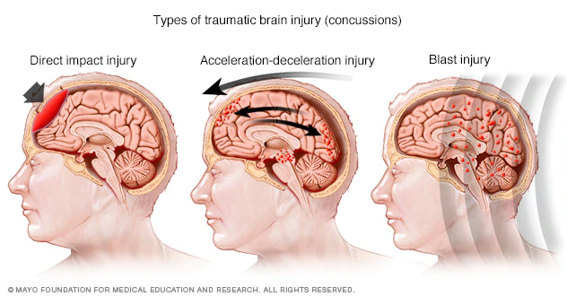
Figure 1. Comparison of three most common types of injuries that lead to concussion. The image on the left is direct contact, the middle image shows a force causing the brain to shift back and forth and the image on the right shows an event with wave energy causing the brain to shake. (https://www.mayoclinic.org/diseases-conditions/concussion/multimedia/img-20456526)
The distance between the brain and the skull is only 0.4-0.6mm. So, a fast movement can cause bruising of the brain which would ultimately lead to inflammation as seen in the middle image of figure 1. The concussions shown in figure 1 lead to hypoactive and hyperactive areas of the brain where blood flow is in excess or depleted (Allen, et al., 2017). Hypoactive areas are where parts of the brain aren’t getting enough oxygen causing decreased levels of activity controlled by that particular area of the brain. Hyperactive is the opposite situation where too much blood is flowing to the brain and causing that person to expend too much energy, and this causes health issues. These hyperactive and hypoactive areas are shown by a new imaging machine called fNCI (functional neurocognitive imaging). These machines are claimed to be 98% accurate in diagnosing concussions (Allen, 2018). The protocol used for diagnosing concussions involves fNCI using multiple tests. One test involves showing the cerebral blood flow to all areas of the brain to see which are hypoactive and hyperactive (Allen, et al., 2017). This idea of hypoactive and hyperactive areas due to blood flow is discussed in further detail with the fNCI machine later in the treatment section of the paper. The hyperactive areas with the increase in blood flow also have an increase in cerebrovascular reactivity as shown in figure 2 when the brains of concussed athletes were investigated by Militana, et al., 2014. 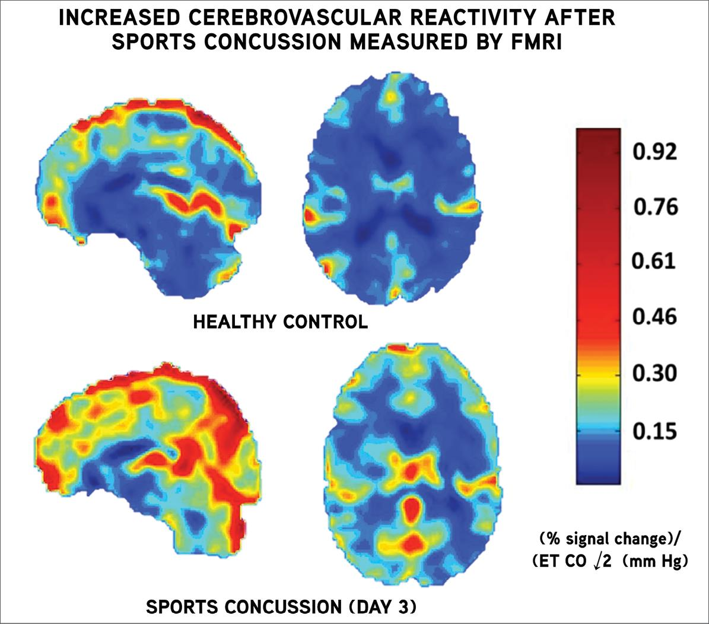
Figure 2; Cerebrovascular Reactivity in the Brain Shown by an FMRI post-concussion
The figure above shows the difference between a healthy brain and a concussed brain. The top healthy brain shows mainly dark blue areas with low levels of cerebral activity, while the bottom concussed brain shows high levels of cerebral activity shown in red. This image was shown by Vanderbilt University to illustrate the work done by Militana, et al. in 2014 (Morgan, 2015)

Figure 2 shows brain function of college athletes ages 18-22 after a concussion. Adam Militana of Vanderbilt University used a functional MRI with increased levels of carbon dioxide (hypercarbia) to show that certain parts of the brain will show elevated cerebrovascular reactivity in concussed athletes (Militana, et al., 2014). The red you see in the bottom portion of the figure shows an acute injury following a concussion. Cerebrovascular reactivity refers to the response of cerebral blood vessels to vasoactive stimuli, which is the widening and closing of blood vessels that controls blood flow. That controlling of blood flow leads to the hypoactive versus hyperactive areas mentioned above (Catchlove, 2018). This increased cerebrovascular reactivity is 33% higher in the concussed brains and these areas lead to severe headache symptoms (Catchlove, 2018). When tissue in our body gets inflamed, it enlarges, and inflammation of the brain could cause the brain to push up against the skull. Pressing brain tissue against the skull could lead to lack of cerebral blood flow thus causing a lack of oxygen to the brain cells initiating a chemical change in the brain. Giza and Hovda, (2001) show that with an injury to the brain, neurotransmitters begin to be released and bind to the N-methyl-D-aspartate (NMDA) receptor causing a large influx of calcium ions and efflux of potassium ions (K⁺) which leads to an increase in extracellular K⁺ concentration seen between minutes 1 and 2 in Figure 3 below. This leads to the sodium potassium pump having to put in extra work to pump the potassium ions back into the cell and this is seen as an increase in the CMRglucose levels figure 3. This hypermetabolism occurs in the process of diminished cerebral blood flow. Hypermetabolism usually lasts for days but in some cases, it can take weeks or months to return to normal. This is called post-concussion vulnerability and basically, there’s an energy crisis that occurs with the supply and demand of glucose making the brain vulnerable and less likely to respond properly to a second injury and longer-lasting defects are often seen (Giza and Hovda, 2001).
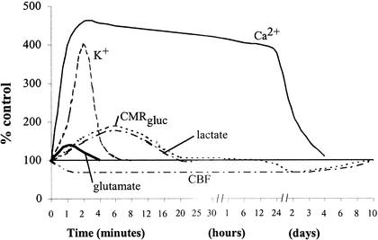

Figure 3; Neurometabolic cascade following a concussion
Figure 3 shows what happens to different ions in the brain after a concussion. The three lines highlighted in the text are Potassium (K⁺), Calcium (Ca²⁺) and CMRglucose (Giza and Hovda, 2001).
Another aspect of molecular changes that occur in a concussion is an increase in intracellular calcium ion concentration (Giza and Hovda, 2001). This high level of calcium in the mitochondria can lead to cell death. This connection between high cytosolic levels of calcium and cell death was described by Maria Calvo-Rodriguez when researchers focused on how the brain reacts in Alzheimer’s patients. They saw elevated levels of calcium in the mitochondria causing oxidative stress and death of neurons by apoptosis (Calvo-Rodriguez, 2020.).
A very rare and serious post-concussion ailment for the brain is Chronic Traumatic Encephalopathy (CTE) (Pruthi, 2019.). CTE is a brain degeneration disease that occurs after a history of multiple head trauma incidents (the exact number has not yet been determined) and has a complex relationship with Second Impact Syndrome (SIS) which is discussed later (Pruthi, 2019). As seen below in figure 4, CTE is pathologically shown by frontal and temporal lobe atrophy which is why the CTE brain on the right of the figure is substantially smaller than the healthy brain on the left. Notice how the brain with CTE has degenerated severely compared with the healthy brain on the left with no history of head trauma (Stein, 2014.). The signs and symptoms of CTE are seen decades after head trauma but they include problems with thinking, memory, sleep as well as emotional and behavioral changes (Pruthi, 2019). 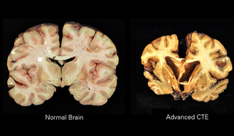
Figure 4; Impact of the degenerative brain disease CTE
The images show the difference between a healthy brain on the left and one impacted by CTE on the right. (https://www.livescience.com/59932-images-brains-cte.html)
So far, a concussion has been defined and the three major injury types that lead to them have been described. After a concussion, several chemical processes that the brain goes through have recently been described and these presumably lead to changes in our emotions and behavior which are discussed later in the psychological effects section of this paper. Lastly CTE was introduced and it was seen how the frontal and temporal lobes degenerate over time. CTE is now becoming recognized as a big issue in retired football players especially those who had long careers in the NFL.

Concussions in Football
Football is one of the most violent sports in the world with the second highest rate for concussions in competition and third highest in practice (Cruz, 2018). From when people start hitting in football at around age 10 until 26, which is the average age of retirement in the NFL, football players are constantly hitting or getting hit (Bloom, 2019). A group of Neurosurgeons from Boston University did a study with 202 brains of deceased football players that were donated to science. These brains included NFL players as well as players that reached the collegiate level. Of the 202, 177 had CTE which is 87% and 110 of 111 former NFL players had CTE (Mez, 2017). New helmet technologies have made great strides to try and limit concussions, but that isn’t actually what helmets were initially made to do. Helmets in the NFL were made to prevent skull fractures that often occurred when football was played with no helmets (Taylor, 2018). These helmet-to-helmet hits are the leading causes of concussions in football players, but hard body contact is a close second (Loewen, 2020). These can be hits to the body that are done with so much force that the player's neck will snap back and cause the brain to bounce around in the skull and cause a concussion by the acceleration/deceleration mechanism seen in Fig. 2 (Loewen, 2020). Only 10% of concussions in the NFL occur from a player getting knocked out (Loewen, 2020). Athletes who suffer a concussion are 4-6 times more likely to have another concussion (Bailes, 2018). From 2012-2019, there were an alarming 254 NFL players per year that had a concussion. To put that number into perspective at any given time throughout the season each of the 32 NFL teams can have a maximum of 53 active players giving us an estimated total of 1,696 players. Yes, this initial concussion is a major issue, but returning to play without proper healing can be a deadly issue. This is called Second Impact Syndrome (SIS) that was mentioned above in regard to its connection with CTE later in life (Bey, et al., 2009). SIS occurs when players have had a concussion and return without the brain properly healed. Bey, et al. 2009 report on a study of 35 high school and college football players showing symptoms of SIS. Severe swelling occurs in SIS which can push the brain tissue intensely against the skull and can sometimes cause herniation of the brain and death within minutes (Bey, et al., 2009). Also, in this study, data was collected over a 13 year period of 92 severe head injuries in high school and 2 at the collegiate level and 71% of these people had a concussion earlier in the same season. In fact, 39% of the people sustaining a second head injury were playing with concussion symptoms they suffered from their initial severe injury (Bey, et al., 2009). Children and teenagers are the most susceptible to concussions because their brains haven’t fully developed yet, and they have much weaker necks muscles (Fins, 2020). Twenty percent of high school football players get concussions every year and 60% of concussions in high school sports are from football (Bailes, 2018) In 2016 the American Academy of Pediatrics did a study on concussions and found that in athletes ages 18 and below there were between 1.1-1.9 million concussions in the United States and between 511,000-1 million of them weren’t seen in healthcare settings (Bryan, 2016). If treated properly with sufficient time for healing, the risk of having any mental issues and the risk of having another concussion go down immensely (Walensky, 2016).
In 2018 NFL protocols were put into place to limit the amount of concussions during play after Tom Savage, a quarterback for the Houston Texans, had a seizure on the field after returning from a head injury earlier in the game. After this injury, a Neurotrauma consultant was added to each team's sideline, overseeing the game to watch for any signs of a possible TBI or concussion (Sills, 2020). If this professional observes any stumbling, falling or signs of confusion, they are to inform the referee and that player is required to be taken to the locker room for evaluation. Once this player is evaluated, they need to be evaluated again within 24 hours, even if they passed the first test to ensure there are no concussion like symptoms (Sills, 2020). Concussions were most common on kickoff plays, where players were running full speed over 30-40 yards at each other (Sills, 2020). In 2018 the NFL moved the kickoff to the 35-yard line from the 20 yard line which resulted in a 34% decrease in concussions on this play because moving this up 15 yards results in more kicks going through the endzone. Therefore, there is no return and the ball just gets put on the 25-yard line automatically (Sills, 2020).
So, as you can see concussions in football are seen in a variety of age groups and leagues. SIS was briefly discussed and has a correlation to CTE; in fact, SIS has been shown to possibly lead to death. The NFL is making strides to protect their players from concussions and limit the chances of returning too early so as to reduce the risk of a SIS injury. Another sport with high rates of concussions is soccer and it is similarly making enhanced efforts to lower the risk of concussions at all age groups especially young kids.

Concussions in soccer
Another major sport in the world that has a concussion issue is soccer (Loewen, 2019). Right away when most people hear this, they think it is all because they’re heading the ball, but actually the most common cause of concussions in soccer is from forceful body to body contact (Loewen, 2019). Professional soccer players head the ball around 6-16 times per match but run into each other much more and concussions are 22% of the injuries in the sport (Nunez, 2020). A study done from 2005-2014 showed that 60% of concussions occurred from player to player contact and 28% were from the behavior of heading the ball (Mooney, et al., 2020). Seventy percent of that overall, 28% were from player to player contact in an attempt to head the ball, not actual ball to head contact (Mooney, et al., 2020). This body-to-body contact is similar to that seen with football in which force of contact makes the neck whiplash, causing the brain to swoosh around and hit the skull and thereby causing a concussion. To investigate this, Rodgrigues, Lasmar and Caramelli had one group of players head the ball for 20 minutes and other players had 20 minutes of no heading and there was no cognitive difference between the two groups after testing (Rodrigues, et al., 2016). Another part of their work included checking the brains of 37 professional and collegiate soccer players with a history of head injuries in the sport, and 81% had mild to severe deficits in attention, concentration, memory and judgement (Rodrigues, et al., 2016). A CT scan was done with these players and one third of them showed some form of central brain atrophy (Rodrigues, et al., 2016). As seen above in regard to football, the younger generation of soccer players are also having concussions issues due to their weaker neck muscles (Loewen, 2019). The US Soccer Federation is taking strides like the NFL Foundation to limit concussions in younger athletes by banning heading for kids 10 and under as well as limiting heading in ages 11-13 (McLaughlin, 2020).
The body-to-body contact injury leading to the acceleration-deceleration movement has been shown to cause concussions now in football and soccer. Two completely different sports in the way they move the ball and levels of contact, but they both have higher rates of concussion than many other sports. The next idea to explore is the question of are there differences in rate of concussions in men’s versus women’s sports.

Comparison of the rates of concussions in Men vs Women
Given that different sports show substantial risk of concussions, let’s investigate the rates of concussions in men’s sports versus women’s sports. The two tables shown below portray how many athletes participated in particular sports at the high school and collegiate level, as well as the concussion rates for practice and overall competition for men’s and women’s sports. Table 1 illustrates the number of participants in each of the listed sports to give context for Table 2 which deals with the actual comparison of concussions in men’s sports versus women’s sports.
In table 1 below, the left side is high school, and right is college (Daneshvar, 2011). In each of those divisions there is a section for men’s and women’s sports. The largest overall participation number seen is football for men at 35.6 million at the high school level and 1.9 million at the collegiate level. Soccer shows a large number of participants at 7 million for men and 5 million for women at the high school level. Basketball and Lacrosse are two sports that also show a large number of participants and almost equal representation by both men and women

Table 1 Athletic participation figures by gender for 20 years
High School |  | College
 | Men | Women | Men | Women
Baseball | 10,916,754 | 23,517 | 616,947 | 0
Basketball | 13,796,973 | 11,041,039 | 374,600 | 328,237
Cross country | 4,546,218 | 3,486,467 | 275,202 | 235,937
Equestrian | 621 (2004–2007) | 4322 (2004–2007) | 1268 (2003–2007) | 6245 (2003–2007)
Field hockey | 2781 | 1,431,676 | 0 | 145,133
American football | 35,623,701 | 17,872 | 1,929,069 | 0
Golf | 480,989 (2005–2008) | 199,721 (2005–2008) | 24,844 (2005–2008) | 12,197 (2005–2008)
Gymnastics | 98,169 | 637,467 | 15,298 | 38,775
Ice hockey | 722, 874 | 72,537 | 99,626 | 17,309
Lacrosse | 858,712 | 589,973 | 151,309 | 106,153
Rowing | 16,147 (2001–2007) | 17,111 (2001–2007) | 14,107 (2001–2007) | 47,310 (2001–2007)
Skiing | 154,979 (1994–2007) | 131,660 (1994–2007) | 16,923 | 15,052
Soccer | 7,175,341 | 5,184,875 | 429,603 | 321,982
Softball | 29,743 | 8,141,872 | 0 | 322,777
Swimming | 2,242,814 | 2,919,225 | 203,271 | 231,394
Tennis | 3,677,132 | 3,832,588 | 199,274 | 203,695
Track | 13,266,497 | 10,747,774 | 933,764 | 728,059
Volleyball | 536,747 (1994–2007) | 5,364,475 (1994–2007) | 15,391 (1994–2007) | 182,530 (1994–2007)
Water polo | 220,778 | 189,126 | 25,543 | 10,266 (1998–2006)
Wrestling | 6,235,016 | 46,361 | 175,353 | 0
Total | 100,602,986 | 54,067,623 | 5,501,432 | 2,953,051
Table from (Daneshvar, 2011).
Table 2 shows the difference in occurrence of concussions not only between men’s and women’s sports, but also between practice and competition (Gessel, et al., 2007). Column 1 shows the particular sport and whether it is men’s or women’s. Column 2 shows the division distinguishing between high school and college. Column 3 is the concussion rate during practice. Column 4 is concussion rates during competition and column 5 is the overall concussion rates in practice and competition combined. Column 6 is the rate ratio in collegiate sports which is the rate of how more or less common a concussion will happen in the particular collegiate group compared to what happened in the high school group. Column 7 is the 95% confidence interval showing that 95% contains the true median of the whole population. Column 8 is the P value which tells about the statistical significance, the smaller the number the stronger the significance to agree with the hypothesis.

Table 2 Concussion rates in US high school and collegiate athletes in practice and competition, 2005 to 2006
 |  | Rates of concussions in 1000 athlete exposures |  |  | Overall Rate Comparison  Collegiate vs High School
Sport | Division | Practice | Competition | Overall | Rate Ratio | 95% CI | P value
Football | High school | 0.21 | 1.55 | 0.47 | — | — | —
 | Collegiate | 0.39 | 3.02 | 0.61 | 1.31 | 1.09, 1.58 | <0.01
Men’s soccer | High school | 0.04 | 0.59 | 0.22 | — | — | —
 | Collegiate | 0.24 | 1.38 | 0.49 | 2.26 | 1.43, 3.57 | <0.01
Women’s soccer | High school | 0.09 | 0.97 | 0.36 | — | — | —
 | Collegiate | 0.25 | 1.80 | 0.63 | 1.76 | 1.21, 2.57 | <0.01
Volleyball | High school | 0.05 | 0.05 | 0.05 | — | — | —
 | Collegiate | 0.21 | 0.13 | 0.18 | 3.63 | 1.39, 9.44 | <0.01
Men’s basketball | High school | 0.06 | 0.11 | 0.07 | — | — | —
 | Collegiate | 0.22 | 0.45 | 0.27 | 3.65 | 2.01, 6.63 | <0.01
Women’s basketball | High school | 0.06 | 0.60 | 0.21 | — | — | —
 | Collegiate | 0.31 | 0.85 | 0.43 | 1.98 | 1.31, 3.01 | <0.01
Wrestling | High school | 0.13 | 0.32 | 0.18 | — | — | —
 | Collegiate | 0.35 | 1.00 | 0.42 | 2.34 | 1.26, 4.34 | 0.01
Baseball | High school | 0.03 | 0.08 | 0.05 | — | — | —
 | Collegiate | 0.03 | 0.23 | 0.09 | 1.88 | 0.79, 4.46 | 0.22
Softball | High school | 0.09 | 0.04 | 0.07 | — | — | —
 | Collegiate | 0.07 | 0.37 | 0.19 | 2.61 | 1.17, 5.85 | 0.03
Men’s sport total | High school | 0.13 | 0.61 | 0.25 | — | — | —
 | Collegiate | 0.30 | 1.26 | 0.45 | 1.78 | 1.52, 2.08 | <0.01
Women’s sport total | High school | 0.07 | 0.42 | 0.18 | — | — | —
 | Collegiate | 0.23 | 0.74 | 0.38 | 2.04 | 1.59, 2.64 | <0.01
Overall total | High school | 0.11 | 0.53 | 0.23 | — | — | —
 | Collegiate | 0.28 | 1.02 | 0.43 | 1.86 | 1.63, 2.12 | <0.01
Collegiate data provided by the National Collegiate Athletic Association Injury Surveillance System. High School data provided by the High School Sports-Related Injury Surveillance System. Abbreviation: CI, confidence interval. Data from Gessel, et al., 2007.
In the men’s versus women’s totals near the end of Table 2, it shows men’s sports having a higher rate of concussions per player (collegiate men with a rate of 0.30 versus 0.23 for women), but that is because collegiate football has the highest rate of concussions at 3.02 (men collegiate competition). If you were to take football out of the equation, women’s sports would have higher concussion rates. When looking at men’s soccer versus women’s soccer there is a large number increase in every category for women’s. Except in high school, the same thing happens in men’s basketball versus women’s basketball suggesting once again that concussions happen at a higher rate in women’s sports. There are several possible explanations. One possibility is that men have bigger and stronger neck muscles so they can brace for contact better to limit the neck snapping back in an acceleration-deceleration injury highlighted in Figure 1 (Jones, 2018). Another possibility is a slight difference in reporting bias, a study showed that men lie about concussion symptoms to stay in the game 79% of the time while women do it 70% (Jones, 2018).
You can also see in Table 2 that concussions happen at a much higher rate in competition versus practice. Daneshvar, 2011 shows that this is because practices are more of a walk through and preparation, while competition is much more intense, thus having a much higher possibility of injury (Daneshvar, 2011). With football, you can see the practice concussion rates in both high school and college are low and close together, but the numbers increase with competition, much higher in college. The large increase in rate is from 1.55 in practice to 3.02 in competition. The same jump from high school to college in concussion rate happens in men’s soccer jumping from 0.04 in practice to 0.59 in competition for high school and from 0.24 in practice to 1.38 in competition for college.
These data showed that women’s sports show a slightly higher concussion rate compared with men if football is excluded and that competition has a much higher rate than practice. But the main point is that there are substantial rates of concussion in both women and men. The next idea that will be discussed is the psychological effects concussions have on athletes.

Psychological effects of concussions
The brain is a very fragile organ, and concussions can take a toll and affect athletes in many ways especially psychologically (Fong, 2020). From her work in private practice, Lina Fong reports that in a study of 1142 patients, 80% had post concussion emotional changes in their personality, 30% of those individuals having long lasting symptoms for months, or years in severe cases like CTE. (Fong, 2020). Fong notes that with severe and multiple concussions, anxiety and irritability are the most common symptoms. She suggests this occurs not from the chemical change in the brain following a concussion, but from the concussions overstimulating a person’s anxiety system, making people feel uneasy and worrying substantially more than usual. Another way concussions lead to anxiety is if patients have long lasting symptoms and they worry if they will ever get their life back to normal (Fong, 2020).
Depression and PTSD are two more severe psychological effects of concussions. A study was done in 98 schools in Nevada with students who had a concussion playing a sport and others who hadn’t had concussions. The group with a history of concussions were asked about their emotional state following the injury, compared with those without injuries being asked what their emotional state was (Yang, and Clements-Nolle, 2019). The students who had suffered concussions showed increases in self-harm, depression, and suicide attempts. According to Madsen, 2018 suicide in people with TBI’s occurs 2 times more often than in people who have not experienced any type of brain injury. The suicide rate for people with TBI’s was 40.6 per 100,000 and those without a TBI the rate was 19.9 per 100,000 (Masden, 2018). Post-Traumatic Stress Disorder (PTSD) is defined by the American Psychiatric Association as “a psychiatric disorder than can occur in people who have experienced or witnessed a traumatic event such as a natural disaster, a serious accident, a terrorist act, war/combat, rape or other violent personal assault.” (Torres, 2020). A major symptom of PTSD is the anxiety that comes with it due to the over activation of the autonomic nervous system (ANS). The ANS controls our bodies fight or flight response, so when we sustain an injury and suffer from PTSD, we will experience changes in blood pressure and heart rate due to that overactivation of the ANS (Torres, 2020). PTSD is a serious issue, but is not common in people with concussions though it does occur. A study done by the National Comorbidity Survey showed that in people who have had traumatic brain injuries 21% of women and 8% of men developed PTSD (Bryant, 2011). Since the brain is so fragile it’s easy to see why such a big injury can affect people so crucially. Depression, PTSD and increased suicide rates are all extremely serious and just a few reasons why concussions need to be taken more seriously by athletes in every sport. They are bad injuries, but with proper treatment and time to heal, permanent injuries to your brain can be avoided after a concussion.

Some Aspects of Concussion Treatment
As stated earlier, a major problem with concussions and TBI’s is that most go unreported. With brain injuries most people go for MRIs and CT scans, but these scans can be used to diagnose brain bleeds or structural damage, like tissue injury and swelling, but are often not enough to detect concussions. To treat concussions, some medical institutions are now starting and ending the treatment process with a functional neurocognitive imaging (fNCI) machine mentioned earlier (Wing, et al., 2017). The fNCI measures the amount of blood sent to different parts of the brain to show which sections are hypoactive and which are hyperactive (Allen, et al., 2017). Hypoactive areas means not enough oxygen is getting to that area so that patients will struggle in tasks that require use of that part of the brain (Allen, et al., 2017). Hyperactive areas have too much blood going to that part of the brain which means the patient is expending more energy and can lead to headaches (Allen, et al., 2017). These changes in blood flow shown by the fNCI allow us to detect concussions effectively. To detect the blood flow a fNCI machine takes 7,000 MRI images in 40 minutes allowing the patient as well as the physician to see their brain in 3D with highlighted areas of where the injury occurred (Allen, et al., 2017 and Wing, et al., 2017)). They are MRI images because the fNCI is the evolved form of fMRI (functional magnetic resonance imaging). It is different from MRI’s because the MRI is just the images taken, while the fNCI deals with the images, then a set of tests are given with an example shown in detail in Figure 5.
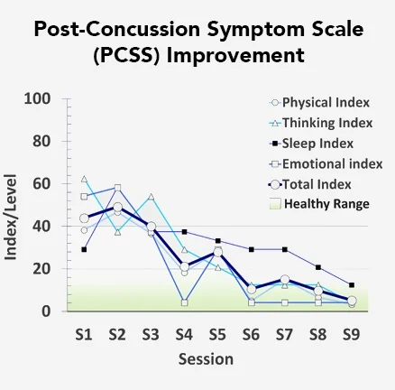
Figure 5; Post-Concussion Symptom Scale determined from fNCI which gives Doctors an idea of what therapy each patient needs
This figure is a graph taken after the first fNCI which shows which part of the brain is functioning better than others which tells us which is getting more blood. Using this, physicians know which therapies to focus on to optimize overall brain function. The index scores for each treatment are shown session by session to track patient progression. Patients are run through 50 minutes of aerobic exercise and neuromuscular therapy to enhance cerebral blood flow then 50 minutes of cognitive therapy. This lasts for 6-8 hours a day over a typical 4 day treatment period (Wing, et al., 2017).
Another measurement is neurovascular coupling which is the connection between the brain and blood in the brain and this is observed by following neurons activating with blood vessel usage (Allen, et al., 2017). Neurons need energy to do tasks for the brain and blood vessels bring the energy to those neurons with blood (Allen, et al., 2017). When a concussion occurs and those blood vessels and neurons can’t work together effectively, symptoms such as fatigue, headaches, attention and sleep problems occur (Wing, et al., 2017). Using the fNCI information and other information a physician can come up with a Severity Index Score shown in Figure 6.
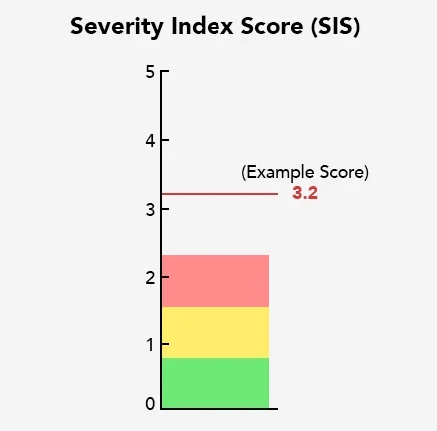
Figure 6. An example of a Severity Index Score or SIS. This SIS shows how many standard deviations away from normal a patient’s brain is. The mean score for patients with concussions is 2.5 and 0 is healthy. Physicians would consider an average of .81 to be “very close to healthy” with the patients just needing a few more sessions (Wing, et al., 2017).

This SIS score is an overall scoring of how healthy your brain is. The scale goes from 0-5, 0 being completely healthy and the average rate of concussed patients is 2.5 (Wing, et al., 2017). The initial fNCI gives the doctors data that can be used to develop a plan for what rehabilitation each patient needs. Developing a schedule means if one patient shows hypoactivity in areas regarding attention and sleep, then those will be the major areas of focus in their rehabilitation. The doctors will be looking at a chart like the one above in figure 6 to show where the patient needs help. The levels of hypoactivity show the doctors and therapists which areas need more attention, while the levels of hyperactivity indicate which areas need to be avoided to allow those levels to go back to normal. The array of interventions range from sensory-motor therapy to cognitive therapy, neuromuscular therapy and cognitive therapy. (Wing, et al., 2017). Cognitive therapy would be used for a patient with behavioral issues following concussions and they may be treated by focusing on present thinking and communication to help prevent them from having negative behavioral outbursts about a past event or injury. Sensory-motor therapy may be used to help patients with receiving a sensory input such as vision or hearing and producing a correct motor response. They could be told to put a blue puzzle piece in a certain position to help them with handling that sensory input to their brain. Neuromuscular therapy involves a therapist massaging, stretching and manipulating tissues to relax them which increases blood flow and reduces inflammation. Once these therapy sessions are done for about 2 weeks, another fNCI is taken. If the doctors are pleased the patient can leave and is scheduled with a follow up in one week and another in 3 months to make sure no post-concussion symptoms have set in after treatment. With proper treatment, all symptoms are usually gone within 2-3 weeks, but without treatment these acute injuries can lead to serious long term effects such as prolonged headaches and emotional and behavioral issues.

Conclusion
This review paper has shown how concussions affect athletes physically and mentally as well as short term and long term. Long term effects include conditions such as a 72% increase for dementia and a 57% increase for developing Parkinson’s disease and CTE. Psychological difficulties such as depression, emotional/behavioral changes and anxiety were also shown to be major injuries for concussed athletes. Concussion injuries have occurred in athletes of both genders, in all age groups, and in people participating in the many sports as detailed in Table 2. Whether these injuries were a result of a direct impact injury, acceleration-deceleration or a blast injury, if the concussion is dealt with properly meaning seeking medical attention and taking the 2-3 weeks needed for the brain to recover, there’s a much higher chance these athletes get back to their sport without longer lasting issues. We’ve seen the horrible things that can happen if an athlete returns to competition too early while still experiencing concussion symptoms. Specifically, it was noted that second impact syndrome (SIS) can occur which is related to CTE later in life and could even cause death. With improving technology, we now have the fNCI machine which can give a physician a detailed description of which parts of a concussed brain are hypoactive or hyperactive and thereby allow development of a specific plan for bringing the athlete’s brain back to its fully healthy form.

References
- Allen, Mark; Epps, Caleb; Tucker, Braden; and Fong, Alina. Functional NeuroCogntitive Imaging and NOTUS. Journal of Neuroimaging in Psychiatry and Neurology, 17 Aug. 2017, unitedscientificgroup.com/journals/ets/articles/v1n1/jnpn-015-caleb-epps.pdf.
- Allen, Mark. “Diagnosing Concussion with Functional NeuroCognitive Imaging.” Cognitive FX, Sep. 2018, www.cognitivefxusa.com/blog/diagnosing-concussion-with-functional-neurocognitive-imaging.
- Bailes, Julian. “What Is a Concussion?”| Brain Injury Research Institute, Brain Injury Research Institute, February, 2018 www.protectthebrain.org/Brain-Injury-Research/What-is-a-Concussion-.aspx.
- Bey, Tareg, and Brian Ostick. “Second Impact Syndrome.” The Western Journal of Emergency Medicine, Department of Emergency Medicine, University of California, Irvine School of Medicine, Feb. 2009, www.ncbi.nlm.nih.gov/pmc/articles/PMC2672291/.
- Bloom, Leslie. “How Long Is the Average Career of an NFL Player?” Work, 5 Mar. 2019, work.chron.com/long-average-career-nfl-player-12643.html.
- Bryan, Mersine, and Ali Rowhani-Rahbar. “Sports- and Recreation-Related Concussions in US Youth.” Pediatrics, U.S. National Library of Medicine, 20 June 2016, pubmed.ncbi.nlm.nih.gov/27325635/.
- Bryant, Richard. “Post-Traumatic Stress Disorder vs Traumatic Brain Injury.” Dialogues in Clinical Neuroscience, Les Laboratoires Servier, 13 Sept. 2011, www.ncbi.nlm.nih.gov/pmc/articles/PMC3182010/.
- Calvo-Rodriguez, Maria. “Increased Mitochondrial Calcium Levels Associated with Neuronal Death in a Mouse Model of Alzheimer's Disease.” Nature News, Nature Publishing Group, 1 May 2020, www.nature.com/articles/s41467-020-16074-2.
- Catchlove, Sarah. “Magnetic Resonance Imaging for Assessment of Cerebrovascular Reactivity and Its Relationship to Cognition: a Systematic Review.” BMC Neuroscience, BioMed Central, 12 Apr. 2018, bmcneurosci.biomedcentral.com/articles/10.1186/s12868-018-0421-4.
- Cruz, Laura. “What Sport Has The Most Concussions?: Concussion Rate.” Complete Concussion Management Inc., 7 Nov. 2018, completeconcussions.com/2018/12/05/concussion-rates-what-sport-most-concussions/.
- Daneshvar, Daniel H. “The Epidemiology of Sport-Related Concussion.” Clinics in Sports Medicine, 1 Jan. 2011, www.sportsmed.theclinics.com/article/S0278-5919(10)00058.
- Dewan, Michael. “Caution Ahead: Linking Concussions to Parkinson's and Dementia.” Parkinson's Foundation, 18 Sept. 2020, www.parkinson.org/blog/science-news/Concussions.
- Fins, Joseph. “Children and Concussions.” Concussion and Brain Injury Clinic, Jan. 2020, concussion.weillcornell.org/about-concussions/kids-and-concussions#:~:text=Young%20children%20are%20more%20susceptible,thus%20more%20vulnerable%20to%20injury.
- Fong, Alina. “Personality Changes After a Brain Injury or Concussion: Cognitive FX.” Personality Changes After a Brain Injury or Concussion | Cognitive FX, 6 Jan. 2020, www.cognitivefxusa.com/blog/personality-changes-after-a-brain-injury-or-concussion.
- Gessel, Luke; Fields, Sarah; Collins, Christy; Dick, Randall; and Comstock, Dawn. Concussions among United States high school and collegiate athletes. J Athl Train 2007;42(4):495–503
- Giza, Christopher C., and David A. Hovda. “The Neurometabolic Cascade of Concussion.” Journal of Athletic Training, National Athletic Trainers' Association, Inc.2001, www.ncbi.nlm.nih.gov/pmc/articles/PMC155411/.
- Harmon, Kimberly.“Concussion and Sports.” BrainLine, 28 Aug. 2018, www.brainline.org/article/concussion-and-sports.
- Loewen, Jaycie. “Football Concussions: Prevention, Diagnosis, & Recovery: Cognitive FX.” Football Concussions: Prevention, Diagnosis, & Recovery | Cognitive FX, 13 Feb. 2020, www.cognitivefxusa.com/blog/football-concussion-prevention-and-recovery#:~:text=Yes!,is%20what%20causes%20a%20concussion.
- Loewen, Jaycie. “Soccer Concussions: Myths, Facts, &amp; Recovery: Cognitive FX.” Soccer Concussions: Myths, Facts, &amp; Recovery | Cognitive FX, 20 Dec. 2019, www.cognitivefxusa.com/blog/soccer-concussions-myths-facts-prevention-and-recovery.
- McLaughlin, Chris. “Has a Ban on Heading the Ball Affected Soccer in the US?” BBC News, BBC, 25 Feb. 2020, www.bbc.com/news/uk-scotland-51618401#:~:text=The%20heading%20of%20the%20ball,some%20worrying%20research%20around%20concussions.
- Mez, Jesse. “Evaluation of Chronic Traumatic Encephalopathy in Football Players.” JAMA, JAMA Network, 25 July 2017, jamanetwork.com/journals/jama/fullarticle/2645104.
- Militana, Adam; Donahue, Manus; Strother, Megan; Sills, Allen; Solomon, Gary; and Morgan, Victoria. Increased Cerebrovascular Reactivity Correlated with Subjective Headache Scores in the Days Following Sports Related Concussion, RSNA, 1 Dec. 2014, archive.rsna.org/2014/14007969.html.
- Mooney, James; Self, Mitchell; ReFaey, Karim; Elsayed, Galal; Chagoya, Gustavo; Bernstock, Joshua; and Johnston, James. “Concussion in Soccer: a Comprehensive Review of the Literature.” Concussion, 30 June 2020, www.futuremedicine.com/doi/full/10.2217/cnc-2020-0004.
- Morgan, Victoria. Department of Radiology.” Studies Point to Quantitative, Prognostic Role for Imaging in Head Injury | Department of Radiology, Vanderbilt University, 1 May 2015,www.vumc.org/radiology/old-news-and-events-news-announcements/studies-point-quantitative-prognostic-role-imaging-head.
- Nowinski, Chris. “What Is a Concussion?” Concussion Legacy Foundation, 9 Jan. 2021, concussionfoundation.org/concussion-resources/what-is-concussion.
- Nunez, Kirsten. “Heading in Soccer: How Dangerous Is It?” Healthline, Healthline Media, 13 Feb. 2020, www.healthline.com/health/heading-in-soccer.
- Pruthi, Sandhya. “Chronic Traumatic Encephalopathy.” Mayo Clinic, Mayo Foundation for Medical Education and Research, 4 June 2019, www.mayoclinic.org/diseases-conditions/chronic-traumatic-encephalopathy/symptoms-causes/syc-20370921#:~:text=Chronic%20traumatic%20encephalopathy%20(CTE)%20is,is%20not%20yet%20well%20understood.
- Rodrigues, Ana Carolina; Lasmar, Rodrigo Pace; and Caramelli, Paulo. “Effects of Soccer Heading on Brain Structure and Function.” Frontiers in Neurology, Frontiers Media S.A., 21 Mar. 2016, www.ncbi.nlm.nih.gov/pmc/articles/PMC4800441/.
- Ruth, Dave, and Andrew Freed. “BU Researchers Find CTE in 99% of Former NFL Players Studied.” Boston University, 26 July 2017, www.bu.edu/articles/2017/cte-former-nfl-players/.
- Sills, Allen. Nfl. “Concussion Protocol & Return-to-Participation Protocol.” NFL.com, NFL, 15 Dec. 2020, www.nfl.com/playerhealthandsafety/health-and-wellness/player-care/concussion-protocol-return-to-participation-protocol.
- Stein, Thor D. “Chronic Traumatic Encephalopathy: a Spectrum of Neuropathological Changes Following Repetitive Brain Trauma in Athletes and Military Personnel.” Alzheimer's Research & Therapy, BioMed Central, 15 Jan. 2014, www.ncbi.nlm.nih.gov/pmc/articles/PMC3979082/#:~:text=As%20CTE%20is%20characterized%20pathologically,increasingly%20categorized%20as%20an%20acquired.
- Taylor, Shawn. “Do Helmets Prevent Concussions in Football?” The Center Foundation, 14 Sept. 2018, www.centerfoundation.org/2018/09/14/concussions-prevention-helmets/.
- Torres, Felix. “What Is Posttraumatic Stress Disorder?” What Is PTSD?, American Psychiatric Association , Aug. 2020, www.psychiatry.org/patients-families/ptsd/what-is-ptsd.
- Trine Madsen, PhD. “Association Between Traumatic Brain Injury and Risk of Suicide.” JAMA, JAMA Network, 14 Aug. 2018, jamanetwork.com/journals/jama/fullarticle/2697009.
- Walensky, Rochelle. “Recovery.” Centers for Disease Control and Prevention, Centers for Disease Control and Prevention, 22 Jan. 2016, www.cdc.gov/traumaticbraininjury/recovery.html.
- Wing, Benjamin; Tucker, Braden; Fong, Alina; and Allen, Mark. “Developing the Standard of Care for Post-Concussion Treatment: Neuroimaging-Guided Rehabilitation of Neurovascular Coupling.” The Open Neuroimaging Journal, Bentham Open, 24 Oct. 2017, www.ncbi.nlm.nih.gov/pmc/articles/PMC5725584/.
- Yang, Max N., and Kristen Clements-Nolle. “Adolescent Concussion and Mental Health Outcomes: A Population-Based Study.” Latest TOC RSS, PNG Publications, 1 Mar. 2019, www.ingentaconnect.com/content/png/ajhb/2019/00000043/00000002/art00003;jsessionid=134ral3m3qv1t.x-ic-live-03.

