¿TODOS ESTAMOS SATISFECHOS? ARE WE ALL SATISFIED?
A Review of the Literature

Honors Thesis
Presented in Partial Fulfillment of the Requirements
For the Degree of Bachelor of Science in Nursing
Within the College of Health and Human Services
At Salem State University

By
Taylor Crampton

Hannah Fraley, RN, MSN
Faculty Advisor
Department of Nursing

***
Commonwealth Honors Program
Salem State University
2015

Abstract
United States healthcare is experiencing a growing need for medical interpretation among diverse populations. Of note, the Hispanic population is steadily growing reaching upwards of 17% of the US population. The Hispanic patient experience and perception of care is poorly understood in the context of patient to provider communication in the US, despite 62% of Hispanics primarily speaking Spanish and limited English. A review of the literature was conducted, the Cumulative Index of Nursing and Allied Health Literature (CINAHL) database was exhaustively searched for English language research published between 2000 and October 2014 that identified disparities between Spanish-speakers and English-speakers regarding their healthcare experiences. Keyword searches included the following: Spanish speaking patients, patient satisfaction, and health disparity. Of twenty-five articles initially yielded by the search strategy, seventeen articles were selected that met inclusion criteria for further analysis and review. Within these articles, it appeared that patients generally did experience a lower rate of satisfaction as compared to English-speaking patients regarding their healthcare providers and the language utilized. Contrastingly, an article described a population of Spanish-speaking patients whose language barrier was not reported as an issue when being assessed for domestic violence. Limited research exists which targets the Hispanic patient population and language barriers faced when communicating with their health care providers. This presents an important gap in the literature to consider for this patient population specifically their experiences and perceptions of how care is delivered in the US. Culturally relevant research is needed in order to appropriately change the way in which health care is delivered to this population, which will ultimately improve patient to provider communication and health literacy.
Keywords: Spanish patient satisfaction, Spanish-speaking patients, language barriers, bilingual healthcare, Hispanic patients
¿Todos estamos satisfechos? Are we all satisfied?
A Review of the Literature
Health disparities affect members of all populations across all countries. One of the largest increasing health disparities in the United States is that minorities continually report lower patient satisfaction rates in multiple settings when compared to the Caucasian demographic of the US. (Cooper-Patrick 1999, Doesher 2000, Boulware 2003, Saha 1999). Healthy People 2020 defines a health disparity as:
“A particular type of health difference that is closely linked with social, economic, and/or environmental disadvantage. Health disparities adversely affect groups of people who have systematically experienced greater obstacles to health based on their racial or ethnic group; religion; socioeconomic status; gender; age; mental health; cognitive, sensory, or physical disability; sexual orientation or gender identity; geographic location; or other characteristics historically linked to discrimination or exclusion.” (US Department of Health and Human Services).
In the past members of minority groups have experienced various difficulties in accessing healthcare. Facing discrimination, lack of interpretive services, low socioeconomic statuses are just a few examples. Today these difficulties continue on a larger scale as the demographics of the US are constantly changing and minorities’ populations are increasing. In the US Census Bureau’s 2013 estimate, 13.7% of the population identifies as black or African American, 1.2% identifies as American Indian or Alaska Native, 5.3% identifies as Asian, 17.1% identifies as Hispanic or Latino, 0.2% identifies as Native Hawaiian or Other Pacific Islander and 2.4% identifies with two or more races. Thus 39.9% of the US population is considered to be in a minority group and most likely has experienced some form of a health disparity. One of the overarching goals of Healthy People 2020 is to “achieve health equity, eliminate disparities, and improve the health of all groups.” (U.S. Department of Health and Human Services). One way of observing whether or not we are eliminating health disparities is to measure patient satisfaction rates.
The Affordable Care Act has changed healthcare policy so that patient satisfaction surveys are now tied through Medicare to reimbursement payments. The idea behind this is that more quality care will result from the relationship between reimbursement payments and patient satisfaction rates. The federal health law also states that physicians will be awarded bonuses or penalties based on their performance by 2015. Any penalty that is given to a hospital or physician group will then be reimbursed and awarded to a hospital or physician group with a high performance rate. Even though patient satisfaction surveys have been regarded as vital to the functionality of a healthcare team in the past, they will continue to grow in importance and relevance in the few short years ahead of us with all of the changes that the Affordable Care Act brings. (Patient Protection and Affordable Care Act of 2010).
In the same way the Joint Commission (TJC), formerly known as the Joint Commission on Accreditation of Healthcare Organizations, has set patient-centered communication standards for hospitals. These standards were implemented in July of 2012 and they take on topics like, “qualifications for language interpreters and translators, identifying and addressing patient communication needs, collecting patient race and ethnicity data, patient access to a support individual, and non-discrimination in care.” (The Joint Commission).
As healthcare moves forward in the twenty-first century, it is clear that there is a need to meet many levels of patient satisfaction through language and culture. TJC released a report on the issues hospitals face regarding culturally competent care called “Exploring Cultural and Linguistic Services in the Nation’s Hospitals: A Report of Findings.” The report addressed the main concerns for patients with culture and language barriers such as the fact that it is simpler to address language concerns rather than culture concerns because interventions may be completed in a more concrete manner. One of the more important findings from the report however, is that “collection of patient demographic data is inconsistent across and within hospitals, and few hospitals use these data to improve services for diverse patients” (The Joint Commission). Thus the Joint Commission and the Affordable Care Act are increasing the pressure throughout the United States healthcare system to perform appropriate, culturally competent care.
More importantly, the US has been experiencing a shift in the demographic in the past decade. According to the US census bureau 2013 there are over 54 million Hispanics living in the United States and this population is predicted to increase to 128.8 million by 2060 (U.S. Census Bureau). The Hispanic population represents the largest minority currently, yet their health disparities seem to be most prevalent. Furthermore, there are many subgroups among the Hispanic minority that all share varying cultural views and linguistic differences. The largest subgroup is constituted of Mexicans at 64%. Puerto Ricans, Salvadorans, Cubans, Dominicans, and Guatemalans make up the majority of the subgroups with 13.7% reporting simple Hispanic origin (United States Census Bureau).
Many healthcare providers understand that the Hispanic culture is one that is rapidly growing and that needs closer attention to provide appropriate care. However, many providers overlook the concept that the subgroups of the Hispanic population all carry different cultural ideals and in particular varying definitions of similar words. The Spanish phrase, “me siento mareado” could translate to “I feel dizzy” or “I feel drunk” depending on the person’s usage and context of the word. In the clinical setting, a mistranslation like this could set off inappropriate medical interventions that could potentially harm a patient instead of helping them. Not only can miscommunication cause adverse events, but at its simplest form, it can make a patient feel alone or uncomfortable. The healing process is inclusive of mentality as well as physicality. It is important to remember that the patient also must have their needs met as presented by Maslow’s Hierarchy of needs to feel well. In addition to physiological needs like breathing, sustenance, water, and sleep, the next most basic human need is to feel safe. A patient may not feel safe in an environment where their needs are being miscommunicated on a regular basis.
Also overlooked by many healthcare providers is that a patients culture can change their view on treatment modalities. In the United States it is commonly expected that patients believe in the power of medicine and science, and would never argue with a vaccination or a treatment modality unless it presented a particular danger. In some Latin cultures, a “santero” is considered to be an ultimate form of healing. A “santero” is a religious healer that may use herbal elixirs as treatment for some diseases. Healthcare providers must consider the impact of modern medicine upon a culture that may be accustomed to using herbs and religion.
There are many factors when measuring patient satisfaction in all minority populations, however, special attention must be paid to this rising demographic and their specific patient needs.

Methods
A review of the literature was conducted, the CINAHL database was exhaustively searched for English language research published between 2000 and October 2014 that identified disparities between Spanish-speakers and English-speakers regarding their healthcare experiences. Keyword searches included the following: Spanish speaking patients, patient satisfaction, health disparity. A flow chart of the research process follows.

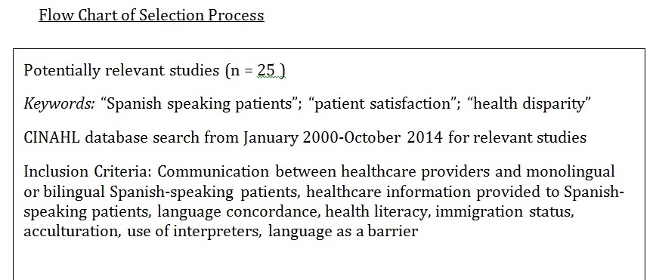
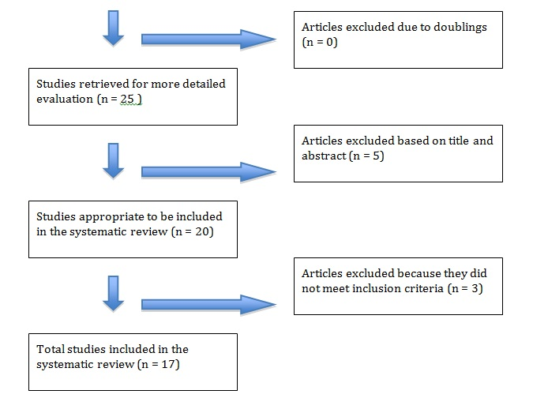
Figure A

Results
Many of the articles attempted to understand the relationship between patients and providers regarding their communication. Low health literacy was strongly connected with poor communication. Spanish-speaking patients reported the poorest communication with their providers (Sudore et al., 2009). Poor health literacy was one of the largest factors in decreased patient satisfaction for this population as it added to other already confounding factors. Interpreters who spoke Spanish as a secondary language were found to lose some of the patient’s exact meanings in translation due to colloquialism or dialects (Lopez, Figueroa, Connor, & Maliski, 2008). Also, another study found that some interpreters are used in a more impromptu fashion rather than full time and may not always be trained in medical terminology, which adds to communication errors (Flores, 2006). Interpreters do not always arrive at a desired time when a Spanish-speaking patient is admitted, thus creating a window where the complete history and physical is not always known (Gravely, 2001). Interestingly however, English-proficient Spanish-speakers reported higher satisfaction rates regarding provider communication than monolingual Spanish-speakers (O’Brien & Shea, 2011). Similarly stated in another article, Spanish-speakers who also spoke English at a certain level were more satisfied when communicating with their provider, however, the same study found that gaps in satisfaction could be attributed to health insurance coverage, acculturation level, and health literacy (Villani & Mortensen, 2014). About 97% of participants in one study reported increased satisfaction if their provider spoke Spanish (Eskes, Salisbury, Johannsson, and Chene 2013). Thus, language concordance was an important factor for many Spanish-speakers. Immigration status was also closely linked to patient satisfaction levels as it was related to level of insurance coverage and a patient’s perceived quality of care (Rodríguez, Vargas Bustamante, & Ang, 2009). Misunderstandings of medical terminology, translational errors, acculturation level, immigration status, language proficiency, health insurance, and language concordance all affect the Spanish-speaking patients’ level of satisfaction.

Discussion and Conclusion
As the Affordable Care Act and the Joint Commission urge the United States’ healthcare system to move forward in their culturally competent care of Spanish-speaking patients, one must also consider how to improve patient satisfaction on a smaller scale. Being that health literacy and language concordance seem to be two of the largest confounding factors, many studies suggest that there be more translated resources for this population – whether those resources be websites, pamphlets or informational hotlines. One might also consider the idea of recruiting more Spanish-speaking providers who already have personal experience with some level of the culture and health literacy that can relate to these populations. Translators should also be expected to understand medical terminology in both languages while also being able to measure the health literacy of the patients that they are speaking to. Extensive culturally competent training should be a staple in the training of translators. One might also consider the possibility of monthly seminars of various populations that the hospital provides care to. More than anything, the US healthcare system needs to better understand the needs of this ever-growing Spanish-speaking population.

References
Advancing Effective Communication, Cultural Competence, and Patient- and Family-Centered Care | Joint Commission. (n.d.). Retrieved April 24, 2015, from http://www.jointcommission.org/Advancing_Effective_Communication/
Alicea-Alvarez, N. (2012). Improving Health Care Outcomes in Hispanic Americans: Recruiting Nurses to Reflect the Growing Hispanic Population to Mitigate Health Care Disparities. Hispanic Health Care International, 10(2), 70–74. http://doi.org/10.1891/1540-4153.10.2.70
Armando, P. D., Martínez Pérez, S. R., Martí Pallarés, M., Solá Uthurry, N. H., & Faus Dáder, M. J. (2008). Development and validation of a Spanish language patient satisfaction questionnaire with drug dispensing. Pharmacy World & Science: PWS, 30(2), 169–174. http://doi.org/10.1007/s11096-007-9158-3
Bean, M. G., Stone, J., Moskowitz, G. B., Badger, T. A., & Focella, E. S. (2013). Evidence of Nonconscious Stereotyping of Hispanic Patients by Nursing and Medical Students: Nursing Research, 62(5), 362–367. http://doi.org/10.1097/NNR.0b013e31829e02ec
Cardelle, A. J. F., & Rodriguez, E. G. (2005). The Quality of Spanish Health Information Websites: An Emerging Disparity. Journal of Prevention & Intervention in the Community, 29(1-2), 85–102. http://doi.org/10.1300/J005v29n01_06
Clark, T., Sleath, B., & Rubin, R. H. (2004). Influence of ethnicity and language concordance on physician-patient agreement about recommended changes in patient health behavior. Patient Education and Counseling, 53(1), 87–93. http://doi.org/10.1016/S0738-3991(03)00109-5
Disparities | Healthy People 2020. (n.d.). Retrieved April 24, 2015, from https://www.healthypeople.gov/2020/about/foundation-health-measures/Disparities
Eskes, C., Salisbury, H., Johannsson, M., & Chene, Y. (2013). Patient satisfaction with language--concordant care. The Journal of Physician Assistant Education: The Official Journal of the Physician Assistant Education Association, 24(3), 14–22.
Flores, G. (2006). Language barriers to health care in the United States. The New England Journal of Medicine, 355(3), 229–231. http://doi.org/10.1056/NEJMp058316
Gravely, S. (2001). When your patient speaks Spanish--and you don’t. RN, 64(5), 65–67.
Jatoi, A., & Breitkopf, C. R. (2011). Is Spanish Language a Barrier to Domestic Violence Assessment? Journal of Women’s Health, 20(7), 1111–1116. http://doi.org/10.1089/jwh.2010.2536
Jean-Pierre, P., Fiscella, K., Winters, P. C., Paskett, E., Wells, K., Battaglia, T., & The Patient Navigation Research Program Group. (2012). Cross-cultural validation of a Patient Satisfaction with Interpersonal Relationship with Navigator measure: a multi-site patient navigation research study: Patient Satisfaction with Navigator-Spanish. Psycho-Oncology, 21(12), 1309–1315. http://doi.org/10.1002/pon.2018
Lopez, G. I., Figueroa, M., Connor, S. E., & Maliski, S. L. (2008). Translation barriers in conducting qualitative research with Spanish speakers. Qualitative Health Research, 18(12), 1729–1737. http://doi.org/10.1177/1049732308325857
O’Brien, M., & Shea, J. (2011). Disparities in Patient Satisfaction Among Hispanics: The Role of Language Preference. Journal of Immigrant and Minority Health, 13(2), 408–412. http://doi.org/10.1007/s10903-009-9275-2
Patient Protection and Affordable Care Act, 42 U.S.C. § 18001 et seq. (2010).
Rodríguez, M. A., Vargas Bustamante, A., & Ang, A. (2009). Perceived Quality of Care, Receipt of Preventive Care, and Usual Source of Health Care Among Undocumented and Other Latinos. Journal of General Internal Medicine, 24(S3), 508–513. http://doi.org/10.1007/s11606-009-1098-2
Schyve, P. M. (2007). Language Differences as a Barrier to Quality and Safety in Health Care: The Joint Commission Perspective. Journal of General Internal Medicine, 22(S2), 360–361. http://doi.org/10.1007/s11606-007-0365-3
Sudore, R. L., Landefeld, C. S., Pérez-Stable, E. J., Bibbins-Domingo, K., Williams, B. A., & Schillinger, D. (2009). Unraveling the relationship between literacy, language proficiency, and patient–physician communication. Patient Education and Counseling, 75(3), 398–402. http://doi.org/10.1016/j.pec.2009.02.019
Terry, R. L., & Fond, M. (2013). Experimental U.S. Census Bureau Race and Hispanic Origin Survey Questions: Reactions From Spanish Speakers. Hispanic Journal of Behavioral Sciences, 35(4), 524–541. http://doi.org/10.1177/0739986313499007
USA QuickFacts from the US Census Bureau. (n.d.). Retrieved April 24, 2015, from http://quickfacts.census.gov/qfd/states/00000.html
Villani, J., & Mortensen, K. (2014). Decomposing the Gap in Satisfaction with Provider Communication Between English- and Spanish-Speaking Hispanic Patients. Journal of Immigrant and Minority Health, 16(2), 195–203. http://doi.org/10.1007/s10903-012-9733-0

