BUSINESS MODEL FOR
TENDER LOVE AND CARE YOGA STUDIO

Honors Thesis

Presented in Partial Fulfillment of the Requirements for the
Degree of Bachelor of Science in Sport and Movement Science

In the College of Arts and Sciences
at Salem State University

By

Cameryn Tierno

Dr. John McArdle
Faculty Advisor
Department of Management

***

Commonwealth Honors Program
Salem State University
2018
ABSTRACT

The proposed business model for the Tender Love and Care Yoga Studio (TLC) was developed as a part of an Honors Thesis by the author, Cameryn Tierno. TLC strives to provide its students with accessible yoga classes that are relaxing and rejuvenating. TLC’s staff and environment fosters relaxation and acceptance, while also offering practical stress-relieving techniques that are beneficial to all. The report presents the various methodologies and tools used for developing the business model and states the individual development plan for Cameryn Tierno as a yoga instructor and business woman before embarking on the journey of becoming a business owner. The report is concluded with Cameryn’s personal reflection of her experience completing this project.

Table of Contents
INTRODUCTION 1
BUSINESS DESCRIPTION 2
EXECUTIVE SUMMARY 4
LOCATION 6
INDUSTRY ANALYSIS 7
THE MARKET 9
MARKETING STRATEGY 11
PRODUCTS AND SERVICES 14
COMPETITION 15
MANAGEMENT 17
PERSONNEL 18
LOAN SUMMARY AND FINANCIAL PROJECTIONS 20
SWOT ANALYSIS 22
Analysis 24
INDIVIDUAL DEVELOPMENT PLAN 26
PERSONAL REFLECTION 30
APPENDIX 33
Class Descriptions 34
Blue Print 36
Class Schedule 37
TLC Pricing 38
Competition & Pricing 39
Cameryn Tierno Resume 40
Survey results 42
Financial Projections 47
REFERENCES 52

ACKNOWLEDGEMENTS

I would like to express my sincere gratitude to my thesis advisor, Dr. John McArdle for not only supervising and guiding me through this project, but also providing me with knowledge and opportunities to grow to my full potential. Without his support throughout my undergraduate career I would not have understood my innate drive and interest in owning and running a yoga studio.
I am highly indebted to Kelly Janos, the director of the Gassett Fitness Center for seeing the potential in me as a student, yoga instructor, and student employee. Over the last three years of working at the Gassett Fitness Center she has fostered an environment of continuous development and support that has molded me into the professional I am today.
I have been blessed with the opportunity to meet and work with Maggie Fiorella-Winter, the owner of Green Tea Yoga. She gave me my first teaching job at a yoga studio and continued to be flexible and understanding with my hectic and demanding schedule as a college student. She truly taught me what it means to stay true to the yoga practice while being a business woman. This is a gift that cannot be matched.
I am grateful for my parents, my sister, and my roommates for seeing me at my worst times, but continuing to support, encourage, and love me the same as they do during my best times.

INTRODUCTION

We live in a fast-paced country where mindfulness was once seen as a practice strictly for Buddhas, monks, yogis, and the like who live in the mountains and retreat from the real world. Fortunately, the western world is starting to embrace the curative powers of mindfulness and welcomes yoga, meditation, and other holistic practices into their everyday routines. Tender Love and Care (TLC) is a yoga studio start-up founded and run by Cameryn Tierno with the aim of providing affordable yoga classes and workshops and TLC merchandise. Many studios in the US today claim to be supportive of students from all backgrounds; however, TLC’s main purpose is to accommodate yoga and other healing techniques for clients of all fitness levels and diversities, so that all students have equal access to the benefits of a holistic regimen in a space that is safe, welcoming, and relaxing. Many yoga studios within and surrounding Boston focus predominately on the physical poses and practice of yoga. Within this safe and inclusive space, our teachers will aim to make their teachings applicable to the students’ everyday lives with philosophy, readings, and discussions about what goes on in life off of the mat. Therefore, TLC brings yoga students deeper into their yoga practice, leaving them more fulfilled and at peace.

BUSINESS DESCRIPTION

It’s 5:50 pm and the students start shuffling in the front door and head towards the front desk to sign in. The front desk staff member greats every student with a smile, knowing the returning students by name and welcoming in each new student to their new home. The students head down the hallway with the dark wooden floors and the sage green walls until they reach the farthest closed door. After opening the door, a large, yet warm studio is presented with the waft of incense. One by one the students take their shoes off outside of the door and head in to grab their cork blocks, neutral colored bolsters, black straps, and roll out their mat in their usual, comfortable spot. There’s a soft, ambient song planning in the background to allow the somewhat discombobulated students to settle onto their mats by taking restorative poses, laying in savasana, or sitting in sukhasana. The new students can sense the community established inside of the studio watching students chat with their neighbors about what’s happened in their family in the past week or how work’s going. When 6 pm hits the clock, the teacher walks into the class, says hello to the students she passes by, and asks if anyone has any requests for class. Throughout the class, the students are reminded to stay present on their mat and connected to their breath. Every pose is adaptable to their needs- each body looks different from the next. 60 to 90 minutes later, the class is finished and the students mindfully roll up their mats, replace their props at the back of the room and slowly make their way out of the studio. Some smile at each other, others catch up with one another and decide to get a cup of coffee, and others stay more internally focused managing a “See you next week,” or a “Thank you” as they exit the studio. Throughout the day, this shuffle occurs with many satisfied, relaxed, and rejuvenated students, or better yet, friends, coming in and out. Some students prefer hot yoga or vinyasa yoga, others prefer yin, gentle, or restorative yoga, but regardless of their different needs, they all find a way to satisfy them within the same four walls of Tender Love and Care Yoga Studio.

The mission of Tender Love and Care Yoga Studio is to provide yoga students of all levels a place to practice different styles of yoga in a safe, nurturing, and welcoming environment. Above all, we strive to give students methods of applying their yoga practice to their life outside of the studio with yogic philosophy, readings, and discussion to impact their overall quality of life and to ensure their yoga practice resonates with them at a deeper, more spiritual level than many other yoga studios offer.

EXECUTIVE SUMMARY
Mission Statement
The mission of Tender Love and Care Yoga Studio is to provide yoga students of all levels a place to practice different styles of yoga in a safe and welcoming environment. Above all, we strive to give students methods of applying their yoga practice to their life outside of the studio with yogic philosophy, readings, and discussion to impact their quality of life and ensure their yoga practice resonates with them at a deeper, more spiritual level than many other yoga studios offer.

Products and Services
Tender Love and Care Yoga Studio is a standard, licensed, and well-equipped yoga studio with a welcoming, comfortable, and relaxing space that can contain 25 students per class. This yoga studio offers yoga classes, workshops, and consultations for kids, teens, and adults to practice the physical poses of yoga as well as the yogic philosophy, spirituality, and meditative aspects that go hand-in-hand with this ancient practice.

Location
TLC will be located in the well-populated residential area and vibrant business environment in Burlington, Massachusetts. Our studio will be complete with calming blue and green walls, wood-sprung floors, and comfortable seating areas to ensure that our students have the feeling of being at a home away from home. In the lobby, there will be a one-stop small store where yoga students can purchase authentic yoga accessories and TLC merchandise. TLC will also have a separate, small conference room with lounge chairs, book shelves, coffee tables, and tranquil paintings where students can discuss beginning or continuing their yoga practice with a licensed professional.

Personnel
At TLC, our intentions and actions stem from a place of caring for and fostering our students’ best interest. All staff will be professional and licensed yoga instructors that continue to practice yoga physically and spiritually so their teaching is relatable and authentic. TLC is a yoga studio that is dedicated to providing an honest, open, and nonjudgmental environment for all students to learn and practice yoga at a price where all walks of life feel as though practicing yoga is affordable and accessible. Staff members that work the front desk will be local yoga students that practice at TLC and receive free yoga classes for each shift worked, allowing those who cannot pay for yoga classes the opportunity to volunteer in return for public yoga classes with a licensed professional.

Financing
Owner and Founder, Cameryn Tierno is seeking to raise $105,000 as a bank loan. The business plan assumes the loan will be paid over 10 years with an interest rate of 4.5%.

LOCATION

After practicing yoga in Burlington, MA, Cameryn decided that Burlington would be the perfect area to open her own yoga studio. Many studios in the area don’t have large enough spaces to meet the needs of their customers, with many students frustrated and left without a consistent yoga practice due to already filled classes.

Not only does the town of Burlington already have a large yoga community, but it’s easily accessible for new students as well. Route 128 and I-95 traverse through Burlington along with the Burlington Mall nearby, making Burlington convenient for students living or working locally and students who travel through town going to or from work can reach the studio simply. Convenience is often the number one reason people choose a particular yoga studio.

Burlington’s median household income is $94,518, which is more than the median income of the US, with the poverty rate at 5.25%. Each household has an average of 2 cars. Both of these facts show that the population of Burlington, MA can not only afford to pay for yoga classes, but also has the accessibility of cars to get to yoga classes.

A floor plan and materials list for TLC can be found in the appendix.

INDUSTRY ANALYSIS

Yoga is a spiritual practice that focuses on using the breath control, meditation, and physical postures for mental and physical health benefits, including relaxation. It is traced back over 5,000 years to ancient India, but it’s physical benefits and relaxation techniques were brought to the western countries in the 1980s. Over the last few years, the yoga industry has grown in the United States due to health-conscious individuals and the awareness being spread that yoga is good for your health and wellbeing.

Yoga studios offer yoga classes to individuals and groups, but also look to selling other health-related supplements and merchandise to increase their revenue. Studios who also bring attention to other health related modalities often get better client retention.

Yoga studios often compete with health and fitness clubs due to convenience, affordability, and variety as well as on-demand websites that offer yoga classes online. However, those with higher per capita disposable income can afford to purchase class packages, one-on-one private yoga classes, and ancillary products. More consumers of the industry are becoming more health-conscious and, therefore, spending more time in leisure and sports which suggests an influx of clientele for yoga studios.

Major markets in this industry are students between the ages of 18 and 34, who not only practice yoga, but also take interest in the environmentally conscious products sold in a yoga studio. The second largest market in the industry are individuals aged 35 to 54 due to their disposable income that allows them to purchase one-on-one yoga classes and yoga class packages. The smallest market in the industry are those ages 55 and older who the yoga industry can better attract by promoting its health benefits and modifications for those with chronic illnesses and pain.

According to the IBIS World report on Yoga and Pilates Studios, the industry is in the growth stage with an annual growth rate of 4.4% from 2017 to 2022. Yoga has also expanded its demographics in the past five years, allowing more students, such as those who are pregnant, seniors, children, or men, to find a yoga class that is fit for them. Although some consumers prefer to take yoga classes as health and fitness clubs due to the pricing and flexibility, many still prefer to practice at a yoga studio due to the community-oriented fitness experience.

Since the yoga industry is already booming within America and expected to grow even further in the next five years, it is a crucial time to open yoga studios or entrepreneurs who have training in teaching yoga.

THE MARKET

As mentioned in the industry analysis, many yoga studios nationally target students between the ages of 18-34 who practice yoga for its health benefits and take interest in environmentally conscious products. To provide a more localized understanding of who is practicing yoga in and around Burlington, MA, Cameryn Tierno conducted a survey of 23 yoga students of a yoga studio in Acton, MA. The survey results can be found in the appendix.

The survey results showed the participants ages were higher than the IBISWorld report, and ranged between 34 to 65 years of age. Many enjoy practicing vinyasa, power, restorative and gentle yoga two to four times a week. Some participants claim they practice yoga to reduce stress, decrease depression, sleep better, and recover from an injury.

These survey participants predominantly practice yoga for the physical benefits, but also for the meditative and spiritual aspects that come along with it; however, when asked what is missing from their yoga practice, many participants put that meditation, spirituality, and philosophy are lacking. TLC strives to create a need and demand for a deeper, more spiritually fulfilling yoga practice through providing philosophic texts and readings with practical usage and application before and after classes.

The yoga practice will continue to grow over the next five years since it has expanded its demographics to those that don’t typically practice yoga, such as men, children, pregnant women, and seniors. The survey showed that these mentioned demographics aren’t practicing yoga, but TLC will target them through offering specific beginners level classes that break down the basics of yoga as well as consultations with a licensed professional to ask questions regarding starting and maintaining a consistent yoga practice. TLC offers private one-on-one and group classes for those seeking more individualized classes.

Through offering both popular, physically demanding and slower, rejuvenating yoga classes, TLC hopes to target the population that was surveyed, as well as the population that falls out of the traditional market of yoga studios. By teaching lessons in meditation and philosophy, TLC will foster an environment where physical fitness is not the only way to health and wellbeing, creating a welcoming and supportive environment for students of all backgrounds.

MARKETING STRATEGY

Before opening, TLC will create a user-friendly website that includes contact information, a class schedule, class descriptions, pricing lists, teacher introductions, workshops, announcements, and a blog. Interested practitioners can subscribe to the website to emails with updates at the studio. In addition to creating a website, TLC will have an Instagram and Facebook account that will be consistently updated with upcoming classes, events, and offerings. Flyers will also be posted in local businesses to spread the word about the opening of TLC Yoga Studio.

To get students in the door for their first class, TLC will offer the student’s first class free. To promote community and also get more students in the door, TLC will implement a give-away program. After a student has referred five other students to our studio, they will win a TLC branded t-shirt.

Once the students are in the door, the teachers and front desk staff will be consistently fostering a warm, welcoming, and positive environment, as well as telling students about our upcoming events and classes first hand.

After surveying a yoga community similar to the one in Burlington, TLC will take their feedback to create the best marketing strategy.

The top yoga styles of the participants include vinyasa, power, restorative, and gentle yoga, which will be offered at TLC. On top of these classes, TLC will offer beginner’s yoga for new students and students who want to strengthen their foundation. Other types of yoga, such as yin yoga, ashtanga yoga, and iyengar yoga can be offered monthly as workshops or eventually added into the schedule if demand calls for it.

The survey participants responded that meditation, spirituality, physical fitness, and community are some of the reasons that they practice yoga; however, almost 50% of the respondents claim to be content with their practice the way things are without any need for more physical challenge, philosophy, spirituality, and mediation. Many current yoga studios strive on teaching the physical aspect of yoga without the meditative or philosophic pieces attached. TLC strives to add philosophy and meditation through readings and workshops to show its customers that there is more to yoga than the physical practice- and that is a lifestyle. After realizing different ways to cope with the common issues of being human, TLC students will, hopefully, begin to see that philosophy and meditation are vital aspects of their yoga practice that have enriched their experience and have been missing from their practice for the past few years.

An important aspect of a yoga studio is creating a sangha, or community. Sixteen participants of the survey answered that they feel as though it is important to be a part of the community of the yoga studio they are taking classes at. In order to do so, TLC will purchase TLC branded apparel, such as t-shirts, tank tops, and water bottles to create a sense of community throughout the studio and in the surrounding environment. 19 of the respondents expressed their interest in wearing branded apparel from the yoga studio they practice at- proving the importance of feeling connected to those you’re practicing yoga with.

After getting students in the door through social media, online, and flyer marketing, TLC will provide its students with styles of yoga that they know they are already drawn to, create a strong community, and show its students vital aspects of a yoga practice that they may not realize have been missing.

PRODUCTS AND SERVICES

TLC’s main source of income will be public and private 60 to 90-minute yoga classes. Students can pay for these classes in advance to ensure they have a designated space in the class or walk into the studio and sign up before class. TLC will also provide consultations for those who are hesitant to start practicing yoga and want to learn more, as well as current students who look to deepen their practice by looking for guidance. Once TLC establishes itself as a successful yoga studio, 200-hour yoga teacher trainings may be available once or twice a year as an additional source of income.

As an additional source of income, Tender Love and Care will have products for sale for students before and after class. New students can rent a yoga mat or purchase a disposable water bottle. To foster a sense of community, students can purchase TLC branded water bottles, t-shirts, and tank-tops, which will also be gifts in our give-aways described in the marketing segment of the business model. Students will also be able to purchase environmentally sustainable yoga props, such as mats, blocks, and straps.

A sample schedule, list of class descriptions, and pricing list can be found in the appendix.

COMPETITION

According to the survey results, the top three reasons for practicing yoga is for meditation and spirituality, physical fitness and community; however, many yoga studios focus on the popular power & hot yoga without much focus on the yogic philosophy, meditation, and spirituality that is another vital part of the yoga practice. At TLC, our teachers will strive to apply yogic philosophy to real life scenarios and offer meditation techniques so students can find more meaning to their yoga practice and utilize their stress relieving techniques during times of high stress.

Since many yoga studios capitalize on a strong, active yoga practice and attract many yogis that are experienced, TLC will offer consultations for those who are skeptical about starting yoga or are unsure of how to begin a practice. Consultations will also be offered for those who have an advanced yoga practice that wish to find ways to deepen their yoga practice, especially on a spiritual level.

In order to attract more novice yoga students, TLC will offer beginner, yin, gentle, and restorative yoga that is not as popular among students who are experienced. These classes slow down the practice and break it down to the basics so students feel more welcomed and comfortable starting a practice. These classes are also the perfect contrast to the popular vigorous, hot power yoga practice.

To be competitive, TLC is offering classes at the same price as the cheapest yoga studio in the area, Roots yoga. This allows TLC to pay for the cost of running a facility, but still keeping the costs low for students. On top of low prices, students will have the consultations, variety of yoga classes, as well as a strong community to differentiate itself from its competition.

A list of competitors and their pricing strategies can be found in the appendix.

MANAGEMENT

Tender Love and Care Yoga Studio will be managed by the sole proprietor, Cameryn Tierno.

Cameryn started regularly attending yoga classes after taking a free beginners class at Roots Yoga in Burlington in 2014. Cameryn had always been an athlete, gravitating towards lacrosse, basketball, and weight lifting, but something about yoga felt more special and relevant to Cameryn than any of the other sports. She noticed after months of practicing yoga that her anxiety disorder had immensely diminished and that her need to share this ancient practice with others was growing. After six months of practicing yoga, Cameryn was accepted to Prana Power Yoga’s 200-hour yoga teacher training in 2015.

In 2015, Cameryn started teaching yoga consistently and decided to start studying Exercise Science and Entrepreneurship at Salem State University with the hopes of someday opening her own yoga studio. Her studies involved exercise physiology, kinesiology, anatomy, and health and wellness, which was directly applicable to her yoga practice and teaching. She spent her years in college working at the university’s fitness facility and gained experience and knowledge navigating the fitness floor, yoga studio, and managerial office.

A complete resume is included in the appendix.

PERSONNEL

Yoga Teacher
Requirements:
  - Hold a Yoga Alliance Registered Yoga Instructor- 200 hour level (RYT-200) certification
  - Have a CPR/AED certification
  - Maintain a positive and energetic attitude
  - Be passionate about yoga and fitness
  - Have 1-2 years of experience leading yoga classes
Responsibilities:
  - Lead yoga classes according to the assigned schedule
  - Arrive 10 minutes early to class to allow proper set up and introduction to new and returning students
  - Teach safe, effective exercises to all levels from beginning to advanced
  - Teach correct postures to ensure maximum benefit and safety
  - Pay attention to the needs to every student throughout the class
  - Take into account health problems and ages of students
  - Maintain a current yoga certification

Front Desk Staff
Requirements:
  - TLC student
  - Strong sales and customer service skills
  - Self-motivated
  - Strong organizational skills
  - Flexible schedule
  - Able to stay calm at all times and act responsibly with customers and staff
  - Familiar with TLC studio and offerings
  - Comfortable with computers and effective at learning and using software products
Responsibilities:
  - Provide superior customer service
  - Conduct sales through software accurately
  - Promote classes and workshops
  - Manage and maintain needs of yoga studio and its teachers and students
  - Work with studio staff to support financial and operational needs of the studio
  - Keep studio clean, stocked, and functional
  - Support manager on various administrative projects as necessary

LOAN SUMMARY AND FINANCIAL PROJECTIONS

Cameryn plans on applying for a business loan of $105,483 in order to pay for TLC’s start-up expenses and first two months of working capital. It is assumed that the loan will be paid over 10 years at a 4.5% interest rate. The start-up expenses include rent, furniture, fixtures, renovations, legal and accounting fees, and insurance. Working capital accounts for the teacher’s pay of $40 per class, rent and utilities, supplies, insurance, and the monthly debt service.

It is assumed that each student will pay an average of $15 per class with 22 classes per week. Teachers will be paid $40 per class. Therefore, it is projected that TLC will have an average of 8 students per class with roughly a quarter of all merchandise sold at the end of year one. Sales are expected to increase at a rate of 4.4% over the next three years. These financial projections were made with the understanding that the class schedule will change due to holidays, weather, and workshop offerings.

Since consultations for both beginner and experienced yoga practitioners is new to the industry, TLC is unsure if students will take the time, effort, or money necessary to take advantage of this offering. Products such as yoga mats, blocks, and straps can also be purchased through other mediums, such as websites or stores, so selling them exclusively at TLC is a financial risk in hopes of making them more accessible for students.

Another risk is the limited space allowed in TLC for yoga practitioners. Although more than 25 students may want to take the class, the studio only allows space for 25 students, meaning TLC will have to turn clients away and lose money.

Overall, considering the location of TLC in a city with a high demand for yoga, TLC is projected to be a profitable business.

SWOT ANALYSIS

Strengths:
- Founder, Cameryn Tierno has over 3 years of experience within the yoga, exercise science, and business industries
- Staff that has experience, education, and passion
- The nature of our classes bring depth to students’ new or developed practices
- Offering consultations for prospective and current students who wish to set goals and evaluate their current practice with a yoga teacher’s advice
- Expenditures will be low due to small number of employees and low overhead expenditures
- Ability to buy equipment, clothing, and beverages

Weaknesses:
- Lack of reputation
- Students already have a “home” studio
- Cameryn doesn’t have experience owning a business
- Depending on location, TLC may have a hard time attracting students by window marketing

Opportunities:
- IBIS World projects that per capita income is expected to increase
- Time spent on leisure and sports is projected to increase
- Yoga classes in the area are starting to reach capacity during peak hours

Threats:
- National unemployment rate is increasing
- On-demand websites offering yoga classes
- Health and fitness centers with yoga classes
- Competition with yoga studios in surrounding areas

ANALYSIS

Cameryn spent her college years working at the university’s fitness facility, which has given her experience cleaning and maintaining equipment, enforcing policies, managing staff, creating, promoting, and marketing events, as well as customer service. The teachers at TLC will also teach a variety of yoga styles, which will expand the demographics that TLC tailors to. Students that are new to the practice or feel as though they need to switch up their practice, TLC will have consultations available. Staffing at the front desk will be free to the studio, as they will be strictly volunteers and paid by free yoga classes. TLC will hire minimal teachers who will teach multiple classes a week. TLC will also increase its revenue by offering merchandise, equipment, and clothing to be purchased before and after yoga classes.

Since TLC is a new studio in a community that has a yoga community already established, it may be difficult for TLC to get students in the door. Many students have a studio that they already practice at; however, by offering philosophy, meditation, and consultations, students may find a more substantial practice at TLC than at the studio they’ve been practicing at already. Although Cameryn doesn’t have the experience owning a business before, she can hire those who have the experience and education, such as accountants, business consultants, and website designers. Despite the location of the studio, flyers will be placed around the local community and online and discounts will be offered to get students into the door at opening.

Per capita income is expected to increase, meaning more people can afford purchasing yoga class packages and private sessions. Yoga class participation is also increasing due to more people spending time on leisure and sports activities. With per capita income and time spent on leisure and sports increasing, yoga classes are filling more now than ever, meaning the yoga studios that are already established can’t meet the demand of the students. By opening a studio in this area, TLC can catch the overflow from the surrounding yoga studios and retain some of the students as well.

Contrarily, national unemployment rate is increasing, meaning that people can’t afford to pay for yoga classes and lean more towards on-demand yoga classes and health and fitness clubs with yoga classes included in the memberships. However, practicing within the community of TLC with the experienced teachers, students will get a more fulfilling yoga class than those found online or at health and fitness clubs. TLC will also offer $5 community classes as well as donation based classes for those students who are financially bound.

INDIVIDUAL DEVELOPMENT PLAN
List your top five skills:
- Time management
- Ability to work under pressure
- Teamwork
- Well organized
- Motivated

List the five values most important to you:
- Feeling that what I do is important
- Keeping my teaching real and relevant
- I hold space for self-reflection as opposed to the constant seeking of perfection
- I offer myself authentically
- I commit to personal ongoing study and practice, so I may be in service to you on the path to health, healing, and happiness

List your top five strengths:
- Presence
- Connection to my Students
- Personalizing Yoga Classes
- Understanding of the Physicality of the Practice
- Love of Yoga

Areas that most need improvement:
- Yogic Philosophy
- Yoga for Special Populations
- Marketing Strategies
- Accounting

List five priority interests:
- Exercising
- Being Outdoors
- Cleaning/Organizing
- Socializing
- Being Productive

List five priority wants:
- Time for Yoga Practice
- Teaching Within a 25 Minute Drive from Home
- Recognition
- Trust
- Growth

Skills and Experience Needs
Based on the previous sections, which skills would be most helpful to my personal and career growth?
- Yogic Philosophy
- Yoga for Special Populations
- Marketing
- Accounting
Action Plan
List key goals:
- Complete 2 Specific 300-Hour Kripalu Yoga Teacher Training Modules
- Enroll in Yoga Journal’s Business of Yoga Online Course
- Book a Consultation Session with BrightenUp Financials

Cameryn Tierno- 2018-2023 Personal Development Plan
Specific Objective | Measurement | Attainable | Relevance | Time Frame
Complete Chakras Granthis, and Nadis: Applied Yoga Philosophy, Subtle Anatomy, and Advanced Practice Kripalu Yoga Module | Attend all sessions and complete all assignments. Receive certificate. | Yes, with permission of my boss to take necessary time off from work for training. | This module directly teaches me yoga philosophy and how to apply it to my teachings and life outside of yoga. | One week spent at Kripalu yoga.
Complete Instructing Yoga for Special Populations: Yoga for Every Body Kripalu Yoga Module | Attend all sessions and complete all assignments. Receive certificate. | Yes, with permission of my boss to take necessary time off from work for training. | This module directly teaches me how to instruct yoga to special populations such as pregnant women, the elderly, and those with chronic health conditions | One week spent at Kripalu yoga.
Enroll in Yoga Journal’s Business of Yoga online course | Receive teachings and free videos each week | Yes, I need to schedule time weekly to sit down, watch videos, and take notes | Supports goal to learn more about marketing in the yoga industry | Ongoing
Book a Consultation Session with BrightenUp Financial | Receive advice and assistance on monthly and annual budgeting, record keeping, payroll and employment taxes | Yes, I need to schedule time monthly and annually to chat with the company | Supports goal to learn more about accounting regarding owning a yoga studio | Monthly and Annually

PERSONAL REFLECTION

I started this project with my creativity flowing, excited for the next semester of truly diving into and creating this yoga studio I’ve always dreamt of in my head. I would sit at my lap top in Starbucks for hours and type and type and type. I felt as though I had so many ideas in my mind that just needed to be translated to the computer screen. My ideas felt limitless and I was motivated and excited to see my finished project.

I brought a lengthy rough draft to Dr. McArdle for one of our first meetings. We sat together and read it and he gave me suggestions. During our meetings, he would alter my wordage and ask me more questions to help me expand what I was touching upon. I had to imagine that the person reading this model didn’t even know what yoga was. Since yoga is inherent to me, it was painful to try to break it down to the basics. I had to start making points in my paper that were blatantly obvious to me, but could be new and vital information to the reader.

The fun and games came to a halt at the end of the first semester I spent on the project (I really planned on having this thesis completed after the first semester). Dr. McArdle started to list off all of these sections that’d I would have to add, such as the market analysis and financial projections. I had taken introductory business and marketing classes, but nothing as in depth as I would have to go for this project. I knew I would have to reach out to other resources for help with some of these intimidating topics.

I reached out to many yoga studio owners, many of which had never created a business plan, didn’t know anything about accounting, financing, and management, or didn’t feel as though it was appropriate to share their experience being a yoga studio owner with me. I decided that my best bet was to go to those more on the business end of things and rely on my knowledge and experience in the yoga industry to bring it all together. Unfortunately, the resources I had been provided with often fell short. Appointments were canceled, forgotten about, or cut short. My last resort was going to the students on campus and asking for help within their fields of study. I was relieved to find most of my support from this avenue.

Come spring break I emailed Dr. McArdle the “final draft” of my paper and told him that I honestly couldn’t put any more energy, effort, or time into this thesis. I had felt as though I had nothing left to contribute. He sent back some edits, told me how close I was to finishing, and set up an appointment to discuss how to wrap this project up. I finally felt as though I was heading towards home base.

Putting the finishing touches on this paper, printing it out, presenting it, and filling out the necessary paperwork to graduate with “Honors” felt like milestones that I never thought I would reach, yet here I am. The past six months or so have been a rollercoaster of feeling excited, motivated, frustrated, burnt out, and completely stuck, but I managed to complete 50 pages of a business model of yoga studio that I can picture in my mind. Even as we sat in his office to put the finishing touches on my paper, there were other edits to make or parts I could expand more upon or explain better. One of the biggest lessons I learned through this project was that a business model is very seldom set in stone- it’s a process that’s ever changing depending on the industry, the market, and other external factors. Although I created a viable yoga studio, the true nature of this project was to show me my weaknesses and strengths so that I can get necessary education, experience, and help where it’s needed for the time I decide to open a studio.

APPENDIX

Class Descriptions

BEGINNERS YOGA- A class for those who have never practiced yoga or who are looking for a nice stretch while breaking things back down to the basis. This class will focus on breathing techniques, strengthening and lengthening, balancing, and introducing students to poses they will see in more advanced classes.

GENTLE YOGA- This class is open to all levels and features more floor-based poses and stretches a few standing poses for strength and balance. This class is easily modified for injures or other health conditions.

VINYASA- A Sanksrit word for “Flow”- this is a vigorous yoga class emphasizes linking movement and breath. Vinyasa yoga includes a wide variety of poses, sun salutations, and relaxation and focuses on endurance, strength and flexibility. The pace builds heat and intensity through Sun Salutations and other flowing sequences.

HEATED YOGA- A vinyasa flow class that is heated to a warm 85-89 degrees to allow for a deeper stretch and moderate sweat. This class builds endurance, strength and flexibility while focusing on connecting movements to the breath. This class is perfect for students looking for a more cardiovascular, calorie-burning form of yoga. Be sure to have your water and towel on hand.

YIN YOGA- Complementary yoga practice to more dynamic classes, such as vinyasa ad heated yoga. Poses will be on the floor and held passively for several minutes in order to access a safe and positive “stress” on the deep layers of connective tissue in the body. Yin restores and maintains the natural mobility of the joints and emphasizes stillness and silence.

RESTORATIVE YOGA- A therapeutic style of yoga that focuses on relaxing the body in restful postures, providing the body an opportunity to renew and heal. Restorative classes use bolsters, blankets, and blocks to prop students in passive poses in order for the body to experience the benefits of the pose without exerting any effort. The poses are held for an extended period of time allowing for stress reduction, increased circulation and calmness. It’s a great way to balance an active yoga practice or busy lifestyle.

Blue Print


The location for a successful yoga studio must provide the following:
- 7 ft by 4 ft for each person
- Natural lighting
- Hardwood flooring
- Higher Ceilings
- Space for a reception area, prop and merchandise storage
- Space for students’ belongings
- Accessible bathrooms
- Enough parking for each student

Class Schedule

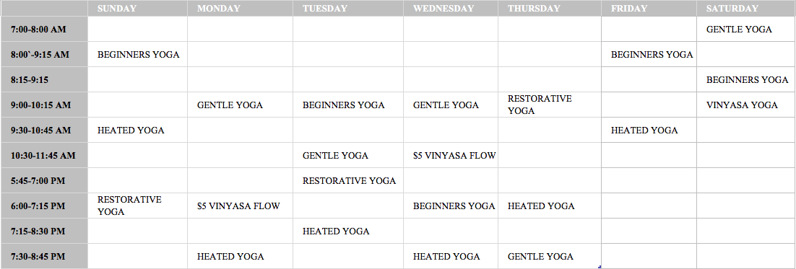

TLC Pricing
TLC Rates
Drop In | $15
5 Classes | $65
10 Classes | $120
20 Classes | $210
Monthly Unlimited | $150
Annual Unlimited | $1,200
Student/Senior Discount
Drop In | $10
5 Classes | $40
10 Classes | $90
Monthly Unlimited | $120
Private Classes
1 Hour Private | $90
New Students
1st Class | Free
3 Class Pack | $20
TLC Product Pricing
Mat Rental |  |  | $1
Water Bottle |  |  | $1
Hanalava Yoga Eco Friendly Yoga Mat with Carrying Strap |  |  | $40
TeekiYoga Pants |  |  | $75
Kleen Kanteen Water Bottle |  |  | $50
Jade Cork Yoga Blocks |  |  | $20
TLC Tshirts |  |  | $15
TLC Tanktops |  |  | $20
TLC Waterbottles |  |  | $10

Competition & Pricing
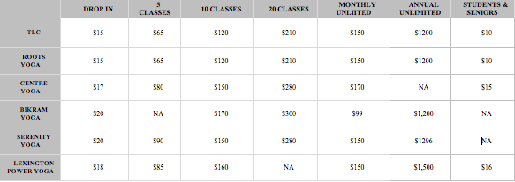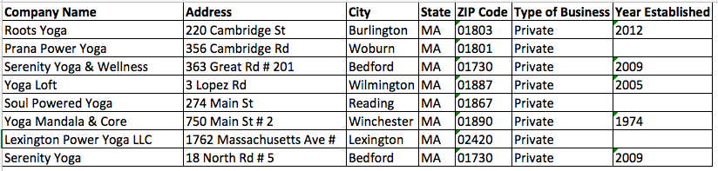

Cameryn Tierno Resume
15 Church Street, Woburn MA 01801 | 339-927-4879 | cameryntierno@gmail.com

Education

salem state university | may 2018 | Salem state university
- Bachelor of Science: Sport and Movement Science
  - Concentration in Exercise Science
  - Minor in Entrepreneurship
- 3.9 GPA, Commonwealth Honors Program
- Related coursework in SMS: Kinesiology, Exercise Physiology, Strength and Conditioning, Biology, Health and Wellness, First Responder
- Related coursework in Entrepreneurship: Financial Accounting, Introduction to Business, Principles of Management, Principles of Marketing, Entrepreneurship for Non-Business Majors, Internship

Experience

office assistant | gassett fitness center | may 2016 - current
- Assist with administrative functions of an office
- Assist with special projects
- Plan departmental activities
- Prepare publication materials including newsletters
- Assist with department events
- Complete departmental filing, data entry and membership management

facility Supervisor | gassett fitness center | Feb 2016 - current
- Assist in management of fitness center programs and daily operations.
- Oversee fitness program area
- Complete and file program paperwork and reports
- Conduct periodic floor checks
- Assist fitness center staff when/where needed
- Ensure member satisfaction

Vinayasa yoga instructor | May 2015 - Current
- Lead all skill levels from beginning to advanced
- Pay attention to each student throughout class
- Work with all body types and fitness levels
- Teach students correct postures to ensure maximum benefit and safety
- Track class numbers and manage student’s payments

Fitness Attendant | Gassett Fitness Center | Sept 2015 – FEB 2016
- Provided a high level of customer service while supervising all fitness areas
- Enforced policies and procedures
- Ensured a clean and safe environment for patrons
- Provided member satisfaction during all shifts
- Provided information concerning safety and usage of the facility and equipment

Skills

200 Hour Registered Yoga Instructor

Certified First-Aid and CPR

Survey results

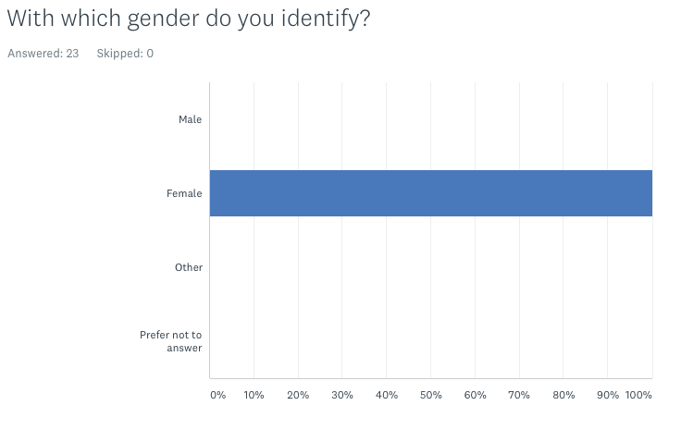



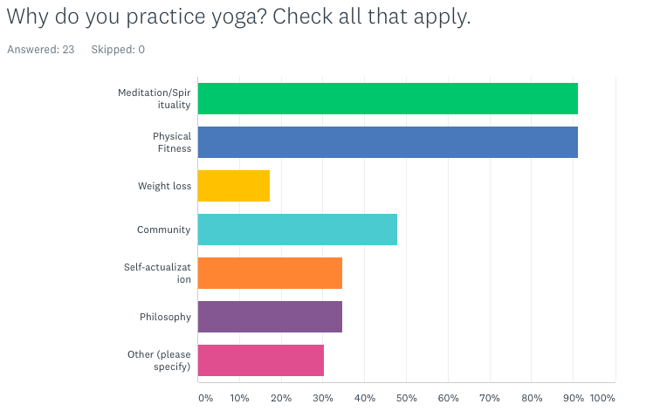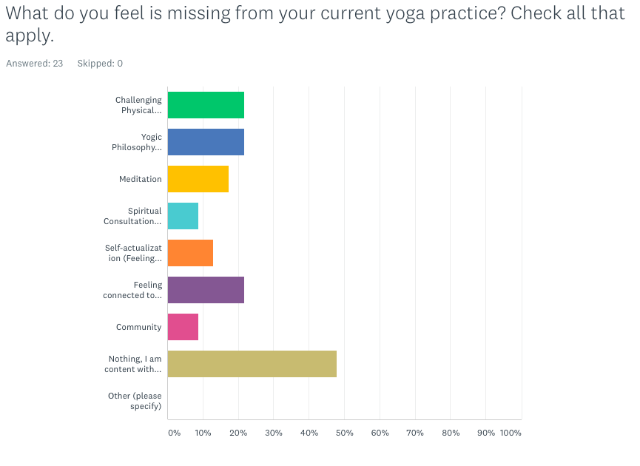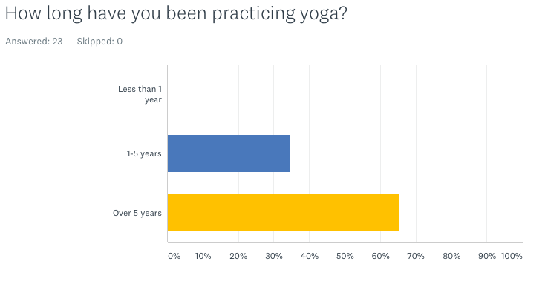

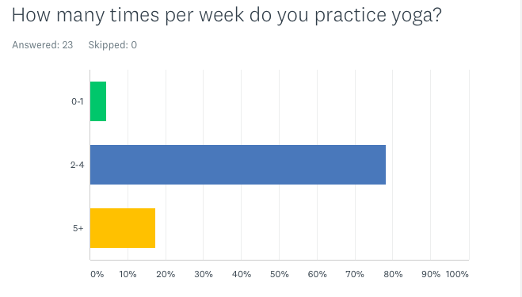
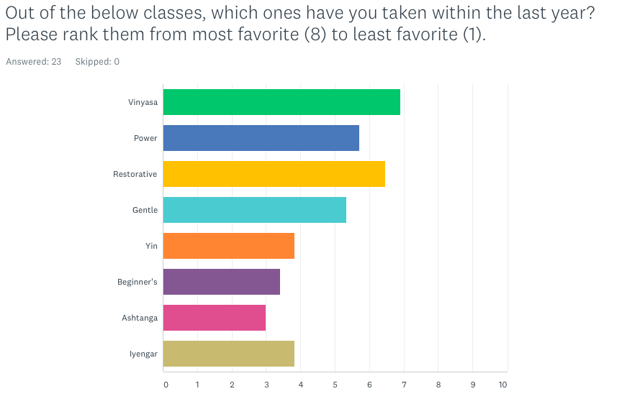

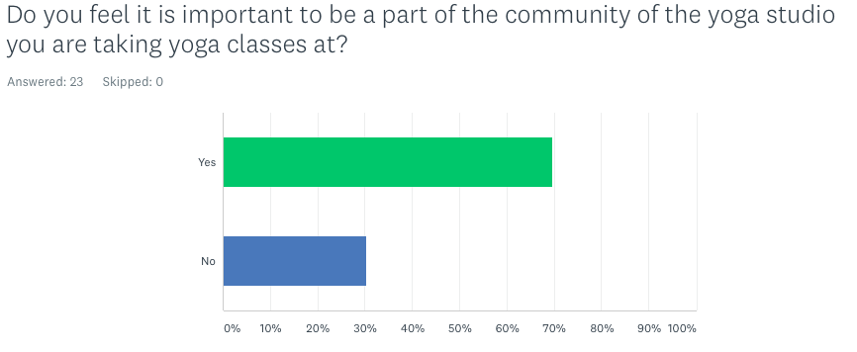
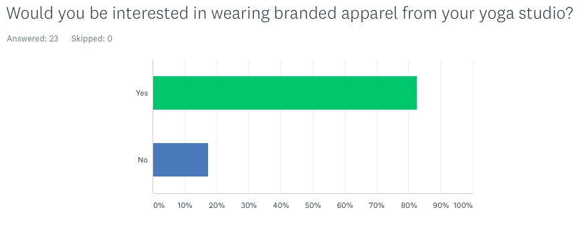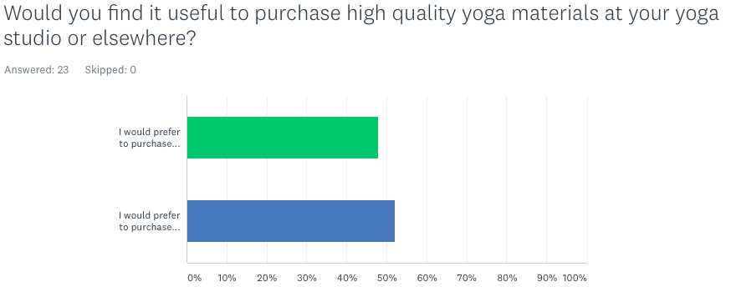

Financial Projections

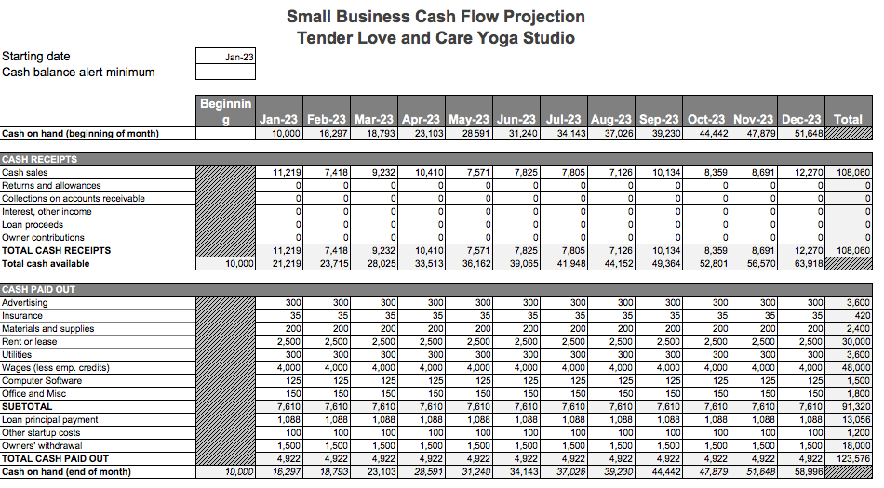

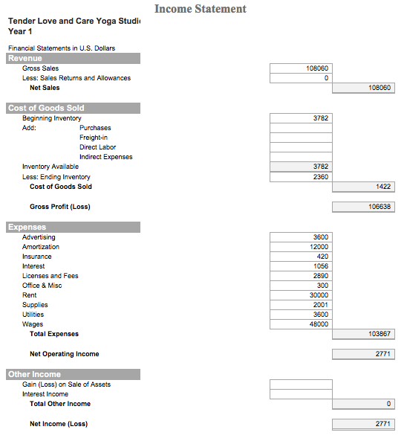



REFERENCES

Alvarez, A. “Industry Products and Markets”. IBISWorld. Retrieved from
http://corvette.salemstate.edu:2150/reports/us/industry/productsandmarkets.aspx?entid=4185. Accessed March 13, 2018.

Alvarez, A (2017, December). IBISWorld. Retrieved from http://corvette.salemstate.edu:2150/reports/us/industry/staglance.sspx?entid=4185. Accessed March 13, 2018

Burlington, Ma. Data Usa. Retrieved from https://datausa.io/profile/geo/burlington-ma/.

Burlington, MA. Data USA. Retrieved from https://datausa.io/profile/geo/burlington-ma/.
Alvarez, A (2017, December). IBISWorld. Retrieved from http://corvette.salemstate.edu:2150/reports/us/industry/productsandmarkets.aspx?entid=4185.
Alvarez, A (2017, December). IBISWorld. Retrieved from http://corvette.salemstate.edu:2150/reports/us/industry/ataglance.aspx?entid=4185.

