Studying land cover change in the Goviefe Todzi sacred forest, Volta Region Ghana

by
Madden Bremer

A thesis submitted to the faculty of Salem State University in partial fulfillment
of the requirements for the degree of Master of Science in Geo-Information Science

Fall 2020

Copyright 2020 Madden Bremer
All Rights Reserved

Acknowledgements

This research would not have been possible without the Goviefe Todzi community. Without their stewardship, there would be no sacred forest. Thanks are also due to Pascal Benson, Winfried Donkor and all members of the Accelerated Rural Development Organization for cultivating a harmonious relationship with the Goviefe Todzi community in pursuit of the common goals of sustainable forest management and conservation to achieve rural development. Thanks are due to Dr. George Ortsin of the UNDP Global Environment Facility Small Grants Programme for continued financial and technical support to projects that conserve and restore the environment while enhancing people’s livelihoods. Thanks are due to Jessica Brown of the New England Biolabs Foundation for fostering community-based conservation through high-impact small grants that promote the importance of global bio-cultural diversity. Thanks are due to the Salem State University Geography department, particularly to Dr. Stephen Young for his endless encouragement and patience. Finally, I must thank my fellow Salem State University graduate student, Peter Adortse, for his essential roles as translator, tour guide, and research partner among many other invaluable contributions.
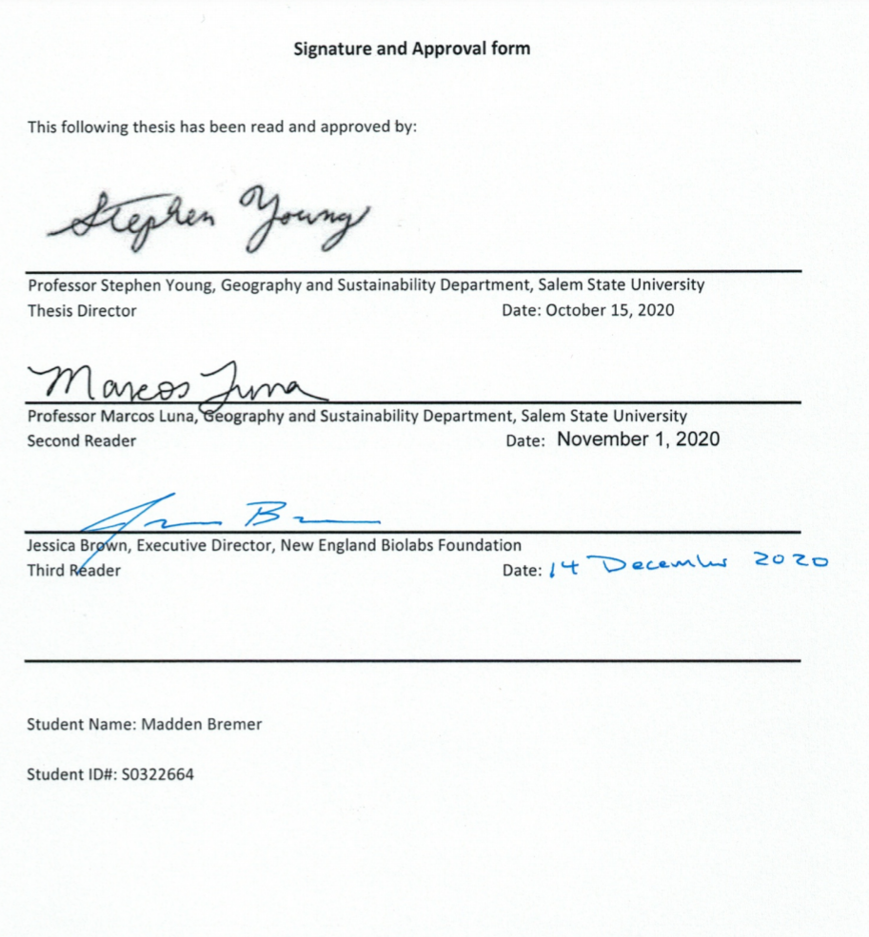

Table of Contents
List of Figures 5
Abstract 6
Introduction 7
Research Background 7
Research Question and Objective 8
Rationale for Study 8
Study Area Landscape 8
Literature Review 9
Sacred Natural Sites in Ghana 9
Governance of Sacred Landscapes in Ghana 10
Forest Policy in Ghana 11
Forest Cover Change in Ghana 12
Forest and Livelihoods 14
Digital Image Processing Methodology 14
Data 15
Land Use Classification 15
Post Classification Change Analysis 16
Field Data Collection for Boundary Demarcation 16
Results 17
Digital Image Analysis 17
Forest Cover Change 18
Conclusion 19
Appendix 21
References 23
List of Figures
Figure 1 - Map of Ghana and neighboring West African countries 9
Figure 2 - Google Earth satellite imagery demonstrating the visibility of forest reserves from space 13
Figure 3 - QuickBird-2 2012 15
Figure 4 - WorldView-2 2015 15
Figure 5 - GPS data collection within the sacred forest 16
Figure 6 - Survey map of forest 16
Figure 7 - Densely vegetated footpath along the perimeter of the sacred forest 17
Figure 8 - Burn scar from agricultural activity 17
Figure 9 - Cleared agricultural land 17
Figure 10 - Land cover gains and losses by category 18
Figure 11 – Contributions to changes in closed forest cover by category 18
Figure 12 – Land cover classification 2012 sacred forest boundary in white 19
Figure 13 – Land cover classification 2015 sacred forest boundary in white 19
Figure 14 – Land cover classification of sacred forest 2012 and 2015 19
Abstract
Sacred natural sites can be defined as any place in nature possessing a unique spiritual significance to peoples and communities. Throughout the world, sacred natural sites support ecological biodiversity, provide habitat stepping stones, and play a crucial role in the continuation of traditional spiritual practices. These variables in combination create a unique biocultural landscape that warrants conservation and conversely, sacred sites offer a mode of conservation. This research examines land cover change within the Goviefe Todzi sacred forest, located in Ghana’s Volta region, using satellite imagery. We utilized techniques in digital image processing to generate land cover classification maps of the study area for 2012 and 2015. Land cover classifications of high resolution QuickBird-2 and WorldView-2 imagery informed the hypothesis that closed forest cover within the sacred site decreased at a lesser rate than neighboring non-sacred closed forest cover. The Global Forest Change dataset from the University of Maryland framed our understanding of how forest cover changes within the study area and how it fits into the global context of forest cover change. Results demonstrated that the Goviefe Todzi sacred forest exhibited less closed forest loss when compared to non-sacred forest and closed forest was most often converted to open forest in the event of a land cover change. We recognized that other factors such as accessibility to nearby settlements, pre-existing agricultural fields, the time span of the study, as well as the topography of the sacred forest may also contribute to its lack of closed forest loss.
Introduction

Research Background
The research presented is the result of a partnership between the community members of Goviefe Todzi, the Accelerated Rural Development Organization (ARDO) led by Pascal Benson and Winfried Donkor, the UNDP GEF Small Grants Programme with support from Ghana’s National Coordinator Dr. George Ortsin, New England Biolabs Foundation (NEBF) led by Jessica Brown, and Salem State University’s (SSU) Graduate Program in Geo-Information Sciences (GIS) with faculty member Dr. Stephen Young and graduate students Madden Bremer and Peter Adortse. In the Fall of 2017, NEBF Executive Director Jessica Brown proposed an opportunity to conduct research in Ghana’s Volta region to Dr. Stephen Young. The objective was to conduct a community mapping workshop for a network of Ghanaian conservation groups, predominantly non-governmental organizations (NGOs), then travel to one of the NGO’s project area sites to demarcate the boundary of the Goviefe Todzi sacred forest. The community mapping workshop focused on building GIS expertise and promoting the capability of community mapping as a tool with which local actors can document community points of interest, make informed planning decisions, solve geospatial problems, and increase the sharing of knowledge.

The successful implementation of the mapping workshop has the potential to empower local actors to continuously gather geospatial data related to a community’s assets. Participatory mapping endeavors have proven successful in the past in Ghana as evidenced by an initiative led by the International Union for Conservation of Nature (IUCN) Global Forest and Climate Change Programme focused specifically on the mapping of forest reserves. The main products of the IUCN mapping program were forest condition maps and forest restoration maps, both of which influence decision making as it relates to planning for future protection and conservation of the forest reserve land. Though forest reserve land and sacred natural sites differ greatly in terms of land governance as well as biocultural valuation, they both benefit from community mapping efforts. In the context of this research, the term biocultural refers to the “diversity of life in all of its manifestations – biological, cultural, and linguistic – which are interrelated (and likely co-evolved) within a complex socio-ecological adaptive system” (Maffi and Woodley 2010). The results of the digital image processing and land cover classification of the Goviefe Todzi scared forest provide the underlying data needed to generate forest condition maps which can be used by local community actors such as ARDO.

After successful completion of the workshop, the research team consisting of Dr. Young, Madden Bremer, and Peter Adortse travelled to the Goviefe Todzi sacred forest with Pascal Benson, Winfried Donkor, Dr. Ortsin, and Jessica Brown and collected Global Positioning System (GPS) data on the location and health of forest cover within the sacred forest. We conducted digital image processing and analysis of the data at SSU’s campus and the findings were shared with all partners. The site visit was made possible through preexisting relationships between the community of Goviefe Todzi, ARDO, GEF SGP, and NEBF. This positive working relationship between all organizations and individuals enabled the SSU research team to travel to the community and officially request permission to enter the scared site. Peter Adortse acted as translator throughout the project, conveying information between Ewe and English. This critical step led by Adortse ensured the research team acted appropriately and followed all necessary community protocols before, during, and after the site visit.

After Adortse proposed the request to enter the forest, the community leaders deliberated amongst themselves and agreed to permit our entry into their sacred natural site. Before completing the data collection, the research team and members of the community hiked to the perimeter of the sacred site and participated in a series of traditions associated with the sacred forest. Before crossing the unmarked boundary into the grounds of the sacred forest, we removed our shoes and socks and washed our faces with water. The community leader then sacrificed a chicken at a designated location and sprinkled the ground with libations. After the necessary offerings were made, the group gathered in a small clearing and watched as community members led songs and dances with accompaniment by drums. Several of the men wore brown tunics to designate their status as traditional warriors of the community. A large meal of roasted goat, soup, and palm wine was shared in the clearing after which the group began the descent back to the village for a ceremony honoring Jessica Brown as a Queen Mother of the community.

The following day, three community members led the research team again to the sacred site and travelled on foot with us along the perimeter of the sacred area to collect GPS points of its boundary and observe the character of the forest. The site visit was a success due to the willingness of the community leaders to approve and support the research team’s proposal, the efforts of Dr.Ortsin - an expert in Ghana’s sacred natural sites, Pascal Benson and Winfried Donkor of ARDO who have a longstanding relationship with the community of Goviefe Todzi, Jessica Brown who had previously visited the village and sacred site, and Peter Adortse for continuous translation throughout the visit.

Research Question and Objectives
The research sought to accomplish land cover classification of the Goviefe Todzi sacred forest for 2012 and 2015 as well as its surrounding landscape using methods in digital image processing to draw conclusions about the status of forest cover change. We aimed to understand trends in forest cover change within the study area as well as identify potential drivers of forest cover loss. Furthermore, we tested the effectiveness of digital image processing techniques for land use classification. Broadly, the research investigated the hypothesis that recognition of a forest as sacred had significant positive implications for its overall health and resilience as a forest environment.

Rationale for Study
The benefits and resulting products of the research are as follows: recognition and support of the rights of the Goviefe Todzi community to lead the management of the sacred natural site, demonstration of the importance of following biocultural community protocols, production of land cover maps of the sacred site, quantification of the sacred site’s forest cover status using satellite imagery, and evaluation of methods in land cover classification. The research supports the current initiative between ARDO and NEBF to conserve biodiversity and promote the study area’s biocultural value within their project titled “Conservation, Protection and Promotion of the Weto Sacred Site at Goviefe Todzi for the Enhancement of the Lives of People” (Excerpt from ARDO project description 2017). Assessing forest cover status within the study area may support the overall goal of sustainable management of sacred forests for the improved livelihoods of community members by highlighting potentially at-risk areas as well as inferring possible threats to forest cover. The project meaningfully contributes to the body of academic research surrounding sacred natural sites by demonstrating a process for monitoring a site with an airborne sensor. Furthermore, the research documents the significance of a specific sacred natural site that has not yet received thorough review in this context. Building on the foundational work of Maffi and Woodley, this work also identifies the active role the Goviefe Todzi community has taken as custodians of the sacred forest over many generations.

The research contributes to a strong body of knowledge related to digital image processing techniques for land cover classification. The use of supervised and unsupervised methods in land use classification are central to the study of remote sensing and digital image processing. This project contributes to the continued efforts in experimenting with best practices for various climactic regions. The sacred forest poses unique challenges in extracting land cover information as it is a somewhat homogenous study area. The ability to discern different types of vegetation that present spectral similarities is a longstanding challenge within remote sensing across different platforms and applications.

Study Area Landscape
Ghana is a West African country bordered by Togo to the East, Burkina Faso to the North, Ivory Coast to the West, and the Atlantic Ocean to the South as seen in Figure 1. The country is demarcated into 16 administrative regions, each with a capital and sub-regional administrative districts. Ghana’s regions each have unique cultural, spiritual, culinary, and linguistic traditions in addition to distinct biocultural landscapes. In some cases, there are significant character differences within individual regions themselves depending on their size and geographic distribution. The Volta region spans over 300 km from North to South with noticeable variation throughout the landscape. The sacred forest of Goviefe Todzi is located in the Volta region, see Figure 1, within the Akwapin-Togo mountain range in the Afadzato South district, proximate to the town of Kpeve where the residents are predominantly of Ewe descent. Despite the steep terrain, the semideciduous forest of the Akwapin-Togo range is fertile enough to farm both tree and ground crops. Goviefe Todzi, like many communities in the area, is considered rural with a large number of citizens relying on agriculture as their primary income source.

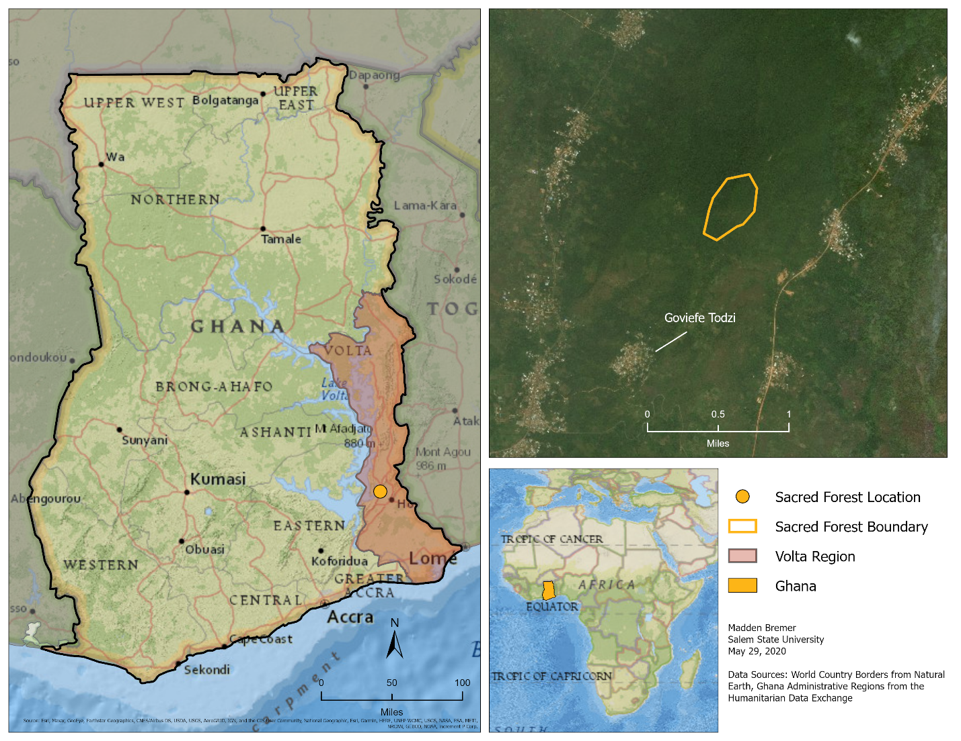
Figure 1 – Location of Goviefe Todzi sacred forest, Afadzato South district, Volta region Ghana

Literature Review

Sacred Natural Sites in Ghana
Sacred landscapes in Ghana come in a variety of forms including but not limited to ponds, forests, caves, mountains, boulders, and other natural features. They are recognized as sacred by the people living in or near the location, however this recognition may not be acknowledged outside of the community’s extent. Without formally designated protections, these hotspots of biocultural diversity are often managed collaboratively by local communities. The long-term association between a community and a sacred natural site is one that often dates back many years, creating a distinct biocultural character (Mallarach 2008). This concept is one that may contrast with traditional notions of Western biodiversity science and requires the acceptance of human and nature not as separate actors but as one interdependent entity (Maffi and Woodley 2010). The IUCN World Commission on Protected Areas guidelines recognizes the biocultural value of sacred natural sites and they may now be considered Category V protected landscapes or seascapes.

The 7 IUCN category classifications differ according to their management objectives and distinguishing features. Category V classification focuses specifically on the protection of a landscape or seascape where interactions between humans and nature over time have created a distinct character with ecological, biological, cultural, and scenic value. Features essential to Category V classification include distinct scenic quality with associated habitats, flora and fauna, and cultural features. There must also be a longstanding balance between human and nature, as well as unique or traditional land-use patterns. This level of recognition by the IUCN is the result of many years of focused efforts to combat a history of overlooking and undervaluing the multi-faceted character of sacred natural sites (Oviedo and Jeanreneaud 2007).

Nearly 400 sacred natural sites have already been inventoried throughout Ghana and this number will only increase with time as the study of sacred landscapes continues to gain momentum on a global scale (Ortsin 2015). Though not officially inventoried at the time of this research, preliminary investigation suggests there are as many as 5,000 traditionally managed sacred landscapes throughout Ghana estimated to cover up to 10,000 hectares in total (Ortsin 2015). The existence of sacred landscapes exemplifies the interconnected nature of human beings and the landscapes in which we live. Central to the study of sacred natural sites is the understanding that a landscape influences inhabitants just as the inhabitants influence their landscape. The historic relationship between humans and the landscapes in which they live and rely on is considered by some scholars to be the very foundation of human spirituality (Verschuuren et al. 2010). See Appendix A for a brief background on the history of the Goviefe Todzi sacred forest provided by Pascal Benson and Winfried Donkor of ARDO to understand its origin. Many sacred sites’ spiritual character derives from the general belief that one or many local gods reside amongst the land. Often referred to as fetishes, the gods are believed to communicate through a fetish priest who is tasked with relaying messages to the community and maintaining the fetish shrine (Ormsby and Edelman 2010; UNESCO 2003).

Governance of Sacred Landscapes in Ghana
Once nestled amongst continuous expanses of forest cover, Ghana’s existing intact sacred natural sites are some of the last remnants of undisturbed habitat (Bossart et al. 2006). Top-down land management decisions, lack of community stakeholder inclusivity, and a general sense of loss of ownership over community natural resources contribute to overall environmental and biocultural degradation in Ghana. As stretches of continuous forest cover succumbed to forces such as sprawling residential development and urbanization, bush fires, logging, mining, and agricultural land conversion, sacred natural sites remained protected by longstanding traditional belief systems and upheld through local governance frameworks (Ntiamoa-Baidu 2001; UNESCO 2003). Governance in this context refers to who, whether an individual or group of people, make decisions on behalf of their community and are backed by influential power. The Goviefe Todzi sacred site is protected under a community governance framework comprised of several local community leaders, the chief of the community, the traditional priest, and the paramount chief. Together, this group of decision makers establish community-wide expectations about which land uses are permitted, to what extent resource extraction from the forest is tolerated, when traditional activities or celebrations should be held, and who is allowed to enter the forest for specific purposes. Effective community-led governance is the primary reason sacred forests like the Goviefe Todzi site still exist today. Local decision makers recognize the resource consumption requirements, like extraction of fuel wood and demand for agricultural land, needed to sustain the livelihoods of the community, while still upholding the value of the sacred forest and preserving its role in their traditional belief system.

Through Ghana’s Forest Investment Programme and the Wildlife Division of the Forestry Commission of Ghana, an integrated natural resource governance and management approach called Community Resource Management Areas (CREMAs) can be utilized to address obstacles related to sacred natural sites. The CREMA framework is an empowering mechanism for the kind of inclusive natural resource management and landscape governance required to support community livelihoods while simultaneously conserving the biocultural aspects of sacred landscapes. The integrated approach prioritizes joint decision making between communities within a geographically defined extent of a CREMA. Building on preexisting decision making structures operating within the constituent communities, this mechanism guides sustainable natural resource management and governance through collective decision. Each CREMA adheres to a constitution developed from the Community Resource Management Committee which guides the CREMA executive structure. Individual land holders are members of the CREMA as well and, through their respective management committees, are given a platform to voice their priorities within the CREMA as well as hold the executive accountable to the constitution. As of 2017 there were 32 CREMAs in Ghana, 24 of which are fully operational.

Forest Policy in Ghana
The primary objective of Ghana’s forest legislation is conservation and sustainable development of the nation’s forest and wildlife resources for maintenance of environmental quality and the perpetual flow of optimum benefits to all segments of society (Kotey et al. 1998). One of the most notable challenges to the successful implementation of this goal is the delicate balance between competing interests directly and indirectly tied to the forest sector. The careful maintenance and monitoring of these agendas are not a challenge faced by Ghana alone. This obstacle is identified globally as it relates to successful environmental conservation and sustainable development. An imbalance of power between the individuals or groups of people tasked with enacting forest policy results in some agendas progressing at the detriment of others with the possibility of significant negative consequences, intended or unintended (Kotey et al. 1998).

As is the case with many African nations once inhabited and still affected by colonizing powers, current policy initiatives are often rooted in norms and ideals introduced during colonial occupation by external agents (Bass and Mayers 2004). A continuous examination of ingrained practices and principles is necessary to ensure national policy reflects the true interests and well-being of all the citizens of a nation. Evidence of colonial-driven forest policy is seen in the demarcation of forest reservation land for the primary purpose of supporting the production of crops with high export value such as cocoa. While colonial occupants did practice conservation in some forested areas, it was specifically to ensure production of lucrative cash crops by protecting watersheds and maintaining soil integrity. By contrast, non-reservation forest land was not officially managed with any sustainable vision and was consistently converted to smaller-scale agricultural land (Bass and Mayers 2004). This practice is merely one example of a plethora which support the widespread notion that forest policy in Ghana has historically been exploitative in nature (Teye 2008).

Poreku (2014) refers to the protection of national park land as ‘fortress conservation’ because it resembles that of a guarded, valuable asset. It is customary for armed officials to stand watch over entry points into the protected forest areas and patrol the forest area, although they are often not able to prevent poaching and other illegal, destructive actions from taking place within the forest. Poreku (2014) highlights the immense cost associated with ‘fortress conservation’, especially considering it is known to not be fully effective at protecting reserved areas. Amy Corbin, of the Sacred Land Film Project, states that the establishment of reserves is a deeply European concept (Corbin, 2008). The belief that land within the reserve must remain untouched and land exterior to the reserve can be heavily exploited does not reflect a traditional forest management system. Traditional management practices enacted at the local level are, in comparison, extremely cost effective and altogether more holistically successful concerning the protection of forest resources. Traditional forest management systems in Ghana and elsewhere globally are typically comprised of several zones of varying uses including but not limited to: a core zone which is heavily protected and not often entered by humans, a buffer zone which is protected but entered more frequently and some forest resources may be harvested, and a transition zone which may host farming and logging activity in a controlled manner.

There currently exist many types of land tenure and management systems in Ghana comprised of both state and customary roles, or formal and informal roles (Kasanga and Kotey 2001). State actors, often referred to as formal actors, of land and forest management in Ghana include, but are not limited to, the Lands Commission, Environmental Protection Council, Environmental Protection Agency, Ministry of Local Government and Rural Development, Ministry of Environment, Science, and Technology, Ministry of Lands and Natural Resources, and the Forestry Commission. Today, the two most apparent formal actors in forest policy decision making are the Forestry Commission and the Environmental Protection Agency, although this was not the case historically. The Environmental Protection Council (EPC) was established in 1974 largely as a reaction to the 1972 United Nations Stockholm Conference on Human Environment, during which it was acutely stated that human activities had begun to create significant challenges environmentally and that continued human activity could pose serious environmental harm with longstanding consequences (Ando 2014). The emerging, unclear identity of environmental protection and human wellbeing in Ghana is reflected in the early years of the EPC, during which it was frequently re-assigned to various Ministries. The EPC operated within the Ministry of Finance and Economic Planning, the Ministry of Local Government and Rural Development, and the Ministry of Environment, Science, and Technology. Following its transition from EPC to Environmental Protection Agency (EPA) in 1994, the true purpose of the organization solidified as regulating the environment and ensuring proper implementation of government policies as they affect the environment.

As a result of the 1972 Stockholm Conference, integrated planning between development and environmental goals became a priority for many nations in attendance, including Ghana. Amongst the key takeaways from this influential global conference was the idea that increasing populations posed a risk to both environmental and human livelihood (Ministry of Science Environment and Technology 2012). Population growth in southern Ghana in particular was estimated to have increased tenfold in the 20th century alone (Wiggins, Marfo, and Anchirinah 2004). As a result, significant environmental legislation was created. Evidence of such legislation is as follows: the Trees and Timber Decree (1974) which enforced compliance with export levies of unprocessed timber, the Forest Protection Decree (1974) which attempted to reign in illegal chainsaw felling of trees, the Timber Resource Management Act (1997) which defines forest resource allocation and timber rights laws, the Forestry Commission Act (1999) which promotes domestic timber industries over timber exports, and the Forest and Plantation Development Act (2000) which financially assists the development of private forest plantations on suitable lands (Forest Legality Initiative). Ghana’s first steps into forest management policy set a perhaps unintended precedent that, while there may technically be a wide range of policies aimed at conserving forest environments, the majority of the policies are prioritized and enforced only in areas rich with timber resources (Wiggins, Marfo, and Anchirinah 2004). Falling in line with a precedent partially established under colonial rule, forest policy in Ghana was still viewed by many as merely a tool used by timber resource extraction industries.

As forest policy took shape in Ghana, informal forest management was still operating beneath the surface as it had historically upon arrival of British colonizers. Chieftaincy was the dominant form of local government and had only been strengthened by indirect colonial rule (Kotey et al. 1998). While individual local communities lacked a formal definition of land tenure rights and access to forest resources, informal agreements between timber extraction operators and chieftains were negotiated until both parties reached an agreeable outcome. This simultaneously undermined formal policy initiatives and created a precarious relationship between powerful industries and local communities. As the timber industry transformed into a domestically operated industry under the guide of a newly independent government, development became the driving force behind forest policy. While timber extraction began to encroach into non-timber forest areas, local communities reverse migrated into soon-to-be reserved state forest land as an attempt to lay claim to the area before government demarcation and limitation of access to the area was enforced (Kotey et al. 1998). Today there exist 266 forest reserves covering a total area of 2.5 million ha (IUCN Forestry Brief 2016), and as noted by Amoako-Atta (1998), the boundaries of the forest reserves are clearly discernable from satellite imagery and lend the impression that very little old growth forest remains outside of the reserves. This observation begs the question of whether there would be any virgin forest remaining without the demarcation of state forest reserves (Amoaka-Atta 1998). Aside from formally protected forest area, it is solely traditional land holding groups that have managed to retain old growth forest. The dynamic and adaptable nature of informal land tenure systems in Ghana is a central reason sacred forests remain healthy ecosystems in the present day.

Forest Cover Change in Ghana
The subject of deforestation within Ghana and the greater landscape of West Africa is considered contested by many scholars. Haile et al. (2016) state that between 1982 and 2006, 20% of global land degradation occurred within Africa, south of the Sahara. Within Ghana, estimates of total forest cover loss between 1900 and the 1990s reach as much as 50% (Teye 2008). The Forestry Commission finds that the high forest zone land area in Ghana diminished from 8.2 million hectares to approximately 1.6 million hectares over the last century (Forestry Commission 2010; Acheampong and Marfo 2011). The overall deforestation rate within Ghana is now believed to hover around 2% annually (IUCN Global Forest and Climate Change Programme 2016). The complex nature of studying loss of forested land in this region is observed distinctly within the existing body of scholarly literature available presently. Research is skewed heavily towards studying forest cover dynamics within Ghana’s allocated state forest reserves as compared to non-reserved forest land such as the Goviefe Todzi sacred forest. This trend in literature could be partially attributed to the vast size differential between sprawling state forest reserves and the typically smaller land areas of non-reserved forest. As large forest reserves are more easily analyzed with freely available satellite imagers such as Landsat and MODIS, more research efforts can be conducted without the added obstacle of obtaining the high resolution imagery needed to differentiate subtle changes in smaller geographic study areas. This observation speaks to the importance of increasing availability of high resolution imagery for research efforts in underrepresented geographic areas within their relevant academic fields. Further adding to the ease of studying state forest reserves are their well-documented boundaries. As seen in Figure 2, the reserved forest areas identified by white arrows contrast so starkly with the degraded landscape surrounding them that their entire polygonal boundaries can be deduced. The darker green forest cover is reserved forest while the lighter vegetative cover is non-reserved.
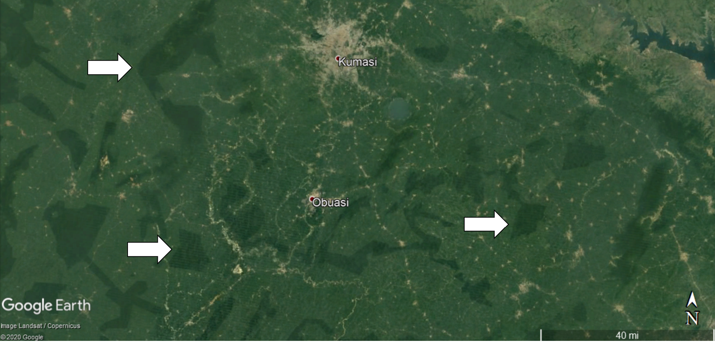
Figure 2 - Google Earth satellite imagery demonstrating the visibility of forest reserves from space

In contrast to state forest reserves, sacred forests are generally located amidst naturally occurring, non-sacred forested land. This fact makes definition of sacred forest boundaries difficult, and thus poses an obstacle to monitoring consistent land cover change in the sacred landscape as compared to its surrounding land cover types. The nature of these fuzzy, and sometimes subjective, sacred landscape boundaries requires a local understanding to successfully undertake research within the area. For these reasons, approximate rates of forest cover change in sacred natural sites is not well understood. What is well understood are the documented threats to the integrity of sacred natural sites. There is ample literature and field observation focused on the forces that result in forest cover loss throughout the country of Ghana. Ghana’s 2010 REDD+ readiness proposal states the main drivers of deforestation are agricultural expansion, timber harvesting, urban sprawl and infrastructure development, and mining and mineral exploitation. The drivers of deforestation do not exist in a vacuum from one another; there is strong scholarly literature supporting the theory that the intersection of economic, environmental, social, and governmental factors strongly influence trends in deforestation at the global scale.

Agricultural expansion within the context of this research is defined as the deliberate conversion of non-agricultural land of any type to agricultural land, including everything from small-scale subsistence farming to expansive commercial-scale farming. The USGS EROS program found that between 1975 and 2000, Ghana’s agricultural land area increased from 13% to 28% of the country’s total land area. That percentage climbed further to 32% of total land area between 2000 and 2013 (CILSS 2016). The use of fire as a land clearing and land management tool is used to support an ever-expanding need for agriculture land in Ghana. According to the 2010 FAO Global Forest Resources report, of the 78 countries that participated in their study from the years of 2003 to 2007, Ghana was one of the most severely affected countries by forest cover loss due to forest fire (FAO 2010). The nature of the fire that resulted in forest cover loss is not defined within the context of these statistics and encompasses both manmade and naturally occurring fires. Although Ghana was not amongst the top 5 countries for total forest land area lost to fire, it was among the top 5 for percentage of forest cover lost along with Chad, Senegal, Botswana, and Portugal (FAO 2010). In addition to loss of forest cover to fire, Ghana was identified as a country in which non-forest, wooded land is likewise affected by fire. This FAO report suggests these findings to be a result of fire as a land-management tool (FAO 2010). While this particular report does not quantify the amount of forest lost specifically to fire for agriculture purposes, it is reasonable to infer that the goal of many manmade fires is to clear land for agriculture.

Forests and Livelihood
Central to the rural livelihoods of Ghanaians, forest resources provide direct and indirect economic benefits to approximately 2.5 million people in-country (Acheampong and Marfo 2011). Timber harvesting includes but is not limited to the use of forest resources for logging, illegal chainsaw activity, charcoal generation, and fuel wood collection. The subject of timber harvesting intersects a great deal with land tenure and tree tenure systems in Ghana. Chainsaw milling in particular, though it has been officially banned since 1998, is still prevalent throughout the country due to a perceived lack of clarity over land and tree tenure rights (Acheampong and Marfo 2011). The outright ban of chainsaw milling was established in reaction to “indiscriminate” tree-felling that was “inconsistent with sustainable forest management practices” (Marfo 2011). Al and Pontius (2008) found in a study of land cover transitions in Ghana’s South Western region that, outside protected forest areas, closed forest land is most often converted to farm land. Comparatively, within protected forest areas logging is the main cause of forest cover loss.

Rapidly growing populations both in urban and rural communities increase the pressure to maximize land use for agriculture to meet both domestic and foreign expectations (Poreku 2014). In addition to the need for expanded agricultural land, infrastructure is needed to support growing populations. With more people, come crowded living conditions and a need for new settlements. Witnessed firsthand during the research team’s visit to Ghana, the city of Tema is a testimony to the rapid rate of expansion experienced throughout the country. The construction of homes and new developments is quickly outpacing the rate at which roads are built to accommodate the new cities. What was once untouched wetland or grazing area are now home to many citizens living just beyond the Accra area. Such is the case in Ghana’s more rural areas as well. Poreku (2014) cites the creation of a new northern district and its capital city of Daboya as an example in which road construction will directly threaten the health of a sacred forest. The construction of a road from Daboya to the regional capital Tamale will intersect the Jaagbo sacred forest and cause fragmentation of the forested land which is noted as harmful to biodiversity. In a 2009 video report posted on the video streaming website YouTube, Voices of Africa mobile reporter Edward Kwame Aklade investigated how development projects in Pokuase, a suburb of Accra, threaten the Guakoo sacred forest. Residential and commercial development is prohibited in the area proximate to the sacred forest, yet Aklade captures video footage of buildings in mid-construction and the poor quality of the remaining forest habitat in the sacred area. Local community members attest to the degradation of the sacred forest and state illicit development as the catalyst for habitat destruction and loss of biodiversity.

Digital Image Processing Methodology

Employing techniques in digital image processing, land cover classification maps are used in this research to investigate land cover change dynamics within the Goviefe Todzi sacred forest and its surrounding forested landscape. The high resolution QuickBird-2 and WorldView-2 satellite imagery used for the study of land use change within the sacred forest area were obtained through the DigitalGlobe imagery grant program. There were two scenes of imagery available that met the percent cloud cover criteria and encompassed the sacred forest and surrounding the study area. The Global Forest Cover dataset (Hansen et al. 2017) was obtained under creative commons license through the University of Maryland. Initiatives like the imagery grant program at DigitalGlobe and generation of global land change datasets such as that developed by Hansen et al. (2017) encourage the progress of knowledge and achievement in the fields of remote sensing and geospatial sciences by supporting research endeavors with high quality global data. The continuation of such programs and initiatives is crucial to achieve accurate studies of the environment. The method of digital image processing chosen for this research and the scale of the study area necessitate the use of high resolution imagery which is unfortunately not accessible equitably across the world. If an individual is granted access to high resolution imagery such as the DigitalGlobe scenes, reliable high-speed internet is almost certainly necessary to complete a successful download to a local computer for processing. Even with a strong internet connection and adequate computing power, downloading and manipulating large raster images can be resource intensive and require proprietary software. It is therefore a priority to disseminate the results and methods so that knowledge can be shared between all stakeholders involved in this research effort who may not otherwise easily access the finer details of the project.

Data
There were 5 QuickBird-2 satellite image products available, pictured in Figure 3, within the general study area, however Product 3 covered the sacred forest directly. Product 3 consists of 2 individual paths both collected on March 16, 2012. Each path covers an area 16.8 km in width and 360 km in length. The imagery tiles were projected in UTM 31-N. One path of WorldView-2 imagery covered the study area, pictured in Figure 4 below. The tile was 120km in length and 15km in width. There were no clouds present in the image and no atmospheric correction was deemed necessary.

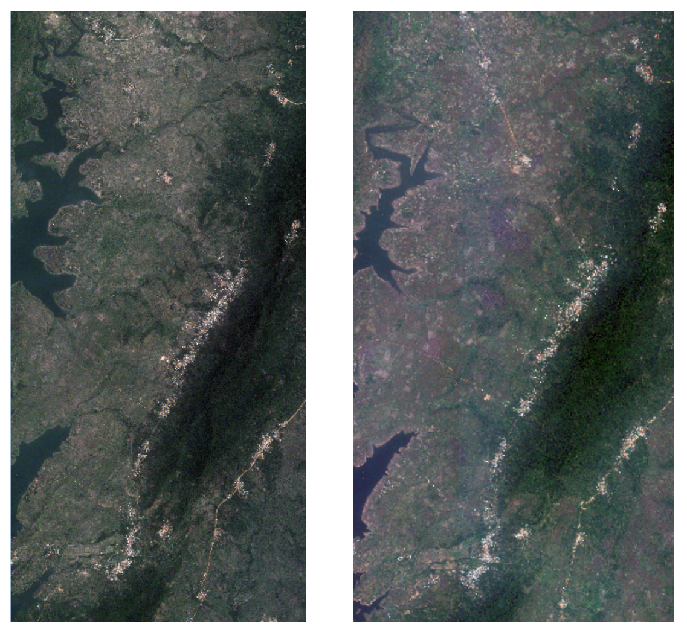
Figure 3 - QuickBird-2 2012 Figure 4 -WorldView-2 2015

The revisit time of WorldView-2 is, on average, 1.1 days and the revisit time of QuickBird was 1-3.5 days depending on latitude. The frequency of revisit time was necessary for the accurate study of geographic areas like Ghana where cloud cover frequently obscured imaging sensors. Critical to the success of this study, high resolution satellite imagery was needed to discern potential forest cover change at a pixel by pixel basis at the smallest scale possible (WorldView-2: 1 pixel = 1.2 meter – multispectral, QuickBird-2: 1 pixel = 2.4 meter – multispectral). As the first commercial high resolution satellite to provide 8 spectral sensors ranging from visible to near infrared (NIR), WorldView-2 outranked all other sensors available at the time of the study. WorldView-2’s red edge and near infrared 2 (NIR2) bands, ranging from 705 to 745nm and 860 to 1040nm respectively, were essential to identifying vegetative land cover (Adamo et al. 2012). QuickBird-2 offered only 4 bands, see Table 1 for details, but did include a NIR band.

Land Use Classification
Knowledge of the study area’s characteristics was required in this multispectral classification exercise because there was a great range of variation within any given land cover class. For this reason, use of generic spectral reflectance libraries was determined not to be feasible for this study. The following informational classes were used in land cover classification: closed forest, open forest, sparse forest, agriculture activity, bare ground, developed/settlement, and water. A histogram peak cluster analysis was conducted for the 2012 and 2015 scenes and significant clusters were reclassed to their most appropriate informational class to generate land cover maps for 2012 and 2015. Informational classes were assigned based on observations gathered in the field using georeferenced photographs taken within the study area as well as close inspection of supportive imagery such as google earth.

Developed or settled land was characterized by non-permeable surfaces such as paved roads and permanent structures in dense clusters. Also included were dirt roads and informal structures both in dense as well as intermittent spacing. Agriculture activity included a wide variety of farming from subsistence to commercial farming of crops such as cassava, corn, rice, palm, banana, coco, and coffee. Subsistence or small-scale farming often occupied areas of land smaller than capable of identification through satellite imagery. Particularly challenging was the ability to discern intermittent tree crops from undisturbed forest cover. Spare forest cover was categorized by predominantly grasslands with intermittent stands of trees, low shrubs and scrub brush. Open forest cover was categorized by predominantly tree cover with sparse undergrowth and no dense canopy. Closed forest was categorized by dense old growth tree cover with thriving underbrush and a dense canopy.
Site visit observations yielded valuable insight into challenges in remote sensing techniques for the study area.

Post Classification Change Analysis
Post classification change comparison, a common strategy for time change analysis using images from different dates (Alo and Pontius 2008), was employed to produce land change maps. Changes were analyzed at the pixel-level using the 2.4m spatial resolution of the 2012 QuickBird-2 imagery. Land change within and exterior to the sacred forest was quantified using the classified scenes of imagery. Results of land cover classification and change were then compared to the global forest change dataset generated by Hansen et al. for changes observed between 2000 and 2017.

Field Data Collection for Boundary Demarcation
The research team used a Trimble GPS to capture the location of cement markers at points along the perimeter of the sacred forest, see Figure 5. The results of the data collection were cross referenced with a preexisting map of the study area generated by a surveyor, pictured in Figure 6.
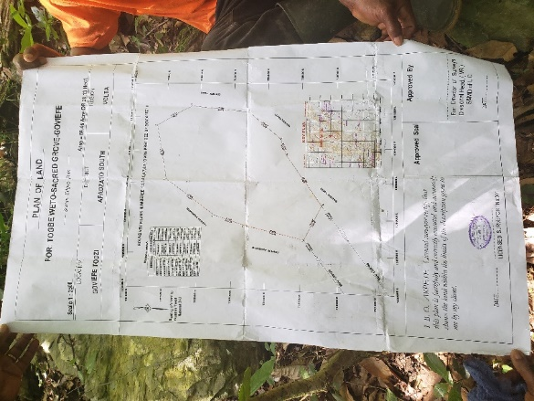
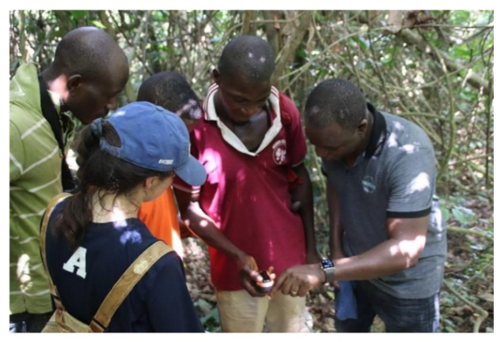
Figure 5 – GPS data collection within the sacred forest Figure 6 – Survey map of forest

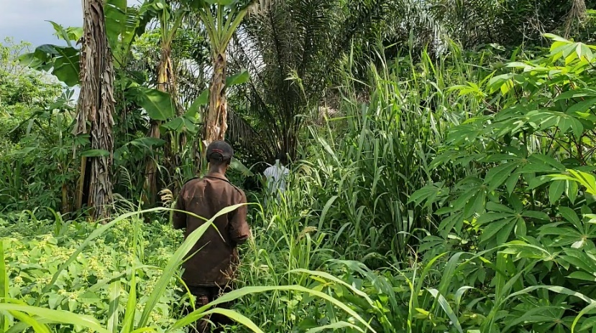
Twelve points were recorded on foot while traversing the perimeter of the sacred forest, with five of the twelve points located at established beacons and the remainder as guidelines to inform boundary generation. The collection of the GPS data was an essential step to generate a vector file of the boundary of the sacred forest, assuming a direct path between each neighboring beacon. The tree canopy was too dense to visibly discern the route taken via satellite imagery. In many places the path had become grown over and required a machete to pass through, see Figure 7 for an example of vegetation growth.

Figure 7 - Densely vegetated footpath along the perimeter of the sacred forest

Results

Digital Imagery Analysis
Unsupervised clustering classification yielded 23 significant clusters and 29 significant clusters for the scenes from 2012 and 2015 respectively. As the scenes are from different sensors with differing spatial resolution characteristics, variation in the appearance of the significant clusters was expected. Further contributing to a variation in results observed, the 2012 clustering incorporated only 4 bands while the 2015 clustering incorporated 7 bands.

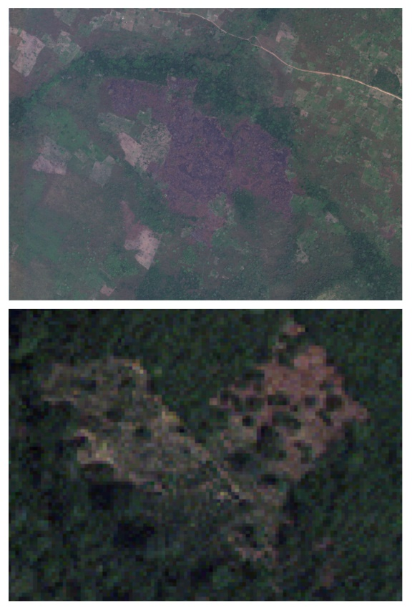
The influence of human intervention was observed within the general study area, most notably the practice of slash and burn on shrub land resulted in burn scars and drastically altered the appearance of the land cover type both on the ground as well as through satellite imagery, see figures 8 and 9.
Figure 8 – Burn scar from agricultural activity Figure 9 – Cleared agricultural land

Stow and Benza-Fiocco’s 2012-2016 work in Ghana discussed challenges such as persistent cloud cover, disruption on clear days from pollution, Harmattan effect wind-borne dust, comingling of agriculture and natural vegetation, difficulty detecting impervious surfaces due to consistent soil covering. Of the identified challenges, the co-location of natural vegetation and agricultural activity was the most difficult to rectify during image processing and may have resulted in agriculture land classified incorrectly as either spare, open, or closed forest and vice versa. Successful identification of agriculture land was more common when considering ground crops as compared to tree crops.

Forest Cover Change

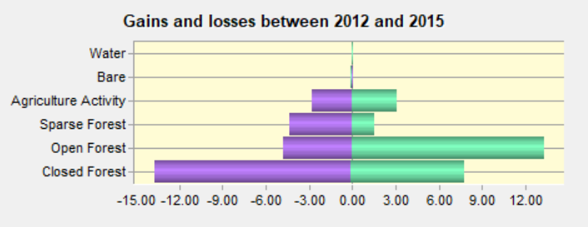
The largest loss in land cover category observed within the 28 hectare sacred forest study area was closed forest with a loss of 13.75% of total study area, equivalent to approximately 7 hectares. The next largest loss was open forest at 4.83%, followed by sparse forest at 4.38% and agricultural activity at 2.8%. Gains and losses of land cover type are pictured in Figure 10 with purple representing loss by area and green representing gain by area along the x-axis. A 13.34% gain was observed in open forest followed by a 7.82% gain in closed forest, 3.07% gain in agricultural activity, and 1.54% gain in sparse forest. Figure 11 depicts the contributions to closed forest loss by category and by area. The main driver of closed forest loss was open forest, followed by sparse forest, and lastly agricultural activity. See Figures 12-14 for land cover classification maps of the sacred forest for 2012 and 2015.
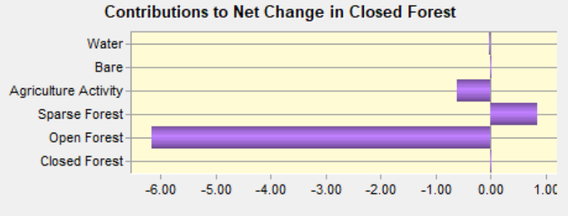
Figure 10 – Land cover gains and losses by category
Figure 11 – Contributions to changes in closed forest cover by category
Hansen’s global forest dataset was used to contextualize the sacred forest land cover change results and establish discernable differences observed inside and outside the sacred forest boundary. We found that within areas of forest cover categorized as greater than 20% forested, the Volta Region experienced a deforestation rate of 4.7%. By contrast, when observing forest cover of greater than 20% within the sacred forest, deforestation occurred at a 0.8% rate between 2000 and 2017. The results demonstrate that forest cover is not lost at the same rapid pace within the sacred forest as it is in the surrounding region.

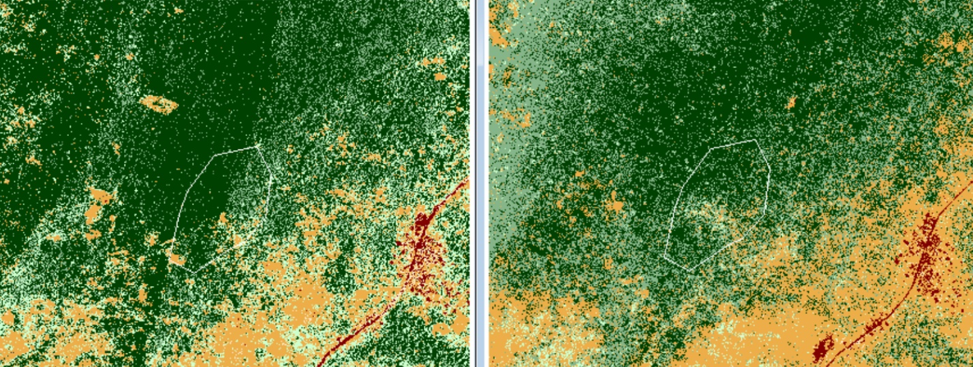
Figure 12 – Land cover classification 2012 Figure 13 – Land cover classification 2015
sacred forest boundary in white sacred forest boundary in white
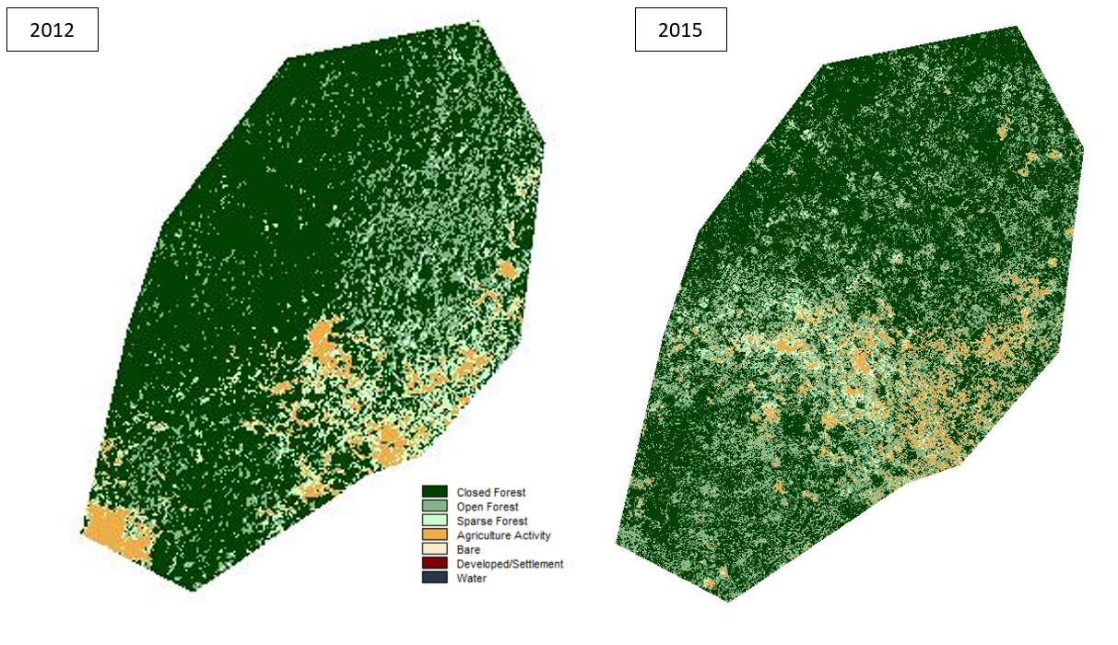
Figure 14 – Land cover classification of sacred forest 2012 and 2015

Conclusion

The results of the research support the hypothesis that recognition of land as sacred plays a role in its ability to retain closed forest cover when compared with non-scared forest. It is reasonable to infer that other factors such as proximity to human settlements, the cultivating capability of the sacred land, and access to the area itself are all factors that play a role in whether forest cover is lost within the sacred boundary. Research should be further pursued to include other identified sacred landscapes within Ghana, beyond the Volta Region. Continued research could bring much needed attention to the importance of sacred forests in global conservation and lead to a better understanding of holistic forest management. The research also highlights the continued need to support local communities’ efforts in conserving sacred natural sites. As demonstrated by the Goviefe Todzi community, the core values of sacred landscape stewardship are deeply rooted in the identity of the people living proximate to the site. Therefore, community actors should by right play a central role in management of the biocultural asset.

Appendix

History of the Goviefe Todzi Sacred Forest
The following excerpt details known oral histories associated with the Goviefe Todzi Sacred Forest according to Pascal Benson and Winfried Donkor of the Accelerated Rural Development Organization:

Sacred groves are established for varying reasons in each community. One common underlying fact is that they have spiritual connotations. They also have healing or curative functions. The location of a site is dependent on the source or its origin. A grove may be established because there was a historical significance to the community. It should be noted that the size varies and has no relationship with its potency. Within the grove is the core where the deity is believe to be inhabiting. These may be a mystical cave, stone a tree or an anthill. It is also
possible that a collection of stones to symbolize the spot where rituals are performed.

Historians have it that, the Ewes who now reside in the Volta Region of Ghana have their origin from ancient Ethiopia or Egypt. In an interview with Togbe Tsoble who is the Caretaker of the Goviefe Todzi sacred grove, he said they brought the deity from Sudan as they migrated, carrying it along. According to them, though they are a small community, the deity protected them against other ethnic groups until they settled in their current home about four hundred years ago. The deity being a warrior, led to the defeat of the Ashantis during their notorious wars of conquest of the Gold Coast.

The mountain is considered the home of the deity, no one was allowed to farm or settle around it thus creating the grove. There are two main sets of prohibitions related to the grove. The first are issues related to managing the grove and the others are related the entire community conduct. Prohibitions in management may include non-interference with the grove. That is to say, no one is expected to enter the parameters of the grove at any moment without the consent of the caretaker. These include harvesting of herbs, hunting gathering of fruits or fuel wood.
A woman is not allowed to visit during her menstrual period or after birth without purification. Some prohibtions disallow persons who had sexual intercourse the previous day from entering them. Anybody who might have shed blood apart from in a war situation or abortion is not allowed to enter most of the groves. However, on special occasion where annual rituals or sacrifices are performed and many other people would be in attendance, a purification and atonement rites are performed for every individual. Typically by sprinkling or bathing them in a special water before entering the grove.

The communal prohibitions are more general to the entire community members. In this case, regardless of where you find yourself, they must be observed. These prohibitions are mostly in the form of totems. Some of the groves prohibit every member of the community from eating specific animals or food. Some even prohibit marriages from some specific ethnic groups because of some historical incidents. The royal python for instance is a totem to some groves in Ghana. No member of that community is allowed to kill or harm it. They are even allowed in their rooms without restriction. Some forbid the consumption of snails, crabs and several other organisms. Eating or violating them may bring a bad omen or calamity to the individual, the family or the entire community. Strange diseases and death occur if the offending individual fails to confess. In order to avoid all these negative results, rituals are performed anytime they want to visit the site for purification. During the first visit to the grove with Jessica Brown, prayers were offered. But our second visit with Henry, the Board Chair of NEBF, rituals involving two goats and two chicken were performed at the community before we set off. The consequences of neglecting to perform rituals include but are not limited to death, insanity, non-stoppage of menstrual flow (hemorrhage), protracted ailment, draught in the community, inexplicable incidents among others happen. For these reasons, the site is not appropriate for tourism.

Two main rituals are performed in association with the grove. The first is the annual rituals of pacification and renewal of allegiance to it. This is normally done in April. The second ritual is called upon for specific reasons which may include occasions of draught, inexplicable occurrences such as deaths or strange diseases, coronation of new Community leaders such as chiefs and youth leaders who are commanders of the army of warriors called Asafo. In times of severe draught, the caretaker performs rituals, and by close of day, there would be heavy downpour of rain. Many other services are provided for individuals who seek help such as child birth or health issues mostly related to spiritual attacks through pledges or vows among others.

The various groves have names along the mountain range. The closest one to Togbe Weto where our research group visited is Weto Nani, others are Sraha Nutsu, Tobge Klikeganoa, Gbegbeto and Mianor, Torvimaduvoe, Mianor, Gbogblotoe (believe to be the linguist of the gods), Dionor and Dayi.

References

Accelerated Rural Development Organization Project Description. 2017.

Acheampong, E. and E. Marfo. 2011. Impact of tree tenure and access on chainsaw milling in Ghana. Ghana Journal of Forestry 27: 68-86.

Alo, C. A. and R. G. Pontius. 2008. Identifying systematic land-cover transitions using remote sensing and GIS: the fate of forests inside and outside protected areas of Southwestern Ghana. Environment and Planning B: Planning and Design. 35: 280-295.

Amoako-Atta, B. 1998. Preservation of Sacred Groves in Ghana: Esukawkaw Forest Reserve and it’s Anwean Sacred Grove. South-South Co-operation Programme for Environmentally Sound Socio-Economic Development in the Humid Tropics. UNESCO, Paris, France.

Ando, D. 2014. Ghana confronted with environmental challenges. https://www.graphic.com.gh/news/general-news/ghana-confronted-with-environmental-challenges.html (accessed March 1, 2020).

Aniah, P., T. A. Arkum, and S. Z. Bonye. 2014. Behind the myth: indigenous knowledge and belief systems in natural resource conservation in north east Ghana. International Journal of Environmental Protection and Policy 2 (3):104-112.

Mayers, J., S. Bass. 2004. Policy that Works for Forests and People: Real prospects for governance and livelihoods. London, UK: Earthscan.

Bossart, J. L., E. Opuni-Frimpong, S. Kuudaar, and E. Nkrumah. 2006. Richness, abundance, and complementarity of fruit-feeding butterfly species in relict sacred forests and forest reserves of Ghana. Biodiversity Conservation 15: 333-359.

Corbin, A. 2008. Sacred Groves of Ghana. https://sacredland.org/sacred-groves-of-ghana-ghana/ (accessed March 1, 2020).

Comité Permanent Inter-états de Lutte contre la Sécheresse dans le Sahel. 2016. Landscapes of West Africa—A window on a changing world: The Republic of Ghana. https://eros.usgs.gov/westafrica/country/republic-ghana (accessed March 1, 2020).

Food and Agriculture Organization. 2010. Global Forest Resources Assessment. 163, Food and Agriculture Organization of the United States.

Forestry Commission. 2010. Forest Carbon Partnership Facility Readiness Preparation Proposal. The Forestry Commission Ghana.

Haile, B., S. Signorelli, C. Azzarri, T. Guo. 2016. Land cover change and rural livelihoods: a spatial analysis on northern Ghana. Paper presented at the 7th International Conference on Agricultural Statistics, Rome, Italy, October 24-26.

Hansen, M.C., P. V. Potapov, R. Moore., M. Hancher, S. A. Turubanova, A. Tyukavina, D. Thau, S. V. Stehman, S. J. Goetz, T. R. Loveland, A. Kommareddy, A. Egorov, L. Chini, C. O. Justice, and J. R. G. Townshend. 2013. High-Resolution Global Maps of 21st-Century Forest Cover Change. Science 342: 850–53.

IUCN Global Forest and Climate Change Programme. 2016. Mapping the health of forest reserves in Ghana. https://www.iucn.org/sites/dev/files/content/documents/20160729_iucn-forest-brief-no-2_web.pdf (accessed March 1, 2020).

Kasanga, K. and N. A. Kotey. 2001. Land Management in Ghana: Building on Tradition and Modernity. International Institute for Environment and Development, London, UK.

Kotey, N. A., J. Francois, J. G. K. Owusu, R. Yeboah, K. A. Amanor, L. Antwi. 1998. Falling into place: policy that works for forests and people. International Institute for Environment and Development, London, UK.

Lee, C. and T. Schaaf. 2003. The Importance of Sacred Natural Sites for Biodiversity Conservation. International Workshop on the Importance of Sacred Natural Sites for Biodiversity Conservation, Kunming and Xishuangbanna Biosphere Reserve, People’s Republic of China, February 17-20.

Maffi, L. and Woodley, E. 2010. Biocultural diversity conservation: A global sourcebook. London, UK: Earthscan.

Mallarach, J. M. 2008. Protected landscapes and cultural and spiritual values: an overview. In Values of Protected Landscapes and Seascapes, ed. T. Amend, J. Brown, A. Kothari, A. Phillips, and S. Stolton. 7-19. Heidelberg, Germany: Kasparek Verlag.

Marfo, E. 2010. Chainsaw milling in Ghana: contexts, drivers, and impacts. Tropenbos International, Wageningen,
the Netherlands.

Ministry of Science Environment and Technology. 2014. National Assessment Report on Achievement of Sustainable Development Goals and Targets for Rio+20 Conference. Ministry of Environment Science and Technology, Accra, Ghana.

Ntiamoa-Baidu, T. 2001. Indigenous versus introduced biodiversity conservation strategies: the case of protected
area systems in Ghana. African Rain Forest Ecology & Conservation. 385-394.

___. 2008. Indigenous Beliefs and Biodiversity Conservation: The Effectiveness of Sacred Groves,
Taboos and Totems in Ghana for Habitat and Species Conservation. Journal for the Study of Religious,
Nature and Culture 2(3): 309-326.

Ormsby, A. and C. Edelman. 2010. Community-based ecotourism at Tafi Atome Monkey Sanctuary, a Sacred Natural site in Ghana. In Sacred Natural Sites: Conserving Nature and Culture, ed. B. Verschuuren, R. Wild, J. A. McNeely, and G. Oviedo. 233-243. London, UK: Earthscan.

Ortsin, G. 2015. Ecological and Socio-Cultural Resilience in Managing Traditional Sacred Landscapes in the Coastal Savannah Ecosystem of Ghana. In Conserving Cultural Landscapes: Challenges and New Directions, ed. K. Taylor, A. St Clair, N. J. Mitchell. 129-143. Abingdon, UK: Routledge.

Oviedo, G. and S. Jeanrenaud. 2007. Protecting sacred sites of indigenous and traditional peoples. In Protected Areas and Spirituality: Proceedings of the First Workshop of the Delos Initiative

Poreku, G. 2014. Sacred groves and biodiversity conservation in the Tolon district, northern region, Ghana. United Nations University Land Restoration Program.

Stow, D. and M. Benza-Fiocco. 2016. The urban transition in Ghana and its relation to land cover and land use change (LCLUC) through analysis of multi-scale and multi-temporal satellite image data. San Diego State
University.

Teye, J. K. 2008. Forest Resource Management in Ghana: an Analysis of Policy and Institutions. PhD diss., The University of Leeds.

Verschuuren, B., R. Wild, J. A. McNeely, and G. Oviedo. 2010. Introduction: Sacred Natural Sites the Foundations of Conservation. In Sacred Natural Sites: Conserving Nature and Culture, ed. B. Verschuuren, R. Wild, J. A. McNeely, and G. Oviedo. 1-15.

Wiggins, S., K. Marfo, and V. Anchirinah. 2004. Protecting the forest or the people? Environmental policies and livelihoods in the forest margins of southern Ghana. World Development 23 (11):1939-1955.

