AN INVESTIGATION INTO THE ROLE OF GAMMA OSCILLATIONS IN ALZHEIMER’S DISEASE AND FUTURE TREATMENT OPTIONS

Honors Thesis

Presented in Partial Fulfillment of the Requirements

For the Degree of Bachelor of Science in Chemistry
In the College of Arts and Sciences
at Salem State University

By

Serena Moge

Dr. Changqing Chen
Faculty Advisor
Department of Chemistry and Physics

***

Commonwealth Honors Program
Salem State University
2022
Abstract
Alzheimer’s disease (AD) is the most common form of dementia and involves the deterioration of memory and other important cognitive functions. Despite 1 in 3 seniors dying from AD or another form of dementia, there still remains no cure.¹ An accumulation of amyloid-beta (Aβ) plaques and tau protein aggregates are what characterize AD. There have been medicines developed that target Aβ and tau protein in order to improve symptoms, but these can neither stop nor delay the progression of AD. Instead, most of the medicines available only aid in symptom control and patient comfort. Researchers have begun to search for new theories of pathogenesis, which may assist in creating new treatments that might cure this disease. One novel area of research in this field is the role of gamma oscillations. It is believed that a disruption in gamma brain waves could be a cause of the formation of Aβ and tau protein aggregation. Although changes in gamma wave activity have been linked to several neurodegenerative and neuropsychiatric disorders, treatments that restore gamma oscillations to their normal activity have not been investigated widely. The goal of this research is to investigate the current knowledge on AD pathogenesis and treatments, with special emphasis on the impact of gamma oscillations and the exploration of treatments that target restoration of gamma waves.

Table of Contents
Abstract i
Acknowledgements iii
Introduction
Overview of Alzheimer’s Disease 1
Characteristics of Alzheimer’s Disease 3
Genetics 6
Detection Methods 7
Treatment of Alzheimer’s Disease
Current Treatment Options 8
New Advancements in Treatment 11
Utilization of Brain Waves in Treatment
Brain Networks and Activity 13
Gamma Oscillations 15
Multi-Sensory Stimulation 16
Comparison of Research Studies 21
Future Application of Gamma Wave Stimulation
Future Treatments 23
Conclusion 25
References 27

Acknowledgements
First and foremost, I would like to thank Dr. Changqing Chen for being the best thesis advisor that I could have asked for. You have helped me beyond words throughout this project with your constant support, advice, and encouragement.
I would also like to thank Dr. Ron MacTaylor for always being a wonderful faculty advisor. You have given me so much guidance over the years and I will be forever grateful to you for shaping my experience within the Chemistry program. I am grateful for everyone within the Chemistry & Physics Department for making my time in this program something that I will never forget. I am happy to say that I truly loved being a part of this program and getting to know all of the amazing faculty and staff.
As I reflect back on my college experience, I am proud of how far I have come. The act of completing a thesis project was something that terrified me, something that I didn’t think I could accomplish. Without the support of Dr. Scott Nowka and my fellow Honors students, I would not be where I am today. Thank you so much for encouraging me to stick it out and have faith in myself and my abilities.
Last but not least, I want to give the warmest gratitude to my family and friends. I truly appreciate all of the love and support you have given me throughout my college career. This is not something that can easily be done alone, and I am so grateful to have such wonderful people by my side through it all.

Introduction
Overview of Alzheimer’s Disease
Alzheimer’s disease is the most common degenerative central nervous disease in the elderly. It is also a well-known form of dementia, which is a condition in which a severe decline in cognitive ability affects daily life. AD accounts for 60-80% of dementia cases and is the sixth leading cause of death in the U.S.² Recently, it has been discovered that the number of AD and dementia deaths has increased by 16% during the COVID-19 epidemic alone.¹ However, there still remains no cure for AD. It has been estimated that as many as 24 million people in the world currently have dementia, and this number is expected to quadruple by the year 2050. Alzheimer’s disease is classified into three categories based on symptoms and level of cognitive impairment: pre-symptomatic, mild, and dementia-stage. Short-term memory loss is the most common first symptom for individuals with AD. After experiencing impairment in short-term memory, individuals tend to encounter problems with multitasking and abstract thinking. In early stages, individuals experience impaired executive functions, followed by difficulty with language and visuospatial skills. In later stages, individuals develop more psychological symptoms, such as social withdrawal, agitation, psychosis, and wandering. AD is known to be a silent disease, as patients tend to only show minor brain abnormalities before memory, cognition, and executive function impairment are noted.² Well known risk factors for AD include Trisomy 21 (also known as Down Syndrome), increasing age, head trauma, depression, higher parental age, family history of dementia, increased homocysteine levels, and the presence of APOE e4 allele. AD can be late-onset and sporadic or early-onset and familial.³ Familial AD accounts for only 1% of cases and is diagnosed based on the presence of specific gene mutations. Although sporadic AD makes up the other 99% of cases, the causes are still not fully known.² Figure 1 illustrates the difference between a healthy brain and a brain with severe AD. The brain with severe AD is shown to have major shrinkage, causing the ventricles to grow larger.

Figure 1. Illustration of a healthy brain versus a brain with severe Alzheimer’s disease⁴
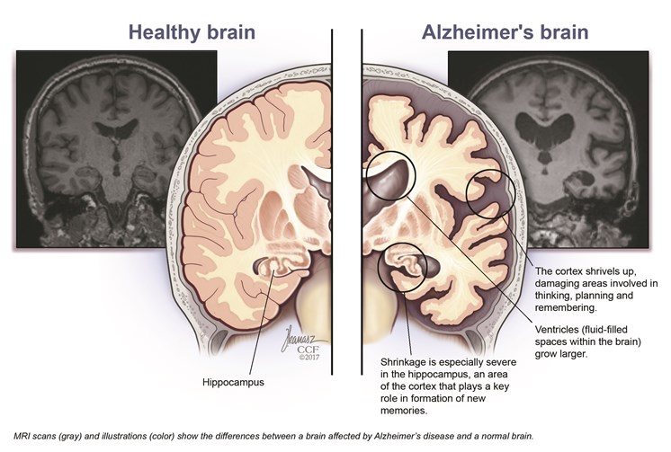
Figure 2 shows the current number of AD patients separated by age in the United States. The majority of patients with AD are between the ages of 75 and 84 (45% of cases), followed closely by those 85 years old and above (36% of cases). Individuals with early-onset AD (<65 years old) make up the smallest percentage of cases at 3%.

Figure 2. Prevalence of Alzheimer’s disease based on age⁵
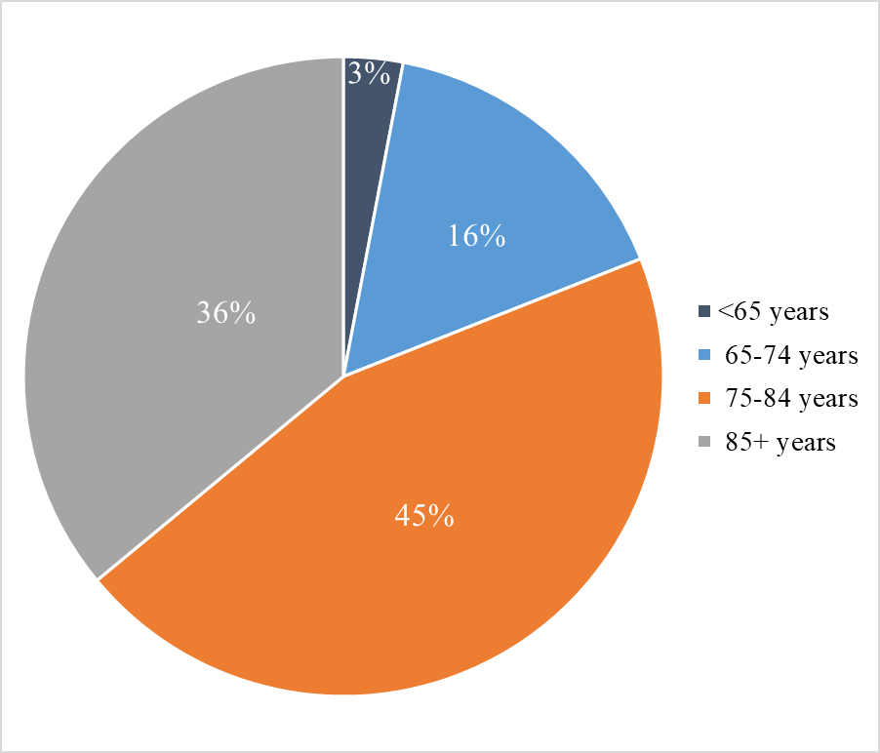
Characteristics of Alzheimer’s Disease
An accumulation of abnormal plaques and neurofibrillary tangles are what characterize AD. Plaques are lesions that contain extracellular amyloid-beta (Aβ) peptides surrounded by enlarged axonal endings. Aβ peptide is cleaved from a transmembrane protein called amyloid precursor protein (APP). Usually, APP is cleaved by α- and γ-secretase, which results in non-toxic fragments. These fragments are soluble peptides that tend not to aggregate.⁶ Sometimes, APP can be cleaved by β-secretase and then γ-secretase, which results in the neurotoxic peptide called Aβ, which tends to aggregate into plaques. One form of Aβ is made up of 42 amino acid peptides (Aβ-42) and has the greatest tendency for aggregation. High levels of Aβ-42 lead to neuronal toxicity due to the aggregation of amyloid. The APP gene is located on chromosome 21, which might suggest why AD is linked to Down Syndrome. This aggregation of amyloid on gray matter in the brain has also been linked to AD.³ Figure 3 shows the cleavage of APP that results in the aggregation of amyloid, and consequently, the formation of Aβ plaques. On the left of the image, normal cleavage of APP by α-secretase can be seen with the Aβ peptide being broken into two smaller non-toxic fragments. On the right of the image, abnormal cleavage by β- and γ-secretase is shown to release the entire neurotoxic Aβ peptide into the extracellular space. This allows for the free Aβ peptides to aggregate and form plaques.

Figure 3. Cleavage of APP⁷
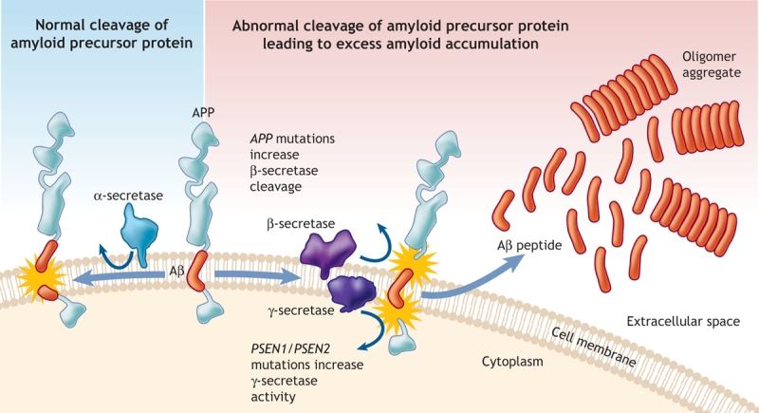
Neurofibrillary tangles (NFTs) are structures in neurons that are formed by the tau protein, which is a protein that stabilizes axonal microtubules. In Alzheimer’s disease, the aggregation of Aβ leads to the hyperphosphorylation of tau which causes the development of tau aggregates.⁸ This process is due to the activation of kinases by the accumulation of Aβ. These tau aggregates form NFTs, which are twisted helical filament pairs of p-tau. Tau aggregates are deposited into neurons and are first seen in the hippocampus but can later be seen in the cerebral cortex. NFTs are known to be associated with dysfunction of the synapse and loss of neurons.⁶ Although both plaques and tangles are associated with AD, studies show that tangles are more strongly correlated to Alzheimer’s than plaques are.³ Figure 4 shows the difference between a microtubule with normal tau protein and a microtubule with NFTs. As these tangles are formed, the microtubule is no longer stabilized by the tau protein and begins to break down. Figure 5 illustrates normal neurons in comparison to Alzheimer’s neurons that contain neurofibrillary tangles and Aβ plaques.

Figure 4. Normal tau protein versus neurofibrillary tangles⁹
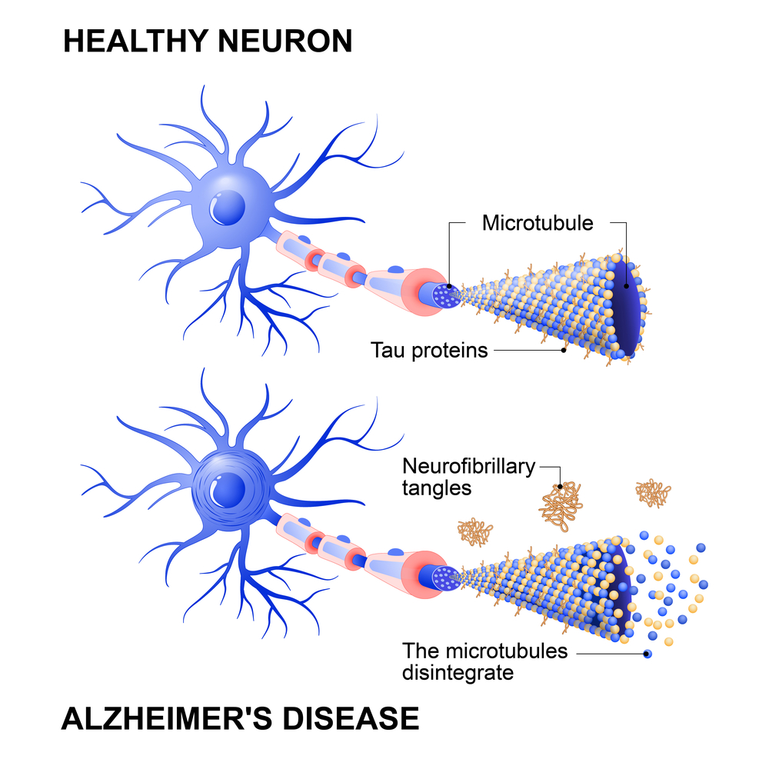
Figure 5. Normal neurons versus neurons with plaques and neurofibrillary tangles¹⁰
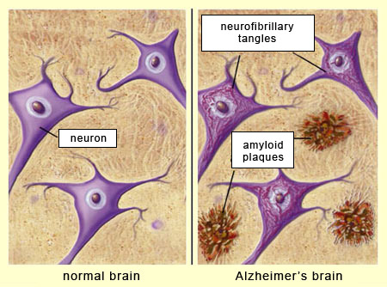

Genetics
Alzheimer’s disease can be inherited as an autosomal dominant disorder that is linked to mutations in the APP gene on chromosome 21, Presenilin 1 (PSEN1) on chromosome 14, and Presenilin 2 (PSEN2) on chromosome 1. The mutations on the APP gene may lead to formation and aggregation of Aβ peptides, while the mutations on PSEN1 and PSEN2 interfere with the processing of γ-secretase, which also leads to Aβ aggregation. These mutations are linked to early-onset AD. Apolipoprotein E (APOE) regulates lipid metabolism and has an affinity for Aβ. The APOE e4 allele has been associated with AD after the age of 65, making APOE a genetic marker for the disease. Studies have shown that individuals who carry one APOE e4 allele have a 50% chance of having AD, while those who carry two alleles have a 90% chance of having AD. Familial AD is associated with mutations in the APP and Presenilin genes, while Sporadic AD is linked to various factors, such as genetics, environment, metabolism, and viruses.³ Additionally, elements such as zinc, copper, iron, and selenium have been shown to be involved in the development of neurodegenerative diseases like AD. It is proposed that the dysregulation of these elements leads to neuronal dysfunction and death. Studies have also shown that these elements may have the ability to influence mutations of Presenilin, APP, and APOE. It is suggested that these elements can serve as biomarkers for the disease in the future.¹¹

Detection Methods
When it comes to the diagnosis of Alzheimer’s disease, neuropsychological testing is found to be the most reliable method for detection of mild cognitive impairment. CT brain scans can also be used to show cerebral atrophy and a widened third ventricle, but these can also be seen in other illnesses. Analysis of cerebrospinal fluid can show elevated levels of Aβ-42 and tau protein. Recently, volumetric MRI has been used to measure volumetric changes in the brain, as brain shrinkage in the medial temporal lobe is linked to AD. This disease is known to affect areas of the brain that are important for learning and memory, such as the hippocampus and medial prefrontal cortex.³ Figure 6 contains the images from PET scans comparing a normal brain, a brain with mild cognitive impairment, and a brain with AD. These scans show severe shrinkage in the AD brain compared to the other two. PET scans are commonly used to determine the levels of Aβ and abnormal tau protein in the brain. New techniques to diagnose AD that are simple and inexpensive, such as blood tests, would be ideal for patients and physicians. However, these types of tests are still being researched for their efficacy.⁶
Figure 6. PET scans of normal brain, mild cognitive impairment brain, and AD brain¹²
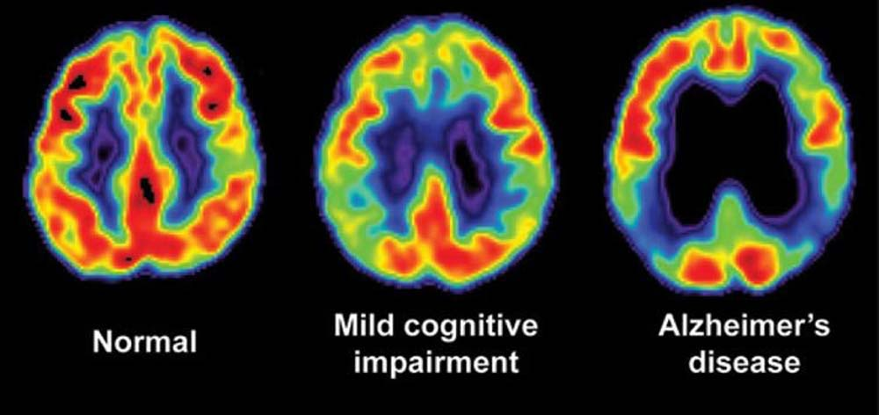

Treatment of Alzheimer’s Disease
Current Treatment Options
Currently, there are a few drugs that target Aβ and tau protein in order to improve symptoms, but these cannot stop or delay the progression of AD. Researchers have begun to search for new theories of pathogenesis, which may assist in creating drugs that might cure this disease. Some theories include gamma oscillations, prion transmission, and cerebral vasoconstriction. In order to create effective drugs to treat AD, researchers must understand the pathogenesis of the disease. The current goal of strategies that target Aβ is to reduce the formation of Aβ aggregates and increase Aβ clearance.¹³ However, anti-amyloid therapies have not shown promising efficacy in their late-stage trials. The most direct way to reduce Aβ production is to control BACE1 and γ-secretase. BACE1, also known as β-site amyloid precursor protein cleaving enzyme 1, is the enzyme that controls the activity of β-secretase. Inhibiting this enzyme is believed to block the rate-limiting step of Aβ production. BACE1 inhibitors have high substrate specificity for APP but have also shown unwanted side effects. Only five BACE1 inhibitors have reached stage III clinical trials over the years (verubecestat, lanabecestat, atabecestat, umibecestat and elenbecestat). These drugs showed a reduction in levels of Aβ in cerebrospinal fluid, but they were discontinued after no improvement of cognition was displayed.⁶ The problem with controlling γ-secretase is that it has low substrate specificity for APP, and it is thought to be toxic to several organs. Two γ-secretase inhibitors (semagacestat and avagacestat) and one γ-secretase modulator (tarenflurbil) were promising in clinical trials but resulted in higher adverse effects and limited benefits. Researchers have also attempted to reduce Aβ aggregation in mice by using endoglycosylation receptor inhibitor TTP488 (azeliragon), which showed cognitive improvement in early trials.¹³
Treatments that target the tau protein have gained popularity due to the failure of Aβ-targeting treatments, since tau is more correlated to the severity of cognitive impairment than Aβ. In recent years, immunotherapies that target tau have become the most investigated strategy, but they have only reached phase II trials. Studies show that tau protein has an important role in the assembly and stabilization of microtubules in the cytoskeleton. Abnormal hyperphosphorylation of tau, which is referred to as p-tau, reduces the protein’s affinity to bind to these microtubules, leading to microtubule dysfunction and increased levels of p-tau in the cytosol. This increase in p-tau can lead to aggregation and the formation of NFTs.⁶ Kinase and tau aggregation inhibitors, microtubule stabilizers, and immunotherapeutic drugs have been major areas of interest. Most anti-tau therapies work to prevent the hyperphosphorylation and aggregation of tau, improve microtubule stabilization, and promote the clearance of tau. The critical step of tau pathology is believed to be hyperphosphorylation, which is caused by the imbalance of phosphatases and kinases. Phosphatases are enzymes that remove phosphate groups while kinases add phosphate groups. Therefore, an abundance of kinases and lack of phosphatases can lead to hyperphosphorylation. The deregulation of glycogen synthase kinase 3-beta (GSK-3β) has shown to produce p-tau and resulting neurodegeneration in AD, which makes this enzyme have the most important role. LMTM (TRx0237), which is an inhibitor of tau aggregation showed toxicity and lack of efficacy, but AADvac1, which is a tau vaccine, was shown to be safer and had better efficacy.¹³
As of right now, cholinesterase inhibitors (AChEIs) and the NMDA receptor antagonist are the only therapies for AD.¹³ It is hypothesized that loss of cholinergic neurons leads to cognitive dysfunction and other symptoms of AD, and AChEIs improve cholinergic neurotransmission by preventing hydrolysis of acetylcholine. Although AChEIs improve the side effects of AD, they also can cause unwanted side effects, such as nausea, vomiting, and diarrhea. The drugs that are inhibitors of the cholinesterase enzyme are donepezil, galantamine, and rivastigmine, while the NMDA receptor antagonist is memantine.⁶ The NMDA receptor antagonist has been shown to improve cognitive function and behavior, but it can also cause hypertension, fainting, and falls.¹³ The NMDA antagonist is a non-competitive inhibitor and is believed to reduce glutamate’s excitatory neurotoxicity effect. However, the exact mechanism of this drug remains unclear. None of the available treatments are able to prevent neuronal loss, brain atrophy, or cognitive decline. It has been suggested that a combination therapy including both AChEIs and memantine could show better efficacy, but this requires further research to support it.⁶ A summary of all these past and current drug treatments is outlined in Table 1.
Table 1. Summary of Previous and Current Treatment Options
Type of Treatment | Name(s) of Treatment | Problem(s)
BACE1 inhibitor | verubecestat, lanabecestat, atabecestat, umibecestat and elenbecestat | Reduced levels of Aβ, but no improvement of cognition displayed
γ-secretase inhibitor | semagacestat and avagacestat | Adverse effects and limited benefits
γ-secretase modulator | tarenflurbil | Adverse effects and limited benefits
Endoglycosylation receptor inhibitor | azeliragon | Still in clinical trials
Tau aggregation inhibitor | LMTM (TRx0237) | Showed toxicity and lack of efficacy
Tau vaccine | AADvac1 | Still in clinical trials
*Cholinesterase inhibitors | donepezil, galantamine, and rivastigmine | Can cause nausea, vomiting, and diarrhea
*NMDA receptor antagonist | memantine | Can cause hypertension, fainting, and falls
*These treatments are the only ones listed that remain used by patients.

New Advancements in Treatment
As of July 7, 2021, a new medication for AD created by the company Biogen was approved for use by the Food & Drug Administration (FDA). Prior to this and despite the need for better treatments for AD, no new treatments had been FDA-approved since memantine in 2003. This drug, called Aduhelm, was approved under the Accelerated Approval pathway, which allows for faster approval based on the likelihood that this drug will have more benefits than the current therapeutic options. Although the FDA predicts a clinical benefit to patients, there is still uncertainty regarding this due to the acceleration of the approval process. However, Aduhelm showed promising results in clinical trials, where it produced a reduction in amyloid plaques.¹⁴ This medication is able to target plaques because it is an Aβ-directed antibody drug, meaning that it uses antibodies to stimulate the immune system to attack these specific cells.¹⁵ This is the first approved drug for AD that has been designed to target Aβ plaques directly, rather than attempting to prevent the plaques from forming. The clinical trials for this drug were the first to show that reducing Aβ plaques can lower cognitive decline in AD patients. This reduction in the levels of Aβ plaques was shown in both a time- and dose-dependent manner, meaning that the reduction intensified over longer periods of time and with higher doses of the drug. As it is now approved for patient use, Aduhelm will continue to be monitored by the FDA in order to verify its clinical benefit, or remove it from the market if it proves to be ineffective.¹⁴
More recently, Brigham & Women’s Hospital (BWH) announced the launch of the first human clinical trial for an intranasal vaccine. Similar to previous AD medicines, this approach will aim to delay the progression of the disease. The difference here is that this is a vaccine that can be delivered to patients nasally. This vaccine is the product of over 20 years of research being conducted in the Ann Romney Center for Neurologic Diseases at BWH. It is believed that this vaccine could offer a nontoxic treatment, as well as early treatment for patients that are at risk for AD in order to prevent the disease. The immune modulator Protollin is used in this vaccine to stimulate the immune system, which activates white blood cells in the lymph nodes and causes them to travel to the brain and induce clearance of Aβ plaques. Currently, the main goal of the clinical trial is to determine the safety and tolerability of the vaccine in participants, as well as the effect of nasal Protollin on immune response.¹⁶

Utilization of Brain Waves in Treatment
Brain Networks and Activity
Other areas of research are narrowing their focus on the connection between brain waves and AD. Brain waves are generated by large groups of neurons that simultaneously oscillate on and off. This synchrony appears to support coordination across brain regions and between different types of brain cells.¹⁷ Imaging techniques, like NMR and EEG, are able to show how neurodegenerative diseases can affect brain networks. Functional magnetic resonance imaging (fMRI) is a widely used technique for detecting brain networks, but it can also be used to measure brain activity. Electroencephalography (EEG) can be used to complement this technique, as this is the main method for analyzing activity in the brain. Brain waves are recorded in an electroencephalogram, which detects surface potential produced by neurons on the top layer of the cortex. This detection produces a voltage that can be measured, which indicates brain activity through the presence of wave oscillations in the brain. Alterations in these brain oscillations can indicate neurodegenerative disorders as well as memory changes.² The common types of brain oscillations and their frequencies are shown in Table 2. Brain waves have shown to be linked to different behavioral states. For instance, theta oscillations occur during both active exploration and rapid eye movement (REM) sleep, while fast/short-wave ripples are observed during periods of inactivity. Gamma oscillations can be seen in conjunction with either theta oscillations or with fast/short-wave ripples in these instances.¹⁸

Table 2. Types of Brain Waves¹⁸
Class | Frequency (Hz)
Delta | 1.5 to 4
Theta | 4 to 7
Alpha | 8 to 12
Beta | 13 to 30
Gamma | 30 to 80
Fast/Sharp-wave ripple | 80 to 200
Ultrafast | 200 to 600

Figure 7. Human Brain Waves¹⁹
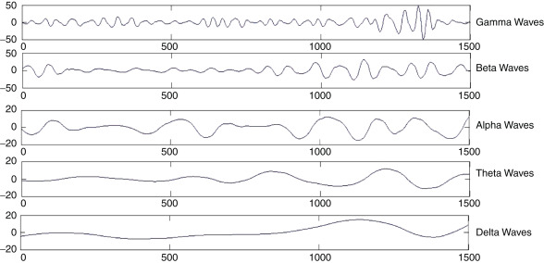
Figure 7 shows the visual difference between the five main types of human brain oscillations. These general wave shapes can be obtained using EEG.

Gamma Oscillations
Gamma oscillations are rhythmic fluctuations of brain waves caused by the activation of inhibitory neurons with a frequency between 30 and 80 Hz.^{13, 18} These are associated with higher order cognitive functions such as consciousness, altruism, and concentration. In recent studies on mice, it has been shown that alterations in the coupling of theta and gamma waves appear before the formation of Aꞵ plaques. As the overproduction of Aꞵ is indicative of the early stages of AD, studying the alterations of gamma waves could provide an even earlier detection method, prior to the formation of these plaques. The association between gamma oscillations and AD can most readily be seen by analyzing brain waves during sleep. Slow waves, such as delta waves, are normally seen during what is called “slow-wave sleep.” These slow-wave oscillations tend to trigger faster gamma oscillations during slow-wave sleep. Disruptions of this slow-wave sleep could therefore be an early indicator of neurodegeneration. The claustrum is a portion of the brain that coordinates slow-wave activity and also regulates information transfer that is vital for memory storage and consolidation. Researchers have found that dysfunction of the claustrum has a role in the development of AD. A recent hypothesis has been proposed that claustrum dysfunction can result in disturbances of slow-wave sleep, which modifies gamma oscillations and affects the formation of Aꞵ aggregates.²
Although changes in gamma wave activity have been linked to several neurodegenerative and neuropsychiatric disorders, treatments that restore gamma oscillations to their normal activity have not been investigated widely. In a recent study, transcranial alternating current stimulation (tACS) was suggested as an alternative brain stimulation technique as a means to improve cognitive function. Gamma oscillations arise from the interaction between inhibitory gamma-aminobutyric acid (GABA)-ergic interneurons and the surface potential from pyramidal cells on the cortex. Inhibitory interneurons that express parvalbumin (PV) have shown to have important roles in the generation of these oscillations, as an increase in PV cells shows a rise in gamma wave activity while a decrease in PV cells shows a decline in gamma oscillations. The correct functioning of these brain waves is vital for cognitive operations, such as memory and learning. To support this idea, impaired functioning of gamma oscillations has been reported in patients with AD, schizophrenia, autism spectrum disorder (ASD), attention deficit hyperactivity disorder (ADHD), and epilepsy. When considering the cause of abnormal gamma activity, an imbalance in the excitatory and inhibitory mechanisms of PV that cause gamma waves is suspected to be a source. Therefore, brain stimulation in the gamma frequency range may be a possible solution to restabilizing gamma waves. Studies on rodents showed that repairing interneuron-specific and PV cell-dominant sodium channel proteins in the brain improves functioning of gamma oscillations. This, in turn, also improves cognitive function, particularly memory retention.²⁰

Multi-Sensory Stimulation
Rhythmic sensory stimulation is one method that is commonly used to regulate brain waves. In recent studies, gamma oscillations in the auditory and visual areas of the brain have been modulated using repetitive stimulation at gamma frequencies.²⁰ For instance, the Tsai Laboratory at Massachusetts Institute of Technology (MIT) have been focusing their research on this form of gamma stimulation to see how it may affect AD in mice. This group was able to induce gamma oscillations in a non-invasive manner, which they termed gamma entrainment using sensory stimuli (GENUS). This method exposes the mice to a light that is programmed to flicker at 40 Hz. The aim of this research was to determine if light flickering could entrain gamma oscillations and affect Aꞵ plaques. In order to do this, mice were exposed to 40 Hz flickering light for one hour per session for 7 days. When compared to random interval flickering and dark exposure, the 40 Hz light flickering induced oscillations at 40 Hz while the other two methods did not.¹⁸ These researchers found that, when targeting the primary visual cortex using visual GENUS, there was a reduction in Aꞵ aggregation. The visual GENUS was able to affect local neural activity by inducing gamma waves in the visual cortex.

Figure 8. Prevention of neuronal loss with visual stimulation¹⁷
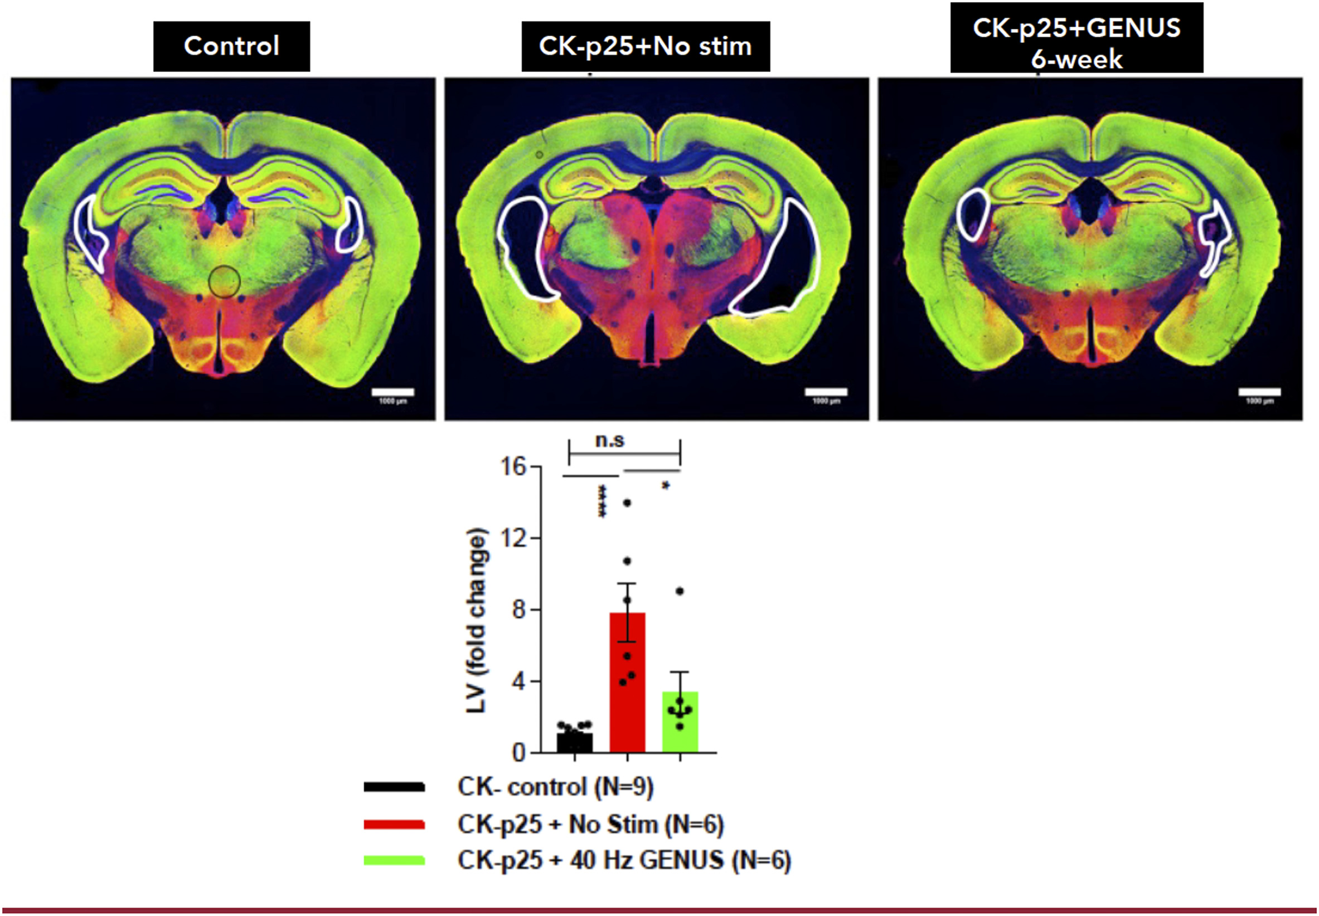
Figure 8 illustrates the difference between the brain of a mouse without AD, a mouse with AD and no stimulation, and a mouse with AD that has experienced GENUS visual stimulation. CK-p25 refers to the model of mice used in this study. As observed in the figure, adding GENUS stimulation significantly lessens neuronal loss when compared to no stimulation. The AD brain with visual stimulation looks more akin to that of the control (no AD) than that of the AD brain without stimulation. This supports the hypothesis that visual GENUS may be an effective treatment against AD and other neurodegenerative illnesses. In this particular study, two neurodegenerative disease mouse models were used: CK-p25 and Tau P301S. The mice were exposed to 40 Hz stimulation for 6 weeks. It was found for both models that long-term application of GENUS elicited a neuroprotective effect in the brain. Neuroprotection can result from the recovery or restoration of the nervous system, nerve cells, brain structure, or function. This study was also conducted by the Tsai Group.^{17, 21}
However, AD does not only affect the visual cortex portion of the brain. It can harm areas of the brain that are important for learning and memory, such as the hippocampus and the medial prefrontal cortex. To address this problem, the Tsai Lab continued their work on this topic by using a multi-sensory approach. These researchers tested the use of auditory stimulation with a series of tones that flicker at 40 Hz. Mice were exposed to a series of tones that repeat at 20 Hz, 40 Hz, and 80 Hz, which was a means to entrain to the 40 Hz stimulation. Neural activity in the auditory cortex, hippocampus, and prefrontal medial cortex was recorded using 32-channel silicon probes in male mice between the ages of 3 and 8 months old. The neural activity was recorded when the mice were active and when they were at rest. It was found that the auditory GENUS improved performance on tasks that are hippocampal-dependent, while reducing the level of Aꞵ aggregation in both the auditory cortex and the hippocampus.²²
In order to determine the effect of multi-sensory stimulation, the mice were presented with 1 ms-long auditory tones coupled with 12.5 ms-long light pulses at 40 Hz for one hour per session. Neural activity was recorded in the auditory cortex, hippocampus, and prefrontal medial cortex using 32-channel silicon probes. This activity was again recorded both when the mice were active and when they were at rest. When visual and auditory GENUS were combined, reduction in Aꞵ aggregation was observed in the auditory cortex, hippocampus, prefrontal medial cortex, and the neocortex. In addition to this, reduction in tau phosphorylation was observed during these experiments. It was discovered that the input of gamma oscillations increased the activity of microglia, which are immune cells in the brain that have the ability to clear Aꞵ plaques and NFTs. Exposure to this dual stimulation showed to also improve the working memory, sensory processing, and spatial navigation of the test subjects. This work paves the way for a non-invasive approach for improving cognition in AD patients and producing positive effects throughout various parts of the brain.^{17, 22}

Figure 9. Combined Auditory and Visual GENUS Immunohistochemistry²²
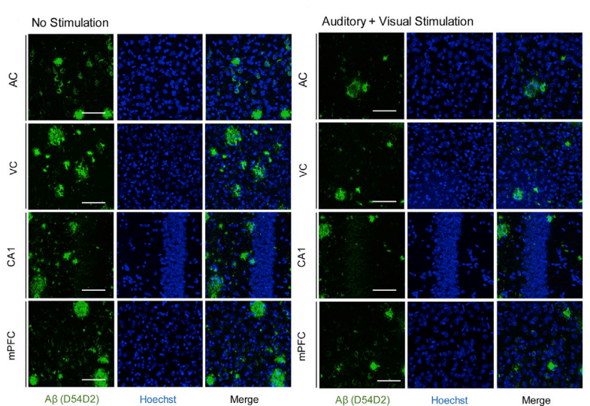
In Figure 9, the immunohistochemistry (IHC) of anti-Aꞵ plaque antibodies in the auditory cortex (AC), visual cortex (VC), CA1 region of the hippocampus (CA1), and medial prefrontal cortex (mPFC) is shown after no stimulation for 7 days in comparison to multi-sensory stimulation. IHC is an application of immunostaining that identifies antigens by staining the antibodies that bind to them. The green splotches in these images indicate anti-Aꞵ plaque antibodies that are bound to Aꞵ plaques, which are the antigens in this case. When comparing the “no stimulation” results to the “auditory + visual stimulation” results, a large reduction in the number and size of green splotches is observed in all brain regions. This data shows that multi-sensory stimulation is able to reduce the level of Aꞵ aggregation in various parts of the brain by inducing gamma oscillations both visually and auditorily. Although it is unclear where these plaques went, it is surmised that clearance of Aꞵ aggregation is due to the breakdown of these plaques.²² The four studies conducted on mice by the Tsai Lab are summarized in Table 3. Based on the results all of the studies conducted by the Tsai Lab, it can be suggested that combined GENUS is the most effective option for promoting Aꞵ clearance and improvement of brain functions. When comparing the studies published by Iaccarino et al. and Adaikkan et al., the results indicate that longer-term GENUS treatments are more successful, as the 6-week study showed more of a neuroprotective effect than the 1-week study.

Table 3. Summary of Tsai Laboratory GENUS Studies
Publication | Duration | Type of Stimulation | Areas of Brain Observed | Main Results
Iaccarino et al. | 1 week | Visual | Visual cortex, hippocampus | Reduced Aꞵ; improved hippocampal functions
Adaikkan et al. | 6 weeks | Visual | Visual cortex, hippocampus, prefrontal and somatosensory cortices | Reduced Aꞵ; neuroprotective effect; improved memory and brain function
Martorell et al. | 1 week | Auditory | Auditory cortex, hippocampus | Reduced Aꞵ; improved hippocampal functions
Tsai et al. | 1 week | Combined | Auditory cortex, visual cortex, hippocampus, medial prefrontal cortex, neocortex | Reduced Aꞵ; improved memory, sensory processing, and spatial navigation

Comparison of Research Studies
The research being conducted by the Tsai Group is novel and groundbreaking. Other research groups are investigating the role of multisensory stimulation on various neurological issues, such as circadian rhythm disorder. The Mourad Lab at University of Washington-Seattle has recently conducted a study to verify the results of the Tsai Lab. This group used transcranial-focused ultrasound with pulses at 40 Hz in order to see if this method safely removes Aꞵ plaques and improves cognition in mice models. The transcranial ultrasound therapy was continued for 5 days, which resulted in reduction Aꞵ aggregation by 50% in the area of the brain directly exposed to ultrasound and by 28% in the CA1 region of the hippocampus. The researchers of this study noted that these results are consistent with those of medications given to mice models over much longer periods of time. The 40 Hz transcranial ultrasound treatment did not produce wide-spreading effects throughout the brain like the combined GENUS treatment did, but these results do show a safe and effective option for further research.²³
The MOE Key Laboratory of Laser Life Science has been investigating the mechanism that visual stimulation of gamma waves plays in AD pathology. They found that light flickering at 40 Hz increased normal cleavage of APP, reducing the production of Aꞵ plaques. This is due to the fact that gamma frequency light flickering appears to encourage the binding of APP to the plasma membrane in a way that leads to normal cleavage. The APP/PS1 mouse model were used as the study subjects and were exposed to 40 Hz light flickering for 1 hour per day for seven days. When compared to mice that were exposed to 80 Hz light flicker and those with no stimulation, the 40 Hz subjects showed a dramatic reduction in Aꞵ levels, which were measured by using Aꞵ labelling in the cortex and hippocampus regions. The 80 Hz subjects had similar results to those of the no-stimulation control, which showed no observed reduction in Aꞵ levels.²⁴ Similarly, the Park Group recently sought to observe the effects that combined exercise and 40 Hz visual stimulation have on the 3xTg-AD mouse model. The mice were subjected to 12 weeks of exercise with 40 Hz light flicker that were delivered either independently or combined. It was found that Aꞵ and tau protein levels were reduced significantly. Moreover, mitochondrial function was improved, neuroinflammation and apoptosis were reduced, and protein expression in the synapses was increased. The results from these groups are consistent with those of the Tsai Group, as they support the idea that visual stimulation using gamma frequency can lead to less aggregation of Aꞵ and improvement of cognition in AD patients.²⁵ Comparisons between the visual GENUS studies conducted by the MOE Key, Tsai, and Park groups are summarized in Table 4. It should be noted that better results were observed with longer durations of study.

Table 4. Comparing Visual GENUS Studies
Group | Duration | Areas of Brain Observed | Main Results
MOE Key Lab | 1 week | Visual cortex, hippocampus | Reduced Aꞵ levels; normal cleavage of APP was induced
Tsai Lab | 1 week | Visual cortex, hippocampus | Reduced Aꞵ; improved hippocampal functions
Park Lab | 12 weeks | Visual cortex, hippocampus | Reduced Aꞵ and tau protein levels; improved memory and brain function; neuroprotective effect

Future Application of Gamma Wave Stimulation
Future Treatments
Although the results of the Tsai Group show promise of an effective non-invasive treatment, these experiments have only been tested on mice. The issue with this is that rodents do not actually get AD, so they must be engineered to display the physical and behavioral traits of AD, such as containing Aꞵ plaques and NFTs.¹⁷ Therefore, it cannot be concluded by these studies alone that GENUS will have the same effect in humans with AD. The next step in this investigation is to test the Tsai approach on human patients. As of April 2019, the Tsai Group began working on a clinical trial that tests this method on human participants. The aim of this trial is to translate the findings in the mouse models to patients with mild cases of AD. The researchers planned to include 40 participants with mild AD, who will all be exposed to the GENUS device that provides auditory and visual stimulation at different frequencies. This device contains light-emitting diode (LED) illumination for visual stimulation and speakers for auditory stimulation. Each participant will use the device for 30 to 60 minutes at a time. Half of the participants will be exposed to active settings of the device, while the other half are exposed to control settings. The participants are also subjected to mental health evaluations and memory tests. The researchers intend to use EEG to analyze how the participants’ brain waves respond to the GENUS stimulation. As this is the first clinical trial of this type on human patients, it may provide insight into the feasibility, tolerability, and safety of gamma frequency stimulation. This trial is expected to be completed in 2023.²⁶
In addition to this, the Tsai Group began working on a second clinical trial in August of 2019, which is expected to be completed in 2025. This study investigates the effects of daily exposure to light and sound stimulation in AD patients. Human participants with mild AD are expected to use the GENUS device at home for one hour per day for 6-to-9 months. Half of the participants are exposed to active settings for the device while the other half are exposed to control settings. After the first 6-to-9-month period, the participants may decide to continue for another 6-to-9-month span of time. For the additional time, all participants will be exposed to active settings of the GENUS device, regardless of which group they were in for the first span of time. Throughout this time period, the participants will undergo periodic evaluations of their cognition, mental health, and memory. Testing of blood, hearing, and vision will also occur at the beginning and the end of the trial. MRI and EEG will be used at the beginning and end of the study in order to analyze changes in brain waves, structure, and function.²⁷ Although no results have been released by this group thus far, Dr. Tsai has expressed that daily hour-long exposure to visual and auditory stimulation has appeared to improve 40 Hz brain waves in patients, and this method has presented no side effects.¹⁷

Conclusion
Many researchers believe that future treatments that can slow or stop the progression of AD should be administered early in the disease process to preserve brain function. In order to detect the disease early enough, researchers must identify the biomarkers of AD. The two most well-studied biomarkers are Aβ and tau protein, however, the drugs that target these biomarkers have only proved to control symptoms.³ Recent advancements in treatment such as the drug Aduhelm and the intranasal vaccine present exciting news for researchers and patients alike, as new medicines for AD have not made headlines since memantine in 2003.¹⁴ The main concern about these new treatments is that they will prove to have unwanted side effects, which is the problem with existing treatment options. Due to this, treatments that limit side effects and maximize benefits for patients are in high demand. One of the most auspicious approaches being studied currently is on the entrainment of gamma oscillations in the brains of AD patients. Previous research on combined visual and auditory stimulation at 40 Hz has shown to induce gamma waves in mice, which simultaneously decreased the amount of Aꞵ plaques and NFTs and limited neuronal loss.
In order to investigate these effects on human patients, clinical trials are currently being conducted on human participants with AD using similar methods to those used on the mice subjects. As discussed previously, the effect of GENUS on the subjects of interest was enhanced when multiple senses were targeted synchronously (auditory and visual). This suggests that focusing on additional senses may improve the effectiveness of this possible treatment on decreasing plaques and tangles. Future research may explore GENUS using stimulation with smell, taste, or touch. For instance, it may be possible to induce gamma oscillations using odor pulses or physical vibrations on the skin at 40 Hz. If stimulation using two senses was more effective in these GENUS studies, it is fair to suggest that targeting all five senses could pose the most effective option for this form of treatment.
One of the biggest problems with modern treatments is the financial burden on patients. Although GENUS therapy would be a non-invasive method of clearing Aꞵ aggregation in AD patients, it might not be possible for patients to complete these treatments with a physician. A more cost-effective option would be for patients to purchase their own 40 Hz lamps and complete at-home treatments. Simple 40 Hz lights can be purchased online through various sites for as low as $45, while more high-tech lamp sets can be found closer to $150.^{28, 29} Additionally, simple 40 Hz audio devices can be purchased for as low as $50 and used in conjunction with the lights for multisensory stimulation.³⁰ Although the GENUS studies offer a new avenue of AD treatment, the results of the Tsai Group clinical trials will be a vital factor in the continuation of this area of research. If the results from the rodent experiments are not translated to the human experiments, the use of multi-sensory stimulation for gamma wave entrainment may not be as promising as it is currently thought to be. Until a safe, effective treatment is developed to stop the progression of AD in patients, researchers will continue working tirelessly to find a solution.

References
(1) Alzheimer's Disease Facts and Figures. Alzheimer's Association, 2022. https://www.alz.org/alzheimers-dementia/facts-figures?utm_source=google&utm_medium=paidsearch&utm_campaign=google_grants&utm_content=dementia&gclid=CjwKCAjw8sCRBhA6EiwA6_IF4UYxzoj3HtX_EtEn59PJNOSsf-qx-_hODXf4PWJ3mxEmp7DD6F12KRoCRBEQAvD_BwE (accessed Jan 10, 2022).
(2) Avila, J.; Perry, G. A multilevel view of the development of Alzheimer’s disease. Neuroscience 2021, 457, 283-293.
(3) Kumar, A.; Sidhu, J.; Goyal, A.; Tsao, J. W. Alzheimer Disease. In-Stat Pearls. Molecules 2020, 25, 5789-5812.
(4) Normal vs. Alzheimer's Brain. Keep Memory Alive, 2021. https://www.keepmemoryalive.org/cc-nevada/alzheimers-brain (accessed March 2, 2021).
(5) 2019 Alzheimer's disease facts and figures. Alzheimer's & dementia 2019, 15 (3), 321-387.
(6) Vaz, M.; Silvestre, S. Alzheimer's disease: recent treatment strategies. European journal of pharmacology 2020, 887, 173554.
(7) Patterson, C.; Feightner, J. W.; Garcia, A.; Hsiung, G. Y. R.; MacKnight, C.; Sadovnick, A. D. Diagnosis and treatment of dementia: 1. Risk assessment and primary prevention of Alzheimer disease. Cmaj 2008, 178 (5), 548-556.
(8) Guo, T.; Zhang, D.; Zeng, Y.; Huang, T. Y.; Xu, H.; Zhao, Y. Molecular and cellular mechanisms underlying the pathogenesis of Alzheimer’s disease. Molecular neurodegeneration 2020, 15 (1), 1-37.
(9) Further Research Into How Tau Proteins Cause Alzheimer's. Five Star Nursing, 2020. https://www.fsnursing.com/further-research-into-how-tau-proteins-cause-alzheimers/ (accessed April 15, 2021).
(10) Bailly, D. Amyloid Plaques And Neurofibrillary Tangles. McGill University, https://thebrain.mcgill.ca/flash/d/d_08/d_08_cl/d_08_cl_alz/d_08_cl_alz.html (accessed Nov 29, 2021).
(11) Lei, P.; Ayton, S.; Bush, A. I. The essential elements of Alzheimer’s disease. Journal of Biological Chemistry 2021, 296.
(12) What if we could use tools to diagnose Alzheimer’s disease and dementia before the symptoms of cognitive and mental deterioration became clinically apparent? Pacific Neuroscience Institute, 2020. https://www.pacificneuroscienceinstitute.org/brain-health/diagnostics-procedures/brain-imaging/ (accessed Dec 7, 2021).
(13) Fan, L.; Mao, C.; Hu, X.; Zhang, S.; Yang, Z.; Hu, Z.; Sun, H.; Fan, Y.; Dong, Y.; Yang, J. New insights into the pathogenesis of Alzheimer's disease. Frontiers in neurology 2020, 1312.
(14) Cavazzoni, P. FDA’s Decision to Approve New Treatment for Alzheimer’s Disease. U.S. Food & Drug Administration, 2021. https://www.fda.gov/drugs/news-events-human-drugs/fdas-decision-approve-new-treatment-alzheimers-disease (accessed Dec 7, 2021).
(15) Aducanumab (marketed as Aduhelm) information, 2021.
(16) Brigham and Women's Hospital Launches Clinical Trial of Nasal Vaccine for Alzheimer's Disease. Brigham and Women's Hospital, 2021. https://www.brighamandwomens.org/about-bwh/newsroom/press-releases-detail?id=4029 (accessed Dec 7, 2021).
(17) Peeples, L. Inner Workings: A pulse of hope in the fight against Alzheimer’s. Proceedings of the National Academy of Sciences 2020, 117 (31), 18142-18145.
(18) Iaccarino, H. F.; Singer, A. C.; Martorell, A. J.; Rudenko, A.; Gao, F.; Gillingham, T. Z.; Mathys, H.; Seo, J.; Kritskiy, O.; Abdurrob, F. Gamma frequency entrainment attenuates amyloid load and modifies microglia. Nature 2016, 540 (7632), 230-235.
(19) Kulkarni, N.; Bairagi, V. EEG-based diagnosis of alzheimer disease: a review and novel approaches for feature extraction and classification techniques. 2018.
(20) Strüber, D.; Herrmann, C. S. Modulation of gamma oscillations as a possible therapeutic tool for neuropsychiatric diseases: A review and perspective. International Journal of Psychophysiology 2020, 152, 15-25.
(21) Adaikkan, C.; Middleton, S. J.; Marco, A.; Pao, P.-C.; Mathys, H.; Kim, D. N.-W.; Gao, F.; Young, J. Z.; Suk, H.-J.; Boyden, E. S. Gamma entrainment binds higher-order brain regions and offers neuroprotection. Neuron 2019, 102 (5), 929-943.
(22) Martorell, A. J.; Paulson, A. L.; Suk, H.-J.; Abdurrob, F.; Drummond, G. T.; Guan, W.; Young, J. Z.; Kim, D. N.-W.; Kritskiy, O.; Barker, S. J. Multi-sensory gamma stimulation ameliorates Alzheimer’s-associated pathology and improves cognition. Cell 2019, 177 (2), 256-271.
(23) Traikapi, A.; Konstantinou, N. Gamma Oscillations in Alzheimer’s Disease and Their Potential Therapeutic Role. Frontiers in Systems Neuroscience 2021, 15.
(24) Shen, Q.; Wu, X.; Zhang, Z.; Zhang, D.; Yang, S.; Xing, D. Gamma frequency light flicker regulates amyloid precursor protein trafficking for reducing β‐amyloid load in Alzheimer's disease model. Aging Cell 2022, e13573.
(25) Park, S.-S.; Park, H.-S.; Kim, C.-J.; Baek, S.-S.; Park, S.-Y.; Anderson, C. P.; Kim, M.-K.; Park, I.-R.; Kim, T.-W. Combined effects of Aerobic exercise and 40Hz light flicker exposure on early cognitive impairments in Alzheimer's disease of 3xTg mice. Journal of Applied Physiology 2022.
(26) Tsai, L.-H.; Boyden, E. S.; Brown, E.; Chan, D. Daily Light and Sound Stimulation to Improve Brain Functions in Alzheimer's Disease. NIH U.S. National Library of Medicine, 2019. https://clinicaltrials.gov/ct2/show/NCT04055376 (accessed Dec 11, 2021).
(27) Tsai, L.-H.; Boyden, E. S.; Chan, D. High Frequency Light and Sound Stimulation to Improve Brain Functions in Alzheimer's Disease. NIH U.S. National Library of Medicine, 2019. https://clinicaltrials.gov/ct2/show/NCT04042922 (accessed Dec 11, 2021).
(28) Gamma Clarity 40 Hz Meditation Lamp. Amazon, https://www.amazon.com/Gamma-40-Hz-Meditation-Lamp/dp/B07TBLXR9W (accessed February 9, 2022).
(29) Clarity 40Hz Light Kit. Gamma, https://gammalighttherapy.com/collections/all/products/gamma-40-hz-light-therapy-kit?gclid=Cj0KCQiA3rKQBhCNARIsACUEW_YZRQy3TG7VwSLUeXwzcE021HCwwFGBkJ8ajyqtSEohOugfoM0eUAIaAqYvEALw_wcB (accessed February 9, 2022).
(30) Clarity 40Hz Audio Device. Gamma, https://gammalighttherapy.com/collections/clarity-40hz/products/gamma-clarity-40-hz-audio-entrainment-device (accessed February 23, 2022).

