THE SOCIOLOGY OF MILEY CYRUS

Honors Thesis

Presented in Partial Fulfillment of the Requirements
for the Degree of Bachelor of Science

In the College of Arts and Sciences
at Salem State University

By

Lindsey McGovern

Professor Meghan McLyman
Faculty Adviser
Department of Sport and Movement Science

****

Commonwealth Honors Program
Salem State University
2015

“The Sociology of Miley Cyrus”
Choreography/Design: Lindsey McGovern
Music: Patrick Beckman
Dancers: Brittney Bythrow, Kayleigh Cyr, Brenna Kenney, Meaghan Noel, Jessica Prince, Cassandra True
Salem Dance Ensemble
Outside In
O’Keefe Center Multipurpose Gym, December 6th and 7th, 2014
https://www.youtube.com/watch?v=NHOUdK2E9xc&list=UUlTKJEjwiSoObx0KXhTFVQA

DEVELOPING MY CONCEPT

Initial Idea Inspiring the Piece: Miley Cyrus is the pop music industry’s current puzzle. The public cannot seem to figure her out and neither can other music professionals. Her goody-two shoes image was birthed through her role of Disney Pop Princess, Hannah Montana when Cyrus was 12. Since then, she has created four studio albums, released 26 singles, taken a break from music, made headlines for raunchy behavior, chopped off her hair, completely recreated her image, and released a triple-platinum single that also won “Video of the Year” at the Music Television Video Music Awards in 2014. Miley Cyrus has found the key to success. She is learning the art of success in her industry as she manages to make herself happy while resonating with audiences and selling albums.

I will create a four-minute piece of dance choreography that reflects the research I have done on the industry and the conclusions I have drawn about the career of Miley Cyrus.

INSPIRATION/RESEARCH

Concepts
Wendy Griswold’s Cultural Diamond: The four points of the diamond are: (1) the social world, (2) the cultural object, (3) the creators, and (4) the receivers

Kristin J. Lieb’s Lifecycle Model for the female popular music star:
- Good Girl Phase: cute, innocent, fun, clean role models
- Temptress Phase: sexual exploitation of the female body in order to make money
- Change of focus: removal from the industry; The Diva: the star labels herself as best in her genre as a marketing point; The Exotic: she uses something unique about her as a marketing tool; The Whore: continues to use her sexuality as her main marketing tool; The Provocateur: engages in deviant/offensive behavior; Hot Mess: public self-destruction.

Literature
“It makes sense, then, that to ensure you will stay the sex you were born you’d adhere rigidly to the rules as you see them and hope for the best…suddenly the magnetic lure of the Disney Princesses became more clear to me: developmentally speaking, they were genius, dovetailing with the precise moment that girls need to prove they are girls, when they will latch onto the most exaggerated images their culture offers in order to stridently shore up their femininity.”
-Peggy Orenstein, Cinderella Ate My Daughter: Dispatches from the Front Lines of the New Girlie-Girl Culture

“Last year, Forbes ranked the 25 highest-paid musicians in 2012. Only eight women made the list, with Britney Spears coming in seventh overall as the richest ($58 million), making a little more than half that of the highest paid male (Dr. Dre, $110 million). But what Spears is expected to do for her money is grossly different from that of her male peers. In fact, of the eight women on Forbes’ list, five have made at least one naked music video in the last seven years. Of the 17 men on the list, only Justin Bieber has made a naked music video, and he was simply shirtless.”
-Andrea Warner, CBS Music

“…record labels could sign artists like Adele, Kelly Clarkson…powerful, music-first singers who resonate deeply with their audiences, but aren’t as hyper-sexualized as most contemporary female popular music stars. But based on the limits of our social system, our modern music industry, our country’s gender norms and expectations, and our capitalist business ideals, we don’t often make this gamble, opting instead to prioritize packaging over talent.” –Kristin J. Lieb, Gender, branding, and the modern music industry: the social construction of female popular music stars

“There is definitely a misogyny problem in pop music, but is sure as hell isn’t Miley Cyrus.”
–Andrea Warner, CBS Music

The Career of Miley Cyrus
- She lands the leading role in children’s television/musical series, Hannah Montana; it included three soundtracks and two music tours; this was the beginning of her career as a popular music star: good girl phase.
- Rebellion sets in as she released her album, Can’t Be Tamed with a lot of media controversy over its rebellious and scandalous nature. At 16 years old, Cyrus began to enter the temptress phase.
- She takes two years off from music and film to live her life in peace. She later refers to this as the time that she spent discovering who she is apart from the industry.
- She releases a successful album, Bangerz, and earns multiple awards including Music Television’s “Video of the Year” for her single, Wrecking Ball.

“…I think if people could see the details, they would know that this isn’t just some big mess; this is all thought out in my mind. Every decision is part of a bigger plan.” –Miley Cyrus, Miley the Movement

ARTISTIC PROCESS

Weekly one hour rehearsals began on September 15th, 2014 and finished on December 1st, 2014, the week of Salem Dance Ensemble’s fall concert.

I broke up the rehearsals by section of my piece and scheduled approximately two or three rehearsals to set the choreography for each section. I rehearsed the sections in the chronological order that they would appear in my final piece. My dancers seemed to respond well to this rehearsal format and I feel that they were able to follow my and understand the purpose of my choreography easily because of the chronological format. I found that the dancers were able to connect and execute the first section of my dance with the most ease and success; the cheesy and dramatically peppy feel to the choreography was well conveyed by each dancer. Perhaps this is because the peppy nature of children’s television and music is ever-present in popular culture today and was unavoidable as we grew up in this society. As a result, little explanation was necessary on my part as to exactly how to convey the exaggerated pep of the first section of my dance.

The second and third sections, however, were slightly more difficult for everyone involved in my process, including me. The second section, its intention being to make the audience feel uncomfortable, was quite challenging to choreograph. In our modern dance program at Salem State, we are currently engrossed in a lot of modern/contemporary dance classes and choreography; this sexual and jazzy section of my piece forced us all to access a style of dance that we are not currently training in. In addition, my dancers struggled with a tendency to focus on Miley Cyrus specifically in this section when I wanted them to convey a general representation of the temptress phase of female popular music stars across the music industry. While my dancers had a tendency to imitate gestures of Cyrus that they had seen on television or social media, I was instead trying to generalize the scandalous behavior of many young female pop stars. I completely understood the struggle that was happening in this section of the choreography, however, because it was difficult to differentiate Cyrus from other music stars through choreography. This turned into the perfect challenge for all of us and truly led to the heart of my project. What makes Miley different from others in her industry?

The third section was challenging because I felt pressure to tie together the entire project in the 45 seconds left of my piece. The dancer portraying Miley in this section was incredibly receptive throughout these rehearsals and aided in making this section go as smoothly as possible though it was still a challenge. I found it tough to smoothly transition between the sexual second section and this softer third section; my adviser, Meghan McLyman, attended a rehearsal toward the end of my process to help me work through this transition. At that rehearsal, we really worked on where the other dancers, who had been representing the other female pop stars in the industry, would sensibly end up in the piece. We eventually decided that they would die off as pop stars and slowly transition into fans of Cyrus as the dancer portraying her finished the piece with her solo. This decision made sense to me and was more aesthetically interesting than simply having the other dancers dissolve and dissipate from the stage.

As part of the Salem Dance Ensemble choreographic process, I attended two informal showings throughout the semester at which I was given feedback from the dance program’s full-time faculty members, Meghan McLyman, Caitlin Corbett, and James Morrow. The feedback was very helpful and was incorporated during the rehearsals following each showing. Perhaps the most resonant and important piece of feedback I received was for the dancers not to fear “going there” entirely; to my professors, it appeared that the dancers were holding back and it was hindering a clear communication of my concept. I completely agreed and my dancers were able to take this criticism and work on it. Together, we figured out specific ways to more clearly and dramatically communicate my concept through movement and acting; for example, slight changes in facial expressions made for vast improvement and helped the dancers to feel more connected to the piece, thus allowing them to fully commit and “go there” entirely. In the end, this piece was about complete commitment from my dancers and I feel that the feedback from my professors helped us all come to this realization.

I worked with Patrick Beckman, a student of electronic production and design at Berklee College of Music in Boston, MA to create the music and sound score for my piece. I communicated with Patrick about the vision I had for the sound score and he then manually created an electronic mix of four songs by Miley Cyrus: “Best of Both Worlds”, “Robot”, “Can’t Be Tamed”, and “Wrecking Ball”. He worked to smoothly transition between the songs and layered audio clippings of Miley Cyrus and Ellen Degeneres over the last minute of the sound score. The music was created to compliment the movement and aid in telling the story. I really enjoyed this process and it was definitely important to have a customized sound score for such a specific concept. Because the production of the music was relatively time-consuming, for the first few weeks of rehearsals my dancers worked with the original versions of the songs as I estimated where the transitions would happen. I had anticipated that when we switched over to the custom sound score we would experience some kinks and obstacles to work through, but my dancers were extremely flexible and adaptive. They were musically inclined and able to adjust quickly to the new sound.

CHOREOGRAPHY DESCRIPTION

My piece opens with one dancer on stage lip-syncing to Hannah Montana’s “Best of Both Worlds”; the scene is a cheesy pop concert which the dancer conveys with a wide smile and enthusiastic expressions. This dancer represents Miley, who is, in this opening section, in the middle of her good girl career phase. She is wearing a sparkly shirt, brown leather jacket, sparkly skirt, and brown boots. Five additional dancers eventually emerge from the wings, taking over the stage as “back-up dancers” with gestural expressions to convey a princess image. They are wearing pink tops, black shorts, and giant sparkly silver bows around their waists. As the dancer who is playing Miley continues to belt her tune, the back-up dancers flounce around the back of the stage with elegance and a sense of awkward confidence. They gesture crowns, blown kisses, and royal hand waves to indicate their status as royalty in the music industry; they are female pop stars. They are positioned behind Miley to represent the presence of others in the industry and the constant comparison that happens among celebrities. This opening scene of the dance represents the good girl phase of the female popular music star—she is, upon landing the status of a young female celebrity, expected to be a good role model with poise, grace, and status. The music suddenly begins to cut in and out as Miley gets tangled in her microphone—she attempts to continue singing as the rest of the “princesses” swarm around her but she eventually helplessly disappears from the stage. She has become lost in the robotic nature of her performance and can no longer access her authentic self.

The back-up dancers suffocating Miley represent how Cyrus and other pop stars become overwhelmed by the pressure of being a role model; they are constantly competing with one another to become the best role model even if they are not completely sure that is what they want to be. After Miley exits the stage, the dancers that swarmed her continue to dance around the stage with cheesy and dramatic smiles and enthusiasm. Their movement is simple and similar to movement that one would see in a beauty pageant; they are on display for their audience and simply serve as a statue of etiquette and poise. Eventually, the dancers situate themselves in a line far downstage in which they are posing and waving. One by one, the dancers transform their movement from innocently cute to quite sexual. They each head toward upstage center as the music slowly builds and implies a transition. At this point, the dancer playing the role of Miley re-enters the stage dressed identically to the rest of the dancers. Right as the music changes, the dancers rip off their silver sparkly bow and throw it on the ground. They are shedding their goody-two-shoes images.

To convey the temptress phase of Cyrus’s career, my dancers transform the stage into a scene full of raunchy movement and sex appeal. They untie and rip off an oversized bow, revealing simply a pink lace bustier, midriff, and short black shorts. They strut downstage and begin to taunt the audience with dance moves that show off their bodies. The music is now an instrumental version of Cyrus’s “Can’t Be Tamed”, the tune I am using to represent the heart of her temptress phase. The goal here was to make the audience as uncomfortable as possible because that is often what happens when “good girls turn bad”. The dancers eventually form a clump from which they dissipate as the music changes, representing the downfall of many female popular music artists.

The dancers in my piece who fall to the ground represent the female music stars who have, for a variety of reasons, lost traction in or removed themselves from the music industry. I conclude that the reason for this dissipation is the inability to find their true selves after so much submission to what the industry formulates as a road to success.

One dancer—the same dancer that opened the piece as Hannah Montana—is left on the stage as the dancers who fell to the ground slowly transform into fans. The remaining dancer represents Miley, who has managed to find herself through the web of confusion on the path to celebrity status. Miley” begins to dance a solo to an instrumental version of “Wrecking Ball”, Miley Cyrus’s most recent and successful released single. Layered over the music are random clippings of Cyrus speaking about her career, taken from interviews and Cyrus’s MTV documentary, Miley the Movement. The quotes outline controversy and depict Cyrus defending her decisions and authenticity. Throughout the chaos that ensued after Cyrus’s performance on the VMAs, her new haircut, and her raunchy videos, she makes it clear that she has made these decisions herself.

The solo begins with the dancer that represents Cyrus crawling sexually downstage. She represents the complete sexual act that Miley has put on for audiences since the wrap-up of her Disney Channel television series. The dancer slowly, through gesture and facial expression, conveys a realization that exaggerating one’s sexuality may not be the only route to success. (Although Cyrus continues to dress provocatively, she has expressed in interviews that she no longer submits to pressure from anyone but herself. This suggests that her decisions involving attire, music videos, and stage performance are all stemmed from what she desires in her own heart). The dancer then begins to acknowledge the “fans” that have gathered near the front of the stage and she engages in a soft, contemporary style solo. She makes her way to the back of the stage and begins to pick up and play with the bows that were ripped off of dancers previously in the dance. She creates a skirt train with the bows and walks slowly downstage to finish the piece. The skirt train represents how Cyrus has used the platform and fandom that the industry gave her (through her television show and first few records) to her advantage. She can now be who she really wants to be with confidence in a loyal fandom and record companies that have faith in her because of her status. She has discovered what the secret to success is in her industry: it involves a deep understanding of its trends and preferences, the need for both authenticity and talent to achieve longevity, and the awareness of one’s true self despite the confusing nature of embodying a brand.

The dancer conveys most of this message through facial expression in the final section of my piece. In general, this dance solo includes softer movement that, unlike the movement prior to this section, is not danced for the audience. For most of this solo, “Miley” is not facing the front of the stage with her movement; rather, she is dancing for herself. She engages in soft, small movement meant for her own expressive outlet. This represents her recent career choices that have given her self-satisfaction and the ability to work for and please herself rather than the receivers from her cultural diamond. The solo ends with the dancer gesturing, “shh” to the audience, implying that her route to success is a secret formula revealed only to those with the confidence and strength to be true to themselves in the popular music industry.

COSTUMES

Dancer portraying Miley Cyrus: She begins the piece with a sparkly skirt, sparkly shirt, leather jacket, combat boots, and a microphone. She changes into a pink lace crop top and black booty shorts with combat boots.

All other dancers: They begin the piece in a pink lace cropped top with black booty shorts and a huge silver, sparkly bow. They eventually take the bow off and are left with a skimpy outfit.

Miley opens the piece dressed as Hannah Montana, representing the good-girl phase. The other dancers are wearing a giant silver bow to also represent that phase. When all dancers change, they are left with a skimpy outfit and a touch of pink to represent the temptress phase that still has a “princess” effect on fans because they turn into idols. Miley, however, is the only one wearing combat boots to represent her differentiation from other stars in her industry.

REFLECTION

I am extremely pleased with how the choreography came together and with how my ideas were conveyed through the movement I created. I feel that my movement was reflective of the concepts I researched and was understood by most audience members that I spoke to following the show.

I received positive feedback from my professors about the dance and was thrilled hear their remarks. I think the lighting, costumes, and music all complimented my movement and aided in effectively telling my story. I feel proud to have created a piece of art that reflects the popular music industry, and more specifically, the career of Miley Cyrus from a sociological standpoint. Art is about making a statement and I know that I surprised at least a few audience members by looking at Cyrus from a scholarly standpoint. Her career brings up societal issues as well as cultural trends; these things are well-represented through art and I feel fortunate to have been given the opportunity to do this in my undergraduate studies.

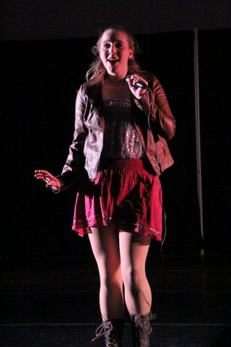
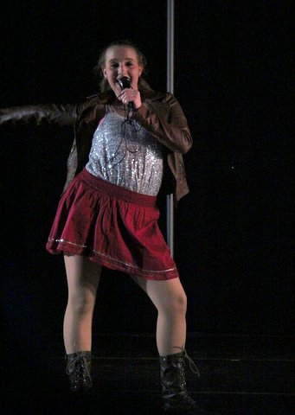
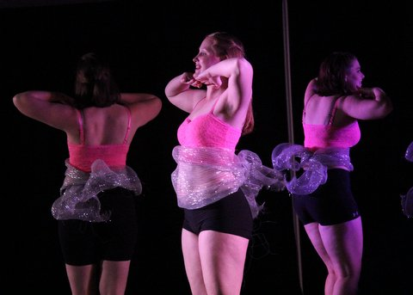
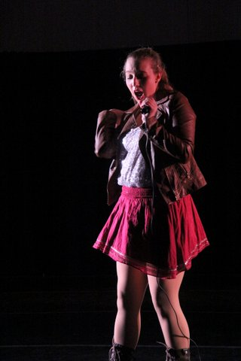
PHOTOGRAPHY FROM PERFORMANCE: (courtesy of Patricia Farrell Beckman)
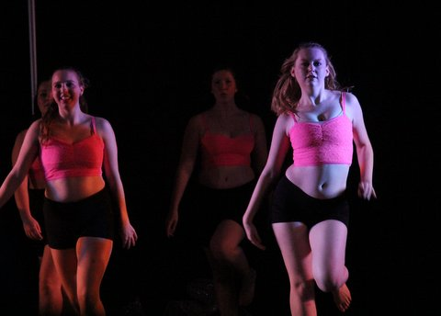
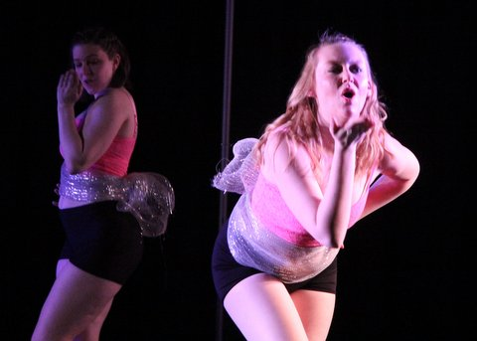
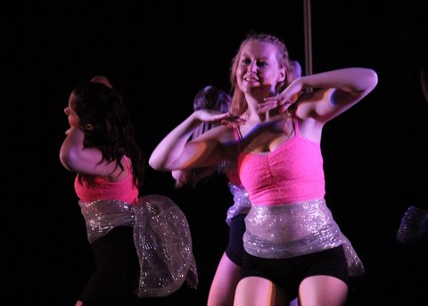
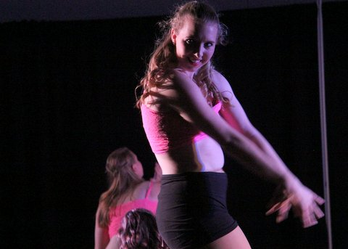
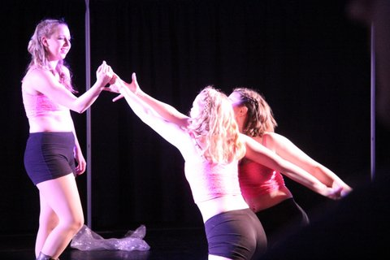
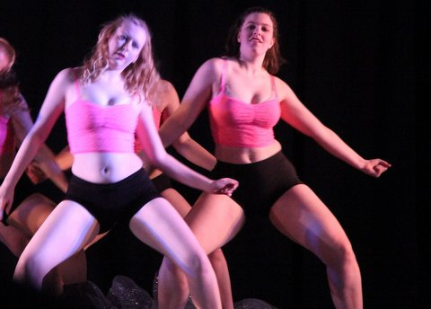
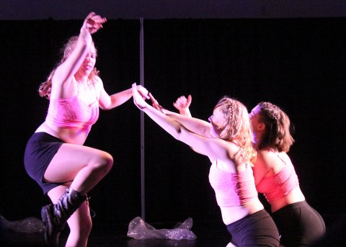
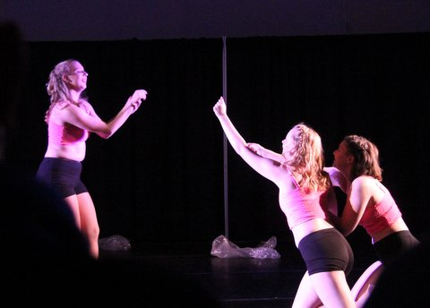
REFERENCES

Bing, Chris. "Skidmore College Debuts New Class Dedicated To 'Sociology Of Miley Cyrus'." Business Insider (originally from The Daily Caller) 1 (2014): n. pag. Business Insider. Web. 4 Oct. 2014.

"Celebrity Central: Miley Cyrus." <i>PEOPLE.com</i>. N.p., n.d. Web. 14 Oct. 2014. <http://www.people.com/people/miley_cyrus/biography/0,,20154291_20,00.html>.

Kalb, Ira. "Miley Cyrus and Justin Bieber are Marketing Geniuses." Business Insider 1 (2013): n. pag. Business Insider. Web. 4 Oct. 2014.

Lieb, Kristin. Gender, branding, and the modern music industry: the social construction of female popular music stars. New York: Routledge, 2013. Print.

MTV News. "Miley Cyrus Twerks, Gives Robin Thicke Some Tongue At VMAs." MTV News. Viacom International, inc., n.d. Web. 25 Aug. 2014. <http://www.mtv.com/news/1713017/miley-cyrus-robin-thicke-vma-twerk/>.

Orenstein, Peggy. Cinderella Ate My Daughter: Dispatches from the Front Lines of the New Girlie-girl Culture. New York, NY: HarperCollins, 2011.

Ramisetti, Kirthana. "MTV VMAs 2014: Miley Cyrus reveals she brought homeless youth as her date to counter Robin Thicke backlash." NY Daily News. NY Daily News, 25 Aug. 2014. Web. 25 Aug. 2014. <http://www.nydailynews.com/entertainment/gossip/miley-cyrus-reveals-brought-homeless-man-vmas-article-1.1916286>.

Sacks, Ethan . "MTV VMAs 2014: Miley Cyrus has formerly homeless man accept her Video of the Year award." NY Daily News. NY Daily News , 25 Aug. 2014. Web. 25 Aug. 2014. <http://www.nydailynews.com/entertainment/tv/miley-vmas-spotlight-homeless-youth-article-1.1915667>.

Stanley, Bob. Yeah! Yeah! Yeah!: the story of pop music from Bill Haley to Beyoncé. New York, NY: W. W. Norton & Company, 2014. Print.

Warner, Andrea. "From Madonna to Miley: Naked Music Videos and the Ritual Sacrifice of the Female Pop Star." CBC Music. Accessed November 28, 2014. http://m.music.cbc.ca/blogs/2013/9/From-Madonna-to-Miley-naked-music-videos-and-the-ritual-sacrifice-of-the-female-pop-star.

Weisman, Aly. "How Miley Cyrus Killed 'Hannah Montana' And Created An Uncharted New Career Path ." Business Insider [New York City] 18 Dec. 2013: n. pag. Business Insider. Web. 29 Sept. 2014.

