PUBLIC TRANSPORTATION: RESOURCES, DEMAND AND MOBILITY
IMPACT ON COMPANIES IN BOSTON, USA AND MUNICH, GERMANY

Honors Thesis

By
Emily Adam

Professor Dr. Keith A. Ratner
Faculty Advisor
Geography Department

***

Commonwealth Honors Program
Salem State University
2019

Abstract

This project researches the impact of access to public transportation on companies and their employees through a comparison between Boston, Massachusetts and Munich, Germany. Long commutes to work together with the traffic problems in the inner cities and the huge environmental impact of single occupancy vehicles, show the increasing importance of public transportation. After analyzing online sources through a literature review, interviews with representatives of different companies in both cities were conducted along with an online survey among the employees about their usage and opinion of the importance of public transportation system to their employer. In addition, to further the research, politicians’ perspectives on public transportation were included.
The results revealed that companies and employees in Munich significantly rely on public transportation. Furthermore, accessibility to public transit influences the location decision of companies and employers. In Boston, on the other hand, public transit is not as widely used as many of the employees stated, that it is not suitable to their work schedule or they do not have access to it. Analyzing both public transportation networks for differences, the research unveiled that the city of Munich has a more advanced and modern public transportation system than the city of Boston. To convince companies and employees in Boston to increase their usage of the public transportation system, improvements to the schedule, accessibility, affordability and reliability should be made. A good public transportation system provides immense benefits to the community by improving the environment and quality of life, as well as attracting companies, creating jobs and increasing tax incomes.

Tabel of Contents
Abstract ii
List of Figures iv
List of Graphs iv
1 Introduction 5
2 Literature Review 6
3 Brief Overview of Public Transit Systems 9
3.1 Boston 9
3.2 Munich 10
4 Online survey results 12
4.1 “How do you usually get to work” 12
4.2 “Why do you not use public transportation at all?” 13
4.3 “Does your company pay for part of the cost?” 13
4.4 “How much of the cost does your company pay in percentage?” 14
4.5 “What types of public transportation do you use?” 15
4.6 “How important was the access to public transportation when you considered taking this job?” 16
4.7 “What price do you pay per month for public transportation?” 17
4.8 “Is the cost for public transit justified?” 18
4.9 “Do you have a pass for public transport and what kind?” 19
5 Conclusions 21
5.1 Boston 21
5.2 Munich 23
5.3 Overall Conclusions 25
6 Bibliography 27
7 Appendix 28
7.1 History of public transportation in Boston 28
7.1.1 Current trains 30
7.2 Introduction of Public Transit in Munich 31
7.2.1 History 31
7.2.2 Current public transit available 32
7.2.3 Technology/ current trains 32
7.2.4 Future 34
7.3 Sustainability of public transportation 34

List of Figures
Figure 1 Boston commuter rail and subways 9
Figure 3 Munich public transportation system map 10
Figure 4 Inside Blue Line 30
Figure 5 North Station 30
Figure 6 Green Line train 30
Figure 7 S-Bahn (suburban train) 33
Figure 8 Tram (street car) 33
Figure 9 Inside subway 33

List of Graphs
Graph 1 "How do you usally get to work" 12
Graph 2 "Why do you not use public transportation at all" 13
Graph 3 "Does your company pay for part of the cost" 13
Graph 4 "How much of the cost does your company pay in percentage" 14
Graph 5 "What types of public transportation do you use" 15
Graph 6 "How important was the access to public transportation when you considered taking this job" 16
Graph 7 "What price do you pay per month for public transportation" 17
Graph 8 "Is the cost for public transit justified" 18
Graph 9 "Do you have a pass for public transport (e.g. monthly ticket)" 19
Graph 10 "Which pass for public transportation do you have" 19

Introduction
The following paper is about the public transportation systems of two major international cities and its impact on their local companies. The cities compared are Boston, Massachusetts in the United States and Munich, Germany. Following are the main research questions this paper answers:
- How is public transportation being used by employees? Is it different in Boston and Munich?
- What is the difference between the public transit systems in Boston and Munich?
- Is public transportation a factor when companies decide where to locate?
- How is public transportation supported by local politicians? Is it different in Boston and Munich?
There were many different research methods used to answer these questions. Personal interviews were conducted with representatives from companies in both cities. There was a total of ten companies that participated in both cities combined, 4 from Boston and 6 from Munich. An online survey was conducted in English and German among the employees of the companies. Over the course of the research, a total of over 100 responses were collected. For the political perspective, three local politicians in total were interviewed, two from the Boston area and one from Munich. To complete the background research into the public transportation systems for the comparison, internet research was done.

Literature Review
Following is a literature review related to the importance of public transit to company location and employee job choise. All sources referenced discuss the topic of accessibility to public transportation as a commuting method for employees. The research is more general and not city specific.
Access to public transportation influences a community and its local businesses in a variety of different ways. For example, it influences a business’ decision on location. For a business, the “location sets [the] tone” (DeWitt, Kaylee) in regard to accessibility, government regulations, growth potential for the business and the kind of competitors. The location the business chooses will “influence [the] customer’s opinion of [the] business.” (DeWitt, Kaylee) If the business location is hard to reach and not convenient, the customer may not recommend it to other people or buy the products. The location decision can affect the possible customers the business will have. Consequently, it is important that the “location strategy conform[s] with, and is part of, [the company’s] overall corporate strategy.” (Heil, Karl) The location strategy is influenced by several factors, like political risk, facilities, logistics, government and environmental regulations, community, and site.
Another location factor relates to employees, especially those who are relying on public transportation. In this case it needs to be accessible and affordable. The price of public transportation can be a barrier to employment, especially for many low-income and minority people (Getting to Work: Transportation Policy and Access to Job Opportunities). If not affordable, people will not use public transportation no matter if it might be more convenient than using their personal cars. According to Richard Florida (The Geography of How We Get to Work), transportation in general is “the biggest item in a typical family’s budget, accounting for an average of 20 percent.” Therefore, cities have to find new ways and incentives to increase transit usage, “increase affordability, and modernize how commuters pay for fares.” (Anderson, Monica) But just making public transport more affordable does not solve the problem. The public transit system also needs to reach the areas where people need it. According to (Getting to Work: Transportation Policy and Access to Job Opportunities), job growth is occurring in outlying areas that are “generally accessible only by car.” This is a barrier to employment for many people that do not have a car. Today, commuting without a car has become very difficult “for a large number of transit-dependent individuals who can no longer get to work because [the] ride has been cut or eliminated.” (Getting to Work: Transportation Policy and Access to Job Opportunities) Therefore, it is necessary to expand the public transit system to areas, where jobs are available. However, in order to expand, the public transportation needs support and funding from the local and state government.
Political support for the development of public transportation is key to making progress. In 2013, a Federal Transit Administration report “estimated that more than 40% of buses and 25% of rail transit around the US are in marginal or poor condition.” (Anderson, Monica) The poor infrastructure can be the cause for delays and make the public transit system less reliable. But to address the infrastructure issues, there needs to be funding available, so that updates and developments can be made according to the needs of the riders. According to (Getting to Work: Transportation Policy and Access to Job Opportunities), projects on public transportation have “greater potential to foster equal employment opportunity across racial and socioeconomic lines.” As claimed by Representative Paul Tucker (Interview), the public needs to be educated on the advantages of public transportation to receive support for local funding plans.
One major advantage of public transportation is how environmentally friendly it is. Reducing the cars on the road by increasing the public transportation options would reduce the amount of traffic in the cities and the carbon emissions produced. Transportation is responsible for 29 percent of greenhouse gas emissions in the United States (Transit's Role in Environmental Sustainability). It is crucial that this number is reduced to save the planet. One simple way is to increase the use of public transportation as “most rail transit vehicles emit little or no pollution, as they are powered by electricity” (Transit's Role in Environmental Sustainability). This also makes public transportation more sustainable for the future.

Brief Overview of Public Transit Systems
In order to better understand the results and conclusions of this study, a brief overview of the two public transportation systems referred to follows.

Boston
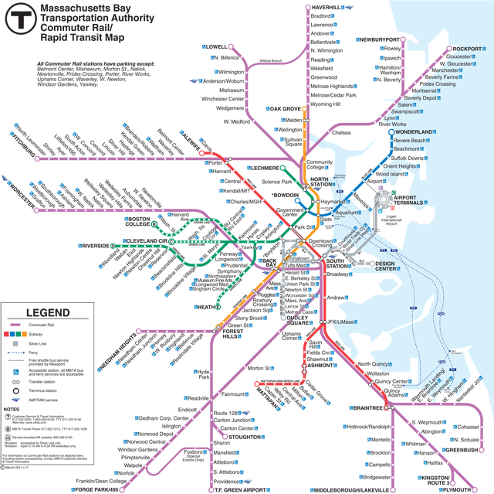
Boston’s public transportation system is one of the oldest in America, with the first subway tunnel opening on September 1, 1897. The public transit system is operated by the MBTA, which stands for Massachusetts Bay Transportation Authority. There are multiple MBTA services including the Commuter Rail, the heavy and light rail services, ferry services and busses. According to the MassDOT (Department of Transportation) Tracker report, in 2017 there were more than 3.1 million passengers daily. The Boston public transit system includes 3 heavy rail subway lines, 2 light rail lines, over 150 bus lines, 12 commuter rail lines and 5 ferry lines. Here is a map of Boston’s commuter rail and subway services.
Figure 1 Boston commuter rail and subways

Munich
Munich’s public transportation system is managed by the MVG, which stands for Munich Transportation Corporation along with the MVV, which stands for Munich Transport and Tariff Association. The Munich public transit system has a history of over 140 years and the MVG is Germany’s second-largest municipal transportation enterprise. For services, there are buses, S-Bahn (suburban trains), U-Bahn (subway) and trams. There are 8 suburban train lines, 8 subway lines, 13 day-tram lines, 4 night-tram lines,
69 day-bus lines and 12 night-bus lines. In addition, there are also multiple regional lines that are connected with the MVV with approximately 700 buses. In 2017, an average of
1.96 million passengers per day were using the public transit system.
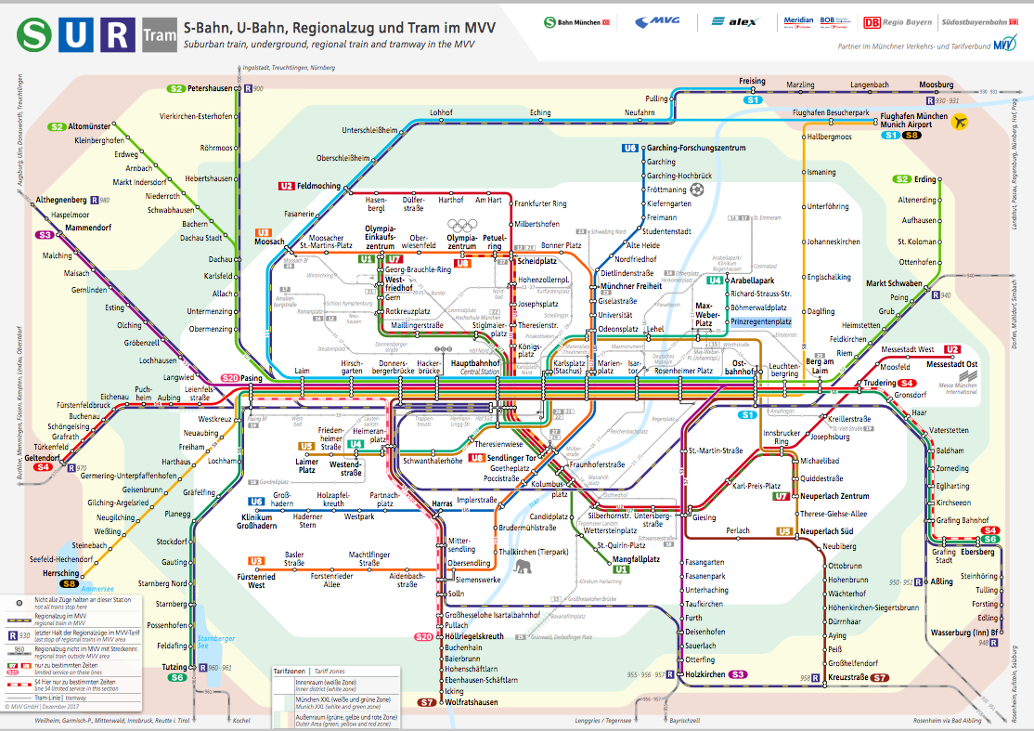
Figure 2 Munich public transportation system map
When looking at the two maps, it is noticeable how Boston’s system seems to be more like a star shape. All trains run from the city center outward with no connection running between them. This makes circumferential trips difficult as people always have to go through the center (North or South Station) and there is no direct connection between these two main points.
In Munich, there is a main route where all trains are connected. This route is called the “Stammstrecke”. At all the stations on this main route, people can easily change to a different line and do not have to go all the way into the inner city. However, the drawback of this layout is that if anything happens on this part of the system, it has major consequences for all lines. To support circumferential trips in Munich, there are many bus lines running between the S-Bahn lines. In Boston, the MBTA started the Urban Ring Project with the first studies being conducted as early as 1972. In the late 1990s, a detailed proposal for the project was published and Phase 1 was partially integrated into the public transportation system. However, the planning of Phase 2 was suspended in January 2010 due to the lack of funding for the project. For more detailed information on the public transit systems refer to the Appendix.

Online survey results

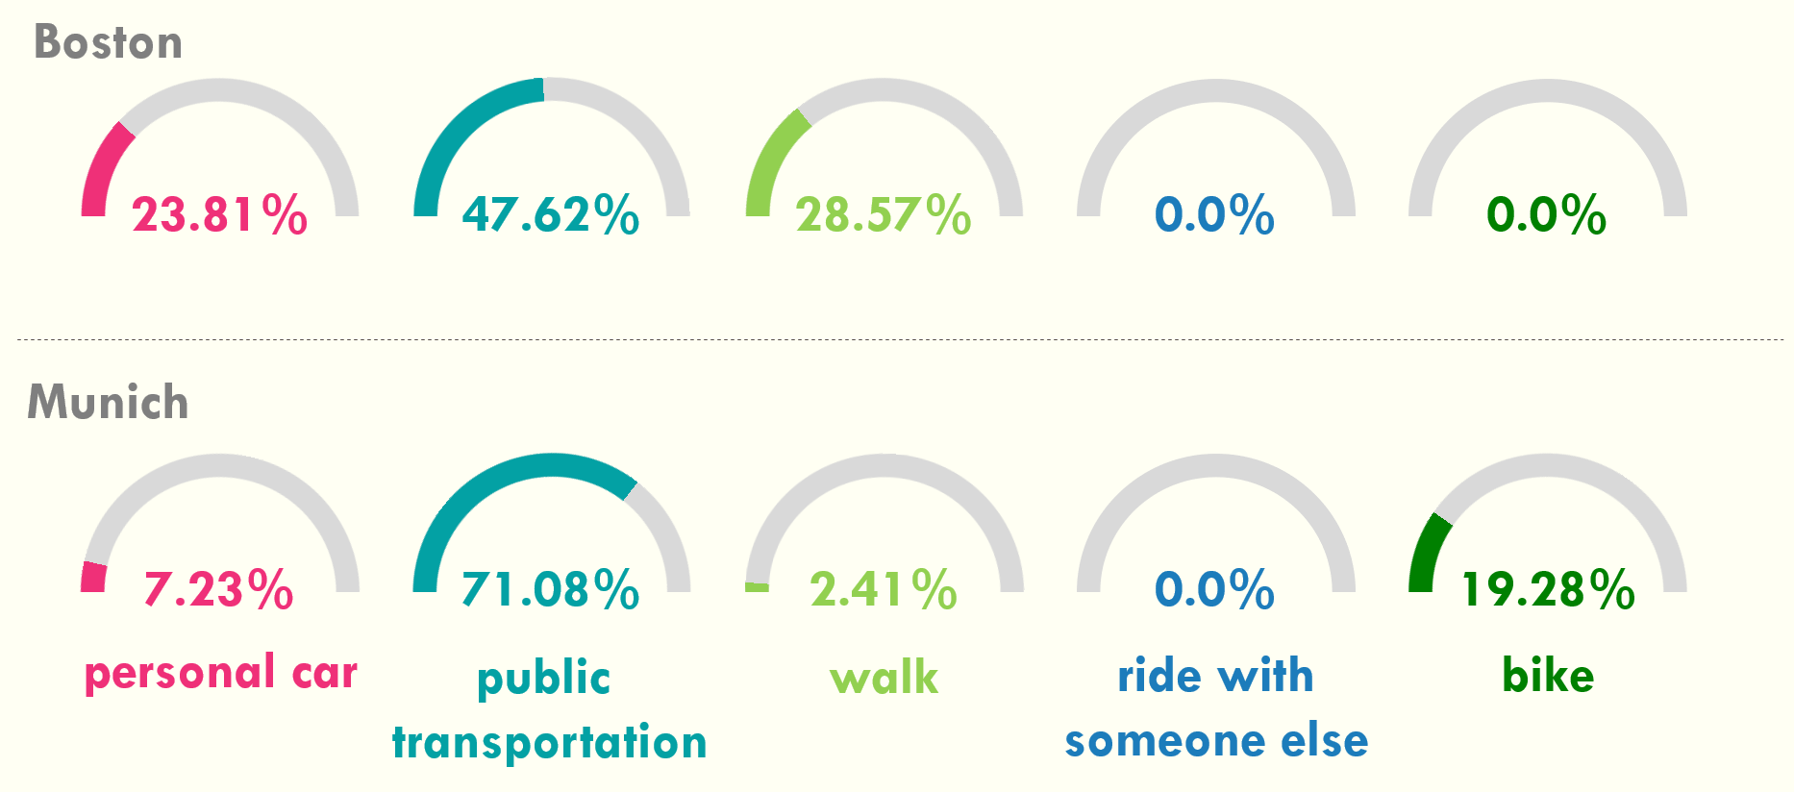
“How do you usually get to work”
Graph 1 "How do you usally get to work"
In Munich, it is clearly visible that the majority (over 70%) of people surveyed take public transportation to get to work. Interesting is the high number (about 20%) of people that are using their bike to get to work. This means that the place of work is easily accessible via the cities’ public transit system.
In Boston, the percentage of people taking public transit is much lower than in Munich. However, it is still close to 50% which means the companies are accessible via public transit, though it is often not utilized. But, the 25% of personal car use means that many people still prefer the car as it might be easier, more convenient or more accessible for them to get to and from work. The answers to this question show that accessibility of public transportation is very important for workers – especially in Munich. Therefore, the connection to public transportation should be an important factor in a company’s decision about where to locate.

“Why do you not use public transportation at all?”
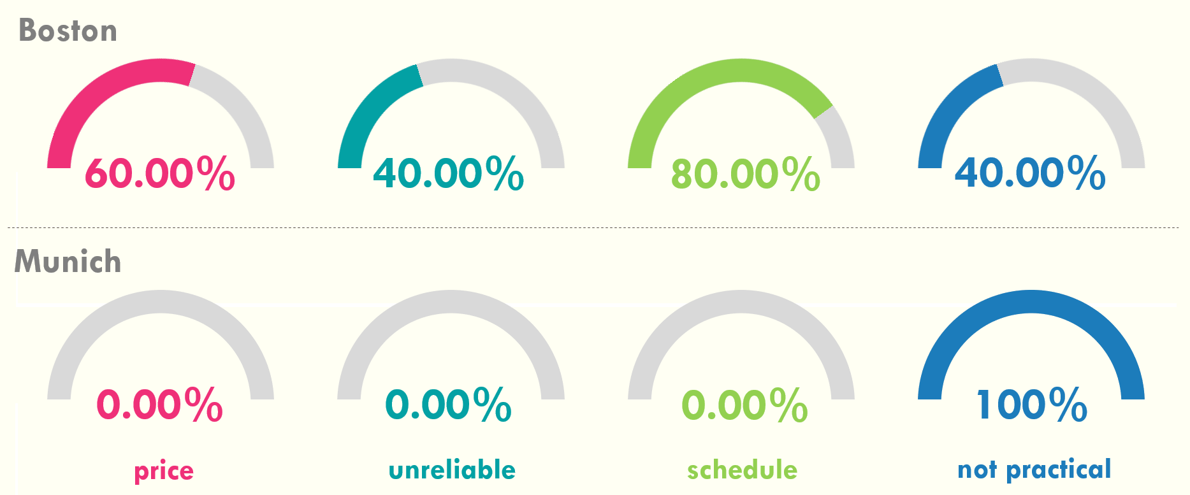
Graph 2 "Why do you not use public transportation at all"
In Boston, people find all kinds of reasons, for not using the public transportation system, with the schedule being the main cause. In Munich, the only reason for not using public transportation is practicality, or that people have no direct access to a station.

“Does your company pay for part of the cost?”
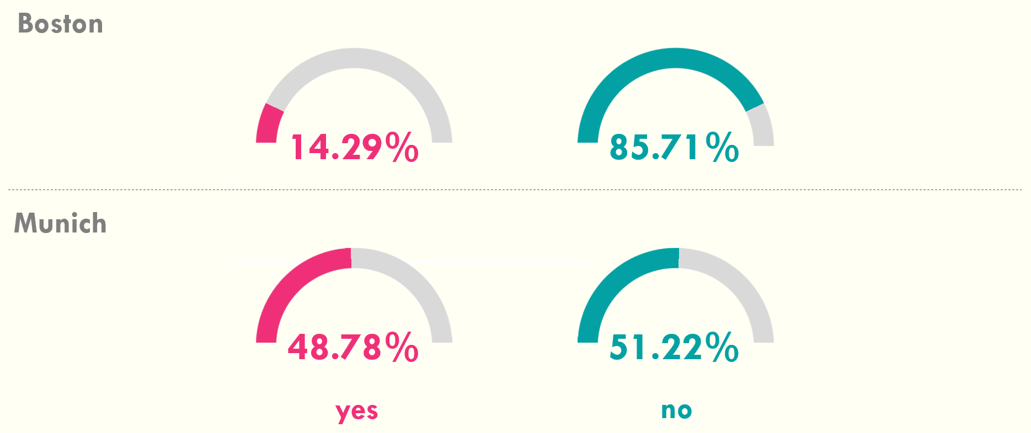
Graph 3 "Does your company pay for part of the cost"
This question revealed one of the biggest differences between the two cities. In Boston over 85% of the companies have no incentives for their employees to use public transportation. In Munich, nearly half of the companies support their employees using public transportation. As shown in chapter 4.6, the access to public transportation is an important factor when choosing an employer. In both cities the majority of people surveyed made this statement. Therefore, by not supporting the use of public transportation, companies could have a harder time finding employees in the future.

“How much of the cost does your company pay in percentage?”
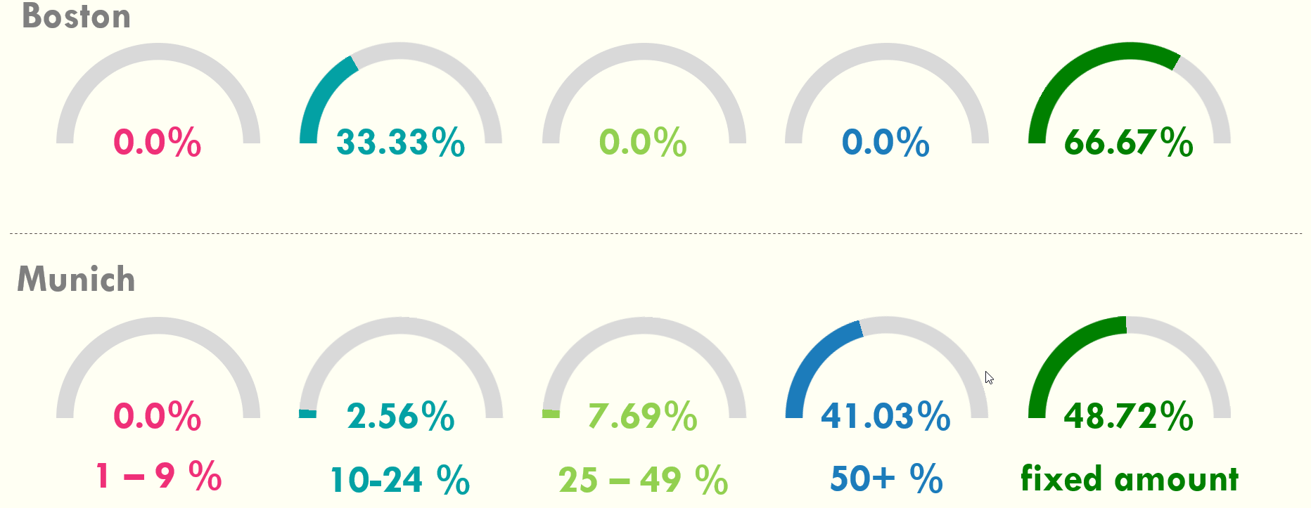
Graph 4 "How much of the cost does your company pay in percentage"
This question revealed a large difference between the two cities. In Munich, about 50% of the companies pay a fixed amount and about 40% of the companies pay over 50% of the costs.
In Boston, the few companies that actually pay either cover a fixed amount or only between 10 to 24% of the cost. That is a relatively small amount when looking at some of the monthly costs (refer to Chapter 4.7).

“What types of public transportation do you use?”
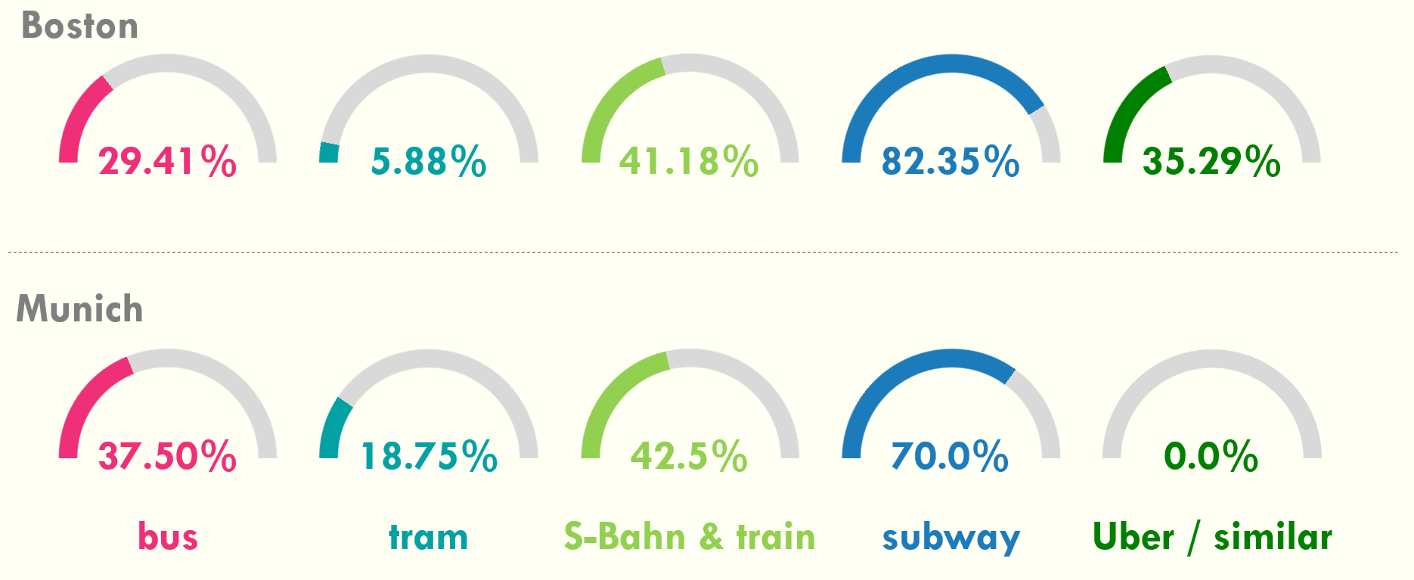
Graph 5 "What types of public transportation do you use"
In this question, the participants had the opportunity to select multiple options. Notable is the high percentage in both cities of subway usage. Also, both cities have about 40% of people using the commuter rail. A surprising amount of people (about 35%) in Boston use Uber or some kind of ride share, which is not actually “public” transportation.

“How important was the access to public transportation when you considered taking this job?”
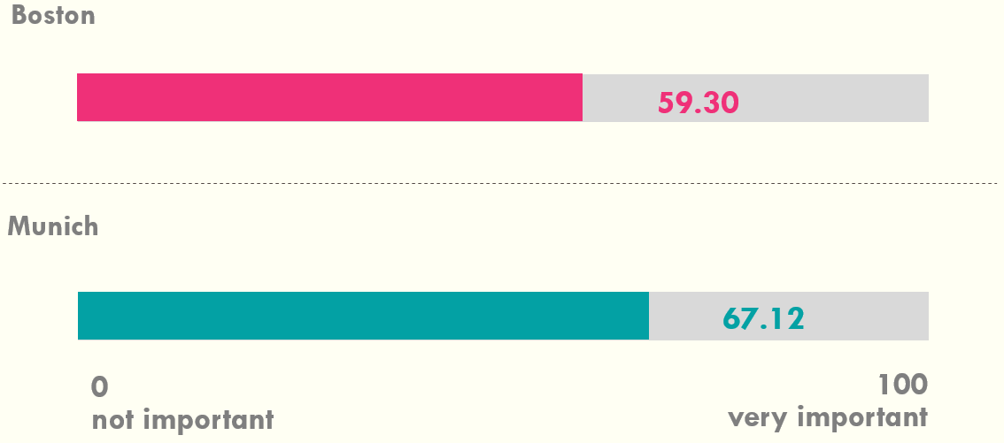
Graph 6 "How important was the access to public transportation when you considered taking this job"
Every surveyed person was asked to rate the importance of access to public transportation on a scale of 0 (not at all) to 100 (very important). In Graph 6, the average response is shown. Both cities have an average score of over 50, but Munich is still higher than Boston.

“What price do you pay per month for public transportation?”
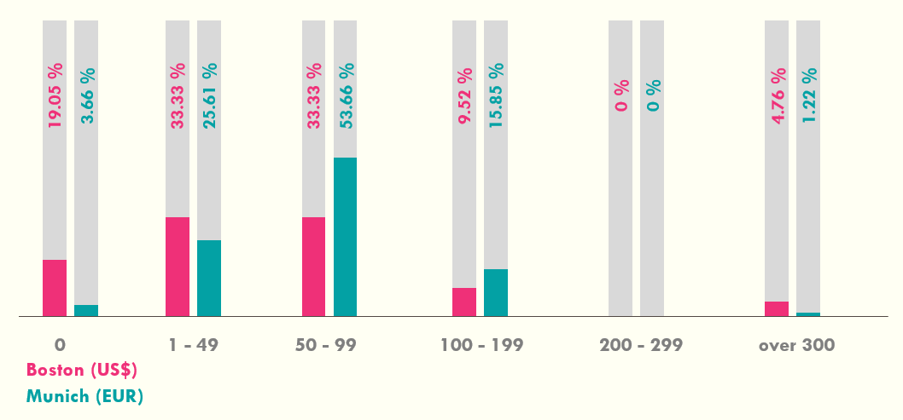
Graph 7 "What price do you pay per month for public transportation"
Graph 7 shows the difference in what people surveyed pay for their usage of public transportation per month. The average monthly costs of using public transportation seems to be relatively equal in both cities even with the different public transit systems.

“Is the cost for public transit justified?”
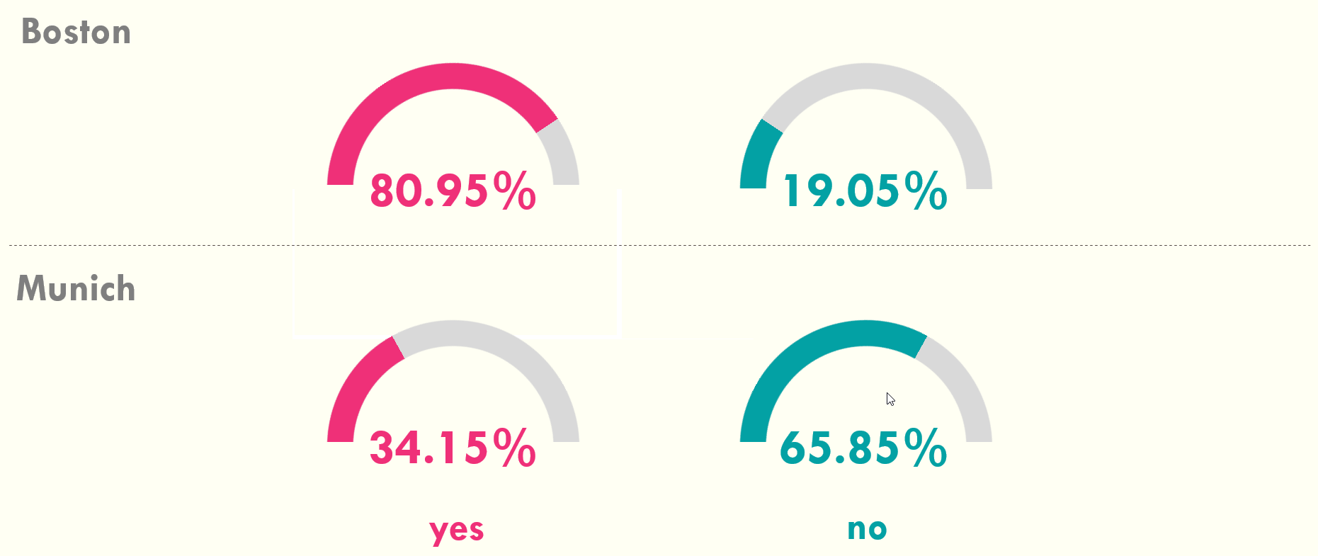
Graph 8 "Is the cost for public transit justified"
This question has a most surprising answer. In Boston the complaints were very clearly stated throughout the personal interviews and in the online survey. Yet, about 80% of people surveyed in Boston stated that the cost for public transportation is justified. The Munich numbers paint a very different picture. The complaints were not as frequent, but still about 65% of people surveyed stated the cost for public transportation is not justified.

“Do you have a pass for public transport and what kind?”
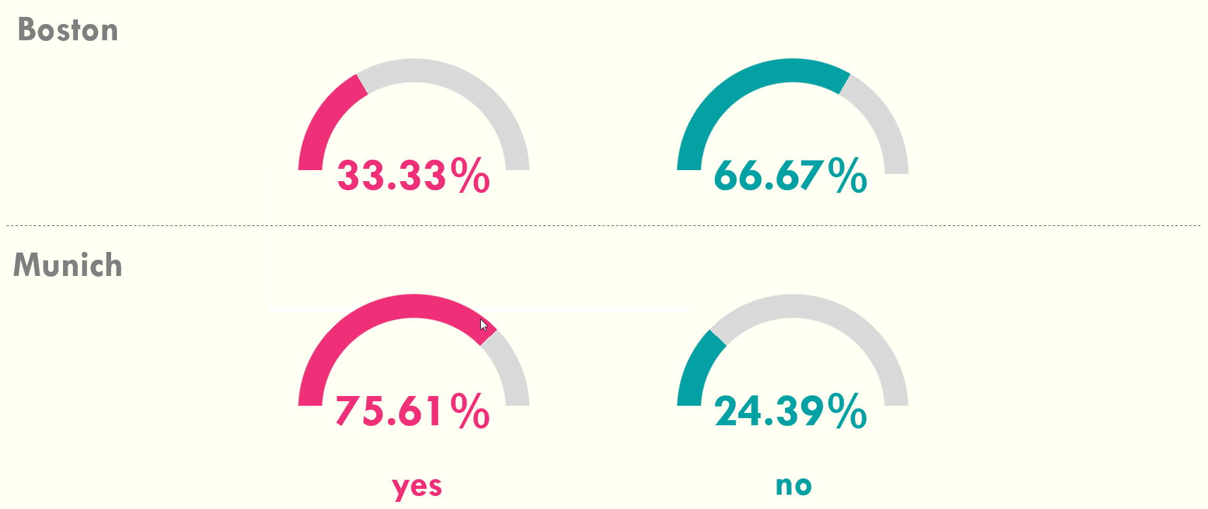
Graph 9 "Do you have a pass for public transport (e.g. monthly ticket)"
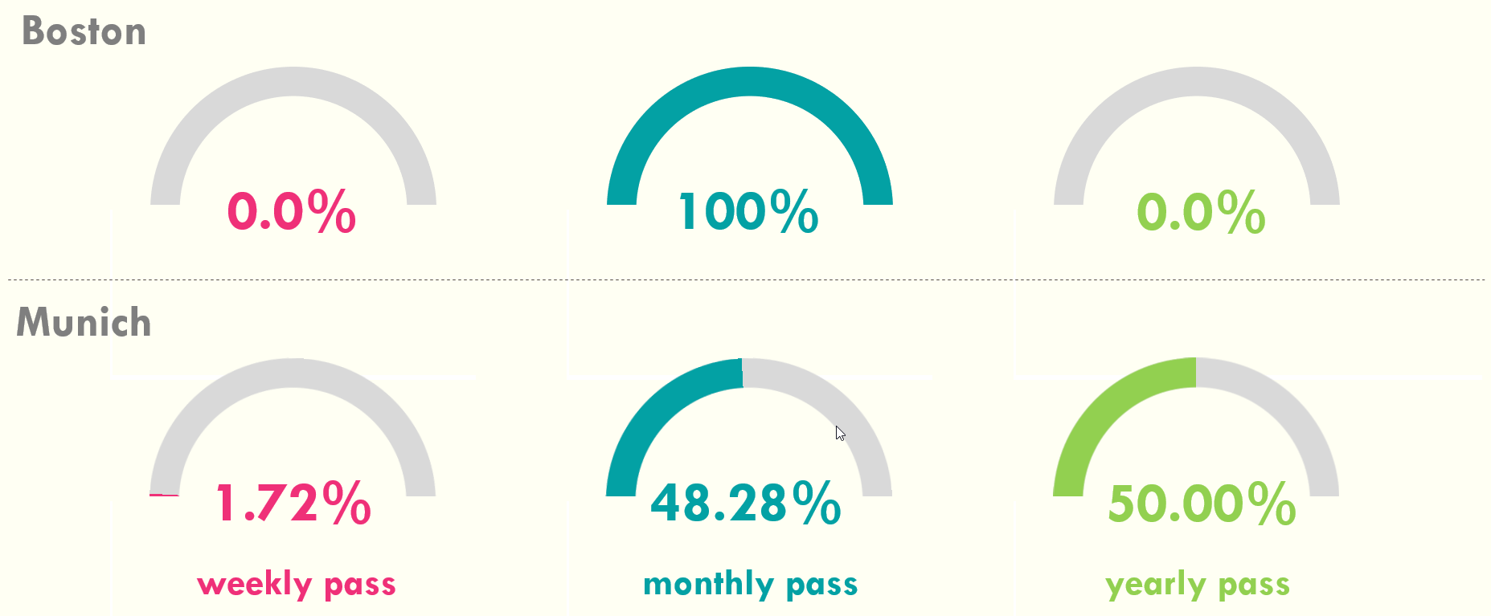
Graph 10 "Which pass for public transportation do you have"
The fact, that only one third of the people in Boston state that they have a pass for the public transportation – compared to over 75% in Munich – seems to indicate, that the system in Boston is much less convenient and far less accepted as a valid transport system. To get people to change from using their car to using public transportation, the public transportation system in Boston seems to need to improve in all sections.
But it is also worth mentioning, that in Munich people are also not happy about the reliability of their system. So, improvements are necessary in both systems. Graph 10 reveals that one third of people interviewed in Boston have invested in a monthly pass. In Munich, close to 50% of people having a pass stated having a monthly pass. Most surprising was that 50% of people in Munich stated having invested in a yearly pass for public transportation, which reinforces the fact that the city of Munich listens to the complaints and improves the public transit system accordingly. It certainly relates back to the fact, that nearly 50% of the companies in Munich support public transportation by paying for part of the cost (Chapter 4.3).

Conclusions

Boston
After interviewing representatives of multiple companies in Boston, they all agreed on the main areas of needed public transit improvements: more convenience, more reliable services regardless of weather conditions, and better pricing.
Currently in Boston, only about 10% of companies interviewed pay for part of the cost for their employees using public transportation. This lack of financial support most likely detracts from the usage of public transportation. According to the Boston surveys, public transit accessibility is having a greater influence on the location decision for newer/ younger companies. However, interviews with a few long-established companies showed that public transportation had no influence on their location decision at all. So with the noted change in attitude, today companies actively supporting their employees in the use of public transportation might have an advantage in the future finding employees.
Throughout the interviews, it became evident that more and more companies in Boston - especially younger companies – see access to public transportation as very important in the future. However, for many established companies the Boston public transportation system currently is not seen as valuable and reliable enough to be actively promoted as a commuting method, which means employees are less inclined to use it.
Overall from the surveys, it is seen that easy access to public transportation is becoming more and more of a factor in a company's decision where to locate. State Representative, Paul Tucker, and the Chief of Staff of the Mayor of Salem, Dominick Pangallo, were the two politicians from the Boston area interviewed for this study. Both politicians emphasized that public transportation and housing are their two top regional priorities where solutions were actively being discussed. Representative Tucker stated that the state of Massachusetts is billions of dollars behind in investments into public transportation, as both the subway system and the commuter rail are in need of major infrastructure updates.
An interesting insight from the interviews were the two possible options for funding public transportation updates that Massachusetts is currently reviewing. They are: the band-aid approach or the big investment approach. The band-aid approach is where issues are only being solved short term with minimal cost, but enough to keep the public transit system up and running. The big investment is committing large amounts of money to fix the issues long term. According to Representative Tucker, there was a Millionaire’s Tax that got proposed but the law never went into effect. This tax would have raised about a billion dollars a year that would have been then invested towards public transportation and helped with the big investment.
Both politicians stated that it is their long-term goal in Boston to increase the availability and use of public transportation. Specifically, two main projects were mentioned: Dominick Pangallo indicated that one of the main improvements he supports is to increase the ferry services into the city of Boston. Through the expansion of the waterway services, his belief is that people’s overall public transportation use would increase.
To achieve their long-term goals, both politicians agreed that the Commuter Rail has to be improved to make it more convenient for people to use. The city of Salem along with Salem State University and the Salem Hospital are working on getting an additional commuter rail stop in South Salem. This new stop would make the commuter rail more accessible to students and employees. Another part that got mentioned is the increase of train frequency to make the times of train arrivals more convenient. Along those lines, President Keenan of Salem State University stated that if the connection to the public transit system was improved and became more accessible, he would increase the promotions for the usage of public transportation to faculty and students.

Munich
After interviewing officials at six companies and a university in Munich, the following conclusion can be drawn. German companies and the university consider public transportation a lot more important when making locational decisions than in Boston. There was only one company surveyd that did not consider public transportation important. On the other hand, the university official stated it chose its current location because of the accessibility through multiple different modes of public transportation.
Compared to Boston, complaints about the public transportation system were definitely not as frequent as all Munich officials said the system is pretty good. But just like in Boston, the weather impact on the suburban trains was stated as a big concern. It is also the reason companies prefer to be connected to the subways, buses or trams over the suburban trains. The other issue with public transportation that was mentioned a few times in Munich was the overcrowding or lack of capacity on trains especially during rush hour. This could impact companies as employees will have a harder time using the trains to get to and from work in the morning and evening. It is also a less pleasurable experience. The greater usage of public transportation in Munich compared to Boston could be partially explained by that the fact that close to 50% of the companies interviewed pay for part of the cost. This means companies have considered public transportation when choosing their location and are promoting its usage by taking over part of the cost from their employees.
A local politician for the city of Munich provided a different perspective from the companies and employees on the importance of public transportation. Unlike in Boston, the city of Munich has recognized and accepted many of the concerns that employees and companies mentioned in the online survey and in the personal interviews, like overcrowding, reliability or convenience. As such, the city of Munich is in full support of expanding the current public transit system to better suit the needs and demands of its people. There are several projects to improve public transportation in Munich, some of which are already being implemented.
Part of the expansion plan is to increase the capacity on the subways and trains in general. In order to address this issue of capacity, the Munich Transportation Corporation has introduced a new model of subway car that has almost double the capacity of the original model of subway cars. Once all the subways have been replaced, it should address the issue of overcrowded trains. In addition, the city is adding a new and additional “Stammstrecke” for the suburban trains to relieve the traffic on the original one, which is being sponsored by the Deutsche Bahn. Furthermore, new subway lines to offer better connections outside the city center and to relieve the existing lines are planned. Finally, the city is also planning to expand their bus network by implementing more bus lines. In order to achieve this, the city has introduced an investment plan for Public Transportation totaling 5.5 billion Euros. This plan is currently under review with the city.
In regards to funding, larger infrastructure projects are financed by the city of Munich and by the Munich Transportation Corporation, as the infrastructure is still owned by the city. Therefore, the city of Munich receives funding from the state of Bavaria, but also from the Deutsche Bahn at the federal level.

Overall Conclusions
There are many advantages the city of Munich sees in public transportation, which also could apply to Boston. They are: more optimal land use as most of public transportation is underground; fewer cars on the streets; a more environmentally friendly method of transportation, therefore contributing positively to climate change. For example, all trains in the Munich public transit system are electric (while the Boston commuter rail is still running on diesel); faster mode of transportation around the city compared to cars; and more mobility for non-drivers such as elderly people and children.
Public transportation is clearly being used by employees as a commuting method to and from work. The main difference is that in Munich public transit is used more than in Boston. This can be related back to the financial support of companies in Munich paying for part of the cost as well as accessibility. But, as seen in the interviews, companies are factoring in public transportation more when making the decision on where to locate.
The overall condition as well as the availibility of the public transportation system play a key role whether people use it as a mode of transportation. While the services offered are comparable between Boston and Munich, the main difference is the up to date technology and the modern trains the city of Munich has implemented, an area were Boston’s public transit system seems to have fallen behind.
In order to update to the newest technology and modern trains, public transportation needs to be fully supported by the city and by local politicians to get the nessesary fundings. While in Boston, some politicians, like Representative Paul Tucker, are in full support of public transportation, it is not enough to provide the funds for the nessesary updates. In Munich, on the other hand, the city is fully supporting public transportation and is constantly updating the system to suit the needs of the people.
Overall public transportation is the ticket to the future for sustainable transportation. Cities like Boston and Munich are reaching limits for cars on the streets and public transportation is the one sustainable solution along with walking and biking. Munich is ahead of Boston, but as can be seen, especially for new companies in Boston, access to public transportation is becoming increasingly important.

Bibliography
Anderson, Monica. “Who Relies on Public Transit in the U.S.” Pew Research Center, Pew Research Center, 7 Apr. 2016, www.pewresearch.org/fact-tank/2016/04/07/who-relies-on-public-transit-in-the-u-s.
DeWitt, Kaylee. “How to Choose a Business Location | Business Location Analysis Guide.” Patriot Software for Small Business, 21 Mar. 2017, smallbusiness.patriotsoftware.com/how-to-choose-small-business-location-factors-analysis/.
Florida, Richard. “The Geography of How We Get to Work.” The Atlantic, Atlantic Media Company, 13 July 2011, www.theatlantic.com/national/archive/2011/07/the-geography-of-how-we-get-to-work/240258/.
Getting to Work: Transportation Policy and Access to Job Opportunities. The Leadership Conference Education Fund, July 2011, http://civilrightsdocs.info/pdf/docs/transportation/getting-to-work-july20.pdf
Heil, Karl. “LOCATION STRATEGY.” Edited by R. Anthony Inman, Reference for Business, www.referenceforbusiness.com/management/Int-Loc/Location-Strategy.html.
Massachusetts Bay Transportation Authority. “The History of the T.” MBTA, www.mbta.com/history.
Muenchen.de. “Munich S-Bahn.” Muenchen.de, www.muenchen.de/int/en/traffic/public-transport/transit-operators/s-bahn.html.
MVG, Authors of. “Munich Transportation Corporation Sustainability Report.” MVG, Sept. 2016, www.mvg.de/dam/mvg/ueber/nachhaltigkeit/mvg-nachhaltigkeitsbericht-eng.pdf.
“MVG Sustainability Report 2014/ 2015.”MVG, Sept. 2016, www.mvg.de/dam/mvg/ueber/nachhaltigkeit/mvg-nachhaltigkeitsbericht-eng.pdf .
mvg.de, Redaktion. “Unsere Fahrzeuge.” MVG, www.mvg.de/ueber/das-unternehmen/fahrzeuge.html.
“Transit's Role in Environmental Sustainability.” Federal Transit Administration, United States Department of Transportation, 14 Dec. 2015, www.transit.dot.gov/regulations-and-guidance/environmental-programs/transit-environmental-sustainability/transit-role.

Appendix

History of public transportation in Boston
America’s public transportation originated in the city of Boston. The subway tunnel under the Boston Common, still in use today, was the first subway tunnel in the country. In 1631, Thomas Williams started the first charted transit service in the country. The Massachusetts Court of Assistance offered anyone a contract, who was willing to operate a ferry between the Peninsula and Charlestown. After the revolution in the 1700s, the geography and population of the city of Boston was growing rapidly, resulting in other modes of transportation around the city gaining in importance. In 1793, the first stagecoach started their services running between Boston and Cambridge. More than 20 different and individual companies offered horsecar services around the city by 1887. An act was passed by the General Court of Massachusetts to consolidate all horsecar companies into the West End Street Railway, which at the time was one of the largest street rail operations in the country. The West End Company and the Boston’s City Council presented the city with the first electric streetcar on January 1st, 1889, which is today’s green line C branch. The Rapid Transit Commission appointed in July 1891 to investigate the public transit system made the following improvement suggestions: four elevated railway lines and a tunnel for streetcars under Tremont Street. Tremont Street subway would become North America’s first subway tunnel opening in 1897. In 1947, the state legislature formed the Metropolitan Transit Authority (MTA), who in 1957 authorized the expansion of rapid transit along the Newton Highlands branch of the Boston and Albany Railroad. The MTA’s debt grew as the demand for the train increased rapidly. On August 3, 1964, the T was voted into law. Because of a massive study of transit needs by urban planners, the existing railroads of greater Boston were integrated into one comprehensive public transit system: The Massachusetts Bay Transportation Authority (MBTA). In 1965, the federal government formed the Urban Massachusetts Transportation Administration (UMTA), now known as the Federal Transit Administration, who proved the initial funding for the MBTA’s first modernization. The UMTA helped the T legally reserve New Haven Railroad’s rail lines and rights-of-way for the development of the MBTA Commuter Rail (Massachusetts Bay Transportation Authority). The FTA has funded 3.5 billion dollars in improvement projects for the MBTA; however, until the late 1900s, the residents in Eastern Massachusetts considered public transit only a supplementary mode of transportation. But, in the 1970s a gas shortage, traffic congestion and concerns about air quality, made the T more popular than ever with more than 300,000 riders per day. Today, the MBTA is considered one of the largest public transportation systems in the country. Combined on the subway, bus, ferry and commuter rail, there are more than 3.1 million daily riders.

Current trains

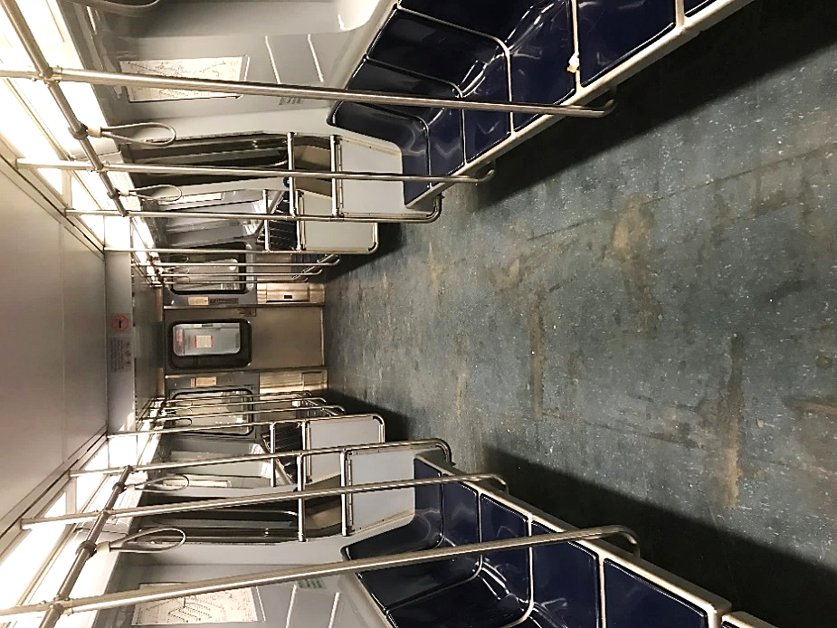
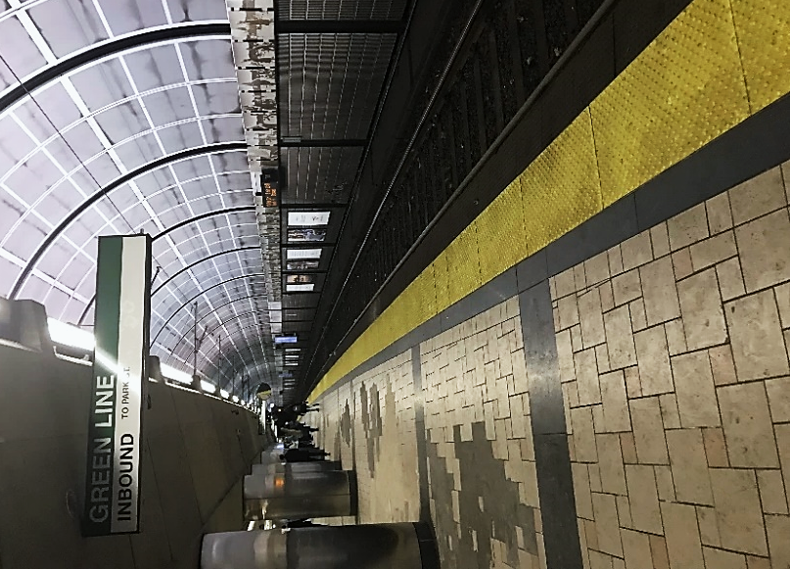
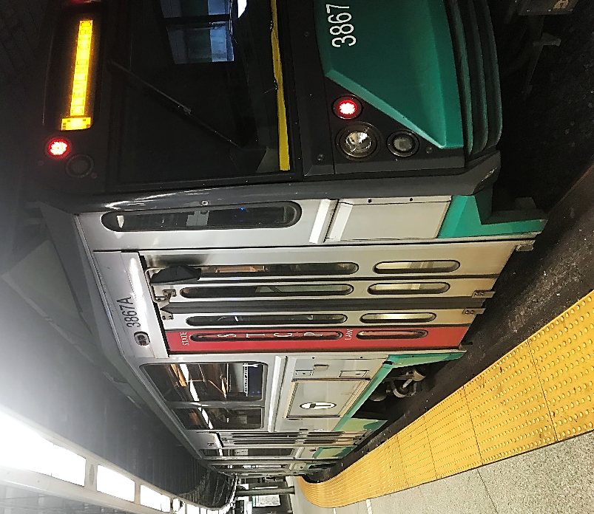
Figure 3 Inside Blue Line
Figure 4 North Station
Figure 5 Green Line train

Introduction of Public Transit in Munich
Munich’s public transportation system is managed by the MVG (Münchner Verkehrsgesellschaft/ Munich Transport Corporation). Along with the MVV (Münchner Verkehrs Verbund / Munich Transport and Tariff Association), the MVG secures public transportation for the city of Munich. MVG’s mission is as follows:” Our commitment to the environment helps make public transportation the obvious first choice, and this is Munich's recipe for success now and in the future.” The MVG’s has around 140 years of history and is Germany’s second-largest municipal transportation enterprise with about 3,700 employees.

History
There is a long history of around 140 years. Here are some dates that marked key events:
- On October 21, 1876, the first tram drove through the city of Munich being pulled by horses.
- In 1934, the city of Munich buys their first own buses.
- On July 21, 1956, there is the first new construction of a tram line since the world war.
- On April 5, 1971, the MVV (Münchner Verkehrs- und Tarifsverbund/ Munich Transport and Tariff Association) was founded.
- The subway line U6 started its services on October 19, 1971.
- The subway line U3 started its service on May 8, 1972
- On January 1, 2002, the MVG (Münchner Verkehrsgesellschaft / Munich Transport Corporation) was founded.

Current public transit available
The current public transportation system consists of the U-Bahn (subway), tram, S-Bahn (suburban trains) and bus. There are 1,200 stops and stations total in Munich. In 2015, the MVG conducted a survey and found that 27% of the movements by Munich’s inhabitants are by underground trains, trams and/or buses. They also found that 38% of Munich’s inhabitants use MVG transport every day.

Technology/ current trains
The S-Bahn (suburban train) has connected Munich to its surrounding towns and beyond for more than 30 years. The S-Bahn is Germany’s largest suburban train network with 442 km of track and two lines S1 and S8 connecting the city and Munich Airport. The trains travel at an average travel speed of 50 kilometers per hour. On a daily basis, more than 720,000 passengers travel with the S-Bahn. The free state of Bavaria and Deutsche Bahn AG have invested more than 266 million Euro in the S-Bahn to increase standards.
The U-Bahn (subway) has been running through Munich since 1971. Today, the network is nearly 100 kilometers larger with trains going up to 80 kilometers an hour. In 2015, close to 398 Million people rode the subway. There have been various types of subway trains, but the newest one was released in 2016 has a capacity of 940 people compared to the original trains, released in 1970, with a capacity of only 290 people.
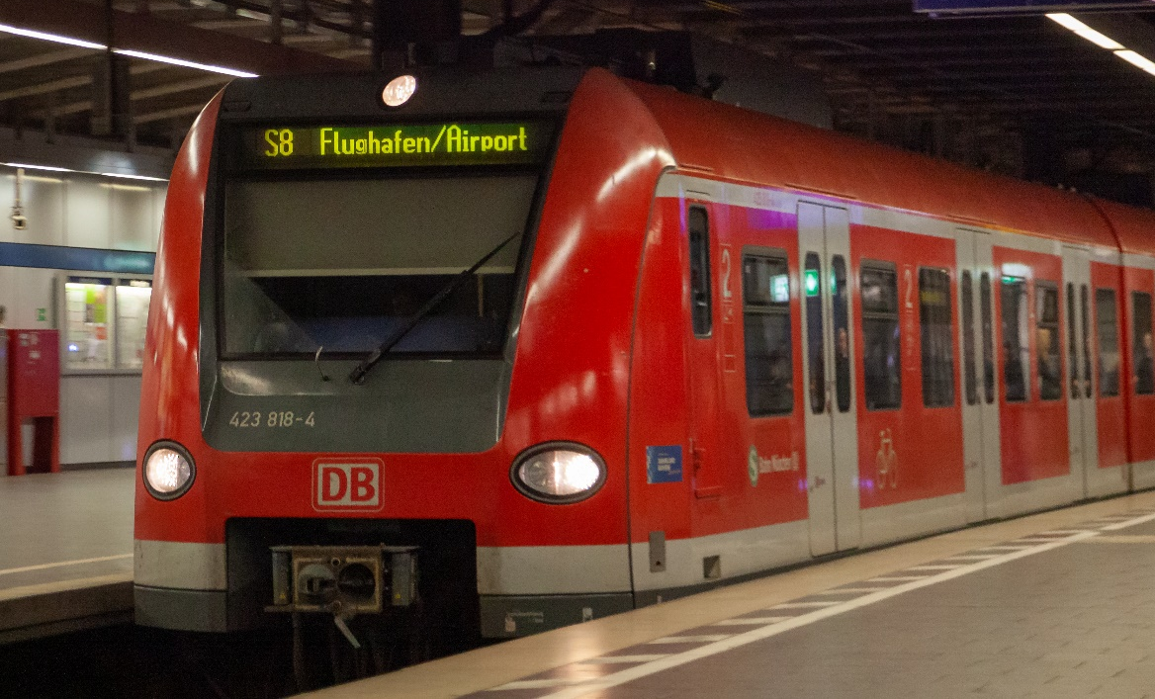
Figure 6 S-Bahn (suburban train)

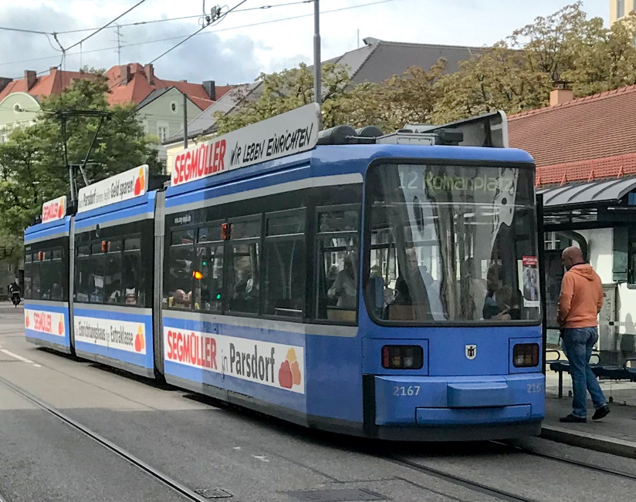
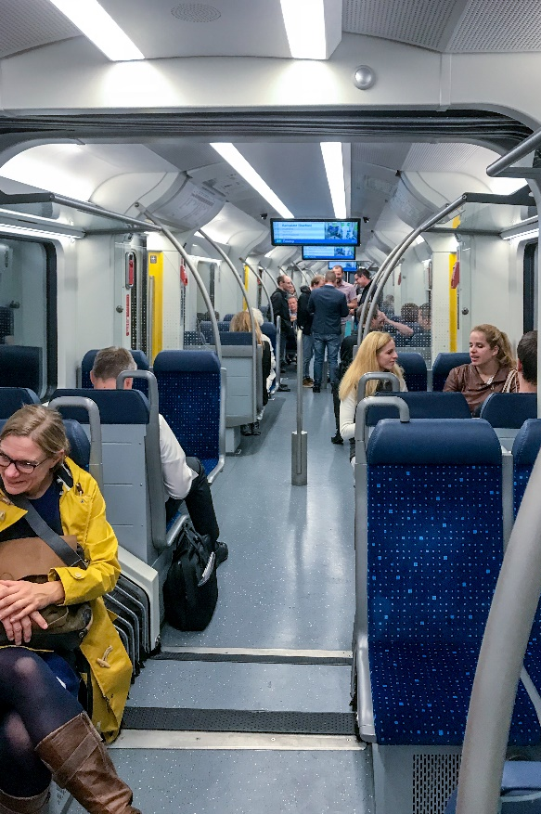
Figure 7 Tram (street car)
Figure 8 Inside subway

Future

Current Development
The S-Bahn tunnel through the heart of the city is currently undergoing renovation. This tunnel is 4.2 kilometers long and is being equipped with new signaling technology. The following stations are also undergoing modernization: Hauptbahnhof (Central Station) and Sendlinger Tor.

Plans
According to the MVG website, they have a service campaign that started back in 2010 and is set to be completed in 2020. The goal of this campaign is to “increase regular services in all sectors”. This campaign outlines several projects/ extensions that are planned to help achieve the goal. For the subway, there are plans for a new line in the city center. The goal is to relieve the existing lines and to extend the established subway network. For the tram, the campaign outlines new line sections, particularly bypasses to relieve existing lines. Finally, for the bus network, the campaign outlines new lines and services. These services will include provisions of the infrastructure for new districts and networking of interchanges.

Sustainability of public transportation
According to MVG’s Sustainability Report from 2014/2015, sustainability influences the activities of the MVG far beyond saving energy, fuel and emissions. They also consider sustainability “in terms of ecological, economic and social aspects”. The MVG’s public transport services is one key pillar of the city’s sustainability strategy. Munich’s public transit system has made a very positive impact on the environment by reducing inner city traffic and improving air quality with over 16,000 bus and train trips per day. This number will only grow as the demand for fast and efficient public transportation is growing among residents. In order for the MVG to face the challenges of tomorrow like energy transition and climate protection, “smart traffic management [has assumed] a pivotal role in enabling urban-friendly sustainable mobility.” (Authors of MVG) The focus now is on modernization and expansion of the public transit network, which includes increasing capacities on established lines and adding new lines as well as updating the fleet and stations with the newest, cutting edge technology.

