ARE PRIVATE NONPROFIT COLLEGES AND UNIVERSITIES IN COMPLIANCE WITH UNRELATED BUSINESS INCOME REGULATIONS?

Honors Thesis

Presented in Partial Fulfillment of the Requirements

For the Degree of Bachelor of Science in Accounting
In the School of Business
at Salem State University

By

Danielle Bedard

Dr. John McArdle
Faculty Advisor
Department of Management

***

Commonwealth Honors Program
Salem State University
2018
Abstract
Nonprofit status is granted to entities organized for a charitable, educational, religious or scientific purpose. Nonprofits are not liable for income tax on their revenues as long as the revenues are related to their core mission. As colleges and universities struggle in an era of declining resources they often seek alternate streams of revenue; some of these look more like businesses and less like nonprofits. This created the question: are nonprofit colleges and universities complying with the unrelated business income (UBI) laws and regulations? The Internal Revenue Service (IRS) audited a sample of thirty-four college and universities and found that 90% of them were underreporting their UBI. UBI is income generated from any activity that is not related to a nonprofit institution’s core mission. Some examples of these activities are: selling clothing, receiving revenue from a fitness center, and offering sports camps over the summer. This study evaluated tax returns from a randomized sample of forty private higher education institutions to determine whether they were compliant with IRS regulations. Several data points were examined to assess the validity of the institution's income reported.

Table of Contents
0 Abstract……………………………………………………………………………….... ii
- Acknowledgements………………………….……………………………………..…iv
2.0 List of tables…………………………...…….……………………………………..…iv
3.0 Introduction……………………………………………………………………………1
3.1 Description of Income and Unrelated Business Income………………………………1
3.2 Motivations & Overview…………………….………………………………………..2
4.0 Literature Review……………………………………………………………………...4
4.1 Origins and Development of Unrelated Business Income Policy……………………..4
4.2 Industry Wide Effects…………………..…………………………………..…………6
5.0 Methods…………………………………………………………………………….....8
6.0 Data………………………………………..…………………………………………11
6.1 Revenue Findings…………………………………………………………………….11
6.2 Income Findings……………………………………………………………………...13
6.3 Tuition Findings……………...………………………………………………………16
7.0 Results……………………………………………………………………………..…17
8.0 Conclusion……………………………………………….…………………………..20
9.0 References……………………………………….………….………………………..21

1.0 Acknowledgments
I would like to thank my thesis advisor, Dr. John McArdle, for his generous
time, expertise, and suggestions for this thesis.
2.0 List of Tables and Figures
Figure 5.1 Method Flow Chart…………………………………………………………...10
Chart 6.1 Unrelated business activity revenue percent of total revenue…………...……12
Chart 6.2 UBI as a percent of total income………………………………………………15
Chart 6.3 Tuition revenue percent of total revenue…………….……….………………17
Figure 7.1 ID# 16’s FY2014 page 1 of 990 form……………..…………………………19
Figure 7.2 ID# 16’s FY2015 page 1 of 990 form……….…….…………………………19
- Introduction
3.1Description of Income and Unrelated Business Income
Income is an excess of revenue over expenses. Section 61(a) of the Internal Revenue Code defines gross income as “gross income means all income from whatever source derived”. This means that gross income is excess total revenues over total expenses or what many call a profit (if a positive amount) or a loss (if a negative amount). All for-profits and nonprofits must report their income, unless they are a public entity. As stated in section 115 of the Internal Revenue Code, “gross income does not include- (1) income derived from any public utility or the exercise of any essential governmental function accruing to a state or any political subdivision thereof”. A public higher educational institution does not have to report their income or pay any income taxes. For this reason, this study is solely limited to private higher educational institutions. Nonprofit private colleges and universities report their income by filing a 990 form and will have to pay taxes on certain income called unrelated business income (UBI). This raises the question; why are private higher educational institutions classified as nonprofit and granted a tax-exempt status?
Private higher educational institutions are classified as nonprofit because they meet the requirements of the Internal Revenue Code § 501(c)(3), which encompasses "[c]orporations, and any community chest, fund, or foundation, organized and operated exclusively for religious, charitable, scientific, testing for public safety, literary, or educational purposes". A college or universities basis for exemption would be for educational purposes. Income from substantially related activities, charitable contributions received, and investment income are not subject to federal income tax . UBI is income generated from any activity that is not related to a nonprofit institution’s mission statement and is subject to federal income tax. The phrase unrelated trade or business means, any trade or business the conduct of which is not substantially related to the exercise or performance by such organization of its charitable, educational, or other purpose or function constituting the basis for its exemption. For example, a higher education institution’s tuition and fees would be considered a related business activity and thus, tax exempt. Endowments would be considered a charitable contribution, and thus, tax exempt. However, for a higher educational institution; selling clothing, receiving revenue from a fitness center, and offering sports camps over the summer are examples of unrelated business activities. Any income received from these activities is subject to tax.
  - Motivations & Overview
Properly reporting UBI is important because any amount of UBTI (unrelated business taxable income) greater than $1,000 is subject to tax at the normal corporate tax rates. If institutions underreport their UBI they would be out of compliance with the UBI statute and regulations. The danger for institutions increasing their engagement in UBI activities is that they could face penalties and revocation their tax-exempt status. However, underreporting UBI appears to be a widespread issue. In 2013 the IRS did an examination of thirty-four institutions in the United States and found that 90% of them underreported their UBI. According to IRS Releases Final Report, the investigation resulted in 180 corrections to the examined institutions' 990 T form, leading to a total increase to UBTI of approximately $90 million. Additionally, changes to UBTI for about one-third of the thirty-four examined institutions developed from corrections related to golf courses, sports camps, arenas, and fitness/recreation centers. As a result of the audit, the IRS issued a statement that moving forward they will examine UBTI reporting "more broadly," concentrating on recurring loss trends from year to year and the allocation of expenses. While there has not been an official compliance audit report since 2013, the IRS has issued guidance for schools. Publication 598, titled Tax on Unrelated Business Income of exempt organizations, was released on Dec 26, 2016 and covered the topics: Organizations Subject to the Tax, The Tax and Filing Requirements, Unrelated Trade or Business, and Unrelated Business Taxable Income. After the audit, and guidance that was released thereafter, one could presume that schools are more aware of the UBI regulations. This study examines whether higher educational institutions are still misreporting UBI and noncomplying with IRS regulations.
4.0 Literature Review
4.1 Origins and Development of Unrelated Business Income Policy
Higher education in America grew tremendously in the late 20th century. American higher education expanded rapidly due to the GI bill which was signed into law in 1944 and aided soldiers returning from World War II with the cost of education. After WWII, numbers of births rose to record highs in the U.S. and a baby boom was pronounced. Furthermore, general fertility began to rise until the late 1950’s then started to decline after 1960. This increased population became old enough starting in the 60’s to go to college. This large influx of students meant that schools had to expand in order to accommodate the increase in enrollment. With the growth of the higher educational industry, many colleges and universities developed not only their educational courses to meet increase student demand but, expanded and grew their unrelated business activities in order to compensate for increased costs. Bradach (2014) argued that growth of UBI was also due to, the increases in the overall enthusiasm for business, which spiked during the flourishing 1990s. Additionally, managers of nonprofits want to be viewed as active entrepreneurs and to reach this goal they would launch commercial projects. Many board members supported these new business ventures because they were accomplished business professionals. Furthermore, Bradach continues by stating that, many foundations and funders have been encouraging schools to become financially independent and have promoted net income as a means to “sustainability.” As a result, nonprofits increasingly felt pushed to launch income earning ventures in order to give the impression of being more innovative and business-like to stakeholders.
Shortly after the rapid expansion, an economic depression took place in the 1970s and 80s. In conjunction with the declining population, schools started to have large drops in enrollment. Since many schools at that time were tuition dependent, when enrollment dropped, they saw a significant drop in revenues. Many schools had to find other ways to generate revenues and started to engage in UBI activities. Institutions started to appear more like for-profit business, as their operations expanded from a traditional educational program to a multifaceted organization. Because of this trend, UBI policies started to be passed. Romer (1989) describes the origins of UBI policies. Unrelated business income tax (UBIT) was enacted in 1950 (after world War Two) in order to ensure that nonprofit organizations do not receive tax free income from business activities that are not related to their tax-exempt purpose. Increasingly, UBIT has become very important to the higher education industry as more institutions have increased the diversification of their revenue raising activities. When they do so their operations become less distinguishable from those of for-profit businesses. In literature this is known as "mission drift” or “mission tension”. UBI has given equal opportunity for for-profit businesses and nonprofits, however this raises the question of; at what point does a nonprofit start looking too much like a for-profit business?
  - Industry Wide Effects
In the recession that followed the post-World War Boom, many schools strived to increase their revenues to cover the costs incurred from expansion and the drop-in enrollment. If a college or university is unable to generate enough funds from tuition or other related activities, then they may need to resort to other activities to generate a revenue stream. However, Kennedy, Casey, and Leonard (2016) asserted that, “Generating much-needed funds while avoiding the trap of UBTI can often be a confusing task for tax-exempt organizations”. This is because the regulations for UBI are "very complex and can be interpreted differently”. The 2013 IRS audit confirmed that schools were having difficulty understanding the regulations. The IRS Release Final Report announced that the majority of the misreporting was from schools claiming losses from activities that did not qualify as a "trade or business" because the institutions failed to show a profit intention for the activities. Because of this, the IRS rejected losses and net operating losses (NOLs) on 75% of the returns examined, resulting in the in a total disallowance exceeding $150 million. The second most misreported item was that the schools misallocated expenses between exempt and UBI activities, resulting in claimed expenses that were not associated with the UBI activity. Jaeger (2013) discusses the additional misreporting was in computation or substantiation of NOLs. NOLs are losses reported in one year that can be carried forward offset income in other years, thus reducing their tax liability. Jaeger continues by arguing that on more than one third of returns examined, the institutions either improperly calculated the NOLs or the losses were not substantiated. Additionally, there was a high amount of misclassification of activities. Nearly 40% of the institutions examined improperly classified certain profitable activities as exempt when the activities should have been reported as unrelated. These unrelated activities would be subject to tax. Majority of the mis-classifications resulted from five main activities: fitness/recreation centers/sports camps, advertising, facility rentals, arenas, and golf courses.

5.0 Methods
A data set of forty higher educational institutions was developed. The data was refined by:
- A set of all the colleges and universities in the U.S from the 2015 Carnegie classification data file was retrieved and consisted of 4,665 institutions. ​
- The data set was refined by removing all the categories except master comprehensive and bachelorette college. This lead to 1,187 schools in the data set.​
- All public institutions were removed from the data set because they do not have to report their income as stated by I.R.C. § 115 (1).​
- Schools that were located in the District of Columbia and Puerto Rico were removed from the data set. This lead to 941 institutions in the refined ​data set.
- Lastly, schools who had less than 100 graduating students were removed from the data set. This left 578 schools in the final data set used in this study.
The sample list of forty schools was then selected using the randomizer function in excel from the final listing of 578 schools. After, a backup randomized pool was created by removing the forty schools from the data set of 578 schools, then randomizing the list of remaining 538 schools using the excel randomizer again. Fifteen schools were picked for the backup school pool. Three of the original forty schools were a branch location of a larger parent school. These branch schools have consolidated 990 forms, making the data largely different than the others; this makes the data hard to compare. Therefore, the three branch schools had to be removed from the sample list. The top three schools that were in the backup school pool were used to replace the branch institutions. This produced a random sample list of forty schools that could be compared. Afterwards, all the higher education institutions were given an ID number, making the study anonymous.
After the sample set of forty schools was finalized, data was collected from each of the forty institutions 990 forms found on guidstar.org. This data was then put into an Excel document. Data was collected from fiscal year 2015 (reported in 2016) and 2014 (reported in 2015), which is the currently the most recent 990 filings that are available. Total revenue was recorded from each of the forty institutions’ 990 forms from part VIII column A line 12, total unrelated business revenue was recorded from part VIII column C line 12, total expenses was recorded from part I line 18, total income was recorded from part I line 19, net UBI was recorded from part I line 7b, and revenue generated from tuition and fees was recorded from part VIII Column A line 2a. The data collected was then analyzed by creating ratios. Ratio analysis allows multiple different organizations to be compared because it removes the dilemma of having schools with different sizes and capacities. The ratio between total revenue and unrelated business revenue was calculated by dividing an institutions total unrelated business revenue by their total revenue. The ratio between total income and UBI was created by dividing net UBI by total income. The ratio between total revenue and revenue only from tuition and fees was created by dividing revenue generated from tuition and fees by total revenue. The average was then calculated using the average function in excel for total unrelated business revenue, net UBI, revenue generated from tuition and fees, the ratio between total revenue and non-taxable revenue, the ratio between total income and non-taxable income, and the ratio between total revenue and revenue only from tuition and fees. In addition, fall enrollment data was collected from the Integrated Postsecondary Education Data System (IPEDS) for both years. The method is displayed in Chart 5.1 Method Flow Chart.
Chart 5.1 Method Flow Chart

- Data
6.1 Revenue Findings
A significant amount of schools (42.5%) reported that they have zero unrelated business revenues. The same schools reported zero unrelated business revenue for fiscal year (FY) 2015 and in FY 2014. This shows that the schools are consistent between years when reporting revenues. The average unrelated business revenue for the sample of forty schools was $408,543 in FY 2014 and 85% of schools reported unrelated business revenues below this average. In FY 2015 the average dropped significantly to -$18,387.58 and only 7.5% of schools reported unrelated business revenues under this average. This huge plunge in the average was due in part to school ID number thirty-three; which reported unrelated business revenue gains of $9,591,681 in FY 2014 and plummeted to a loss of $3,735,610 in FY 2015. This was consistent with their total revenues which decreased as well. Their student enrollment in FY 2014 was 1,795 students and this increased to 1849 students in FY 2015. This que’s the question why did they report lower total revenues and lower unrelated business revenues if there was an increase in student enrollment?
Revenue from UBI is taxable only after expenses have been considered, making it income. However, revenue is important to look at compared to the total revenue because this ratio shows how much unrelated business revenue is produced per dollar of total revenues. If an institution’s ratio is high, they could be at risk of losing their exempt status. The average ratio of unrelated business revenue to total revenue for the sample is 0.00198 in FY 2014 and 77.5% of the schools had a ratio that fell below the sample average. This average then decreased to 0.000648 in FY 2015 and 67.5% schools had a lower ratio than the sample average. This is a significant amount of schools that raised revenues less than the sample average. Each individual school’s ratio of UBI revenue to total revenue is shown in Chart 6.1 UBI revenue percent of total revenue. As shown in the chart, the seventeen schools which reported zero unrelated business revenues have a ratio of zero.
Chart 6.1 UBI revenue percent of total revenue.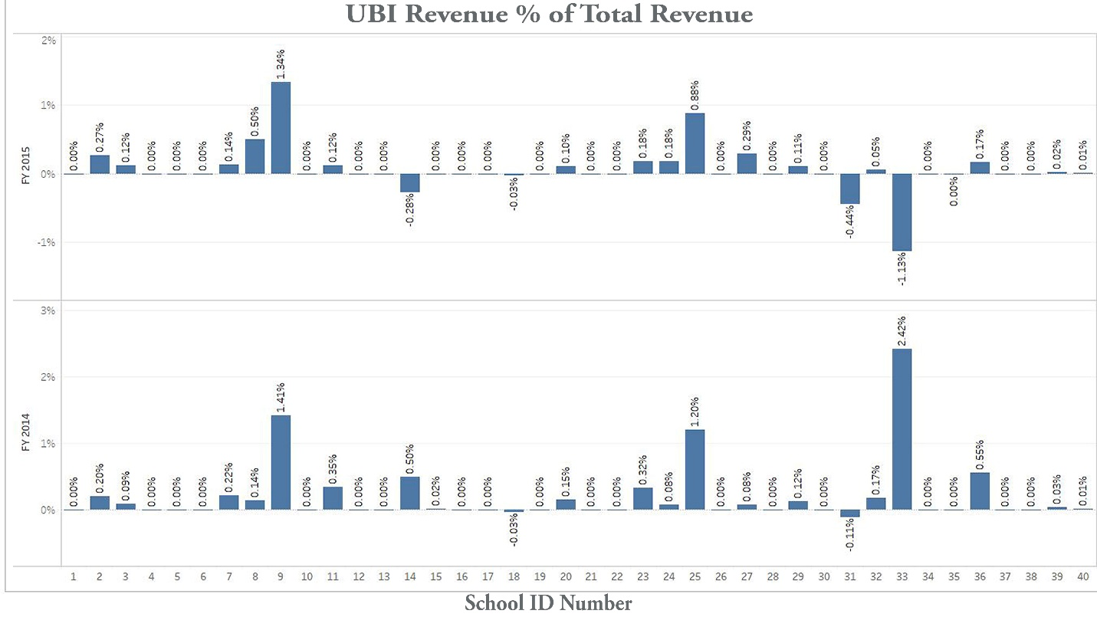
Each individual school’s ratio is important to look at because as the school’s ratio gets larger, they are engaging in more unrelated business activities. Thus, they are increasingly likely to have a higher liability to pay UBIT and to engage in mission drift. However, schools that have a very low ratio and report zero unrelated business revenues could be misclassifying UBI activities as related activities that are exempt from income taxes. Overall, all schools in this sample reported unrelated business revenues that compromised less than 3% of their total revenues.
6.2 Income Findings
Unrelated business income is the basis used for computing the tax an institution will owe, so it is vital that institutions correctly report their UBI. From the data collected, out of forty institutions, 65% and 52.5% of schools reported zero UBI in FY 2014 and FY 2015 respectively. The average UBI for FY 2014 was -$15,141.58 and 15% schools reported less than the sample average. UBI for FY 2015 declined to -$23,1536.3 and 12.5% schools reported less than the sample average. Both years had an average that was a loss. There were five schools which reported zero UBI in FY 2014, but then did report UBI in FY 2015. Coincidentally, all five of these schools reported a loss in FY 2015. Two of the five schools saw a decrease in enrollment from FY 2014-15. By this data it shows that because of the dropping enrollment, they decided to start up other ways to generate revenues, however these turned out to be unprofitable and even resulted in a loss. Three of the five schools saw an increase in enrollment from FY 2014-15. This raises a red flag because enrollment increased so they did not have a need to engage in UBI activities. In addition, Under Code section 172(b), an organization generally may carry an NOL back up to 2 tax years or forward up to 20 tax years. This means that the net income loss these schools reported could go back two years to offset any tax that they may have paid in a prior year, or the loss could be carried forward for twenty years to offset any future UBIT. This is one motive for schools to report an UBI loss. As seen in the IRS audit in 2013, majority of the misreporting was from schools claiming losses from activities that did not qualify as a "trade or business" because the institutions failed to show a profit intention for the activities.
The average ratio between non-taxable income and total income for FY 2014 was 0.012178 and 85% of schools had a ratio between non-taxable income and total income that was below this average. For FY 2015 the average was -0.03354 and only 12.5% schools were below sample average. Each individual school’s ratio of between non-taxable income and total income is shown in Chart 6.2 UBI as a percent of total income. As shown in the graph twenty-six schools in FY 2014 reported zero UBI and twenty-one schools in FY 2015 because of this, their ratio between total income and UBI would be zero.
Chart 6.2 UBI as a percent of total income. 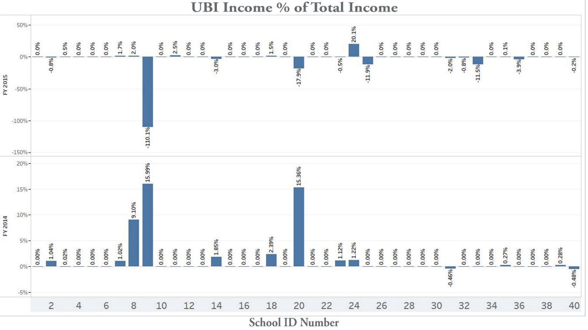
Schools ID number nine had the largest ratio of UBI to total income in this sample. What is interesting is that they reported that UBI made up 15.99% of their total income and 2014 and this increased to UBI contributing to over 100% of their total income loss. This substantial increase was due to them reporting total income of -$10,427,710 in FY 2014 and net UBI of -$1,667,216. While in FY 2015 they reported net income became $1,479,661 and UBI decreased to -$1,629,030. In addition, their revenue also increased from FY 2014-15. However, it is surprising that they reported such a large total income gain from FY 2014-15 when their enrollment dropped by 145 students. This shows that tuition and fees did not cause the extra revenues and profits, and they must have been engaging in other activities to make up for the drop-in enrollment. These other activities could have been profitable UBI activities, yet they reported a large UBI loss in FY 2015.
6.3 Tuition Findings
Schools which have a higher tuition percent of total revenue are more dependent on student enrollment. These tuition dependent schools are more likely to try to find other ways to compensate for the drop-in revenue and often end up engaging in UBI activities. Larger institutions can absorb the cost of the drop-in enrollment because they receive more endowments than smaller schools. Schools with low endowments are like a person who lives paycheck to paycheck without a savings account.
For FY 2014, on average, revenue from tuition and fees compromised 63.96% of the sample of school’s total revenues, while in FY 2015 that increased to 66.68%. This means that approximately 40% of their revenue stream is coming from sources other than tuition and fees, yet the percentage of unrelated business revenues only compromises between 0.198% 0.0648% of their total revenue. So where is the rest of the revenue coming from? Revenue could be coming from other exempt sources; such as endowments, room and board, and fundraising events. School’s individual tuition as a percent of revenue is shown on chart 6.3 Tuition revenue percent of total revenue.
Chart 6.3 Tuition revenue percent of total revenue. 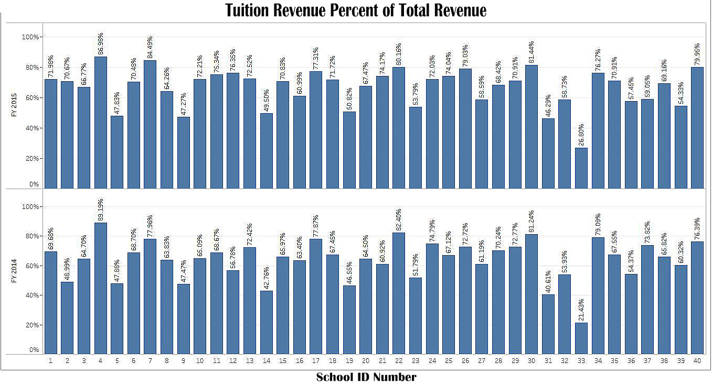
Majority of the schools in the sample are very dependent on tuition as their main revenue stream. School ID number four is the most dependent out of all the schools in this sample, having tuition revenue of 89.19% of total revenue for FY 2014 and 86.98% of total revenue for FY 2015. This institution would be the most likely to engage in UBI activities however, they reported zero UBI in FY 2015 and 2014.
7.0 Results
As the school’s ratio of unrelated business revenue to total revenue and ratio between UBI and total income gets larger, they are increasingly likely to have a higher UBIT liability. In addition, those schools are more likely to engage in mission drift and are at a greater risk of losing their exempt status. However, the sample average of ratio of unrelated business revenue to total revenue and ratio between UBI to total income was low (less than 3% for revenue and less than 0.6% for income). This indicates that the schools could be misclassifying UBI activities as related activities that are exempt from income taxes and could be misallocating expenses from related activities to unrelated business activities.
Additionally, many schools reported zero unrelated business revenues and even more reported zero UBI. In particular, twenty-three school’s reported unrelated business revenues, yet only fourteen schools in FY 2014 and nineteen schools in FY 2015 reported UBI. This shows that somehow nine schools generated unrelated business revenues in FY 2014 yet reported UBI of zero. And in FY 2015 four out of the twenty-three schools which reported unrelated revenues reported UBI of zero. Since the schools are generating revenues from their unrelated business activities it is questionable why many of them (relative to the sample size) reported zero UBI. This reinforces the argument that misreporting is still prevalent in the private nonprofit higher education sector.
Further evidence was found during the data collection. School ID number sixteen’s data from fiscal year 2015 and 2014 was inaccurate because the prior year data that they reported was exactly the same to the penny for both years, as shown in figure 7.1 and 7.2.

Figure 7.1 ID# 16’s FY2014 page 1 of 990 form
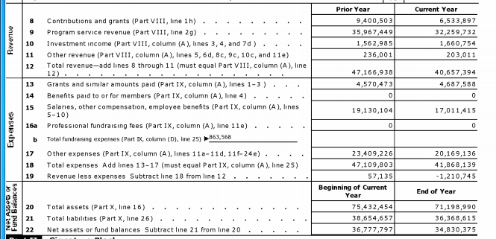
Figure 7.2 ID# 16’s FY2015 page 1 of 990 form
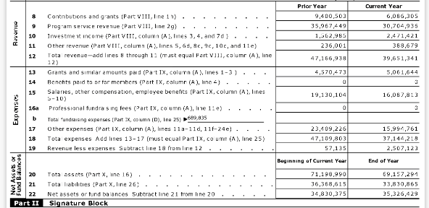
The current year’s data was used in the sample for both fiscal years for all the sample colleges. However, the prior year data was looked at to confirm the correct figures were recorded. In doing some research it was apparent that this school was going through financial troubles and had a president change in FY 2015, the year the mistake was made. This shows that other data could not be valid and that the 990 forms are generally not reliable or accurate. This also proves that there is inaccurate reporting and errors being made by institutions. These mistakes are not being found by the IRS. Additionally, institutions are not held accountable for errors in their financial reports.
8.0 Conclusion
This sample suggests that there is still misreporting of UBI and indicates that reporting problems are widespread. Generally, schools who misstate UBI fall into 1 of 4 categories: First, they truly don’t have unrelated business income, second, they didn’t classify UBI properly, third, they don’t know how to report it properly, and lastly, they misreport on purpose to avoid UBIT. It is outside the scope of this project which combination of these factors may be occurring here, but it warrants future examination. Nonetheless, to decrease the amount of misreporting the IRS should make more frequent audits of the 990 forms, hold institutions accountable for any misreporting, and issue more guidance for institutions including manuals and training sessions.

9.0 References
A. (2017, November 9). Tax-Exempt Status of Universities and Colleges. Retrieved from https://www.aau.edu/key-issues/tax-exempt-status-universities-and-colleges
Bradach, W. F. (2014, August 01). Should Nonprofits Seek Profits? Retrieved from https://hbr.org/2005/02/should-nonprofits-seek-profits
Dezhao, C. (n.d.). The "Decline" of U.S. Economy: A Historical Comparison. Retrieved from http://www.ciis.org.cn/english/2011-11/18/content_4635120.htm
I.R.C. § 61 (a).
I.R.C. § 115 (1).
I.R.C. § 172 (b).
I.R.C. § 501(c)(3).
I.R.C § 513 (a).
IRS Releases Final Report On Tax-Exempt Colleges And Universities Compliance Project. (2013, May 13). Mondaq Business Briefing. Retrieved from http://bi.galegroup.com/essentials/article/GALE%7CA329603781/29b7a7ed32dc43a375f02152201c3699?u=mlin_n_state
Jaeger, J. (2013, July). Avoiding a tax probe in the higher-education sector. Compliance Week, 10(114), 24+. Retrieved from http://link.galegroup.com/apps/doc/A342770639/PPBE?u=mlin_n_state&sid=PPBE&xid=235ed319
Jeter, T. M. (2017). Exploring mission drift and tension in a nonprofit work integration social enterprise (Order No. 10259898). Available from ProQuest Dissertations & Theses A&I. (1876934973). Retrieved from https://corvette.salemstate.edu:5208/docview/1876934973?accountid=13661
Kennedy, Casey, and Leonard Weld. "Not-for-profit organizations and UBTI: even minor differences can impact whether an activity generates unrelated business taxable income for a tax-exempt organization." Strategic Finance, Apr. 2016, p. 15+. Business Collection, http://link.galegroup.com/apps/doc/A459634947/ITBC?u=mlin_n_state&sid=ITBC&xid=333ebd82. Accessed 23 Apr. 2018.
Mcardle, J. F., & Chene, D. G. (2017). Entrepreneurial activity of small colleges and universities: UBIT liability issues. Journal of Taxation, 127(6), 256-265. Retrieved from https://search.proquest.com/docview/1973321513?accountid=13661
Meloy, A. (2013). Legal Watch: Can You Take a Call from the IRS?: Making Sure You're Complying with Unrelated Business Income Rules. Presidency, 1-3
Romer, J. D. (1989, January). UBIT: What's next? Fund Raising Management, 19(11), 42+. Retrieved from http://bi.galegroup.com/essentials/article/GALE%7CA7056436/037d5882ae8e90411a9e01ab95cbeb9d?u=mlin_n_state
Sweetser, F. L., & Piepponen, P. (1967). POSTWAR FERTILITY TRENDS AND THEIR CONSEQUENCES IN FINLAND AND THE UNITED STATES. Journal of Social History, 1(2), 101-118. Retrieved from https://corvette.salemstate.edu:5208/docview/60077154?accountid=13661
U.S. Department of the Treasury. Internal Revenue Service. (2016). Publication 598: Tax on Unrelated Business Income of Exempt Organizations (Cat. No. 46598X). Retrieved from https://www.irs.gov/pub/irs-pdf/p598.pdf.

I.R.C. § 61 (a).
I.R.C. § 115 (1).
I.R.C. § 501(c)(3).
A. (2017, November 9). Tax-Exempt Status of Universities and Colleges. Retrieved from https://www.aau.edu/key-issues/tax-exempt-status-universities-and-colleges
I.R.C § 513 (a).
Kennedy, Casey, and Leonard Weld. "Not-for-profit organizations and UBTI: even minor differences can impact whether an activity generates unrelated business taxable income for a tax-exempt organization." Strategic Finance, Apr. 2016, p. 15+. Business Collection, http://link.galegroup.com/apps/doc/A459634947/ITBC?u=mlin_n_state&sid=ITBC&xid=333ebd82. Accessed 23 Apr. 2018.
Mcardle, J. F., & Chene, D. G. (2017). Entrepreneurial activity of small colleges and universities: UBIT liability issues. Journal of Taxation, 127(6), 256-265. Retrieved from https://search.proquest.com/docview/1973321513?accountid=13661
Meloy, A. (2013). Legal Watch: Can You Take a Call from the IRS?: Making Sure You're Complying with Unrelated Business Income Rules. Presidency, 1-3
IRS Releases Final Report On Tax-Exempt Colleges And Universities Compliance Project. (2013, May 13). Mondaq Business Briefing. Retrieved from http://bi.galegroup.com/essentials/article/GALE%7CA329603781/29b7a7ed32dc43a375f02152201c3699?u=mlin_n_state
U.S. Department of the Treasury. Internal Revenue Service. (2016). Publication 598: Tax on Unrelated Business Income of Exempt Organizations (Cat. No. 46598X). Retrieved from https://www.irs.gov/pub/irs-pdf/p598.pdf.
Mcardle, J. F., & Chene, D. G. (2017). Entrepreneurial activity of small colleges and universities: UBIT liability issues. Journal of Taxation, 127(6), 256-265. Retrieved from https://search.proquest.com/docview/1973321513?accountid=13661
Sweetser, F. L., & Piepponen, P. (1967). POSTWAR FERTILITY TRENDS AND THEIR CONSEQUENCES IN FINLAND AND THE UNITED STATES. Journal of Social History, 1(2), 101-118. Retrieved from https://corvette.salemstate.edu:5208/docview/60077154?accountid=13661
Mcardle, J. F., & Chene, D. G. (2017). Entrepreneurial activity of small colleges and universities: UBIT liability issues. Journal of Taxation, 127(6), 256-265. Retrieved from https://search.proquest.com/docview/1973321513?accountid=13661
Bradach, W. F. (2014, August 01). Should Nonprofits Seek Profits? Retrieved from https://hbr.org/2005/02/should-nonprofits-seek-profits
Dezhao, C. (n.d.). The "Decline" of U.S. Economy: A Historical Comparison. Retrieved from http://www.ciis.org.cn/english/2011-11/18/content_4635120.htm
Mcardle, J. F., & Chene, D. G. (2017). Entrepreneurial activity of small colleges and universities: UBIT liability issues. Journal of Taxation, 127(6), 256-265. Retrieved from https://search.proquest.com/docview/1973321513?accountid=13661
Romer, J. D. (1989, January). UBIT: What's next? Fund Raising Management, 19(11), 42+. Retrieved from http://bi.galegroup.com/essentials/article/GALE%7CA7056436/037d5882ae8e90411a9e01ab95cbeb9d?u=mlin_n_state
Jeter, T. M. (2017). Exploring mission drift and tension in a nonprofit work integration social enterprise (Order No. 10259898). Available from ProQuest Dissertations & Theses A&I. (1876934973). Retrieved from https://corvette.salemstate.edu:5208/docview/1876934973?accountid=13661
Kennedy, Casey, and Leonard Weld. "Not-for-profit organizations and UBTI: even minor differences can impact whether an activity generates unrelated business taxable income for a tax-exempt organization." Strategic Finance, Apr. 2016, p. 15+. Business Collection, http://link.galegroup.com/apps/doc/A459634947/ITBC?u=mlin_n_state&sid=ITBC&xid=333ebd82. Accessed 23 Apr. 2018.
IRS Releases Final Report On Tax-Exempt Colleges And Universities Compliance Project. (2013, May 13). Mondaq Business Briefing. Retrieved from http://bi.galegroup.com/essentials/article/GALE%7CA329603781/29b7a7ed32dc43a375f02152201c3699?u=mlin_n_state
Jaeger, J. (2013, July). Avoiding a tax probe in the higher-education sector. Compliance Week, 10(114), 24+. Retrieved from http://link.galegroup.com/apps/doc/A342770639/PPBE?u=mlin_n_state&sid=PPBE&xid=235ed319
http://carnegieclassifications.iu.edu/
All 990 form data was retrieved from guidstar.org
School ID number seventeen on the 990-part VIII Line 2a educational-programs-undergrad was reported, line 2b reported educational-programs-graduate. This was different from all the other universities who have tuition and fees from both graduate and undergraduate programs consolidated on line 2a. To get school ID number seventeen’s total tuition and fees, lines 2a and 2b were added together.
Enrollment data was retrieved from https://nces.ed.gov/ipeds/
I.R.C. § 172 (b).
IRS Releases Final Report On Tax-Exempt Colleges And Universities Compliance Project. (2013, May 13). Mondaq Business Briefing. Retrieved from http://bi.galegroup.com/essentials/article/GALE%7CA329603781/29b7a7ed32dc43a375f02152201c3699?u=mlin_n_state
Images of the 990 forms was retrieved from Guidstar.org

