WHAT IS THIS THING CALLED HAPPINESS?
AN INTEGRATIVE ASSESSMENT OF HAPPINESS ACROSS
SEVERAL DEMOGRAPHIC VARIABLES

Honors Thesis

Presented in Partial Fulfillment of the Requirements

For the Degree of Bachelor of Psychology

In the College of Arts and Sciences
at Salem State University

By
Rachel M. Kaplan

Dr. Joanna Gonsalves
Faculty Advisor
Department of Psychology

Dr. M. J. Mulnix
Faculty Advisor
Department of Philosophy

***
Salem State University
2016

Abstract

The purpose of this study is to qualitatively examine attitudes about the meaning of happiness across several demographics. The primary goal is to better understand the ways in which individuals define happiness in their own words and whether these definitions fit within the three major philosophical categories of happiness (hedonism, satisfactionism, and eudaimonism). The secondary goal of this research study is to discover any significant correlations between definitions of happiness and demographic information provided by participants (i.e., age range, gender, and level of education). It was hypothesized that there would be different associations between demographic data and philosophical view of happiness. The study was conducted using a SurveyMonkey questionnaire with a link that was distributed via email. Participants (N = 93) were asked to respond to both multiple choice and open-ended questions. Open-ended responses were then coded into either one of the three philosophical categories for happiness or an ‘other’ category. Quantitative descriptive statistical analysis reinforces the findings of earlier studies in which concepts of happiness change with age range (Mogilner, Kamvar, & Aaker, 2010). This study also found a connection between level of religiosity/spirituality and differences in happiness views in terms of concept and meaning. Qualitative analysis supported recent findings by Fave et al. (2016), in which family, friends, and love were important features of happiness. This study also found that the components of family, friends, and love were important across all three philosophical views of happiness (hedonistic, satisfactionistic, and eudaimonistic).
Keywords: happiness, hedonism, satisfactionism, eudaimonism, qualitative analysis

Acknowledgements
This work would not be what it is (and in some cases not even possible) without the assistance and insights of several individuals.
Thank you to Joanna Gonsalves, for being flexible in allowing me to explore the subject matter via the integration of philosophical and qualitative methods. Thank you also for your enthusiasm and curiosity.
Thank you to M. J. Mulnix for relevant reading recommendations, clarifications on a complex topic, and for helping in the research process via careful coding and useful comments. Your contributions despite a busy schedule of your own are appreciated, as is your willingness to always listen to ideas and share thoughts.
Thank you to Mark A. A. Harrison, my fiancé, for your suggestions and assistance with the research process, as well as your effort put forth in obtaining participants. Your patience and energy were and always will be invaluable to me.
Thank you to Professor Marcia Weinstein for your initial reactions and subsequent help regarding the qualitative aspects of my project. Thank you also for sharing an excellent reading list with me.
Thank you to my future in-laws, Colin and Lynn Harrison, for your excitement, participation, and assistance with finding participants for this project, as well as for your unwavering support.
Thanks and appreciation goes out to the participants of the study, who were both eager and considerate in their responses.

Table of Contents
Introduction.…………………………………………………………………………. 5 – 17
Literature Review……………………………………………………………. 5 – 11
Present Study……………………………………………………………....... 11 – 14
Enter Philosophy……………………………………………………………. 14 – 17
Methods……………………………………………………………………………... 17 – 20
Participants………………………………………………………………….. 17 – 19
Materials…………………………………………………………………….. 19
Coding Procedure…………………………………………………………… 20
Analysis……………………………………………………………………………... 20 – 22
Results and Discussion……………………………………………………………… 22 – 32
Quantitative Discussion…………………………………………………….. 22 – 26
Qualitative Discussion……………………………………………………… 26 – 31
Further and Future Research………………………………………………... 31 – 33
Conclusion………………………………………………………………………….. 33
References…………………………………………………………………………... 34 – 36
Figures………………………………………………………………………………. 37 – 53
Methods Figures…………………………………………………………….. 37 – 40
Results and Discussion Figures……………………………………………... 41 – 53
Appendices…………………………………………………………………………... 54 – 60
Appendix A: Materials………………………………………………………. 54 – 59
Appendix B: Instructions for Coders.……………………………………….. 60

What Is This Thing Called Happiness?
An Integrative Assessment of Happiness Across Several Demographic Variables
Since the first reflections of happiness as a phenomenon, thinkers from numerous disciplines have questioned its meaning, cause, and attainability. However, not until fairly recently has happiness been so popular a topic that it has begun to be analyzed by the social sciences. Scholars design studies to measure happiness and its practical applications. Policy makers, social economists, and other professionals might utilize academic findings for the benefit of small and large-scale society. Legislators and public health officials can use happiness studies in an effort to recognize the concrete and intangible contributors to happiness and how those factors can possibly improve the livelihood of citizens (Mohanty, 2014). The United Arab Emirates, for example, appointed a “minister of happiness” in early February of 2016 (McKenzie, 2016). According to Sheikh Mohammed bin Rashid Al Maktoum (ruler of Dubai and prime minister of the United Arab Emirates), the position was created to “align and drive government policy to create social good and satisfaction” (McKenzie, 2016). In the 1970s, the Bhutanese king Jigme Singye Wangchuck developed a political movement called Gross National Happiness (GNH), which measured happiness with the level of importance that western countries measured gross domestic products (Centre for Bhutan Studies & GNH Research, 2016). As of 2015, the GNH Index still surveys the citizens of Bhutan and considers the results to be an invaluable measure of national achievement (Centre for Bhutan Studies & GNH Research, 2016). Happiness has become the hottest metric for appraising success (both individually and societally) and the field of psychology has been a leader in the production and assessment of empirical studies related to happiness.
The descendent of philosophy and hard science, psychology produces a unique perspective on happiness. Psychologists aim to investigate the complexities of the human experience – a venture well known to philosophers – but via the scientific method and statistical analysis. Psychological studies attempt to quantify the concept of happiness in terms of numerical scales, as well as on the individual, group, and global level. Inquiries of correlation are a frequently used method with questions such as: to what is happiness linked? Are some more likely to be happy than others? What characteristics are aligned with happiness or a lack thereof? A common question asked of participants is “are you happy?” Many times, this question is measured against variables such as weather, unemployment, age, stress, or income, to name a few (Connolly, 2013; Mikucka, 2014; Mohanty, 2014; Schiffrin et al., 2008). These studies are often designed using self-report, survey approaches to assess the variables and often the reports are Likert style (numerically ranking a labeled spectrum of the variable). Participants must reflect on their lives and themselves when answering each question and so the survey must strategically account for internal and external factors that may influence responses. These responses may lead to inaccurate representations and may skew results. For example, survey questions should take into consideration and/or attempt to control for the current experiences of the participant (i.e. she got into a car accident earlier that day) so that the answers are not derived from emotional or hasty responses to the questions and are instead more reflective of the participant’s established beliefs. If the survey does not counteract skewed answers due to recent or current experiences and feelings, then the results may be affected by a bad mood. This is especially so when the participant recognizes happiness as a state of mind and may be even more problematic for the researcher if the operational definition of happiness geared toward a definition of overall life satisfaction. As such, these considerations are also dependent on the researchers’ understanding(s) of happiness as a concept. For instance, if they are measuring happiness in terms of life satisfaction and/or pleasure principles, then the questions will be designed relative to those respective notions of the concept. Astute researchers will have included questions to control for varying meanings of happiness and have a clear sense of what they mean by the word. Hence, it is imperative that researchers clarify what is meant by the key terms of a study, in this case happiness.
Indeed, operational definitions are foundational for reliable psychological research, especially when that research regards semantics and the use of everyday words. Unfortunately, the operational definitions between different happiness studies can vary substantially, making it difficult to directly compare effects and relationships. An example of this may be observed in cross-cultural studies, especially when eastern values (i.e. collectivistic outlooks) are compared with those of the west (i.e. individualistic outlooks), and when the same concepts (usually western) are applied to both (Liao, 2014; Lim, 2008). A 2015 study conducted by Ford et al. found that in addition to conceptual understanding of happiness, the ‘pursuit of happiness’ (i.e. the manner in which one tries to obtain it) is also formed by an individual’s respective culture. In addition, the study discovered a negative correlation between the search for happiness and the wellbeing of the participant, and this finding was most prominent for participants from Western regions (i.e. North America, Europe, parts of South America) (Ford et al., 2015). The Ford et al. (2015) results are unsurprising when considered critically, because the understanding of a concept such as happiness will be connected to the process by which an individual tries to possess it. In individualistic cultures (i.e. western regions), happiness is often equated with the individual’s experience (sometimes measured in conjunction with success) and so the method for becoming happy likely revolves around the individual’s personal actions and experiences. On the contrary, collectivistic cultures (i.e. eastern regions) relate happiness to a shared experience and the process of becoming happy involves something greater than the single individual. The collectivistic person sees herself as a part of a greater whole (i.e. a family, a community) and working with such a mindset allows the pursuit of happiness to be a collective endeavor, as opposed to something independent. With this in mind, the failure to succeed in pursuing happiness (whatever that may be for the person) is perhaps a solo burden for the fervent individualistic seeker of happiness (Ford et al., 2015). Indeed, a 2011 study found that too much importance placed on possessing happiness can lead to counter-effects, in which one is less happy (Mauss, Tamir, Anderson, & Savino 2011).
As can be seen, definitions of happiness may differ, and so several scales have been created to measure happiness as a subjective and/or universal experience (O’Connor, Crawford, & Holder, 2014; Parackal, 2015). Studies have been conducted regarding the validity of such scales, which in itself is not uncommon, but further reveals the complexity of trying to quantify something that is often discussed qualitatively in the general public and which has numerous meanings for different individuals (Liao, 2014; Lim, 2008; O’Connor et al., 2014; Parackal, 2015). For instance, Parackal (2015) examined the global happiness scale to determine how well it resisted answers that steered results towards hedonism. Since the global happiness scale is designed to measure wellbeing, Parackal’s goal was to ensure that the scale accounted for participants who answered according to hedonistic values or pleasure states. Parackal’s results showed that the scale controlled for such answers satisfactorily (2015), but this assumes that happiness and wellbeing are one and the same.
Despite the popularity of happiness in the mass media and academic avenues, few quantitative studies address the nature or definition of happiness in relation to the individual participant’s understanding of the word. This is an issue because happiness is considered to be an everyday term that is often considered experientially subjective and thus is often contingent on each participant’s understanding of the idea. As such, it may be beneficial to include a focus on research that (1) is qualitative (at least in part), and (2) extends attention to the concept of happiness as it is used or understood by the people (as opposed to whether or not it has been obtained or is valued by the people).
There are several studies on the scene that have begun to look at happiness through a more philosophical and more qualitative scope. One study looked at Filipino adolescents and their understanding of happiness as a frequently used concept (Datu & Valdez, 2012). Based on their qualitative results, the authors of the study concluded that happiness is a complex, versatile idea and it is comprised of positive themes such as satisfaction of wants, absence of worries, expression of positive emotions, motivational drive, and fulfillment of relational needs (Datu & Valdez, 2012). While these results are compelling and indicative of the intricacy that is happiness, the study itself had a sample size of only 10 teenagers. Although this makes for more in-depth qualitative analysis, the sample size limits the generalizability of the study results. Further, the study’s focus was on adolescents (ranging from 16-20 years of age), which may affect results due to the large gap in neuropsychological development between 16 (mid adolescence) and 20 (late adolescence) years of age. Further, studies on adolescents may not be generalizable to other ages due to differences in psychological development and life experience of older participants (i.e. beyond general college age). Known as the sophomore problem, this possible issue with external validity demonstrates the need for more studies that are representative of the public (Cooper, Mccord, & Socha, 2010). When dealing with a concept such as happiness, it is crucial to keep age in mind. There is growing evidence to support the assertion that concepts of terms such as happiness and values affiliated with such terms are influenced by an individual’s age and life experiences (Mogilner, Kamvar, & Aaker, 2010). For example, the way a person thinks about happiness in her early twenties is likely to be different from how she thinks about it in her mid fifties. For this reason, the present study endeavored to procure participants from numerous age ranges and from demographics outside of the traditional undergraduate milieu.
A study in the Journal of Social Psychology used the qualitative approach to assess the origins of happiness (Lu & Shih, 1997). The study was conducted in Taiwan and compared qualitative data from Chinese participants with the results of western participants (Lu & Shih, 1997). Lu and Shih’s results reflect the cultural differences that similar studies have found (Ford et al., 2015; Liao, 2014; Lim, 2008). That is, western participants prized “intrapersonal or internal evaluation and contentment” and eastern participants valued “interpersonal or external evaluation and satisfaction” when asked about happiness and what makes an individual happy (Lu & Shih, 1997). Lu and Shih (1997) comment on the recent development of the word happiness in the Chinese culture and within the lexicon of Chinese dialects, noting that the western idea of happiness often biases the studies about happiness in terms of design and result interpretation.
Lu and Shih (1997), Datu and Valdez (2012), and Ford et al. (2015), as well as thematically comparable studies, are reminders. Researchers must be aware of cultural and/or generational biases when examining complex concepts, such as happiness, that appear to be simultaneously universal and conditional. Hence, the present study will be a snapshot of outlooks about happiness in a particular place and time. Revealed observations and results will not necessarily be applicable to some demographics, but this is one of the reasons for using qualitative data – looking closer into the beliefs of a select group of humans. Perhaps a snapshot does not disclose of trends over time and it may not appear to be instantly pertinent to policy makers and economists, but small steps may lead to unforeseen discoveries. As more medical and public health officials look to individualized medicine, qualitative data may assist with individualized mental health as it tackles problems related to happiness and well being. Perhaps a better understanding of one’s own conception of happiness will have positive outcomes for the individual.
The Present Study

The purpose of the present study was to examine happiness within a slightly different sphere by using qualitative methods and a philosophical perspective and integrating these into the standard, quantitative approach. Numerous attempts have been made to better understand happiness by using a multitude of media. However, the focus is often about whether or not happiness has been attained by participants. Further, levels of happiness are gauged by whether or not the participants responded in a statistically significant manner. The operational definition of happiness is most often predetermined by the researchers and may differ from the participant’s understanding and use of the word.
On the contrary, this study proposes that we look at what we mean when we say “happiness” and in doing so the findings may bring further discourse and a better understanding of how we may then attain happiness. The primary goal is to better understand the ways in which individuals define happiness, in their own words. Further, do these definitions fit within the three major philosophical categories of happiness (hedonism, satisfactionism, and eudaemonism, to be defined later in this paper)? Or, is there yet another component to happiness that has remained overlooked until now? Hence, this project intends to ask not “Are you happy?” but rather, “What is happiness to you?”
A secondary aspect of this research study follows a more traditional quantitative approach. This secondary goal is to discover any significant correlational effects between definitions of happiness (via word frequencies) and the demographic information provided by participants. What observations may emerge as a result of analyzing these two components alongside one another? For example, is there a relation between religious affiliation and definition of happiness? What about with variables such as age and gender? If demographic identity (i.e. culture, age, etc.) is correlated with level of happiness, it follows that the understanding of the word itself would also be influenced by such personal factors (Connolly, 2013; Mikucka, 2014; Mogilner et al., 2010; Mohanty, 2014; Schiffrin et al., 2008).
The importance of qualitative methods. Quantitative methods are unarguably useful and reliable in psychological research. However, when used as the sole mode of inquiry they provide an incomplete view of both the subject of study and the participants. Quantitative methods are limiting because they obscure a part of the greater picture that is human complexity. As Gergen, Josselson, and Freeman (2015) note, “the qualitative movement enriches the discipline as a whole through the special ways in which it inspires new ranges of theory, fosters minority inclusion, and invites interdisciplinary collaboration… qualitative work enhances communication with the society and the world.” By including qualitative methods, the present study endeavors to look at the words we use when we talk about happiness, perhaps scraping away at previously unknown or unexamined aspects of the concept.
A recent article in the International Journal of Wellbeing (Thin, 2012) explored the conflict and cooperation between science and narrative in relation to happiness. Recognizing that a kind of quantification (i.e. to count one’s blessings, to count one’s sorrows) can be found in the way that individuals understand their personal stories, Thin (2012) has designed a “happiness lens” for researchers. This “happiness lens” allows happiness scholars to address qualitative inquiries, which are essential to the study of happiness (Thin, 2012). Experimental design ought to be empathetic (i.e. demonstrating attentiveness to the subjective feelings of participants) and benefits from accounting for the many (sometimes diverse) spheres and occurrences of an individual’s life and identity. Referencing Julia Annas’ 2004 paper, “Happiness as achievement,” Thin (2012) underscores the importance of acknowledging participants via qualitative methods, especially discarding the Likert-style surveys. He notes,
Happiness scholarship has largely come to public attention via survey findings… surely the least empathetic, most reductionist, and most decontextualizing and temporally blind of social research methods. Scientific detachment is required of the surveyor, while the respondents are required to meekly answer the restrictive questions, which either show no interest in the content of their happiness, or do so in a piecemeal fashion with no attention to narrative happiness. Respectful of the first-person perspective to the point of naivety, the happiness quantifier is interested in whether your glass is half full but refuses to listen to your stories about what’s in the glass and how it got there. [Such methods result in] reducing happiness to a thing-like, countable entity that seems systematically comparable across time and space (Thin, 2012, p. 326)

The world is socially, professionally, and economically connected; there is a narrowing of cultural and geographical differences, in which networks span beyond one’s backyard and around the globe. This stenosis has connected fields of specialization, ironically expanding the web of knowledge. Similarly, Academia has become less domain-restrictive and more interdisciplinary. Answers to age-old questions are becoming less binary; for instance, the nature-nurture debate has mainly resulted in the epigenetic idea that nurture affects nature (Moore & Nesterak, 2015). That is, it takes both sides to make an individual whole. Qualitative and quantitative processes – like nature and nurture – ought to be employed in tandem to construct a more expansive representation of humankind. Many thinkers have endeavored to better understand happiness – one of the most pursued ideas in human history – and the addition of a qualitative perspective can only enhance the full range of happiness as a concept.
Enter Philosophy

Happiness has been considered philosophically for millennia. It has been contemplated by thinkers all throughout the Hellenistic period, during the theological Middle Ages, into the modern era of the Enlightenment, the 19th and 20th centuries, and up to the present day. In his Nicomachean Ethics, Aristotle asserts, “happiness is a perfect thing” (Bk VII.13), but what is this ‘thing’? As Socratic method demonstrates, it is difficult to move forward with the exploration of an abstract thing when one has yet to understand what, exactly, it is or means (if there is such a distinctive definition, of course). Inquiries into happiness will likely lead to more questions about the nature of this very multi-faceted idea. The concept’s semantic fluidity, so to speak, derives several possible descriptions, each one philosophically legitimate. Three major categories arise amid these many delineations, (1) Hedonism, (2) Satisfactionism, and (3) Eudaimonism.
The purpose for including a philosophical perspective in the present study is twofold, involving the historical duration of philosophy and the qualitative aspects of it. As noted, philosophy is a primary discipline that spans millennia. In particular, the philosophical examination of happiness predates the dominant fields and manners of inquiry that currently assess the concept. To clarify, philosophy has endured to ask better questions so that better answers may be uncovered. Philosophical modes of assessment also emphasize critical skills that seek to explore complex truths, recognizing the ambiguities that sometimes arise with such topics of interest. Hence, the nature of philosophical inquiry is well suited as a partner of qualitative methodology as the two techniques pursue the motivations involved with concepts, such as happiness.
Further, philosophers have become adept at categorizing such a multifaceted concept as happiness. The three broad, philosophical categories (i.e. hedonism, satisfactionism, and eudaimonism) can be applied to the present participant responses for greater insight into the data. This is especially so since the philosophical categories correspond well with psychological groups for happiness. For example, some individuals believe happiness is a feeling whereas others think it is an attitude (Mulnix & Mulnix, 2015; Schiffrin et al., 2008). As a feeling, happiness would be something felt ‘in the moment’. As an attitude, happiness might resemble a trait that one possessed from birth or that one developed from experiences, depending on the assessment. Therefore, a philosophical approach can only enhance the present methodology.
Part one: Happiness as pleasure – Hedonism. When happiness is defined or understood as a concept requiring pleasure it is categorized as hedonistic. Pleasures are not limited to the activities associated with sin, such as gluttony, lust, and sloth, for example. There are more sophisticated pleasures that tickle the intellect and bring about nice feelings. A defining characteristic of the hedonistic conception of happiness is not the type of pleasure, but rather that it is a temporary experience. Happiness as pleasure is episodic and involves positive or negative feelings, moods, emotions, and transient desires (Mulnix & Mulnix, 2015a). In a 2008 psychological study, authors Schiffrin, Rezendes, & Nelson observed, “people use current mood as information when making global assessments of their level of happiness” (p.37). This may indicate that many individuals see happiness (either consciously or unconsciously) as a state of being. When used colloquially and as an adjective (i.e. “I’m so happy to hear that!”), the term often suggests a mood and/or feeling. An issue with hedonistic happiness and its fleeting nature is that it does not account for the significance of one’s life as a whole (or, ‘up until now’), which may actually contribute to one’s happiness (Mulnix & Mulnix, 2015a).
Part two: Happiness as satisfaction – Satisfactionism. This category addresses happiness in a way that does integrate the total life of the individual with the concept. Instead of happiness as an emotional response to experiences, satisfactionism is stable and involves attitudes about one’s life as a whole. It is subjective appraisals of life goals and desires and whether or not those have been met. Happiness as satisfaction means one is satisfied when things are ‘going my way’ and therefore, one is relatively happy. Because it relies on the individual’s personal goals and desires – what the individual wants out of life – satisfactionism ties happiness to identity (Mulnix and Mulnix, 2015a). The individual’s happiness is relative to the individual’s evaluations of the past, present, and future, both overall and specific to areas of life, called domain specific (i.e. job success, health, etc.). As such, satisfactionism is personal and is comprised of first-hand experiences.
Part three: Happiness as eudaimonia. The third category of happiness is also the most difficult to grasp because it is not as colloquial as hedonism and satisfactionism. Eudaimonia derives from the Ancient Greek philosophical tradition and is commonly translated to happiness. The Platonic version of this happiness requires the individual to act out of virtue (Mulnix & Mulnix, 2015a). The Aristotelian version also necessitates acting virtuous, but also places importance on developing the physical and mental bodies; happiness is about a process of greater purpose or meaning and working towards accomplishing the process (Mulnix & Mulnix, 2015a). Through this actualizing activity, the individual cultivates contentment and equanimity and so happiness is equated with wellbeing (Mulnix & Mulnix, 2015a). However, eudaimonism also requires extra-mental components; that is elements of reflection outside of the self (Mulnix & Mulnix, 2015a).
Methods
Participants
Although 171 individuals responded to the online questionnaire, only those who filled it out to ~90% or more completion (i.e. all but one or two questions were answered) and were from the Northeast of America were selected for analysis. The participants who fit these criteria were 93 adults (25 males, 66 females, and one individual who did not answer the question of gender) currently residing in the greater New England area. Participants chose the age range where best they fit, which were in six-year increments up to 87 years of age (see Figure 1). For ease of analysis, age ranges were then combined into 13-year spans with the exception for the ages ranging from 18-24. This is because individuals within the 18-24 age range are considered to be psychologically in late adolescence, called the emerging adulthood stage of life. Both 6 and 13-year spans were used in analysis. There were 25 participants (3 male, 22 female) who reported an age of 18-24; eight participants (2 male, 6 female) for ages 25-38; 18 participants (7 male, 11 female) for ages 39-52; 19 participants (5 male, 14 female) for ages 53-66; 23 participants for 67+ (9 male, 13 female, and one individual who did not answer the question of gender) (see Figure 2).
Participants were mainly garnered via three main electronic sources. One set of participants learned of the study through the SONA system, where they would receive 0.5 credits for participation. Another set of participants was solicited through the Commonwealth Honor’s Program student e-list. The final set of participants was obtained from the Cytometry department within a local biotechnology company, Cell Signaling Technology of Danvers, MA. In the latter two, the participants did not receive college credit. Two family members of the author requested to participate and were allowed to do so since they met the criteria and did not know the details of the hypotheses. After taking the survey, they were given permission by the author to share the survey link with friends and members of their church. All other participants for the study were individuals who received the shared link from any original participant (as well as a message from the author explaining the risks, benefits, and voluntary nature of the study) and volunteered to participate as well. All of the participants’ responses were collected anonymously and all participated voluntarily.
Overview of demographic data. The majority of participants had completed graduate studies (35.5%), were current college students (23.7%) or had completed a baccalaureate degree (17.2%) (see Figure 3). For participants who were not current college students, the dominating category of occupation was science related (21.5%), followed equally by administrative and business/management related fields (11.8%) and education (11.8%) (see Figure 4). The ‘retired’ group of participants comprised only those who responded with only “retired” as their category of occupation. Participants who responded that they were retired, but included information about their former career, were grouped within the category of occupation that corresponded most appropriately with their previous job description (i.e. “Sciences, retired” would be grouped within the sciences field).
As previously noted, the present study is a snapshot. As such, participants represent a geographical niche (i.e. New England) and a particular period in time (i.e. early March in 2016). Participants also tended to be educated, employed and/or a student, and moderately to very religious/spiritual (see Figures 5 & 6).
Materials
All responses were collected via the website, SurveyMonkey.com. The survey, titled “Looking Into Happiness,” was designed and compiled by the author (see Appendix A). It had 19 questions, including a disclosure statement and consent form on the first page. Participants had to confirm that they had read the disclosure statement and were aged 18 years or older. The disclosure statement contained information about the study’s IRB approval, as well as the contact information of the principal investigator and her faculty sponsor. Nine of the questions allowed the participants to type in their own answers via text boxes. The majority of these questions related to conceptions of happiness (i.e. meanings, examples, etc.). A few of these questions also asked about information such as a description of religious identity, the category of occupation or career specialization (e.g. management, retail, education, etc.), and whether or not the participant had ever been exposed to anything about the concept of happiness (i.e. formal course, book, film, etc.). All other questions allowed the participant to select a response according to answers from multiple-choice or drop-down menu formats. Along with gender and age, participants were also asked about aspects of lifestyle such as level of religiosity/spirituality, kind of religion (if applicable), major of specialization (if a college student), profession (if not a student), and level of education (if not a student). The question that asked participants about level of religiosity/ spirituality allowed participants to answer via a 5-point Likert scale that ranged from “Not at all” to “Extremely.” All questions that relied on non-text box answers allowed participants to pick “other” and type in a response. The last page of the survey thanked participants for their time and participation.
Coding Procedure and Criteria
The aforementioned three major categorizations of happiness, as well as one category of “Other,” were used to code the participant data. Coders (n=3) were college educated with experience in psychology, philosophy, or both fields. Besides the author of the present study, two other coders were retained. Coders were given an instruction sheet that defined the codes and directed the method of coding to ensure consistency (see Appendix B). The coder instruction sheet utilized information from Mulnix and Mulnix (2015a, 2015b) and Nettle (2005).
All of the codes were collected and entered into a spreadsheet that had a designated column for each coder, as well as a ‘final code’ column. For a code to be final, it had to either (a) have at least two coders in agreement or (b) be reevaluated and/or discussed amongst the coders. Due to time and schedule constraints, some of the discordant responses were not included in quantitative analysis since the coders could not meet to discuss. Interestingly, these particular responses tended to be represented by a completely different code from each coder (i.e. coder one gave it a 4, coder two gave it a 1, and coder three gave it a 2).
Analysis
Overview of Quantitative Statistical Analyses
The intention of the present study was to examine the meaning of happiness across several demographic variables by seeing if there were any similarities and differences between happiness concepts and demographics (i.e. age, gender, highest level of education, etc.). After the open-ended conceptual responses were coded into one of three philosophical categories or one ‘other’ designation, they were evaluated against demographic responses using IBM SPSS software.
Chi-square analyses were used to compare the conceptual variables with the demographic variables. The results regarding concept of happiness and age range were not significant (p > 0.05, two-tailed). Chi-square analysis was run on the original 6-year age increments and there was a significant difference observed for the results regarding concept of happiness and 6-year age ranges, χ² (36, N = 93) = 53.798, p = 0.029 (two-tailed). The results regarding concept of happiness and gender were not significant (p > 0.05, two-tailed). The results regarding concept of happiness and level of religiosity/spirituality were significant, χ² (15, N = 91) = 27.685, p = 0.024 (two-tailed). Two participant responses were removed from this analysis due to no coder consensus. The results regarding meaning of happiness and level of religiosity/spirituality were significant, χ² (25, N = 93) = 42.215, p = 0.017 (two-tailed). The results regarding concept of happiness and level of education were not significant (p > 0.05, two-tailed). The results regarding concept of happiness and category of occupation were not significant (p > 0.05, two-tailed). The results regarding concept of happiness and college major or specialization were not significant (p > 0.05, two-tailed). The results regarding being currently happy and level of religiosity/spirituality were significant, χ² (25, N = 93) = 41.496, p = 0.020 (two-tailed). The results regarding being currently happy and college major/area of specialization were significant, χ² (35, N = 89) = 51.140, p = 0.038 (two-tailed). There was an observed difference on the cusp of significance for example of happiness and 6-year age ranges, χ² (27, N = 93) = 39.766, p = 0.054 (two-tailed).
Overview of Qualitative Statistical Analyses
Word frequencies for participant responses were generated using Wordle (wordle.net). Following the deletions of proper sentence beginnings (e.g. “An example of happiness is…” or “I think happiness is…”) and irrelevant and/or misleading text (e.g. “I already answered this question” or “It is not what others think it is”), responses from “concept of happiness,” “example of happiness,” and “meaning of happiness” were used to create respective word frequency clouds. Further, within two of the aforementioned questions (“concept of happiness” and “example of happiness”), participants’ responses were separated into their respective codes of 1 (hedonism), 2 (satisfactionism) 3 (eudaimonism) and 4 (other). The responses that did not have coder consensus were included in the analysis for responses coded as 4 (other).
Results and Discussion
Quantitative Results
Age. The results suggest that concept of happiness may be related to age range (when analyzed over six year increments, p = 0.029), especially when individuals reach middle age (53+) (see Figure 7) 56% of participants in the 18-24 year range tended to think of happiness along hedonistic terms (i.e. feelings, episodic, temporary pleasures). Other responses from that age range were varied across the other groups (satisfaction, eudaimonism, other). Although there were not as many participants in the age ranges 25-31 (n = 4) and 32-38 (n = 4), they, too, tended toward hedonism 50% and 75% of the time, respectively. Participants in the 39-45 age range (n = 10) tended 60% toward hedonism and participants in the 46-52 age range (n= 8) tended toward hedonism 50% of the time. This is compared to participants who were in the 53-59 age range (n = 12), who tended toward eudaimonism 50% of the time (followed by hedonism 40% and satisfactionism 8% of the time). Participants in the age range 60-66 (n = 7) leaned toward satisfactionism 70% of the time. Similarly, participants in the 67-73 age range (n = 16) leaned toward satisfactionism 50% of the time (followed by <20% in hedonism, eudaimonism, and other). Participants in age ranges 74-80 (n = 3) and 81-87 (n = 4) showed a tendency toward eudaimonism 67% and 50% of the time, respectively.
The finding that 18-25 year olds tend to have more hedonistic conceptions of happiness supports earlier literature on the subject of age and concept differences (Mogilner, Kamvar, & Aaker, 2010). This is unsurprising, since individuals in that age range are in late adolescence to emerging adulthood and may tend to view the world in more immediate terms (e.g. instant gratification). Further, these participants have likely not had the experience or time to achieve goals and/ or feel satisfied about their respective progress in life. For those younger participants who do feel satisfied, it is likely more of a ‘domain specific’ than an overall feeling of life satisfaction.
That participants tended toward eudaimonism in the 53-59 age range is interesting because it slightly suggests Erik Erikson’s Middle Adulthood stage of development, generativity vs. stagnation (1998). For these participants, happiness may be about achieving something greater than the self and contributing to the community in terms of mind and/or body.
It is possible that older participants (60s to early 70s) tended toward satisfactionism because they were at a reflective point in life and had accumulated enough experiences and/or completed enough goals about which to feel satisfied. Participants who were 74 years and up may have tended toward eudaimonism because of a perceived divine purpose. Participants from this age group were ‘moderately’ to ‘very’ religious and when asked about current and overall happiness included responses that included elements of feeling at peace due to God (i.e. “I believe in God. I am at peace with myself most of the time”; “I am always happy because God and his world are awsum [sic]”). Participants of this age group also used the words “hope” and “hopeful” in relation not only to themselves but also to people and things external to themselves.
The observed difference between age ranges and examples of happiness were strongest for the 18-25 year olds, who tended toward hedonistic examples of happiness 68% of the time. Many of these examples were experiential (e.g. warm sun, dogs playing, laughing with friends).
Religiosity/Spirituality. Concept of happiness was associated with level of religiosity/spirituality. The most significant association was between a hedonistic view of happiness and being ‘not at all’ religious/spiritual. This could be influenced by a few factors. For one, many of the participants who were employed in science related fields were either ‘not at all’ or ‘moderately’ religious/spiritual. Hedonistic views of happiness also tend to include more neuro-physiological concepts (i.e. endorphins, neurotransmitters) and individuals who consider themselves to be scientists would likely be aware of more bio-psychological explanations for happiness. This is one possible reason for the results. Another reason has to do with the ages of participants. This is because the majority of participants in the 18-24 age range selected ‘not at all’ for the level of religiosity/spirituality and then these same 18-24 year olds also tended toward hedonistic views of happiness (see Figure 8).
Meaning of happiness for participants (i.e. participants were asked “what do you think about happiness and what does it mean to you?”) also may be relatively different depending on level of religiosity/spirituality. Hedonism was not as popular for level of religiosity/ spirituality and meaning, with less than 10% per level of religiosity/spirituality fitting within hedonism (and less than 18% in hedonism combined for ‘not at all’, ‘slightly’, and ‘very’). Participants who identified as ‘very’ religious/spiritual, tended to hold a more eudaimonistic meaning of happiness. Responses were geared towards genuine relationships (i.e. “to be loved” and “companionship) and working toward a particular life (i.e. “Just peace of mind in living a good life”). Perhaps ‘very’ religious individuals view happiness as a something to be achieved and it is done so via one’s religious community. This is a process outside of the individual self and so happiness is more about connecting with other individuals and the world. Since the majority of religions (western or otherwise) emphasize ‘doing good’ and making the world a better place, it makes sense that ‘very’ religious participants would have a meaning of happiness associated with eudaimonism. Participants who were in either the ‘slightly’ or ‘moderately’ religious groups were most likely to think about happiness in a satisfactionist way. Satisfactionism tends to be internal, because the individual is satisfied with personal goals and achievements, either overall or in specific domains. It is difficult to speculate, but perhaps the participants who were slightly to moderately religious were not as involved in activities outside of themselves and so that was not where they found meaning. Rather, they instead found it via their own successes. Participants who identified as ‘not at all’ religious/spiritual were 35% likely to think of happiness in hedonistic terms, whereas 47% thought of happiness in satisfactionist terms. However, only 12% of those ‘not at all’ religious/spiritual participants thought of happiness along eudaimonistic terms (see Figure 9).
The majority of participants responded affirmatively as being happy currently and overall with only 13% claiming to not be currently happy and 7% claiming to not be happy overall. For the question regarding current happiness, all of the participants who identified as some level of religious/spiritual (from ‘not at all’ to ‘extremely’) had a highest percentage within satisfactionism (see Figure 10). What does it mean that individuals are more likely to associate current happiness with aspects of satisfactionism? One would expect that, due to the basic nature of satisfactionism, overall happiness would garner more satisfactionist responses. Further, one would expect that current happiness would be related to more hedonistic responses since hedonism is present and the participants were being asked about happiness in the present. Some participants were consistently coded within the same philosophical group, whereas others had, for example, hedonistic examples of happiness combined with a satisfactionist concept and a eudaimonistic meaning.
Qualitative Results
Since the outcome of participants was far greater than expected (foresaw less than 50 participants, n = 93), and there were time and resource constraints, the qualitative elements of this study were not as penetrative as the author had initially endeavored. Further, the open-ended participant responses were a goldmine of information, insights, and questions. Hence, much of the qualitative analysis had to be limited in scope and depth. A section regarding future research will highlight ideas related to observations and potential research questions.
Negative responses to questions of current and overall happiness. The previously noted observation regarding current and overall happiness is especially interesting when examining the negative responses. For example, one participant responded in the negative for both questions due to current stressors and overall pessimism. These responses indicate that even without the current stressors there would not be total happiness, “I don't believe a fulfilled life and complete happiness can be achieved.” This statement appears to generate from a pseudo-eudaimonistic view of happiness, because the participant suggests that happiness is attempted via fulfillment and achievement, but that this happiness is also unattainable. This leads to another question of the participant’s understanding of the word “overall”, since s/he appears to understand the word in terms of completion (see quote above), as opposed to an awareness of wholeness. There is a distinction, however, because overall relates to an assessment, a recognition of past, present, and future that weighs some values higher than others.
Another participant responded to the question of current happiness in the negative due to being “currently stressed over schoolwork,” but responded in the affirmative to the question of overall happiness stating, “Yes. Because I have a home, my health and an amazing family.” The former recognizes happiness as a temporary feeling that can be swayed by internal and external stressors. The latter shows a satisfactionist view of happiness because the participant recognizes that his or her life is satisfactory in areas that are likely important to the participant (and are typically important in life).
Word frequency clouds. There were several theme words that were observed for the two questions of happiness on concept and example (see Figures 11 through 19). A few of the more frequent and interesting words were selected for discussion.
Feeling. For the collection of responses on the concept of happiness, the word ‘feeling’ is a dominating one. It is equally large on the word cloud for hedonistic concepts and satisfactionist concepts. This is likely because of the way in which the word ‘feeling’ was used. For responses categorized as hedonistic, happiness was itself a feeling that often produced joyous, pleasant experiences and emotions. In this context, happiness is about feeling good on a psychological and/or physical level. For responses categorized as satisfactionist, the word feeling comes with qualifiers such as ‘overall’ and ‘satisfied’. The responses did not suggest that happiness was a feeling, but rather that it was an overall attitude of satisfaction or contentment, and often participants gave the example of life as that with which one was satisfied. Feeling for these two categories is significantly present in the word clouds, but it differs in meaning depending on the surrounding words in the participant responses. The concept of happiness responses that were categorized as eudaimonistic did not appear to contain the word feeling (at least not noticeably so). Words that stand out for eudaimonistic concepts of happiness suggest qualities such as gratitude and appreciation, peace, love, and hope. Each of these words requires another word that is prominent in the eudaimonistic word cloud for concept of happiness: people. The participants who used the word “people” tended to use it in the context of pro sociality (i.e. “helping other people”) or with regard to the wellbeing of family and friends (i.e. “knowing the people you love are well” and “appreciating the people in your life”).
The size of the word ‘feeling’ in the hedonistic ‘example of happiness’ word cloud shows that participants abundantly used it to characterize happiness. The examples that included the word ‘feeling’ involved the episodic situations such as “feeling the moment” and “feeling spring” that epitomize hedonistic views of happiness. The presence of the word ‘feeling’ was negligible in the ‘example of happiness’ word clouds for satisfactionist and eudaimonistic views of happiness.
Buying. The word frequency cloud for the “example of happiness” in the eudaimonistic view displays bolded words such as ‘person’, ‘friends’, ‘goal’, ‘family’ and ‘love’. Amidst these more (eudaimonistically) expected words is the large and bolded word ‘buying’. The word ‘buying’ is misleading without context. On its own, it may suggest materialistic ideals and consumerism and in that way it would be counterintuitive to the eudaimonistic view of happiness. However, taking a closer look at the participant responses shows that the word is used in two ways. For one, it is used to describe prosocial actions that help the less fortunate (i.e. “Buying a bag of cashews for a homeless person”). The other way in which it is used is to show the process of accomplishment, such as “buying your first house all on your own.” The words “on your own” create an important distinction that categorizes the example into a eudaimonistic view of happiness, as opposed to hedonistic or satisfactionistic. This is because the purchase and therefore possession of a house is not the determining factor of happiness, otherwise there would have been little need for the participant to include the “on your own” as a qualifier. In this sense, it is not the ownership of a house that brings happiness. Instead, it is the achievement of owning a house as a result of the individual’s hard work. If the participant were to win the house in a lottery or receive the house via another’s hard work, then would that participant still consider the purchase an example of happiness? Based on the work of Julia Annas (2004), it is likely that the answer would be no. Using an example that she credits to a former student, Annas illustrates the position of labor (be it physical, emotional, or intellectual) in the formation of happiness in the eudaimonistic view (2004). In brief, the example goes something like this: individuals are asked about what they think comprises a happy life. Often, examples include tangible things such as houses, cars, and money. The individuals are then supposed to imagine that these material goods are granted to them the following day (via a wealthy “unknown benefactor”) and are then asked if this sudden power to procure the desired things would make them happy (Annas, 2004, p. 49). The majority of individuals (often students in the case of Annas) emphatically reply that ‘no’, this would not make them happy (Annas, 2004). The reason for this is because it is not the things themselves that bring happiness, but rather it is the act of working toward a goal, the process of achieving that which one possesses. Annas hypothesizes that it is the efforts put forth and the subsequent earning of one’s possessions that brings happiness (2004, p. 50).
Family, friends, and love. A word frequency cloud was created for all of the participant examples of happiness, regardless of how they were coded. For that word cloud, the words that stand out the most (due to frequent usage) are family, friends, and love. These three words are also boldly present within the individual word clouds that were created for examples of happiness in the hedonistic, satisfactionistic, and eudaimonistic views. These words and the themes they represent traverse the distinctions between the different views of happiness. This result shows that regardless of the philosophical type of situation, family, friends, and love are important across all views of happiness. This result supports recent research conducted by Fave et al. (2016), in which participant contextual conceptions of happiness included such relationships as friends and family (i.e. loved ones). Where the present study found similarities in this regard between the different philosophical views of happiness, the Fave et al. study also found a universality indicating that age, gender, and geographic area did not matter when it came to family and friends being a factor (2016). Had the word cloud generator been more advanced, tags could have been created to include ‘child’, ‘parent’, and other word within the count for ‘family’, thus making it more abundant. Likewise, if ‘loved’ had been combined into the word ‘love’ it would have broadened the frequency.
Although analyzing and interpreting the results of qualitative data is a challenge that demands time and patience, it is a demonstratively worthwhile method of research design. An issue with using strictly quantitative methods (i.e. pre-written answers for participant’s to select as a response and/or Likert scales) to explore a concept such as happiness is that the responses from participants may be less authentic. Participants may feel the need to embellish responses or claim traits that are not truly important to them. For example, if the participant was asked about happiness in relation to helping others then it is likely the participant would respond in such a way as to make prosocial behaviors a priority. However, this may not be an accurate portrayal of the participant’s true feelings or beliefs about happiness. Further, individuals may be inclined to choose answers or particular ratings to consciously elevate their sense of self or because they unconsciously see themselves as extraordinary. This becomes an issue because it leads to less valid, skewed results. Similarly, if the participant was asked about the importance of family then it is likely s/he would respond in favor of that theme. However, it would not be the candid results of participants thinking of family as a major aspect of happiness without prompt. Hence, qualitative research design and analysis protect against insincere responses from participants and ensures a more genuine exploration of the subject matter.
Further and Future Research

An interesting observation was made with regard to the language that participants used when answering the open-ended questions. Some participants worded their responses in such a way as to appear authoritative on the subject (i.e. “Happiness is a feeling…) whereas other participants chose to personalize their responses (i.e. “To me, happiness is…). A deeper examination into the language, specifically the verbs used by participants, may show interesting differences between how individuals understand concepts in conjunction with their own place in the world. That is, if the participant asserts that the concept is XYZ then does that participant believe that the concept is universally XYZ or does the participant recognize the subjective element to the concept?
Further analysis could be done with regard to the examples of “happiness” vs. “being happy”, to see if the two forms of the concept (noun and adjective) provoke different instances for participants. For example, one participant gave a more vague example of happiness (i.e. “Happiness is the dance of airborne leaves as the wind picks them up and carries them away on a breezy, peaceful Sunday afternoon.), but her example of what it is like to be happy was more personal, more connected to the individual with the use of particular words such as “you” and “your” (i.e. “It's bliss. You feel content and at peace. There's no worries jumbling around in your mind or stress weighing on your shoulders. You can let go and enjoy the moment.”). Another participant gave very similar examples for happiness and what it feels like to be happy, “The love of my wife and the respect from my peers” and “The joy of seeing my grandchildren succeed,” respectively.
Another aspect that deserves further exploration is participant consistency. Since each open-ended response from the participants was coded for fit within the three major philosophical views of happiness, it would be interesting if future research could examine the regularity of participant responses about happiness. Do participants tend to be consistent across the questions or do they tend to have responses that are, for example, satisfactionist here and eudaemonist there? A quick glance at the participant data shows that some participants do appear consistent in accordance with coder choice (i.e. one participant felt that money was both happiness itself and an example of happiness, and he was neither currently nor generally happy due to “not enough money.” All of this participant’s answers were consistent with a hedonistic view of happiness). A quick glance at another participant shows varied views of happiness (i.e. a hedonistic concept, a satisfactionistic example, and a meaning that the coders agreed was ‘other’). Using more in-depth analysis to examine each participant’s response, as they relate to the categories of philosophical views of happiness, may shine further insight on the nature of happiness view and the possibility of variation within even an individual’s understanding of such a widely used and important term.
When asked about the meaning of happiness, several participants noted that it was a concept of great importance, but that it also caused concerns. These participants had their own observations of happiness holding too much value for people and/or happiness being different for everyone. Variations of this sentiment included participant remarks about happiness not requiring possessions and actual happiness being different from the happiness that people strive to obtain. Perhaps these types of responses illustrate a discrepancy (either quantitative or perceived) between the happiness that is personal and real for the individual and the happiness that individuals feel pressure to achieve or obtain.
Conclusion
So then, what is this thing called happiness? An investigation into this ancient concept suggests it is as multi-faceted as it is prevalent. It is present in the everyday vernacular, used sometimes without semantic consideration, whilst it is also deliberated and challenged in intellectual milieus. To some, it is a meaningful and powerful concept that must be chosen by the individual. For others, it is the careful ballet of neurotransmitters and stimuli. Some tend not to think about happiness, while others make it their lifelong pursuit. Observations from the present study offer insights into the richness of such a versatile concept as happiness. In concurrence with previous studies, age was correlated with concept of happiness and younger participants tended to have a more hedonistic view of happiness. Level of religiosity/spirituality was associated with happiness in terms of personal meaning. Level of religiosity/spirituality was also associated with the current happiness view and it was found that the majority of participants identifying within all levels of religiosity/spirituality tended to have a satisfactionistic view of happiness when they considered their current happiness. Qualitatively, family, friends, and love was the most frequent keyword for examples of happiness across all views of happiness. Regardless of whether or not the participants tended to view happiness along hedonistic, satisfactionistic, or eudaimonistic lines, it was clear that having love of family and friends was a significant factor in representing happiness for many.

References

Annas, J. (2004). Happiness as achievement. Daedalus, 133(2), 44-51. doi:10.1162/001152604323049389
Aristotle (n.d). Nicomachean ethics. (W. D. Ross, Trans.). (Original work written 350 BCE ). Retrieved from http://classics.mit.edu/Aristotle/nicomachaen.html
Centre for Bhutan Studies & GNH Research. (2016). Gross national happiness index. Retrieved April 10, 2016, from http://www.grossnationalhappiness.com/
Cooper, C. A., Mccord, D. M., & Socha, A. (2010). Evaluating the college sophomore problem: The case of personality and politics. The Journal of Psychology, 145(1), 23-37. doi:10.1080/00223980.2010.528074
Connolly, M. (2013). Some like it mild and not too wet: The influence of weather on subjective well-being. Journal Of Happiness Studies, 14(2), 457-473.
Datu, J. A., & Valdez, J. P. (2012). Exploring Filipino adolescents’ conception of happiness. International Journal of Research Studies in Psychology IJRSP, 1(3). doi:10.5861/ijrsp.2012.251
Erikson, E. H. (1998). The life cycle completed. London: W.W. Norton &.
Fave, A. D., Brdar, I., Wissing, M. P., Araujo, U., Solano, A. C., Freire, T., . . . Soosai-Nathan, L. (2016). Lay definitions of happiness across nations: The primacy of inner harmony and relational connectedness. Frontiers in Psychology Front. Psychol., 7. doi:10.3389/fpsyg.2016.00030
Ford, B. Q., Dmitrieva, J. O., Heller, D., Chentsova-Dutton, Y., Grossmann, I., Tamir, M., . . . Mauss, I. B. (2015). Culture shapes whether the pursuit of happiness predicts higher or lower well-being. Journal of Experimental Psychology: General, 144(6), 1053-1062. doi:10.1037/xge0000108
Laboratory of Adult Development. (n.d.). Retrieved April 11, 2016, from http://www.massgeneral.org/psychiatry/research/adult_dev_study.aspx
Liao, P. (2014). More happy or less unhappy? Comparison of the balanced and unbalanced designs for the response scale of general happiness. Journal Of Happiness Studies, 15(6), 1407-1423.
Lim, H. (2008). The use of different happiness rating scales: Bias and comparison problem? Social Indicators Research, 87(2), 259-267. doi:10.1007/s11205-007-9171-x
Lu, L., & Shih, J. B. (1997). Sources of happiness: A qualitative approach. The Journal of Social Psychology, 137(2), 181-187. doi:10.1080/00224549709595429
Mauss, I. B., Tamir, M., Anderson, C. L., & Savino, N. S. (2011). Can seeking happiness make people happy? Paradoxical effects of valuing happiness. Emotion, 11(4), 807–815. http://doi.org/10.1037/a0022010
McKenzie, S. (2016). United Arab Emirates appoints minister of happiness. Retrieved April 15, 2016, from http://www.cnn.com/2016/02/15/middleeast/united-arab-emirates-minister-of-happiness/
Mikucka, M. (2014). Does individualistic culture lower the well-being of the unemployed? Evidence from Europe. Journal Of Happiness Studies, 15(3), 673-691.
Mohanty, M. S. (2014). What determines happiness? Income or attitude: Evidence from the U.S. longitudinal data. Journal Of Neuroscience, Psychology, And Economics, 7(2), 80-102. doi:10.1037/npe0000019
Mogilner, C., Kamvar, S. D., & Aaker, J. (2010). The shifting meaning of happiness. Social Psychological and Personality Science, 2(4), 395-402. doi:10.1177/1948550610393987
Moore, D. S., & Nesterak, E. (2015). The end of nature versus nurture: The psych report. Retrieved April 1, 2016, from http://thepsychreport.com/books/the-end-of-nature-versus-nurture/
Mulnix, J. W., & Mulnix, M. J. (2015a). Happy lives, good lives: A philosophical examination. Peterborough: Broadview Press.
Mulnix, J. W., & Mulnix, M. J. (2015b). Theories of happiness: An anthology. Peterborough: Broadview Press.
Nettle, D. (2005). Happiness: The science behind your smile. Oxford, UK: Oxford University Press.
O’Connor, B. P., Crawford, M. R., & Holder, M. D. (2014). An item response theory analysis of the subjective happiness scale. Social Indicators Research, 124: 249-258. doi:10.1007/s11205-014-0773-9
Parackal, M. (2015). A global happiness scale for measuring wellbeing: A test of immunity against hedonism. Journal Of Happiness Studies, doi:10.1007/s10902-015-9657-1
Schiffrin, H. H., Rezendes, D., & Nelson, S. K. (2008). Stressed and happy? Investigating the relationship between happiness and perceived stress. Journal of Happiness Studies, 11(1), 33-39.
Thin, N. (2012). Counting and recounting happiness and culture: On happiness surveys and prudential ethnobiography. International Journal of Wellbeing, 2(4), 313-332.

Figures

Figure 1.

Figure 2.

Figure 3.

Figure 4.

Figure 5.

Figure 6.

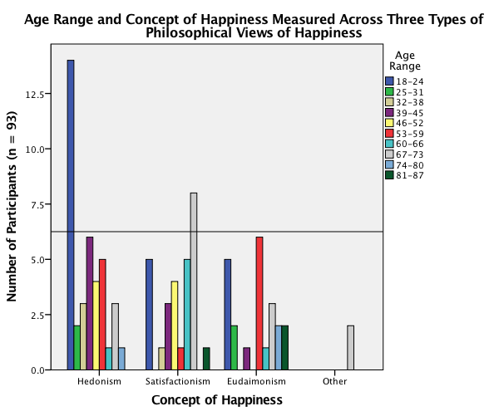

Figure 7.

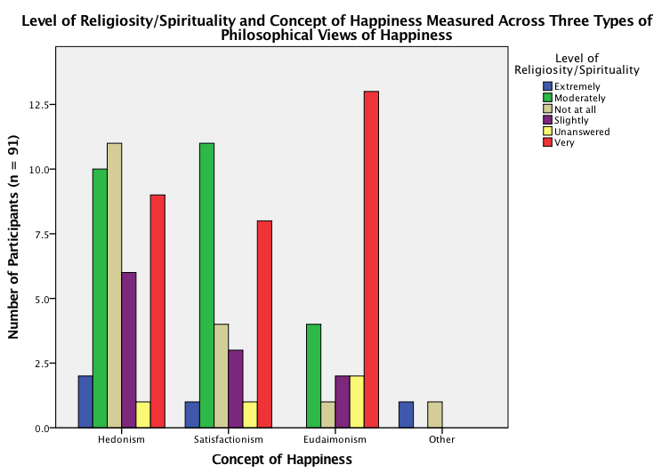

Figure 8.

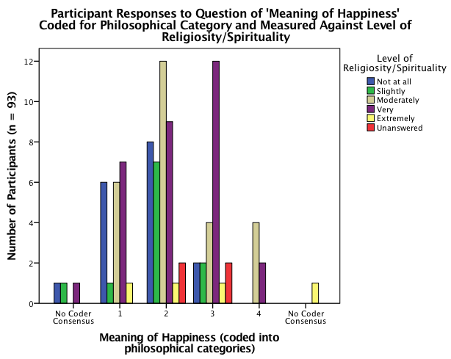

Figure 9.

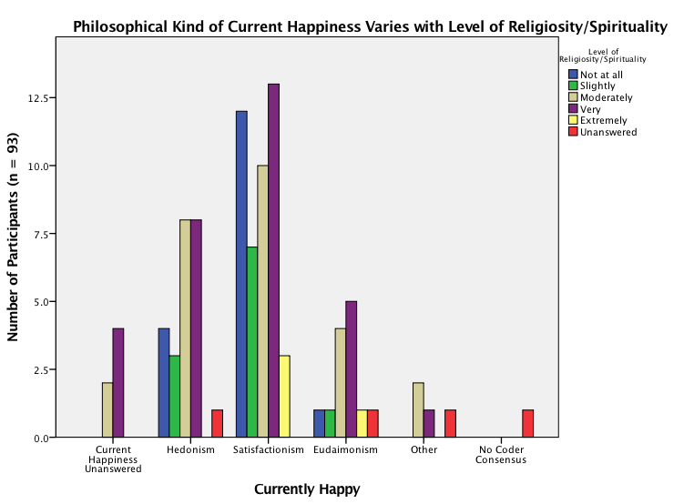

Figure 10.

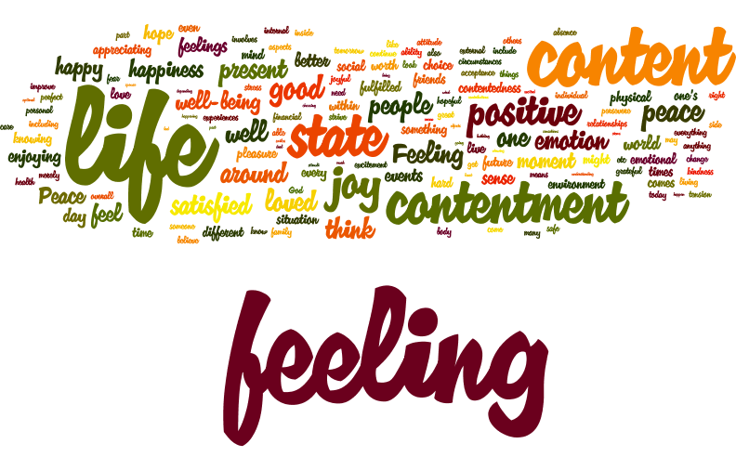

Figure 11. Concept of happiness

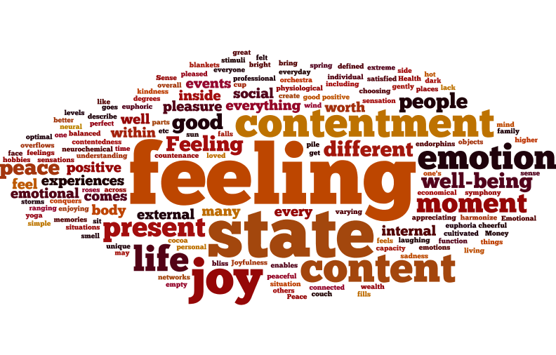

Figure 12. Concept of happiness for hedonistic view of happiness

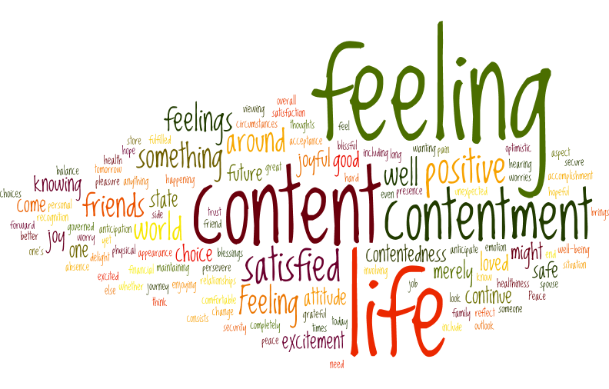

Figure 13. Concept of happiness for satisfactionistic view of happiness

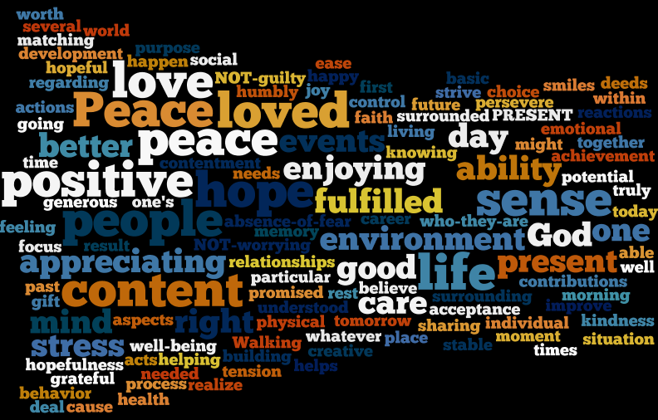

Figure 14. Concept of happiness for eudaimonistic view of happiness

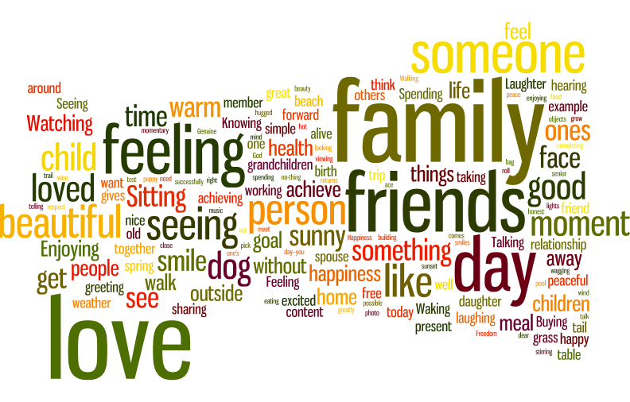

Figure 15. Examples of happiness for three philosophical views of happiness

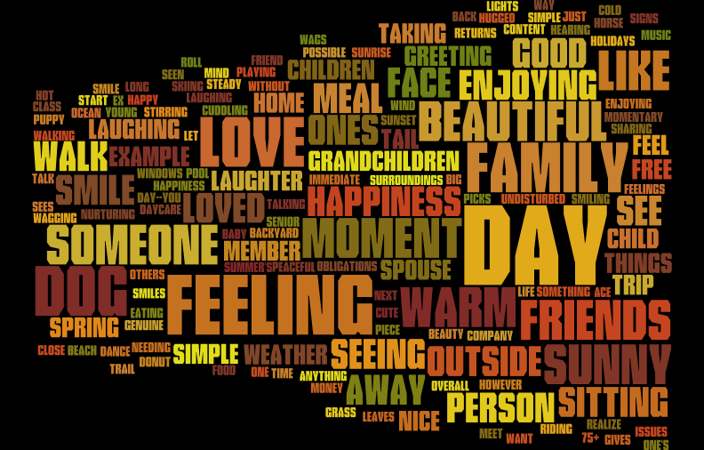

Figure 16. Examples of happiness for hedonistic view of happiness

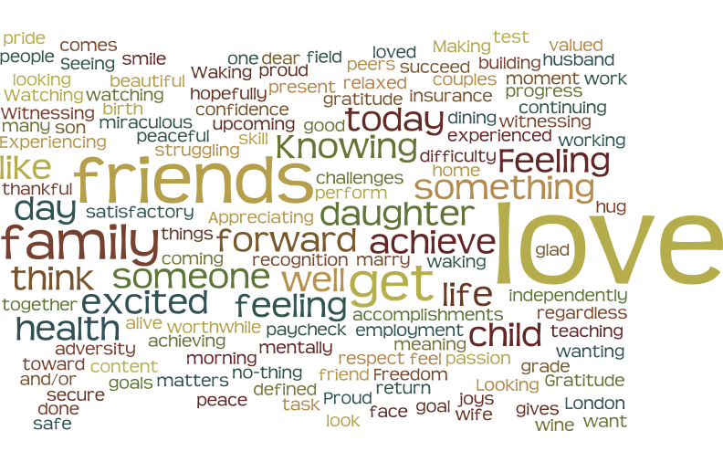

Figure 17. Examples of happiness for satisfactionistic view of happiness



Figure 18. Examples of happiness for eudaimonistic view of happiness

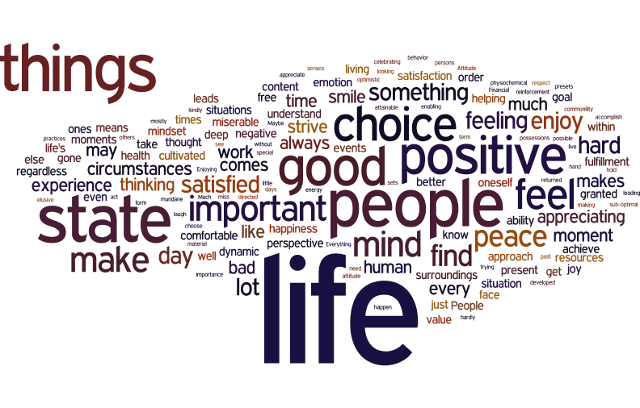

Figure 19. Meaning of happiness for three philosophical views of happiness

Appendix A
Materials
Survey Disclosure Form and Survey Questions as the participants saw them
Looking Into Happiness
Disclosure Form

Salem State University Institutional Review Board (IRB) Disclosure Statement

My name is Rachel Kaplan. This questionnaire is for a research paper I am doing for school. It will ask you questions about happiness and being happy. Do not worry about spelling and grammar, as they do not matter in this context.

This survey should take about 10 - 15 minutes to complete. Filling it out is completely voluntary. There are no right or wrong answers. You may stop at any time. All answers will remain completely anonymous. You do not have to answer any questions that make you feel uncomfortable.

There are no risks as a result of participation in this study. Benefits to participating in this research include contribution to the field of psychology.

An analysis of the results and an explanation of the study will be available after May 1, 2016, by email request (r_kaplan1@salemstate.edu; jgonsalves@salemstate.edu) or through the Psychology Department at Salem State University.

Understand that your name or identity will not be used in reports or presentations of the findings of this research. The information provided to the researchers will be kept confidential with the exception of information which must be reported under Massachusetts and Federal law such as cases of child or elder abuse.
This research project has been approved by the Institutional Review Board at Salem State University. Thank you for your help. Date of Exemption: March 2, 2016
Date of Salem State University IRB Approval: March 2, 2016 For questions or concerns about the research, please contact:
Principle Investigator, Rachel M Kaplan (r_kaplan1@salemstate.edu) Faculty Sponsor, Joanna Gonsalves (jgonsalves@salemstate.edu)

********************************************************************************************* For concerns about your treatment as a research participant, please contact:
Institutional Review Board (IRB) Sponsored Programs and Research Administration Salem State University 352 Lafayette Street
Salem, MA 01970
(978) 542-7556 or (978) 542-7177 or irb@salemstate.edu
This research project has been reviewed by the Institutional Review Board at Salem State University in accordance with US Department of Health and Human Services Office of Human Research Protections 45 CFR part 46 and does not constitute approval by the host institution.

*1. I have read the above disclaimer.
By clicking 'Yes' I am giving my consent to participate in this study and I certify that I am 18 years of age or older.
 Yes  No
Looking Into Happiness
Reminder: Do not include any personal or identifying information.

Please define the concept of happiness.

  - Please give an example of happiness.

  - What do you think about happiness or what it means to be happy?

  - Please give an example of what it is like to be happy.

  - Please give an example of what it is like to be happy.

- Please give an example of what it is like to be happy.

- Please give an example of what it is like to be happy.

- Do you consider yourself currently happy? Why or why not?

- Do you consider yourself happy overall? Why or why not?

- Where do you reside? If you are a student living on campus, please choose that region as your current residence.
 Northeast, United States of America  Midwest, United States of America
 South, United States of America (South-Atlantic and south-central)  West, United States of America (Mountain and Pacific)
 Outside the United States
 If outside the U.S.A, please feel free to include your current country of residence.

What is your gender?

 Male  Female

What is your age range?

18-24
25-31
32-38
39-45
 46-52
 53-59
 60-66
 67-73
 74-80
 81-87

88

Do you consider yourself to be religious or spiritual?

Not at all Slightly Moderately Very Extremely



Other (please specify)

How would you describe your religious or spiritual identity?

- Are you currently a college student?

 Yes  No

What is your major or area of specialization?

- In what category is your occupation and/or area of specialization? Please be vague with this answer. Examples include: Sciences, Administration, Education, Retail, Management and so on.

- What is the highest level of education you have completed?

 High school diploma/GED
 Some college
Certification program/licensure
Associate’s degree
 Baccalaureate  Graduate studies  Doctorate
 Post-doctoral
 Other (please specify)

Have you taken a course/seminar, read a book, watched a documentary, or recently learned about the concept of happiness? Please specify.

THANK YOU
for YOUR
TIME and PARTICIPATION!
Appendix B
Instructions for Coders

For each question, please assign a code (see below). Include any comments that are necessary or pertinent to the coding decisions, paying careful attention, for instance, to more challenging-to-interpret responses. Please work downwards, or column-by-column (as opposed to row-by-row), so that responses are viewed and coded by question and not participant. If choosing the “Other” category (code 4), please ensure that the response does not fit into the other three, established groups (codes 1-3). If a response fits into all three categories, please choose the one that suits it best; do not choose “Other” if the response fits into more than one category. If choosing the “Other” category (code 4), please include comments and describe reasons for the coding choice.
Descriptions for table 1 were written with the use of Mulinix and Mulnix (2015a; 2015b). Figure 1 is a reprint of Nettle’s figure “Three Different Senses of the Term ‘Happiness’” (2005).

TABLE 1
Code | Title of Code (for reference) | Description of Code (for reference)
1 | Hedonism | An episodic state. A positive affect. Pleasures felt. Pleasures could be physical, emotional, psychological. Includes desires, emotions, moods.
2 | Satisfactionism | Overall satisfaction with life and goals. Satisfied that desires have been met/satisfied. Attitudes (i.e. pros and cons) such as approving, appraising, positively evaluating. Properly, attitudes do not require feelings or affective states.
3 | Eudaemonism | A process. Flourishing, examples include finding genuine relationships, finding meaning and purpose, achievements, fulfilling human potential, fully actualizing, equanimity, morality, and autonomy.
4 | Other | Does not fit in with above descriptions
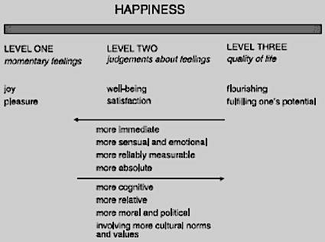
FIGURE 1

See also the Grant Study and the Glueck Study of Adult Development, out of the Laboratory of Adult Development at Mass General Hospital. http://www.massgeneral.org/psychiatry/research/adult_dev_study.aspx
It is important to note that the descriptions of happiness categories are fairly generalized for the context and brevity of this paper. A close or ‘in-the-know’ reader may point to other aspects that have been excluded from the descriptions. For the purpose of this study – the coding and analyses that follow in the Methods and Results section, the descriptions here will be broad-spectrum. For more information, please see Mulnix and Mulnix (2015a, 2015b).
The headings for the following sections on philosophy have been taken and adapted from Mulnix and Mulnix (2015).
a. Mulnix, J. W., & Mulnix, M. J. (2015). Theories of happiness: An anthology. Peterborough: Broadview Press. b. Mulnix, J. W., & Mulnix, M. J. (2015). Happy lives, good lives: A philosophical examination. Peterborough: Broadview Press.
Nettle, D. (2005). Happiness: The science behind your smile. Oxford, UK: Oxford University Press.

