ON LATINO REPRESENTATION IN THEATRE

Honors Thesis

Presented in Partial Fulfillment of the Requirements

For the Degree of Bachelor of Arts
In the College of Arts and Sciences
at Salem State University

By

Jazmine Mateo

Professor William Cunningham
Faculty Advisor
Theatre and Speech Communication Department

***

Commonwealth Honors Program
Salem State University
2018

Abstract
Theatre is becoming more inclusive, more diverse, and I am intending on this paper to shed light on it, so others may see this too. Growing up I didn’t see much Latino representation in Broadway theatre, so naturally the feeling I got when I was first presented with In the Heights by Lin Manuel Miranda at my high school was incredible. Seeing people on stage that looked like me and had stories like mine for the first time in my life was inspiring. It left me wondering, wanting, and curious to see what else was out there. I also want young people, such as the ones I have run theatre workshops for in my hometown in the summer, to know, that should they choose to pursue theatre, they have role models to look up to in the field and plays that tell stories they can really relate to. This was my inspiration for my thesis. I conducted research on Latinos and Latinas in theatre and interviewed people in the field to hear their experiences. I have also collected data to find out if the number of Latinos in theatre is growing or diminishing. During my research I concentrated on how many Latino actors were playing Latino roles, how many Latinos were playing non-Latino roles, how many plays exist that realistically display Latinos, and what the future of Latino theatre will look like. This is information I want others so that they can see Latino theatre in a new light.

Table of Contents
Abstract ii
Acknowledgements iv
Latinx v
1950's Hispanic Theater: West Side Story 1
1960s Hispanic American Theater 10
1970's Latino Theater Boom 14
1980's Latino Theater: One for the “Books” 19
1990's Latino Theater: Claiming Latino Voice 24
Present Day Latinx Theatre 26
Numbers 32
Analysis of Interviews 33
Letter to Next Generation Me 37
Bibliography 39
Bibliography for Images 42

Acknowledgements
I would like to thank my advisor, Professor William Cunningham, for pushing me to make this thesis something beyond an average history project. I would like to thank all involved in the process… your advice, guidance, and support have helped me in the grandest of ways. Lastly, I would like to thank my family – but more importantly – my mom, without whom I would not be where I am today. Thank you Mami!

Latinx
In the 1970s the United States census changed to include "Hispanics" to group people with Latin American identities. Prior to the change, people of Latin American descent were referred to as Puerto Rican, Mexican, or Cuban. Then people started using Latino, or someone of Latin American descent, because Hispanic refers to Spain or Spanish speaking countries. Calling someone “Latino” implies that the person is a male of Latin American descent. The same applies for “Latina”, which is a female of Latin American descent. Throughout this work, I may refer to actors and things associated with the Latin American culture as “Latinx”. This is a new term associated with the Latin culture. As defined in the Merriam-Webster dictionary, Latinx is a gender-neutral term for people of Latin American descent. For this thesis, I will use variations of the words "Latino", "Latina", and "Latinx" where I feel they apply best. I have titled my thesis On Latino Representation in Theatre. This is not because I am focusing on male representation, but rather because I have identified as Latino for a large part of my life and I want to reflect the impact of the word in my thesis. Even though it has been male dominated in history, times are changing, so here is my reflection on that change.

1950’s Hispanic Theater: West Side Story
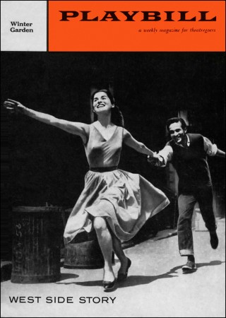
(Playbill, 1958)
The Show
Playwright: Arthur Laurents
Composer: Leonard Bernstein
Lyricist: Stephen Sondheim
Director and Choreographer: Jerome Robbins
Summary
In 1957 we were introduced to a renovation of the "Romeo and Juliet" story of two star-crossed lovers in West Side Story. It takes place in the West Side of New York City in the summer of '57. Maria falls in love with Tony who wants to break away from the savagery of the streets. The issue is that the lovers are caught between their warring street gangs. One gang, the Jets, are Polish American and used to be led by Tony. The other gang is called the Sharks and they are Puerto Rican and led by Maria's brother Bernardo. The gangs are fighting for territory and it escalates to the point where they plan a rumble. Maria asks Tony to try and stop the fight, but it goes wrong, and tragedy strikes in the end.
Relevance
While there are definite influences of the Latin culture in the words, rhythms, and characters in the show, the actors playing Puerto Rican that were Puerto Rican or Latinx identified at all were slim to none. In the casting of the show, they auditioned Latina/o actors for principle Shark roles but didn't consider them for the Jet roles. Non-Latinos did however get cast as Sharks. (Herrera) Of the original 1957 cast, Latinx actors played only 2 of the Sharks. The first of the two Sharks is Anita, the main character Maria's cousin. Chita Rivera, an actress of Puerto Rican descent, played Anita. In the later film adaptation Anita was again one of the only characters played by an actor of Latinx descent, Rita Moreno. In both cases, the character was portrayed as the stock character of a fiery Latina, or a "Latina spitfire". Another stock character is presented to U.S. Popular performance in West Side Story through Chino. This character depicts the Latino gang member. It is the 2nd of the two characters in the play to be portrayed by a Latin actor. Puerto Rican identified actor, Jaime Sánchez, played Chino. In this next section I will explore the lives of these actors at the time of the show and after the show as well as the stock characters of a Latina Spitfire and Latino Gang member that they played.
The Latina Spitfire: Anita
Spitfire- n.) A person with a fierce temper.
Whether intentional or not, West Side Story displayed the stock character of the fiery Latina that has been carried out in works before its time and all the way through to present day 2018. For a while, Rita Moreno and Chita Rivera were given roles specific to the Latina spitfire character, which narrowed their talents into a certain category, but also gave them opportunities in the theatre industry. The character Anita is in fact a Latina spitfire, but she has a level of authenticity and strength to her that the actresses could relate to and thrive playing. In this next section I will investigate how playing Anita impacted both actresses' lives.

Chita Rivera
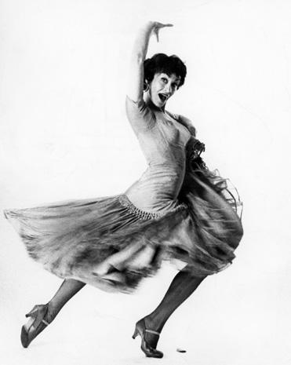
(Photofest)
Born Dolores Conchita Figueroa del Rivero in Washington D.C. in 1933, Rivera started training in dance at a young age. She won a scholarship to the School of Ballet in New York so her and her mother moved and trained there for 3 years. Rivera landed dancer and chorus roles in Call me Madame (1952), Can Can (1953), and Shoestring Revue (1955) ... but her big break was in West Side Story (1957). Rivera originated the role of Anita on Broadway. Leo Lerman, who wrote Dance Magazine's "At the Theatre" column, said in his review of the premiere:
"[The] star of the piece is, indisputably, Chita Rivera. She is one of the few who can sing, can act, and, of course, dance magnificently. Here is a performer of enormous individuality with a dance approach quite uniquely her own. She has made the transition from chorus to star with seemingly no effort, shedding irritating mannerisms and replacing them with the superbly assured manner of, with luck, a future great lady of the American musical theater."(Lerman)
Since then she originated roles in over a dozen Broadway plays. Her first major credit after West Side Story was Bye Bye Birdie in 1960 where she played the role of Rose Grant. The character was initially supposed to be a Polish woman. The actor they created the role for was Carol Haney, but just rehearsing the score she lost her voice. They decided to search for a new leading lady, and the creators came across Rivera. She was not Polish; so to add her into the show they changed the role from Polish to Spanish. This character is the love interest and secretary for one of the main characters, Albert Peterson. In comparison to West Side Story Rivera had a much bigger role. Rose Grant takes charge of her situation and the role is quite powerful. In present day, the character's name has been changed to Rose Alvarez. Though there is no specific record of why it was changed, having a Latina actress originate the role must have played a factor. This role paved way for other major credits including Chicago (1975).

Rita Moreno
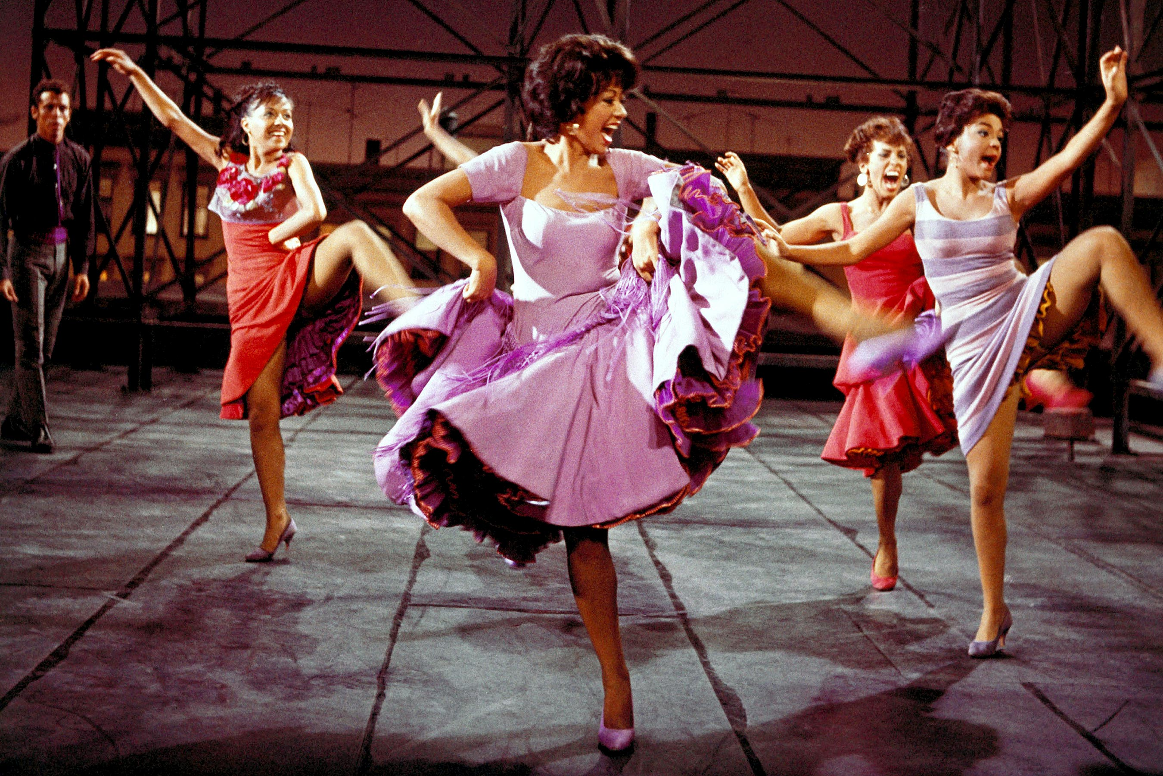
Moreno center stage (Everett Collection)
Moreno was born Rosa Dolores Alverio on December 11th, 1931, in Humacao Puerto Rico. She came to the United States when she was 5 years old. Moreno made her Broadway debut at age 13 in Skydrift, a play in which a group of paratroopers killed in a plane crash make ghostly returns to their surviving loved ones, despite their sergeant's objections. She was under the name Rosita Cosio in the Playbill. Moreno signed a 7-year contract with MGM at age sixteen but was disappointed because the roles they gave her were only ethnic parts such as a Polynesian girl, Indian princess, and Arabian girl. In an interview she said,
"These roles objectified us... They almost always portrayed us as ignorant, uneducated, completely passive, unable to read and write and, most importantly, morally corrupt, usually some white man's mistress."(Dargan)
When she was cast as Anita she pointed out how this character was different from all the others because she stood up for her rights, and she was Puerto Rican. There were no characters like this for Moreno before that role. She won an Oscar for playing the role of Anita, but it didn't change the view of Latinas in theatre. Unfortunately for a while after West Side Story, she was only offered parts in gang movies in lesser parts. It discouraged Moreno for a few years, but she continued her journey. Moreno later starred in a role that satirized the Latina spitfire, Googie Gomez, in the play The Ritz (1975) for which she won a Tony. She starred in "The Electric Company" and won a Grammy for her work in that show. Moreno later won two Emmy's for her work in "The Muppets" (1977) and "The Rockford Files" (1978). Moreno is the first and only Latina EGOT, meaning she has been awarded an Emmy, Grammy, Oscar, and Tony for her work. She was a role model for young Latinas then and continues to be a role model for Latinas today.
The Latino Gang Member
U.S. popular performance in the 1950s depicted the stereotype of a Latino gang member. More accurately, at the time it was Chicano gang members and fights that were the focus. Youth criminality at the time was masculine. Journals at the time accounted for the "real west side story", in which they looked at what Puerto Rican boyhood actually looked like. (Herrera) This helped people put into perspective that a boy like Bernardo could have died the night before, and a boy like Chino could be seeking revenge for it.

Chino
Chino is the translation of the character Paris of Romeo and Juliet into West Side Story. He is described as sweet-faced and innocent, and he is the person Bernardo intends for his sister Maria to marry. His character arc shows that while he is bitter and vengeful in the end, he starts off as a sweet character. He is the only other Shark character to have scripted lines aside from Bernardo. This is said keeping in mind that all named Jet characters get a scripted line of a speech, song, or both.
Jaime Sánchez
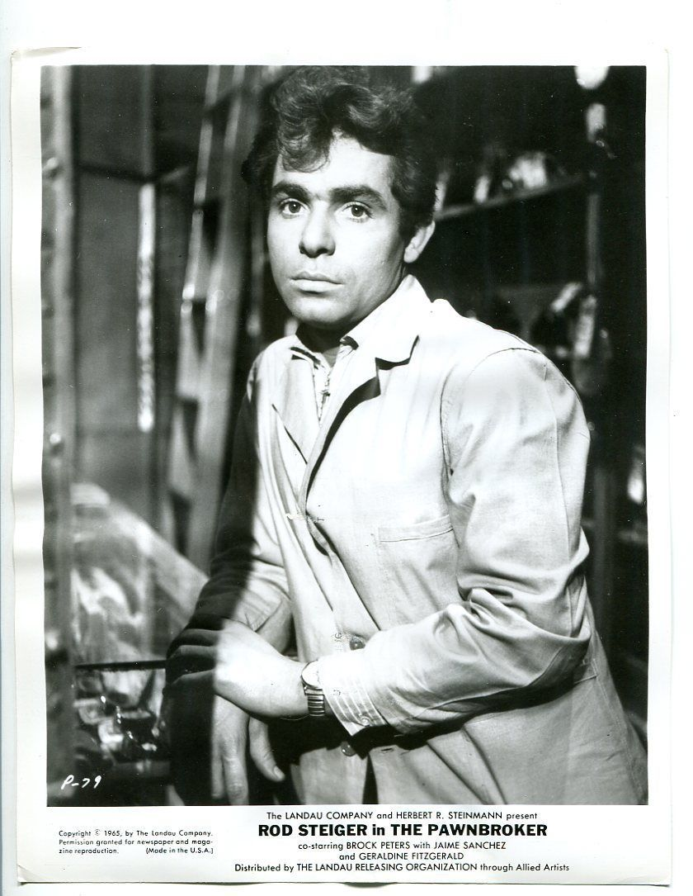
(Pinterest)
Born Jaime Luis Sánchez Rodríguez in Rincón, Puerto Rico on December 19th, 1938. Sánchez was the only actor from Puerto Rico, born and raised, of the original Broadway cast. After West Side Story he went on to do projects mostly in film such as Pawnbroker (1964) and The Wild Bunch (1969), but he also performed on stage in Julius Caesar as Marc Antony, in Coriolanus as Titus Lartus, and in Richard III as Ratcliffe.

1960’s Hispanic American Theater
El Teatro Campesino
In English, "el teatro campesino" translates to "the farmworker's theatre". Founded in 1965 by Luis Valdez and farmworkers, that is exactly what it was. It was the first of its kind in the United States. The theatre was started to get farmworkers to join the union founded by Cesar Chavez, the National Farm Workers Association (NFWA). The NFWA was holding strikes against the area's grape ranches. They used actos, which are short, typically comedic skits that are created through improv and can be presented anywhere to convince workers to join. In actos heroes and villains are clearly defined as well as the solutions, which usually were to unionize.
Over time the group developed other performance genres such as mitos (myths, which typically reflect the lost Chicano indigenous heritage), corridos (folk ballads about fighting injustice), and carpas (this translates to "tents" and is a performance for working-class audiences).
"The Teatro became a voice for the voiceless, giving Chicano audiences in particular a sense of belonging in a society that had ignored and suppressed them for generations." (Huerta)
This theater created a ripple effect. Everywhere they performed theatres were then being created. They began hosting annual Chicano theatre festivals. A national movement was in the works. The company is currently based in San Juan Bautista, California.

Luis Miguel Valdez
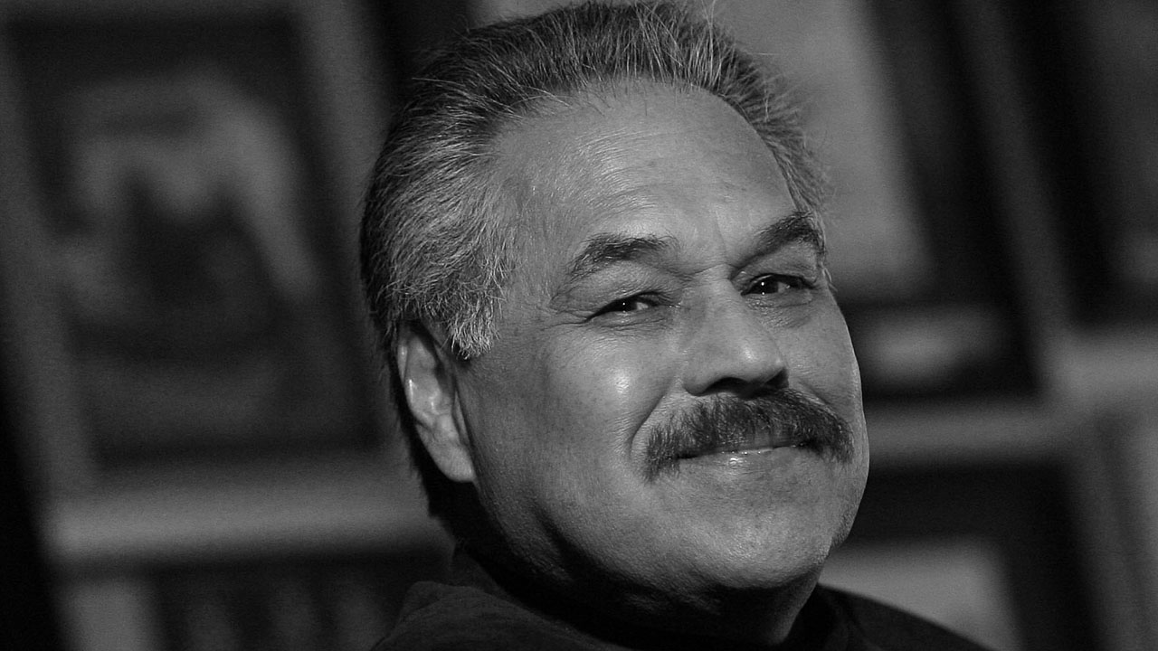
(El Teatro Campesino)
Valdez was born on June 26, 1940 in Delano, California. His parents were Chicano migrant farm workers. Valdez started working in the fields at the age of six. Later in 1960 he was awarded a scholarship to San Jose State College. There he won an award for his one-act play, The Theft. At the end of his four years he wrote his first full-length play The Shrunken Head of Pancho Villa (1964). It is an absurdist comedy about Mexican-Americans on the verge of the Chicano Civil Rights movement of the 1960s.
In the following year, 1965, Valdez founded El Teatro Campesino to get farm workers to join the union. Slowly it began to grow. The company traveled, and more theatre companies were starting to open across the U.S. For Valdez's successes, he would be awarded a variety of honors and awards. One of which is the Rockefeller Foundation Grant, which enabled Valdez to create Zoot Suit (1977), a play that would later become a movie based on the Zoot Suit Riots and the Sleepy Lagoon murder. This play was the first Chicano theatrical production on Broadway. In 1986 he wrote, I Don't Have to Show You No Stinking Badges. It received critical acclaim, but Zoot Suit helped set a new tone that is still relevant today even in last year's revival.
Overall Valdez's contributions to Latinx theatre in the United States sparked a movement. He was honored with the National Medal of the Arts in 2015. When being presented with the award, the spokesperson said of him, ‘“[Valdez is being awarded] for bringing Chicano culture to American drama,’ ... ‘As a playwright, actor, writer and director, he illuminates the human spirit in the face of social injustice through award-winning stage, film, and television productions.”’(Wildman) His work continues to inspire Latinx artists and activists to this day.
Miriam Colón and the Puerto Rican Traveling Theatre (PRTT)
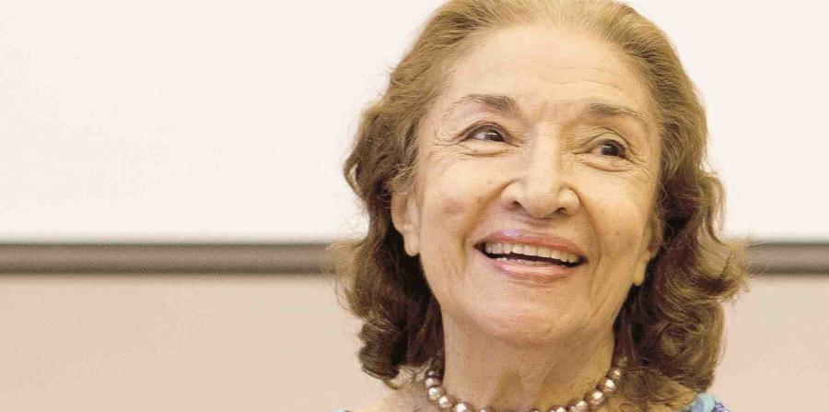
(Theater Scene)
Colón was born on August 20^{th,} 1936 in Ponce, Puerto Rico (PR). She first started acting in the Ramon Baldoriatry de Castro School in PR. From there she developed a big passion for the theatre and started taking classes at the University of Puerto Rico, or UPR. She loved traveling to local towns with UPR's touring company to perform.
She said of her tours, "When the University of Puerto Rico’s Touring Company would go into the small towns in Puerto Rico, I would see their faces light up. It was like the circus for them. We were creating the strongest community bond…through theatre." (Ramírez)
That inspired Colón to later found the Puerto Rican Traveling Theatre (PRTT) in 1967. They performed works from Puerto Rican playwrights and alternated between Spanish-language performances and English-language ones. They pioneered productions of Nuyorican and Hispanic playwrights. It is permanently housed in 47th Street in New York. PRTT also recent merged with another major Puerto Rican theater company, Pregones Theater. Pregones Theater was founded in 1979 by Rosabla Rolón to create theatre works in Carribean and Latin American performing ensembles.

1970’s Latino Theater Boom
Repertorio Español
In 1968 this theatre was the idea of René Buch and Gilberto Zaldivar. They wanted a theatre dedicated to Spanish language theater and cultural exchange. When they met Robert Federico, who became the executive director for the company, the idea became a reality. In 1972, El Repertorio Español was established at Manhattan's East 27th Street in the Gramercy Arts Theatre. Their mission is to, “produce the best Latin American, Spanish and Hispanic-American theatre in distinctive, quality productions, and to bring theatre to a broad audience in New York City and across the country, including seniors, students, and Hispanics of all national backgrounds.” (El Repertorio Español) The company has performed works in Spanish translated simultaneously in English in their auditorium that seats 154 people. In present day they are now beyond 40 years running and have produced over 250 shows for over 1.5 million people and 750,000 high school students! They have received critical acclaim for their work including an array of OBIE, Drama Desk, Ace, HOLA, and ENCORE awards. El Repertorio is taking action to increase representation and is dedicated to the next generation of Latinx artists. They hold an annual competition for young playwrights sponsored by MetLife called Nuestras Voces. They also have the Edward and Sally Van Lier Fellowship for Directors that helps them foster recently graduated directors.
TENAZ and the Chicano Theatre Boom
Luis Valdez, El Teatro Campesino, and Los Mascarones founded el Teatro Nacional de Aztlán (TENAZ) in the 1970s in response to the boom of Chicano theatres being formed. There were over 20 that opened in the 1970s alone. TENAZ had 3 main goals: First, establish communication between teatros (theatres). Second, provide a means for sharing materials. Third, establish a summer workshop for representatives for as many teatros (theatres) as possible. Overall the goal for companies involved with TENAZ was to gain, "unity of the Chicano".
Miguel Piñero
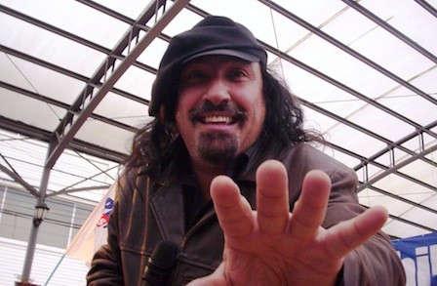
(Poetry Foundation)
Piñero was a playwright born Miguel Antonio Gomez Piñero in Gurabo, Puerto Rico. He came to the United States when he was 4 years old and grew up in New York's Lower East Side. When his father left, Piñero would steal food for his family. He later joined a gang and was convicted soon after for robberies in 1964 and 1972. It was during his second incarceration that Piñero wrote Short Eyes as part of a playwriting workshop in jail. Short Eyes is a drama about prison life set in a house of detention where a group of young convicts- who are predominantly Black and Puerto Rican- taunt, fight, insult, and entertain one another in attempt to preserve their sanity and create a semblance of community. A young prisoner accused of child molesting is thrown into the mix and this sets the stage for a series of explosive events because the child molester, nicknamed “Short eyes” for his conviction, is considered the lowest of criminals. While on parole in 1973, the play was presented in several New York venues, nominated for 6 Tony's, and won both the New York Dramatic Critic's Circle Award and an OBIE Award for best play. His play was the first play written by a Puerto Rican to be featured on Broadway. His success led to more playwriting and in the following years Piñero wrote Sideshow (1974), The Guntower (1976, The Sun Always Shines for the Cool (1976), Eulogy for a Small-Time Thief (1977), and Playland Blues (1980). He was also a key part of the Nuyorican literary movement and one of the co-founders of the Nuyorican Poets Café.
INTAR
It was originally known as Agrupatión de Arte Latino Americano (ADAL) when Max Ferrá founded it in 1967. Later, when the organization achieved equity status as an off-Broadway theatre the name was changed to INTAR – short for International Arts Relations – in 1977. INTAR has helped progress Latino theatre in major ways:
"INTAR Theater, with its varied programs, including a MainStage Season and the NewWorks Lab, has played a major role in identifying, supporting, nurturing, developing and producing unique theatrical Latino voices that have made a significant impact in American dramatic writing." (INTAR)
INTAR has commissioned, developed, and produced over 175 works by Latino writers, composers, and choreographers. It has helped playwrights, directors, and actors obtain their first professional theatre credits, memberships, and reviews in English-language media.
For about 14 years, INTAR hosted the Hispanic Playwrights in Residence Lab. It was founded and directed by María Irene Fornés, a successful Cuban American playwright popular for her works Fefu and Her Friends (1977), Mud (1983), and The Conduct of Life (1985). Fornes helped many new Latinx playwrights develop their work. Some of the playwrights she worked with include Nilo Cruz, Lisa Loomer, Migdalia Cruz, and Milcha Sánchez-Scott.
Lou Moreno is the current Artistic Director for the organization. The mission continues to live on at West 52nd street in New York, New York today.
Ivan Acosta
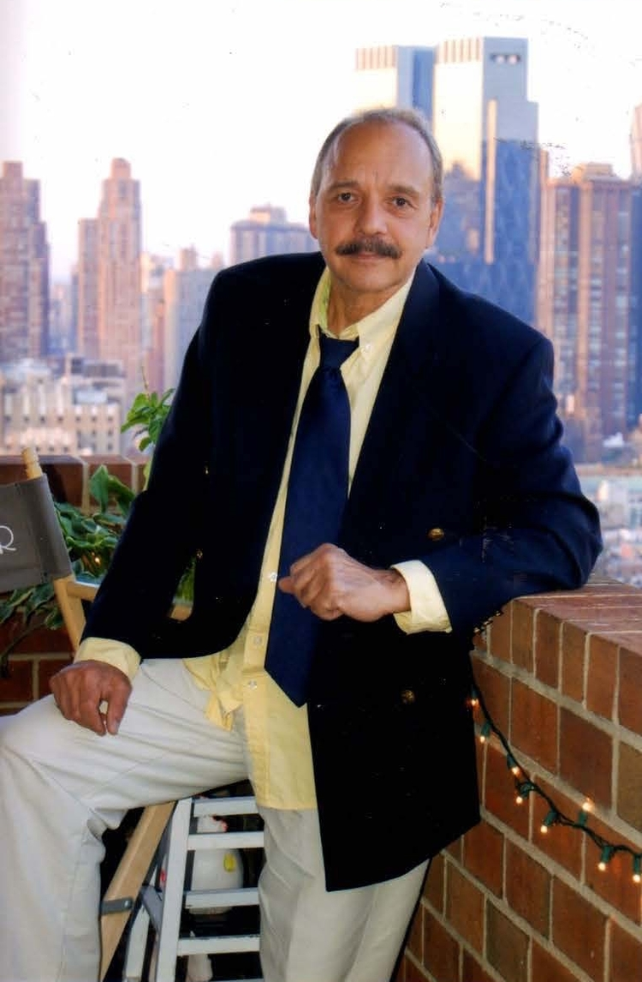
(The Un-Gyve Limited Group)
Ivan Mariano Acosta is a famous Latino playwright and filmmaker born in Santiago, Cuba on November 17, 1943. He immigrated to the United States with his parents during the Cuban Revolution. He graduated from New York University in film in 1969. He worked as a playwright and director in the Centro Cultural Cubana. There he produced his play, El Super (The Superintendent), which became one of the biggest breakout shows in the Latino community. The play did well and was later adapted into a movie and won 12 awards for best script and best director.

1980s Latino Theater: One for the “Books”
"Hispanic" officially added to the United States Census.
Arte Publico Press
Nicolás Kanellos founded it in 1979. It was sparked by Kanellos' efforts to have more Hispanic writers published by mainstream presses. From the 1980's all the way through to today Arte Publico Press has continued to publish literary works from the Hispanic heritage. They have published the work of Sandra Cisneros, Luis Valdez, and Miguel Piñero to name a few. Arte Publico Press publishes about 30-35 books per year. They also started a Hispanic Literary Heritage project in 1992, in efforts to recover, index, and publish lost Latino writings from the American colonial period to 1960. Since the project's inception, they have found over 18,000 books published by Latinos before 1960.
Milcha Sanchez-Scott
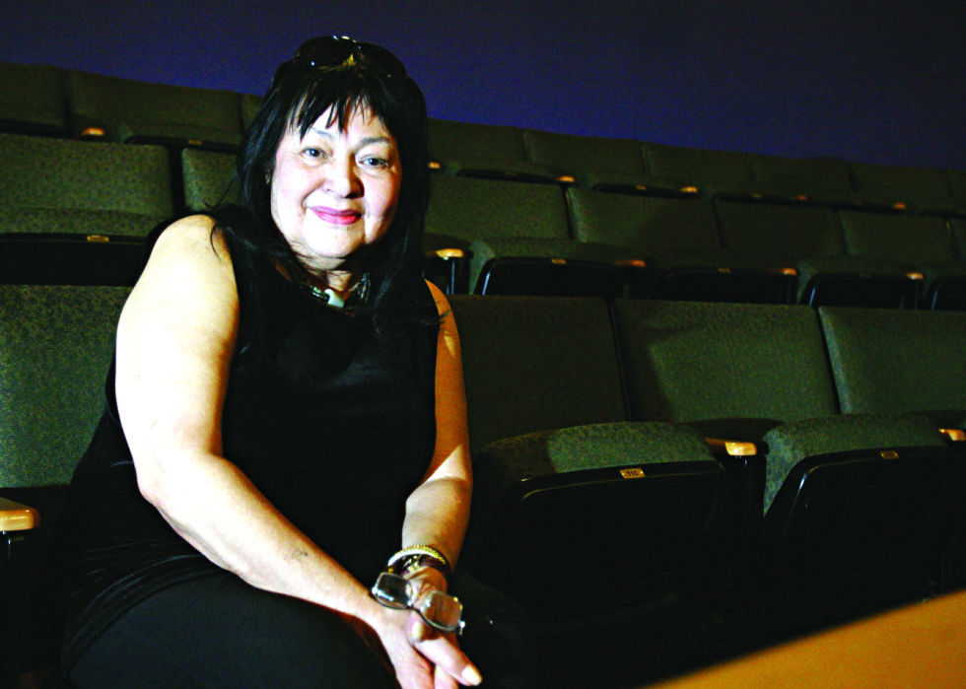
(Martinez, 2014)
Sanchez-Scott was born in 1953 on an island called Bali. She has a lot of diversity in her cultural heritage, as she’s Indonesian, Chinese, and Dutch, and Columbian. Sanchez-Scott attended school in Europe while her father worked there and later lived in Columbia and Mexico for a few years before moving to California. She earned a degree in Literature, Philosophy, and Theatre at the University of San Diego.
Through her work in the San Diego Zoo and in an employment agency for maids, she began to collect stories of immigrant women who were applying for work. This inspired her to create her first play, Latina. She was hired by L.A. Theatre Works, which premiered her play Latina in Los Angeles in 1980. She was later invited to join Maria Irene Fornes' playwriting workshop at INTAR in New York in 1984-1985. Sanchez-Scott's plays Dog Lady and The Cuban Swimmer were written in 1982 and produced by INTAR in 1984. Sanchez-Scott then wrote Roosters, in 1985. INTAR later produced Sanchez-Scott's play Roosters in 1987. The play has become one of most widely produced Latino plays.

Migdalia Cruz
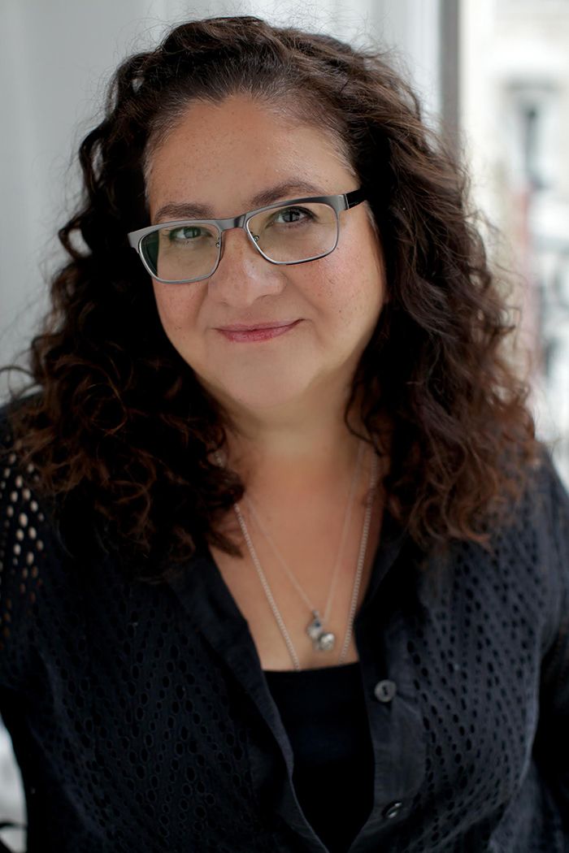
(Lopez)
Cruz is a Puerto Rican playwright who grew up in South Bronx, New York. She went to Stuyvesant High School, and graduated Magna Cum Laude with a BFA from Lake Erie College in 1980. In 1984 Cruz graduated from Columbia University with an MFA in playwriting. From 1984-1990 she joined INTAR's Hispanic Playwrights in Residence Laboratory with Maria Irene Fornes. There she learned to "tell the truth" in her writing.
Cruz has taught at Princeton University and Amherst College. She has also guest lectured at Yale University, Wesleyan University, Mount Holyoke College, and Columbia University. She has won a variety of fellowships and awards for her work throughout her life. She has written over 60 plays, operas, screenplays, and musicals and has worked with many different theater companies in her lifetime. Some of her most famous works include Miriam's Flowers (Produced in 1990) Fur (Written in 1991 and produced in 1997) and The Have-Little (Produced in 1991).
"Migdalia Cruz's work is described as startling and uncompromising. Her highly charged images are both theatrically powerful and emotionally compelling." (Peterson & Bennett)
Culture Clash
It was first born in 1984 because of the Latino/Chicano arts scene in California and was known as "Comedy Fiesta". Later it became "Culture Clash" because of the culture clash of Latinos against mainstream America as well as the culture clash between different Latino races. The group included the trio Herbert Siguenza, Richard Montoya, and Ricardo Salinas. They mostly did sketch comedy cabaret style shows for audiences. They produced and cast themselves into roles that they might have otherwise been denied in mainstream American theatre.
Culture Clash produced their first full-length show in 1988. It was called The Mission:
"The Mission is the synthesis of many traditions. It is a play about us: Richard, Ric, and Herbert, a culmination of three separate lives coming together in a desperate plea to tell the world about our dilemma. It is a semi-autobiographical romp about three frustrated Latino actors from San Francisco's Mission District trying to break into the show biz." (Montoya, Siguenza, & Salinas)
Their writing of that show was a response to the lack of Latino representation in mainstream. They believed that if they were going to get their shot, they had to write it and do it themselves. They inspired new groups to form using the Culture Clash model such as Latins Anonymous (1987), Chicano Secret Service (1988), SalSoul Comedy (1993), ChUSMA (1997), and Latino Comedy Project (1998).

1990’s Latino Theater: Claiming Latino Voice
"The characters are not stereotypes- they are real- but in the hands of the wrong director or producers, the plays can be a devastating portrayal of the Chicano culture."- Jorge Huerta (Herrera)
Nilo Cruz
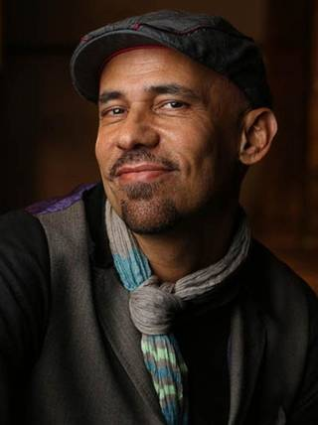
(PortlandStage)
Cruz was born in 1960 in Cuba. He immigrated to Miami in 1970, fleeing Cuba with his family on a Freedom Flight. Though he was young when he lived in Cuba, there are many elements of Cuba in his writing from the physical settings to the linguistic rhythms. He won a Pulitzer Prize for Drama for his play Anna in the Tropics in 2003. He is only Latino playwright to win that category to date. Nilo Cruz's plays have been widely produced. Some of his works include Two Sisters and a Piano (1998), Night Train to Bolina (2004), and Beauty of the Father (2007).
John Leguizamo
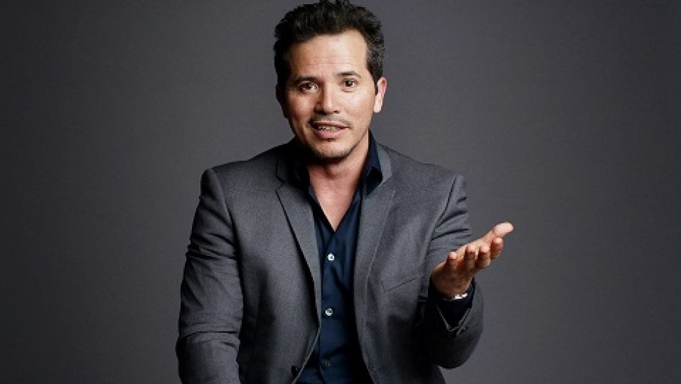
(Clement, 2016)
Leguizamo was born in 1964 in Bogota, Columbia. He wasn't landing many opportunities in the industry, and the few times he was called in to audition, it was for roles as a Latino murderer or drug dealer. As a graduate from New York University, he felt he could and should do more. Leguizamo had a similar mindset to the trio of Culture Clash. The mindset was, if he was going to land mainstream roles, he had to create them for himself.
Leguizamo did just that. His first one-man show was Mambo Mouth in 1991. He received multiple awards for his performance. That show was followed with his second one-man show, Spic-O-Rama in 1992 and third one man show, Freak in 1998. These shows helped Leguizamo find the presence on the mainstream stage that he hoped for, without the misrepresentation of stereotypes.
Present Day Latinx Theater
Today: In The Heights
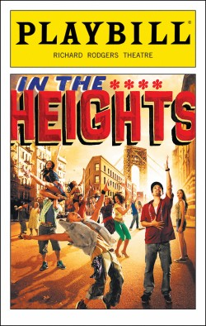
(Playbill, 2008)
The Show
Book: Quiara Alegría Hughes
Music and Lyrics: Lin-Manuel Miranda
Summary
In the tight-knit neighborhood of Washington Heights, Manhattan we follow the stories of small shop owners over the course of 3 really hot summer days. At the show's core is Usnavi, the owner of the local bodega (corner store) who pines after Vanessa, the gorgeous girl working in the neighboring beauty salon, and dreams of winning the lottery to return to his native Dominican Republic. Meanwhile Nina Rosario, who is a childhood friend of Usnavi, returns from her first year in college with shocking news for her family who spent their life savings on their daughter's education. Times are tight, and everyone is chasing the "American Dream". In the end, Usnavi and the residents of Washington Heights realize what it means to be home.
Relevance
This musical shows how much times have changed since West Side Story. For starters, it is a show written by Latinos for a prominently Latino cast. The influences of Hip Hop and Latin rhythms such as Merengue and Salsa show an important aspect of Latin culture in the United States. It genuinely portrays the Latino experience. For me, this was the first time I could really see myself on stage through Nina Rosario and Vanessa. Living in a predominantly Latino community, I connected with the Piragua man and the ladies from the salon. This shows proof that mainstream doesn't have to be the Latina spitfire anymore. It is the Latina who aspires to do something bigger, and who might fall sometimes, but has the ability to get back up again.

Lin-Manuel Miranda

(Hiatt, 2016)
Miranda was born January 16th, 1980 in New York. He grew up northern Manhattan and went to a public school for gifted children in the Upper East Side. From a young age, Miranda had influences of Latin music and Hip Hop in his life. He also had influences of musical theatre because his father loved listening to musicals. In his early years, his parents couldn’t afford to go to see all musicals, but he saw Les Miserables, Cats, and Phantom of the Opera. All other shows, they were able to get recordings of or saw when they became films.
Miranda met Steven Sondheim when in high school, and now sends him unfinished drafts of his work for feedback. While in college at Wesleyan, Miranda wrote his first draft of In the Heights. That would later become a Tony award winning show. Miranda’s childhood influences are present in his works from the Latin rhythms in In the Heights to the Hip Hop/Broadway mash-up in Hamilton. He is bringing a new sound to the Broadway stage.

Quiara Alegría Hudes
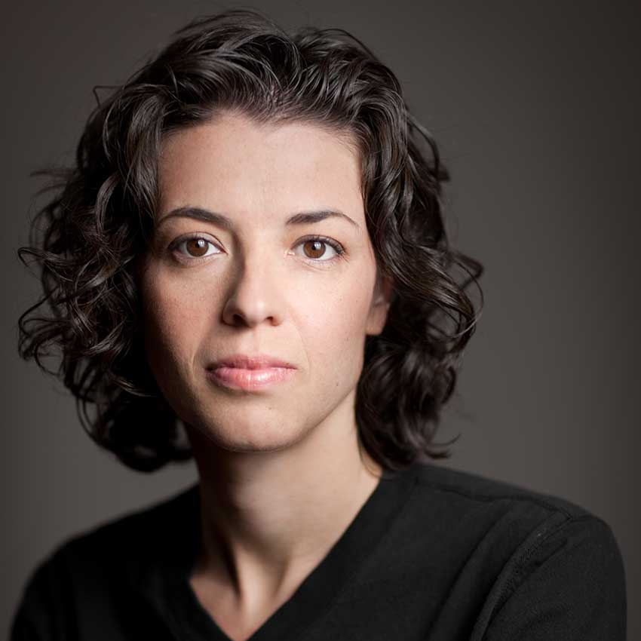
(WME Speakers)

Hudes was born in 1977 in West Philadelphia, Pennsylvania. She grew up hearing her mother’s Afro Caribbean tracks every morning. Her aunt - Linda, who was a composer and keyboardist for the Big Apple Circus, taught her how to read music. Her aunt’s husband, who was the circus’ bandleader, would bring Hudes to Tower Records and let her pick out tapes from all sorts of genres – which Hudes would learn to play by ear. Hudes went on to study music composition at Yale University. She was the first in her family to attend college. She would later receive her M.F.A. at Brown University. She was introduced to Lin-Manuel Miranda in 2004, and wrote the book for his Tony Award winning musical In the Heights. It was a Pulitzer Prize finalist. Her voice brought the show to a new level. Hudes received the Pulitzer Prize for Drama in 2012 for her play Water by the Spoonful. Her more recent works include, Miss You Like Hell and “Emancipated Stories” which she founded as a way to put a personal face on mass incarceration by having inmates share one page of their life story with the world.
On Your Feet!

(Murphy)
The Show
Book: Alexander Dinelares
Music and Lyrics: Gloria Estefan and Emilio Estefan
This is the story of Emilio and Gloria Estefan. Through unwavering dedication to one another and their pursuit of the American dream, they showcased their talent, their music, and their heritage to the world in a remarkable rise to global superstardom. (Playbill)

Relevance
This show is providing opportunities for Latinx actors on Broadway, as it is a predominantly Latinx cast. It brings classic Latinx songs from Emilio and Gloria Estefan to the mainstream of the Broadway stage. As with In the Heights, this show is another way that the Latinx youth of today can see themselves on stage. It is another way I can see myself on stage. I grew up listening to Gloria Estefan because my mother would play her CDs. That connection to the material is what could bring more Latinx individuals to audiences. This connection provides a way for others like myself to see them on stage, and that is so important. In that sentiment, shows like On Your Feet! provide more opportunity and hope for Latinx artists.

Numbers
The Asian American Performer’s Coalition (AAPAC) published a report on Ethnic Representation on New York City Stages for 2015-2016. Within that, it is noted that 7% of roles on Broadway were given to Latinx performers. The 10-year industry average for hiring Latinx performers is 3.8%. Also in 2015-2016 of the 51,057 actors that were active members in the Actors Equity Association, 1,389 or 3.2% were Latinx. American Asian actors made up 2.2%, multiracial actors made up 4.2%, and African American actors made up 9%. 34,736 or 81.1% was made up of Caucasian actors. This is a slight increase for Latinx actors from 2014-2015 where they made up 2.9% and a decrease of Caucasian actors, which made up 83.3%. This shows that while numbers of Latinx actors are low, they are beginning to increase from previous years, but there is still a long way to go.

Analysis of Interviews
I have taken a sample of students and people who have studied theatre and are pursuing theatre to hear a bit about their experiences. For the purpose of this thesis their names will remain anonymous, but I will highlight quotes that cover general views and bullet notes that I found important.
Key terms that came up:
- Color Blind Casting: Casting without regard to an actor’s race and ethnicity.
Some respondents reflected that color blind casting is devaluing, because even though it can provide more opportunity for an actor of color it ignores the identity of the actor.
- Color Conscious Casting: Casting with regard to an actor’s race or ethnicity.
Every respondent said that while it is understood that not every director will have easy access to the actors that fit the description of a role they should do everything in their power to cast an actor of color in a role meant for an actor of color. To say that there aren’t any actors of color available shows that it probably isn’t the time to do that show, or that a director needs to look a little harder.
- Passing: When a person classified as a member of one racial group is also accepted as a member of a different racial group.
Some Latinx actors, especially on mainstream theatre, are seen as White “passing”.

On Acting
- Acting is not a “practical” career option – not commonly supported by families, so students can’t always afford it. Influences at home and in life play a huge factor on whether an actor continues on or not.
- You don’t have to look Latinx to be Latinx.
On Casting
- Mostly cast in small/sidekick type roles
- Should roles for Latinx characters be strictly given to Latinx actors –Consensus: Yes.
“If a character is specifically a POC, cast that character with a POC actor. It’s not like there’s not enough of us! And if a director/company wants to say they can’t find the POC actor then they aren’t trying hard enough.”
“If you look at it very closely, most people cast in shows like Hamilton that may be the first or second show they are cast in, unless the role is bent to their ethnicity. I think there is a difference between a character written for a person of color that is given to a White actor vs. an ambiguous character being cast as a person of color.”
- In acting, White actors can play pretty much whatever they want, but Latinx actors can’t play just any other character.
- There is a lack of authenticity when the role is given to someone not of Latinx descent.
“Yes Latin actors should be filling roles that are written for Latinos. Art is about telling a story and if we want to tell a story accurately we have to cast people with those experiences. We need empathy and to place actors in roles where they can portray the role truthfully.”
On Writing
- Mexicans write about the Mexican experience, Dominicans about the Dominican experience. One cannot write for the other in an authentic way. Latinx individuals are from similar ethnic identities, but within those identities all have different experiences based on geographic location, the color of their skin, the colloquialisms they grow up with, and so many other factors.
- All those interviewed are willing to write, and some are already writing.
On Latino Representation in Theatre
- Everyone interviewed mentioned Lin-Manuel Miranda and his major impact on Latinx theatre at least once. This was however the only Latinx artist listed consistently.
“Lin-Manuel Miranda. He’s doing everything. I emulate him because he pushes boundaries; he knows the challenges people of color go through. He’s had backlash too, but he’s successful. I want more of us to be like him.”
- Playwrights mentioned: Stephen Adly Guirgis (Jesus Hopped the ‘A’ Train, 2002), José Rivera (Marisol, 1992), Josefina Lopez (Real Women Have Curves, 1990)
- Other inspirations: John Leguizamo, America Ferrera
- Need more people that “look like me” on stage.
- Latinx stories are being written, but not told enough.
- Most interviewed had not been cast in a Latinx role before. They have landed roles for people of color, but only 1 had actually landed a Latinx role and that is because the director was color conscious in the actors they chose.
“What’s crazy is that I don’t think I’ve ever been in a play where I’ve played a Latinx actor. Which says something of the system, but there have been roles that make me proud to be an actor of color.”
- Brownface still happening today. It happened in the 1950s for West Side Story actors in which they applied make up that made their skin darker to look more Puerto Rican. Though it happens much less than in the ‘50s, a person interviewed has seen it happen in recent years.
- Salem State University has created their first ever Person of Color deputy role in Spring 2018.
- Local theatres currently promoting diverse roles: Huntington Theatre Company, Company One.
Call to Action
- We need more Latinx directors, artistic directors, or positions of power where your voice is heard more directly.
“It’s up to people of color to take the reigns and really start producing more stories.”

Letter to Next Generation Me
Dear Incoming Freshmen,
I hope that in reading this, you realize that you are not alone. For starters, there are plays for Latinx actors – but it requires some digging. There is authentic writing out there that has evolved from our first Latina Anita’s and Latino Chino’s to our goal driven Usnavi’s and Nina’s. Latinx representation in the written work has changed significantly. The Latinx presence on stage hasn’t lined up with the amount of work done however. There is still work to be done. Someone may still tell you that you need to sound “more Latinx” or to be more “spicy” or “fiery”. The problem of one show making it mainstream is that everyone else frames it as what Latinx individuals and the Latin experience are supposed to be. Anita is a great character, but it’s not encompassing of every Latina. Some Latinx individuals have accents, some don’t. Some have lighter skin, and some have darker skin. Some love to dance, and some stay far away from dance. There is no one formula for a Latinx individual. Please don’t tell a Latinx actor to act more “Latinx”. Luckily today, the voice and portrayal of Latinx individuals is being more authentically written than our 1950’s spitfires. That being said there is still a long way to go.
Latinx individuals are still underrepresented in mainstream theatre, but there is a slow and steady rise. We have the works of amazing individuals such as Lin-Manuel Miranda and Quiara Alegría Hudes driving us forward. They provide opportunities for us on the mainstream stage. We have had the foundations set forth by Luis Valdez and El Teatro Campesino, El Teatro Repertorio Español, and INTAR who helped to create Latinx theatre. More Latinx artists are getting an education, teaching, creating, and helping progress the movement forward. Now, mi gente (my people), it’s up to you.
There is still work to be done. Recently we’ve had two shows specifically for Latinx individuals on Broadway: In the Heights and On Your Feet are only 2 shows. How many productions of those can we do? My advice to you is, if you don't see the type of theatre you want on Broadway, step up and create it as Latinx artists have done in the past and continue to do today. We need more people like Lin-Manuel, Chita Rivera, and Luis Valdez if we want more representation. So to the incoming freshmen and young Latinx actors… your time is now.
Best,
Jazmine Mateo

Bibliography
A&E Television Networks. (n.d.). Luis Valdez Biography. In The Biography.com Website. Retrieved March 20, 2018, from https://www.biography.com/people/luis-valdez
About Migdalia . (n.d.). In Migdalia Cruz. Retrieved from https://www.migdaliacruz.com/?page_id=13
Agan, C. D. (2016). Miguel Piñero. Salem Press Biographical Encyclopedia.
"Anna in the Tropics" by Nilo Cruz. (n.d.). In The Pulitzer Prizes. Retrieved from http://www.pulitzer.org/winners/nilo-cruz
Arte Público Press. (n.d.). About Arte Público Press. In Arte Público Press. Retrieved from https://artepublicopress.com/about-arte-publico-press/
Bio (n.d.). In Quiara . Retrieved April 29, 2018, from http://www.quiara.com/bio

Bouknight, J. (1990). Language as a cure: an interview with Milcha Sanchez-Scott. Latin American Theatre Review, 23(2), 63-74.

Cooper, M. A. (2016). RITA MORENO: "if you have a dream, you should go after it". Outlook-12, 2(6), 6-9. Retrieved from https://search.proquest.com/docview/1837898420?accountid=13661
Dargan, Michele. (2015) Rita Moreno reflects on her life; Early struggles, Brando romance among topics. Actress tells Four Arts about early career,. Palm Beach Daily News, p. 1A. Retrieved from http://link.galegroup.com/apps/doc/A404746221/STND?u=mlin_n_state&sid=STND&xid=93ab8a14
DiPaola, S. (2016). 2015-2016 Theatrical Season Report. In Actor's Equity Association. Retrieved from http://www.actorsequity.org/docs/about/AEA_Annual_15-16.pdf
DiPaola, S. (2015). 2014-2015 Theatrical Season Report. In Actor's Equity Association. Retrieved from http://www.actorsequity.org/docs/about/AEA_Annual_14-15.pdf

El Teatro Campesino. (n.d.). Our History. In El Teatro Campesino. Retrieved from http://elteatrocampesino.com/our-history/
El Repertorio Español. (n.d.). Our History. In Repertorio. Retrieved from https://repertorio.nyc/#/repertorio-espanol
Frommer, M., & Frommer, H. (1998). It happened on Broadway : an oral history of the great white way. New York : Harcourt Brace & Company, 1998.
Glenn, A. N. (2005). Casting themselves: Culture clash and the comedy of resistance. Contemporary Theatre Review, 15(4), 413-426. doi:10.1080/10486800500280438
Herrera, B. E. (2015). Latin numbers : playing Latino in twentieth-century U.S. popular performance. Ann Arbor, Michigan : University of Michigan Press, [2015].
History and Mission. (n.d.). In Pregones Theatre Puerto Rican Traveling Theater. Retrieved from https://pregonesprtt.org/ensemble/mission/
Hubeaut, M. F. (2008). Repertorio Espanol, a theatrical life. Hispanic, (8). 48.
Huerta, J. A. (1973). Concerning Teatro Chicano. Latin American Theatre Review, 6(2), 13-20.
Huerta, J. A. (2016). EL Teatro's living legacy: after 50 years Luis Valdez's company retains both its Chicano identity and its broader mission. Next: the return of the troupe's most famous creation, Zoot Suit. American Theatre, (10). 28.
INTAR. (n.d.). History. In INTAR: Producing Latino Voices in English since 1966. Retrieved from https://www.intartheatre.org/history/
INTAR. (n.d.). Mission. In INTAR: Producing Latino Voices in English since 1966. Retrieved from https://www.intartheatre.org/mission/
Kanellos, N. (1992). Hispanic Theatre in the United States: Post-War to the Present. Latin American Theatre Review, 25(2), 197-209.
Kanellos, N. (2003). Hispanic literature of the United States: a comprehensive reference. Greenwood Publishing Group.
Lerman, L. (2012). 55 Years Ago This Month. Dance Magazine, 86(11), 75.
Merriam Webster, Incorporated. (n.d.). The Word History of Latinx. In Merriam Webster. Retrieved from https://www.merriam-webster.com/words-at-play/word-history-latinx
Montoya, R., Siguenza, H., Salinas, R., & Culture Clash (Comedy, t. (Comedy troupe). (2012). Culture Clash : Life, Death and Revolutionary Comedy. New York: Theatre Communications Group.
Paulson, M. (2015, August 12). Lin-Manuel Miranda, Creator and Star of 'Hamilton,' Grew Up on Hip-Hop and Show Tunes. In The New York Times. Retrieved from https://www.nytimes.com/2015/08/16/theater/lin-manuel-miranda-creator-and-star-of-hamilton-grew-up-on-hip-hop-and-show-tunes.html

Peterson, J. T., & Bennett, S. (1997). Women Playwrights of Diversity: A Bio-Bibliographical Sourcebook. Greenwood Publishing Group.

Playbill. (n.d.). On Your Feet!. In Playbill. Retrieved from http://www.playbill.com/production/on-your-feet-marquis-theatre-vault-0000014080
Poetry Foundation. (n.d.). Miguel Piñero. In Poetry Foundation. Retrieved from https://www.poetryfoundation.org/poets/miguel-pinero

Pollack-Pelzner, D. (2018, April 5). Quiara Alegría Hudes rewrites the American landscape. In The New Yorker. Retrieved from https://www.newyorker.com/culture/persons-of-interest/quiara-alegria-hudes-gives-the-american-landscape-a-puerto-rican-voice

Ramírez, J. (2017). Miriam Colón: Puerto Rican Icon and Theatrical Traveler. Latin American Theatre Review 50(2), 233-237. Center of Latin American Studies, University of Kansas. Retrieved April 9, 2018, from Project MUSE database.
Reid, C. (2003). Arte Publico: branding Hispanic history. Publishers Weekly, (40). 10.
Rodriguez, B. (2017). One for the Books: He built a legendary career and followed it up with staunch advocacy work for Latinos in Hollywood. Now, John Leguizamo delivers 'Latin History for Morons'. Back Stage, National ed, (42). 14.

Sutton, R. (2016, October 20). Art Talk with Playwright Nilo Cruz. In National Endowment for the Arts. Retrieved from https://www.arts.gov/art-works/2016/art-talk-playwright-nilo-cruz

The Asian American Performers Action Coalition. (2018, January). Ethnic Representation on New York City Stages: 2015-2016. In The Asian American Performers Action Coalition. Retrieved from http://www.aapacnyc.org/uploads/1/1/9/4/11949532/aapac_2015-2016_10year_report.pdf

Wildman, S. (2016, September 23). Luis Valdez Receives National Medal of Arts at White House. In San Jose Inside. Retrieved from http://www.sanjoseinside.com/2016/09/23/luis-valdez-receives-national-medal-of-arts-at-white-house/

Bibliography for Images
Clement, O. (2016, March 8). New John Leguizamo Show Will Play the Public. In Playbill. Retrieved May 9, 2018, from http://www.playbill.com/article/new-john-leguizamo-show-will-play-the-public
El Teatro Campesino. (n.d.). About Luis. In El Teatro Campesino. Retrieved from http://elteatrocampesino.com/about-luis/
Everett Collection. (n.d.). Rita Moreno remembers West Side Story's bold, subversive 'America'. In Entertainment Weekly . Retrieved from http://ew.com/movies/2017/07/04/rita-moreno-west-side-story-america/
Hiatt, T. (2016). Lin-Manuel Miranda to Host 'Saturday Night Live' in New Season. In Rolling Stone. Retrieved from https://www.rollingstone.com/tv/news/lin-manuel-miranda-to-host-saturday-night-live-in-new-season-w442433
Ivan Acosta on El Super @ Ramapo College. (n.d.). In The Un-Gyve Limited Group . Retrieved from https://www.un-gyvelimitedgroup.com/events/2016/3/14/d86ss7zli1gqpd3wg2jkh68q2eyx7p
Lopez, D. (n.d.). About Migdalia. In Migdalia Cruz. Retrieved from https://www.migdaliacruz.com/?page_id=13
Martinez, J. (2014, February 22). milcha. In The Monitor. Retrieved from http://www.themonitor.com/milcha/image_42d43b28-a0c3-11e3-b321-001a4bcf6878.html
Miriam Colón 1936-2017. (n.d.). In Theater Scene. Retrieved May 9, 2018, from http://www.theaterscene.net/blogs/one-long-extravaganza/miriam-colon-1936-2017/darryl-reilly/
Murphy, M. (n.d.). Gloria Estefan Musical ‘On Your Feet!’ to Close on Broadway in August. In Variety. Retrieved from http://variety.com/2017/legit/news/on-your-feet-musical-closing-broadway-1202448070/
Photofest. (n.d.). Chita Rivera. In CBS News. Retrieved from https://www.cbsnews.com/pictures/chita-rivera/5/
Pinterest. (n.d.). Jaime Sanchez is Angel in 'The Wild Bunch' (Sam Peckinpah). In Pinterest. Retrieved from https://i.pinimg.com/736x/04/a4/a6/04a4a6c0939a65f6c88add889af93e5d--sam-peckinpah-westerns.jpg
Playbill. (1958, September). Playbill Cover for West Side Story at the Winter Garden Theatre . In Playbill. Retrieved May 7, 2018, from http://www.playbill.com/playbillpagegallery/playbill-cover-gallery?asset=00000150-aea7-d936-a7fd-eef76ae80002&type=PlaybillCover
Playbill. (2008). In the Heights. In Playbill. Retrieved from http://www.playbill.com/production/in-the-heights-richard-rodgers-theatre-vault-0000003064
Poetry Foundation. (n.d.). Miguel Piñero. In Poetry Foundation. Retrieved from https://www.poetryfoundation.org/poets/miguel-pinero

Quiara Alegría Hudes. (n.d.). In WME Speakers. Retrieved from http://www.wmespeakers.com/speaker/quiara-alegr%C3%ADa-hudes

Sotto Voce by Nilo Cruz. (n.d.). In PortlandStage The Theater of Maine. Retrieved from https://www.portlandstage.org/show/sotto-voce/

